|  |  |
| --- | --- |
| **Project: New Haven Urgent Care Team#4** | |
|  | **Test Date:** |
| **Test Case ID#: 7** | **Name(s) of Tester(s):**  **Jian Wang** |
| **Test Description (What are you testing? – you must be specific):**  Can only service providers make a diagnosis(es)? |  |
|  |  |

**NOTE: The following information must be provided to be given credit for any test.**

**Test Data (Provide the file name of the script used to insert data, provide a screen capture to reflect data, or provide script here):**

insert into DEPARTMENT

values ('1', 'INTAKE');

insert into INTAKE_DEPARTMENT

values ('1','INTAKE');

insert into EMPLOYEE

values ('121','Charle', 'C', 'Andrew', '12345678', '1');

INSERT INTO SERVICE_PROVIDER

values ('121','Charle', 'C', 'Andrew', '12345678');

INSERT INTO DIAGNOSIS

values ('12312312441','nama', '12-12-2018','12-13-2018','12345678');

**SQL Query(s) used for testing:**

select *

from DIAGNOSIS;

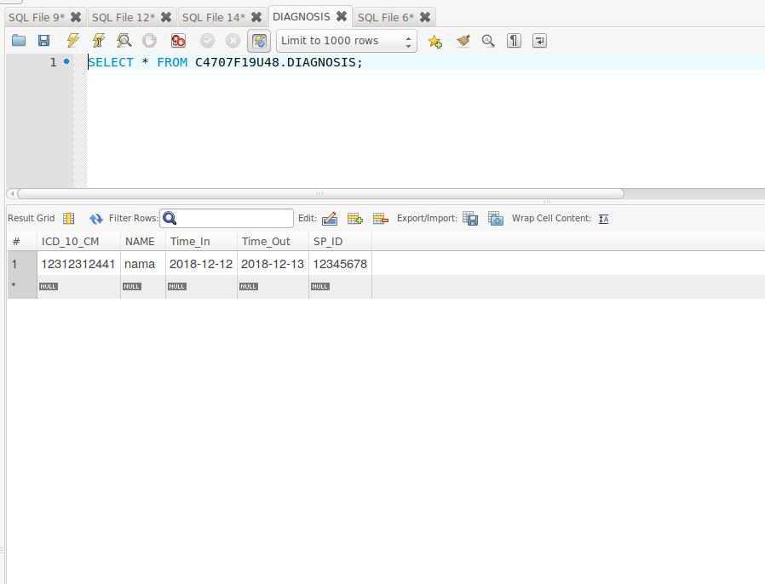We don’t satisfy the requirement. Although, I have the result of diagnosis. But it is not done by service provider only. Service provider have foreign key from EMPLOYEE. EMPLOYEE have foreign key from INTAKE_DEPARTMENT. Therefore, SERVICE PROVIDE can not make DIAGNOSIS ONLY.