|  |  |
| --- | --- |
| **Project: New Haven Urgent Care Team#** | |
|  | **Test Date: 2019/12/12** |
| **Test Case ID#: 5** | **Name(s) of Tester(s): JunRen Huang** |
| **Test Description (What are you testing? – you must be specific):**  This test is to test that can a patient be seen by only one service provider per visit |  |
|  |  |

**NOTE: The following information must be provided to be given credit for any test.**

**Test Data (Provide the file name of the script used to insert data, provide a screen capture to reflect data, or provide script here):**

insert into PATIENT

values (001,'wang','k', 'xi',null,null,null,'xxxx','1001-01-01', 19);

insert into PATIENT

values (002,'wan','k', 'xian',null,null,null,'xxx','1001-02-02', 10);

insert into PATIENT

values (003,'wa','k', 'xiang',null,null,null,'xxxx','1001-02-02', 100);

insert into DEPARTMENT

values (1, 'First department');

insert into INTAKE_DEPARTMENT

values (1, 'Intake department1');

insert into EMPLOYEE

values (1, 'Ken', 'A','Jian',123456789, 1);

insert into EMPLOYEE

values (3, 'Jun', 'A','Huang',123456785, 1);

insert into EMPLOYEE

values (2, 'Wang', 'A','Jian',123456781, 1);

insert into NURSE

values (1, 'Ken', 'A','Jian',123456789);

insert into ASSESSMENT_NURSE

values (1, 'Ken', 'A','Jian',123456789);

insert into VISIT

values (1, 123.2, "1010-03-04", 1, 1, 1, 12, "xxxx", "yyyy");

insert into SERVICE_PROVIDER

values (2, 'Wang', 'A','Jian',123456781);

insert into SERVICE_PROVIDER

values (3, 'Jun', 'A','Huang',123456785);

**SQL Query(s) used for testing:**

select *

from VISIT

select *

from SERVICE_PROVIDER

The result are following

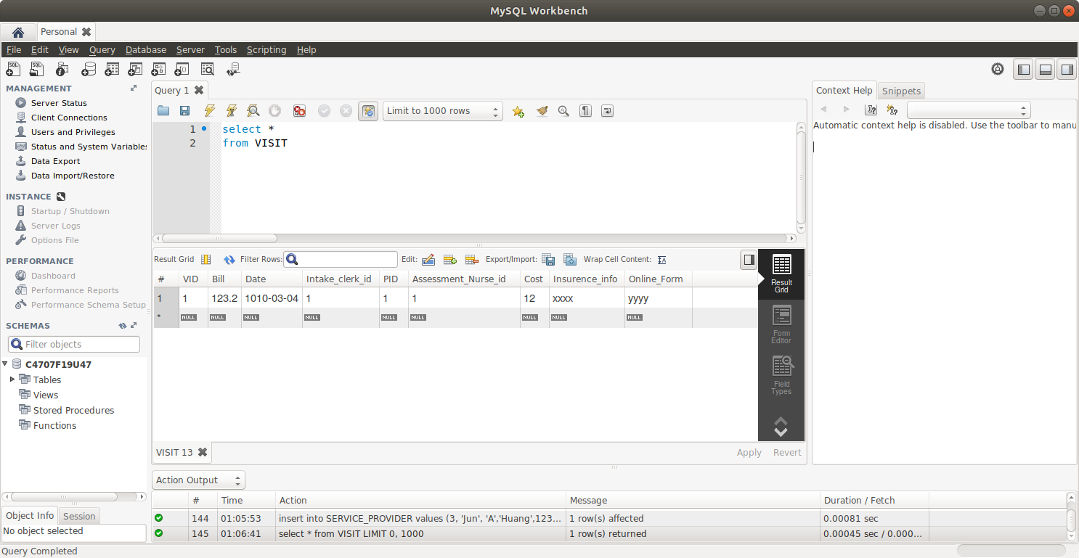

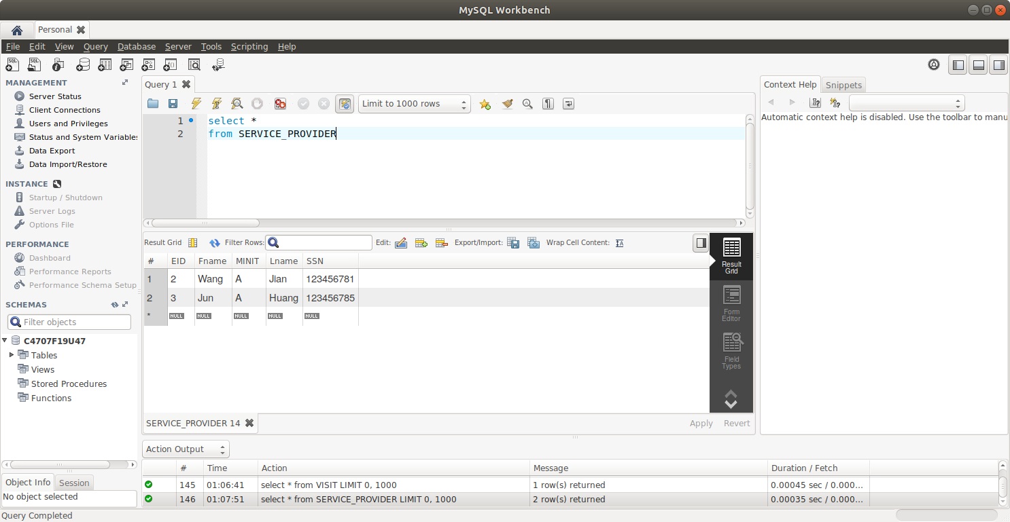

Explanation and Discussion

No possible Query to prove that a patient can be seen by only one service provider per visit at all because VISIT has no direct or indirect relationship with SERVICE_PROVIDER. Therefore, Our design does not meet the requirement that a patient be seen by only one service provided per time. The VISIT has no relationship with SERVICE_PROVIDER at all. This is a huge design mistake. There should a relation between SERVICE_PROVIDER and VISIT, but somehow we miss it. The result is we can insert a row to VISIT without anything in SERVICE_PROVIDER, so patients can have a visit without a service provider.