|  |  |
| --- | --- |
| **Project: New Haven Urgent Care Team#** | |
|  | **Test Date:** |
| **Test Case ID#: 20** | **Name(s) of Tester(s): Guipeng Xie, Xi He, JunRen Huang, Jian Wang.** |
| **Test Description (What are you testing? – you must be specific):**  You should have two tests to test two primary keys or other keys. (your choice of PKs or keys) |  |
|  |  |

**NOTE: The following information must be provided to be given credit for any test.**

**Test Data (Provide the file name of the script used to insert data, provide a screen capture to reflect data, or provide script here):**

INSERT INTO PATIENT VALUES(001, 'XIE', 'T', 'GUIPENG', '2508 DELAWARE',null, null, 'alkfjaklfj', '1998-07-23', 20);

INSERT INTO PATIENT VALUES(001, 'Fary', 'k', 'Berd', '1141 DELAWARE',null, null, 'ueuiqiuer', '1998-09-23', 21);

INSERT INTO DEPARTMENT VALUES(001, 'A0');

INSERT INTO DEPARTMENT VALUES(001, 'D0');

**SQL Query(s) used for testing:**

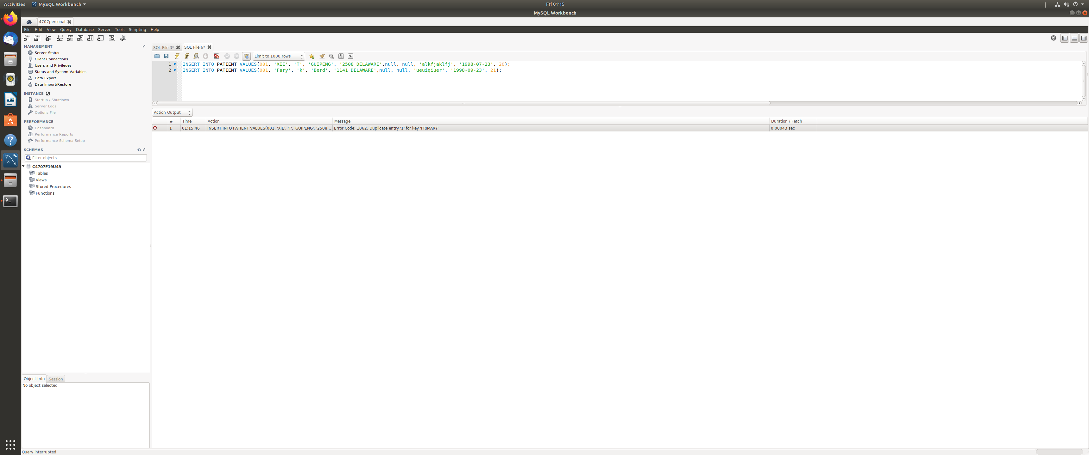

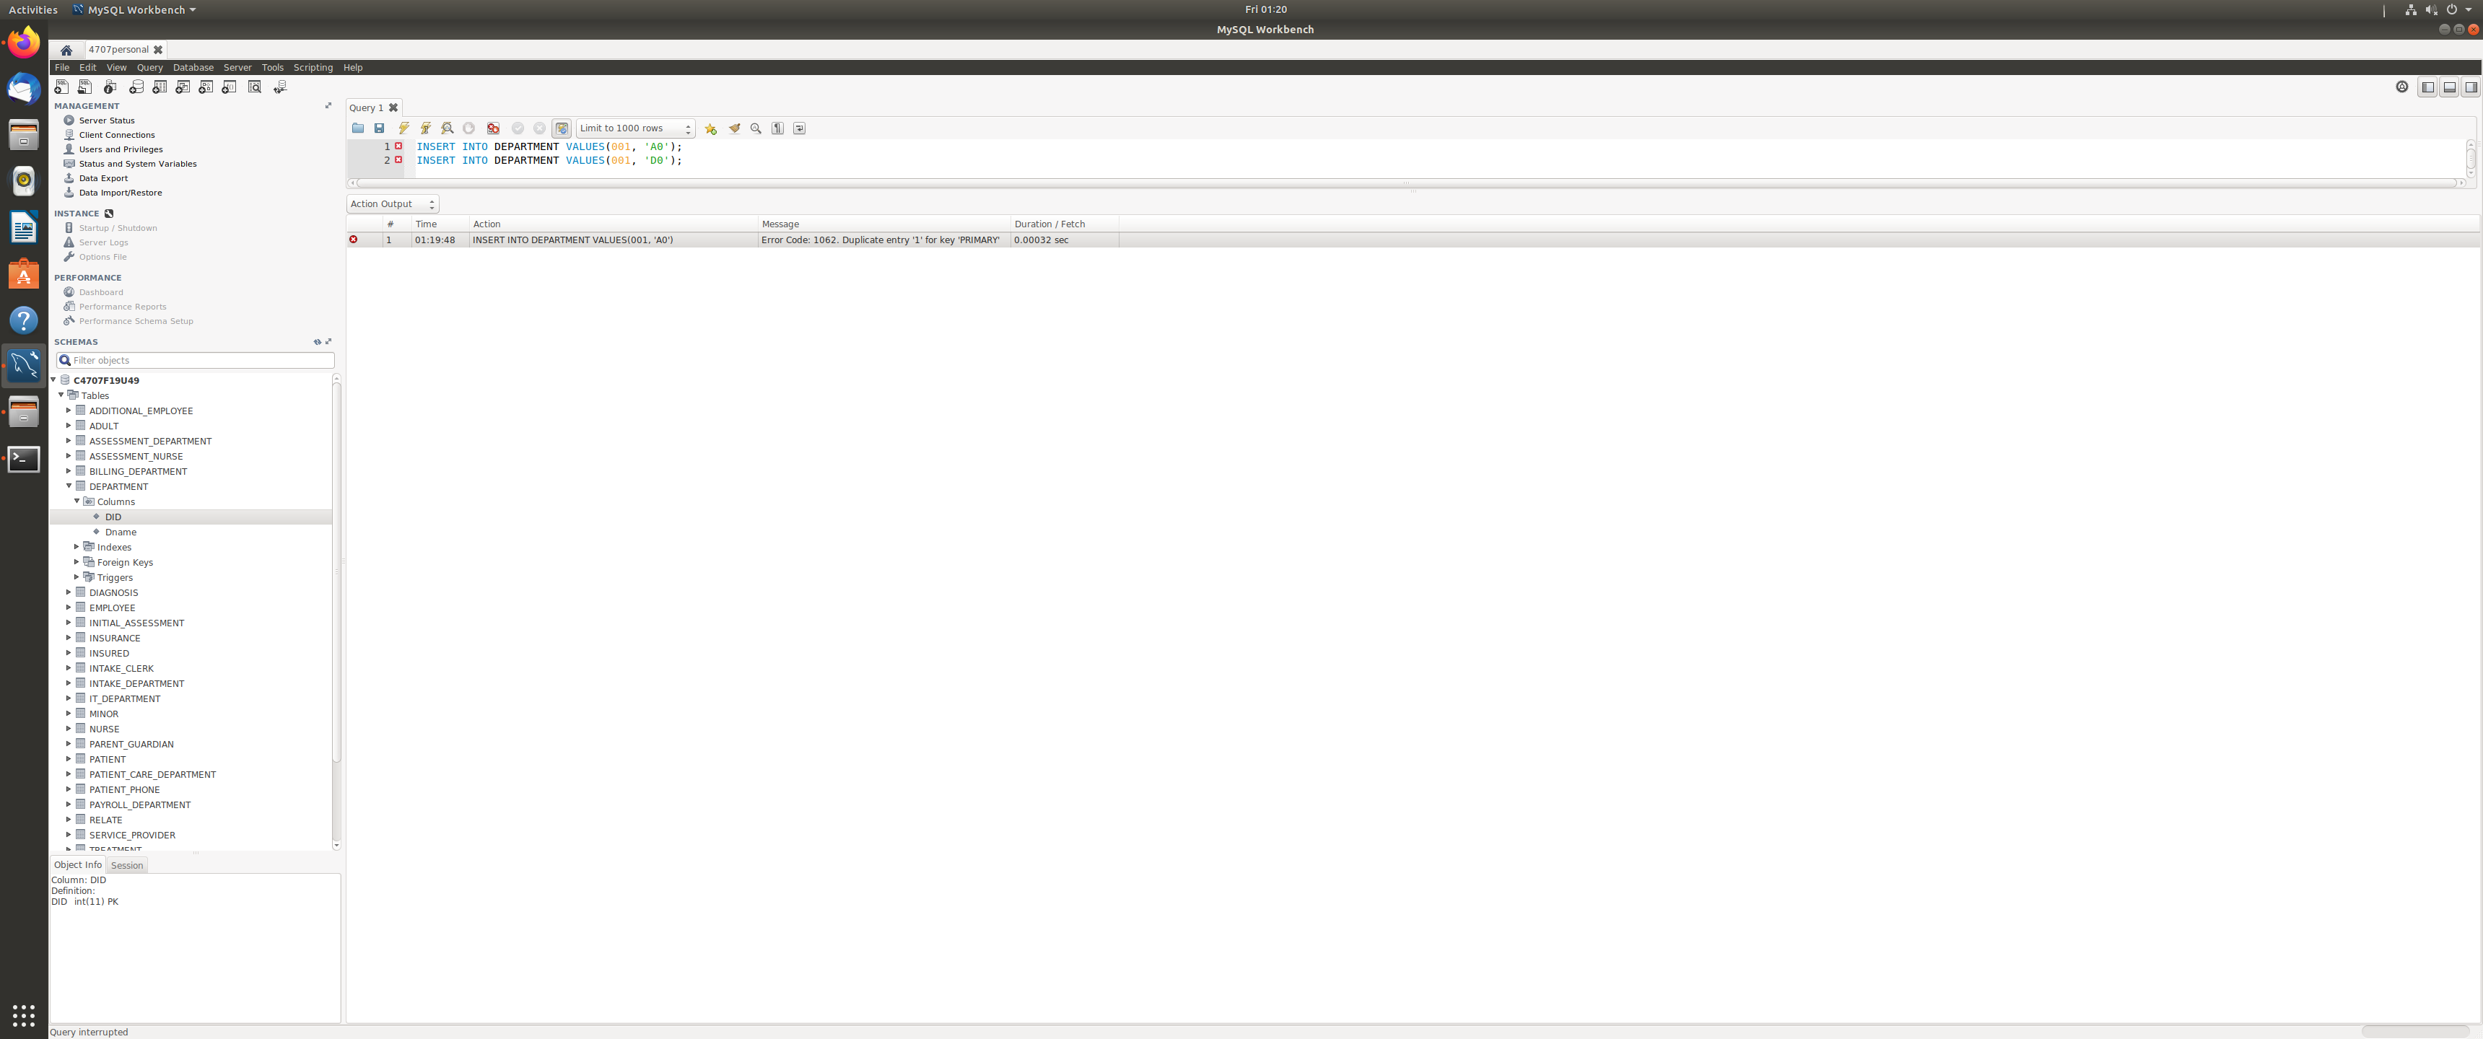

Discussion:

First, we inserted the patient information with PID 001, then we inserted another patient information with PID 001. The result returned an error, which shows the primary key can not duplicate.

Second, we inserted the Department information with DID 001, then we inserted another Department information with DID 001. The result returned an error, which shows the primary key can not duplicate.