Pulse Biometric Collector — User Guide
For campus staff. Version 1.0.3. No technical background required.
Pulse (Biometric Collector) is the desktop app on the campus PC. It reads time-in and time-out from ZKTeco biometric devices and sends them to the cloud so People360 can use them later. Pulse is not the payroll app — People360 handles pay and attendance processing.
1. Before you start
- Pulse is installed on the campus computer (Windows or Mac).
- Biometric devices are powered on and on the same network as the PC (Wi‑Fi or LAN).
- Keep Pulse open while the campus is operating — automatic collection only runs while the app is open.
- Know each device’s name, IP address (e.g. 192.168.1.201), and Comm key (usually 0 if no password is set).
2. Opening the app
Double-click the Pulse icon. The Dashboard opens. At the top you will see: Dashboard, Collected logs, Download DTR, Deleted log backups, Upload backup JSON, and Device users. The version (e.g. v1.0.3) appears in the top-right corner. If an update is offered, wait for it to finish before continuing.
3. Dashboard — first-time setup
This is your daily home screen. Work through the cards from top to bottom.
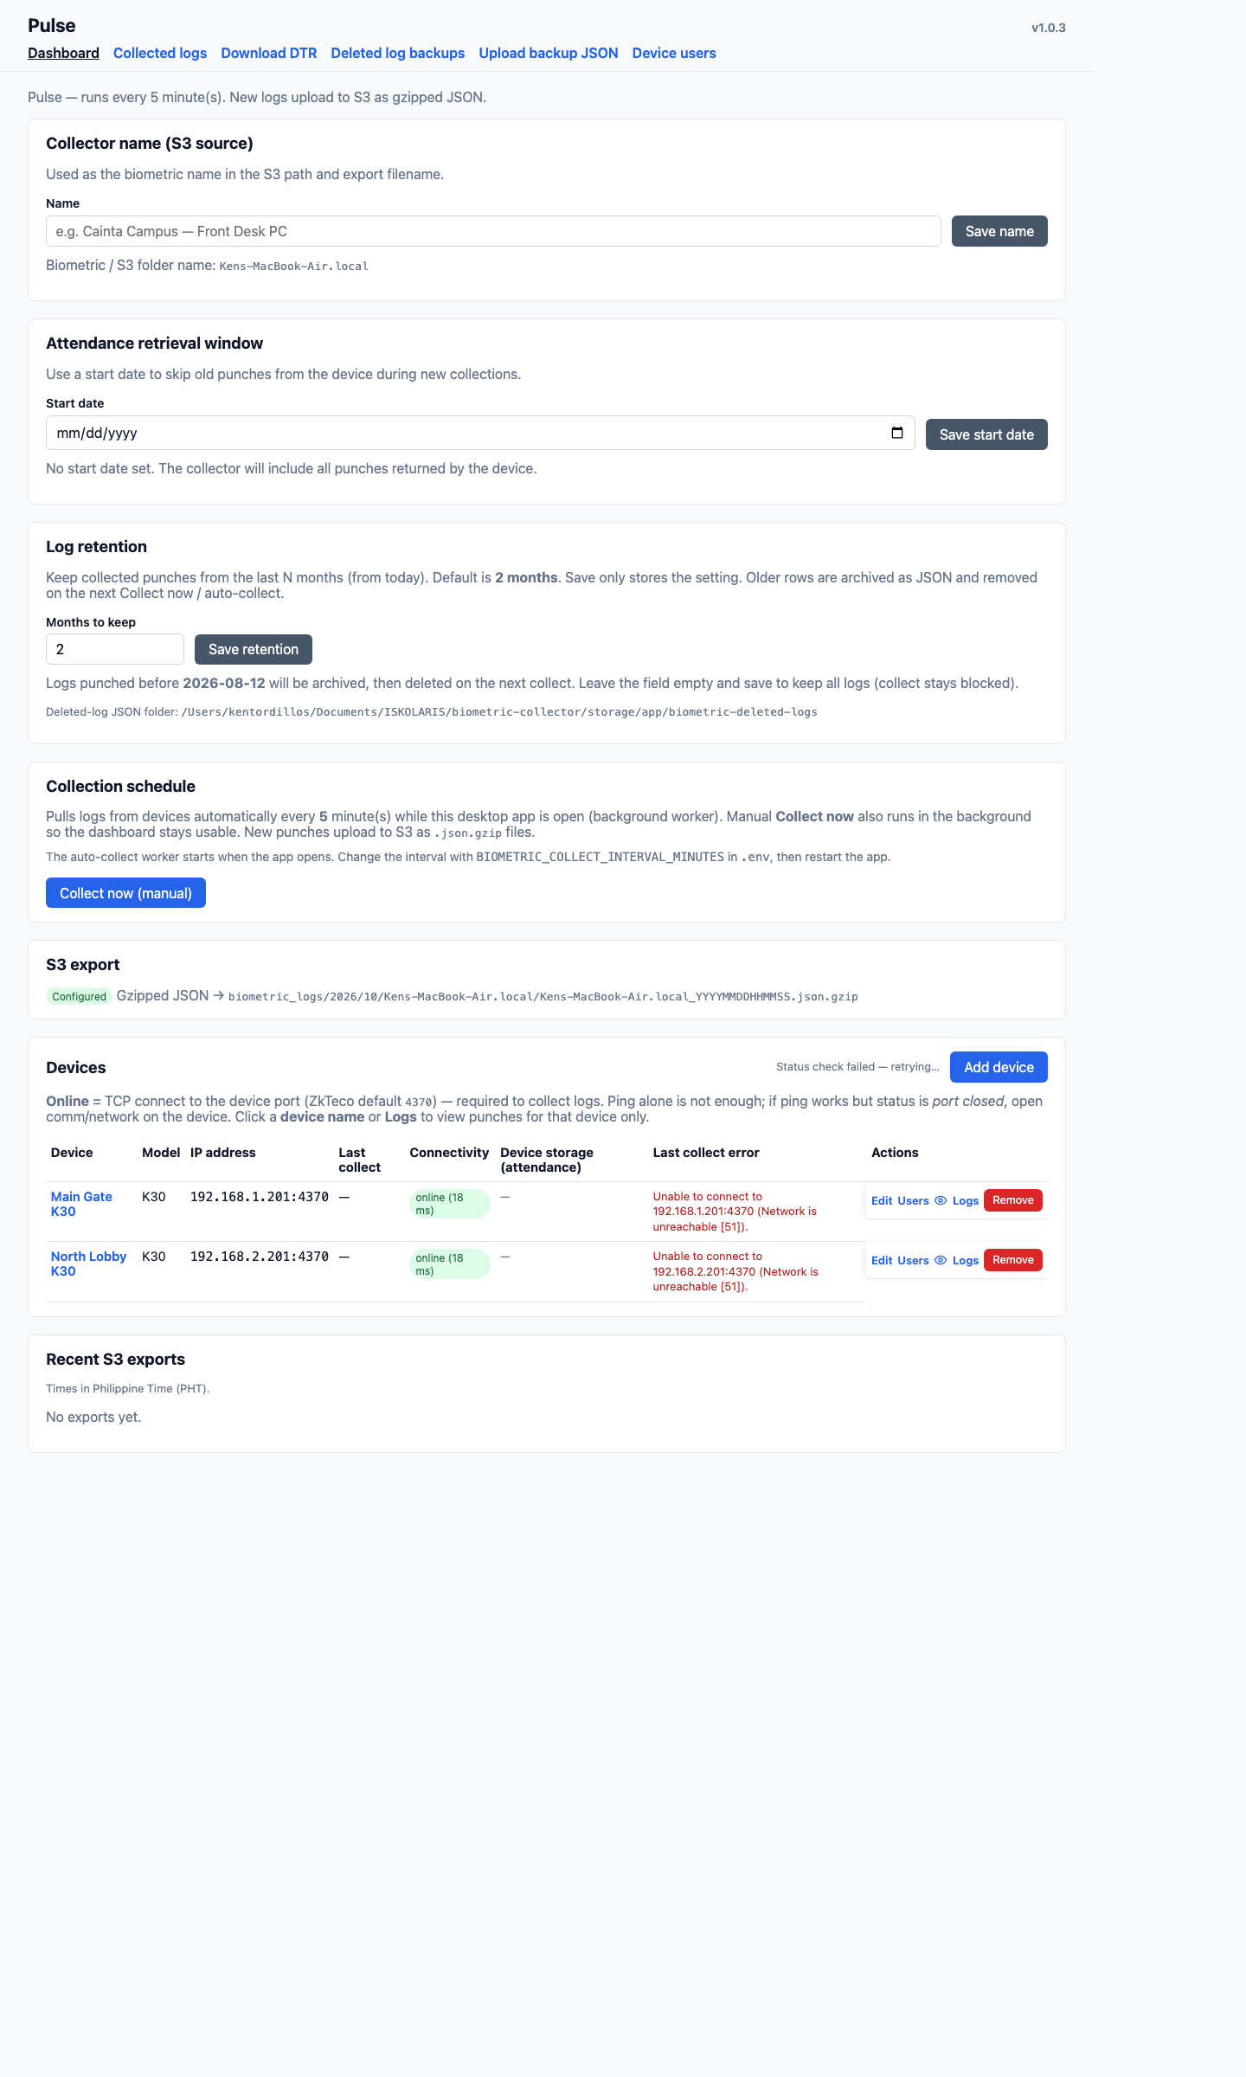
Figure 1. Dashboard — name, start date, months to keep, and Collect now.
Collector name
Enter a label for this campus or desk (e.g. Cainta Campus — Front Desk). Click Save name. This name is used when logs are sent to the cloud so People360 can tell which campus they came from.
Attendance start date
Optional. If you set a date, punches older than that date will not be collected on the next run. If left blank, Pulse collects all punches the device returns. Click Save start date after choosing a date.
Months to keep (auto-delete on this PC and on the time clock)
The default is 2 months. After Collect now or an automatic collect, punches older than that are saved to a JSON backup first, then removed from Pulse on this PC. The time clock is cleared only at the end of the month (or on the next collect if that day was missed), and only when it still has a punch older than the cutoff. Pulse saves a JSON backup and checks that those old punches are in the file before it erases anything on the clock. The time clock can only clear its whole attendance log, not one date at a time, so newer punches on the clock are included in that same backup and stay in Pulse. Users and fingerprints on the device are not removed. If the backup cannot be saved, the clock is not cleared. Find the files under Deleted log backups.
- Click Save retention after changing the number.
- Do not leave Months to keep blank — collection will not run.
- Pulse will not erase the time clock if the JSON backup file cannot be saved.
Collect now
While the app is open, Pulse collects logs automatically (usually every 5 minutes). Click Collect now (manual) for an immediate run. You can keep using the screen while collection runs. When a device is reachable, Connectivity shows Online.
4. Biometric devices
The device table is at the bottom of the Dashboard. Device storage (attendance) shows how many log slots are used and how many are free, e.g. 1,500 / 80,000 (78,500 free). These are attendance record counts on the device, not disk space in GB. Numbers appear when the device is Online. While Offline or during collect, you may see a dash (—).
- Add device — register a new time clock.
- Edit — change name, IP, port, or Comm key.
- Users — people enrolled on that device.
- Logs — punches already collected from that device.
- Remove — remove the device from Pulse (does not delete the physical device).
Adding a device
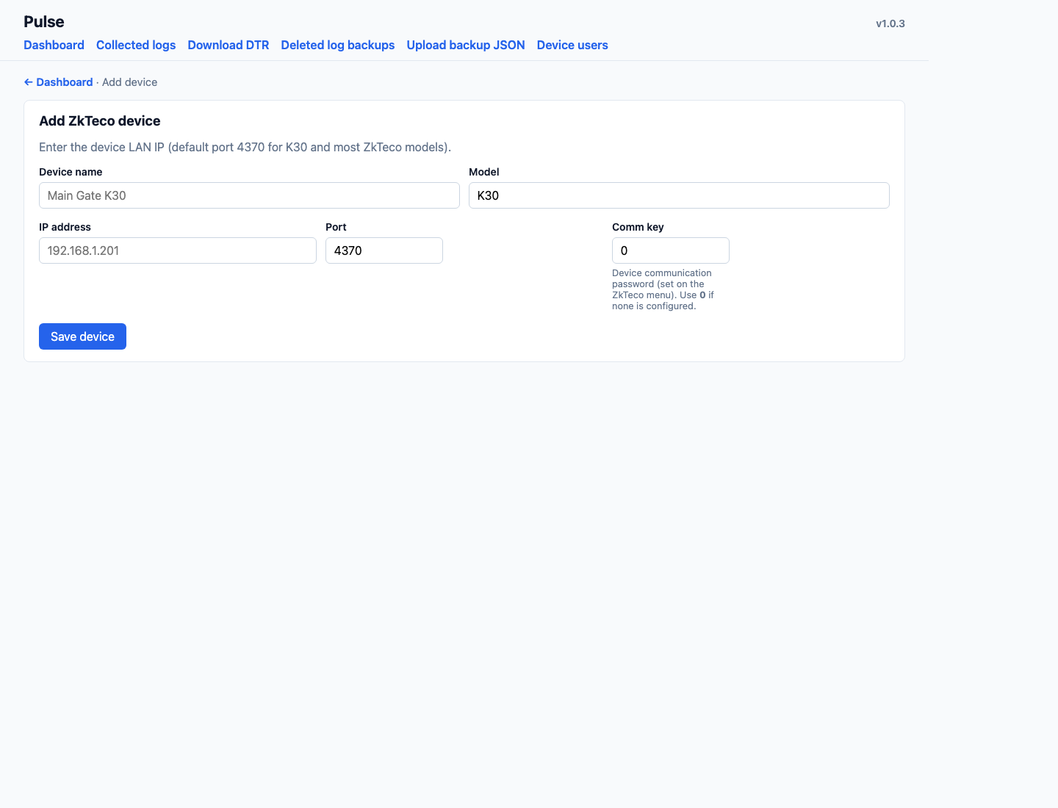
Figure 2. Add device — name, model, IP, port, and Comm key.
On the Dashboard, click Add device, then fill in:
- Device name — a friendly label, e.g. Main Gate.
- Model — usually K30; leave as shown if correct.
- IP address — the device’s network address. Ask IT if unsure.
- Port — usually 4370. Do not change unless IT says so.
- Comm key — device password. Use 0 if none is configured.
Click Save device. Return to the Dashboard and wait for Online. If status is Offline or port closed, check IP, power, and TCP/comm settings on the device.
Connectivity: Online vs port closed
Online means Pulse can connect to the device on TCP port 4370 (required to collect). Ping alone is not enough — the device must accept connections on that port. If ping works but Pulse shows port closed, enable Ethernet/TCP comm on the ZKTeco and confirm port 4370 on the device menu.
5. Collected logs
View time-in and time-out records stored on the Pulse PC. Filter by device, date, or name / ID. Pushed or uploaded means the log was sent to the cloud. People360 still needs to pull biometric logs in Time Logs before they appear in payroll.

Figure 3. Collected logs — find punches by device and date.
6. Download DTR
Use this when you need a Daily Time Record file (spreadsheet-style) for selected people and dates. Choose device, date range, and users, then download. This is a report from collected logs — it does not replace payroll in People360.
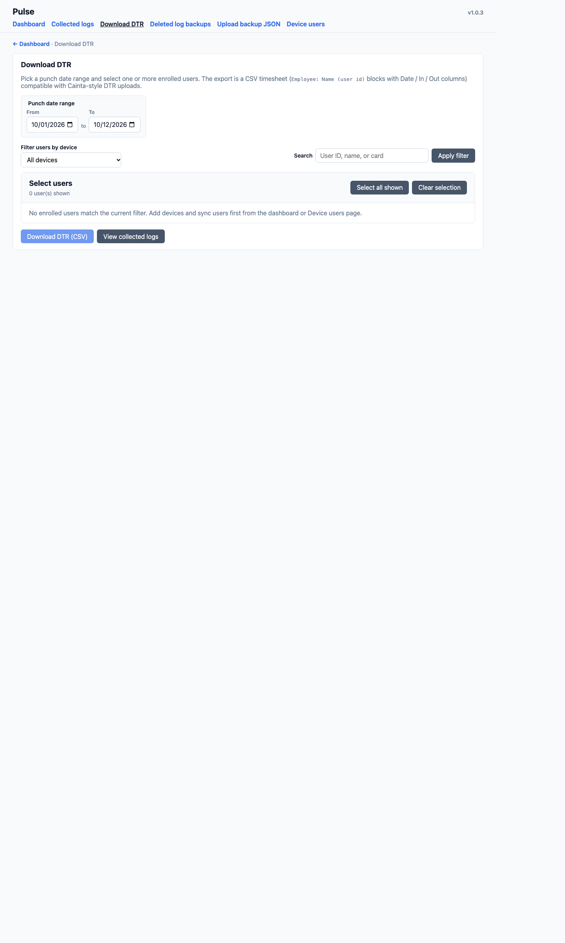
Figure 4. Download DTR — select device, dates, and users.
7. Deleted log backups
When logs are older than Months to keep, Pulse archives them to a backup file before removing them from the list. Deleted log backups lets you view and download those files. Upload backup JSON restores an archive if you need old punches back in Pulse.

Figure 5. Deleted log backups — list of archived old logs.
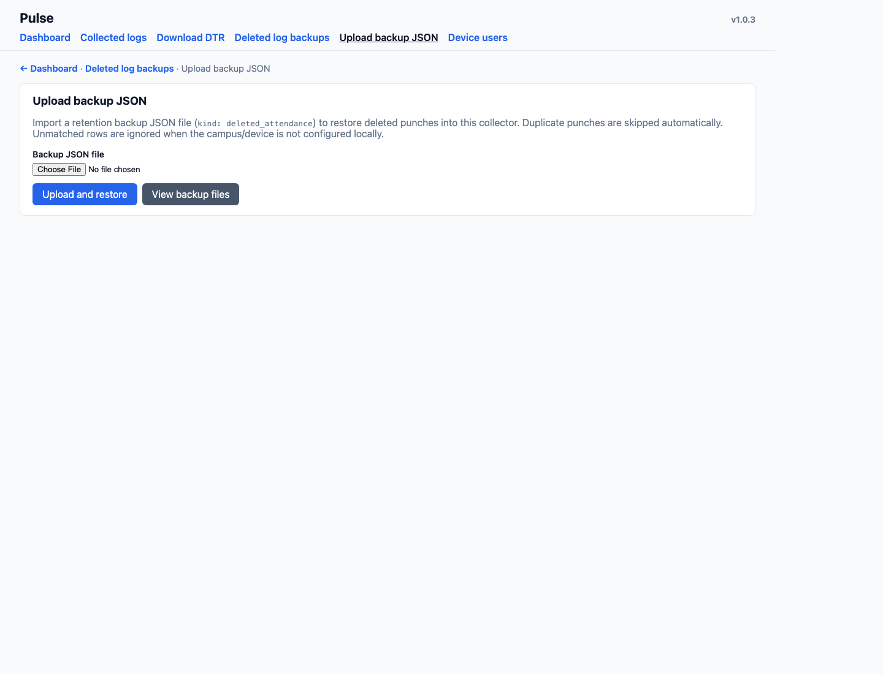
Figure 6. Upload backup JSON — restore archived logs when needed.
8. Device users
People enrolled on the biometric device (name, user ID, fingerprint). You can refresh from the device, add users, or enroll fingerprints while the person is at the machine. Follow the on-screen steps when enrolling (usually several finger scans).

Figure 7. Device users — enrolled users on the time clock.
9. Daily checklist
- Open Pulse in the morning and leave it running.
- On the Dashboard, confirm each device shows Online (or fix port closed / offline).
- If a device is offline, check power, network, and IP; try Collect now afterward.
- Check Device storage. If free space is low, notify IT — Pulse does not auto-clear logs on the device.
- In People360, pull biometric logs when attendance or payroll needs them.
10. Common questions
Why are there no new punches?
Make sure Pulse is open, the device is Online, and Months to keep is saved. Click Collect now and check Collected logs for new rows.
Does Pulse delete logs on the biometric machine?
Yes, at the end of the month, and only after a JSON backup. If the clock still has a punch older than Months to keep, Pulse saves those punches to a JSON file, checks the file, then clears the attendance log on the device. If that last day was missed, the next collect does it once. Punches still inside the retention window stay in Pulse. Users and fingerprints are not deleted. If the backup cannot be saved, the clock is not cleared.
Why are punches not in People360 yet?
Pulse sends logs to the cloud. In People360 you must pull biometric logs under Time Logs before they are used in payroll.
Guide date: 12 October 2026. App: Pulse Biometric Collector 1.0.3.

