People360 — User Guide
For campus HR staff, payroll processors, approvers, and system administrators.
People360 is the desktop app for employees, timekeeping, and payroll. Pulse Biometric Collector is a different app on the campus PC. Pulse only reads the time clock and sends the punches. People360 is where you pull those punches, check attendance, and compute pay.
Version 2.0. Last updated 14 October 2026. Document owner: People360 HR and Payroll operations.

Who this guide is for
- HR staff — campuses, employee records, documents, and memos.
- Payroll processor — calendars, uploads, batches, review, and payslips.
- Approver — document approvals and a posted batch that still needs a decision.
- System administrator — users, roles, database backup, and restore. Restore is not a daily HR task.
A button you cannot see is hidden for your role. Ask an administrator. Do not share a login to reach a menu you do not have.

Contents
The contents follow the work, not the order of the left menu. Setup comes before the screens that depend on it.
Right-click this line and choose Update Field to fill the contents.

Quick start checklist
Finish this list before the first live payroll. Tick each item only after you can open the screen and see your own data.
1. Sign in and confirm you can see Employees, Time Logs, and Payroll Batches.
2. Campuses, departments, positions, employment types, colleges, and programs exist.
3. At least one employee is saved, with a campus and an employment record.
4. A shift code and a timekeeping policy exist, and that policy is on the employee profile.
5. Day types exist, then a rate group that uses them, and the salary points at that rate group.
6. Income, deduction, and loan types exist. Government tables (SSS, PhilHealth, Pag-IBIG, withholding tax) are the current official rows.
7. A payroll calendar period covers the pay dates you will process.
8. Pulse Biometric Collector is running on the campus PC, and People360 can pull time logs.
9. You have a database backup before the first post.

End-to-end workflow
Use this path for a normal pay cycle. Parts 2 and 5 are setup. You do not repeat them every cutoff unless a rate, a holiday, or a government table changed.
1. Employee setup — add or upload the person, then complete employment, salary, and the Loans tab if a loan should be deducted.
2. Timekeeping assignment — shift, holiday group, and timekeeping policy on the employee profile.
3. Biometric logs — Pulse Collector stays open on the campus PC. In People360, pull or upload time logs.
4. Attendance check — open Time Logs and the employee attendance view. Fix only the rows you are allowed to edit.
5. Payroll inputs — upload hours, incomes, deductions, or loans that are not already on the employee record. Tick the loan types on the payroll calendar for this period.
6. Process — create the payroll batch, add employees, and process.
7. Review — gross pay, deductions (including the loan line), net pay, and missing attendance.
8. Post — only after the authorized reviewer confirms the batch.
9. Outputs — payslips, BIR forms, and other reports. Do this after the batch status is Posted.

Common buttons
Almost every list stays on the same page. A window opens on top of it. Closing the window does not save.
- Add — the blue button at the top right. Fill in the window and save.
- Edit — the pencil on the row.
- View — the eye, when the row has one. It does not change the record.
- Inactive — the green switch. Turn it off when you must stop using a row but keep the history. This is the label on the screen. Do not look for Deactivate or Disable.
- Delete — the red trash. On many lists it appears only after the row is Inactive. Read the question. Cancel if you are not sure.
Important. Delete, Unpost, and Restore are not the same action. Delete removes an unused setup row. Unpost reverses a posted payroll batch. Restore replaces the whole database. Each one is described in its own section.

Words used in this guide
- DTR — daily time record. The attendance view of punches already stored in People360.
- Pulse Biometric Collector — the campus app that reads the time clock. It is not People360.
- Day type — regular day, rest day, holiday, and similar. Rate groups use day types.
- Rate group — the pay rates for each day type. A salary points at one rate group.
- Payroll batch — one campus and one pay period, processed and then posted.
- Payroll calendar — the pay period dates, plus which loan and deduction types apply to that period.
- Posted — the batch is final for payslips and reports until an authorized user unposts it.

Part 1 — Introduction and Getting Started
Sign in, find your way around, and learn the buttons that repeat on every list.

Sign in
Double-click the People360 icon. Type the email and password given by your administrator, then click Sign in. Tick Remember me only on a computer that other people do not share.
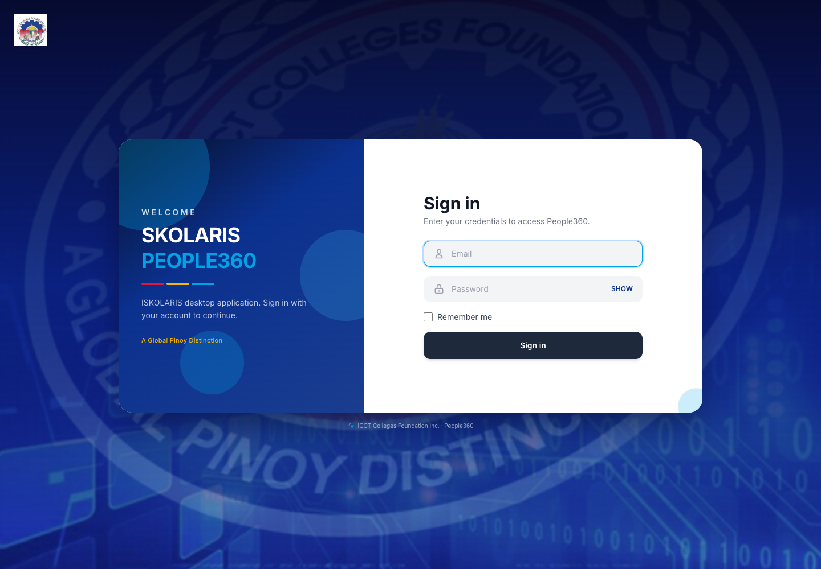
Figure 1. People360 sign-in screen

Dashboard
This is the home screen after you sign in. Use the blue menu on the left. Search modules is at the top of that menu. The cards summarize people and payroll. There is no Add or Delete on this page.
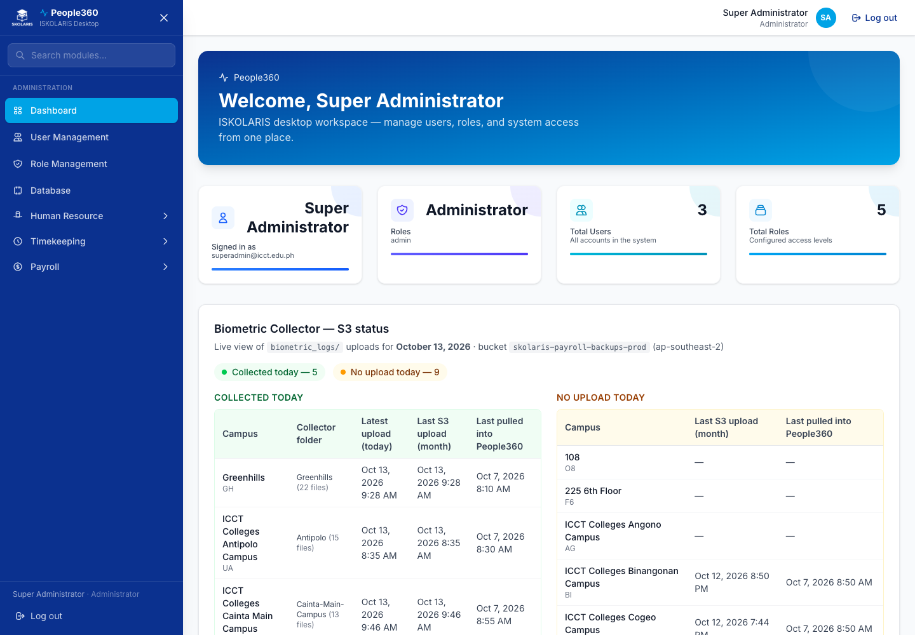
Figure 2. People360 dashboard and main navigation

Part 2 — Initial System Setup
Create the reference lists before you add people. Later screens only offer values that exist here.

Campuses
Use the common Add, Edit, Inactive, and Delete steps in Part 1. This section only adds what is specific to this list.
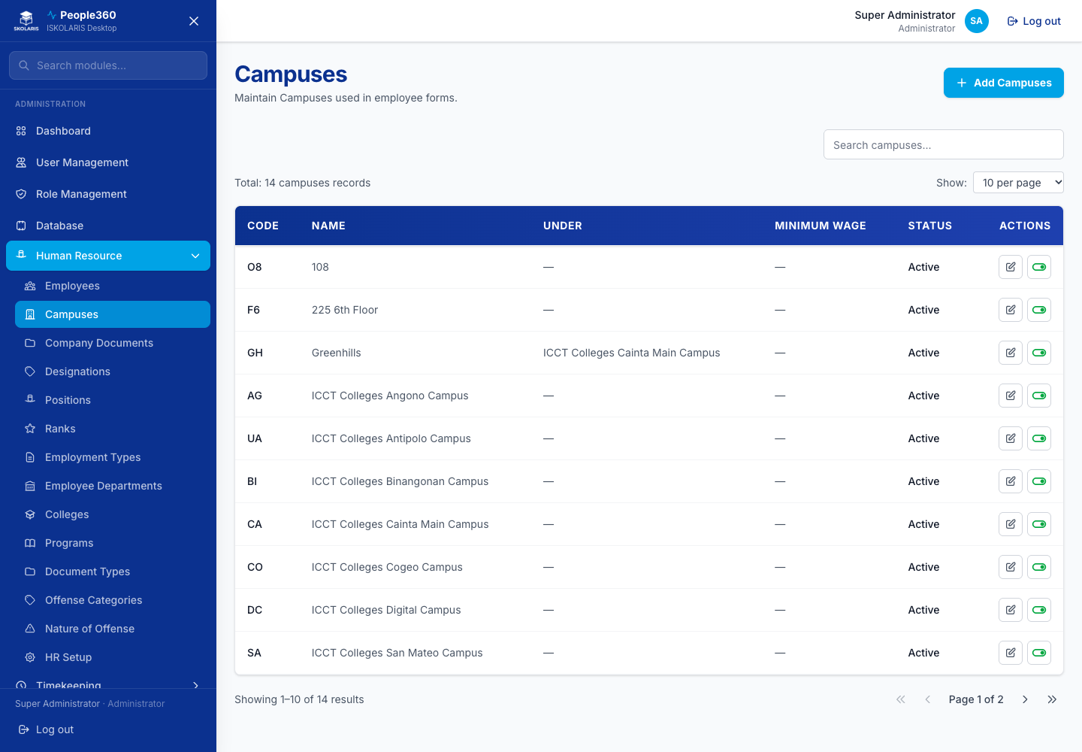
Figure 3. Campuses screen
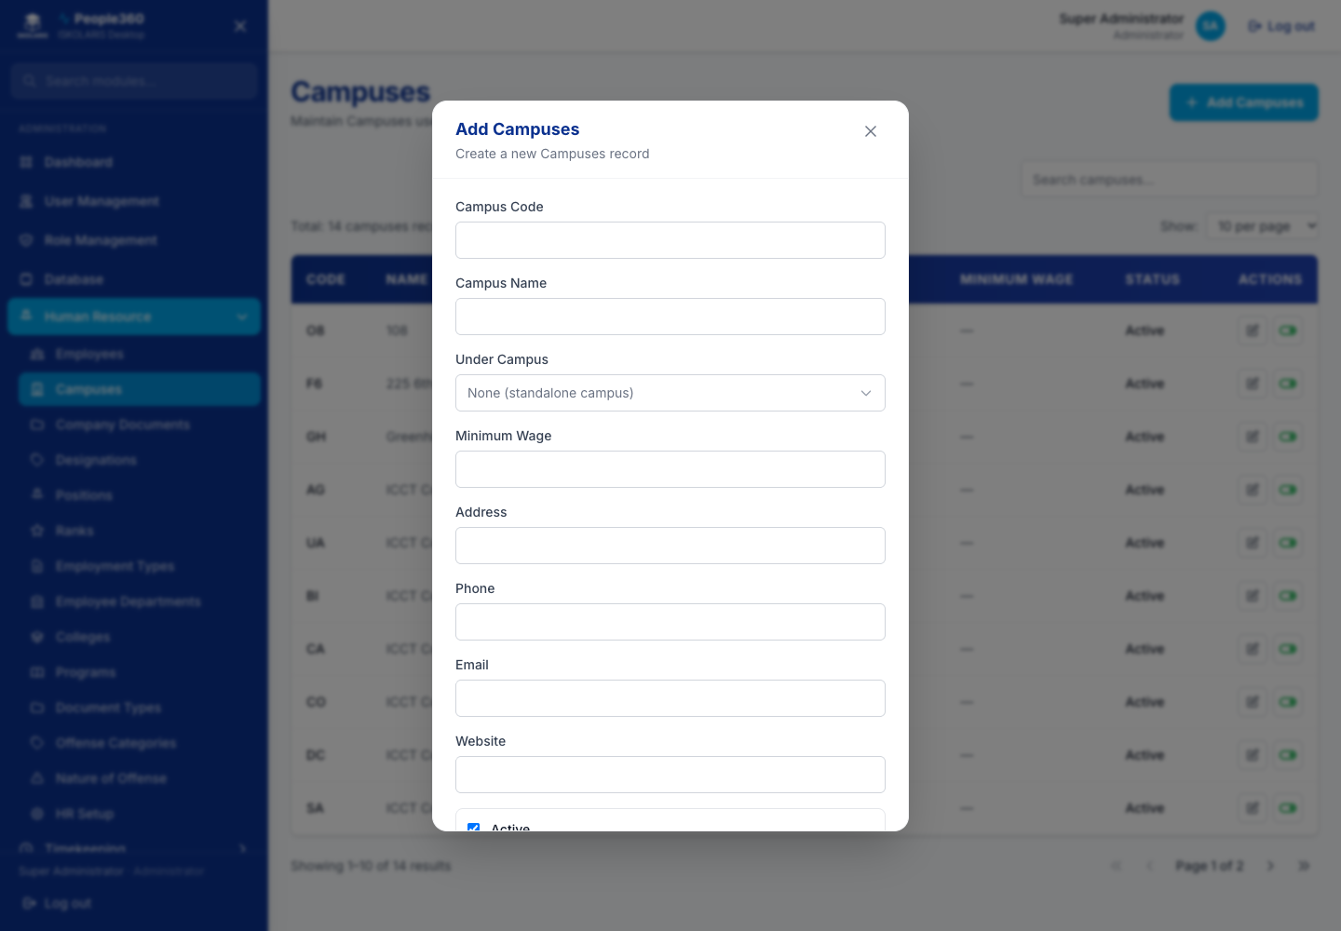
Figure 4. Campuses — Add window. Use the blue Add button, then save in this window.
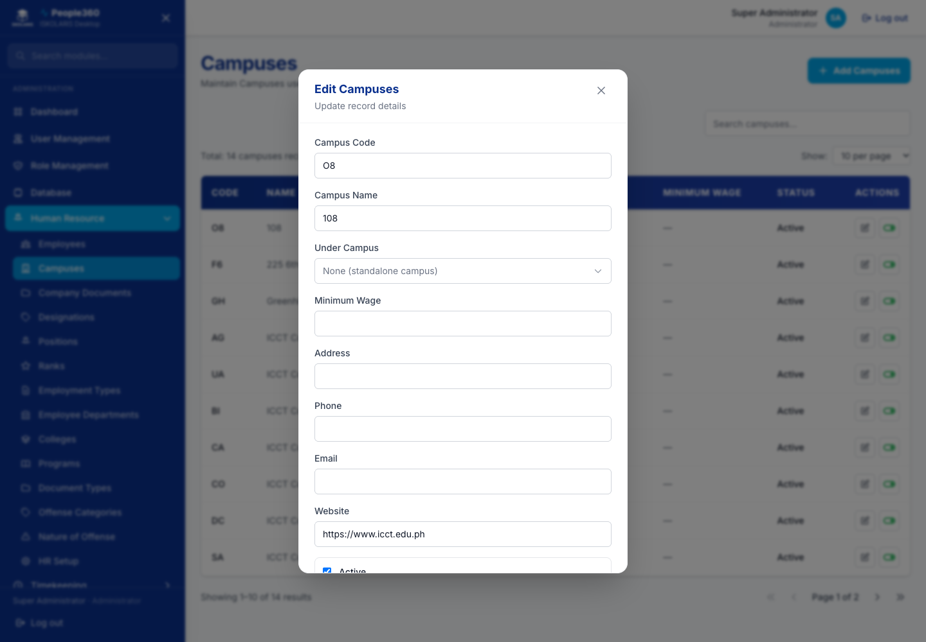
Figure 5. Campuses — Edit window. Open it with the pencil on the row.

Employee Departments
Use the common Add, Edit, Inactive, and Delete steps in Part 1. This section only adds what is specific to this list.
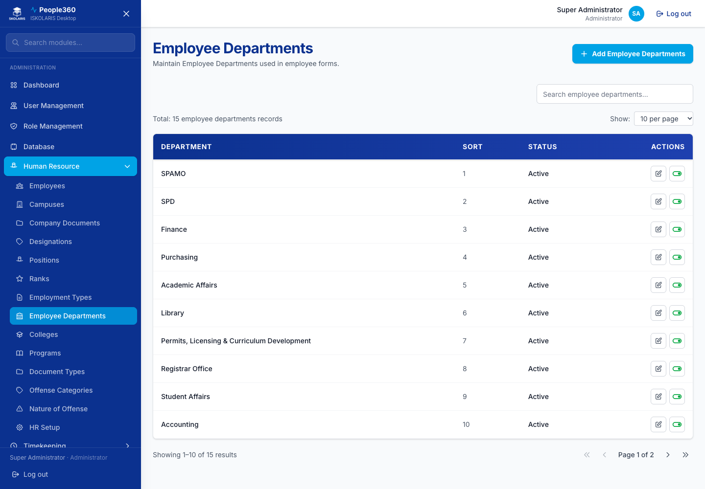
Figure 6. Employee Departments screen
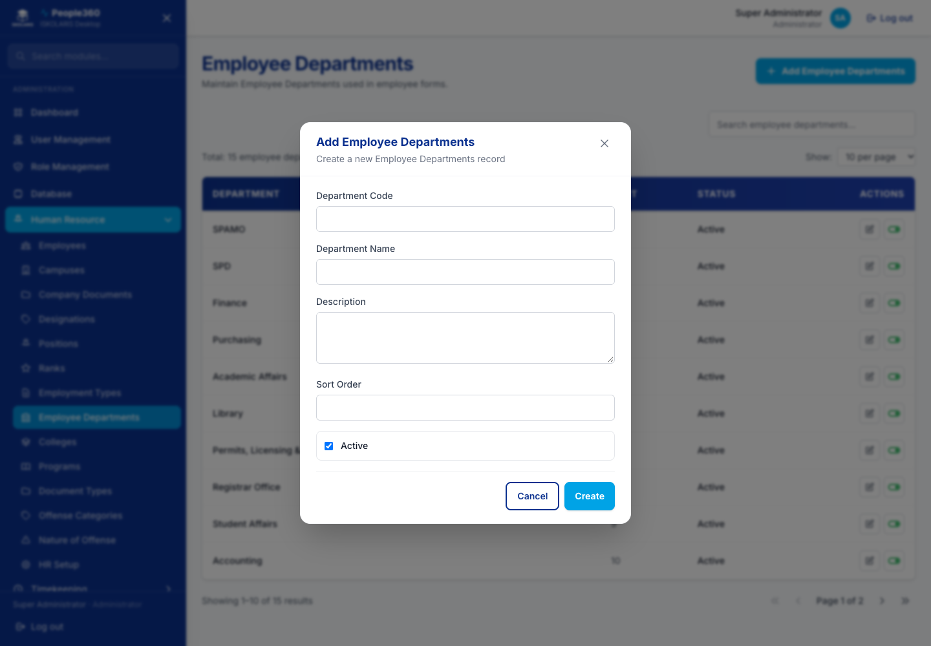
Figure 7. Employee Departments — Add window. Use the blue Add button, then save in this window.
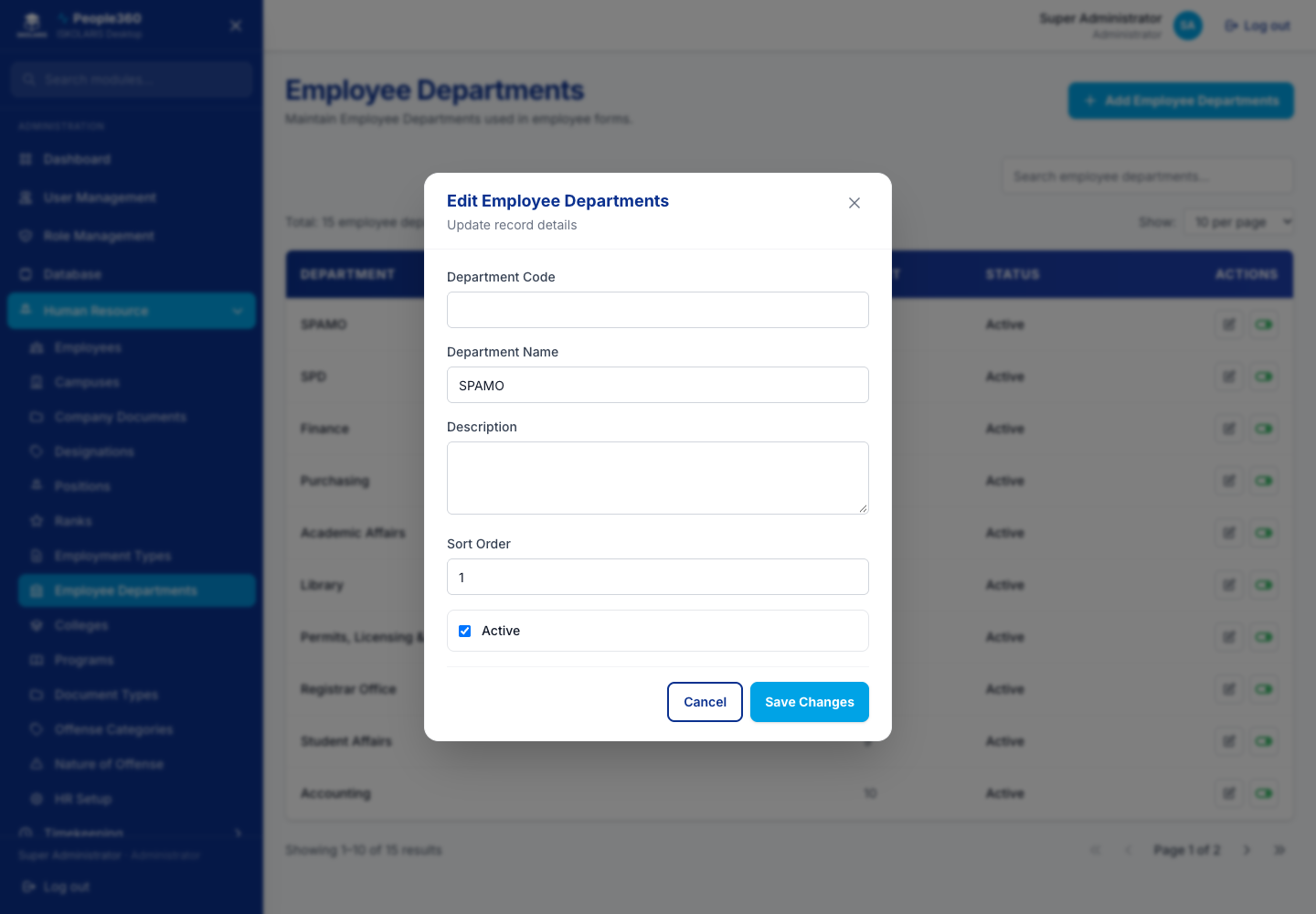
Figure 8. Employee Departments — Edit window. Open it with the pencil on the row.

Designations
Use the common Add, Edit, Inactive, and Delete steps in Part 1. This section only adds what is specific to this list.
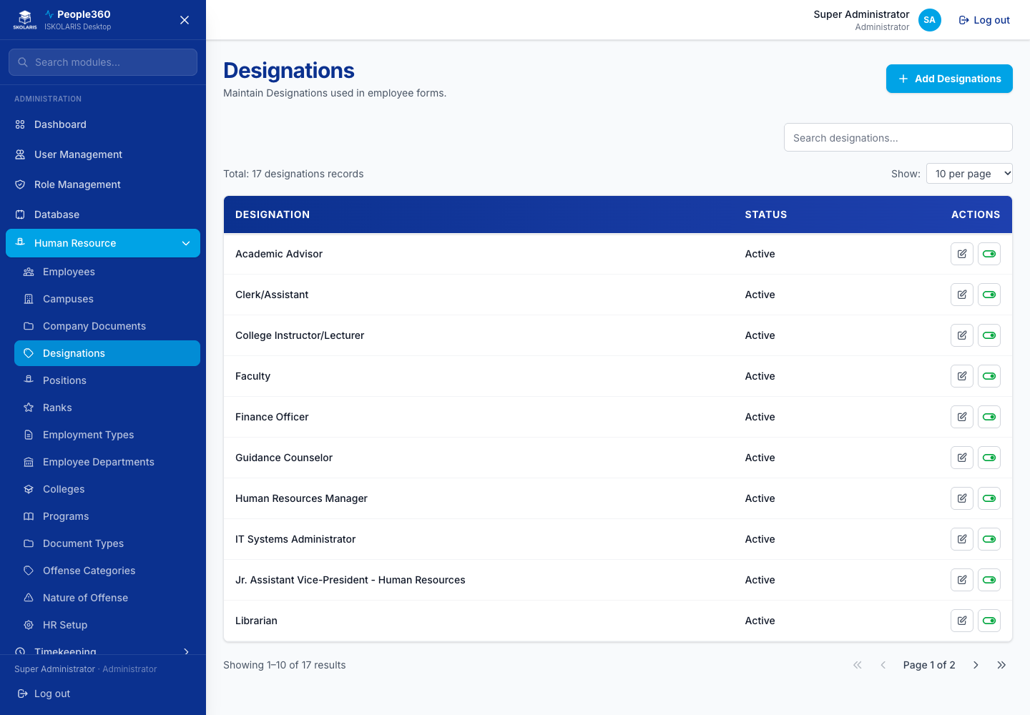
Figure 9. Designations screen
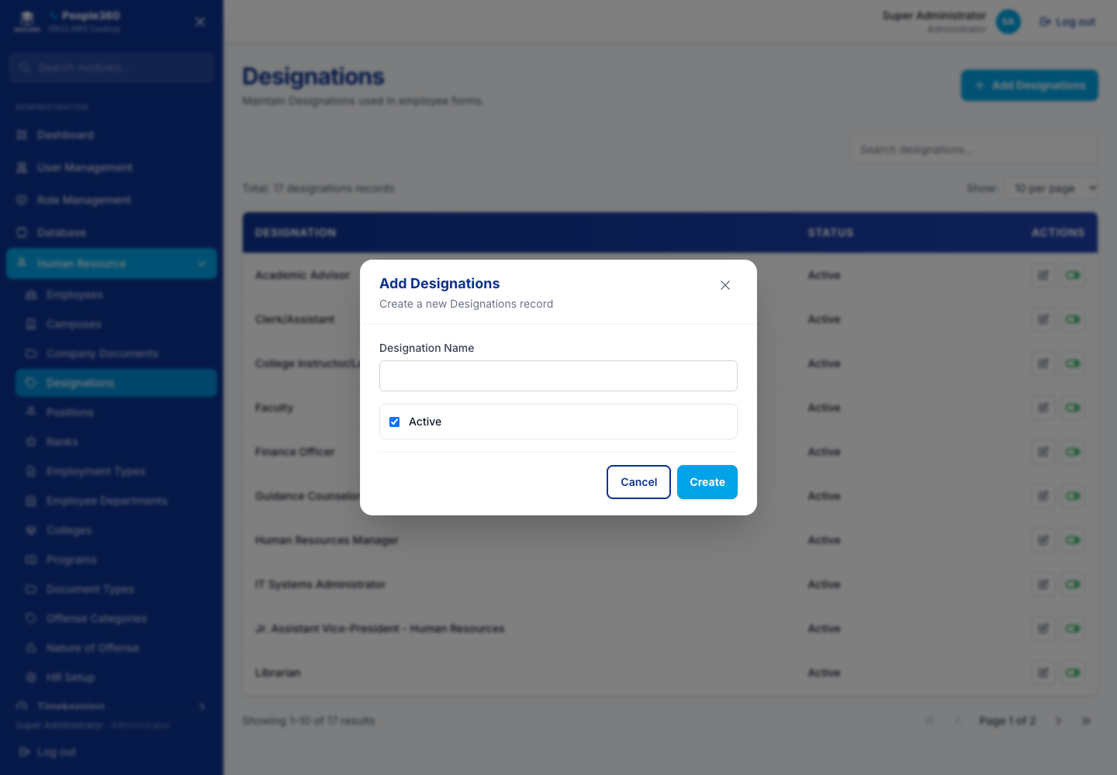
Figure 10. Designations — Add window. Use the blue Add button, then save in this window.
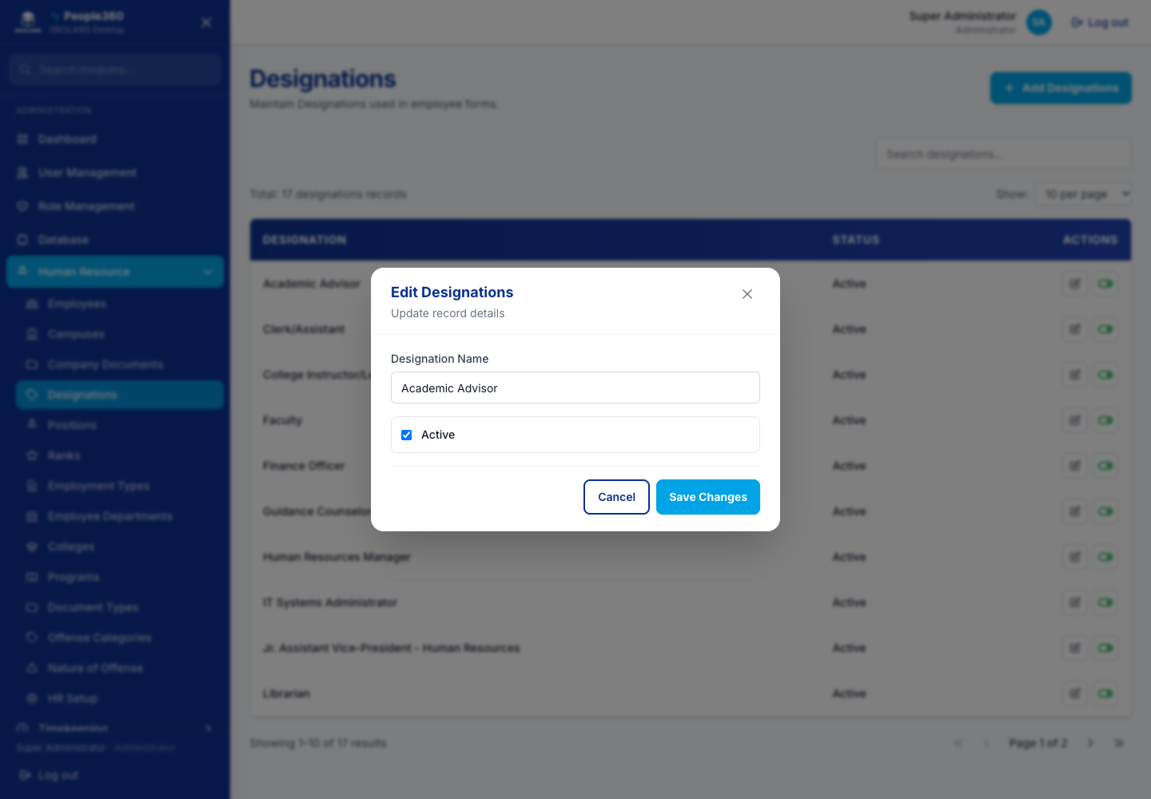
Figure 11. Designations — Edit window. Open it with the pencil on the row.

Positions
Use the common Add, Edit, Inactive, and Delete steps in Part 1. This section only adds what is specific to this list.
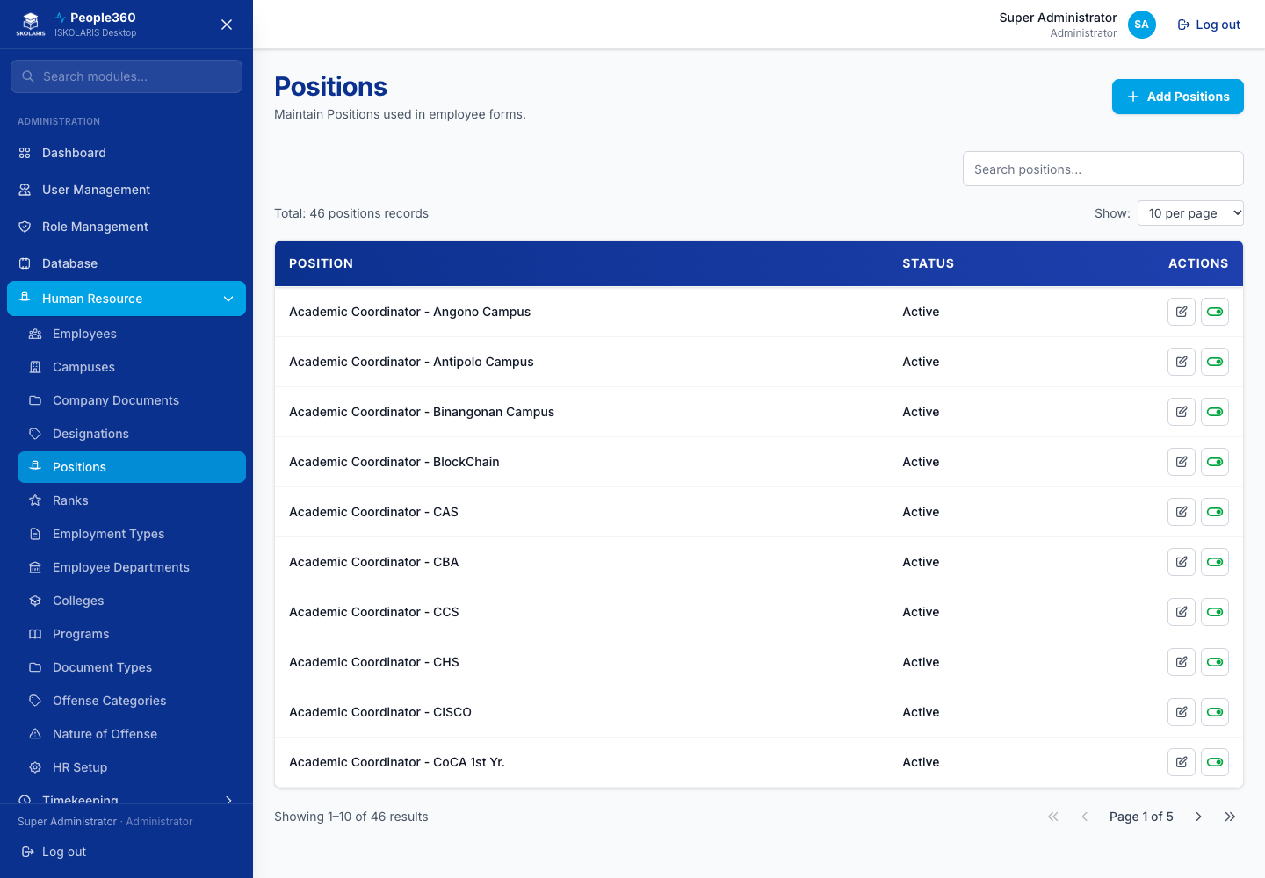
Figure 12. Positions screen
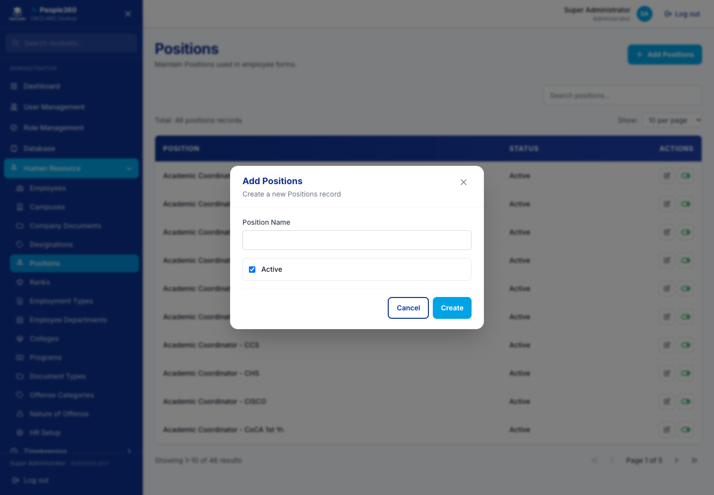
Figure 13. Positions — Add window. Use the blue Add button, then save in this window.
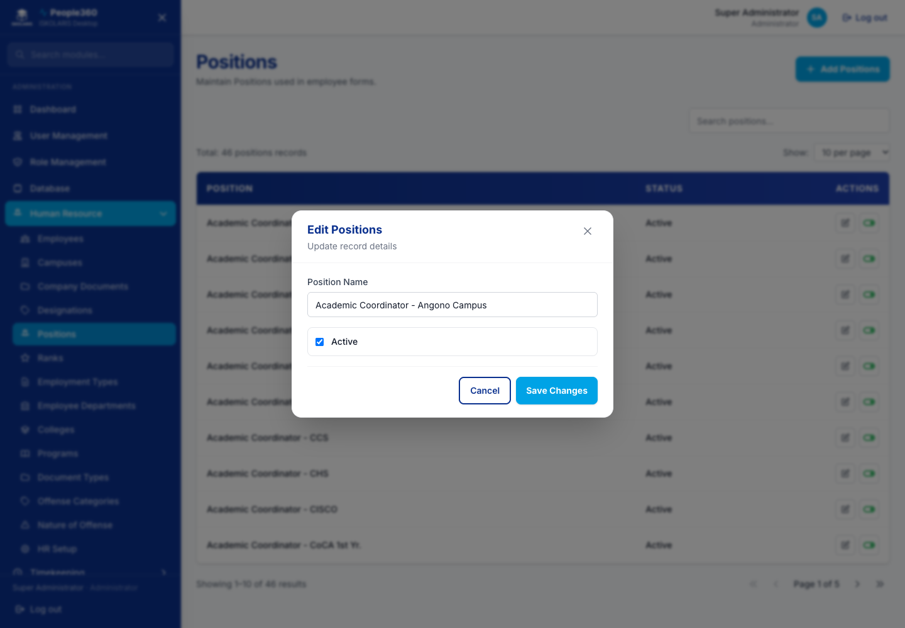
Figure 14. Positions — Edit window. Open it with the pencil on the row.

Ranks
Use the common Add, Edit, Inactive, and Delete steps in Part 1. This section only adds what is specific to this list.
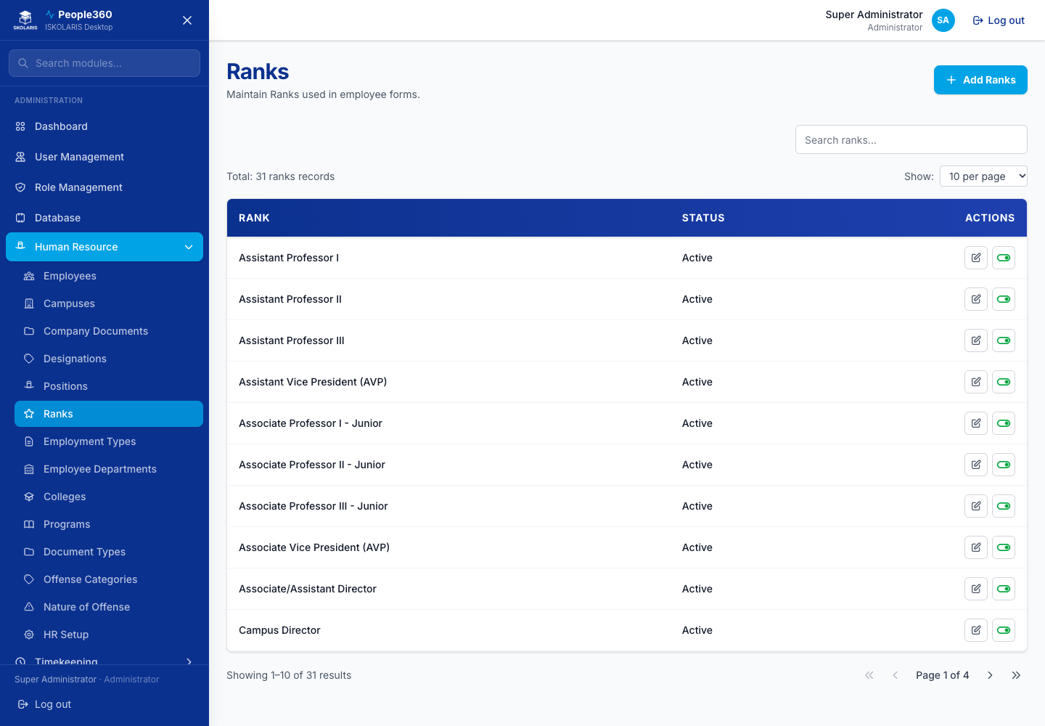
Figure 15. Ranks screen
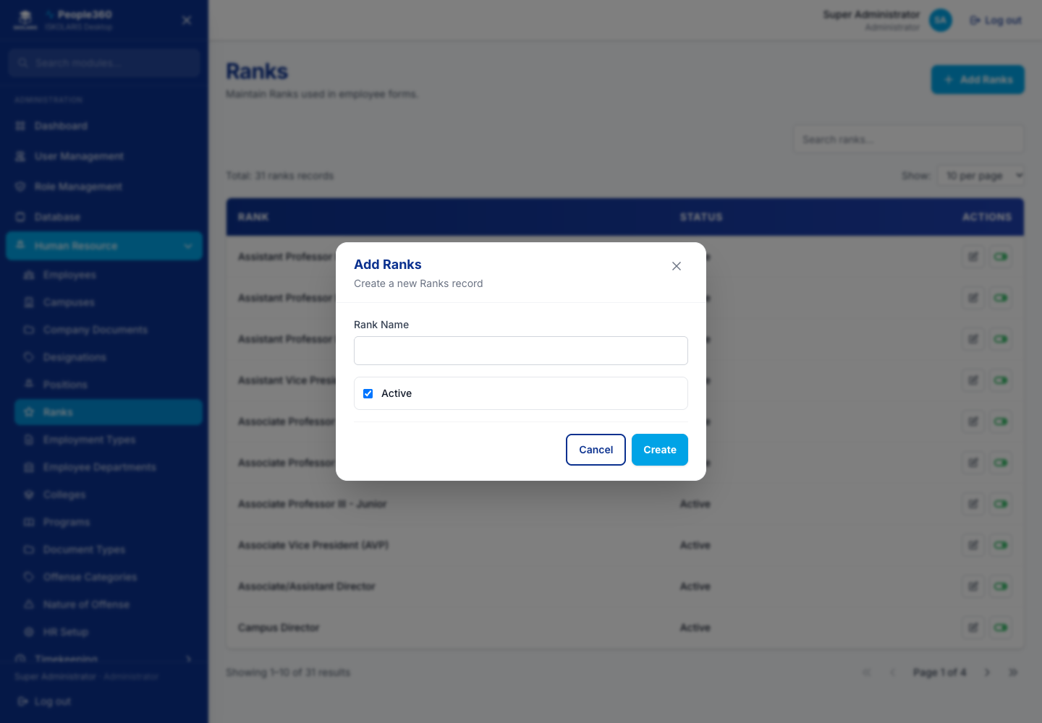
Figure 16. Ranks — Add window. Use the blue Add button, then save in this window.
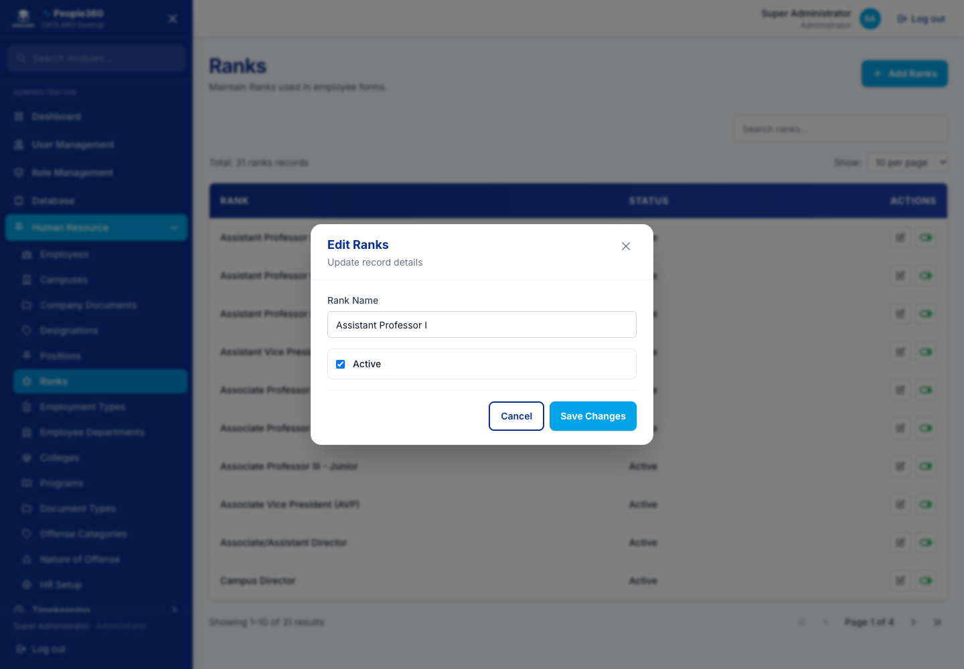
Figure 17. Ranks — Edit window. Open it with the pencil on the row.

Employment Types
Use the common Add, Edit, Inactive, and Delete steps in Part 1. This section only adds what is specific to this list.
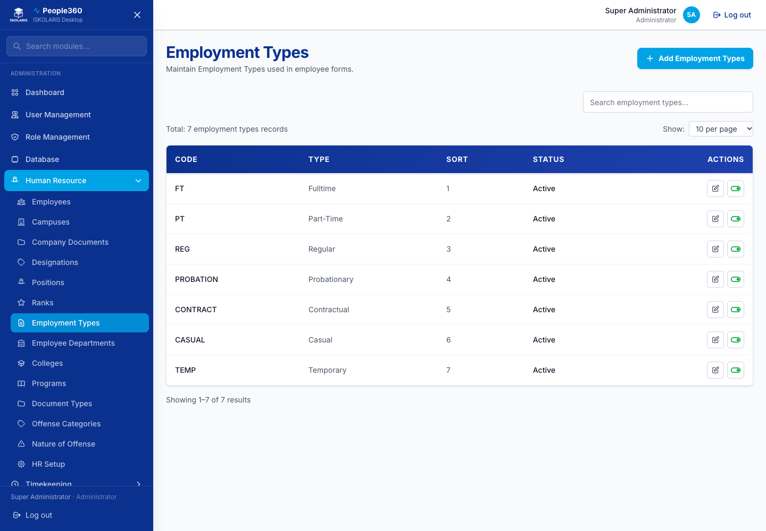
Figure 18. Employment Types screen
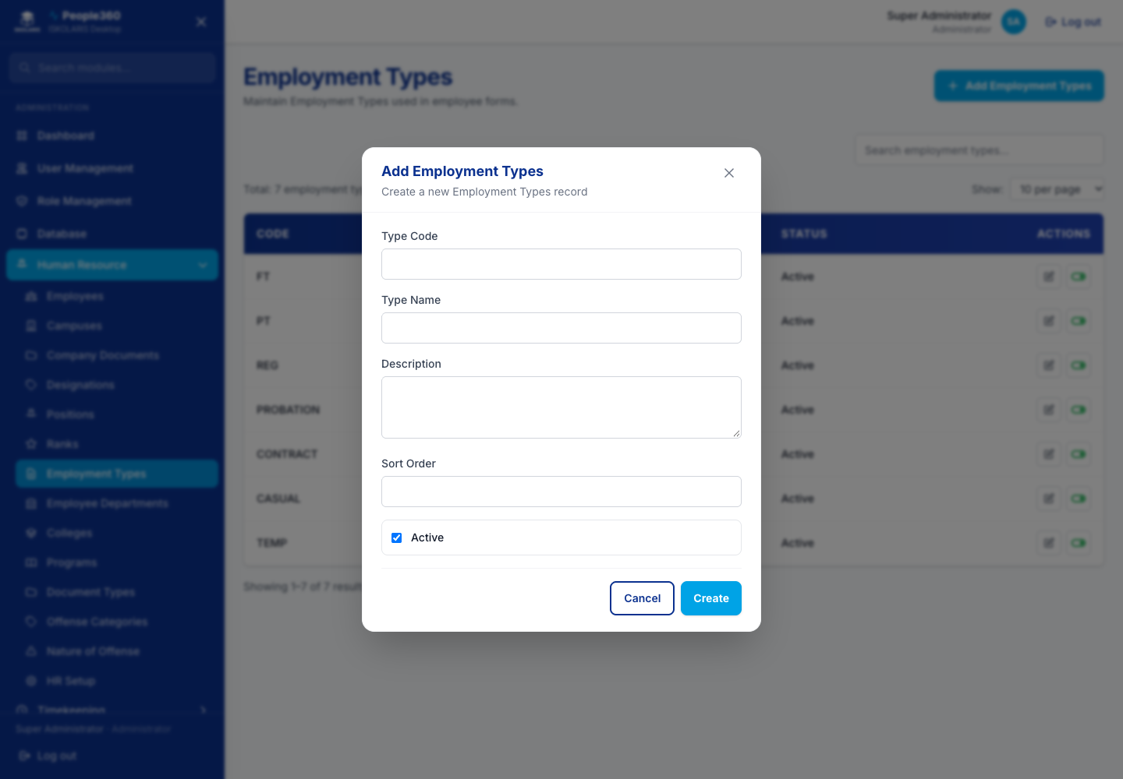
Figure 19. Employment Types — Add window. Use the blue Add button, then save in this window.
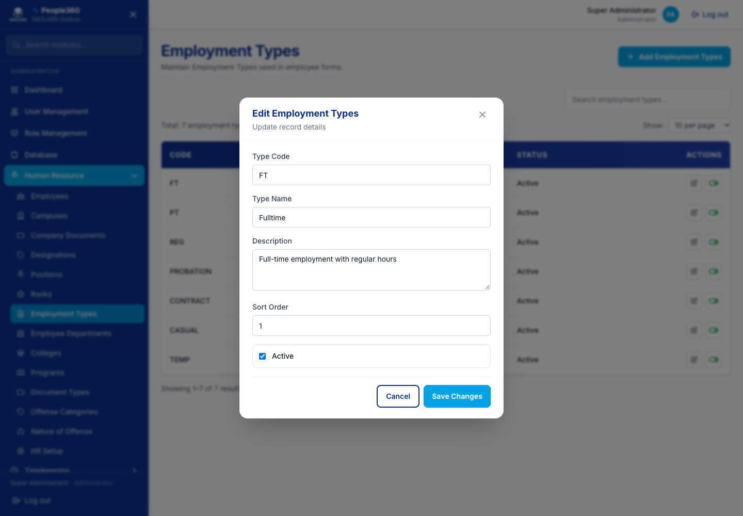
Figure 20. Employment Types — Edit window. Open it with the pencil on the row.

Colleges
Use the common Add, Edit, Inactive, and Delete steps in Part 1. This section only adds what is specific to this list.
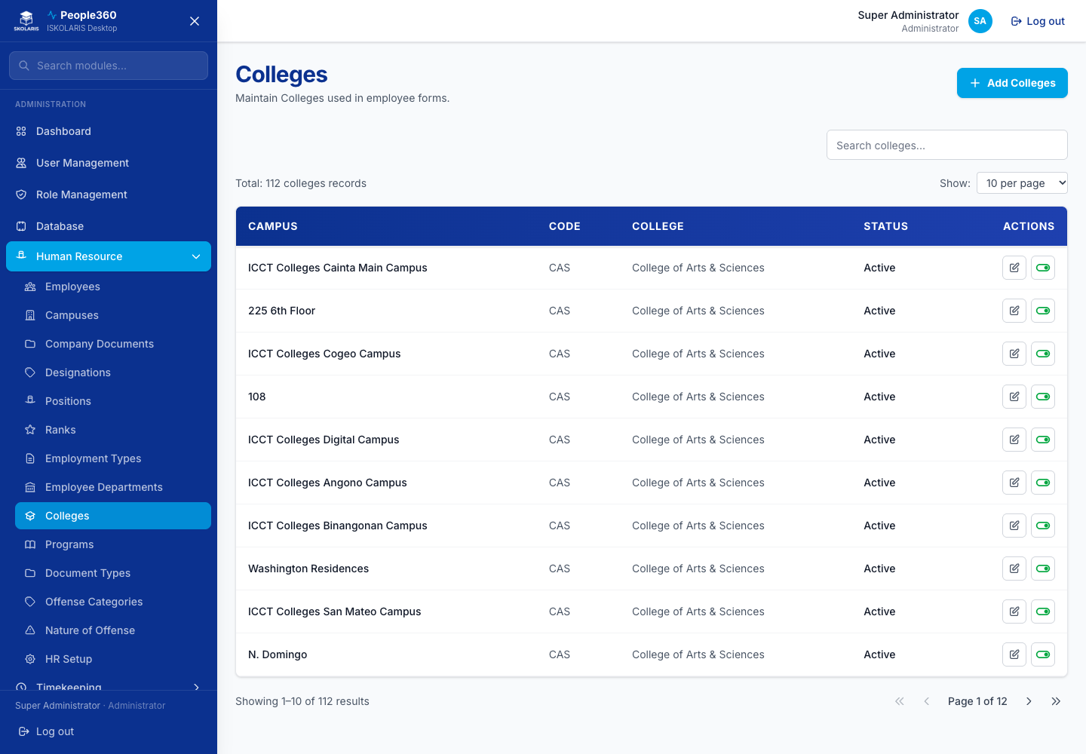
Figure 21. Colleges screen
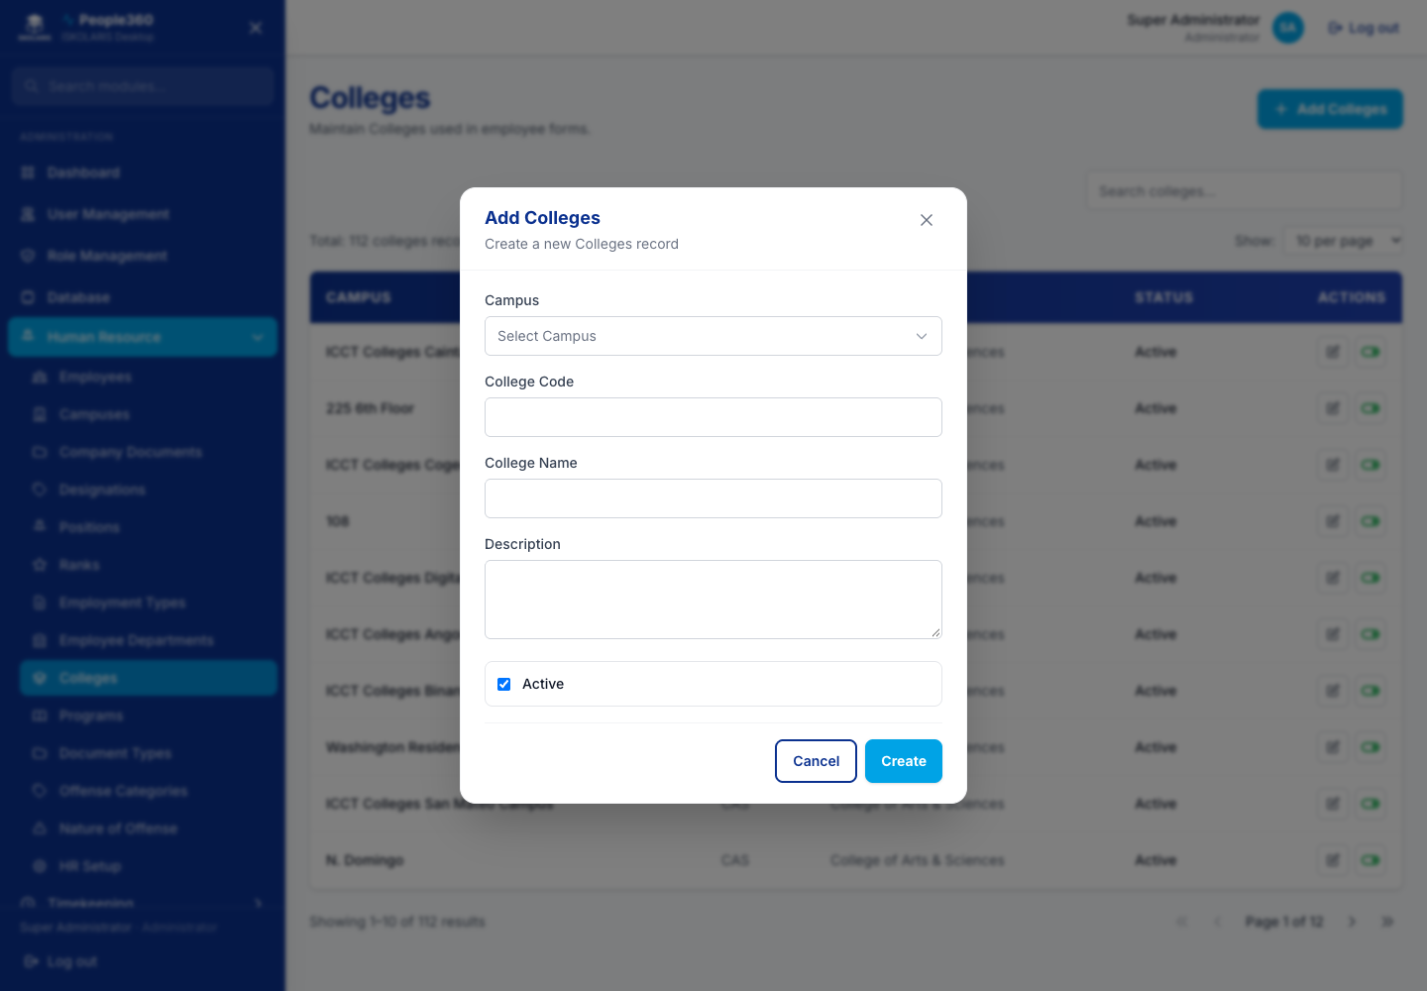
Figure 22. Colleges — Add window. Use the blue Add button, then save in this window.
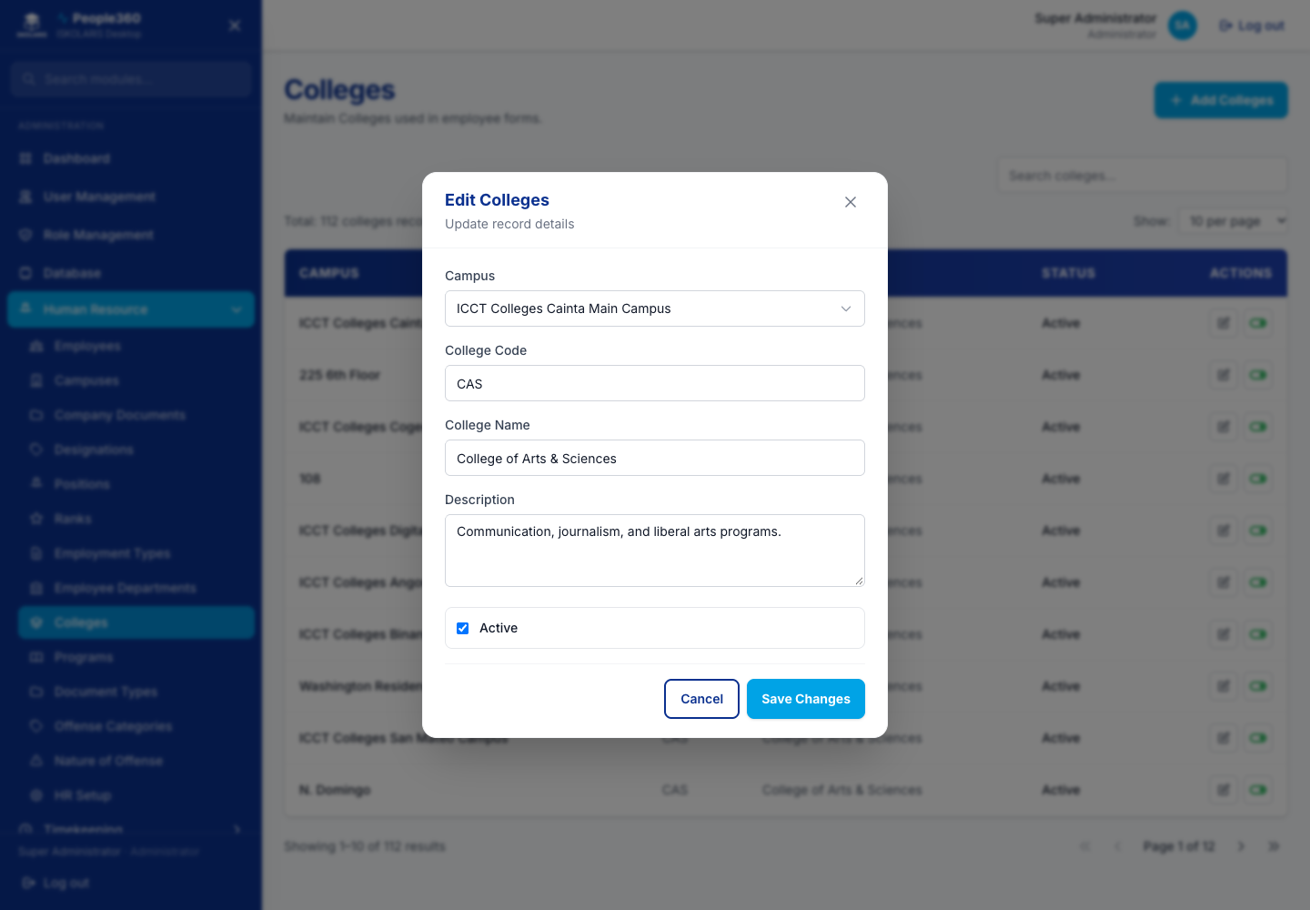
Figure 23. Colleges — Edit window. Open it with the pencil on the row.

Programs
Use the common Add, Edit, Inactive, and Delete steps in Part 1. This section only adds what is specific to this list.
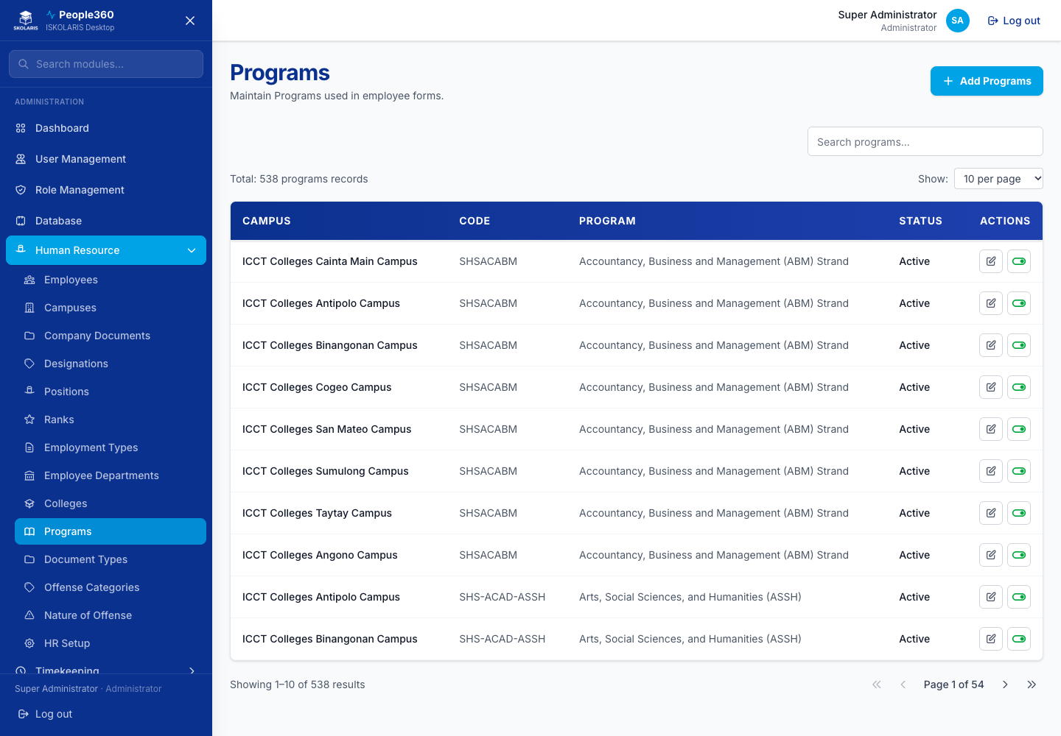
Figure 24. Programs screen
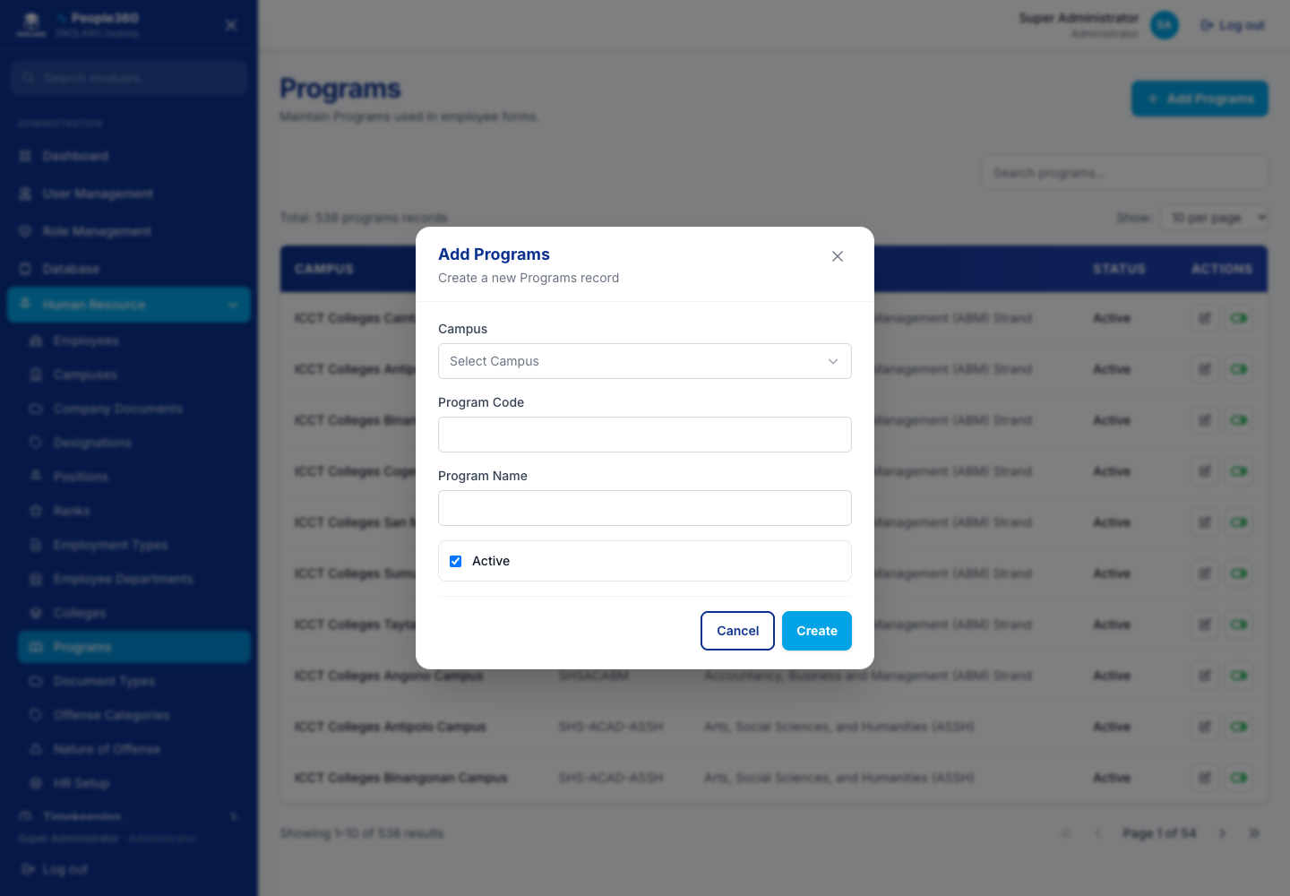
Figure 25. Programs — Add window. Use the blue Add button, then save in this window.
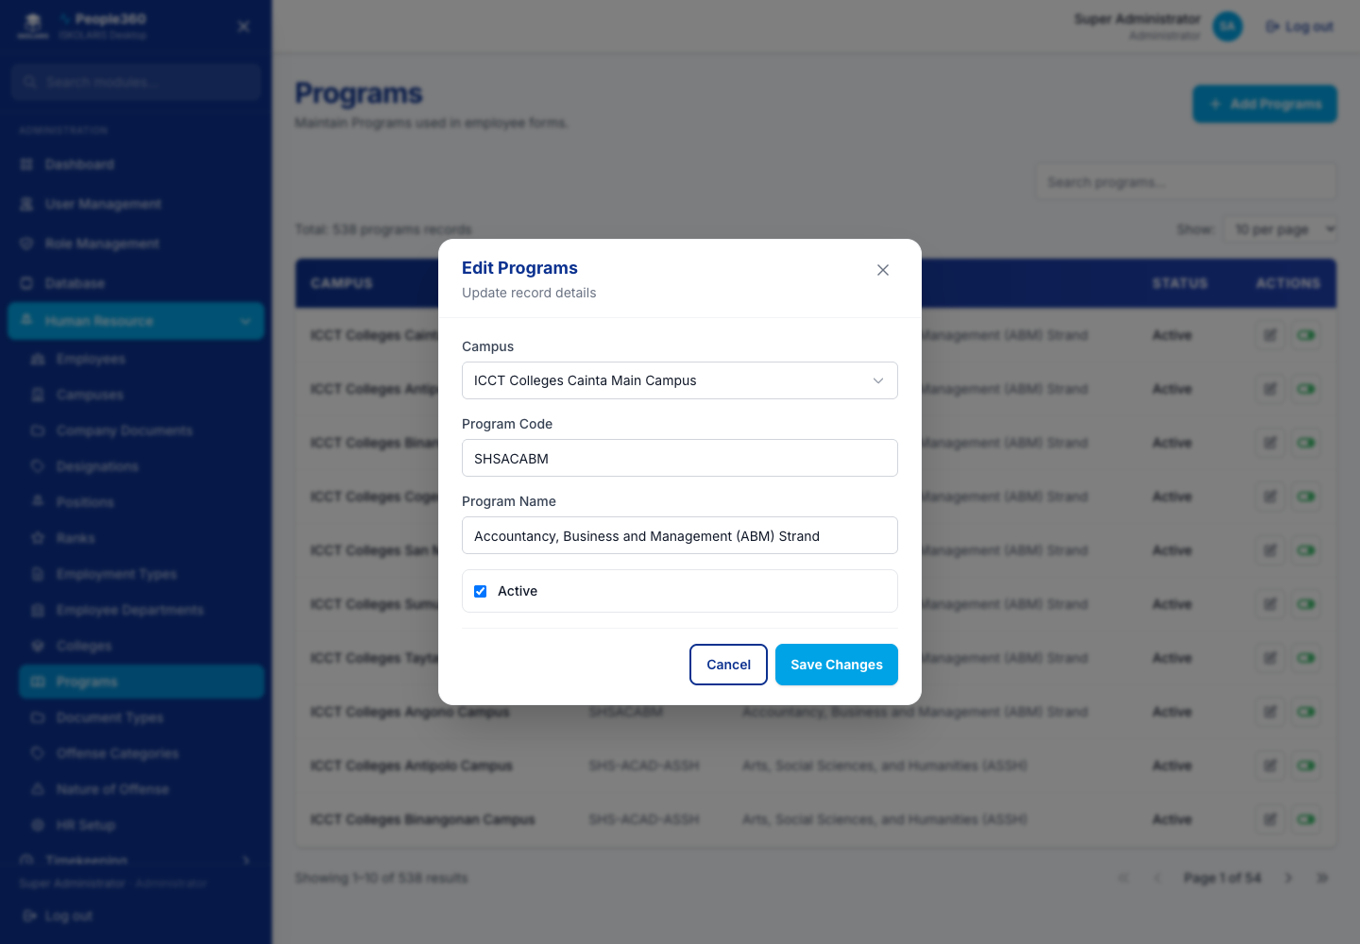
Figure 26. Programs — Edit window. Open it with the pencil on the row.

Document Types
Use the common Add, Edit, Inactive, and Delete steps in Part 1. This section only adds what is specific to this list.
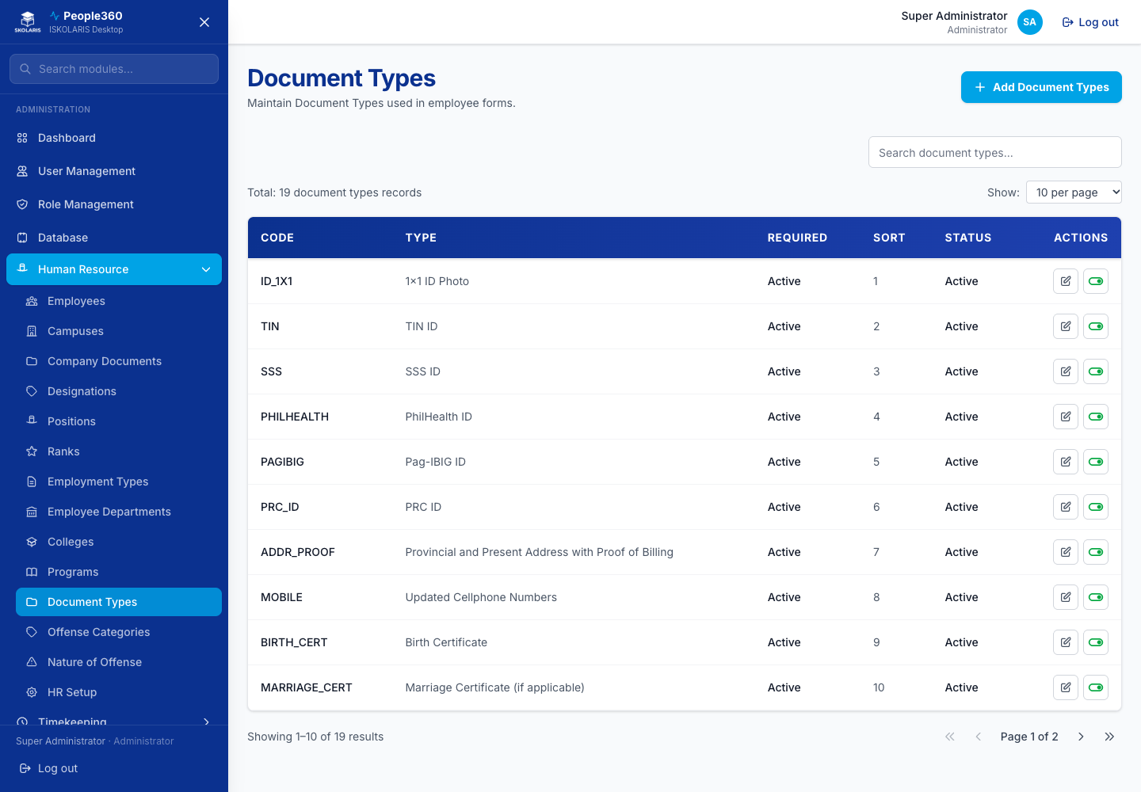
Figure 27. Document Types screen
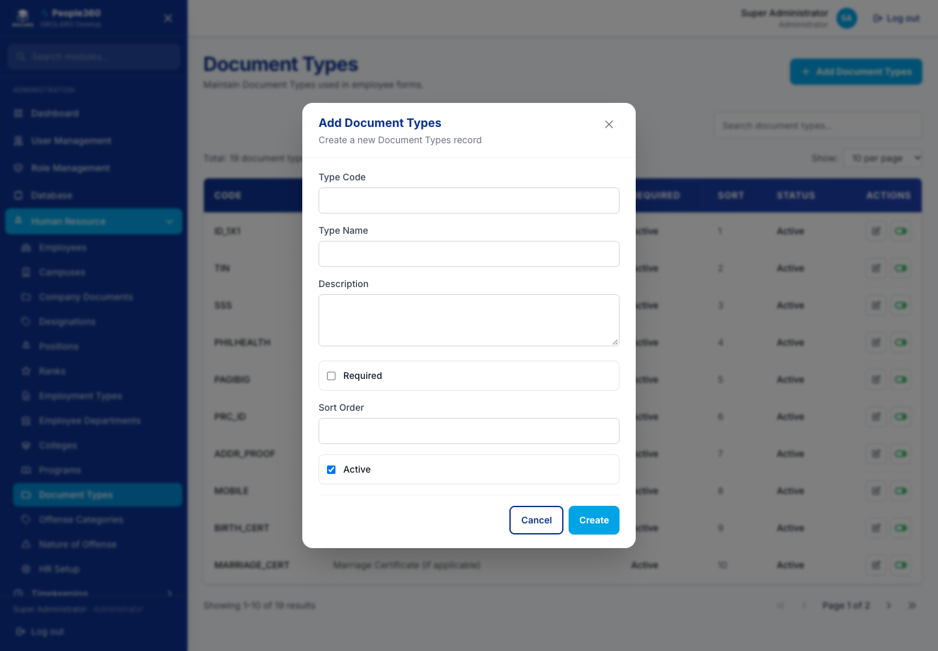
Figure 28. Document Types — Add window. Use the blue Add button, then save in this window.
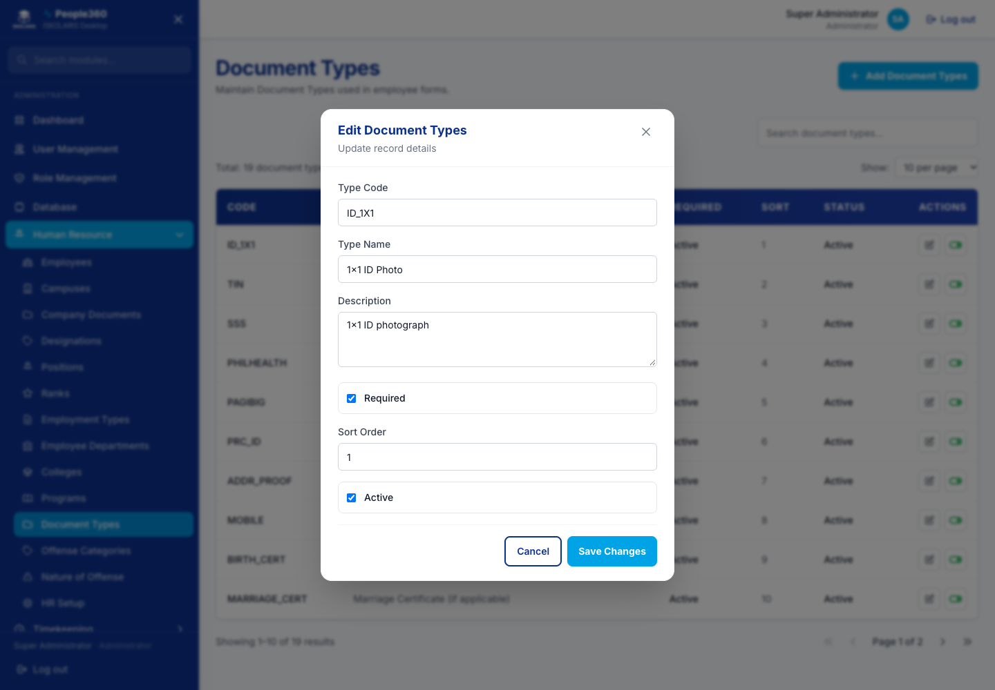
Figure 29. Document Types — Edit window. Open it with the pencil on the row.

Offense Categories
Use the common Add, Edit, Inactive, and Delete steps in Part 1. This section only adds what is specific to this list.
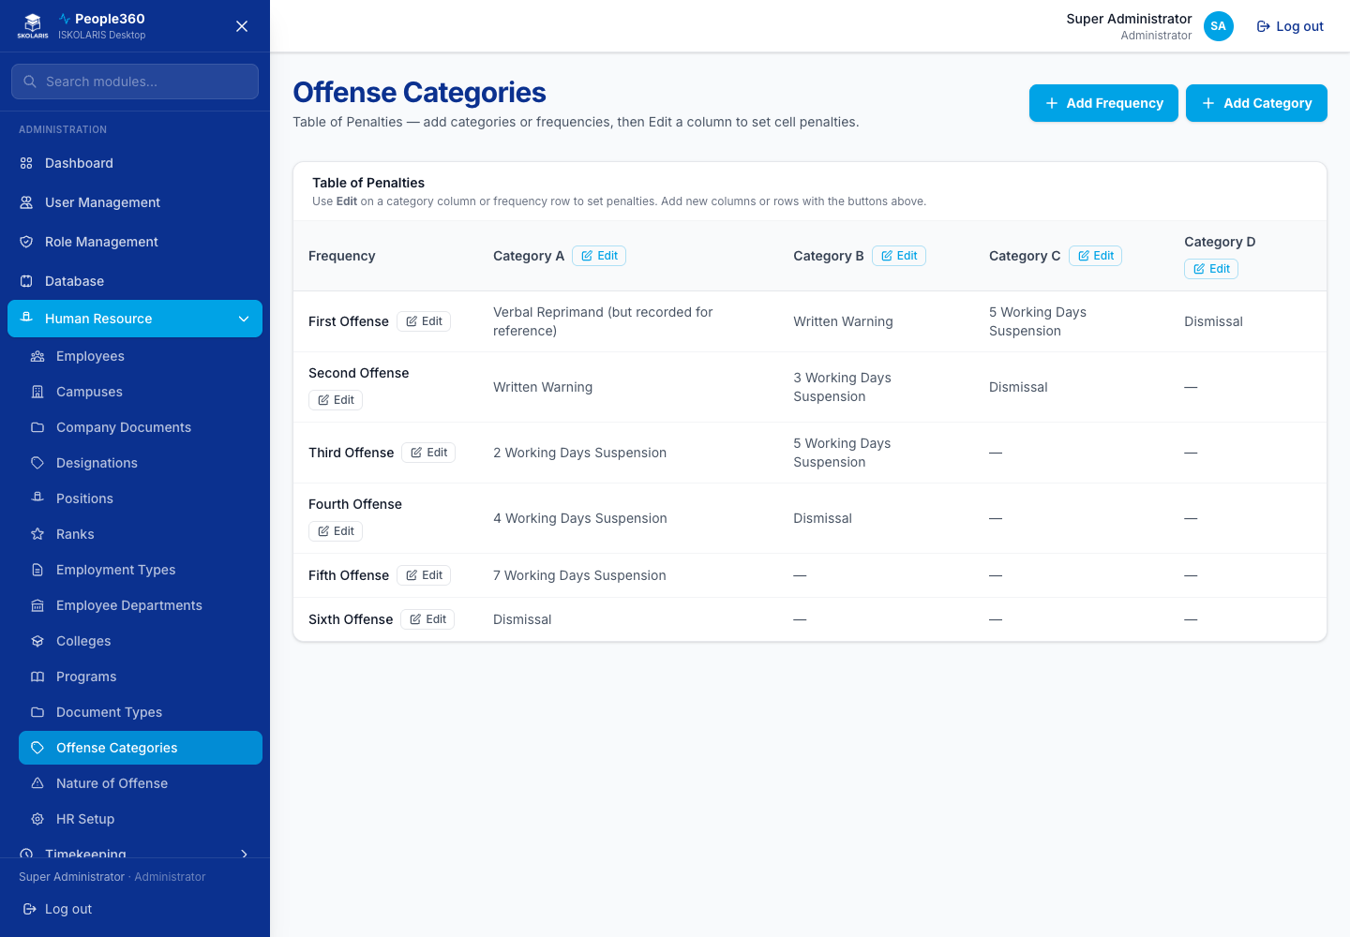
Figure 30. Offense Categories screen
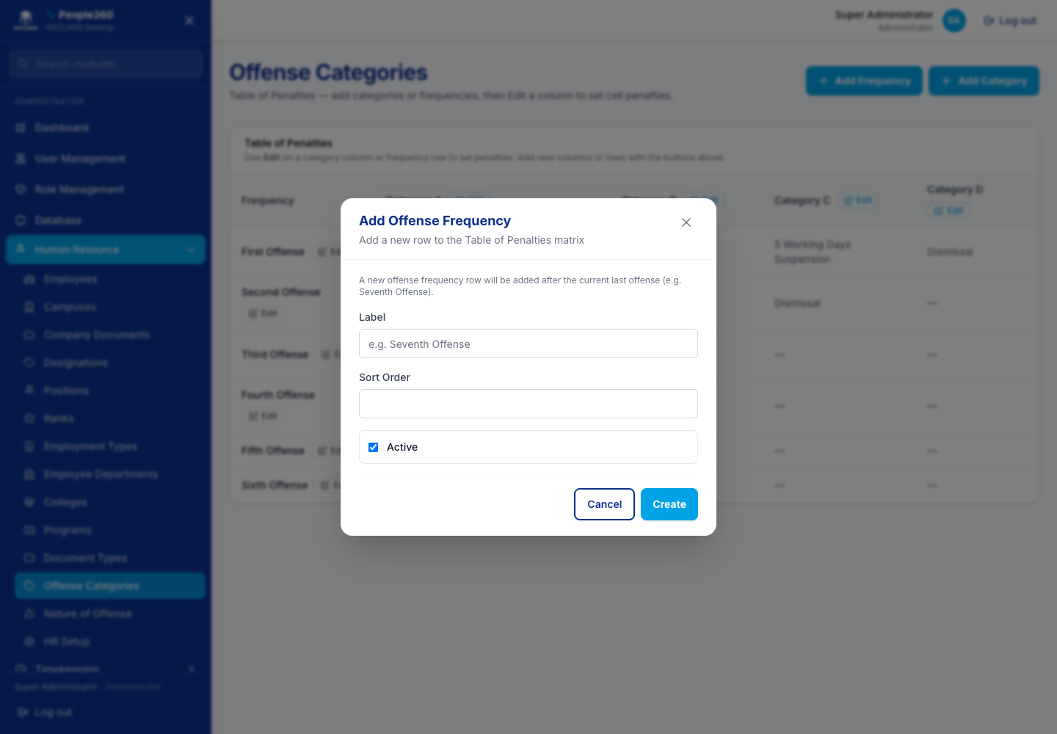
Figure 31. Offense Categories — Add window. Use the blue Add button, then save in this window.

Offense Frequencies
Use the common Add, Edit, Inactive, and Delete steps in Part 1. This section only adds what is specific to this list.
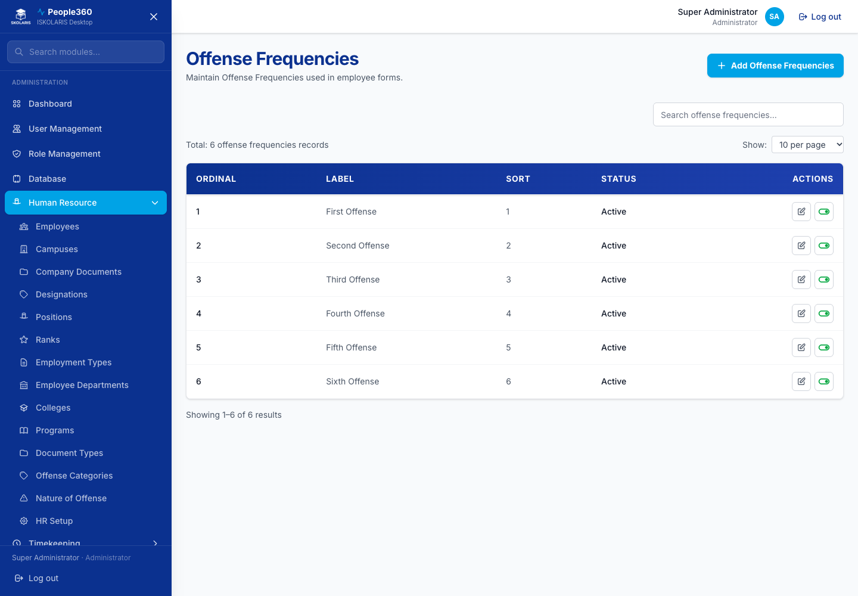
Figure 32. Offense Frequencies screen
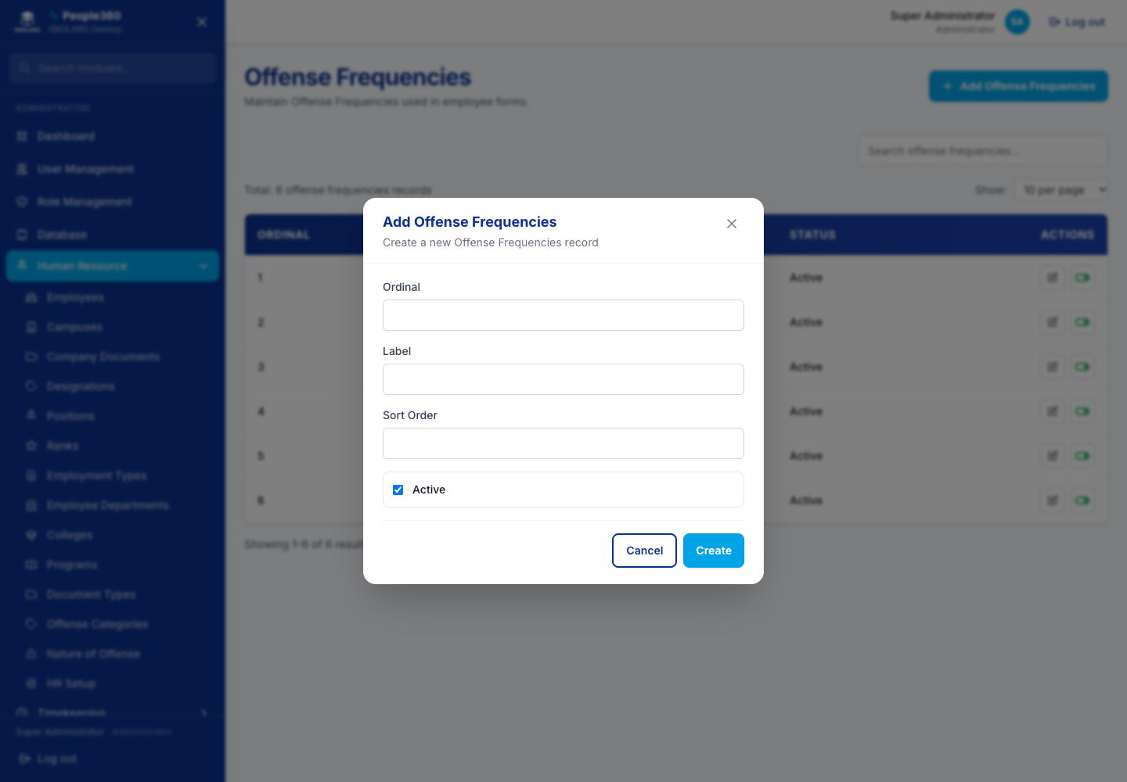
Figure 33. Offense Frequencies — Add window. Use the blue Add button, then save in this window.
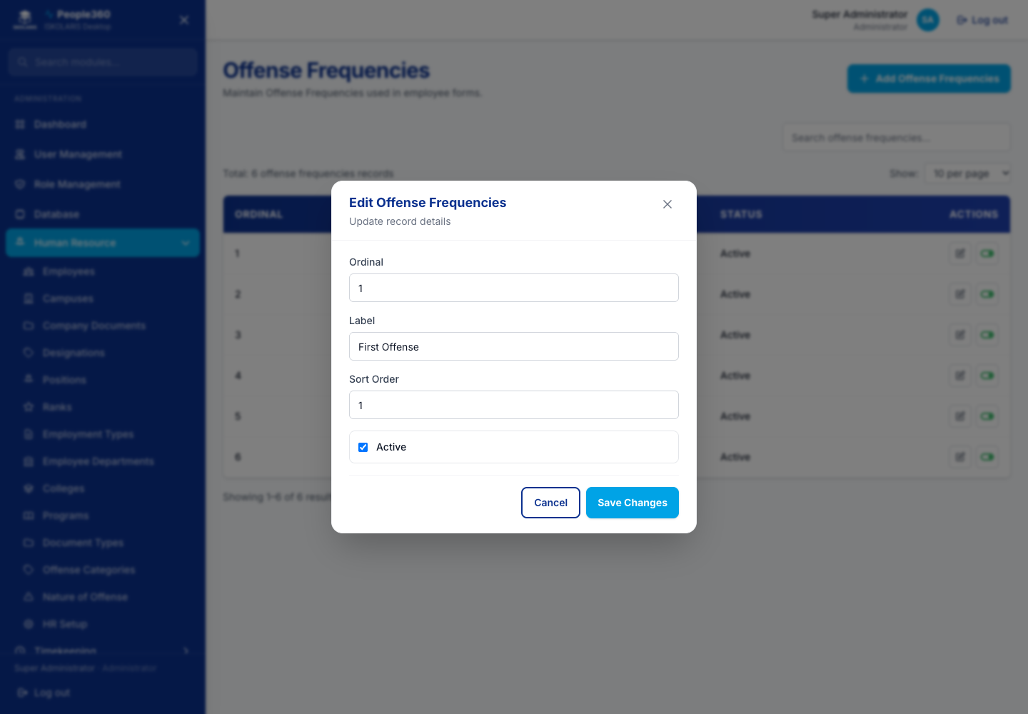
Figure 34. Offense Frequencies — Edit window. Open it with the pencil on the row.

Category Penalties
Use the common Add, Edit, Inactive, and Delete steps in Part 1. This section only adds what is specific to this list.
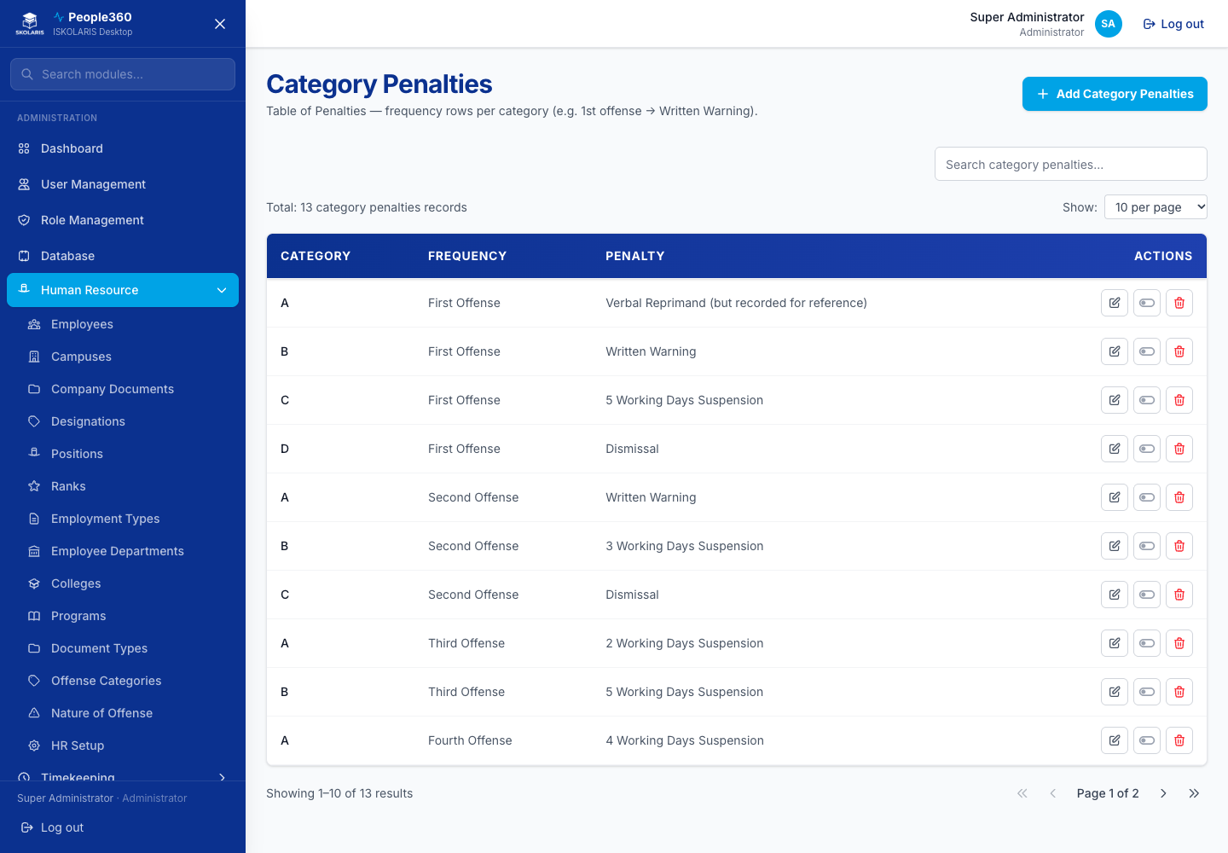
Figure 35. Category Penalties screen
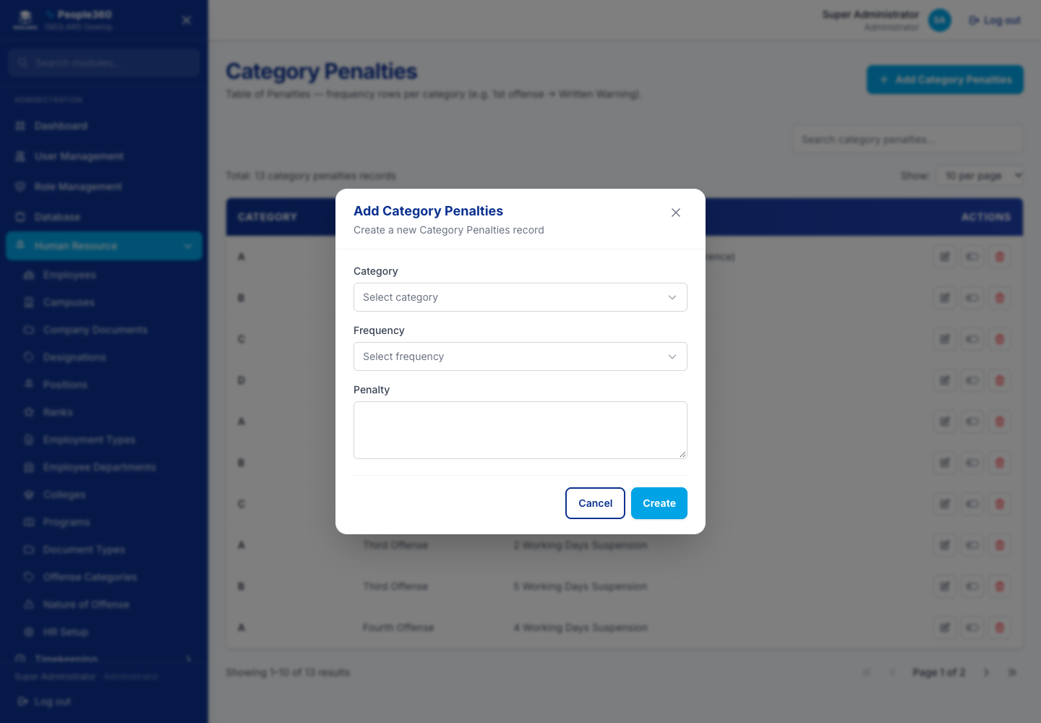
Figure 36. Category Penalties — Add window. Use the blue Add button, then save in this window.
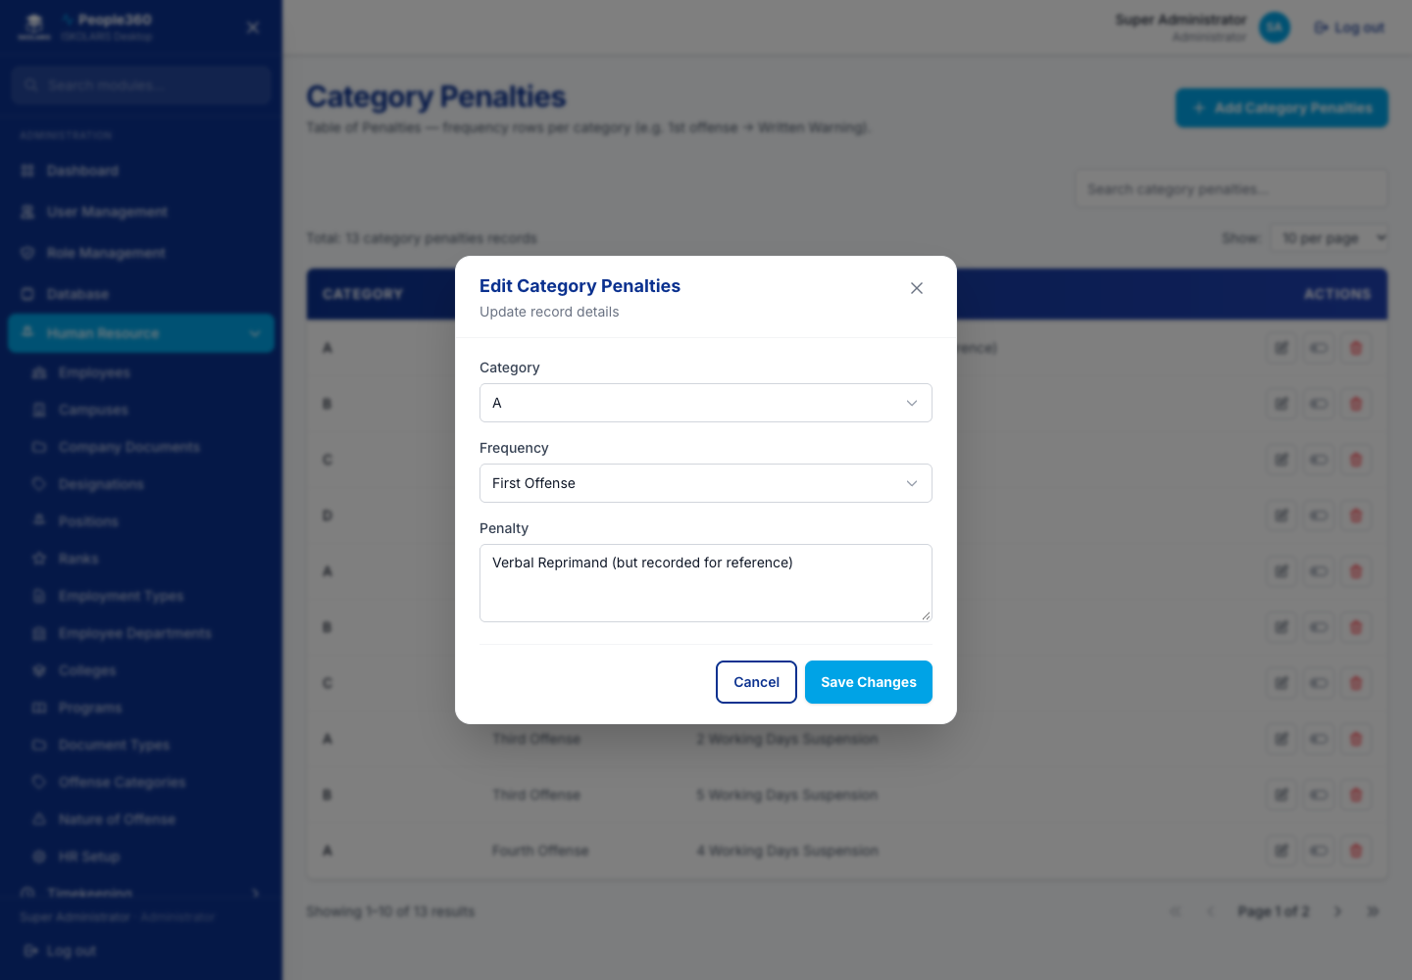
Figure 37. Category Penalties — Edit window. Open it with the pencil on the row.

Nature of Offense
Use the common Add, Edit, Inactive, and Delete steps in Part 1. This section only adds what is specific to this list.
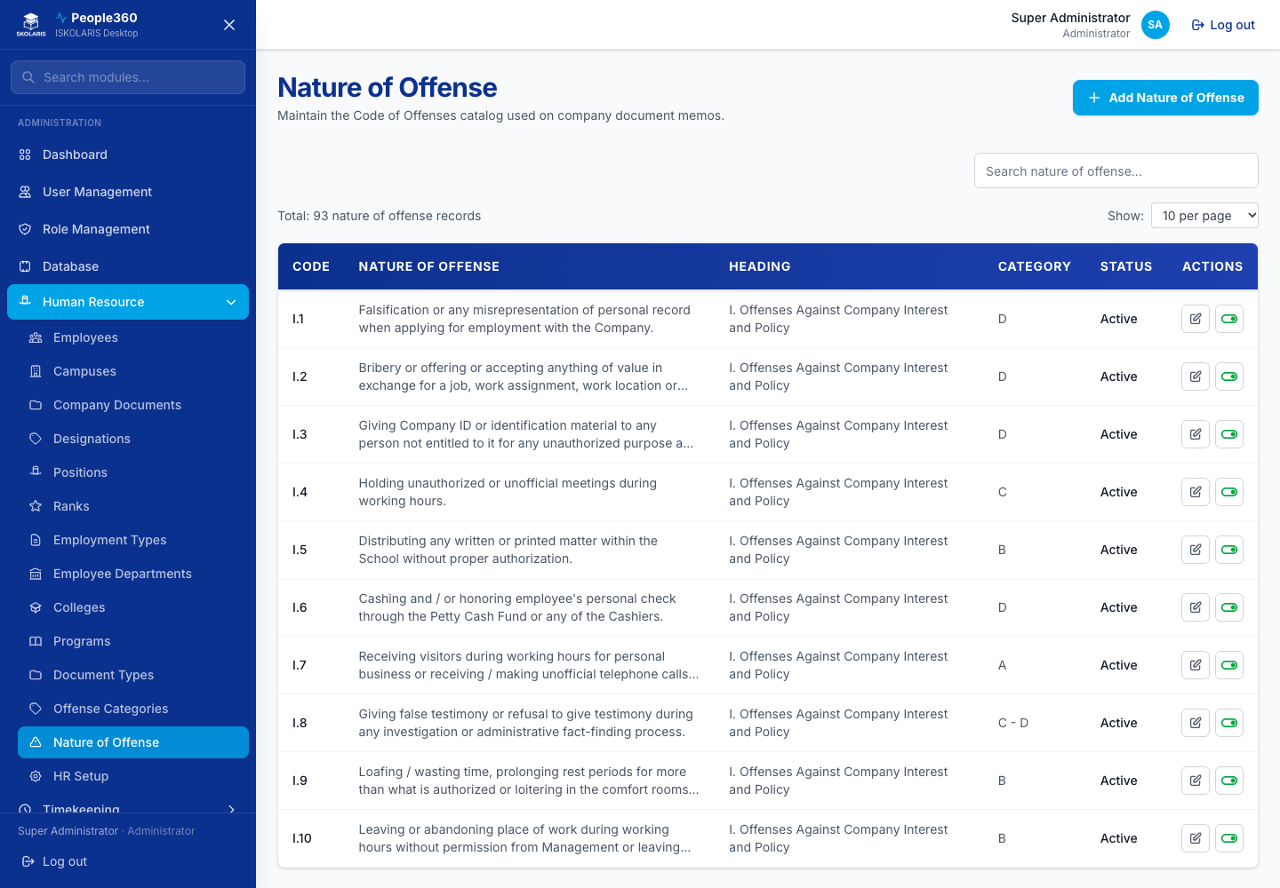
Figure 38. Nature of Offense screen
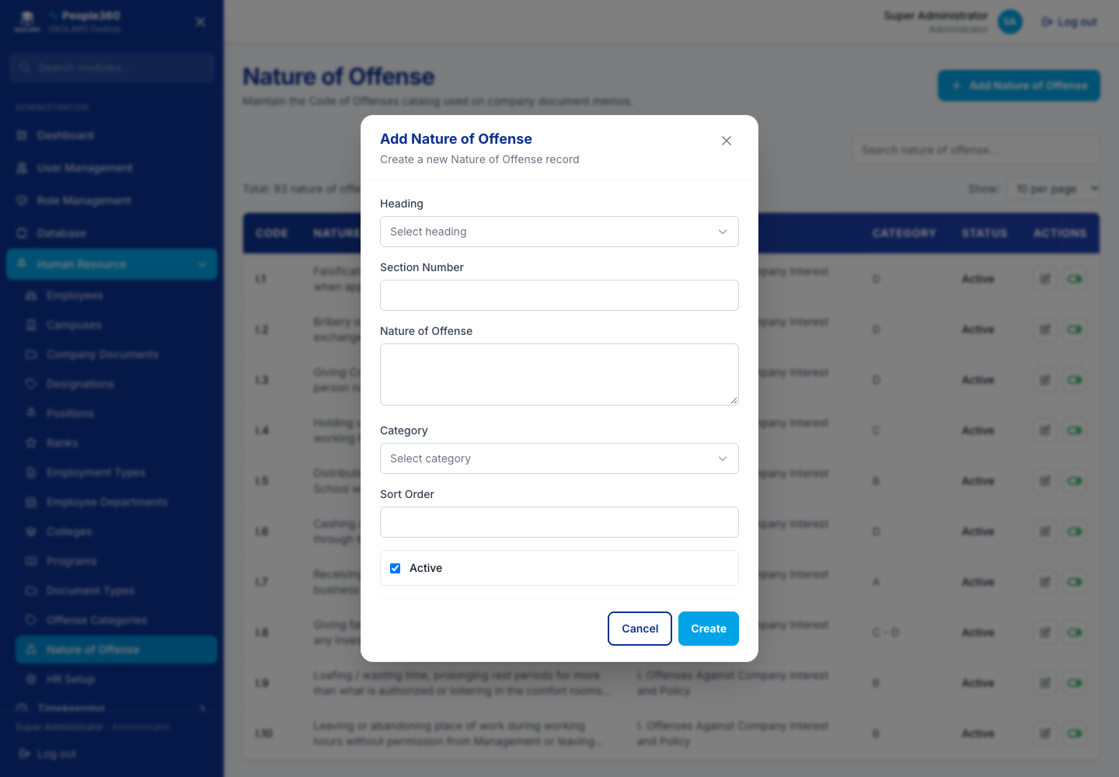
Figure 39. Nature of Offense — Add window. Use the blue Add button, then save in this window.
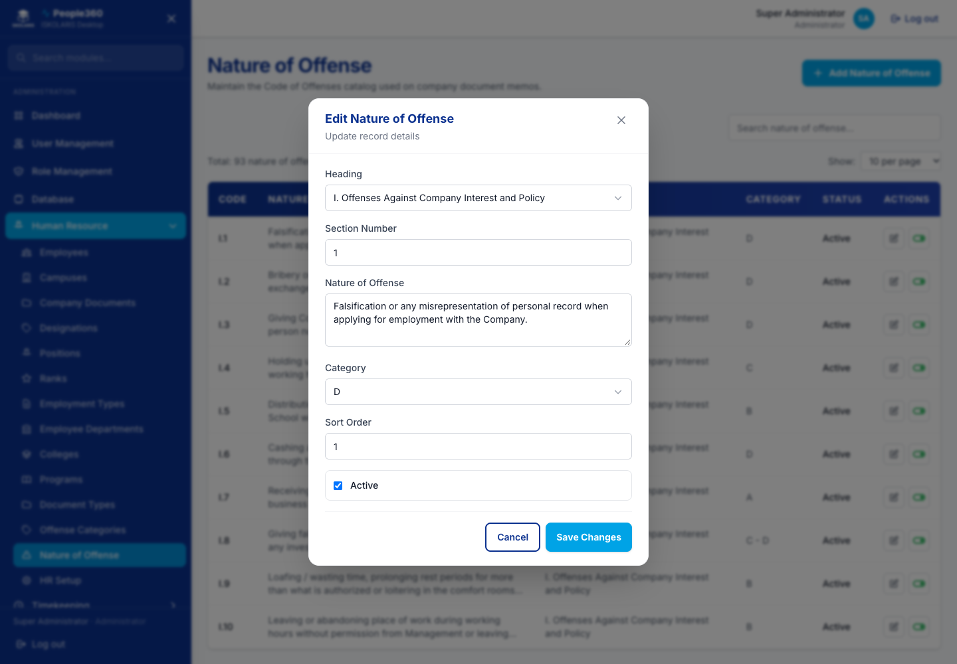
Figure 40. Nature of Offense — Edit window. Open it with the pencil on the row.

Part 3 — User and Employee Management
Who can sign in, and the employee record that timekeeping and payroll will use.

Users
Add User creates a login. The pencil opens Edit so you can change the name, email, or role. People360 does not show a trash icon here. To stop someone from signing in, edit the user and turn access off, or remove the role.
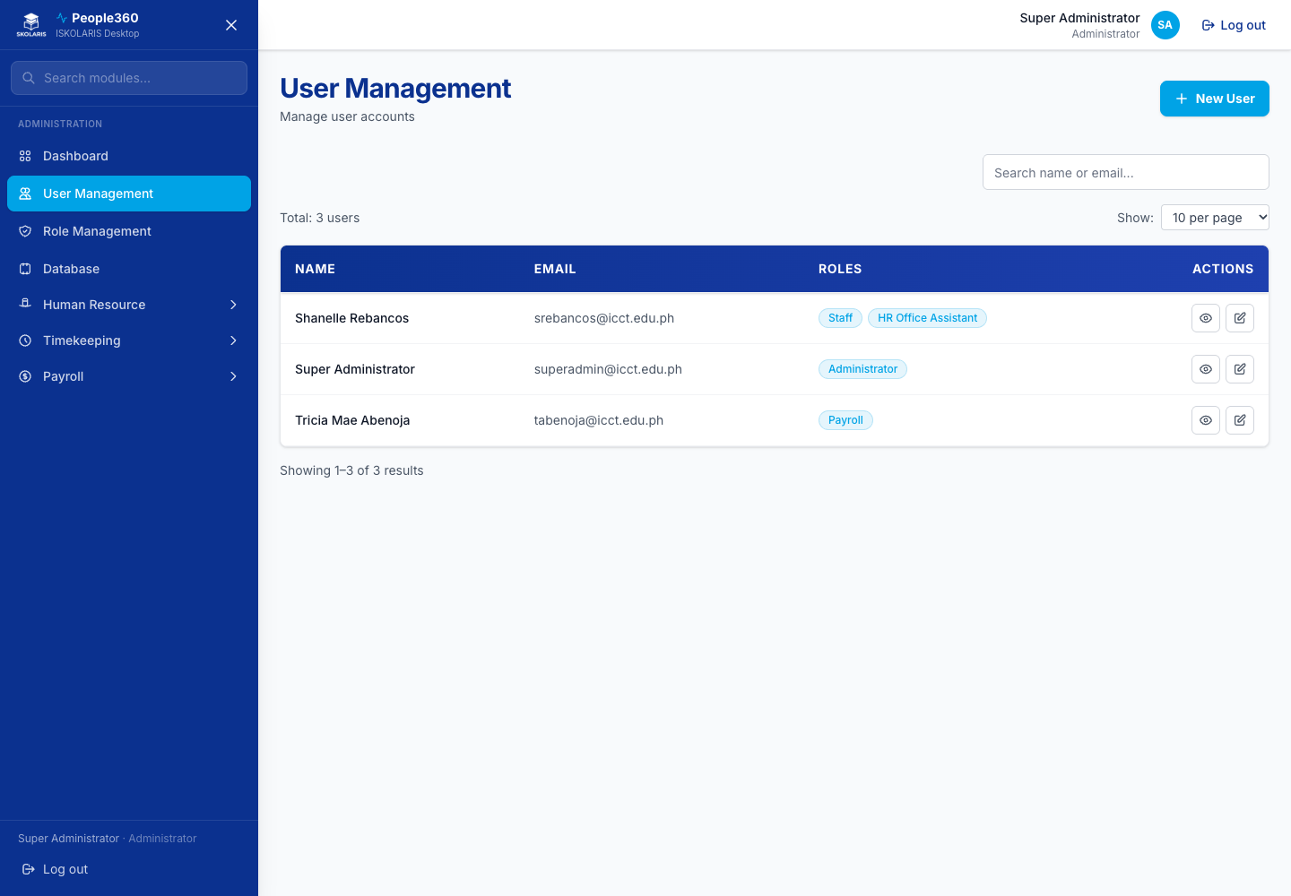
Figure 41. Users screen
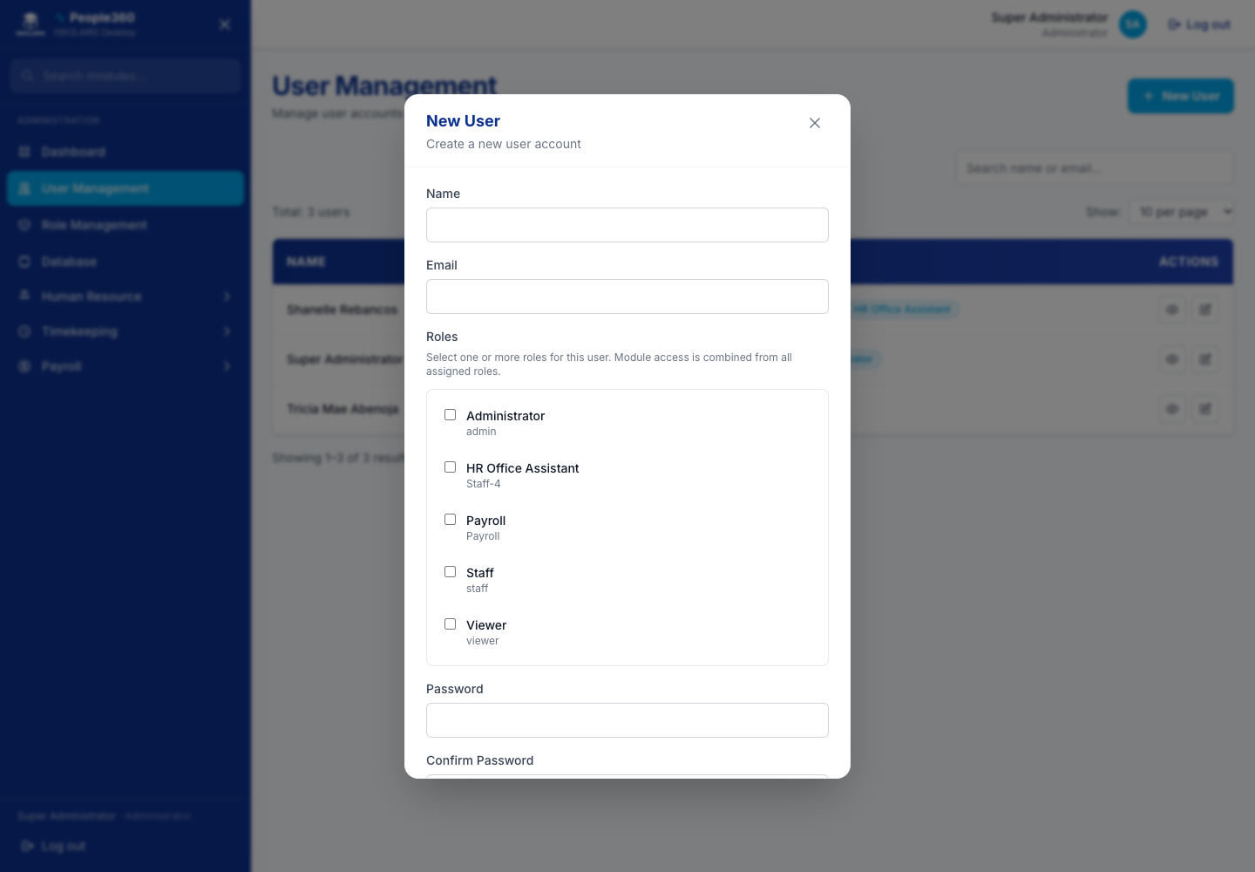
Figure 42. Users — Add window. Use the blue Add button, then save in this window.
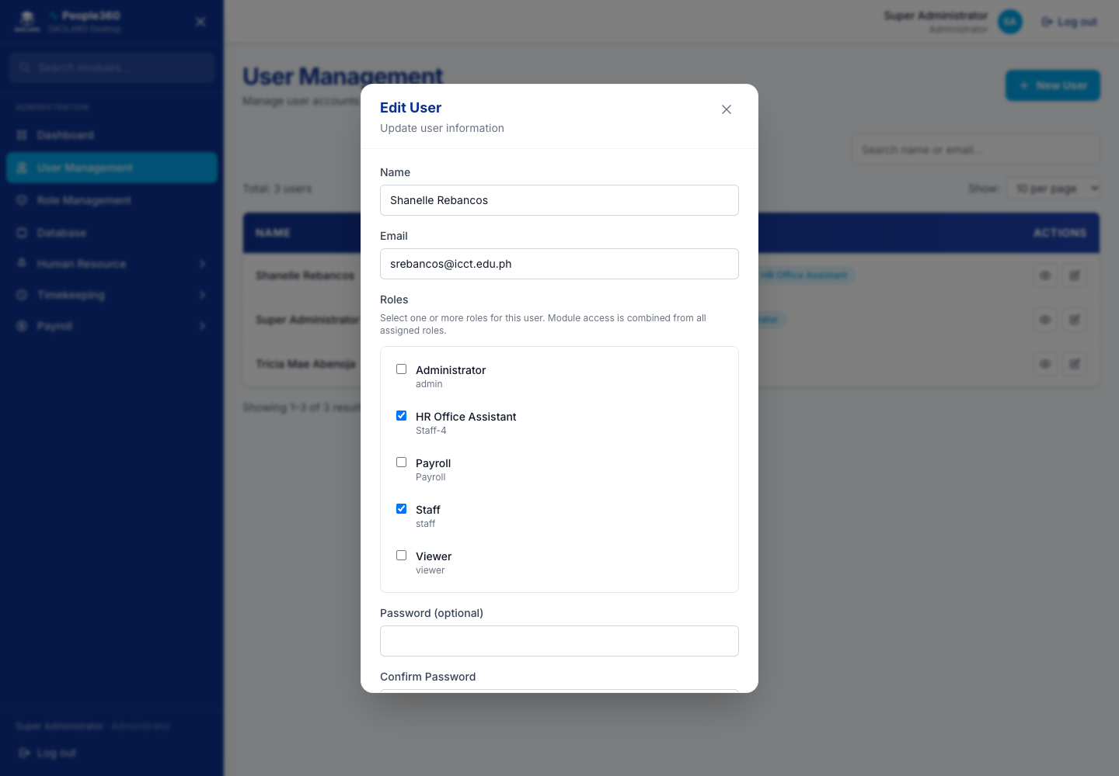
Figure 43. Users — Edit window. Open it with the pencil on the row.

Roles
Add Role creates a permission set. Edit (pencil) changes which menus that role can open. Assign the role on the user record. Do not delete a role that people are still using.
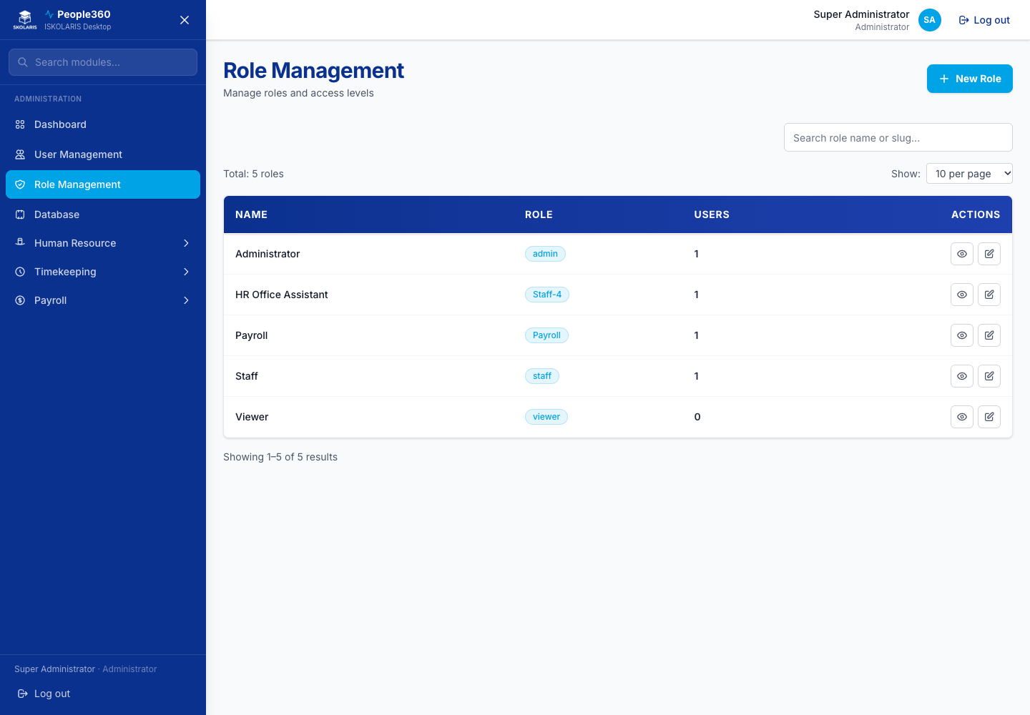
Figure 44. Roles screen
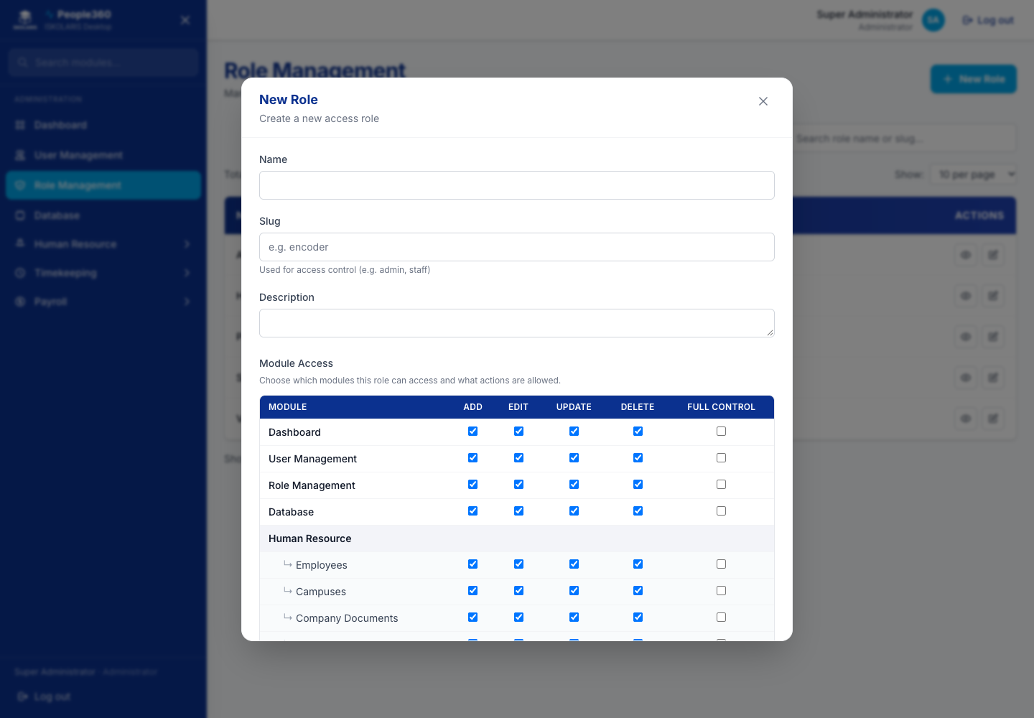
Figure 45. Roles — Add window. Use the blue Add button, then save in this window.
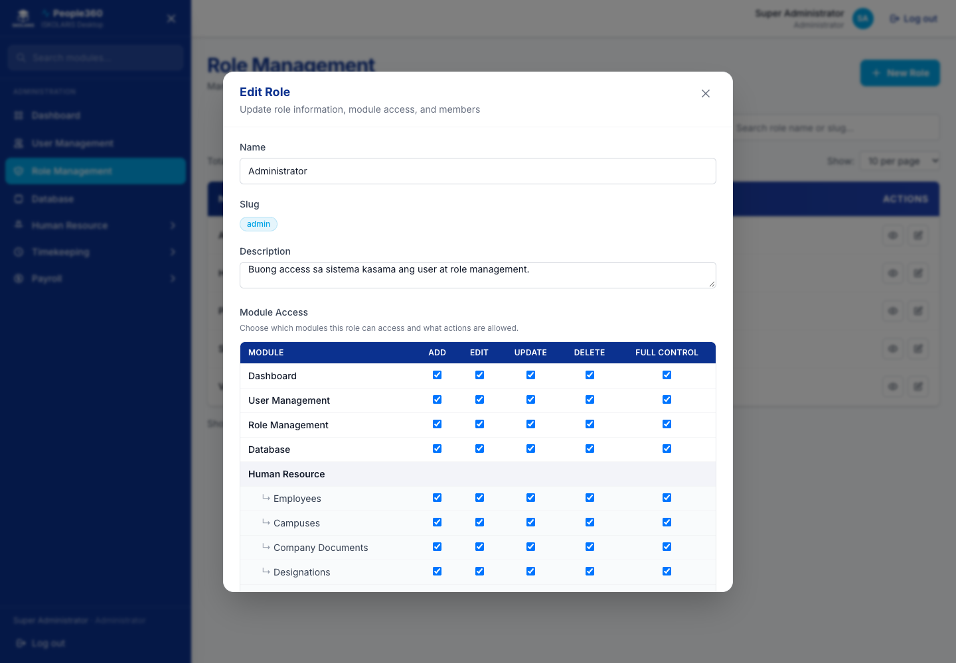
Figure 46. Roles — Edit window. Open it with the pencil on the row.

HR Setup
Campus notification and HR setup options. Save the form. This page is settings, not a row you add and delete.
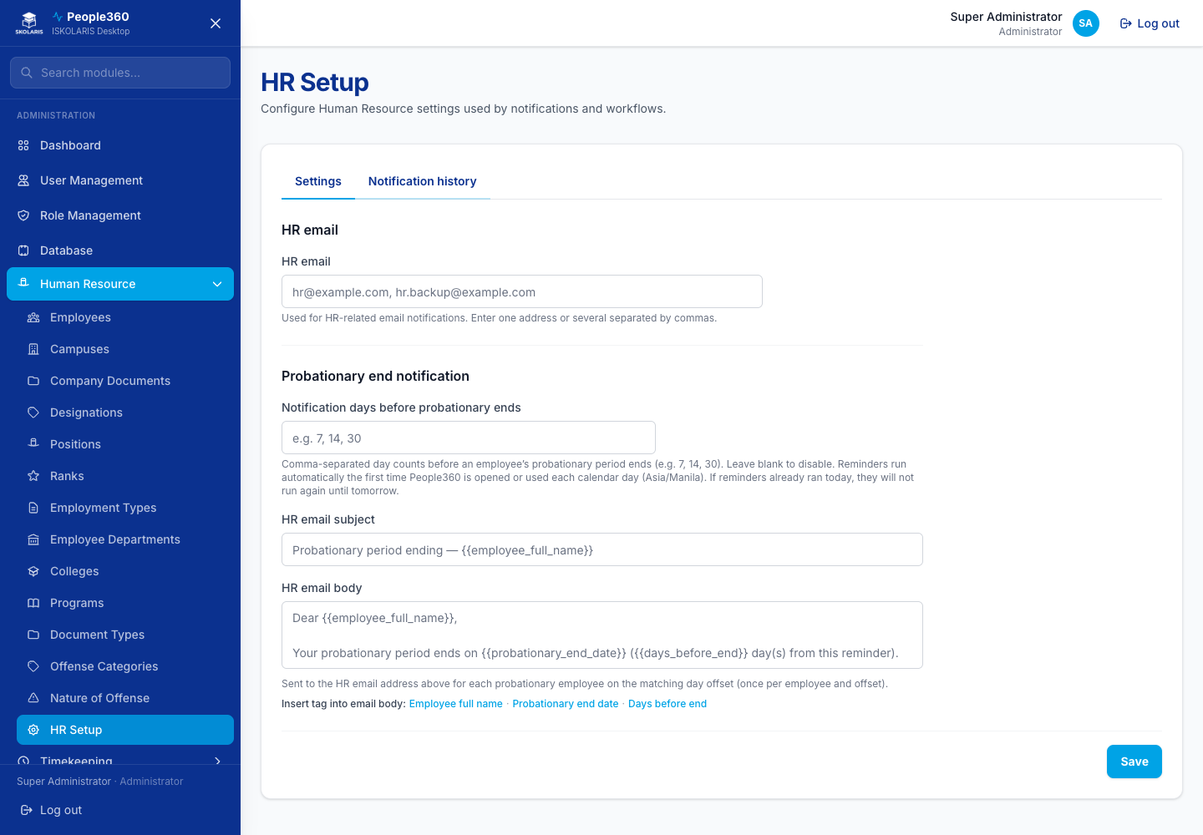
Figure 47. HR Setup screen

Employees
Add Employee opens a step-by-step window on this same page (campus, personal details, employment, salary). Upload brings in many employees from the spreadsheet template. Approve is for records waiting for compliance. On each row, the eye is View, the pencil is Edit, and the red trash is Delete. Delete is for a record you are allowed to remove. Active people should be set Inactive instead of deleted when they leave.
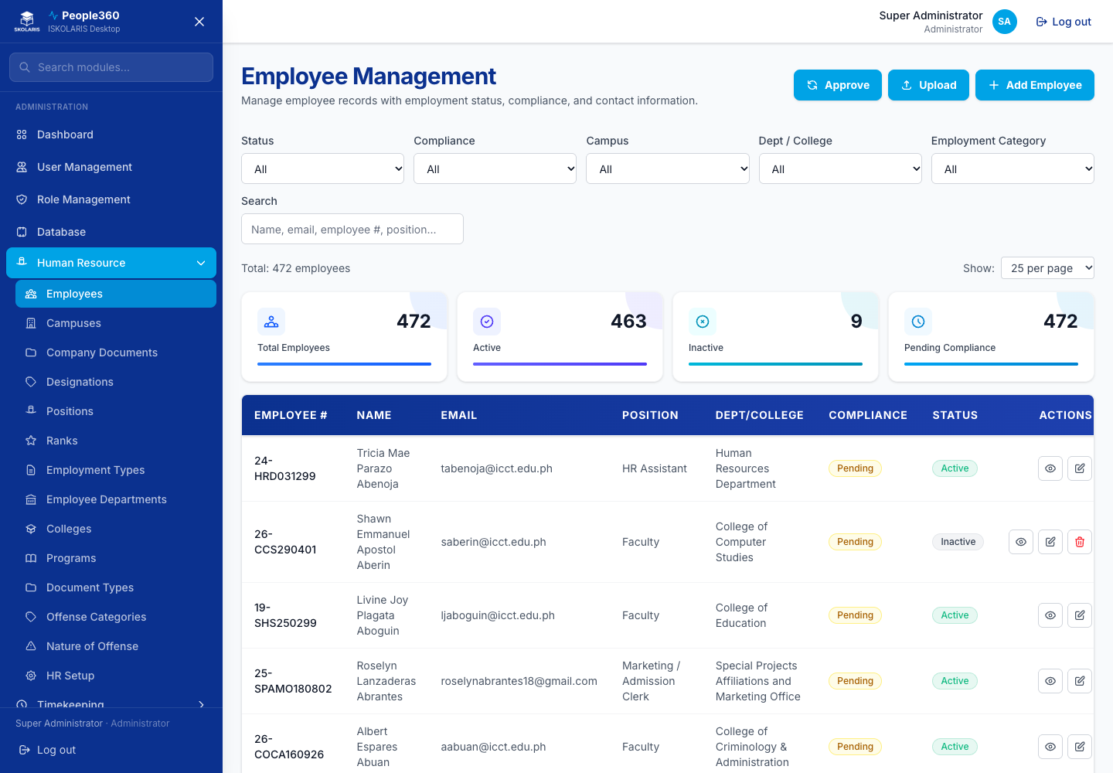
Figure 48. Employees screen
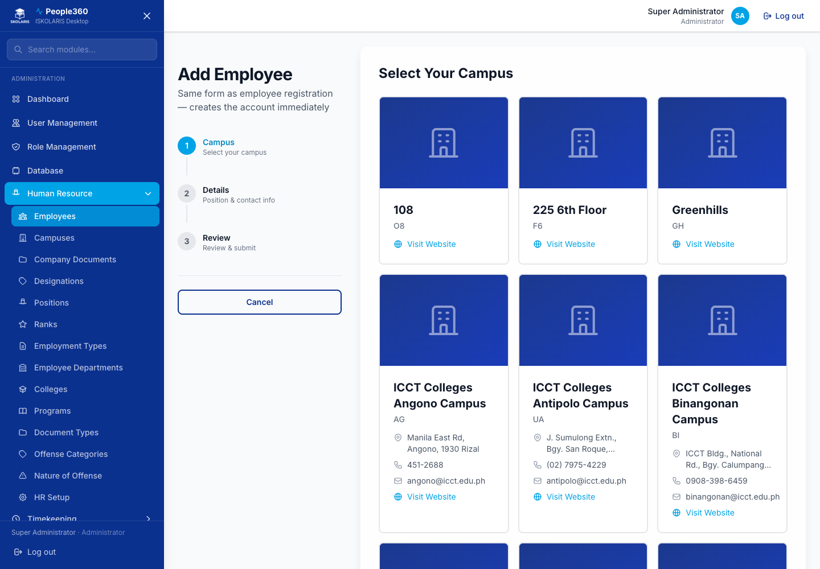
Figure 49. Employees — Add window. Use the blue Add button, then save in this window.
Delete, when shown, is the red trash on the row. Read the question. Confirm only when this row should be removed. Leave a row Inactive when history must be kept.

Employee loans
Loans live on the employee record, not on the employee list. Open the person, click Edit, then open the Loans tab. The list shows loan date, loan type, payment scheme, loan amount, amortization, and balance.
Before you begin. Save the employee first. The Loans tab stays visible, but Add is available only after the employee exists. Loan types must already exist under Payroll.
1. On Employees, open the person with the pencil (Edit).
2. Open the Loans tab.
3. Click Add. The window stays on the employee page.
4. Choose Loan Type and Loan Date. Both are required.
5. Choose the payment scheme. User-entered amortization: you type the amortization amount. Based on number of payments: enter the number of payments and People360 computes amortization as loan amount divided by that number. You cannot type the amortization in that scheme.
6. Enter Loan Amount. Payment Start Date is the first pay period that may deduct this loan. Interest, paid from previous, deducted from new loan, and purpose are optional.
7. Save. The eye on the row opens the payment history (batch, pay period, batch status, date, payment, and penalty). The pencil edits the loan. The trash asks you to confirm before the loan is removed.
Expected result. The row shows a balance. The eye shows no payroll deduction until a batch actually deducts it.
Important. A tick on the payroll calendar does not deduct the loan by itself. All of these must be true: the loan type is ticked on that pay period, the employee has this loan, and the payment start date is on or before the period end. Each employee loan is deducted on one batch only. A later period does not deduct it again, even if the calendar stays ticked. To recalculate the amount, reprocess that same batch. Changing the amortization after the first deduction does not create a second deduction.
After process, open the employee on the batch. The loan appears on the Deductions tab and in net pay. The same amount is on the payslip and the payroll register. The eye on the employee loan shows the batch status, including Posted after you post.

Part 4 — Timekeeping Setup and Operations
Shifts and policies first, then assign them on the employee profile, then bring in attendance.

Shift Codes
Add Shift Code sets the time-in and time-out pattern. Edit changes an existing shift. Delete removes a shift that is not assigned. If people still use it, leave it and stop assigning it.
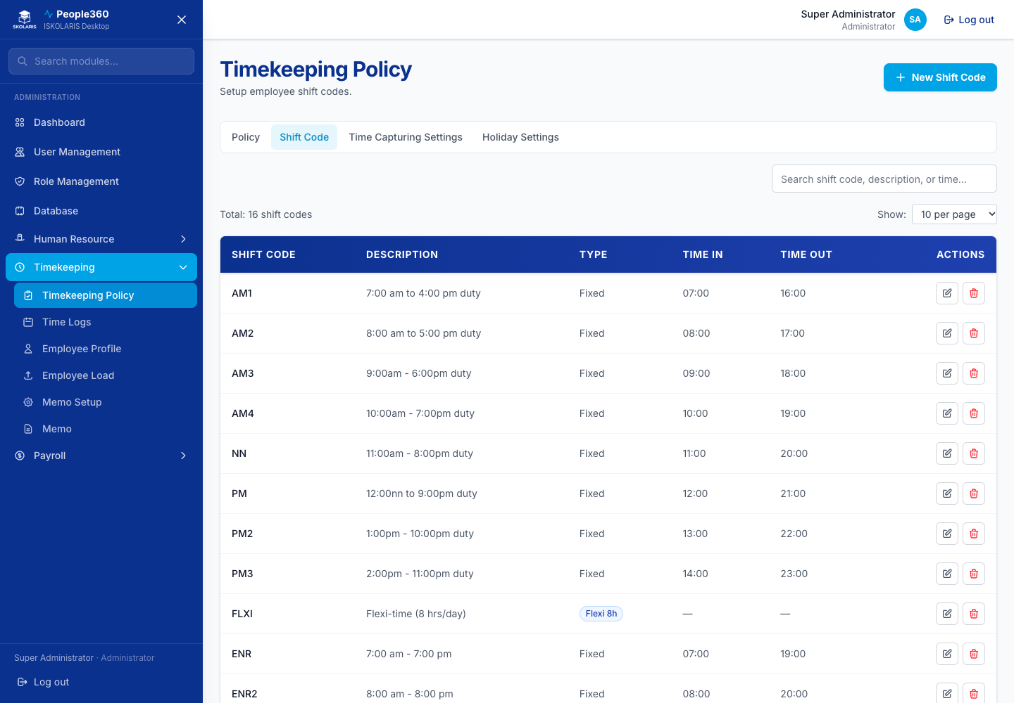
Figure 50. Shift Codes screen
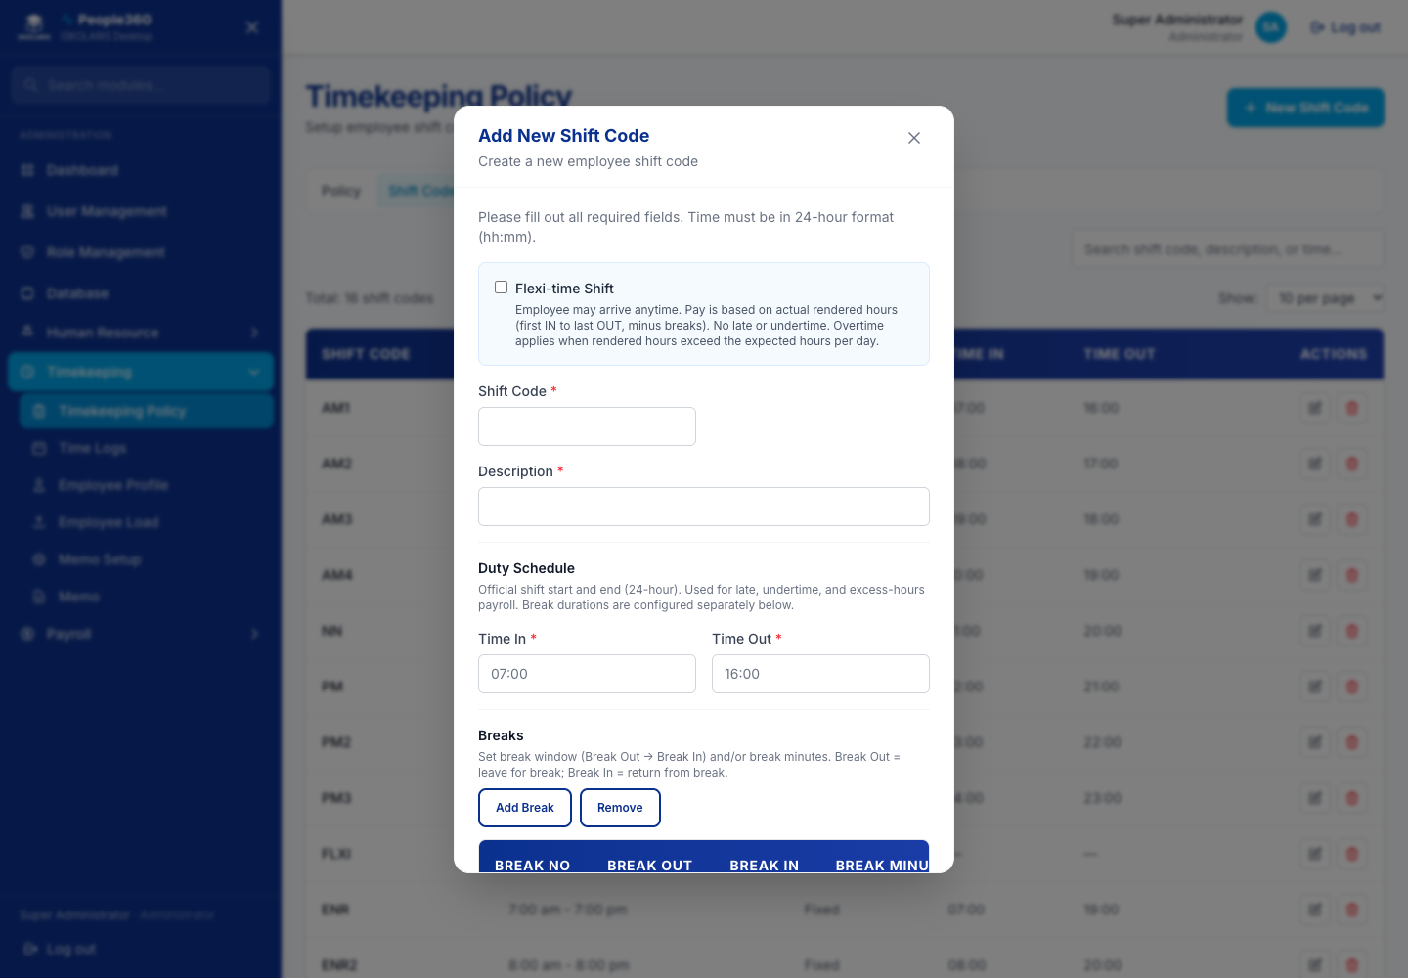
Figure 51. Shift Codes — Add window. Use the blue Add button, then save in this window.
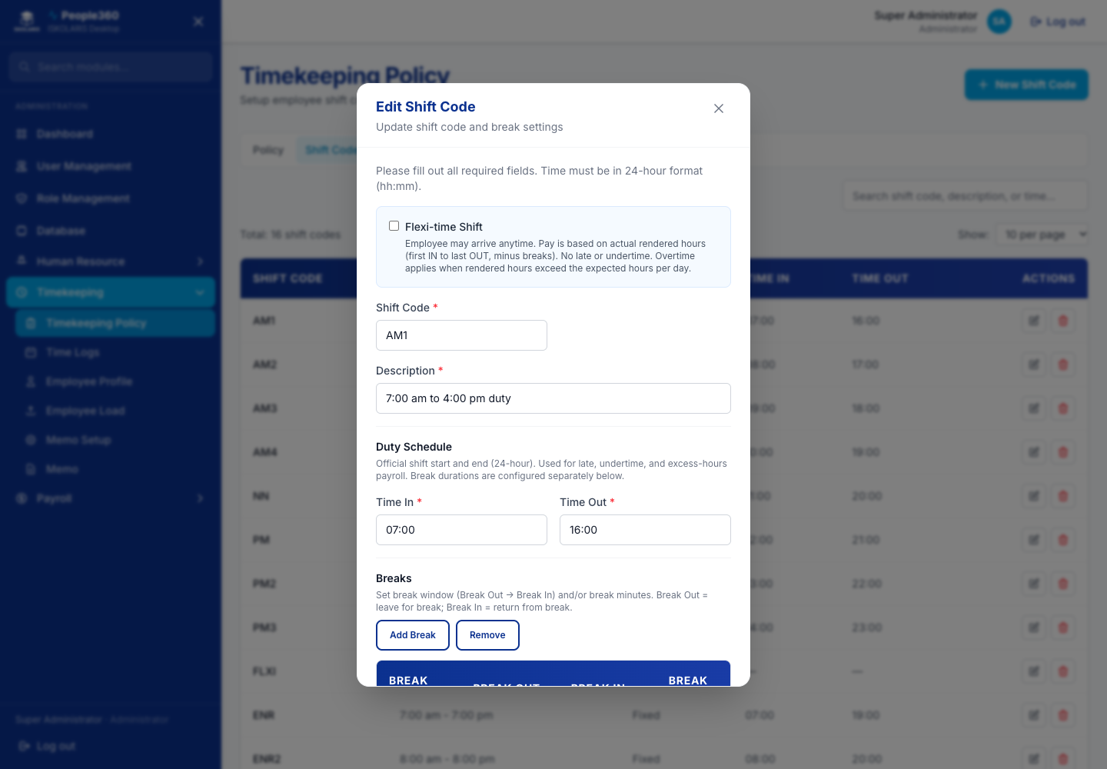
Figure 52. Shift Codes — Edit window. Open it with the pencil on the row.
Delete, when shown, is the red trash on the row. Read the question. Confirm only when this row should be removed. Leave a row Inactive when history must be kept.

Holiday Settings
Add a holiday, holiday group, or year entry from the buttons on this page. Edit changes a row. Delete removes a holiday that should not be paid or observed.
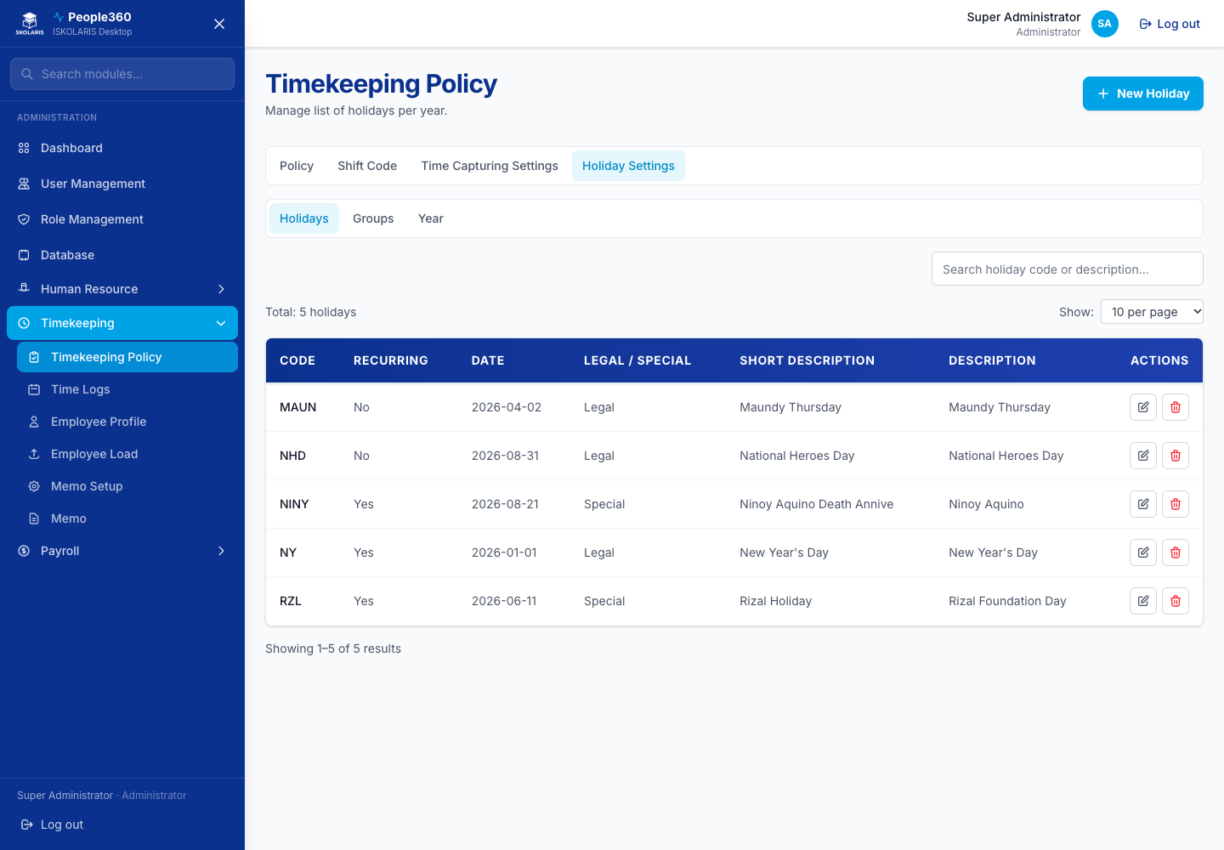
Figure 53. Holiday Settings screen
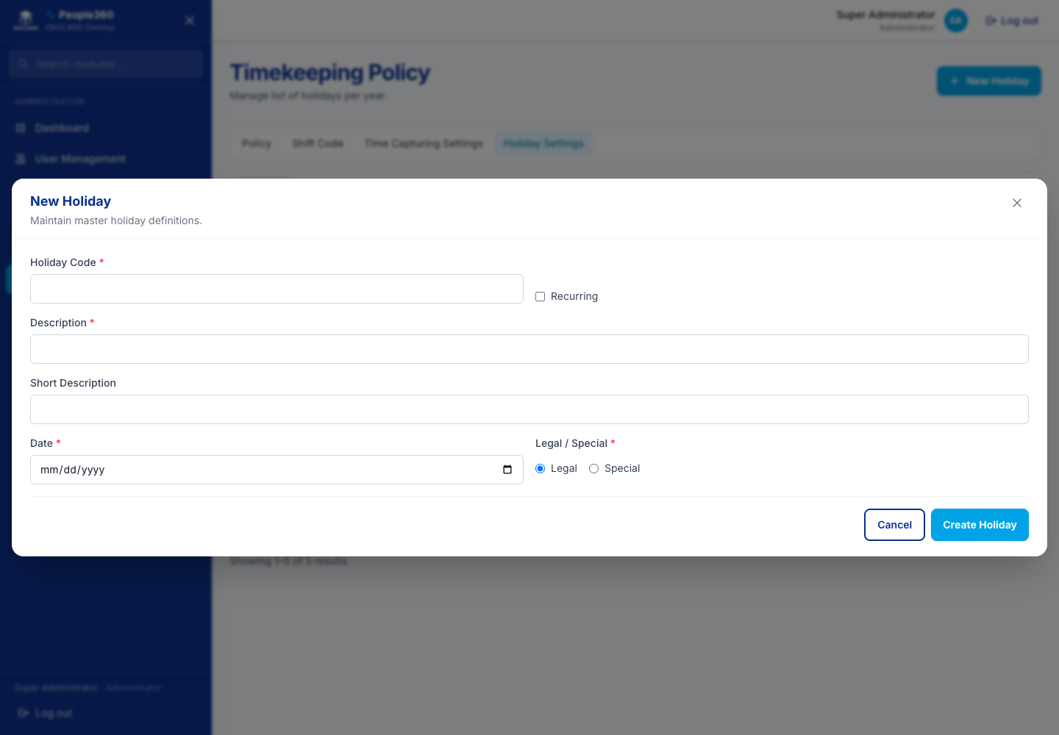
Figure 54. Holiday Settings — Add window. Use the blue Add button, then save in this window.
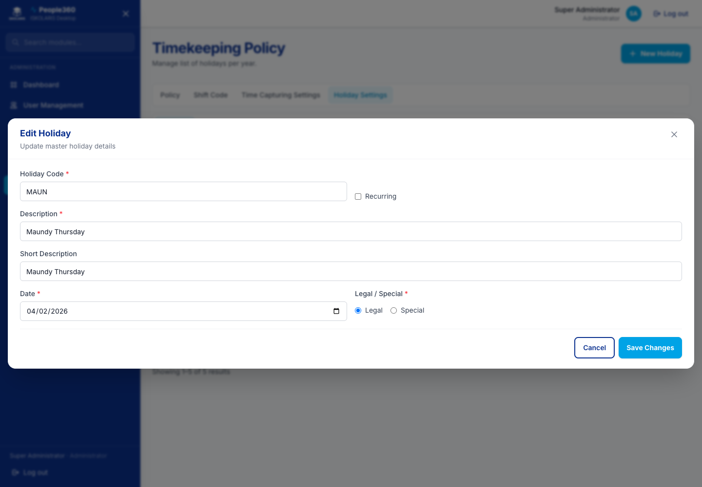
Figure 55. Holiday Settings — Edit window. Open it with the pencil on the row.
Delete, when shown, is the red trash on the row. Read the question. Confirm only when this row should be removed. Leave a row Inactive when history must be kept.

Time Capturing Settings
Add a time-capture format so uploads and biometric files match the columns People360 expects. Edit changes a format. Delete removes one you no longer use.
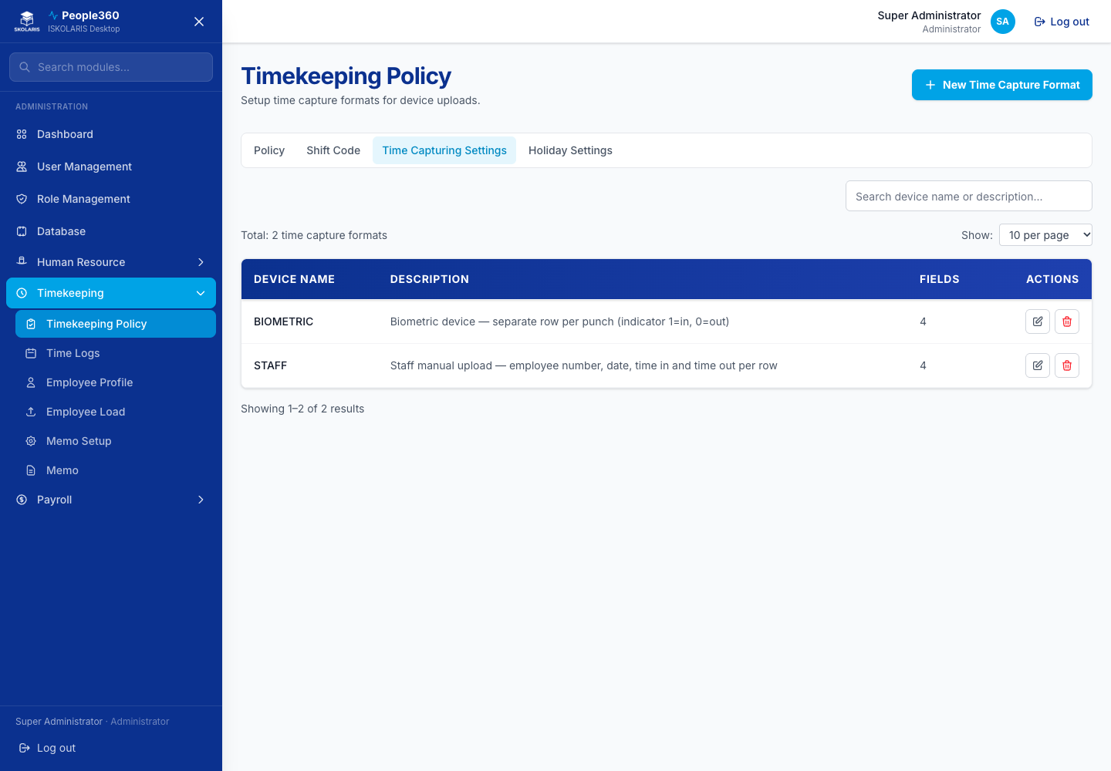
Figure 56. Time Capturing Settings screen
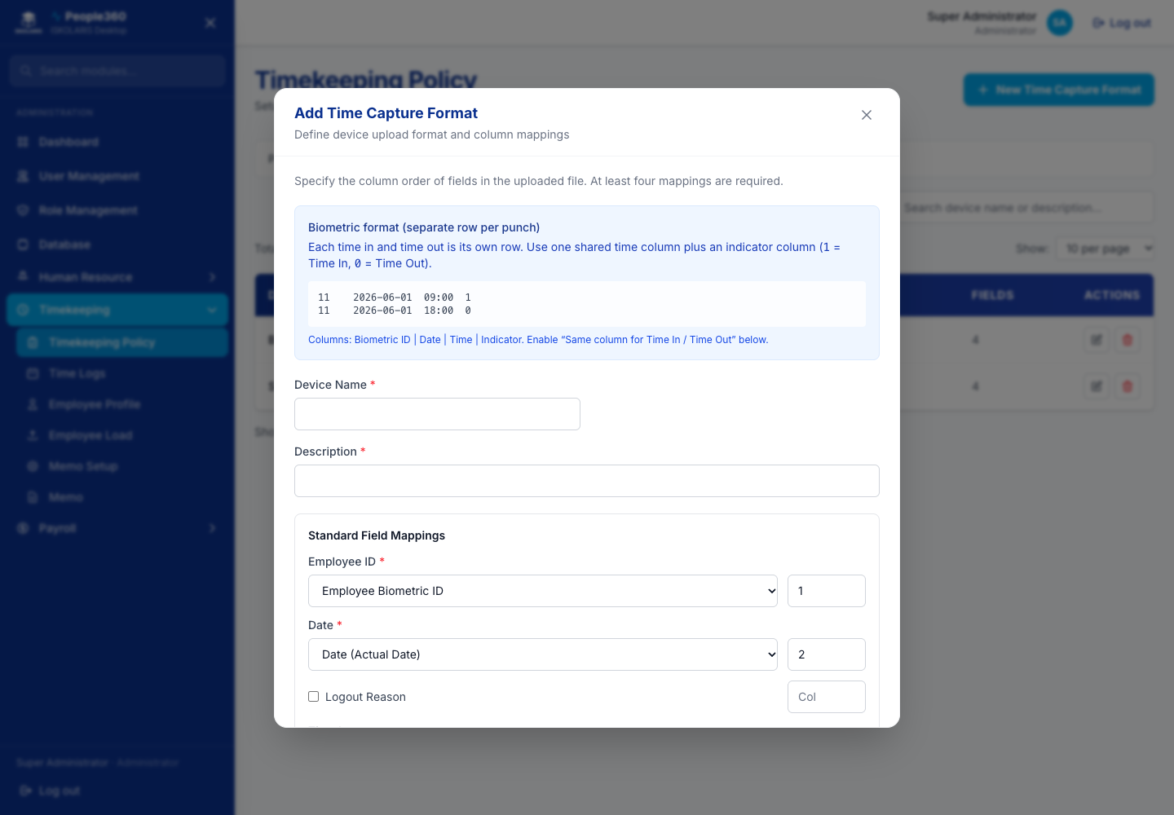
Figure 57. Time Capturing Settings — Add window. Use the blue Add button, then save in this window.
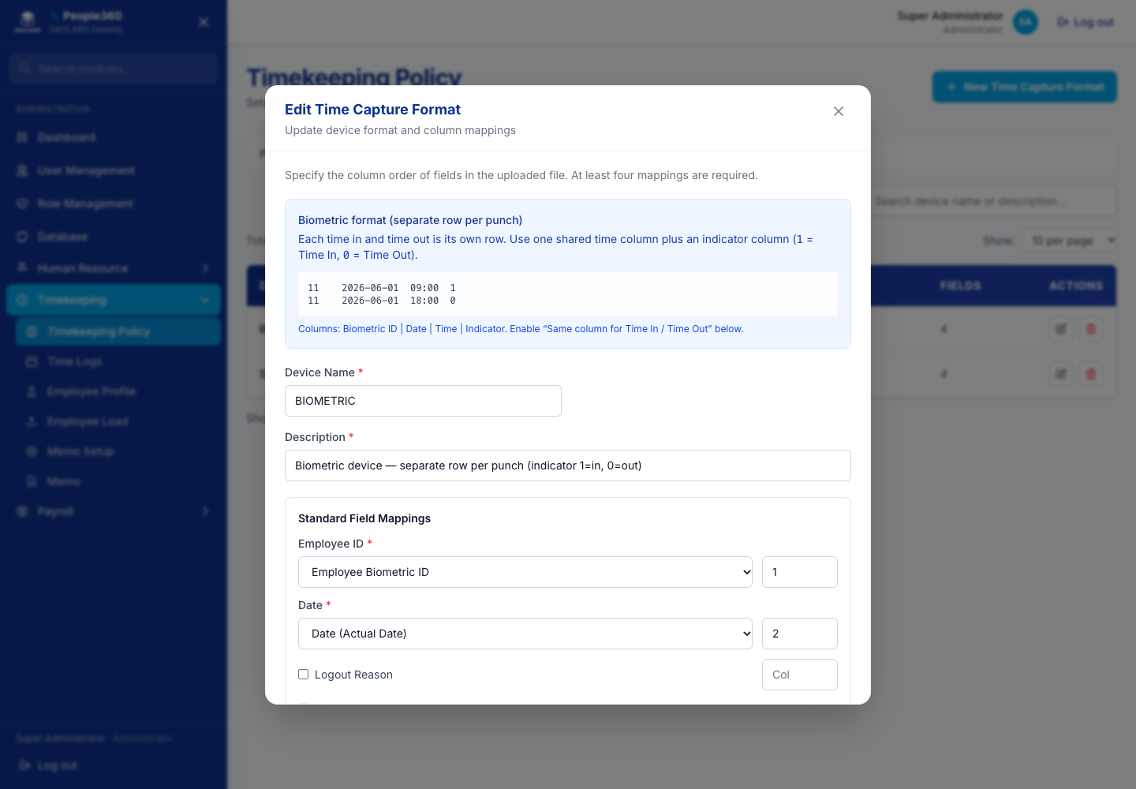
Figure 58. Time Capturing Settings — Edit window. Open it with the pencil on the row.
Delete, when shown, is the red trash on the row. Read the question. Confirm only when this row should be removed. Leave a row Inactive when history must be kept.

Timekeeping Policy
Add Policy creates a policy. Edit (pencil) opens it. Inside a policy, use the settings pages (tardiness, overtime, breaks, night differential, general) and click Save. Do not delete a policy that employees still use. Set it inactive instead.
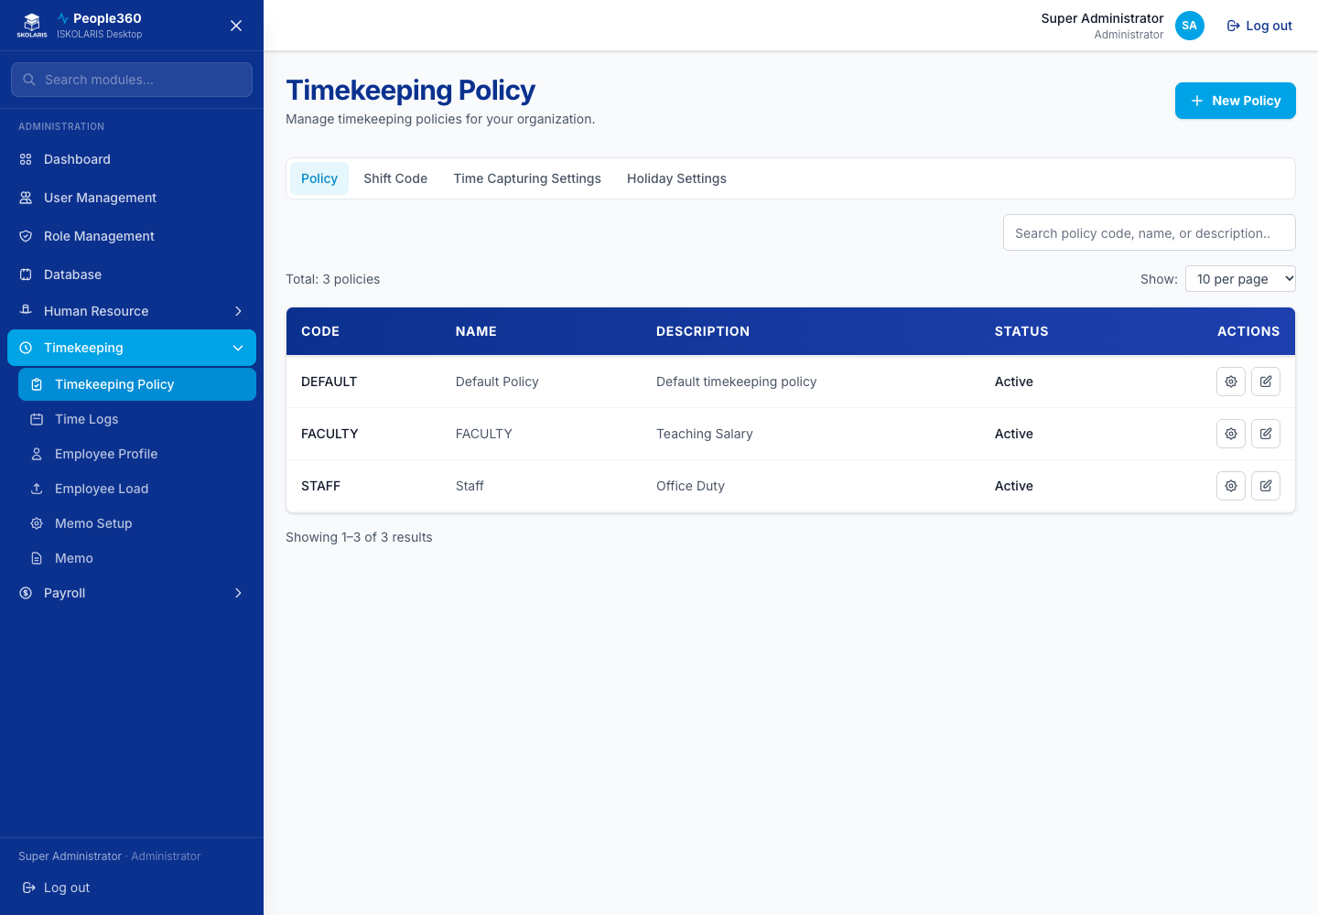
Figure 59. Timekeeping Policy screen
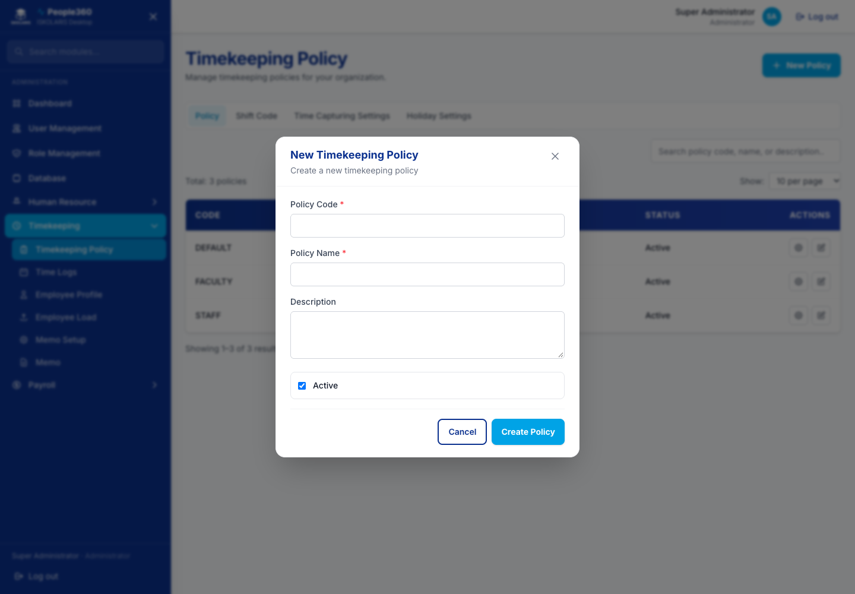
Figure 60. Timekeeping Policy — Add window. Use the blue Add button, then save in this window.
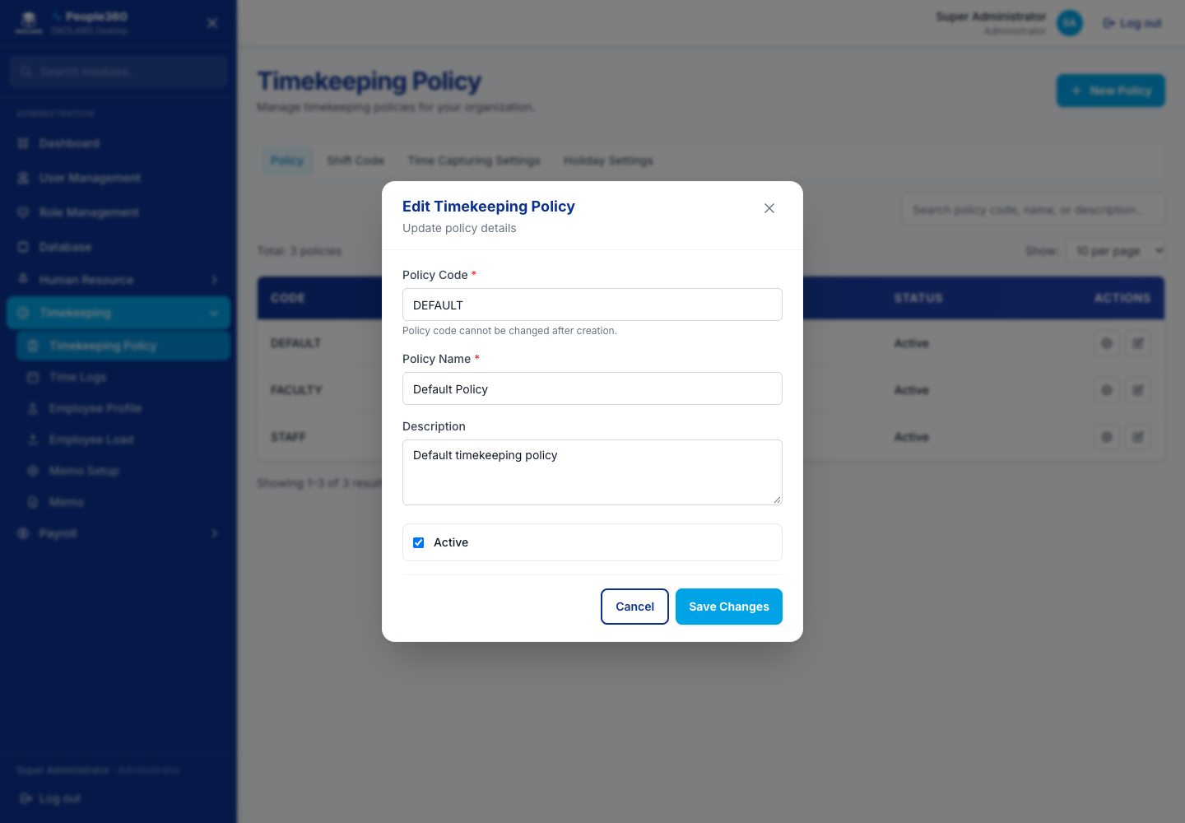
Figure 61. Timekeeping Policy — Edit window. Open it with the pencil on the row.

Policy — Tardiness and Undertime
Open the policy, then this settings page. Change the rules and save. This is an edit of the policy, not a new list row. Delete, when shown, removes an extra rule row after you confirm.
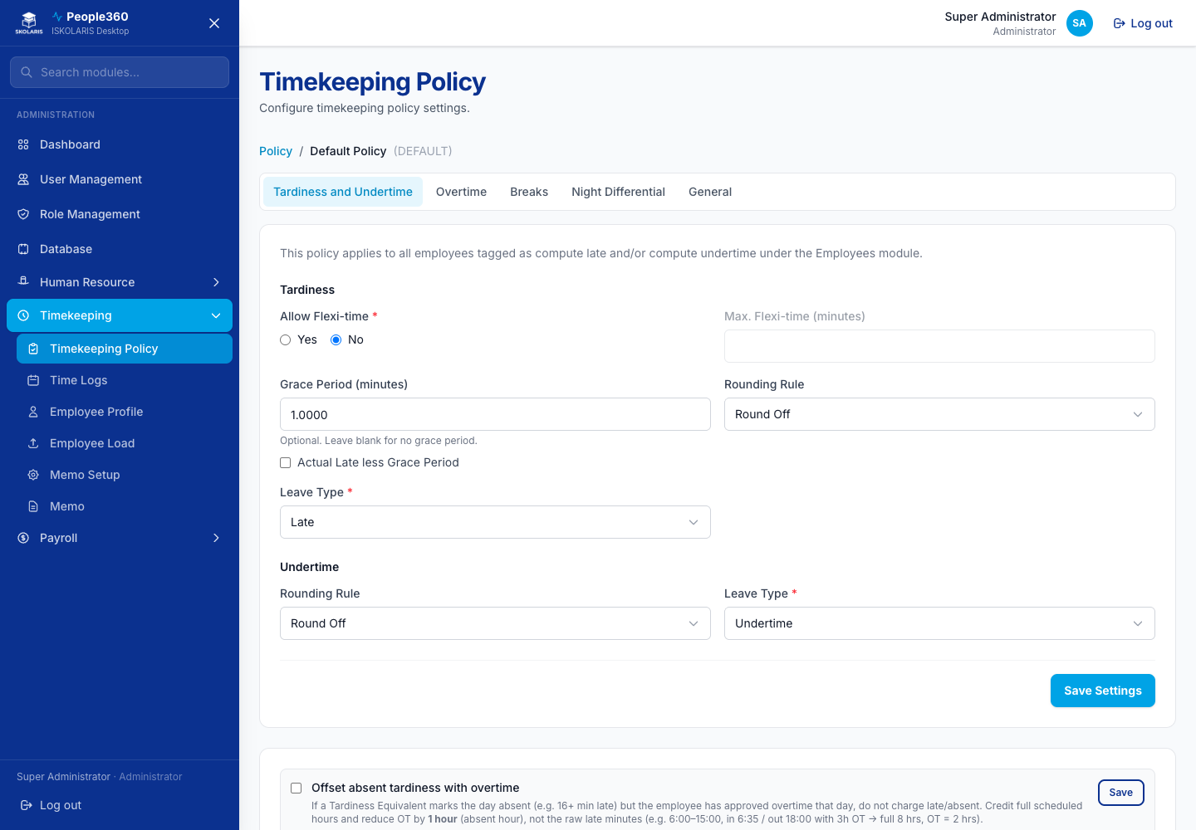
Figure 62. Policy — Tardiness and Undertime screen
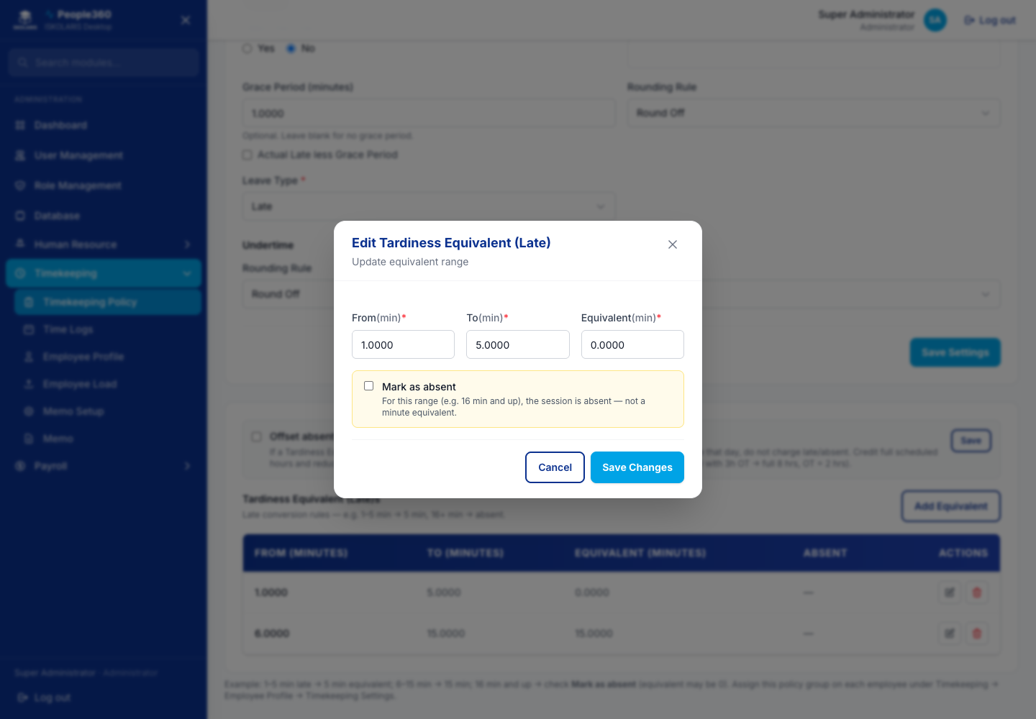
Figure 63. Policy — Tardiness and Undertime — Edit window. Open it with the pencil on the row.
Delete, when shown, is the red trash on the row. Read the question. Confirm only when this row should be removed. Leave a row Inactive when history must be kept.

Policy — Overtime
Set what happens to extra hours. For Regular Days and For Non-Regular Days each have their own choice: compute overtime automatically, require a form for regular and overtime, or compute regular hours but require a form for overtime. Save when you are done.
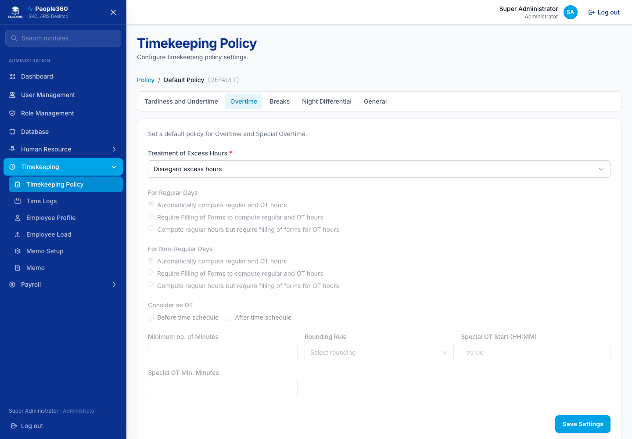
Figure 64. Policy — Overtime screen

Policy — Breaks
Set break rules for this policy, then save. There is no separate employee list on this page.
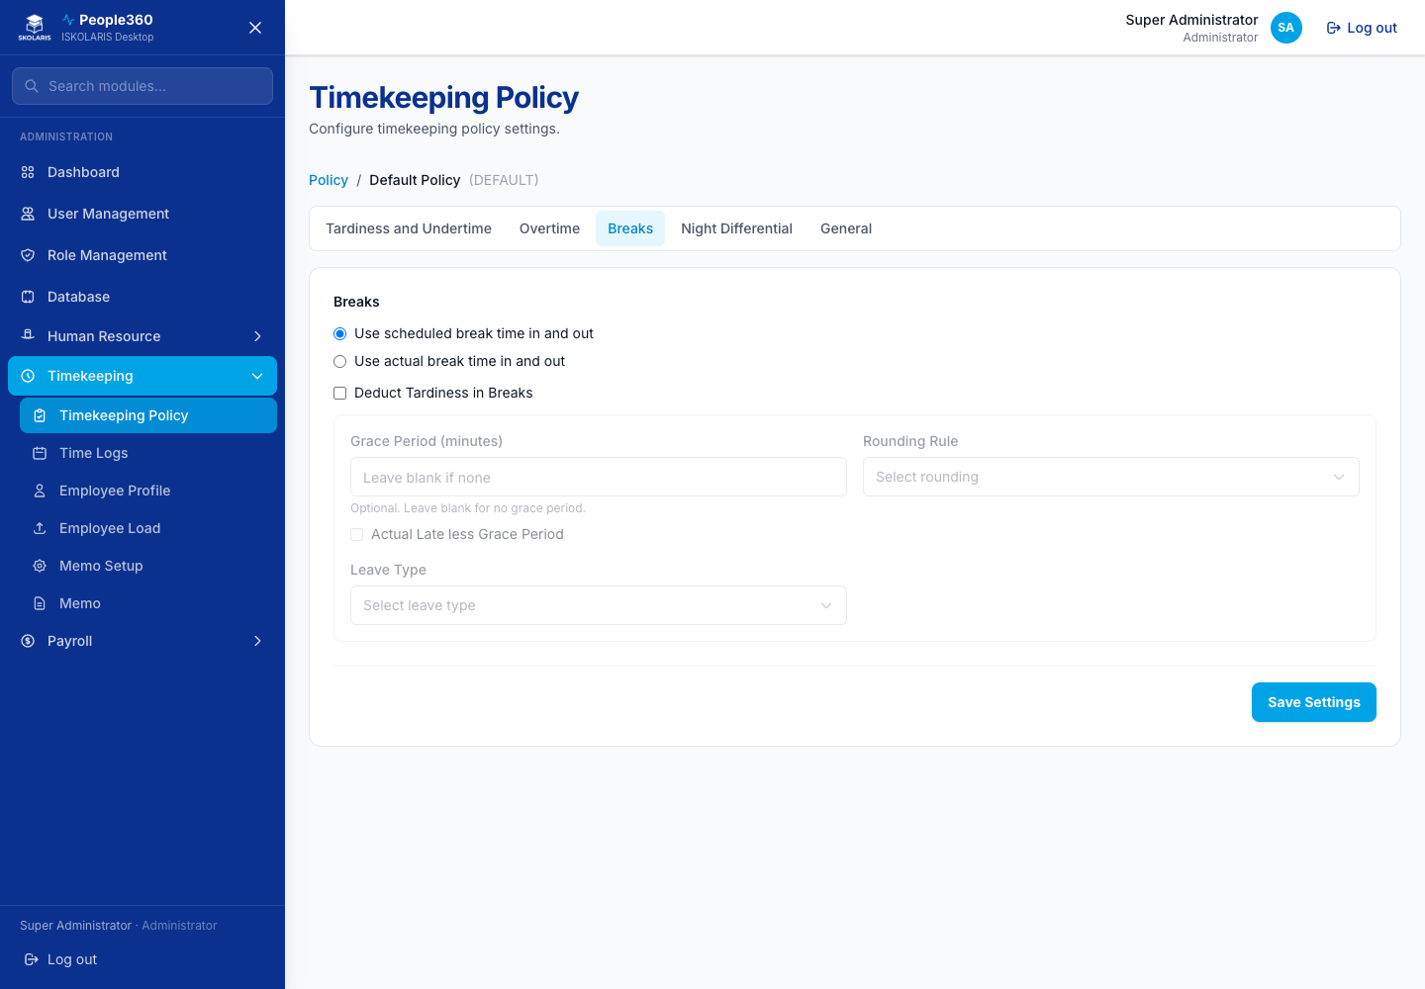
Figure 65. Policy — Breaks screen

Policy — Night Differential
Set night-differential hours for this policy, then save.
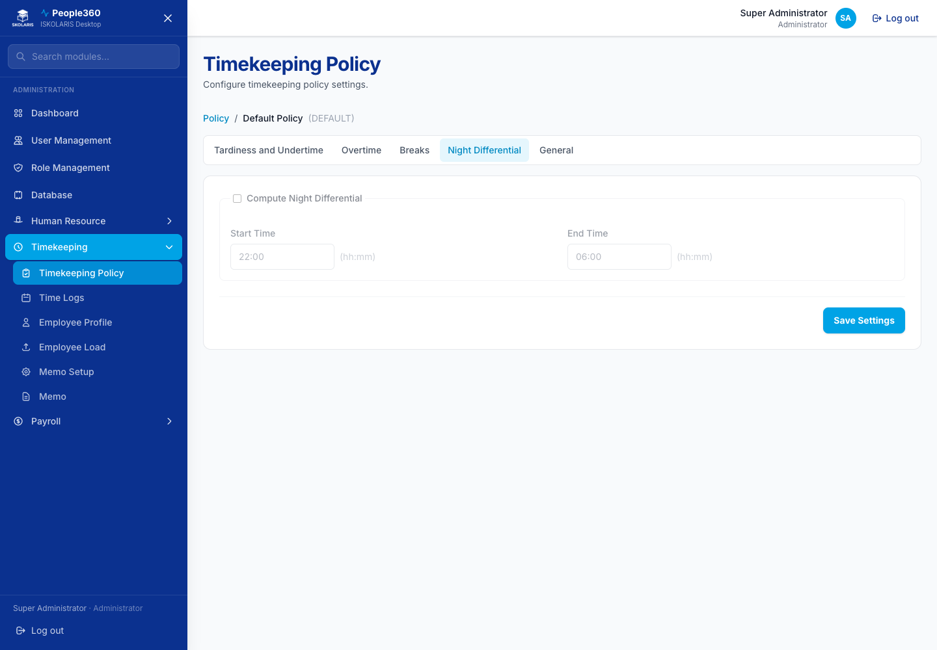
Figure 66. Policy — Night Differential screen

Policy — General
Set the general policy options, then save.
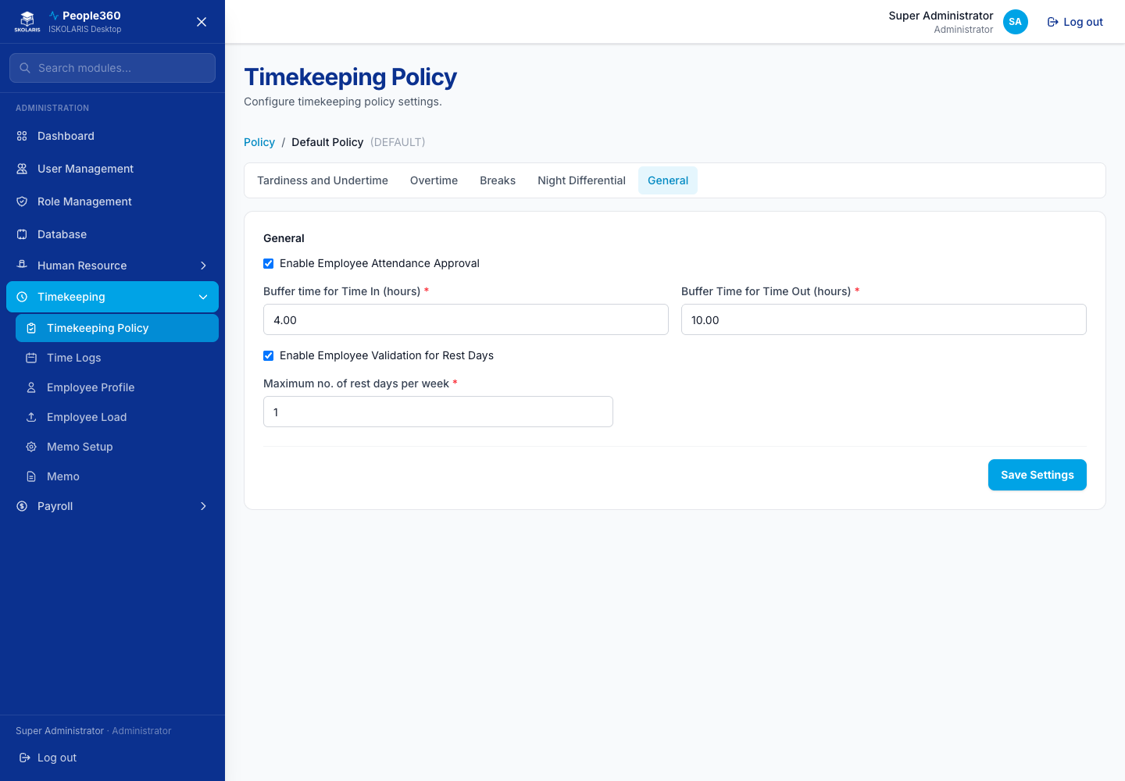
Figure 67. Policy — General screen

Employee Profile
Search the person, then open the row. Setup or Edit is where shift, policy, and timekeeping details are saved. Attendance view shows the punches. Changes here affect payroll computation.
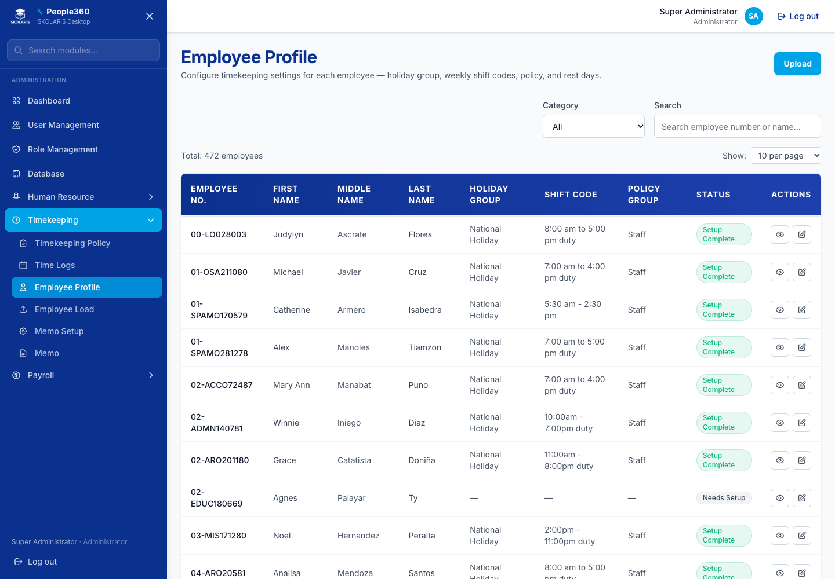
Figure 68. Employee Profile screen

Employee Load
Faculty load used for faculty pay. Upload a file or edit a row. Delete removes a load entry that should not be paid.
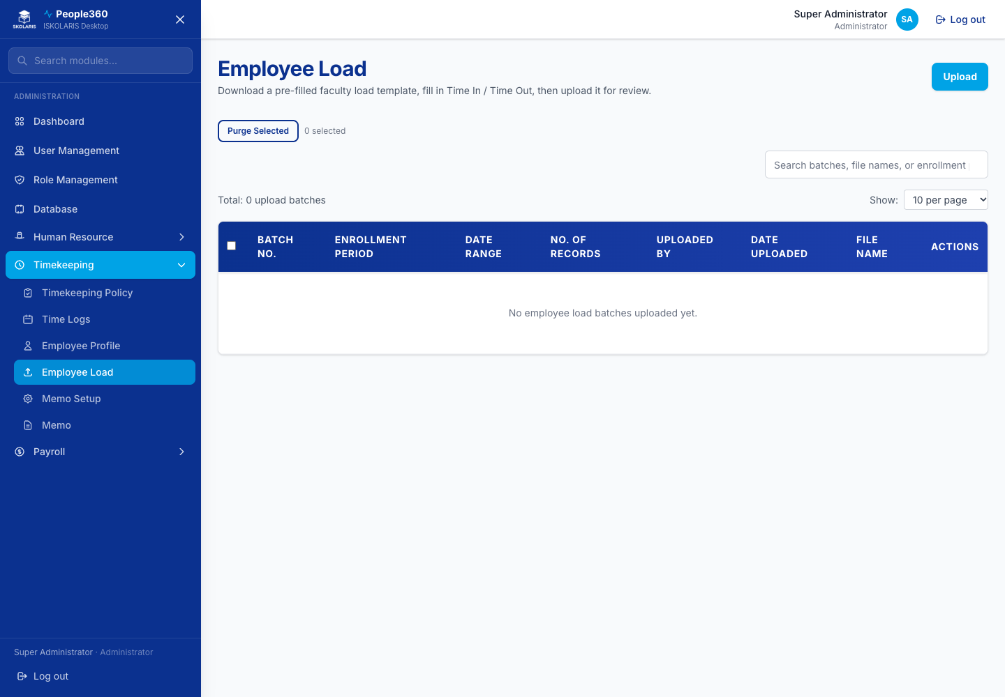
Figure 69. Employee Load screen

Before and after time logs
Do these checks around every pull or upload. They prevent an empty or doubled attendance file from reaching payroll.
1. Before: Pulse Biometric Collector is open on the campus PC and has collected punches for these dates.
2. Before: The date range in People360 matches the pay period, not a wider range than you intend to pay.
3. Before: You know whether this is a new pull or a replacement. A second upload of the same file can duplicate punches if you do not purge the bad batch first.
4. Pull or upload. Wait until the page finishes. Read the result count.
5. After: Open the list and confirm the employees and dates you expect are present.
6. After: Open one person on Employee Profile attendance, or on Time Logs — DTR, and confirm in and out times.
7. After: If the file was wrong, purge or delete that upload batch only. That does not erase the time clock.

Time Logs — Time In/Out
This is where biometric punches from Pulse are pulled in, and where a file can be uploaded. Use the upload or pull action on the page. Purge or delete removes a bad upload batch after you confirm. It does not erase the time clock.
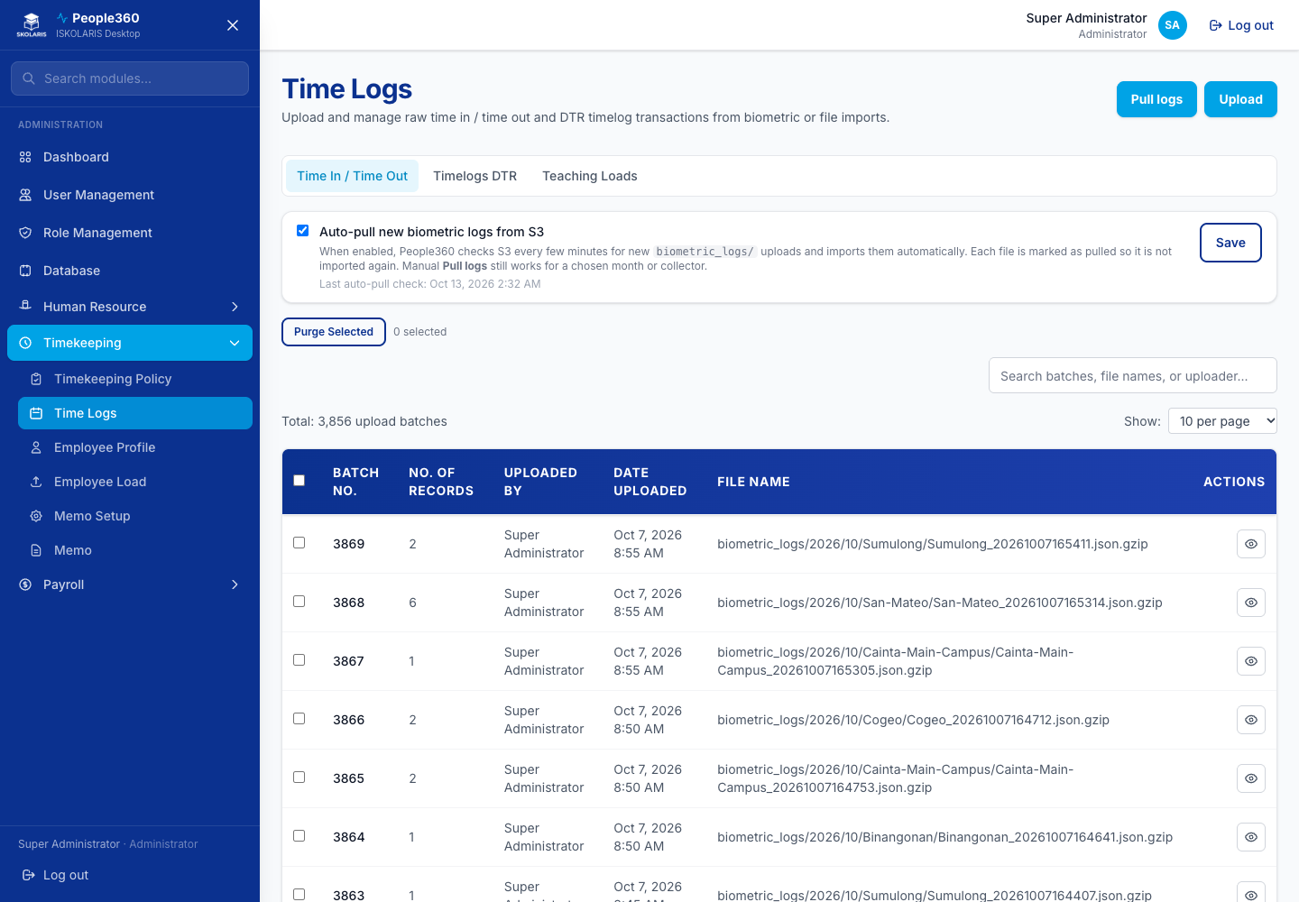
Figure 70. Time Logs — Time In/Out screen

Time Logs — DTR
Daily time record view of the logs already in People360. Filter by person and date. Correct a row only when you are allowed to edit attendance.
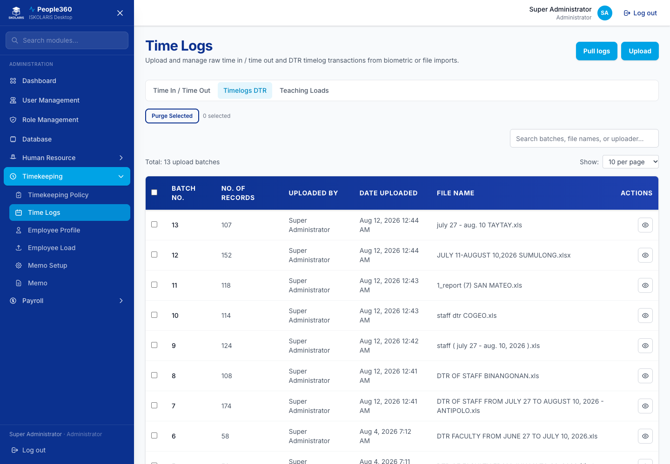
Figure 71. Time Logs — DTR screen

Time Logs — Teaching Loads
Pull faculty teaching loads, or open the uploaded-load list. Delete removes an uploaded load file you do not want to keep, after you confirm.
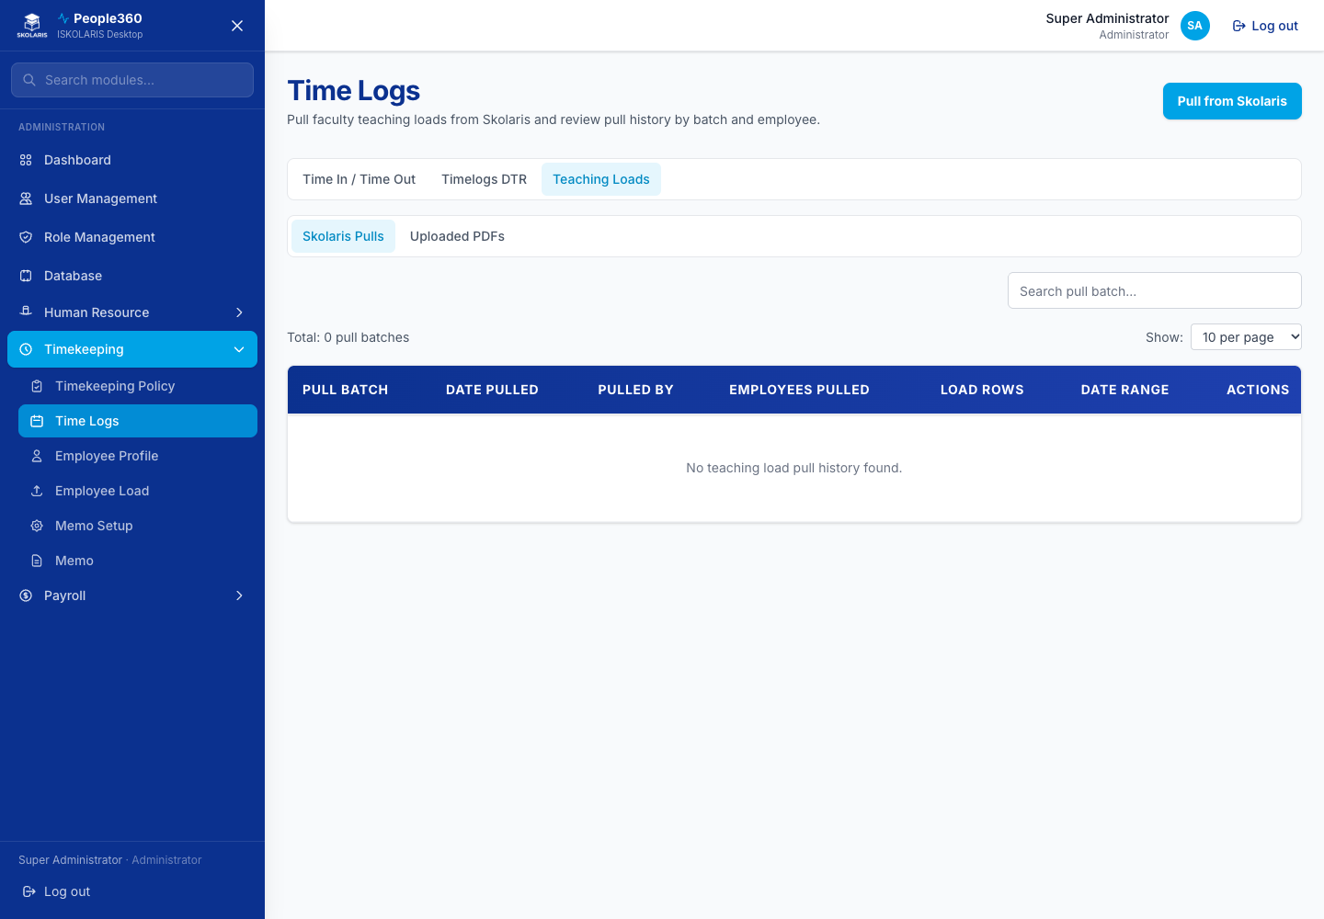
Figure 72. Time Logs — Teaching Loads screen

Part 5 — Payroll Configuration
Day types come before rate groups, because a rate group uses day types. Government tables and the payroll calendar come after the income, deduction, loan, and leave types.

Day Types
Add a day type (regular day, rest day, holiday, and so on). Edit changes the name or pay treatment. Delete removes a type that is not used on a rate group.
Use the common Add, Edit, Inactive, and Delete steps in Part 1. This section only adds what is specific to this list.
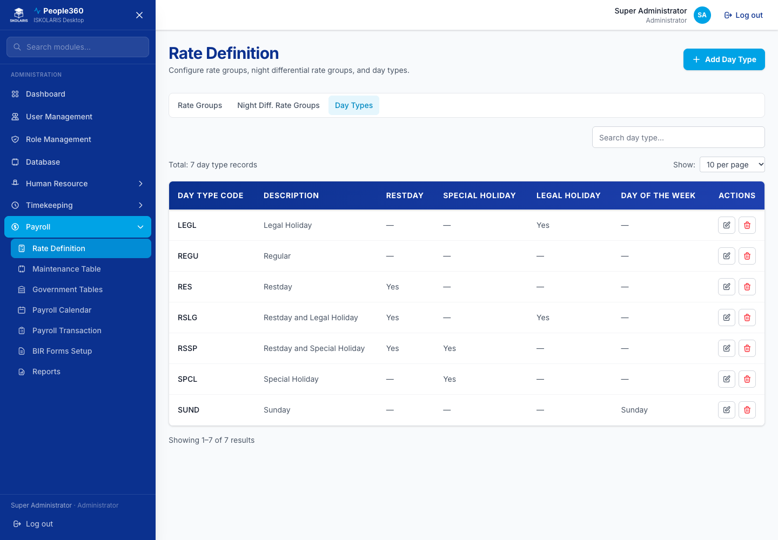
Figure 73. Day Types screen
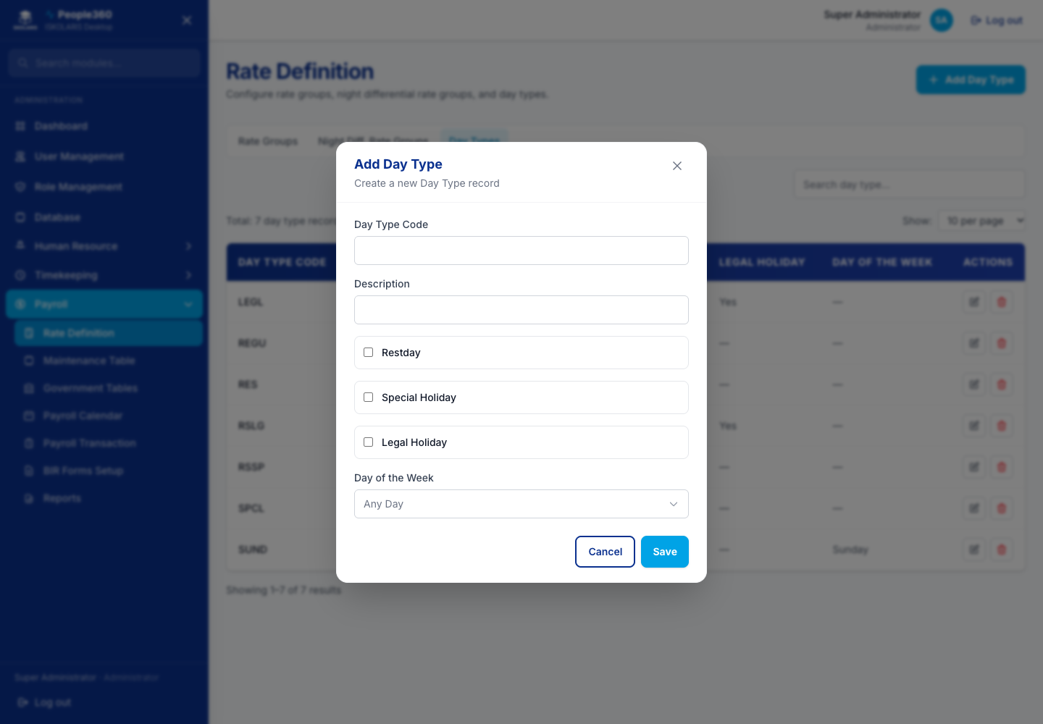
Figure 74. Day Types — Add window. Use the blue Add button, then save in this window.
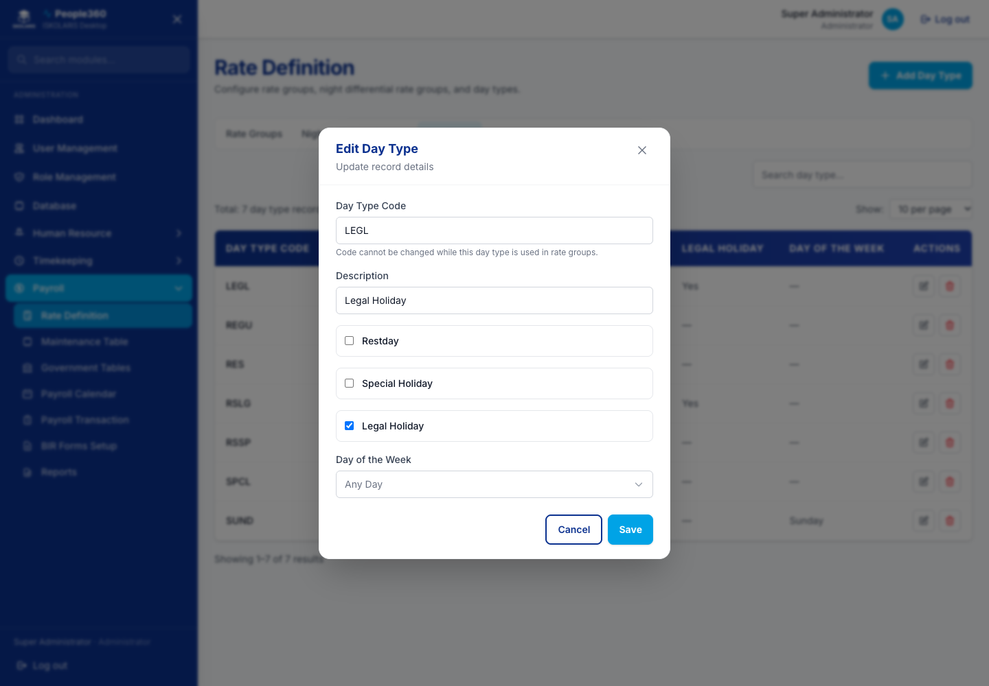
Figure 75. Day Types — Edit window. Open it with the pencil on the row.

Rate Groups
Add a rate group and the day-type rates inside it. Edit changes the rates. Delete removes a group that no salary uses. If a salary still points at it, do not delete it.
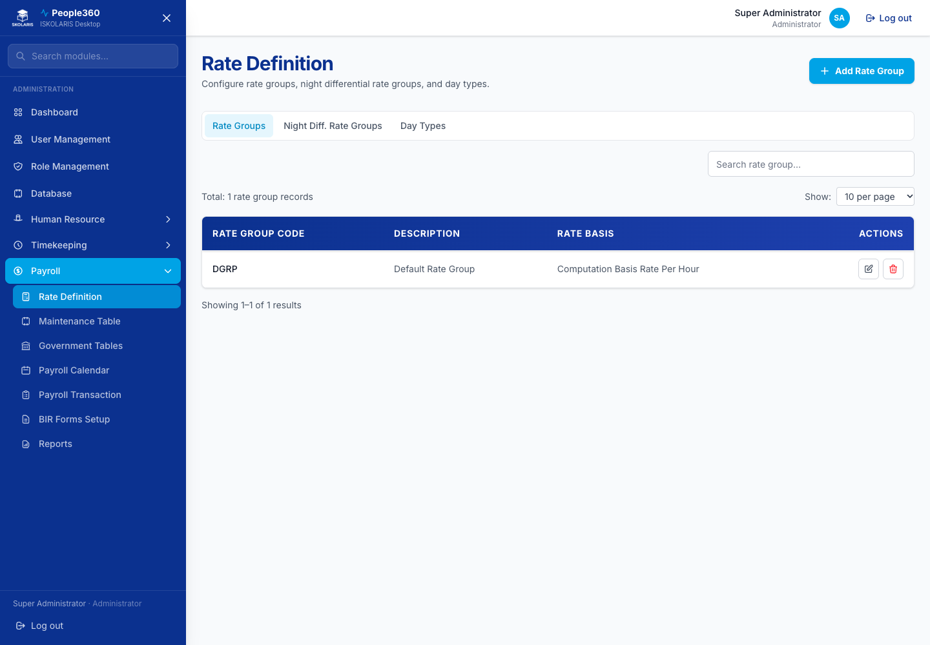
Figure 76. Rate Groups screen
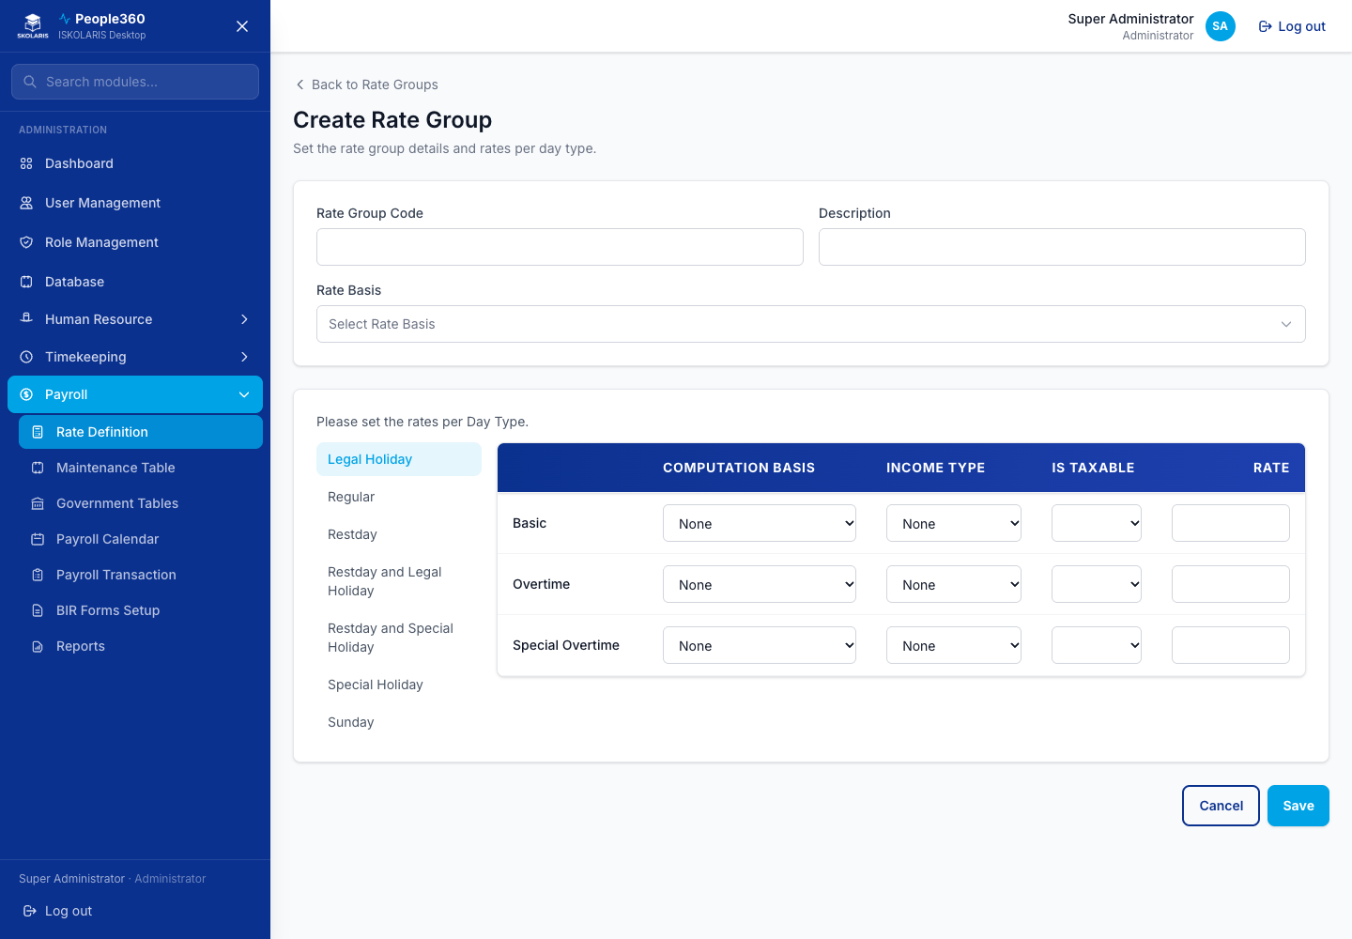
Figure 77. Rate Groups — Add window. Use the blue Add button, then save in this window.
Delete, when shown, is the red trash on the row. Read the question. Confirm only when this row should be removed. Leave a row Inactive when history must be kept.

Night Differential Rate Groups
Same as rate groups, for night differential. Add, edit, then delete only when nothing uses the group.
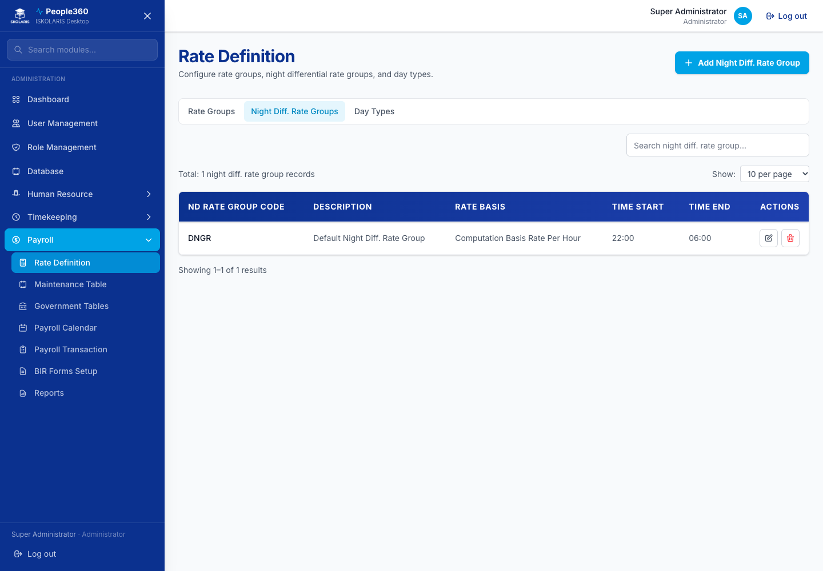
Figure 78. Night Differential Rate Groups screen
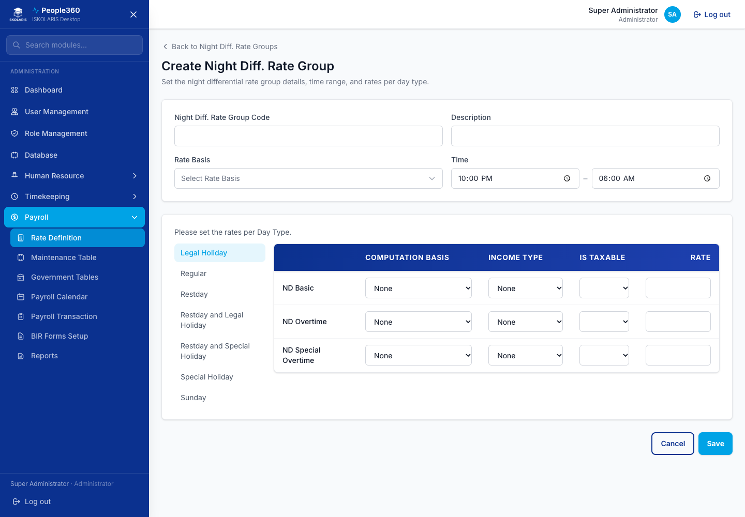
Figure 79. Night Differential Rate Groups — Add window. Use the blue Add button, then save in this window.
Delete, when shown, is the red trash on the row. Read the question. Confirm only when this row should be removed. Leave a row Inactive when history must be kept.

Income Types
Add an income (allowance, bonus, and similar). Edit changes it. Turn it inactive when you should stop using it. Delete is for an inactive type that no payroll still needs.
Use the common Add, Edit, Inactive, and Delete steps in Part 1. This section only adds what is specific to this list.
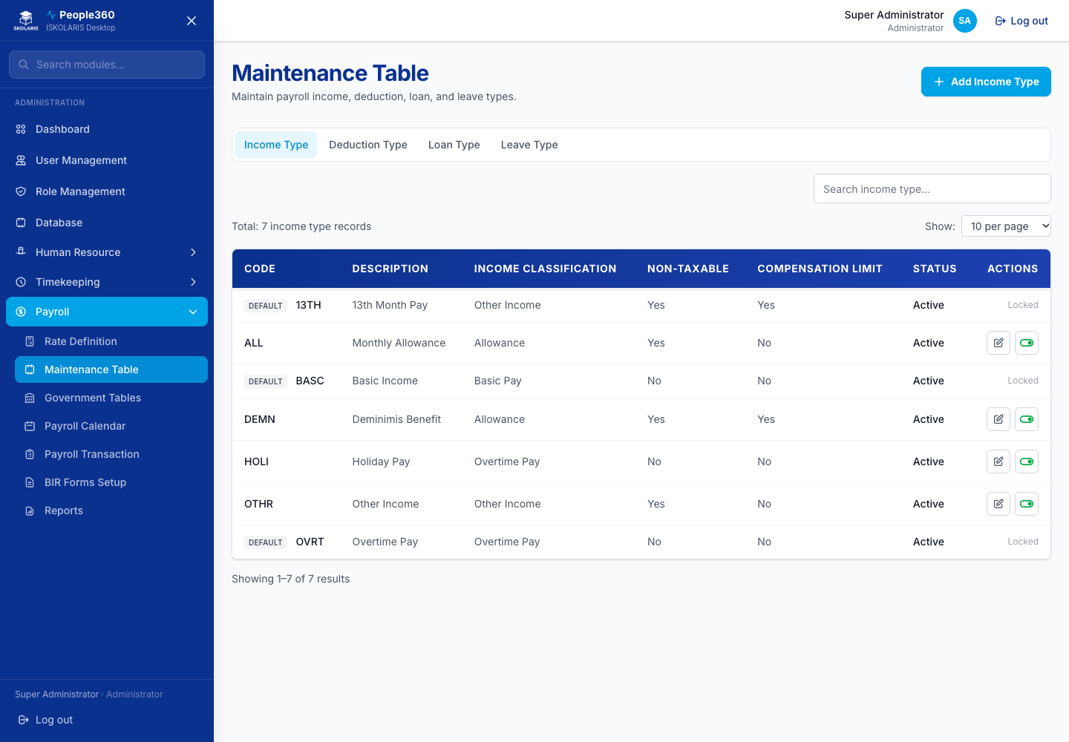
Figure 80. Income Types screen
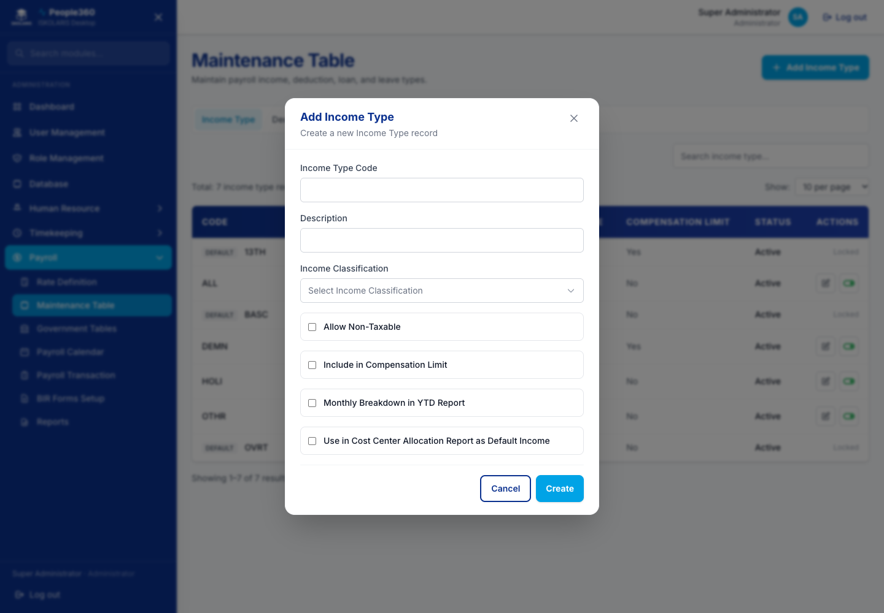
Figure 81. Income Types — Add window. Use the blue Add button, then save in this window.
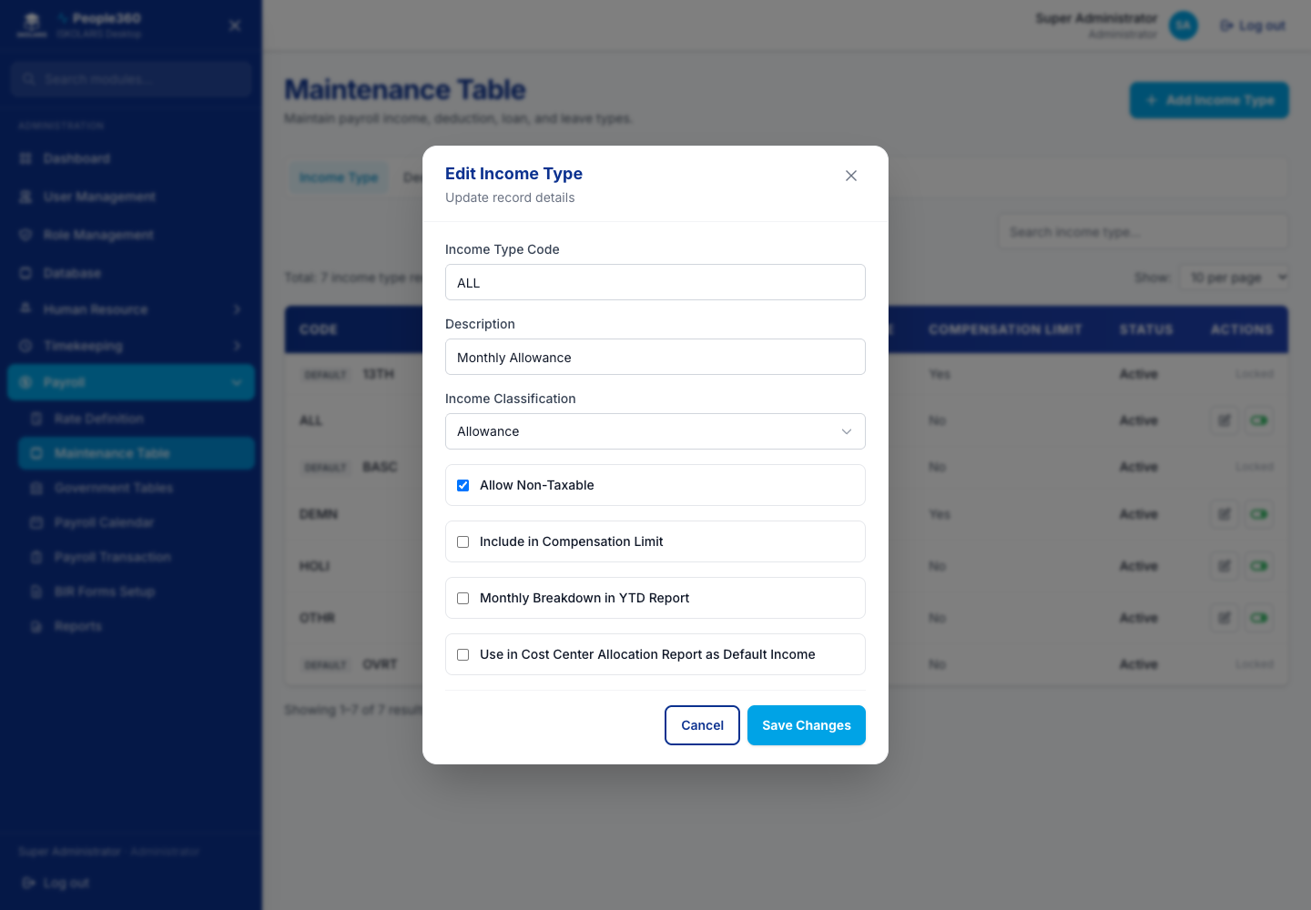
Figure 82. Income Types — Edit window. Open it with the pencil on the row.

Deduction Types
Add a deduction. Edit changes it. Inactive first, then delete only if it is unused.
Use the common Add, Edit, Inactive, and Delete steps in Part 1. This section only adds what is specific to this list.
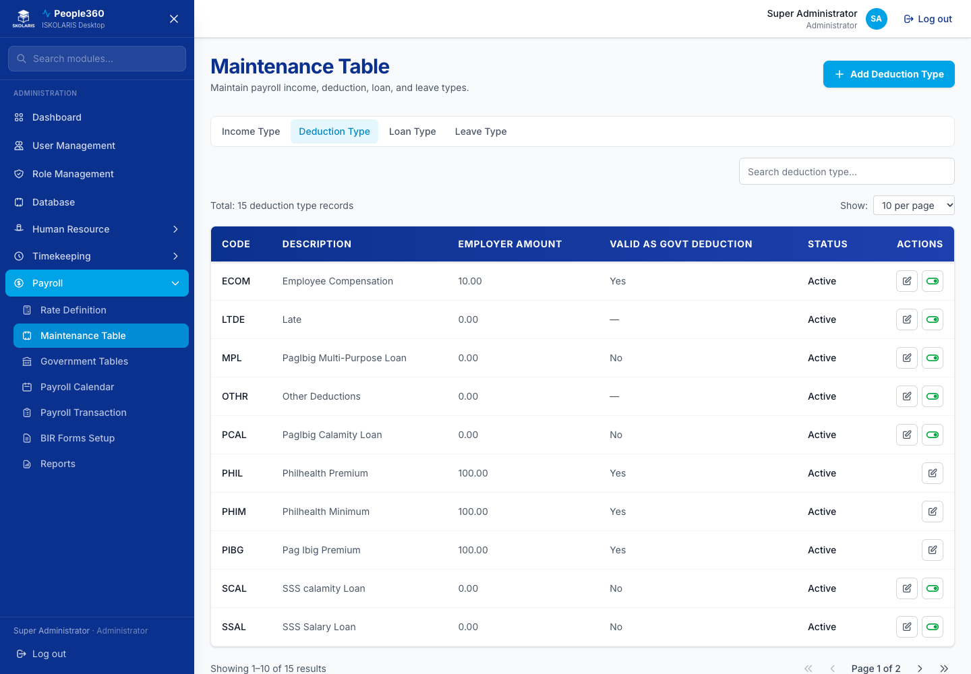
Figure 83. Deduction Types screen
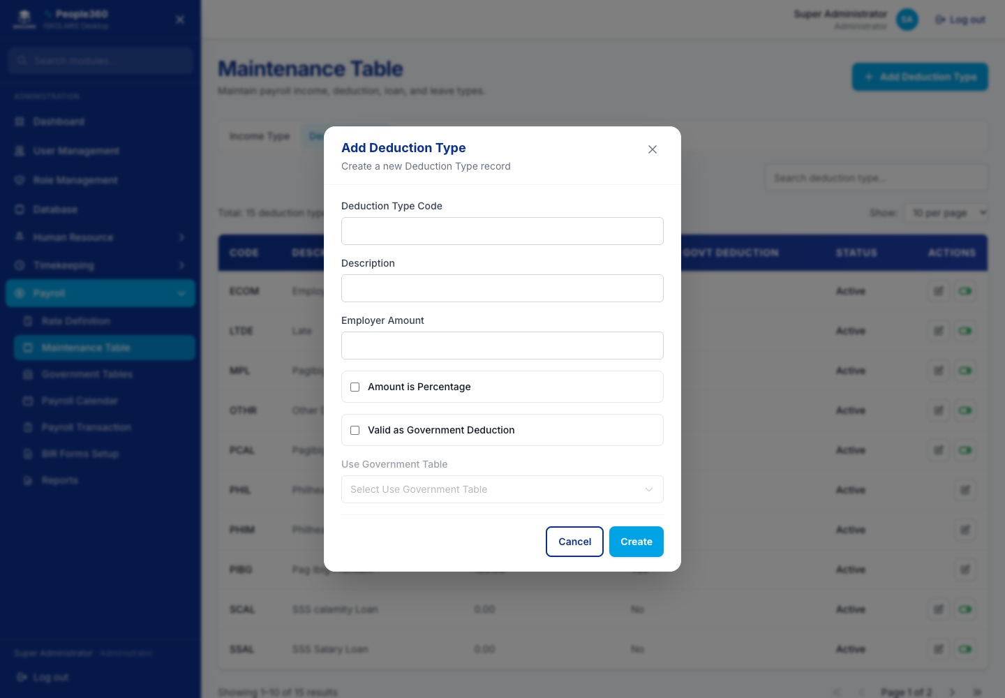
Figure 84. Deduction Types — Add window. Use the blue Add button, then save in this window.
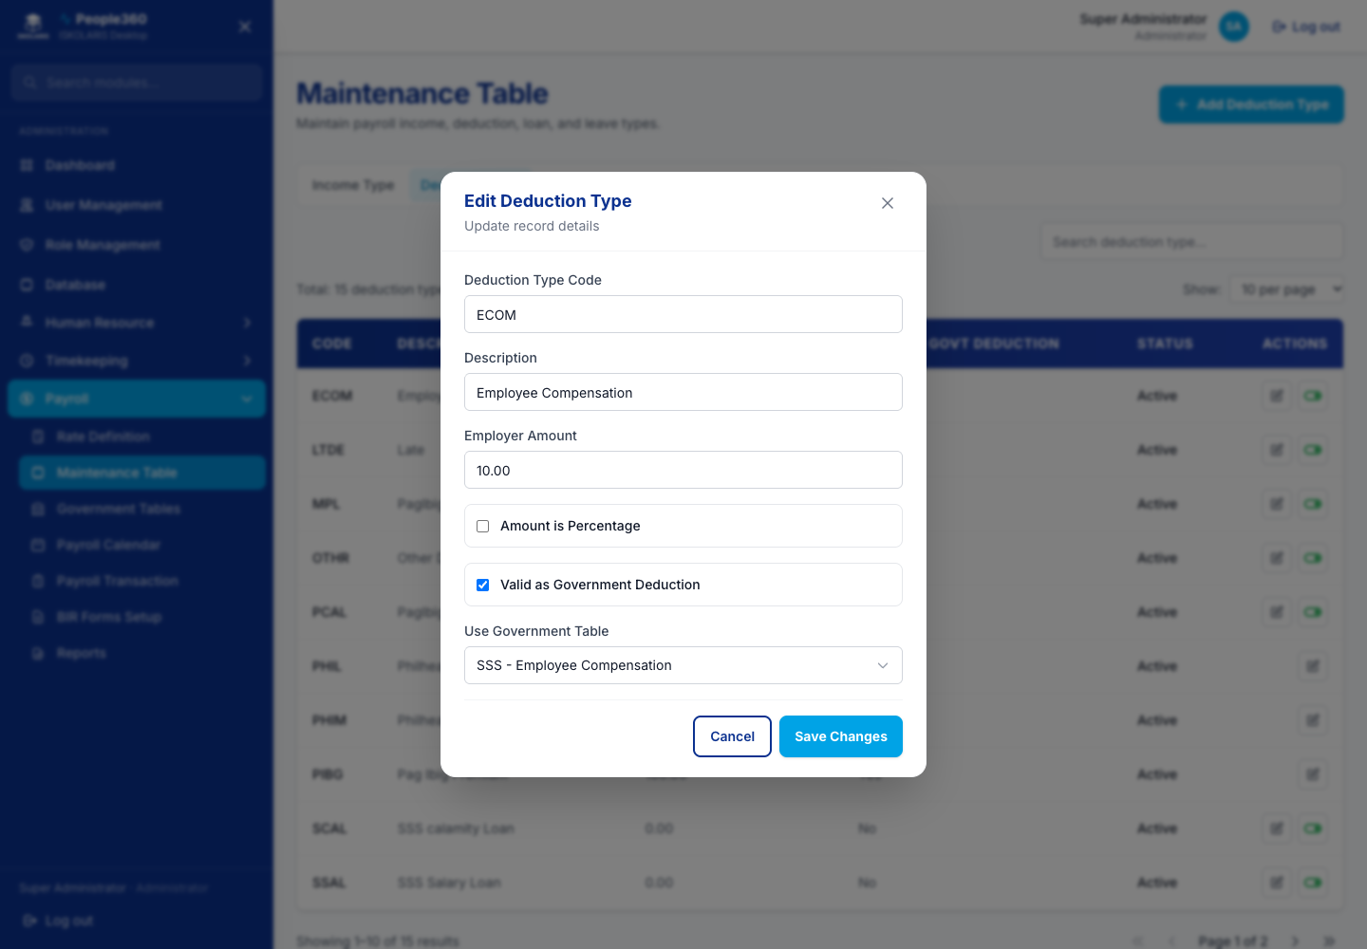
Figure 85. Deduction Types — Edit window. Open it with the pencil on the row.

Loan Types
Add a loan type. Edit changes it. Inactive first, then delete only if it is unused.
Use the common Add, Edit, Inactive, and Delete steps in Part 1. This section only adds what is specific to this list.
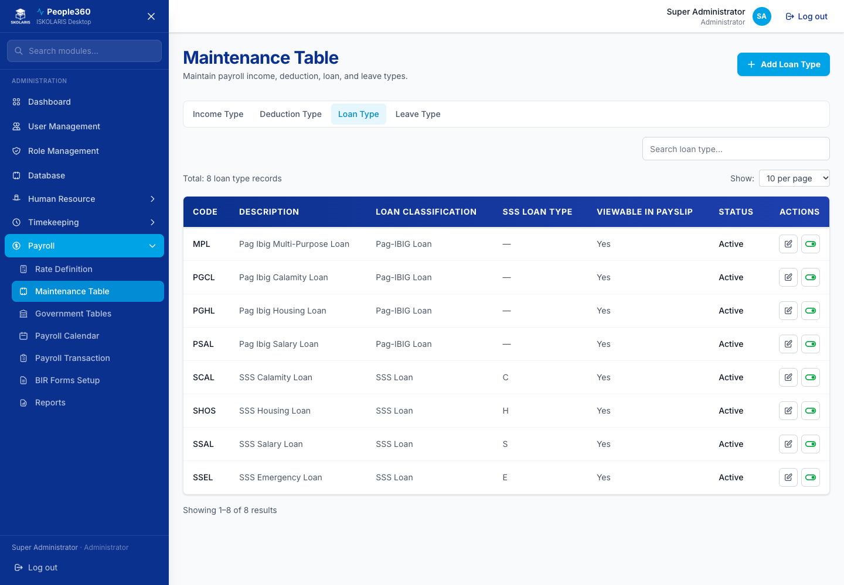
Figure 86. Loan Types screen
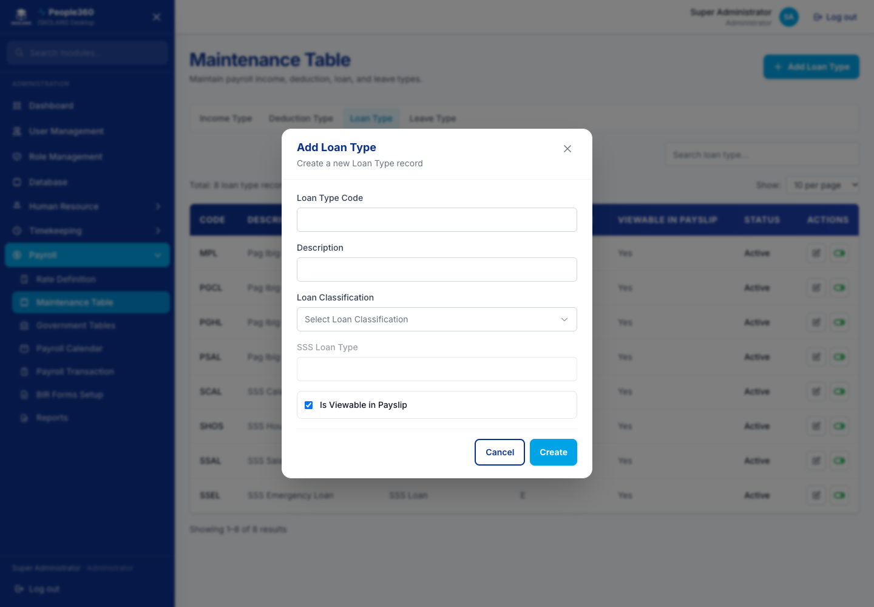
Figure 87. Loan Types — Add window. Use the blue Add button, then save in this window.
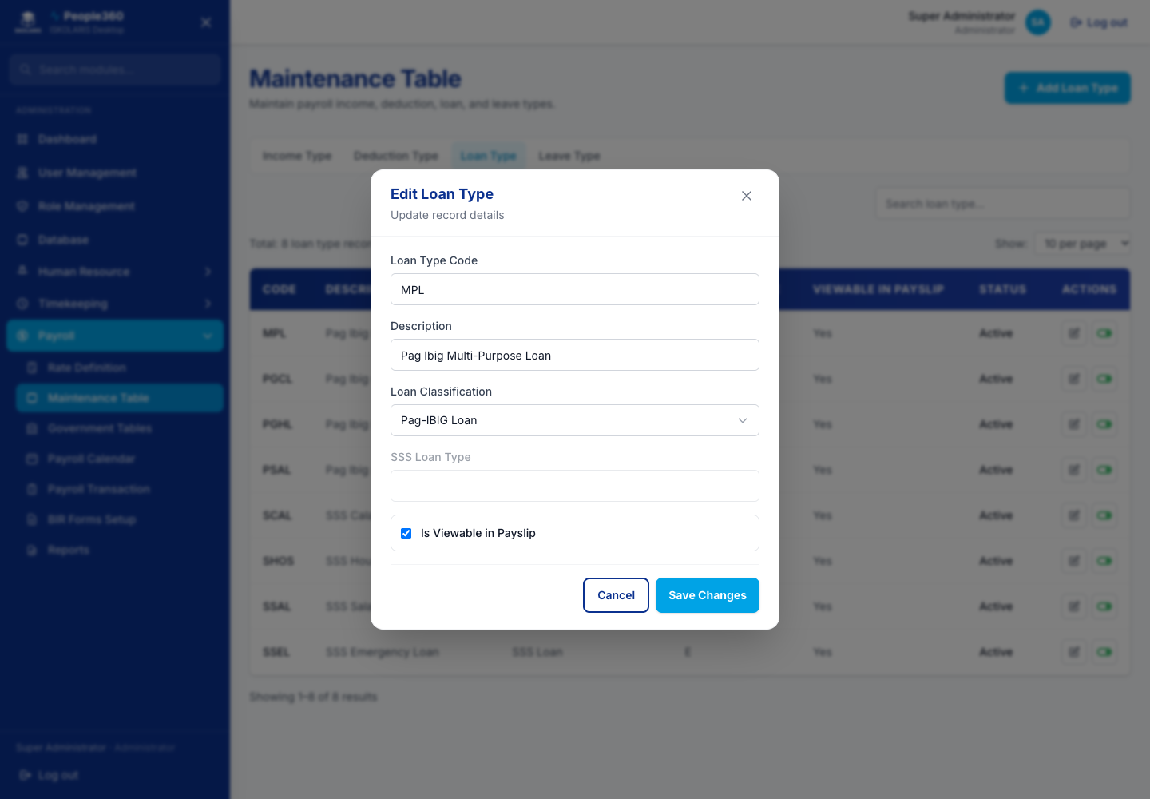
Figure 88. Loan Types — Edit window. Open it with the pencil on the row.

Leave Types
Add a leave type. Edit changes it. Inactive first, then delete only if it is unused.
Use the common Add, Edit, Inactive, and Delete steps in Part 1. This section only adds what is specific to this list.
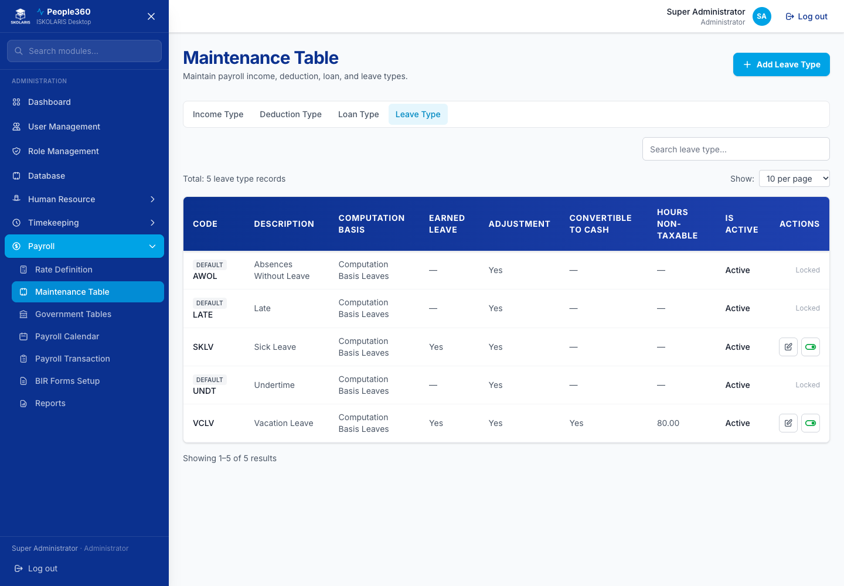
Figure 89. Leave Types screen
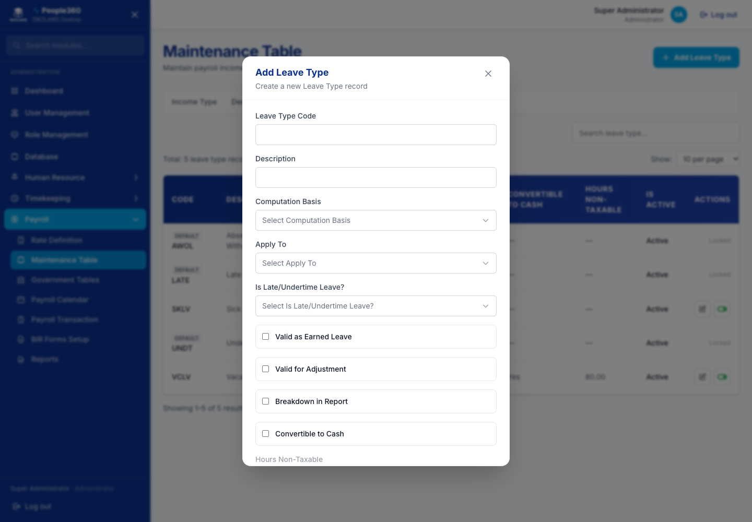
Figure 90. Leave Types — Add window. Use the blue Add button, then save in this window.
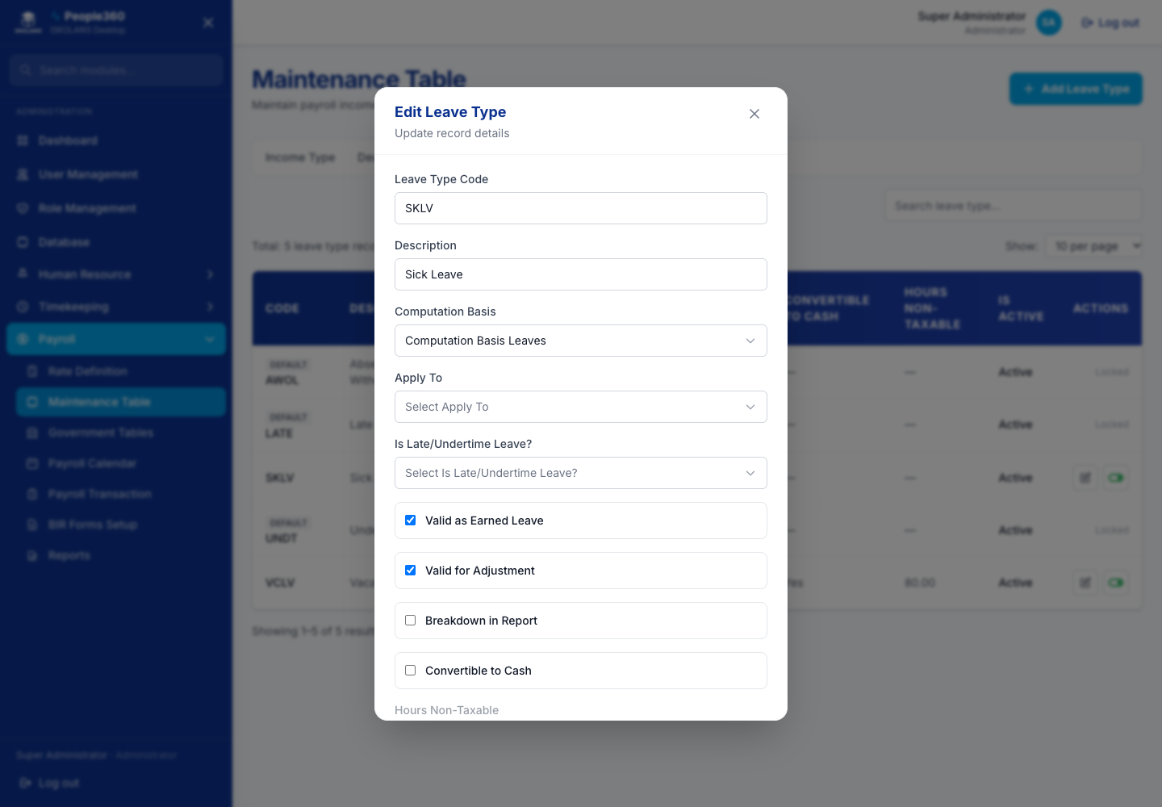
Figure 91. Leave Types — Edit window. Open it with the pencil on the row.

Pag-IBIG
Add or edit a contribution row when the official table changes. Delete only a wrong inactive row. Do not delete the current official row.
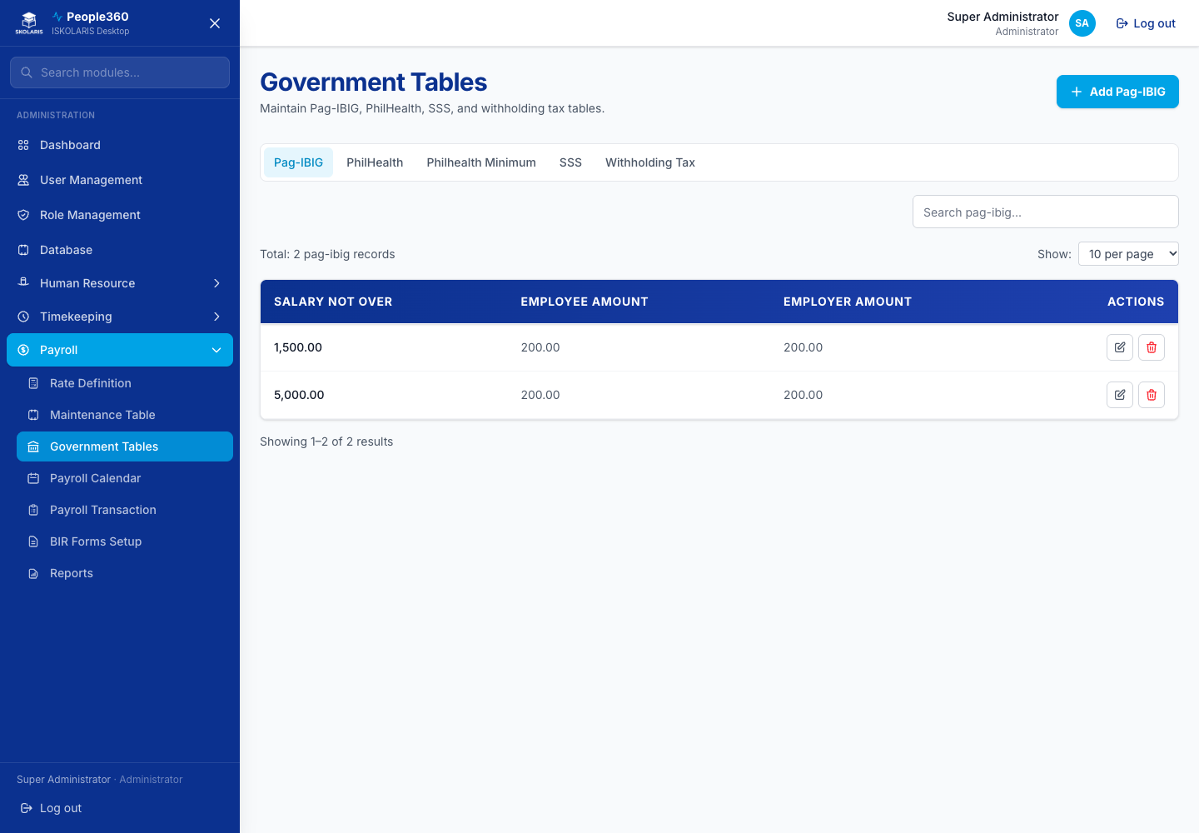
Figure 92. Pag-IBIG screen
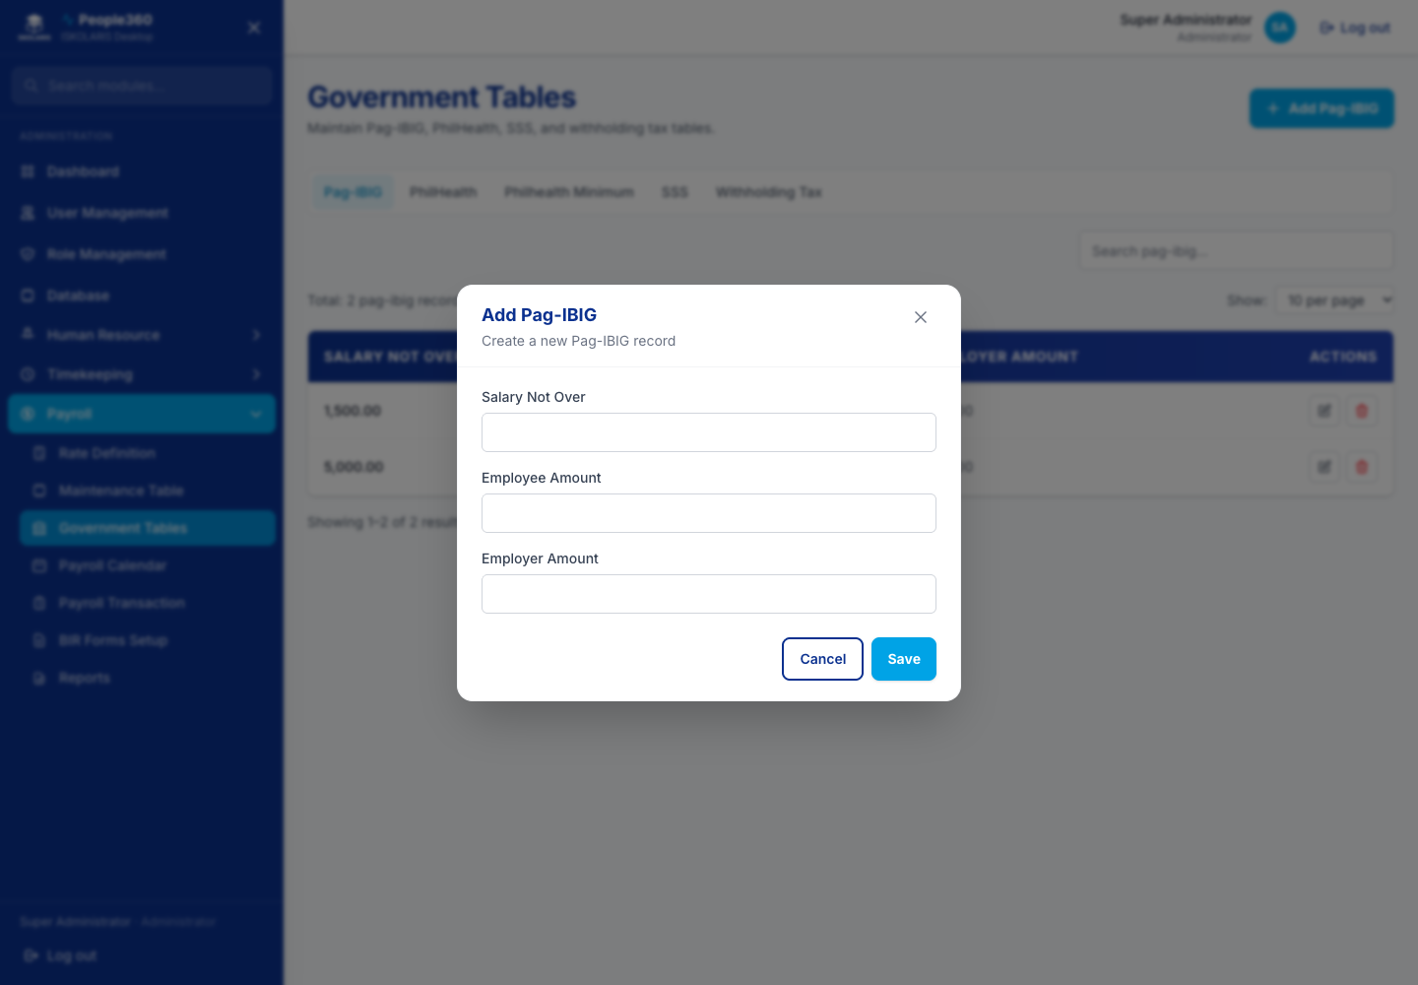
Figure 93. Pag-IBIG — Add window. Use the blue Add button, then save in this window.
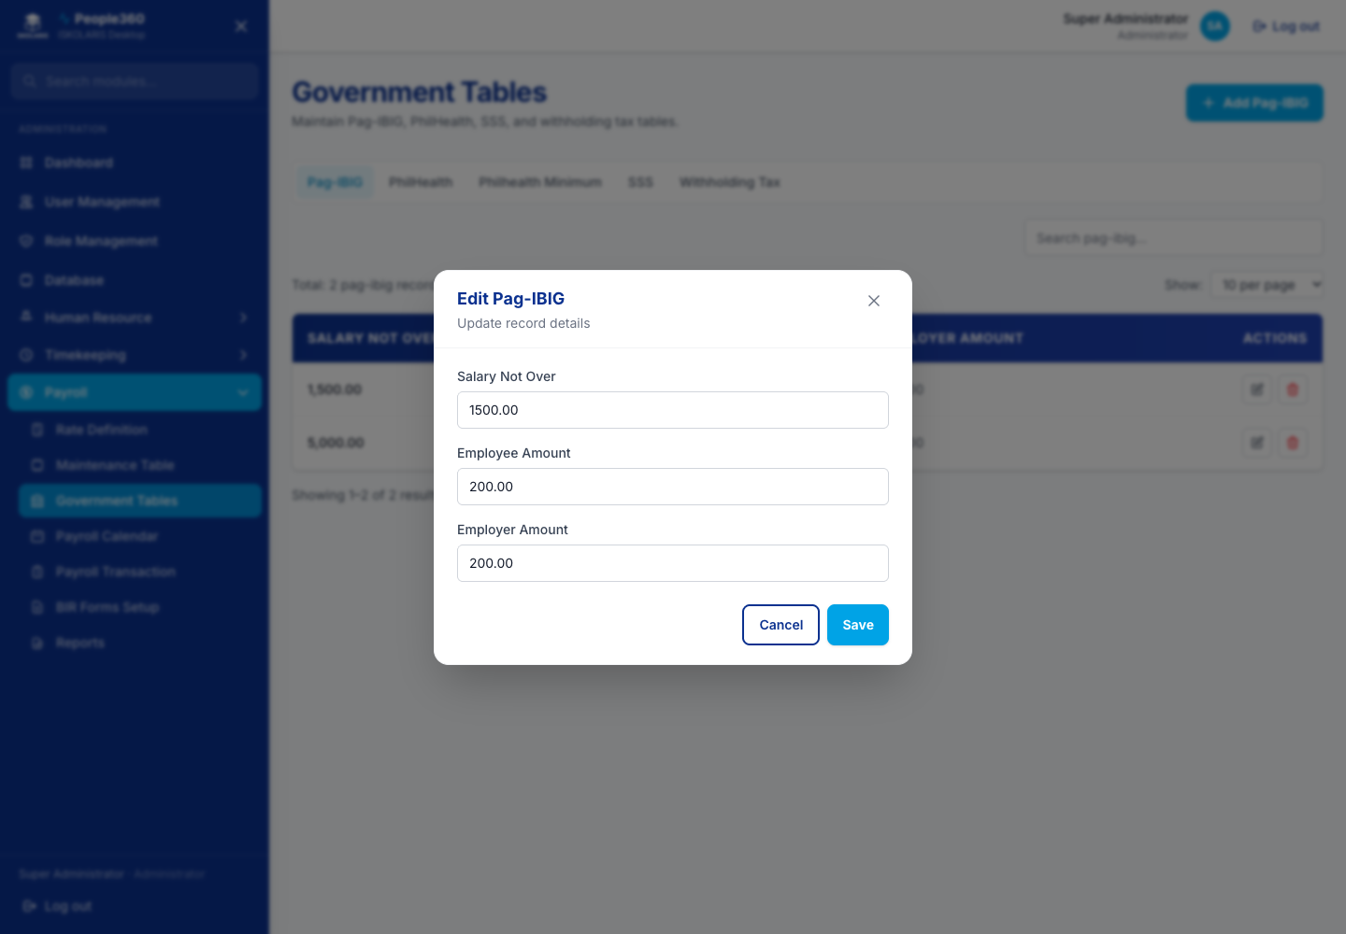
Figure 94. Pag-IBIG — Edit window. Open it with the pencil on the row.
Delete, when shown, is the red trash on the row. Read the question. Confirm only when this row should be removed. Leave a row Inactive when history must be kept.

PhilHealth
Add or edit a contribution bracket. Delete only a wrong inactive row.
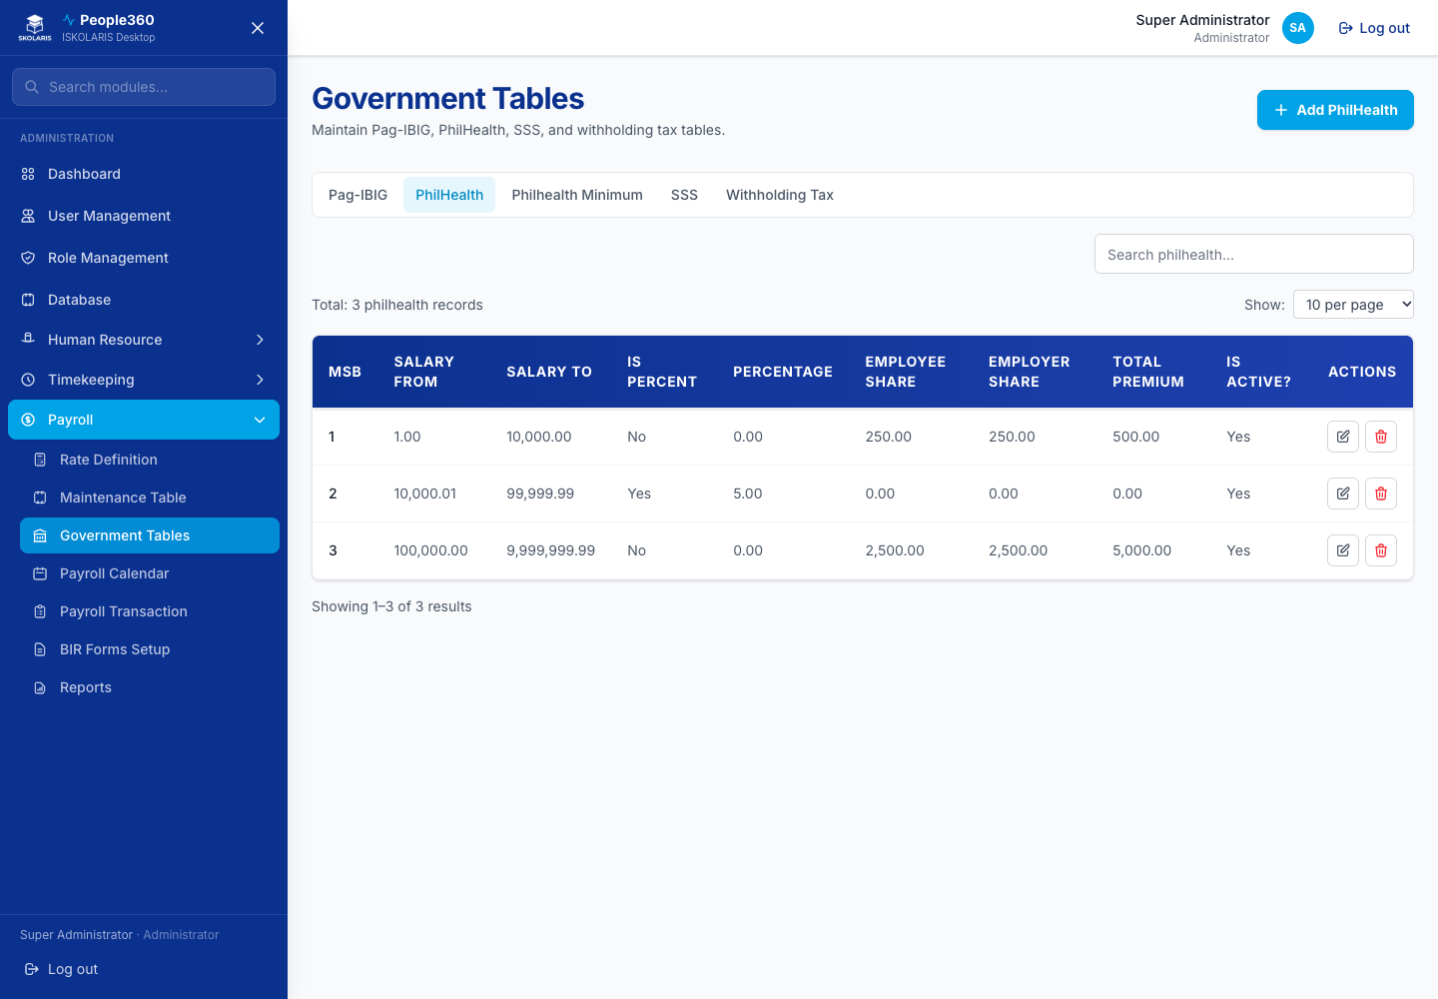
Figure 95. PhilHealth screen
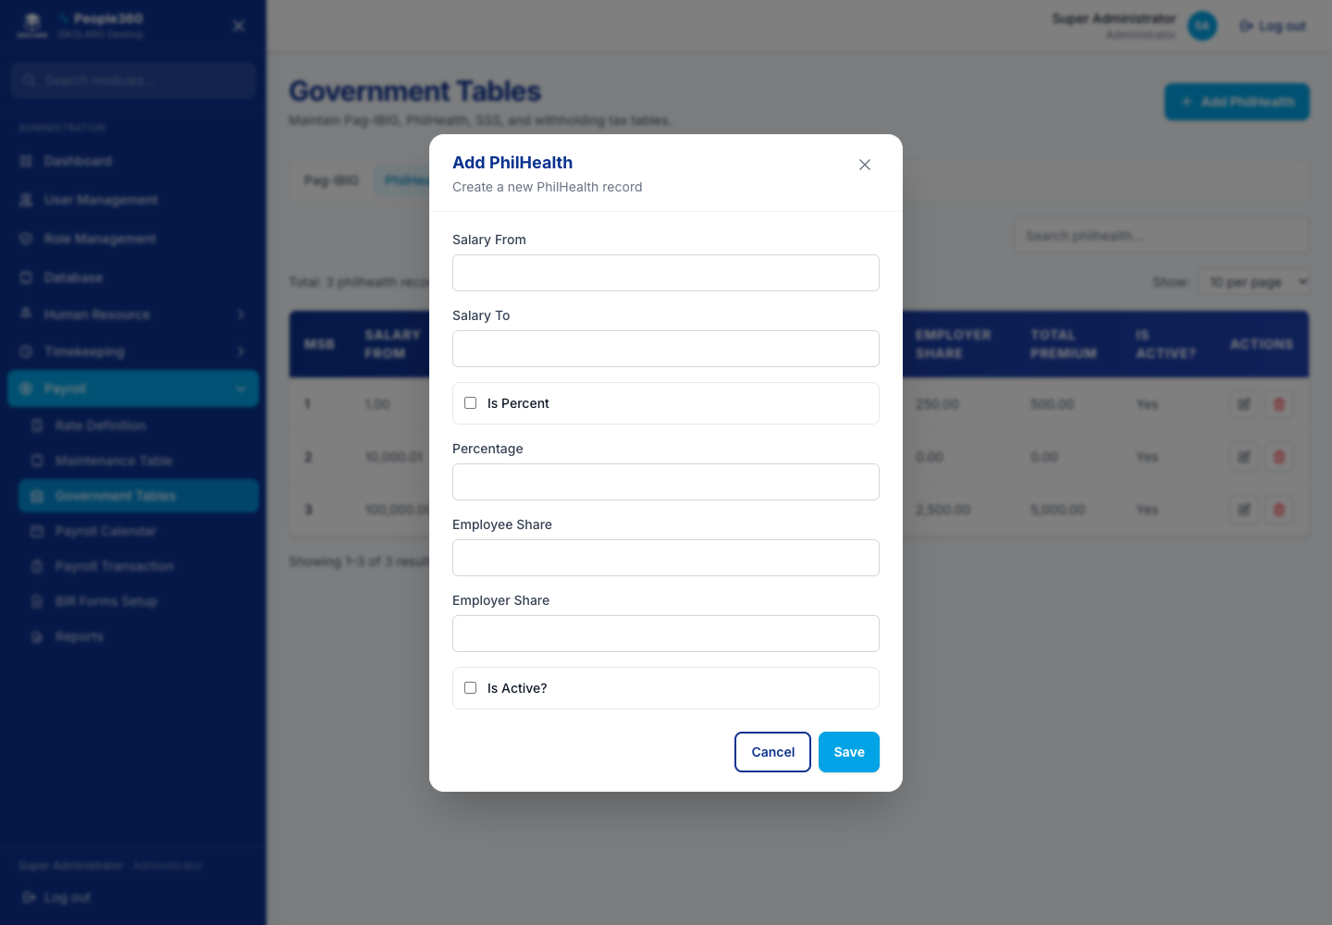
Figure 96. PhilHealth — Add window. Use the blue Add button, then save in this window.
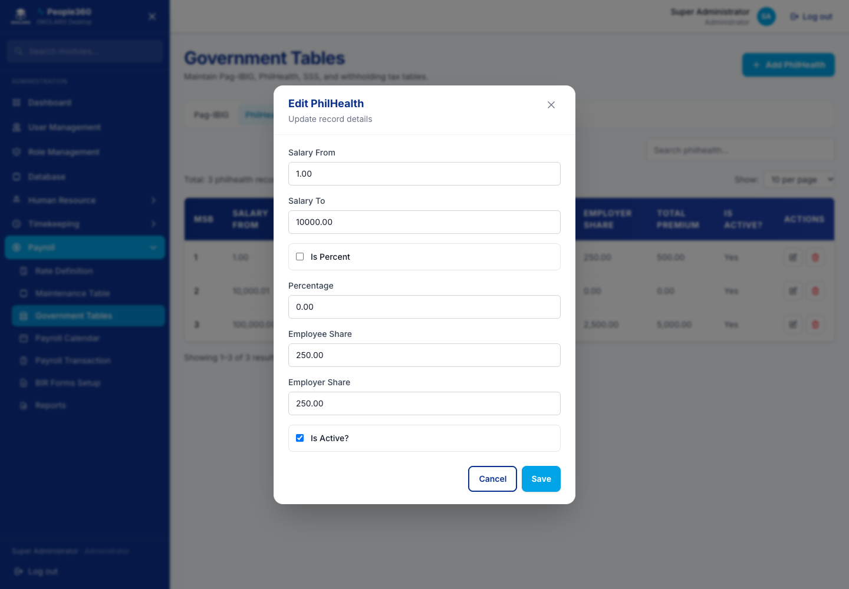
Figure 97. PhilHealth — Edit window. Open it with the pencil on the row.
Delete, when shown, is the red trash on the row. Read the question. Confirm only when this row should be removed. Leave a row Inactive when history must be kept.

PhilHealth Minimum
Edit the minimum table when the official amount changes. Save. Do not delete the live row.
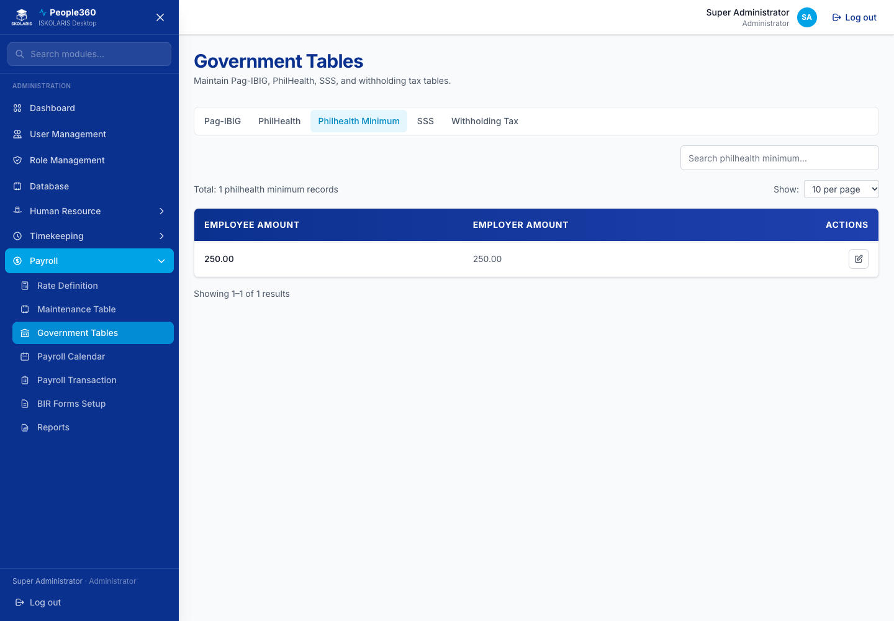
Figure 98. PhilHealth Minimum screen
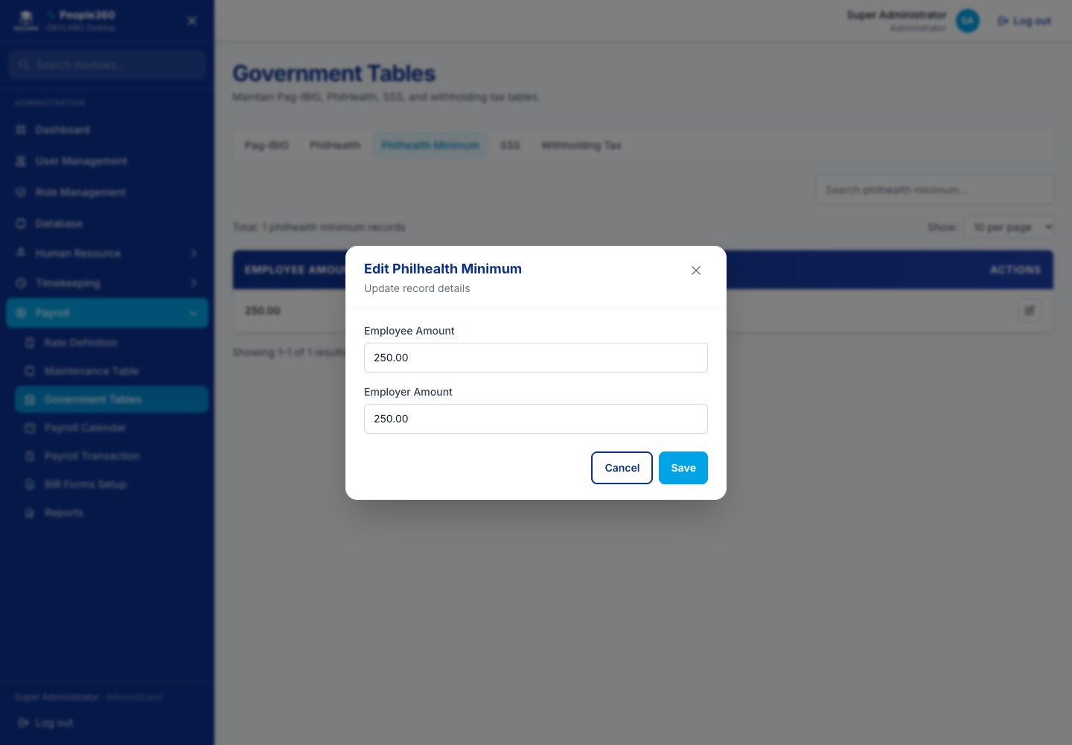
Figure 99. PhilHealth Minimum — Edit window. Open it with the pencil on the row.

SSS
Add or edit an SSS bracket. Delete only a wrong inactive row.
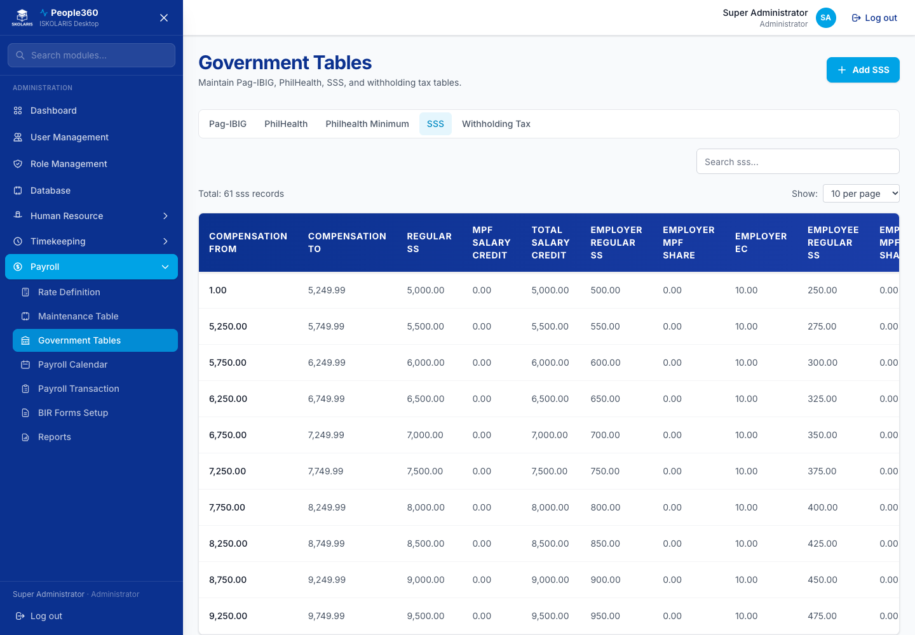
Figure 100. SSS screen
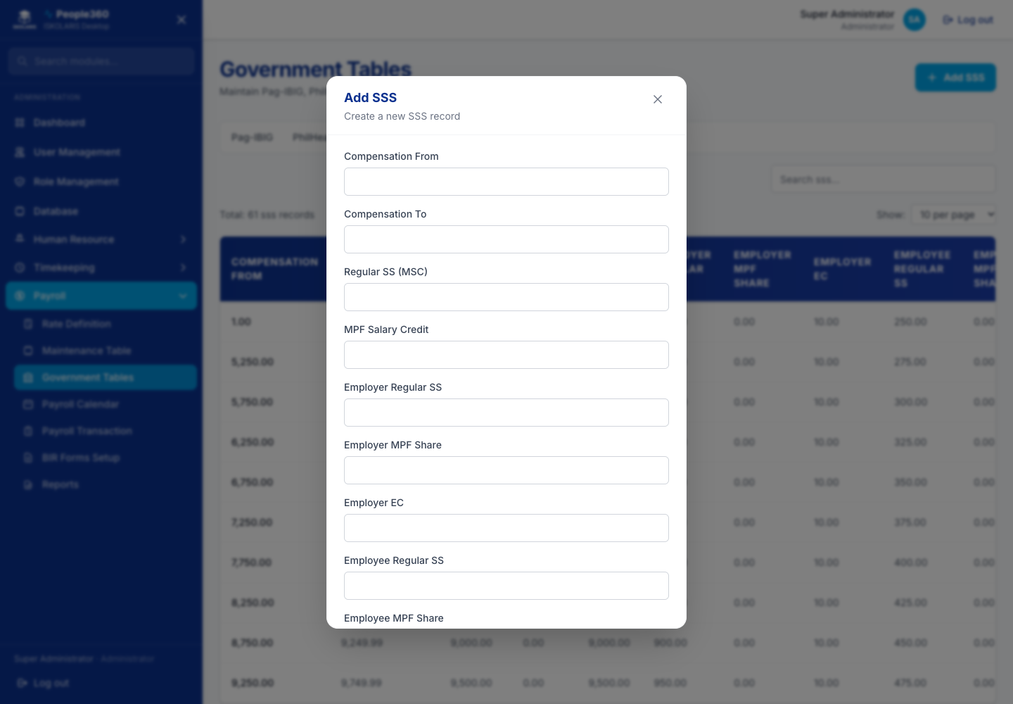
Figure 101. SSS — Add window. Use the blue Add button, then save in this window.
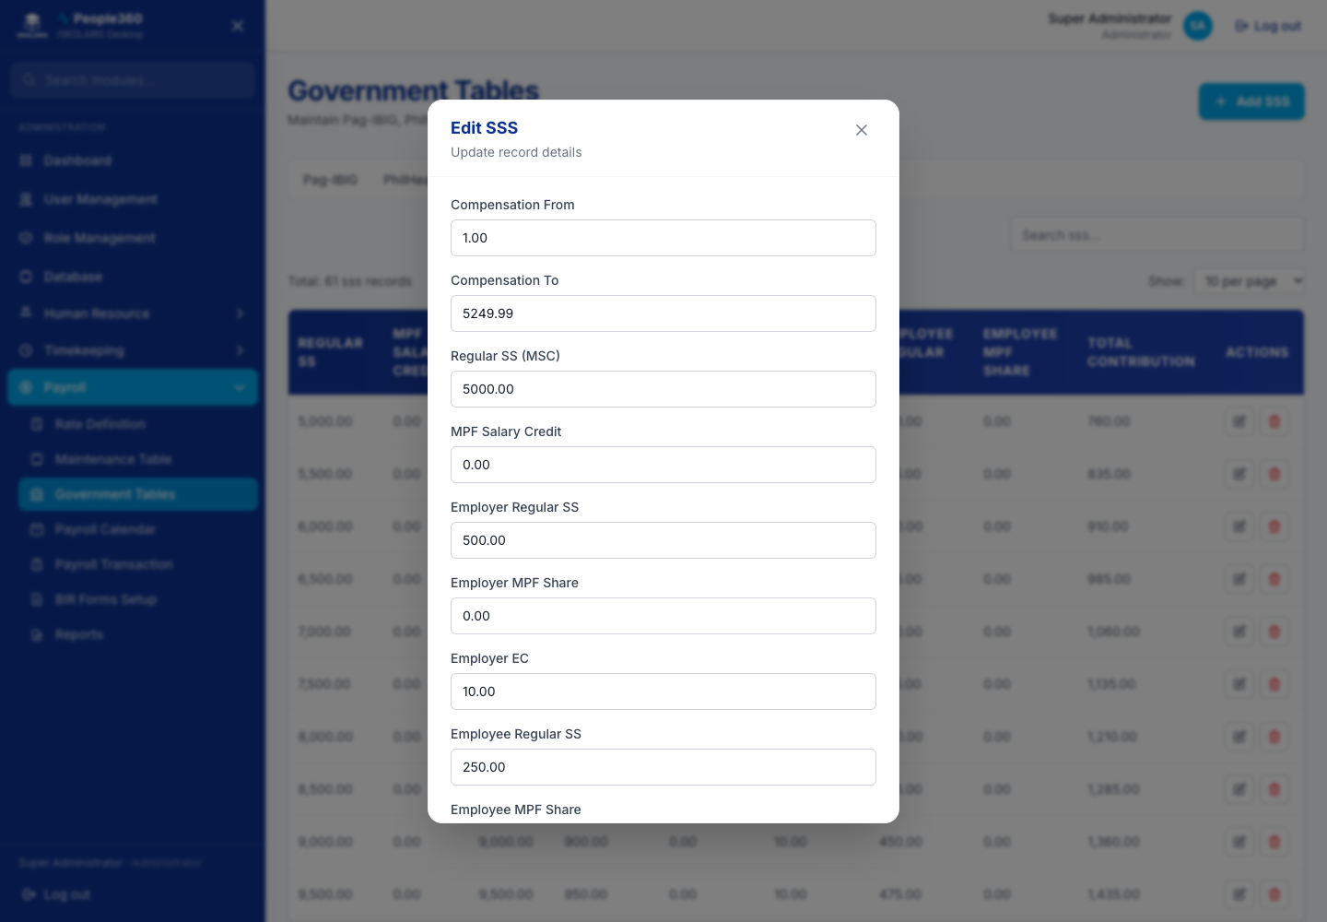
Figure 102. SSS — Edit window. Open it with the pencil on the row.
Delete, when shown, is the red trash on the row. Read the question. Confirm only when this row should be removed. Leave a row Inactive when history must be kept.

Withholding Tax
Open the frequency (daily, weekly, semi-monthly, monthly, or annual) and edit the official BIR table. Save. Do not delete the current table.
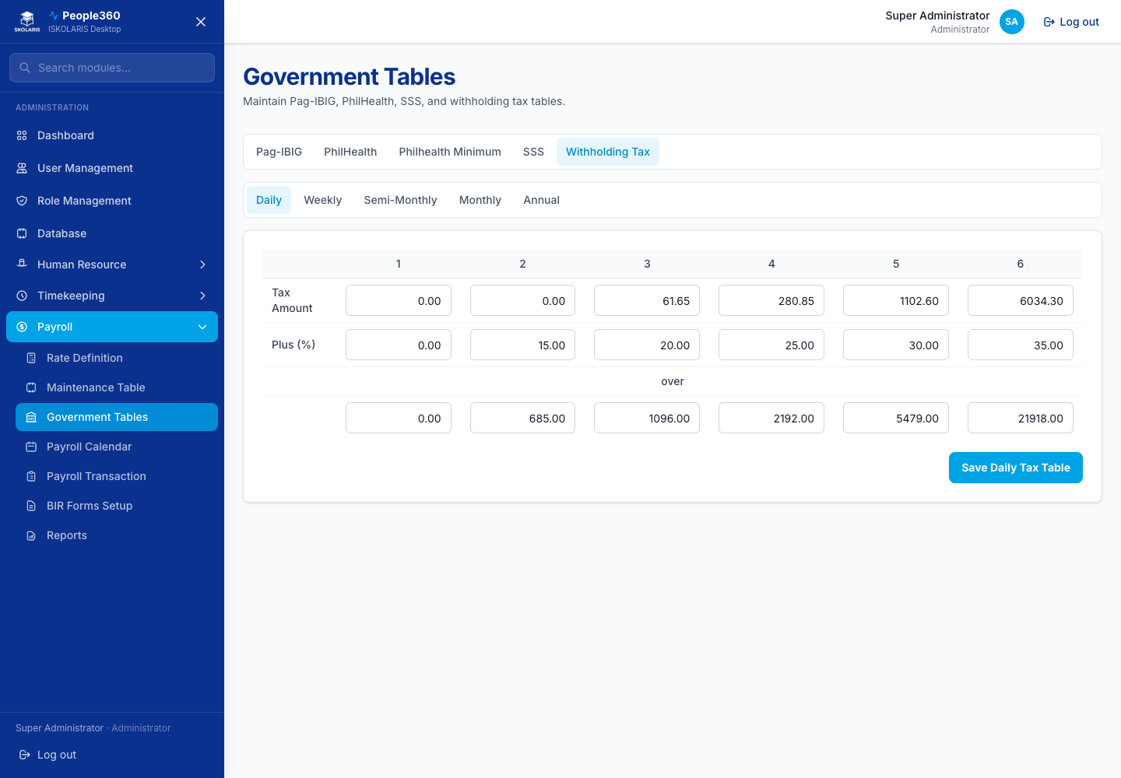
Figure 103. Withholding Tax screen

Payroll Calendar
Add a pay period for the pay type (daily, weekly, semi-monthly, or monthly). Edit the dates or the payroll schedule. Delete removes a period that has no posted payroll. Use the tabs to switch pay type.
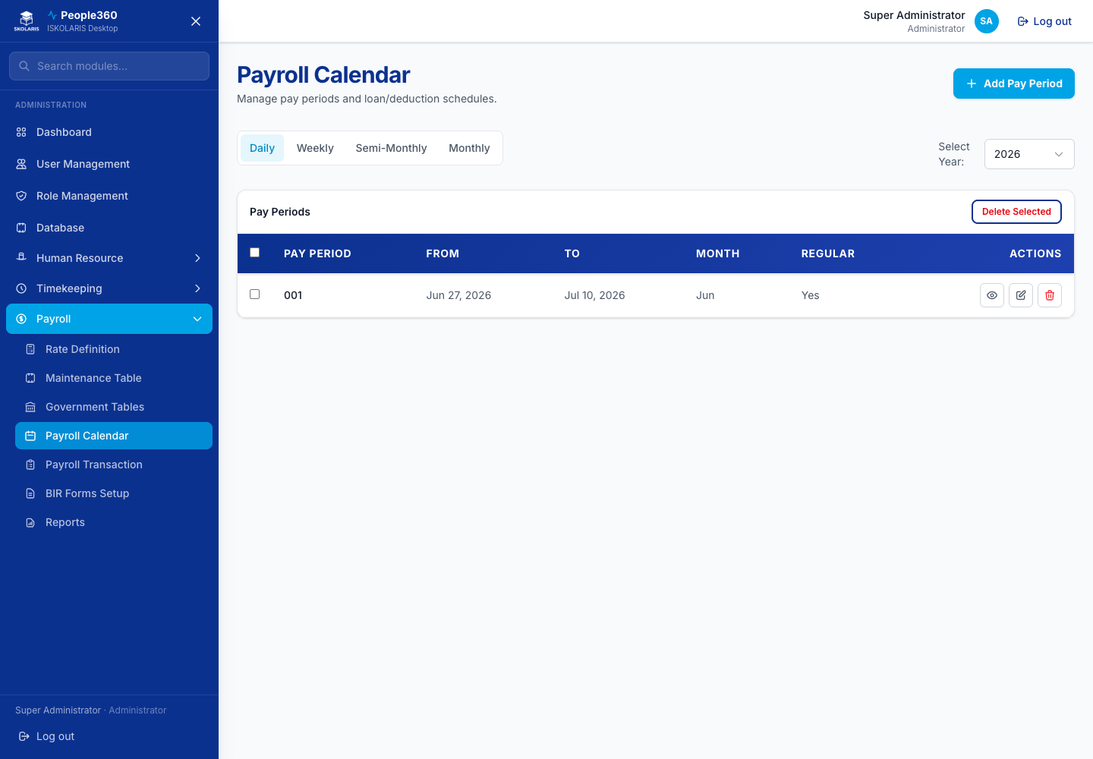
Figure 104. Payroll Calendar screen
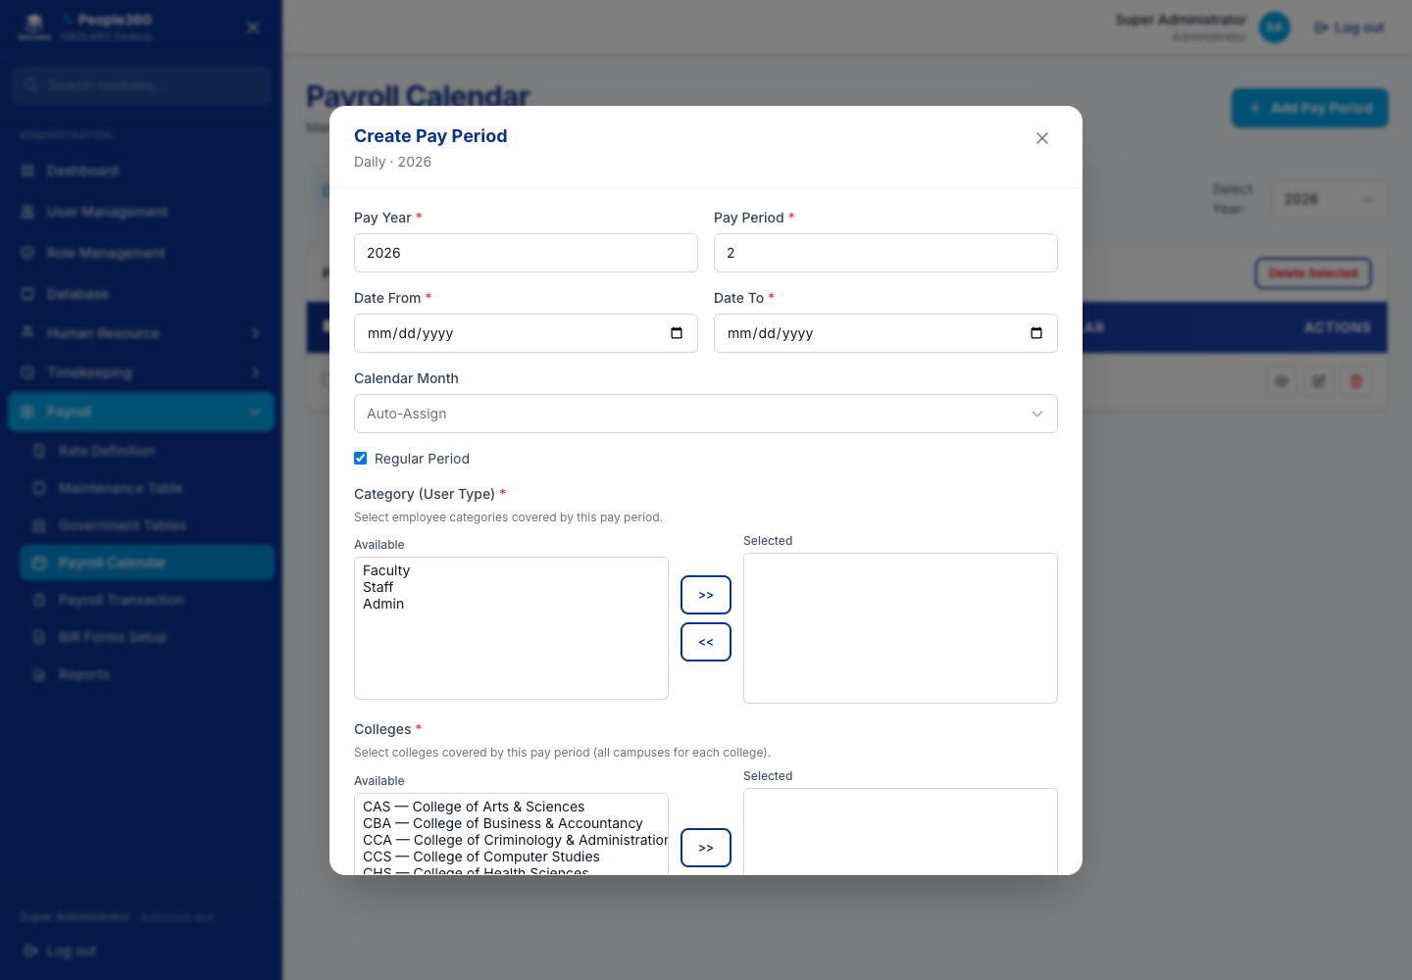
Figure 105. Payroll Calendar — Add window. Use the blue Add button, then save in this window.
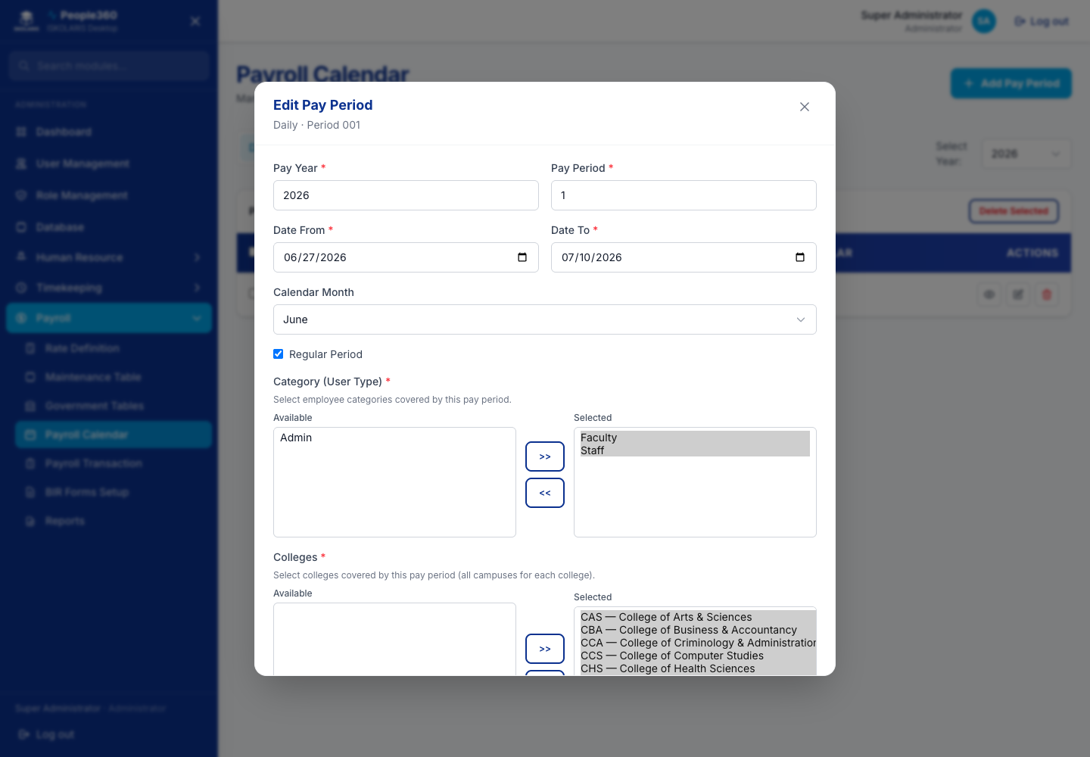
Figure 106. Payroll Calendar — Edit window. Open it with the pencil on the row.
Delete, when shown, is the red trash on the row. Read the question. Confirm only when this row should be removed. Leave a row Inactive when history must be kept.

Calendar Priority
Set which calendar People360 uses first when more than one pay type applies. Edit the order. Delete only an extra priority you added by mistake.
Figure 107. Calendar Priority screen
Figure 108. Calendar Priority — Add window. Use the blue Add button, then save in this window.
Figure 109. Calendar Priority — Edit window. Open it with the pencil on the row.
Delete, when shown, is the red trash on the row. Read the question. Confirm only when this row should be removed. Leave a row Inactive when history must be kept.

Part 6 — Payroll Processing
This is the regular pay cycle: upload extras, create the batch, process, review, then post.

Upload reference
Employee master data, employee salary, and payroll transactions each have their own template. Download the template from the upload window in People360. Do not reuse an old file after the columns change.
- Employee upload — Employees, then Upload. Excel (.xlsx) is the usual file. Dates are YYYY-MM-DD or an Excel date such as 1/1/2000. The match key is employee number plus email. One campus is required unless Disable required fields is ticked for a partial update. Blank, when ticked, downloads headers only. Leave Blank unticked to download every existing employee.
- Payroll uploads — Upload Transactions. Pick the upload type (incomes, deductions, loans, or hours). Download the template for that type, fill from row 4, and do not rename the header rows. Preview shows valid rows and errors. Commit only after you accept the preview.
- If Save or Commit shows a red message, a required column is empty, a code is unknown, or a date is not valid. Correct the file and upload again. The window stays open.
Expected result. The preview count matches the rows you meant to load, and a spot-check employee shows the new value on the profile or on the batch.

Upload Transactions
Upload incomes, deductions, loans, or hours from the template. Preview, then commit. Purge or delete removes an upload batch that was not supposed to be kept.
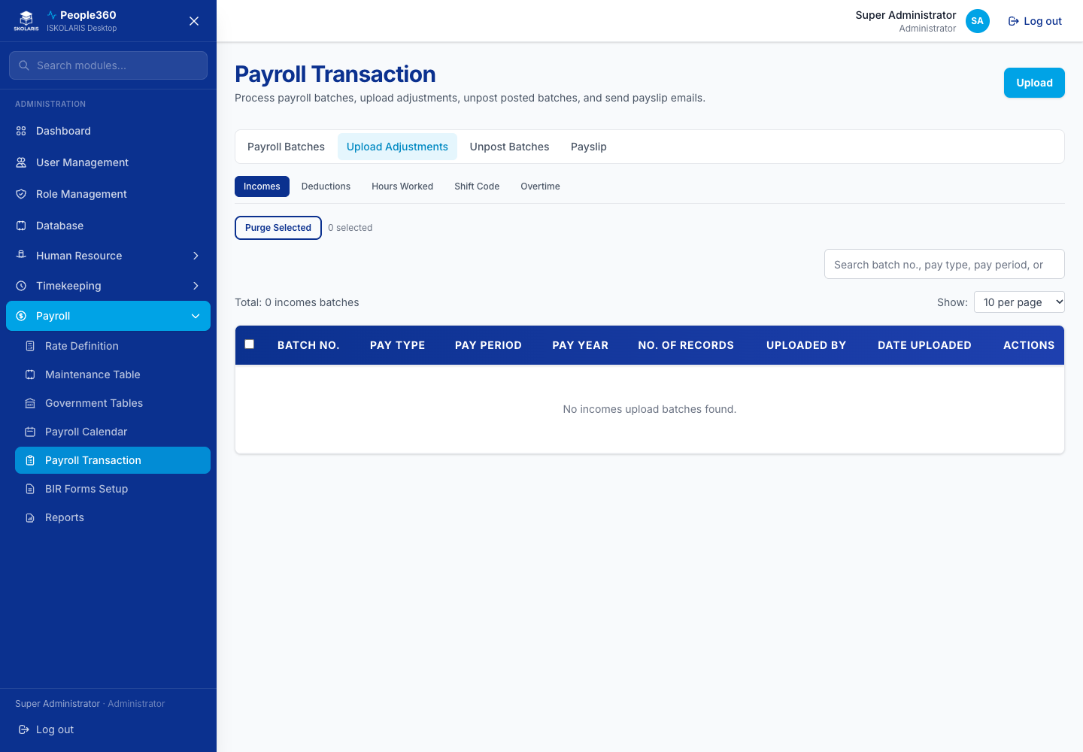
Figure 110. Upload Transactions screen

Process payroll
Follow this procedure every cutoff. The screen notes under Payroll Batches name the buttons. This section is the order of work.
Before you begin. Employee profiles have a shift and a timekeeping policy. Attendance for the period is in Time Logs. The payroll calendar covers the dates. Rate groups and government tables are current. Loan types for this period are ticked on the calendar, and employee loans have a payment start date on or before the period end.
1. Open Payroll Batches.
2. Create a batch for the campus and the pay period, then save.
3. Add the employees who should be paid in this batch.
4. Upload hours, incomes, or deductions first if those amounts are not already on the employee record. Preview the upload and commit only the valid rows.
5. Process the batch.
6. Review each person: gross pay, deductions, loan lines, and net pay. Investigate missing attendance and amounts you did not expect.
7. Post only after the authorized reviewer confirms the results.
8. Confirm the batch status is Posted before you print payslips or generate BIR forms.
Expected result. The batch shows Posted. Payslip and BIR Forms can use it. An employee loan that was deducted shows that batch in the loan payment history.
Important. Do not delete a posted batch from a list. Unpost is a separate screen and a separate permission. Unpost only when payroll must be corrected. Then fix the data, process again, review, and post.

Payroll Batches
Add a payroll batch for a campus and period. Open the batch to add employees, review pay, process, and post. Unpost is on the Unpost Batches tab, not a trash icon on a posted batch.
Important. Post is final for payslips and BIR forms until someone unposts the batch. Review gross pay, deductions, loans, and net pay before you post.
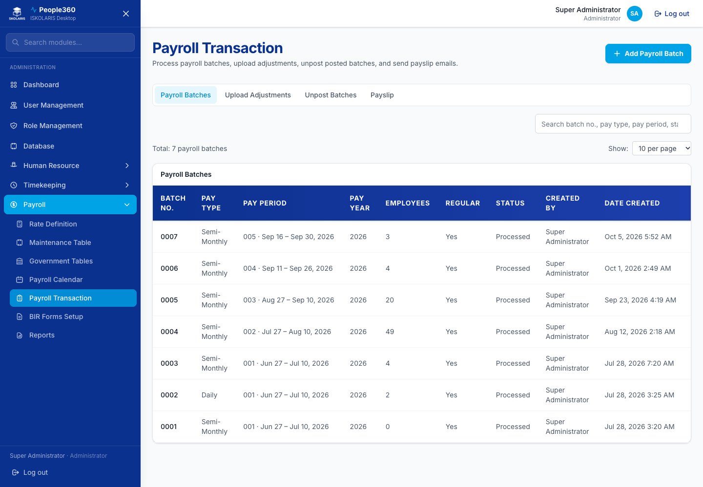
Figure 111. Payroll Batches screen
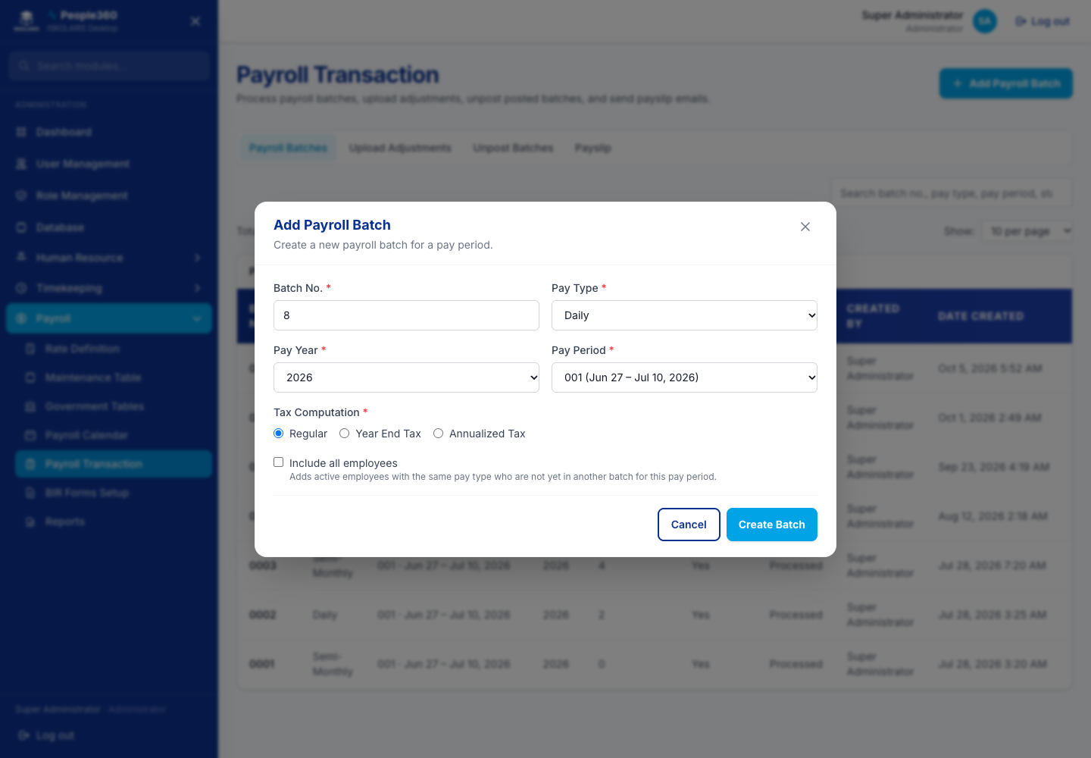
Figure 112. Payroll Batches — Add window. Use the blue Add button, then save in this window.

Unpost Batches
Find a posted batch and unpost it when payroll must be corrected. Unpost is the reverse of post. Do this only when you are sure, then reprocess.
Important. Unpost reverses a posted batch. Payslips and reports that used that post are no longer final. Only an authorized user should unpost. After unpost, fix the source data, process again, review, and post.
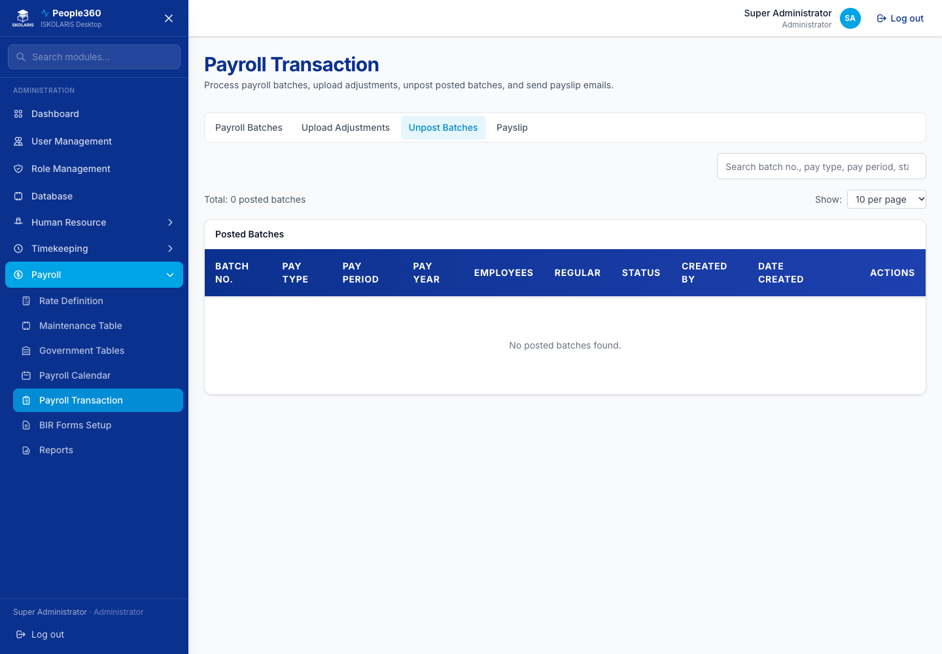
Figure 113. Unpost Batches screen

Part 7 — Payslips, Reports, and Documents
Do these after payroll is posted, or when you send HR letters and memos.

Payslip
Open a posted batch and send or print payslips. You do not add a new employee here.
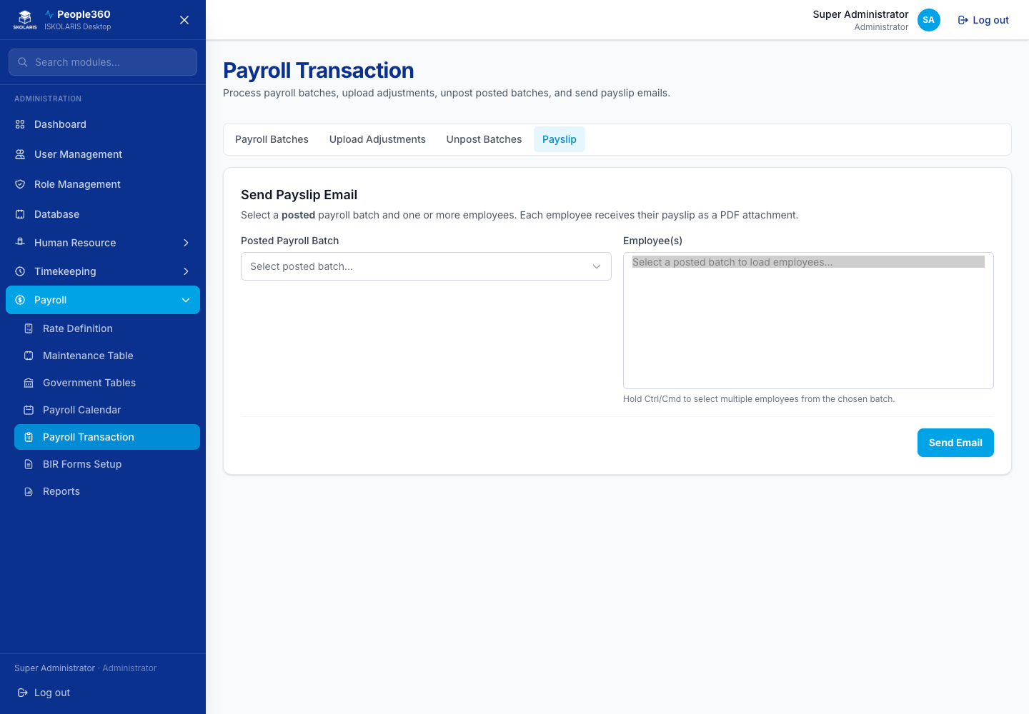
Figure 114. Payslip screen

BIR Forms
Prepare BIR form data from posted payroll. Follow the buttons on the page (generate or export). This is a report step, not a lookup you delete.
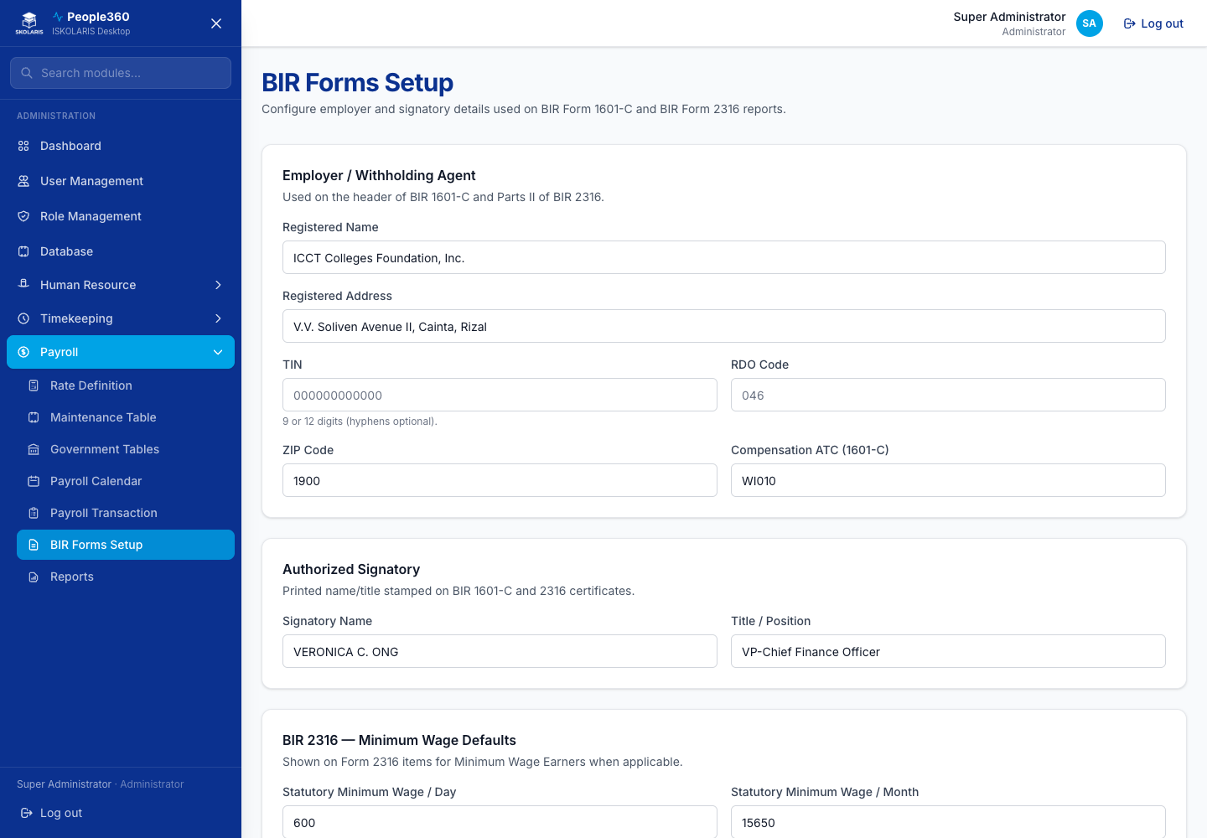
Figure 115. BIR Forms screen

Reports
Choose the report, the period, and the output, then generate. Nothing is deleted from this page.
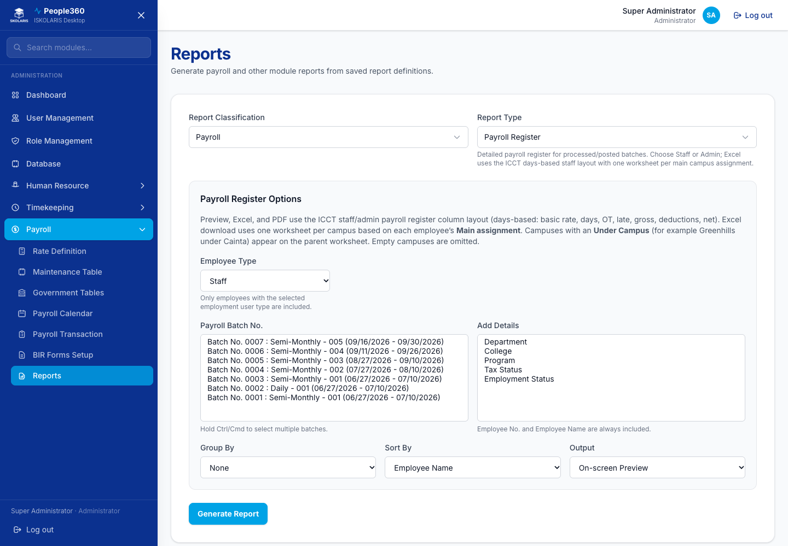
Figure 116. Reports screen

Company Documents
Add Company Documents creates a form. Edit changes it. Delete removes a document you no longer send. Sending and approval are separate actions on the same row.
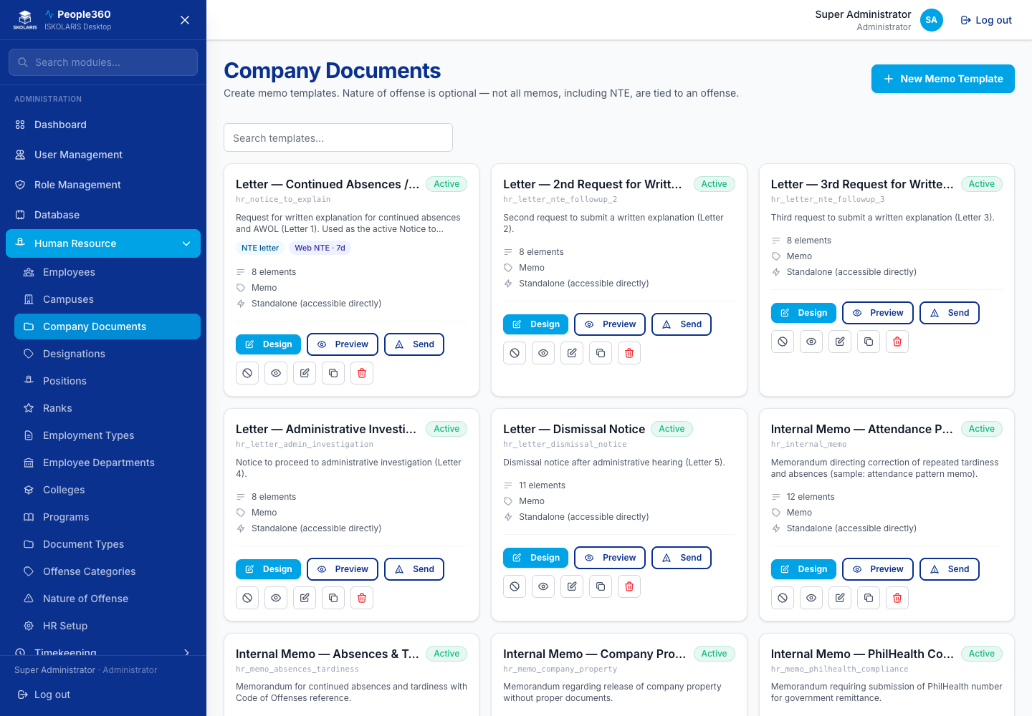
Figure 117. Company Documents screen
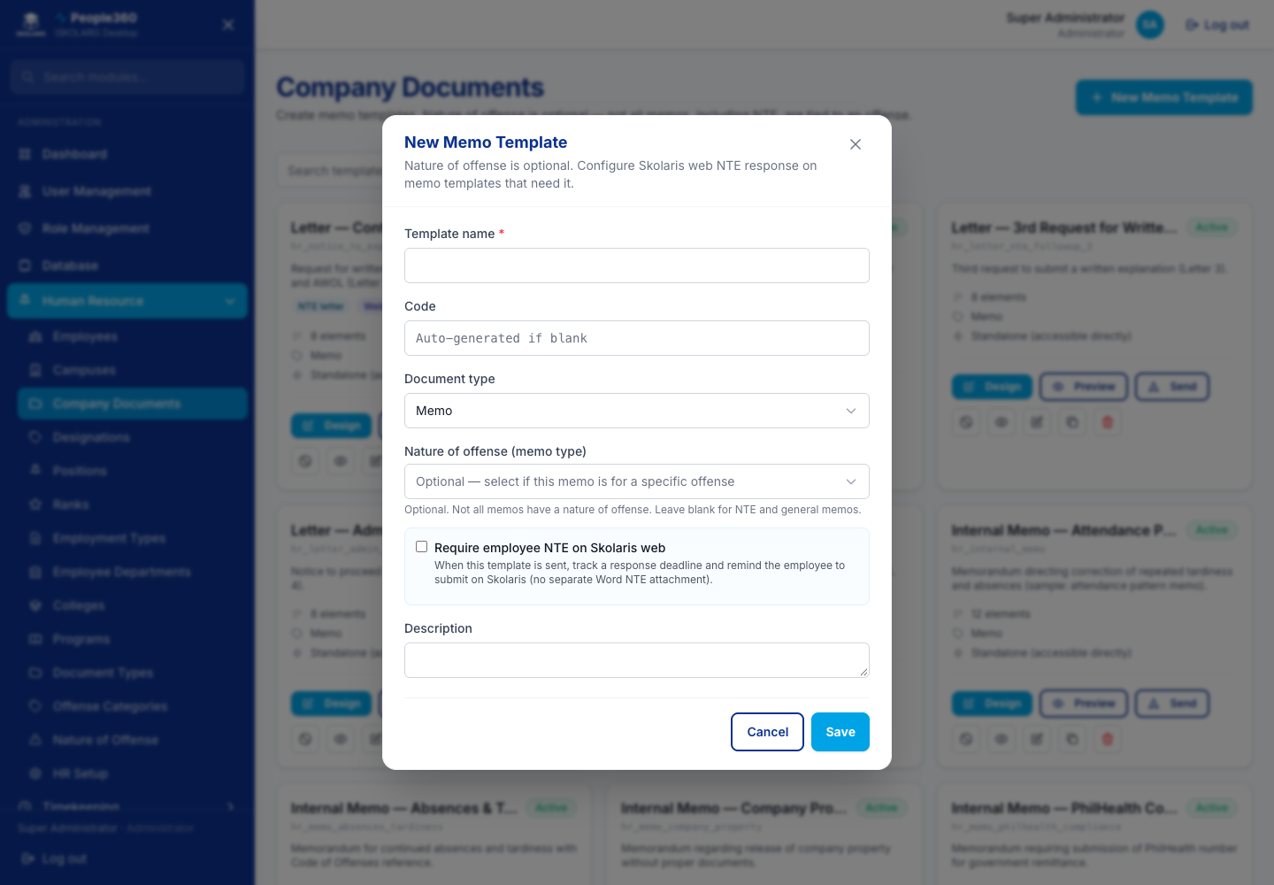
Figure 118. Company Documents — Add window. Use the blue Add button, then save in this window.
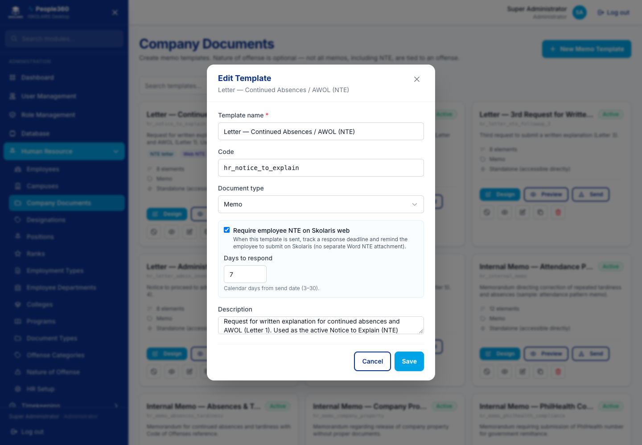
Figure 119. Company Documents — Edit window. Open it with the pencil on the row.
Delete, when shown, is the red trash on the row. Read the question. Confirm only when this row should be removed. Leave a row Inactive when history must be kept.

Document Approvals
This list is for documents waiting for a decision. Open a row to review it. You do not add a new lookup here.
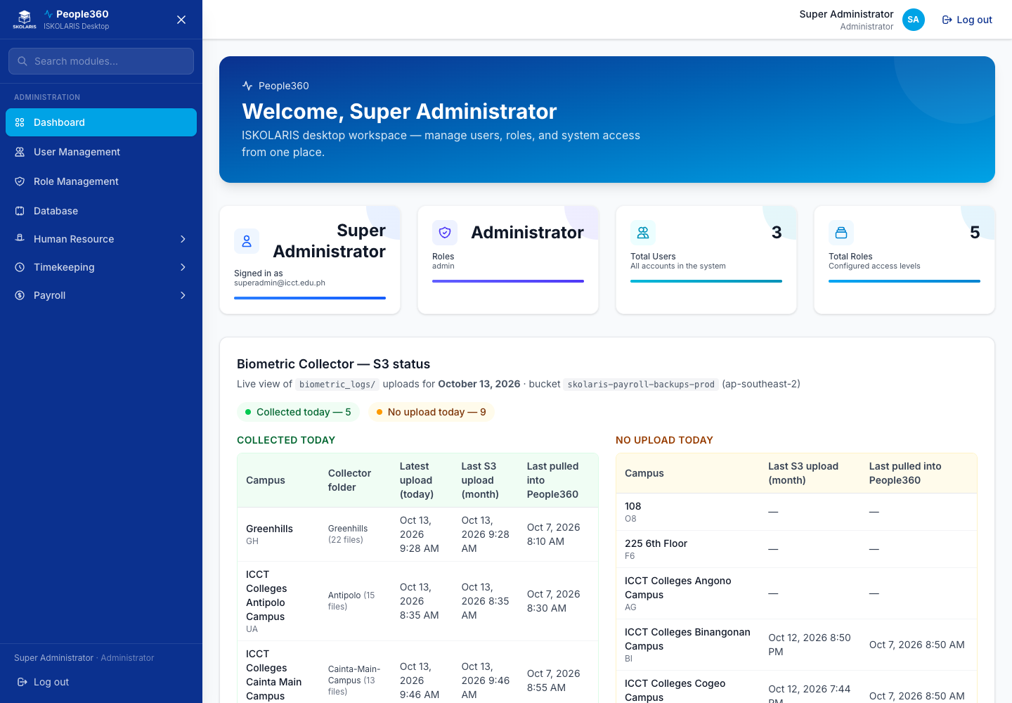
Figure 120. Document Approvals screen

Memo Setup
Set the memo template and how it is sent. Save. This is a settings form.
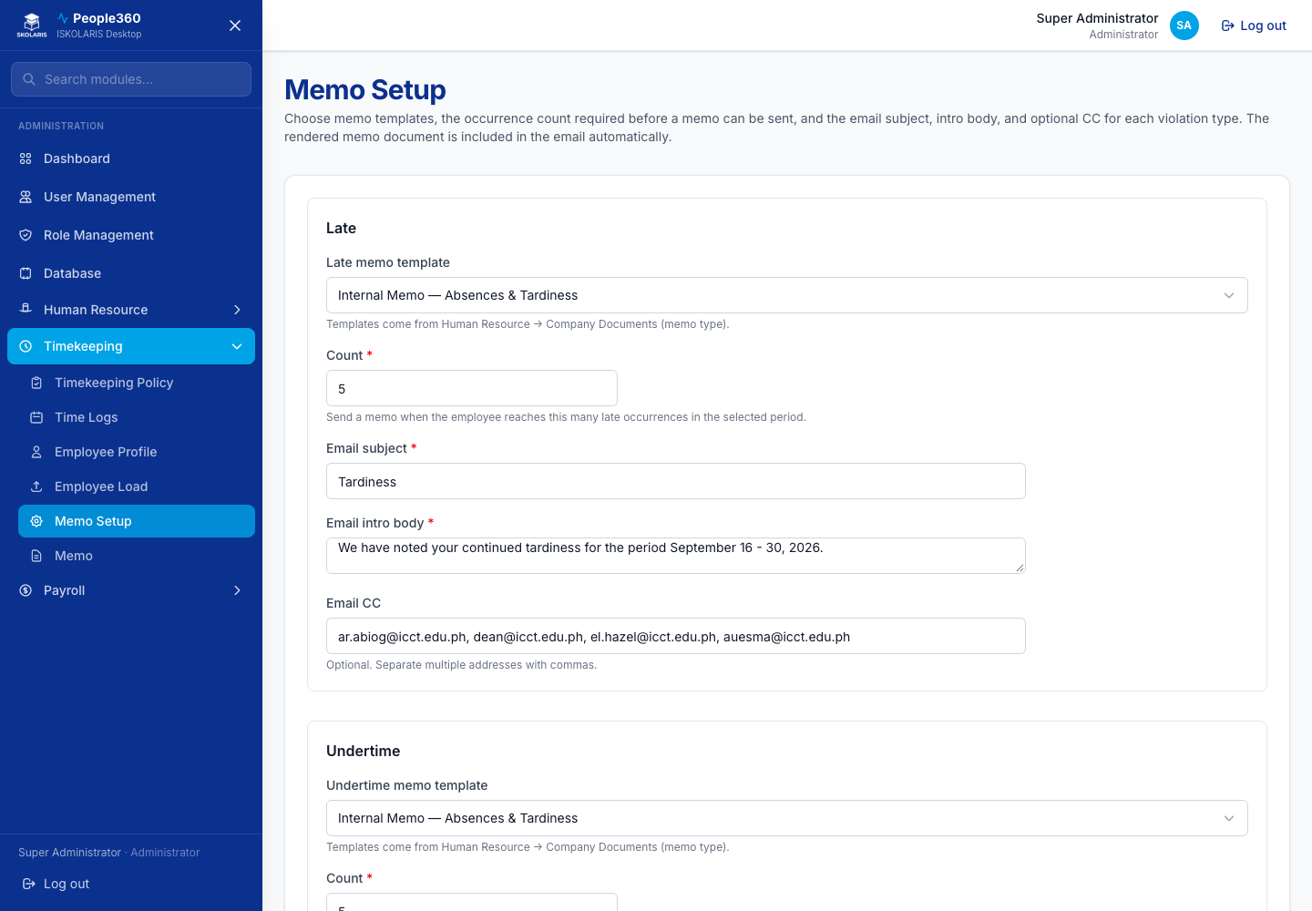
Figure 121. Memo Setup screen

Memo
Pick the people and the period, preview the memo, then send. You are not creating a lookup row.
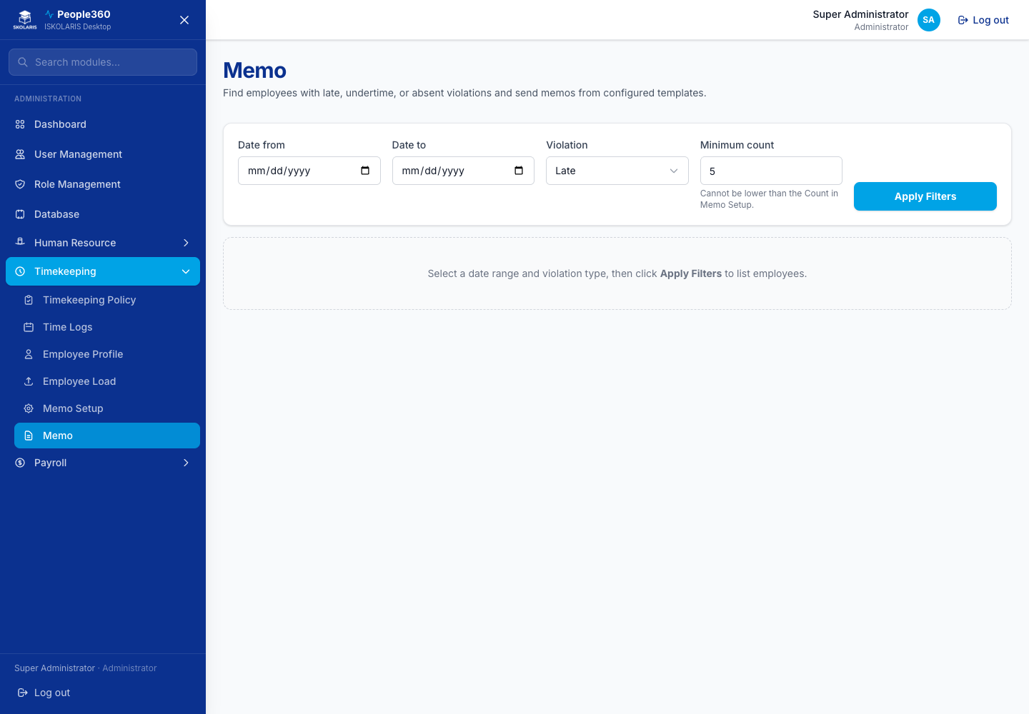
Figure 122. Memo screen

Part 8 — Administration and Troubleshooting
Backup, restore, and what to check when a screen or a pay result looks wrong. Restore and unpost are administrator tasks.

Database
Use this page to back up or restore the People360 database. This is not a list of employees. Restore replaces data, so take a backup first and do it only when an administrator asks you to.
Important. Backup and restore are administrator actions. Restore replaces the data in this People360 installation. Take a backup first. Do it only when an administrator has told you to, and confirm you are restoring the file you intend.
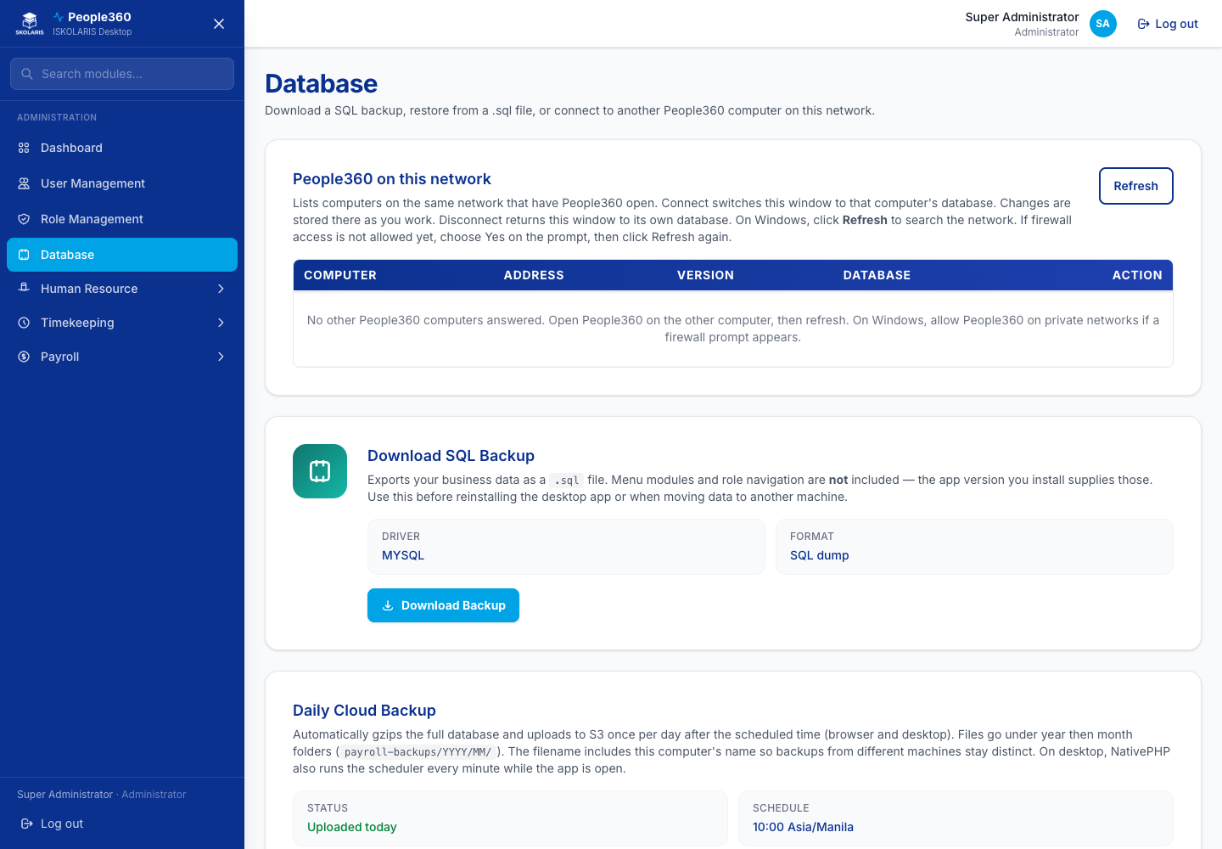
Figure 123. Database screen

Monthly payroll checklist
1. Attendance for the period is pulled or uploaded, and a sample of employees was checked.
2. Uploads for hours, incomes, deductions, and loans are committed, or you have confirmed none are due.
3. The payroll calendar period is correct, including loan types ticked for this cutoff.
4. The batch is processed and reviewed (gross, deductions, loans, net).
5. The authorized reviewer has agreed, and the batch is Posted.
6. Payslips are sent or printed from the posted batch.
7. BIR forms and other reports are generated from the posted batch.

If something looks wrong

Timekeeping
- A person has no time logs — Pulse Biometric Collector must be open on the campus PC, and People360 must pull biometric logs under Time Logs for those dates.
- Times are duplicated — purge the extra upload batch, then pull or upload once.
- Attendance is in Time Logs but pay ignores it — the employee profile needs a shift and a timekeeping policy, and the batch must be processed after the logs arrived.

Payroll
- A loan did not deduct — the loan type must be ticked on this calendar period, the employee loan needs a payment start date on or before the period end, and that loan must not already have been deducted on another batch.
- Pay looks wrong — check the employee profile, the rate group, the calendar period, uploaded transactions, and that you processed after the latest logs.
- You need to change a posted batch — use Unpost Batches. Do not delete the batch from the list.

Any screen
- You cannot see a menu — your role does not include it. Ask an administrator.
- Add or Save shows a red message — a required field is empty, or the code is already used. Correct that field. The window stays open.
- Escalate to an administrator when restore, a missing role, or a posted amount still looks wrong after the checks above.

