Using Final Tax Return Data for a Heterogeneous-Agent Dynamic General Equilibrium Model

Hiroshi Gunji
Kazuki Hiraga
Kenji Miyazaki

April 15, 2026

Abstract
This study uses novel Japanese final tax return (FTR) data to estimate both the progressive income tax function and income shock and examines the impact of utilizing these in a heterogeneous agent macro model featuring both tax return filers and withholding taxpayers on the macroeconomy and income distribution. The findings reveal that, regarding the tax function, tax progressivity in the FTR data is low and almost flat. Regarding the income shocks, the FTR data indicate that both the variance and persistence of income shocks are larger than the estimates based on Japanese survey data. The model calibrated based on the FTR data overestimates the income and asset inequality of the Japanese data but successfully replicates the consumption inequality.

Keywords: Final tax return, Labor income tax, Income distribution, Heterogeneous-agent macroeconomic model
JEL Classification Code: E62; H23; H24

- Introduction

This study estimates a disposable labor income function to capture the characteristics of both taxpayers from final tax return data (FTR) and withholding taxpayers from survey data, thereby estimating the degree of tax progressivity and its income process. Using FTR data allows us to examine income processes and tax progressivity, including data on high-income earners not captured by survey data. Our analysis, through data and model calibration, enables us to capture the current state of income, asset, and consumption inequality across the Japanese economy. This is because the labor income tax rate becomes lower due to the existence of groups that receive tax refunds or are exempt from taxation through filing tax returns. We also investigate the advantages and drawbacks of tax return data compared with other administrative data on income and income taxes, given the characteristics of tax data (tax returns). Additionally, we estimate the Gini indices of income, consumption, and asset holdings using a heterogeneous-agent dynamic macroeconomic model. Simultaneously, we estimate the disposable income function and income shock using data from the Japan Household Panel Survey (JHPS), which contains representative survey data in Japan, and compare the results with FTR data.
This study’s contribution to the literature is twofold. First, to the best of our knowledge, this is the first study to estimate labor income functions using administrative data. Borella et al. (2023) used survey data from the PSID, while studies using administrative data, such as Guvenen et al. (2021), did not analyze labor income tax using administrative data. Second, we show that administrative tax data can be used to examine the progressive structure of labor income tax, including the total (all individuals) and income quintiles.
This study also reviews related studies. The first is the strand of literature using administrative data. Guvenen et al. (2021) used payroll data recorded by the U.S. Social Security Administration to analyze the characteristics of workers’ payroll income in the U.S., and the Global Repository of Income Dynamics (GRID) project compiled a database of economic disparities. Hoffmann (2019) analyzed the earning process using German administrative data. Hoffman et al. (2022) analyzed disparity trends using administrative data from the Italian National Institute of Social Security from 1985 to 2016. Halvorsen et al. (2022) estimated income risk using demographic data on the Norwegian population from 1967 to 2010.
The second strand contains studies on various dimensions of inequality in Japan. Abe and Yamada (2009) and Kitao and Yamada (2025) estimated income and consumption inequality in Japan using microdata from the National Survey of Family Income and Expenditure (NSFIE). Lise et al. (2014) documented the main features of the distribution of wages, earnings, consumption, and wealth in Japan from 1981 to 2008 using four primary data sources: the Basic Survey on Wage Structure (BSWS), Family Income and Expenditure Survey (FIES), NSFIE, and Japanese Panel Survey of Consumers (JPSC). Ohno et al. (2024) used household microdata from the NSFIE from 1994 to 2014 to explain deductions and trends in household distribution over 20 years while considering each factor’s contribution to changes in the tax base through their decomposition.
The third strand concerns the progressivity of income taxation, either by estimating it or studying its implications using macro models. Feldstein (1969) used a progressive income tax to estimate income tax progressivity based on the number of labor income customs. Borella et al. (2023) used survey data from the Panel Study of Income Dynamics (PSID) to obtain empirical results on tax progressivity.
Next, we review studies utilizing administrative data on taxes and social security in other countries. In the United States, the Office of Tax Analysis (OTA) of the U.S. Department of Treasury and the Compliance Data Warehouse (CDW) of the Internal Revenue Service compile tax return information. Additionally, the Statistics of Income Section (SOI), a statistical division of the Internal Revenue Service, publishes a public-use file that excludes personal information and provides only fully anonymized and partially sampled data for a fee. Datalab and His Majesty’s Revenue and Customs (HMRC) provide tax data for the United Kingdom. Denmark’s number system allows tax data to be collated and analyzed using other administrative data (DIA), such as the Danish Integrated Database for Labour Market Research. Chetty et al. (2014) and Kleven and Schultz (2014) used this dataset. In Japan, the University of Tokyo’s Center for Research and Education in Program Evaluation (CREPE) analyzes income and local taxes using municipal tax data, such as resident taxes. Kitao et al. (2025) examined life-cycle earnings risk and income inequality in Japan using municipal administrative tax records. Heathcote et al. (2017) and Holter et al. (2019) analyzed heterogeneous macroeconomic models using progressive income taxes. This study distinguishes itself from the prior research discussed in this paragraph by utilizing tax return data encompassing high-income earners and survey data from withholding agents to capture the income process and tax progressivity of the Japanese economy as a whole.
The remainder of this paper is organized as follows. Section 2 explains the Japanese income tax system and the FTR data. Section 3 constructs the prorated labor income and its tax, estimating the labor income tax function. Section 4 estimates the labor income process. Section 5 presents the heterogeneous-agent macroeconomic model with exogenous and endogenous labor supplies. Section 6 describes the model calibration. Section 7 presents the results of the calibrated models. Finally, Section 8 concludes the study.

- Explanation of Japanese FTR data

This section provides a comprehensive overview of the Japanese Income tax and FTR system.

  - Explanation of the Japanese income tax system

Japan’s personal income tax system is characterized by a combination of withholding at source, year-end adjustment, and self-assessment through final tax returns, depending on the type of income and the taxpayer’s employment status. For the majority of salaried workers, income tax is collected primarily through a withholding system. Employers are legally required to withhold income tax from monthly wages and bonuses based on statutory tax tables issued by the National Tax Agency (NTA). These tables incorporate the progressive tax schedule and standard deductions, thereby approximating the employee’s annual tax liability throughout the year.
At the end of the calendar year, employers conduct a year-end adjustment. This procedure reconciles the total amount of tax withheld during the year with the employee’s actual annual tax liability, taking into account eligible income deductions such as basic deductions, employment income deductions, social insurance contributions, and certain personal deductions (e.g., deductions for dependents). For employees whose income consists solely of employment income from a single employer and who meet specific conditions, the year-end adjustment effectively finalizes their national income tax liability, eliminating the need to file a FTR.
In contrast, individuals who earn non-wage income—such as self-employment income, rental income, capital gains, or income from multiple employers—are generally required to file a final tax return. Under this self-assessment system, taxpayers calculate their total annual income, apply relevant deductions and credits, and determine their tax liability. Any difference between the tax owed and the tax already paid through withholding or advance payments is settled at the time of filing.
Self-employed individuals and certain high-income taxpayers are also subject to prepayment of income tax. Advance payments are typically made in two installments during the tax year, based on the previous year’s tax liability. This mechanism serves to smooth tax payments over time and reduces liquidity constraints at the time of final settlement.
Overall, Japan’s income tax payment system can be interpreted as a hybrid model that combines administrative efficiency with elements of taxpayer self-reporting. The extensive use of withholding and year-end adjustment reduces compliance costs and tax evasion among salaried workers, while the self-assessment and prepayment systems maintain horizontal equity across taxpayers with heterogeneous income sources.

  - Explanation of the Japanese FTR

Japan's tax year follows the calendar year, with the filing period running from February to mid-March of the following year. Tax returns can be filed either in person at a tax office or electronically via e-Tax. Two types of taxation methods exist: comprehensive (Sougou-Kazei) and separate (Bunri-Kazei). Comprehensive taxation is a progressive tax system (5%-45%), while separate taxation is a flat tax system (20.315%). When calculating Japanese income tax, taxable income is calculated after the two-stage income deduction process. First, income is calculated by deducting the necessary expenses (employment income deductions) from earnings shown in Table 1. Second, taxable income is calculated by deducting income from the income shown. Additional income deductions, such as insurance premium deductions, are required to calculate tax amounts. Finally, income tax amounts are calculated according to Table 2 for comprehensive tax, or 20.315% for separate taxation, with some tax credits, such as special credits for housing loans, mitigating the burden. For example, if the taxable income of a taxpayer is 4 million yen without tax credit, the income tax amount of the taxpayer is 0.3725 million yen (=1.95 million×0.05+1.35 million×0.1+0.7 million×0.2).

Table 1. Calculation of employment income deductions

Table 2. Calculation of comprehensive income tax rates

Two types of tax collection methods exist: one where only the withholding tax is collected and one where an FTR must be filed with the tax office. Next, we discuss the Japanese tax return system. Taxpayers who meet any of the following conditions are required to file a tax return:

[1] Those working as sole proprietors or freelancers.
[2] Employees whose employment income exceeds 20 million yen.
[3] People whose income from side jobs exceeds 200,000 yen per year.
[4] Persons who receive a certain amount of public pension.
[5] Persons who earn a certain profit from stock trading.
[6] Those with other income, such as real estate.
[7] Those who receive a certain income from two or more employment locations.

In addition to those who fall under the above categories, another notable feature is that many people voluntarily file tax returns to claim refunds of withheld taxes due to medical expense deductions or the special deduction for housing loans (commonly known as the housing loan tax deduction). Table 3 shows the composition of tax return filers, with approximately 12 million of the 21 million tax filers eligible for refunds, accounting for more than half of the total.

Table 3. Number of final returns for income tax in 2014 (Unit: 1,000 people)
Source: National Tax Agency Annual Report, 2015

Among the tax data to be provided, for income tax data, the information for each item listed in Form 1 (Dai 1 Pyou) and Form 3 (Dai 3 Hyou) of the “Income Tax and Special Reconstruction Income Tax Finalization Form” are available (however, taxpayers’ names are not accessible for privacy protection). The Japanese income tax system classifies income based on its nature, stipulating a method to calculate the amount of each type of income. Form 1 is an income tax form for entering income subject to the progressive tax rate and includes business (business and agricultural income), real estate, interest (excluding the portion subject to withholding tax), dividends (excluding the portion subject to withholding tax), employment (including income subject to withholding tax), miscellaneous (miscellaneous income from pensions, business, and others), short- and long-term transfers, and occasional income other than land and buildings subject to comprehensive taxation.
However, some reported income is subject to separate taxation. Form 3 lists income-related items in the tax return form. Specifically, the items include short-term (general and reduced) and long-term (general, specific, and light) transfers of income from land and buildings subject to separate taxation; income from the transfer of general stocks, listed stocks, dividends, and other income from listed stocks; and miscellaneous income from futures transactions. Additionally, forest and retirement income are subject to tax treatments that differ from general income and are taxed separately, as shown in Form 3. The sum of each income type listed in Form 1 of the tax return for comprehensive income and in Form 3 for separate taxation is called the “total amount of income.” After deducting the deduction for loss carried forward, it is called “total income” in comprehensive taxation only and “gross income” in the case of taxable income, including separate taxation on declarations.
If no separate taxable income exists, the tax amount is calculated by applying the tax rate to the taxable gross income after deducting the income tax credits (“taxable gross income”). If separate taxable income exists, it is calculated in the third table in addition to the gross income, and the amount of income and tax are posted in the first table. Various tax credits have been deducted, such as dividend income tax credits to adjust double taxation on dividend income at the corporate and individual levels and special credit for housing loans, donations to political parties, and earthquake-proofing houses. Finally, the tax already paid to the foreign government is deducted as a foreign tax credit. If any withholding tax on declared income exists, the withholding tax amount is deducted from the declared tax amount.

  - Advantages and considerations of using FTR data

The tax data, provided in collaboration with the National Tax Agency, includes detailed items for calculating the amount of tax for each reported income tax bracket. Additionally, the availability of tax data over a given year (2014–2020), rather than sample surveys, allows the coverage of a large number of taxpayers (over 20 million), including non-taxpayers of income tax, in a single year. The total number of income taxpayers in Japan is approximately 50 million per year, so the FTR data accounts for 40% of all taxpayers. Additionally, many wage earners determine their tax liability through withholding and year-end adjustments. The FTR data are also unbalanced panels because they assign each taxpayer an ID and are classified. This includes very-high-income taxpayers, who are likely underrepresented in the survey data. Unlike survey data, a certain degree of accuracy is ensured, and the data is highly reliable because additional taxes and, in the most egregious cases, penalties are imposed on taxpayers who file untruthful tax returns.
However, the tax data on reported income taxes have several limitations. First, coverage is limited to reported income tax data involving the filing of tax returns. Japan has two forms of taxation: self-assessment (in which the taxpayer must file a tax return) and separate self-assessment (in which the taxpayer must file a tax return and pay taxes at the source) taxation. The “interest income” subject to comprehensive taxation included in Form 1 of the tax return is limited to income not subject to withholding tax in Japan, such as interest on deposits paid outside Japan. For example, if you do not carry out profit and loss calculations for dividend income or capital gains, you must only pay a withholding tax and not file a final tax return. Additionally, since the introduction of an elaborate year-end adjustment system for employment income in Japan, many salaried workers with no income other than salaries have completed the tax payment procedure by withholding taxes and have not filed income tax returns. However, because tax returns are now required for salaried workers with salaries exceeding 20 million yen, these workers were included in the data provided in this report. Particularly, the former caveat makes extracting taxpayers’ “true” capital income and capital income tax amounts challenging. Therefore, we analyze a macro model that includes heterogeneity in labor income (labor productivity) by estimating the labor income tax function and income process. Unayama et al. (2025) also states that tax return data is not necessarily desirable as data representative of all income groups.
Considering the above concerns, this study uses the JHPS to estimate a disposable income function and income process and then compares the results with the FTR data. The JHPS data are collected by the Panel Data Research Center at Keio University, which comprises a nationwide survey of 4,000 males and females. The JHPS data includes data that the FTR data does not include, such as economic and employment status, family, education, healthcare, household income withholding, and filing taxpayer information. We use the household income and (tax-deducted) income to compare with the FTR individuals’ data. This is because information on the income of each member of the household is insufficient (information on the amount of income tax paid by each individual is not available). To maintain consistency with the FTR data period, we also use JHPS data from 2014 to 2020 which excludes samples for which filing a tax return meeting any of the seven conditions mentioned above is mandatory, to obtain samples that closely resemble withholding tax. Additionally, we compare and verify whether any discrepancy exists between the group that voluntarily FTR and JHPS data. Specifically, we compare whether differences exist in the parameters of labor income taxation and income shocks between voluntary filing in the FTR and those who are not required to file tax returns in the JHPS data.

  - Sample Selection of the FTR data
This study assumes a household model in which the head of the household decides on household consumption and labor supply (in the case of the endogenous labor supply model). However, we could not identify the head of household from the FTR data. For example, if taxpayers with a full-time housewife (or husband) are eligible for spousal tax deductions, they evidently have a spouse. However, extracting household information from the FTR data is difficult if the household is a dual-income household. This paper focuses on the progressivity of labor income and its role and therefore uses only data from the working-age population (from 25 to 65 years old) for analysis. Restricting the FTR data to aged<24 and aged < 66yields a sample size of approximately 100 million individuals.
This study limits its sampling to working-age individuals (ages 25 to 65). Consequently, a sampling bias occurs, excluding data on the elderly (such as pension recipients and older workers) and higher-income individuals under age 25 from the analysis. The reason for excluding the elderly in this study is to focus the analysis on trends in labor income among the working-age population. While it is possible to extend the analysis to a life cycle model using FTR data, this falls outside the scope of this study and is left as a topic for future research.

- Estimating the labor income tax function

This section estimates Japan’s labor income tax function using the FTR data. We define a nonlinear income tax function, construct labor income and tax data from FTR records, and estimate a disposable income function. The analysis covers the total data and income quintiles for working-age (from 25 to 65 years old) from 2014 to 2020. The reason for limiting the data to only active male household members is that the FTR data are for each taxpayer, and information about households cannot be accurately captured, as it can only be clarified by whether a dependent or spousal exemption exists.

  - Data construction of labor income and labor income tax

This section discusses methods for estimating “proportionally allocated” labor income, labor income tax, and labor income tax rates which deducts labor income from labor income tax from FTR data. Strictly defining and analyzing labor income is difficult because some of the reported income includes “business income” (business income and agricultural income), “miscellaneous,” and “occasional income,” which is a mixture of labor and capital income. Additionally, information on family structure is difficult to analyze because each family files its own tax returns. Therefore, only inferring which individuals are married couples is possible, and the family structure can only be inferred from the existence or nonexistence of deductions for dependents.
The labor income tax rate is calculated using the labor income in the reported income tax in Form 1. However, to define labor income, we estimated the proportion of labor income within mixed income, as defined by Cooley and Prescott (1985) and Gunji and Miyazaki (2011), using labor share data calculated from the System of National Accounts (SNA), as shown in Eq. (1) below.
Labor income = salary income + retirement income + labor share × (operating income + agricultural income + forestry income + miscellaneous income + occasional income). (1)

Considering that retirement, forestry, and occasional income are classified in Gunji and Miyazaki (2011), the labor share is calculated from employer compensation divided by national income in the factor cost representation in the System of National Accounts. The Form 3’s schedule, subject to separate taxation and the labor income tax oration method, is defined in Eq. (2).
$$Labor Income Tax=Comprehensive Taxation×\frac{\begin{aligned}Employment Income+Labor Share×(Agrecultural Income+Operating Income \\ +Miscellaneous income+Occasional Income)\end{aligned}}{Income for Comprehensive Taxation}+Separate Taxation×\frac{Retirement Income+Labor Share×(Timber Income)}{Income for Separation Taxation}. (2)$$
In Eq. (1), for income that includes labor and capital income, the portion corresponding to labor income is divided by the labor share in the SNA (compensation of employees/national income expressed as a factor cost). In Eq. (2), labor income tax is divided by the share of labor income defined in Eq. (1) for the total and separate taxation (expressed as fractions).
When estimating disposable income, deducting income tax, which is a national tax, as well as resident tax, is necessary. Resident tax in Japan is divided into two parts: income tax, which is proportional to income, and a flat-rate tax. The income tax portion is levied at 10% of the previous year’s taxable income (6% municipal tax and 4% prefectural tax), and the flat-rate tax is levied at a fixed amount of 5,000 yen.
Table 4 shows the summary statistics of the total labor income and tax data, and Tables 5 and 6 show the subsample statistics for each year (Table 5) and five income quantiles (Table 6). Figure 1 shows the levels of prorated labor income. Figure 2 shows the log difference in labor income; its distribution appears to be normal. Finally, Table 7 shows the summary statistics of household income and tax amounts, and Figure 3 shows the distribution of household income in the JHPS data.

Table 4. Summary statistics of all FTR data (Observations: 100,573,843)

Variables | Mean | S.D. | Min
Labor income (Unit: Ten thousand yen) | 436.070 | 519.798 | 0
Labor income tax (Unit: Ten thousand yen) | 41.572 | 195.902 | 0
Age | 48.262 | 11.817 | 25

Note: Restriction of data availability: We cannot show the maximum value of labor income and labor income tax. Additionally, we cannot report the maximum amount of labor income and its tax as the identification of individuals is protected.

Table 5. Summary statistics of total labor income and labor income tax by year (Unit of Labor income and Labor income tax: 10,000 yen)

 | 2014 | 2015 | 2016 | 2017 | 2018 | 2019 | 2020
Labor income | 409.355 | 414.455 | 424.499 | 439.452 | 451.333 | 452.636 | 449.534
Labor income tax | 36.941 | 38.541 | 38.868 | 40.422 | 42.613 | 43.211 | 44.731
Observations | 14,010,138 | 14,073,169 | 14,238,347 | 14,325,986 | 14,332,257 | 14,365,012 | 14,625,326

Table 6. Summary statistics of total labor income and labor income tax by income quantile (Unit: 10,000 yen)

 | 1st | 2nd | 3rd | 4th | 5th
Labor income | 37.929 | 156.046 | 282.821 | 471.924 | 1213.172
Labor income tax | 0.329 | 2.988 | 7.791 | 20.073 | 169.581
Observations | 8,622,149 | 8,621,959 | 8,614,109 | 8,624,112 | 8,620,580

Note: The income of individuals in each income quintile for each year is divided and averaged within the respective income quintile.

Table 7. Summary statistics of the JHPS data from 2014 to 2020 (Observations: 9,024)

Variables | Mean | S.D. | Min | Max
Household income (Unit: Ten thousand yen) | 447.719 | 357.426 | 0 | 6528
Income tax (Unit: Ten thousand yen) | 109.085 | 102.525 | 0 | 3300
Age (Unit: years old) | 47.893 | 10.130 | 25 | 65

Figure 1. Histogram of prorated labor income in FTR data (Unit: Yen)

(Note) $e^{+0x}$ representss ${10}^{X}$.

Figure 2. Histogram of log difference of labor income ($dl$) in FTR data
Note: The average growth rate is -0.0413, standard deviation is 0.008, skewness is -0.4143715, and kurtosis is 24.9508.

Figure 3. Histogram of household income distribution in the JHPS data (Unit: 10,000 yen)

  - Estimation of disposable labor income function

Following Feldstein (1969), Benabou (2002), Heathcote et al. (2017), and Borella et al. (2023), we model the nonlinear (labor) income tax function as follows:
$$T\left(Y\right)=Y-(1-λ_{0})Y^{1-λ_{1}},$$
where $T\left(Y\right)$ is (labor) income tax and $Y$ is (labor) income. Parameter $λ_{1}$ represents the degree of progressivity. Income tax is progressive if $0<λ_{1}<1$. We estimate the disposable income function as follows:
$$Y-T\left(Y\right)=(1-λ_{0})Y^{1-λ_{1}}.$$
The marginal tax rate is obtained by $T'\left(Y\right)=1-(1-λ_{0})(1-λ_{1})Y^{-λ_{1}}$ and the average tax rate is obtained by $1-(1-λ_{0})Y^{-λ_{1}}$.
We estimate the following log-linearized disposable income equation:
$$\ln\left(Y_{i,t}-T_{i,t}\right)=ln⁡(1-λ_{0})+(1-λ_{1})\ln{Y_{i,t}}+ζ_{i,t}, (3)$$
where $Y_{i,t}-T_{i,t}$ is disposable income; $Y_{i,t}$ is income; and $ζ_{i,t}$ is the disturbance term. We estimate the OLS following Borella et al. (2023).
Table 8 presents the estimation results using FTR (2nd line) and JHPS data (3rd line). In Table 8, tax progressivity is almost linear ($λ_{1}=0.011$) in FTR data and relatively progressive in JHPS data. These estimated parameter values are less than that in previous studies, such as Heathcote et al. (2017), Holter et al. (2019), and Borella et al. (2023). The low tax progressivity is due to two reasons. First, taxpayers (particularly business owners who file blue returns) receive various tax credits, resulting in lower actual tax payments for higher-income taxpayers. Second, the declared income of those who file tax returns is low, with many facing low tax rates, as Figures 1 and 3 show. The model in Figure 3 has a zero tax rate, and most taxpayers’ tax rates are less than 20%. Conversely, zero income (Figure 4) and the average income tax rate (Figure 5) in the JHPS data are much lower than those in the FTR data.

Table 8. Results of estimating the disposable income function in the FTR and JHPS data

 | $$λ_{0}$$ | $$λ_{1}$$ | Average tax rate
FTR | -0.032 (0.001) | 0.011 (0.001) | 0.102
JHPS | -3.767 (0.924) | 0.108 (0.001) | 0.273
Note: The parameters within parenthesis are the standard deviation. We calculate the average tax rate using the formula $1-(1-λ_{0})(1-λ_{1})Y^{-λ_{1}}$, with average annual labor income.

Figure 4. Histogram of average labor income tax rate (averagetax, Unit: %)

Figure 5. Histogram of average labor income tax rate in the JHPS data (Unit: %)

  - Comparison of taxpayers not required to file and pay taxes in the FTR and JHPS data

Both the FTR and JHPS data contain segments that do not meet the conditions described in the previous section. Specifically, the JHPS data includes taxpayers who filed tax returns and taxpayers who only had taxes withheld. This subsection examines whether differences exist between similar groups by comparing a subsample of voluntary tax return filers from the FTR data with a subsample of JHPS data that includes both tax return filers and withholding taxpayers. Specifically, for both FTR and JHPS data, we extract only the data for individuals who do not meet the conditions required filing a tax return as described in Section 2 and estimate the disposable income function.
Table 9 presents the estimation results for the disposable income function using a subsample of voluntary filers (FTR data) and the JHPS data, which includes individuals not required to file tax returns. Table 9 indicates that the JHPS data shows a higher degree of income progressivity and a higher average tax rate. This difference remains significant even after accounting for the impact of social insurance premiums, suggesting that filing tax returns is motivated by tax-saving behaviors and other factors distinct from those of voluntary filers.
Table 9. Results of estimating the disposable income function in the FTR and JHPS data excluding the sample in which filing a tax return is not mandatory.

 | $$λ_{0}$$ | $$λ_{1}$$ | Average tax rate
FTR | 1.024 (0.001) | 0.014 (0.001) | 0.100
JHPS | -4.829 (0.891) | 0.098 (0.001) | 0.241
Note: The parameters within parenthesis are the standard deviation. We calculate the average tax rate using the formula $1-(1-λ_{0})(1-λ_{1})Y^{-λ_{1}}$, with average annual labor income.

- Estimating the labor income shock

We estimate the labor income process, which is discretely approximated using a Markov chain, to obtain the transition probability matrix of labor income (or labor productivity), following Tauchen (1986).

  - Estimation strategy

First, we estimate the labor income shock as follows:
$$\ln{Y_{i,t}}=κ_{0}+κ_{1}{age}_{i,t}+κ_{2}{age}_{i,t}^{2}+ζ_{i}+ζ_{t}+v_{i,t}, (4)$$
where ${age}_{i,t}$ is the filing taxpayer i’s age in year t, ${age}_{i,t}^{2}$ is the quadratic variable of ${age}_{i,t}$, $ζ_{i}$ and $ζ_{t}$ are the components of the two-way fixed effects, and $v_{i,t}$ is the disturbance term. Next, we estimate the AR (1) process of residual $v_{i,t}$ using Eq. (5) and obtain the parameters of $ρ$ and $σ_{v}^{2}$:
$$v_{i,t}=ρv_{i,t-1}+ϵ_{i,t}, (5)$$
where $ϵ_{i,t}$ is the disturbance term of Eq. (5) and follows $N\left(0,σ_{v}^{2}\right)$. Following Tauchen (1986), we compute the transition probability matrix using $ρ$ and $σ_{v}^{2}.$
4.2. Estimating labor income process using the FTR and JHPS data

The estimation results for Eqs. (4) and (5) are presented in the 2nd row (FTR data) ad 3rd row (JHPS data) of Table 10. The parameter for income shock persistency of the FTR data, $ρ(=0.731)$, is smaller than other empirical evidence in the U.S. data, where $ρ$ is above 0.9. Figure 6 lists the Markov transition probabilistic matrix. Kitao et al. (2025) estimates $ρ$ using local government tax data, with ρ estimated at around 0.6 to 0.8. As for the results using the JHPS data, persistency ρ is larger than that of the FTR data. On the other hand, variance $σ_{v}^{2}$ is significantly lower than those of the FTR data. Figure 7 lists the Markov transition probabilistic matrix.

Table 10. Results of estimating the AR (1) labor income process in the FTR and JHPS data

 | $$κ_{0}$$ | $$κ_{1}$$ | $$κ_{2}$$ | $$ρ$$ | $$σ_{v}^{2}$$
FTR | 4.738 | 0.444 | -0.005 | 0.731 | 0.580
JHPS | 11.131 | 0.1552 | -0.0013 | 0.844 | 0.516

Figure 6. Estimated transition probabilistic matrix in the FTR data
$$\left[\begin{aligned}ε_{1,t+1}^{FTR} \\ ε_{2,t+1}^{FTR} \\ ε_{3,t+1}^{FTR} \\ ε_{4,t+1}^{FTR} \\ ε_{5,t+1}^{FTR} \\ ε_{6,t+1}^{FTR} \\ ε_{7,t+1}^{FTR}\end{aligned}\right]=\left[\begin{matrix}\begin{matrix}0.44 & 0.192 & 0.164 \\ 0.306 & 0.186 & 0.188 \\ 0.193 & 0.16 & 0.191\end{matrix} & \begin{matrix}\begin{matrix}0.11 & 0.059 \\ 0.15 & 0.095\end{matrix} \\ \begin{matrix}0.181 & 0.136\end{matrix}\end{matrix} & \begin{matrix}\begin{matrix}0.024 & 0.011 \\ 0.047 & 0.026\end{matrix} \\ \begin{matrix}0.081 & 0.057\end{matrix}\end{matrix} \\ \begin{matrix}0.111 & 0.121 & 0.172 \\ 0.057 & 0.081 & 0.136\end{matrix} & \begin{matrix}0.193 & 0.172 \\ 0.181 & 0.191\end{matrix} & \begin{matrix}0.113 & 0.053 \\ 0.195 & 0.144\end{matrix} \\ \begin{matrix}0.026 & 0.047 & 0.095 \\ 0.011 & 0.024 & 0.059\end{matrix} & \begin{matrix}0.15 & 0.188 \\ 0.11 & 0.164\end{matrix} & \begin{matrix}0.186 & 0.306 \\ 0.192 & 0.44\end{matrix}\end{matrix}\right]\left[\begin{aligned}ε_{1,t}^{FTR} \\ ε_{2,t}^{FTR} \\ ε_{3,t}^{FTR} \\ ε_{4,t}^{FTR} \\ ε_{5,t}^{FTR} \\ ε_{6,t}^{FTR} \\ ε_{7,t}^{FTR}\end{aligned}\right]$$

Figure 7. Estimated transition probabilistic matrix in the JHPS data
$$\left[\begin{aligned}ε_{1,t+1}^{JHPS} \\ ε_{2,t+1}^{JHPS} \\ ε_{3,t+1}^{JHPS} \\ ε_{4,t+1}^{JHPS} \\ ε_{5,t+1}^{JHPS} \\ ε_{6,t+1}^{JHPS} \\ ε_{7,t+1}^{JHPS}\end{aligned}\right]=\left[\begin{matrix}\begin{matrix}0.508 & 0.231 & 0.157 \\ 0.307 & 0.24 & 0.223 \\ 0.152 & 0.19 & 0.242\end{matrix} & \begin{matrix}\begin{matrix}0.074 & 0.024 \\ 0.143 & 0.063\end{matrix} \\ \begin{matrix}0.214 & 0.129\end{matrix}\end{matrix} & \begin{matrix}\begin{matrix}0.005 & 0.001 \\ 0.019 & 0.005\end{matrix} \\ \begin{matrix}0.058 & 0.019\end{matrix}\end{matrix} \\ \begin{matrix}0.06 & 0.115 & 0.202 \\ 0.019 & 0.054 & 0.129\end{matrix} & \begin{matrix}0.244 & 0.202 \\ 0.214 & 0.271\end{matrix} & \begin{matrix}0.115 & 0.06 \\ 0.19 & 0.152\end{matrix} \\ \begin{matrix}0.005 & 0.019 & 0.063 \\ 0.001 & 0.005 & 0.024\end{matrix} & \begin{matrix}0.143 & 0.223 \\ 0.074 & 0.157\end{matrix} & \begin{matrix}0.24 & 0.307 \\ 0.231 & 0.508\end{matrix}\end{matrix}\right]\left[\begin{aligned}ε_{1,t}^{JHPS} \\ ε_{2,t}^{JHPS} \\ ε_{3,t}^{JHPS} \\ ε_{4,t}^{JHPS} \\ ε_{5,t}^{JHPS} \\ ε_{6,t}^{JHPS} \\ ε_{7,t}^{JHPS}\end{aligned}\right]$$

4.4. Estimating labor income process using the FTR and JHPS data of taxpayers not required to file taxes

Similar to Subsection 3.4, we estimate income shocks using data from voluntary taxpayers in the FTR data and from the segment requiring tax returns in the JHPS data to examine whether income shocks differ across similar income groups. Table 11 presents the estimated parameters for income shocks based on the above data, while Figures 8 and 9 show the Markov transition probabilistic matrices. For both the FTR and JHPS data, the values for the persistence ρ and variance of the shocks are small, and no statistically significant relationship is observed.
Based on the analysis results from Sections 3 and 4, we use the estimation results from the FTR (Tables 8, 10, and 11) and JHPS data excluding income groups requiring tax returns (Tables 9, 13, and 15) for calibration to construct a macro model for the Japanese economy as a whole.

Table 11. Results of estimating the AR (1) labor income process in the FTR and JHPS data excluding the sample in which filing a tax return is not mandatory.

 | $$κ_{0}$$ | $$κ_{1}$$ | $$κ_{2}$$ | $$ρ$$ | $$σ_{v}^{2}$$
FTR | 7.228 | 0.257 | -0.003 | 0.856 | 0.827
JHPS | 7.131 | 0.384 | -0.0042 | 0.878 | 0.780

Figure 8. Estimated transition probabilistic matrix in the FTR data
$$\left[\begin{aligned}ε_{1,t+1}^{FTR} \\ ε_{2,t+1}^{FTR} \\ ε_{3,t+1}^{FTR} \\ ε_{4,t+1}^{FTR} \\ ε_{5,t+1}^{FTR} \\ ε_{6,t+1}^{FTR} \\ ε_{7,t+1}^{FTR}\end{aligned}\right]=\left[\begin{matrix}\begin{matrix}0.518 & 0.237 & 0.154 \\ 0.306 & 0.249 & 0.229 \\ 0.144 & 0.195 & 0.253\end{matrix} & \begin{matrix}\begin{matrix}0.067 & 0.019 \\ 0.14 & 0.057\end{matrix} \\ \begin{matrix}0.219 & 0.126\end{matrix}\end{matrix} & \begin{matrix}\begin{matrix}0.004 & 0.001 \\ 0.016 & 0.003\end{matrix} \\ \begin{matrix}0.049 & 0.015\end{matrix}\end{matrix} \\ \begin{matrix}0.053 & 0.113 & 0.207 \\ 0.015 & 0.049 & 0.126\end{matrix} & \begin{matrix}0.254 & 0.207 \\ 0.219 & 0.253\end{matrix} & \begin{matrix}0.113 & 0.053 \\ 0.195 & 0.144\end{matrix} \\ \begin{matrix}0.003 & 0.016 & 0.057 \\ 0.001 & 0.004 & 0.019\end{matrix} & \begin{matrix}0.14 & 0.229 \\ 0.068 & 0.154\end{matrix} & \begin{matrix}0.249 & 0.306 \\ 0.237 & 0.518\end{matrix}\end{matrix}\right]\left[\begin{aligned}ε_{1,t}^{FTR} \\ ε_{2,t}^{FTR} \\ ε_{3,t}^{FTR} \\ ε_{4,t}^{FTR} \\ ε_{5,t}^{FTR} \\ ε_{6,t}^{FTR} \\ ε_{7,t}^{FTR}\end{aligned}\right]$$

Figure 9. Estimated transition probabilistic matrix in the JHPS data
$$\left[\begin{aligned}ε_{1,t+1}^{JHPS} \\ ε_{2,t+1}^{JHPS} \\ ε_{3,t+1}^{JHPS} \\ ε_{4,t+1}^{JHPS} \\ ε_{5,t+1}^{JHPS} \\ ε_{6,t+1}^{JHPS} \\ ε_{7,t+1}^{JHPS}\end{aligned}\right]=\left[\begin{matrix}\begin{matrix}0.537 & 0.248 & 0.146 \\ 0.302 & 0.269 & 0.238 \\ 0.129 & 0.203 & 0.271\end{matrix} & \begin{matrix}\begin{matrix}0.054 & 0.013 \\ 0.133 & 0.046\end{matrix} \\ \begin{matrix}0.228 & 0.12\end{matrix}\end{matrix} & \begin{matrix}\begin{matrix}0.002 & 0.000 \\ 0.01 & 0.002\end{matrix} \\ \begin{matrix}0.04 & 0.009\end{matrix}\end{matrix} \\ \begin{matrix}0.041 & 0.107 & 0.216 \\ 0.009 & 0.04 & 0.12\end{matrix} & \begin{matrix}0.272 & 0.216 \\ 0.228 & 0.271\end{matrix} & \begin{matrix}0.107 & 0.041 \\ 0.203 & 0.129\end{matrix} \\ \begin{matrix}0.002 & 0.01 & 0.046 \\ 0.000 & 0.002 & 0.013\end{matrix} & \begin{matrix}0.133 & 0.238 \\ 0.054 & 0.146\end{matrix} & \begin{matrix}0.269 & 0.302 \\ 0.248 & 0.537\end{matrix}\end{matrix}\right]\left[\begin{aligned}ε_{1,t}^{JHPS} \\ ε_{2,t}^{JHPS} \\ ε_{3,t}^{JHPS} \\ ε_{4,t}^{JHPS} \\ ε_{5,t}^{JHPS} \\ ε_{6,t}^{JHPS} \\ ε_{7,t}^{JHPS}\end{aligned}\right]$$

- Model

We construct the model of Aiyagari’s (1994) well-used heterogeneous agent model, which we apply to seven states of labor productivity and introduce progressive labor income tax, flat capital income, and consumption tax with two-types individuals with different tax payment methods (i.e., withholding or filing). We compare two types of models: exogenous and endogenous labor supply, as in Heer and Trede (2003), Marcet et al. (2007), and Zhu (2020). The model adjusts Aiyagari’s (1994) model to seven states and introduces a progressive (labor) income tax system and has exogenously decided two-types of tax payments j. For taxpayers filing final returns, we use values derived from FTR data (j=FTR) for income shocks and disposable income functions. For the JHPS data (j=JHPS), samples required to file tax returns are excluded from the analysis. The reason for this is to obtain information on withholding agents from the JHPS data. Therefore, subsequent analyses will utilize the full sample of FTR data and data from the JHPS cohort for whom tax filing is not mandatory. Specifically, the estimated results for the disposable income function and income shocks using JHPS data—excluding the cohort required to file taxes—is used as de facto withholding tax data for the calibration described later.

  - Exogenous labor supply model

We analyze an exogenous labor supply model as a benchmark model.

    - Individual

An individual belongs to either the FTR or JHPS (=withholding) group. With total population normalized to unity, FTR households constitute a fraction $μ$ (where $0<μ<1$). The expected utility function of the individual is as follows:
$$E_{0}\sum_{t=0}^{∞}{β^{t}\frac{{\left(c_{t}^{j}\right)}^{1-σ}}{1-σ}}, (5)$$
where $c_{t}^{j}$ is individual consumption for taxpayer j, $β$ is the discount factor, and $σ$ is relative risk aversion.
Each household has an inelastically effective labor supply, $ε_{t}^{j}$, under idiosyncratic risk to labor efficiency for taxpayer j. In this study, $ε_{t}^{j}$ is independent across households but faces one of the seven labor efficiencies in each period in the form of conditional probabilities of labor efficiency in the previous period. We follow a Markov process with transition probability $π\left(ε' | ε\right)$, where $ε'$ denotes effective labor in the next period.
The labor income of individuals is ${ε_{t}^{j}w}_{t}$, and after-tax labor income is expressed as $\left(1-τ\left(ε_{t}^{j}\right)\right)ε_{t}^{j}w_{t}$ ($w_{t}$ is the wage per effective labor). We assume a tax rate that depends on the current productivity shock, and we abstract away from the potential progressivity of the tax schedule relative to hours worked. By not explicitly modeling a progressive labor income tax, we may overlook certain behavioral responses that arise from households internalizing the progressivity of the tax system. This could affect labor supply decisions and, consequently, general equilibrium outcomes.
Considering that Japan’s income tax system is progressive, we identify and analyze the following post-tax income functions:
$${disp}_{t}^{j}=(1-λ_{0}^{j}){\left(ε_{t}^{j}w_{t}\right)}^{1-λ_{1}^{j}}, (6)$$
where ${disp}_{t}^{j}$ is the disposable income (equal to $\left(1-τ\left(ε_{t}^{j}\right)\right)ε_{t}^{j}w_{t}$) for taxpayer j. For the calibrations described below, Eq. (3) is log-linearized in Eq. (6) to estimate $λ_{0}$ and $λ_{1}$.
The budget constraint equation for the individual for taxpayer j is expressed as:
$$(1+τ_{C})c_{t}^{j}+a_{t+1}^{j}=\left(1-τ\left(ε_{t}^{j}\right)\right)ε_{t}^{j}w_{t}+\left(1+(1-τ_{K})r_{t}\right)a_{t}^{j}, (7)$$
where $τ_{C}$ is the consumption tax rate, $a_{t}^{j}$refers to asset holdings, $τ_{K}$ is the capital income tax rate, and $r_{t}$ is the rate of return on asset.
Individuals face the following borrowing constraint:
$$a_{t+1}^{j}≥0. (8)$$
In Eqs. (7) and (8), each household considers its consumption, and savings plans in their state for each period without borrowing.
We define the total asset $A_{t}^{j}$ for taxpayer type $j$ as follows:
$$A_{t}^{j}=\sum_{ε}{\int{a^{j}{dg}_{ε,t-1}^{j}\left(a^{j}\right)}},$$
where $g_{ε,t}^{j}\left(a\right)$ is the probability density function for $a$ and $ε$.

    - Firm

The production function of the (representative) firm is expressed as follows:
$$Y_{t}=K_{t}^{α}L_{t}^{1-α}, (9)$$
where $K_{t}$ is the total capital stock and $L_{t}$ is the total labor supply.
By solving the profit maximization problem, we obtain the following conditions for the factor prices:
$$\begin{matrix}w_{t}=\left(1-α\right){\left(\frac{K_{t}}{L_{t}}\right)}^{α} \\ r_{t}=α{\left(\frac{K_{t}}{L_{t}}\right)}^{1-α}-δ\end{matrix} (10)$$
where δ is the depreciation rate.

    - Government

The government levies labor income tax, capital income tax, and consumption tax for each taxpayer and issues the government debt $B_{t+1}$ to finance government consumption $G_{t}$ and debt repayment $\left(1+r_{t}\right)B_{t}$, as shown in Eq. (11):
$$\sum_{j}{\sum_{ε}{\int{\left[τ\left(ε^{j}\right)ε^{j}w_{t}+τ_{C}c_{t}^{j}+τ_{K}r_{t}a^{j}\right]{dg}_{ε,t-1}^{j}\left(a^{j}\right)+B_{t+1}}}}=G_{t}+\left(1+r_{t}\right)B_{t}. (11)$$
We assume that the government consumption per output is constant.

    - Aggregation
We combine two types of aggregate functions using a weight $μ$ (where $0<μ<1$) to form the overall aggregate assets, labor supply, and consumption:
$$\begin{matrix}A_{t} & =\sum_{j}{\sum_{ε}{\int{a^{j}{dg}_{ε,t-1}^{j}\left(a^{j}\right)}}}=μA_{t}^{FTR}+\left(1-μ\right)A_{t}^{JHPS}, \\ L_{t} & =\sum_{j}{\sum_{ε}{\int{ε^{j}{dg}_{ε,t-1}^{j}\left(a^{j}\right)}}}=μL_{t}^{FTR}+\left(1-μ\right)L_{t}^{JHPS}, \\ C_{t} & =\sum_{j}{\sum_{ε}{\int{c^{j}{dg}_{ε,t-1}^{j}\left(a^{j}\right)}}}=μC_{t}^{FTR}+\left(1-μ\right)C_{t}^{JHPS},\end{matrix}$$
Asset market clearing is as follows:
$K_{t}+B_{t}=A_{t}.$

5.2. Endogenous labor supply model

Next, we extend the model to endogenous labor supply. The difference from the exogenous labor supply model is that the utility function in Eq. (4) can be rewritten as Eq. (12):
$$E_{0}\sum_{t=0}^{∞}{β^{t}\left(\frac{{\left(c_{t}^{j}\right)}^{1-σ}}{1-σ}-χ\frac{{\left(h_{t}^{j}\right)}^{1+η}}{1+η}\right)}, (12)$$
where $h_{t}^{j}$ is labor supply, $χ$ is the disutility parameter of labor supply, and $η$ is the inverse of labor supply elasticity with respect to wages. For the income process, we assume that a labor productivity shock follows the AR (1) process in Eq. (5), and the difference between labor income and labor productivity shocks is ignored when the same stochastic process is used for both.
The individuals’ budget constraint is also rewritten as follows:
$$(1+τ_{C})c_{t}^{j}+a_{t+1}^{j}=\left(1-τ\left(ε_{t}^{j}\right)\right)ε_{t}^{j}h_{t}^{j}w_{t}+\left(1+(1-τ_{K})r_{t}\right)a_{t}^{j}, (13)$$
Note that $h_{t}^{j}$ is 1 in the previous model. We define the total labor supply $L_{t}$ as follows:
$$L_{t}=\sum_{j}{\sum_{ε}{\int{ε^{j}h^{j}{dg}_{ε,t-1}^{j}\left(a^{j}\right)}}}.$$
Note that $h_{t}^{j}$ is included. The government budget constraint is rewritten as:
$$\sum_{j}{\sum_{ε}{\int{\left[τ\left(ε^{j}\right)ε^{j}h_{t}^{j}w_{t}+τ_{C}c_{t}^{j}+τ_{K}r_{t}a^{j}\right]{dg}_{ε,t-1}^{j}\left(a^{j}\right)+B_{t+1}}}}=G_{t}+\left(1+r_{t}\right)B_{t}.$$
Marcet et al. (2007) and Zhu (2020) show that in a macroeconomic model of an incomplete market with endogenous labor supply, due to differences in the income effect of the impact on endogenous shocks, the self-insurance function applies more than in the exogenous labor supply model, in terms of income and assets. This is because households facing higher labor efficiency reduce their labor supply because of the positive income effect. However, real wages increase labor supply owing to the substitution effect caused by the increase in real wages, both of which are present. Individuals facing higher labor income due to a progressive income tax system experience both a substitution effect from taxation and a negative income effect.

- Calibration

This study uses Winberry’s (2018) method to derive stationary equilibrium, which involves the following two steps to derive the steady-state equilibrium. This study assumes the existence of two types of individuals with differing tax payment methods and income shocks, using the values estimated in Section 8 in the FTR data and Table 9 in the JHPS data for the parameters of their respective disposable income functions and income shocks in Table 10 in the FTR data and Table 13 in the JHPS data. For the parameterization of $μ$, we take the ratio of taxpayers filing tax returns to all taxpayers and set µ=0.4. Table 16 summarizes the calibration parameters. This study assumes $α=0.364$, $β=0.96$, and $δ=0.057$ from Gunji et al. (2024). We set $χ=0.8054,$ so the steady state has $L=1$ under the representative agent economy without taxation. As a benchmark, we set $σ=2$ and $η=1$. We conduct a sensitivity analysis under other parameters, $σ$ and $η,$ in Section 8. Note that $χ$ takes a different value from $σ$ and $η$. For tax rates, except for the labor income tax rate, we set $τ_{C}=0.1$ and $τ_{K}=0.2$. In Japan, the separate tax rate on capital income (including interest income, dividend income, and capital gains from the sale of shares) is 20%. The consumption tax rate is 10% in principle, except for the reduced rate. Using calibrated parameters, we simulate the stationary equilibrium. For government consumption, we assume that government consumption per output is 0.2. The steady-state government debt balance is calculated such that it equals tax revenue and government consumption divided by the government bond interest rate.
For labor productivity (relative labor income in the exogenous labor supply model), as shown in Table 17, we normalize average labor income (or labor productivity). Each household pays a labor income tax based on labor income. The labor income tax rate is derived by calculating the average labor income tax rate for each income type using the parameters obtained by estimating the disposable income function, as shown in Table 17.

Table 16. Benchmark parameter value of the model
Parameter | Meaning | Value
β | Discount factor | 0.96
α | Capital Share | 0.362
σ | Relative risk aversion | 2
$$χ$$ | Disutility of labor supply | 0.8054
$$η$$ | Elasticity of labor supply | 1

Table 17. Relative labor productivity in this study

 | FTR |  | JHPS
 | Relative income | Average  income tax rate | Relative income | Average  income tax rate
$$ε_{1}$$ | 0.112 | 0.055 | 0.196 | 0.227
$$ε_{2}$$ | 0.233 | 0.077 | 0.338 | 0.235
$$ε_{3}$$ | 0.482 | 0.099 | 0.581 | 0.244
$$ε_{4}$$ | 1 | 0.120 | 1 | 0.252
$$ε_{5}$$ | 2.074 | 0.140 | 1.721 | 0.260
$$ε_{6}$$ | 4.300 | 0.161 | 2.962 | 0.268
$$ε_{7}$$ | 8.918 | 0.180 | 5.104 | 0.276

Note: The JHPS data excludes the mandatory-filing taxpayers.

- Results

7.1. Results of the exogenous and endogenous labor supply models

The numerical simulation results are as follows. Figure 6 shows the asset-holding distribution at the stationary equilibrium for each income state. Figure 7 shows the total assets in the next period, consumption, and labor supply (set to one in the exogenous labor supply model) at the stationary equilibrium. Figure 6 demonstrates that the smoothed asset-holding distribution shifts to the right as labor productivity increases. Figure 7 presents theoretically consistent results.
Next, we investigate the endogenous labor supply model. Figure 8 shows the asset-holding distribution at the stationary equilibrium for each labor productivity state. Unlike the results from the exogenous labor supply model, the asset-holding distribution in the endogenous labor supply model is not smooth and can be seen as non-monotonic. Figure 9 shows the policy functions of asset holdings, consumption, and labor supply in the next period. The policy functions for asset holdings and consumption in the endogenous labor supply model are qualitatively similar to those in the exogenous labor supply model. However, the endogenous labor supply model suggests that increasing the labor supply of individuals facing high productivity (the fifth labor productivity state) increases labor income and encourages consumption. Regarding the fraction of households with zero assets, the exogenous labor supply model shows 4.0%, whereas the endogenous labor supply model shows 1.7%, which may be explained by the self-insurance mechanism of labor supply.

Figure 6. Asset distribution in steady state of exogenous labor supply model

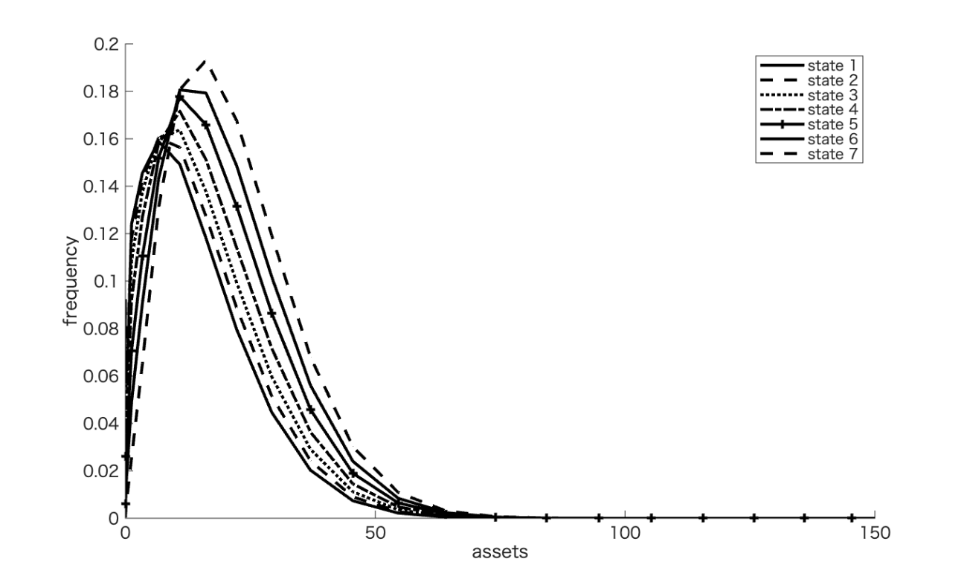

Note: State i (i=1,2,3,4,5,6,7) represents the ith income state.

Figure 7. Total assets (left), consumption (middle), and labor (right) at the steady state in the exogenous labor supply model
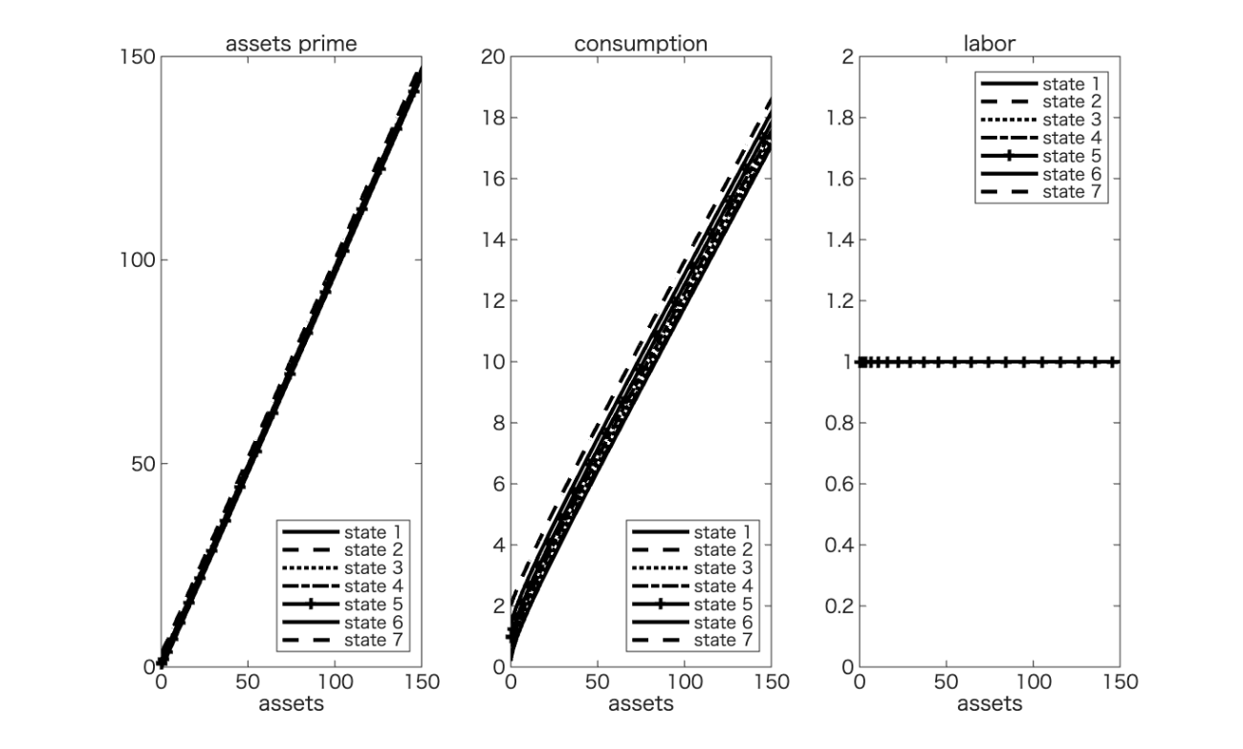

Note: State i (i=1,2,3,4,5,6,7) represents the ith income state.

Figure 8. Asset distribution in steady state of endogenous labor supply model
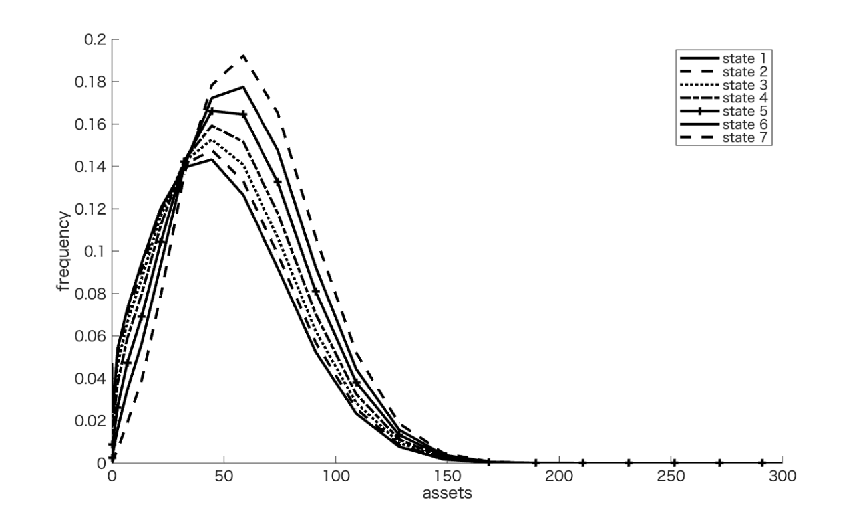

Note: State i (i=1,2,3,4,5,6,7) represents the ith income state.

Figure 9. Assets (left), consumption (middle), and labor (right) at the steady state in the endogenous labor supply model

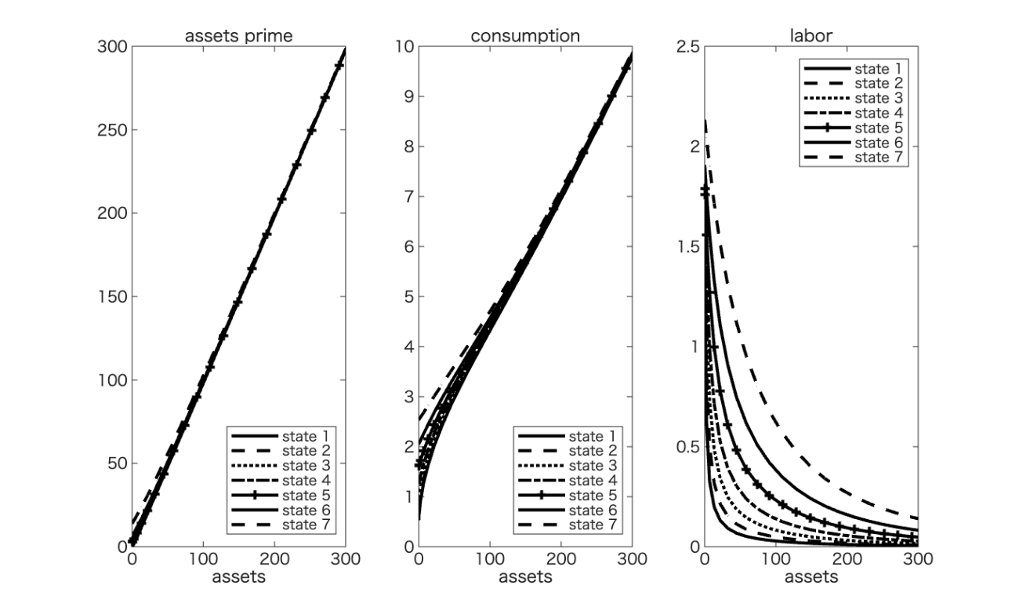

Note: State i (i=1,2,3,4,5,6,7) represents the ith income state.

7.2. Inequality measures in the model and comparison with the data

Table 18 presents the Gini coefficients obtained using the calibrated model. Asset inequality widens more than income inequality because entities facing higher labor income can save more (financial) assets. However, consumption inequality is smaller than income inequality because of consumption smoothing. The differences between the results of the exogenous and endogenous labor supply models are twofold. First, disposable total income inequality increases because higher (lower) labor productivity encourages (discourages) labor supply, and labor income inequality is much larger. Second, consumption inequality increases slightly because the total disposable income inequality increases.

Table 18. Gini index of labor income, assets, and consumption in exogenous and endogenous labor supply models

 | Calibration |  | Empirical evidence
 | Exogenous labor supply | Endogenous labor supply | Lise et al. (2014) | Kitao and Yamada (2019) | Kitao and Yamada (2024)
Assets | 0.501 | 0.420 |  | 0.32–0.35
Disposable labor and capital income | 0.442 | 0.608 | 0.22–0.25 |  | 0.22–0.26
Disposable labor income | 0.505 | 0.689 |  | 0.56–0.64
Consumption | 0.356 | 0.255 | 0.21–0.25 |  | 0.22–0.275

Next, we compare the results of our data-based Gini coefficient estimates with those from survey data-based analyses in Japan. Lise et al. (2014) used four primary data sources: the Basic Survey on Wage Structure (BSWS), Family Income and Expenditure Survey (FIES), National Survey of Family Income and Expenditure (NSFIE), and Japanese Panel Survey of Consumers (JPSC) from 1981 to 2008. Kitao and Yamada (2019) used a national consumption survey from 1984 to 2014, and Kitao and Yamada (2024) used a household survey from 1981 to 2021. Lise et al. (2014) and Kitao and Yamada (2019) found that the Gini index rose from 0.32 to 0.35 for income and from 0.58 to 0.64 for wealth over the same period. Kitao and Yamada (2024) found that the Gini index ranged from 0.22 to 0.26 for disposable income, while it moderately increased from 0.22 to 0.275 for total consumption. The income Gini index from the simulation is higher than that of Kitao and Yamada (2019, 2024), and the asset Gini index is smaller than that of Kitao and Yamada (2019). However, the consumption Gini indices are consistent with those reported by Lise et al. (2014) and Kitao and Yamada (2024). This implies that the higher-income states in the FTR data (especially the fifth-income state) reported higher Gini coefficient values than the other survey data, partly due to their higher relative mean incomes. Nevertheless, consumption smoothing in our simulated results works well, and consumption inequality is mitigated, consistent with the empirical results. Therefore, the Gini coefficient is considered an issue.

- Conclusion

This study numerically analyzes the Japanese economy’s consumption, capital distribution, and labor supply in the total and income quintiles using Japanese tax return data from 2014 to 2020. Additionally, it numerically simulates an incomplete market model with individuals with different incomes and labor productivity. We discuss the characteristics of administrative and tax return data and what should be considered when comparing them with administrative data from other countries. In the calibrations to obtain the model parameters, we use labor income tax data from the FTR to estimate the transition process of proportional labor income and the income tax rate function to analyze the macro model. Specifically, we compare the simulation results of a benchmark model with an exogenous labor supply and an endogenous model with an endogenous labor supply for consumption and asset distribution trends by income quintile in the steady state. The simulation analysis results show that the consumption and income inequalities are greater than those in Kitao and Yamada (2024). However, the asset inequality results derived implicitly from this model are generally consistent.
A limitation of our current framework is that we abstract from modeling a fully progressive labor income tax system and instead assume a tax rate that depends solely on the productivity shock. While this simplification allows us to focus on the core mechanisms under investigation, it does not capture the nuanced labor supply responses that arise under a progressive tax schedule. Future research could extend our analysis by incorporating a more detailed tax structure to explore how progressivity affects household behavior, particularly the interplay between labor supply and productivity shocks. This extension would provide a more comprehensive understanding of the role of taxation in shaping the macroeconomic dynamics and policy implications.
Although FTR has some limitations and restrictions, it can be applied to macroeconomic models. Future research must make the FTR data more applicable to macro models. First, a more precise analysis of government expenditure and revenue is required. Regarding revenue, an additional examination of capital income and consumption taxes, as well as social insurance contributions and inhabitant taxes that exist in conjunction with income taxes, is required. Expenditures include subsidies, pensions, other income transfers, government debt, and consumption. A heterogeneous life-cycle model can also be simultaneously applied. As information on the age of each taxpayer is available in the FTR data, breaking down the data within and between generations to analyze the factors contributing to the disparity is possible. Finally, to construct a dataset that approximates the population data for all taxpayers in Japan, the data for withholding-only taxpayers can be analyzed to complement the survey data.
References
Abe, N. and Yamada, T. (2009), “Nonlinear Income Variance Profile and Consumption Inequality,” Journal of the Japanese and International Economies, Vol. 23, pp.344–366.
Aiyagari, R. (1994), “Uninsured Idiosyncratic Risk and Total Saving,” Quarterly Journal of Economics, Vol. 109, pp.659–684.
Benabou, R. (2002), “Tax and Education Policy in a Heterogeneous Agent Economy: What Levels of Redistribution Maximize Growth and Efficiency?” Econometrica, Vol. 70(2), pp.481–517.
Borella, M., De Nardi, M., Pak, M., Risso, N. and Yand, F. (2023), “The Importance of Modeling Income Taxes over Time: U.S. Reforms and Outcomes,” Journal of the European Economic Association, forthcoming.
Chetty, R., Friedman, J., Leth-Petersen, S., Nielsen, T. and Olsen, T. (2014), “Active vs. Passive Decisions and Crowd-Out in Retirement Saving Accounts: Evidence from Denmark,” Quarterly Journal of Economics, Vol. 129(3), pp.1141–1219.
Cooley, T. and Prescott, E. (1995), “Economic Growth and Business Cycles,” Frontiers of Business Cycle Research, 1.
Feldstein, M. (1969), “The Effects of Taxation on Risk Taking,” Journal of Political Economy, Vol.77 (5), pp.755–764.
Gunji, H. and Miyazaki, K. (2011), “Estimates of Average Marginal Tax Rates on Factor Income in Japan,” Journal of the Japanese and International Economies, Vol. 25(2), pp.81–106.
Gunji, H., Hiraga, K. and Miyazaki, K. (2024), “Tax Deduction Matters: Elasticities of the Laffer Curve, Taxable Income, and Tax Revenue,” International Advances in Economic Research, Vol. 30, pp.1–19.
Guvenen, F., Karahan, F., Ozkan, S. and Song, J. (2021), “What Do Data on Millions of U.S. Workers Reveal about Lifecycle Earning Dynamics,” Econometrica, Vol. 89(5), pp.2303–2339.
Halvorsen, E., Ozkan, S. and Salgado, S. (2022), “Earnings Dynamics and Its Intergenerational Transmission: Evidence from Norway,” Quantitative Economics, Vol. 13(4), pp.1707–1746.
Heer, B. and Trede, M. (2003), “Efficiency and Distribution Effects of a Revenue-Neutral Income Tax Reform,” Journal of Macroeconomics, Vol. 25, pp.87–107.
Heathcote, J. Storesletten, K. and Violante, G. (2017), “Optimal Tax Progressivity: An Analytical Framework,” Quarterly Journal of Economics, Vol. 134, pp.1693–1754.
Hoffmann, F. (2019), “HIP, RIP, and the Robustness of Empirical Earnings, Processes,” Quantitative Economics, Vol. 10(3), pp.1279–1315.
Hoffmann, E. B., Malacrino, D. and Pistaferri, L. (2022), “Earnings Dynamics and Labor Market Reforms: The Italian Case,” Quantitative Economics, Vol. 13(4), pp.1637–1667.
Holter, H., Krueger, D. and Stepanchuk, S. (2019), “How Do Tax Progressivity and Household Heterogeneity Affect Laffer Curves?,” Quantitative Economics, Vol. 10(4), pp. 1317–1356.
Kitao, S., Suzuki, M. and Yamada, T. (2025), “Nonlinear Earnings Dynamics and Inequality over the Life Cycle: Evidence from Japanese Municipal Tax Records,” RIETI Discussion Paper Series 25-E-081.
Kitao, S. and Yamada, T. (2019), “Dimensions of Inequality in Japan: Distributions of Earnings, Income and Wealth between 1984 and 2014,” RIETI Discussion Paper Series 19-E-034.
Kitao, S. and Yamada, T. (2025), “Earnings, Income, and Wealth Inequality in Japan: A Long-Term Perspective, 1984-2019,” Japanese Economic Review, Special Issue: Heterogeneity and Macroeconomics, April 2025, Vol. 76(2), pp. 231–283.
Kitao, S., Suzuki, M. and Yamada, T. (2025), “Nonlinear Earnings Dynamics and Inequality over the Life Cycle: Evidence from Japanese Municipal Tax Records, ” RIETI Discussion Paper Series 25-E-081.
Kleven, H. and Schultz, E. (2014), “Estimating Taxable Income Responses Using Danish Tax Reforms,” American Economic Journal: Economic Policy, Vol. 6(4), pp.271–301.
Kunieda, S. and Yoneta, Y. (2023), “Significance of Tax Data-Based Analysis of Japan’s Income Tax System,” NTC Joint Research Discussion Paper Series 230100-1 (in Japanese).
Lise, J., Sudo, N., Suzuki, M., Yamada, K. and Yamada, T. (2014), “Wage, Income and Consumption Inequality in Japan, 1981–2008: From Boom to Lost Decades,” Review of Economic Dynamics, Vol. 17, pp.582–612.
Marcet, A., Obiols-Homs, F. and Weil, P. (2007), “Incomplete Markets, Labor Supply and Capital Accumulation,” Journal of Monetary Economics, Vol. 54, pp.2621–2635.
Ohno, T., Sakamaki, J., Kojima, D. and Imahori, T. (2024), “Factor Decomposition of Changes in the Income Tax Base,” Japanese Economic Review, Vol. 75(1), pp.1–28.
Tancueh, G. (1986), “Fini State Markov-Chain Approximations to Univariate and Vector Autoregressions,” Economics Letters, Vol.20 (2), pp.177–181.
Winberry, T. (2018), “A Method for Solving and Estimating Heterogeneous Agent Macro Models,” Quantitative Economics, Vol. 9(3), pp.1123–1151.
Zhu, S. (2020), “Existence of Stationary Equilibrium in an Incomplete-Market Model with Endogenous Labor Supply,” International Economic Review Vol.61 (3), pp.1115–1138.

Appendix 1. Detailed features of the FTR data

This appendix presents some remarkable (but substantial) statistics of the FTR data. Particularly, we select more detailed (ten-percentile) quantile and prefectural statistical data.

・Tenth quantile statistics of labor income and tax

Table A1. Summary statistics of total labor income and labor income tax in five income quantiles (Unit: 10,000 yen)

 | 1st | 2nd | 3rd | 4th | 5th
Labor income | 8.221529 | 67.62063 | 127.3881 | 184.6395 | 246
Labor income tax | 0.026703 | 0.631385 | 2.106156 | 3.869004 | 6
Observations | 4,310,288 | 4,310,897 | 4,308,214 | 4,311,897 | 4,309,719

 | 6th | 7th | 8th | 9th | 10th
Labor income | 319.7707 | 410.9032 | 533.0432 | 718.8935 | 1707.46
Labor income tax | 9.475469 | 14.98455 | 25.17056 | 49.96979 | 289.1961
Observations | 4,310,818 | 4,310,327 | 4,310,107 | 4,310,329 | 4,310,249

Table A2. Prefectural sub-sample summary statistics

Table A3. Prefectural sub-sample summary statistics (Continued)

Appendix 2. Aiyagari model algorithm in this study
・Algorithm for the Aiyagari model
The solution to the Aiyagari model is characterized by a fixed-point algorithm:
- Initial guess: Start with initial values for aggregate assets $A_{0}$, labor $N_{0}$, and tax revenue $TX_{0}$.
- Factor prices: Using $A_{0}$, $N_{0}$, and $TX_{0}$, solve the firm’s problem to compute the interest rate $r$ and wage $w$. Specifically, solve the following equations:
$$\begin{matrix}rB\left(r\right) & =TX_{0}-gY\left(r\right), \\ w & =\left(1-α\right)k{\left(r\right)}^{α},\end{matrix}$$
- where $g$ is the ratio of government spending to output, and
$$\begin{matrix}A_{0} & =B\left(r\right)+k\left(r\right)N_{0}, \\ Y\left(r\right) & =k{\left(r\right)}^{α}N_{0}, \\ k\left(r\right) & ={\left(\frac{1+r-δ}{α}\right)}^{\frac{1}{α-1}}.\end{matrix}$$
- Household policy functions (FTR): Given $r$ and $w$, solve for policy functions (consumption, savings, and labor supply) of households with FTR: $g_{ϵ}^{FTR}\left(a;r,w\right)$, $l_{ϵ}^{FTR}\left(a;r,w\right)$ and $c_{ϵ}^{FTR}\left(a;r,w\right)$.
- Aggregate functions (FTR): Given the FTR household policy functions, compute the aggregate assets and labor supply with FTR:
AFTRr,w=ϵ​∫adgϵFTRa;r,wNFTRr,w=ϵ​∫lϵFTRa;r,w dgϵFTRa;r,wCFTRr,w=ϵ​∫cϵFTRa;r,w dgϵFTRa;r,w
- Household policy functions (JHPS): Given $r$ and $w$, solve for policy functions of households with JHPS: $g_{ϵ}^{JHPS}\left(a;r,w\right)$, $l^{JHPS}\left(a,ϵ;r,w\right)$, and $c_{ϵ}^{JHPS}\left(a,ϵ;r,w\right)$.
- Aggregate functions (JHPS): Given the JHPS household policy functions, compute the aggregate assets and labor supply with JHPS:
AJHPSr,w=ϵ​∫adgϵJHPSa;r,wNJHPSr,w=ϵ​∫lϵJHPSa;r,w dgϵJHPSa;r,wCJHPSr,w=ϵ​∫cϵJHPSa;r,w dgϵJHPSa;r,w
- Aggregate distribution: Combine two types of aggregate functions using a weight $μ$ (where $0<μ<1$) to form the overall aggregate assets, labor supply, and consumption:
$$\begin{matrix}A\left(r,w\right) & =μA^{FTR}\left(r,w\right)+\left(1-μ\right)A^{JHPS}\left(r,w\right), \\ N\left(r,w\right) & =μN^{FTR}\left(r,w\right)+\left(1-μ\right)N^{JHPS}\left(r,w\right), \\ C\left(r,w\right) & =μC^{FTR}\left(r,w\right)+\left(1-μ\right)C^{JHPS}\left(r,w\right),\end{matrix}$$
- and calculate the tax revenue:
$$TX\left(r,w\right)=τ_{c}C(r,w)+τ_{l}wN\left(r,w\right)+τ_{a}rA\left(r,w\right).$$
- Convergence check: If $\left|A\left(r,w\right)-A_{0}\right|<tol$, the equilibrium is found. Otherwise, update the guess $A_{0}$, $N_{0}$, and $TX_{0}$, and return to step 2.

Appendix 3. Sensitivity analysis
We compared the benchmark results with other parameters of relative risk aversion $σ$ and labor supply elasticity $η$. We have added a sensitivity analysis in the case of $σ=1$ and 3, and $η=0.5$ and 2. In this appendix, we calibrate the model using the FTR data.
Figures A1 and A2 show the asset distribution and policy functions when $σ=2,$ and Figures A3 and A4 show them when $σ=3$. Households with higher $σ$ try to hold more precautionary savings to reduce consumption as well as income volatility. Regarding the comparison of labor supply elasticity, Figures A5 and A6 show asset distribution and policy functions when $η=0.5$, while Figures A7 and A8 show them when $η=2$. When $η=0.5$, the wage elasticity of labor supply is high, and labor supply is more volatile in labor productivity. Conversely, labor supply is less volatile when $η=2$. From Table A4, we can see that the difference in the values of σ and λ has a greater impact on the Gini coefficient for asset, income, and consumption inequality.

Table A4. Gini index of labor income, assets, and consumption in both exogenous and endogenous labor supply models in sensitivity analysis

σ | 2(benchmark) | 1 | 3 | 2 | 2
η | 1(benchmark) | 1 | 1 | 0.5 | 2
Assets | 0.362 | 0.420 | 0.332 | 0.340 | 0.383
Disposable labor and capital income | 0.604 | 0.608 | 0.607 | 0.663 | 0.548
Disposable labor income | 0.683 | 0.689 | 0.685 | 0.765 | 0.611
Consumption | 0.185 | 0.255 | 0.147 | 0.167 | 0.205

Figure A1. Asset distribution in the steady state of endogenous labor supply model When $σ=1,η=1$

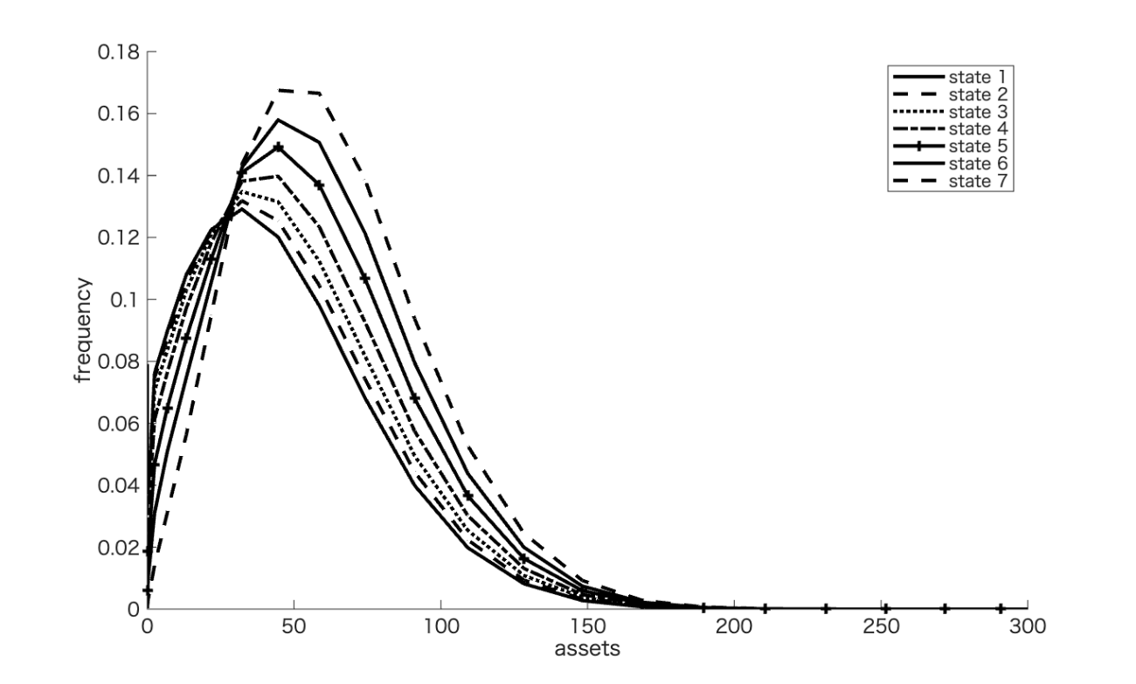

Note: State i (i=1,2,3,4,5,6,7) represents the ith income state.

Figure A2. Assets (left), consumption (middle), and labor (right) at the steady state in the endogenous labor supply model when $σ=1,η=1$

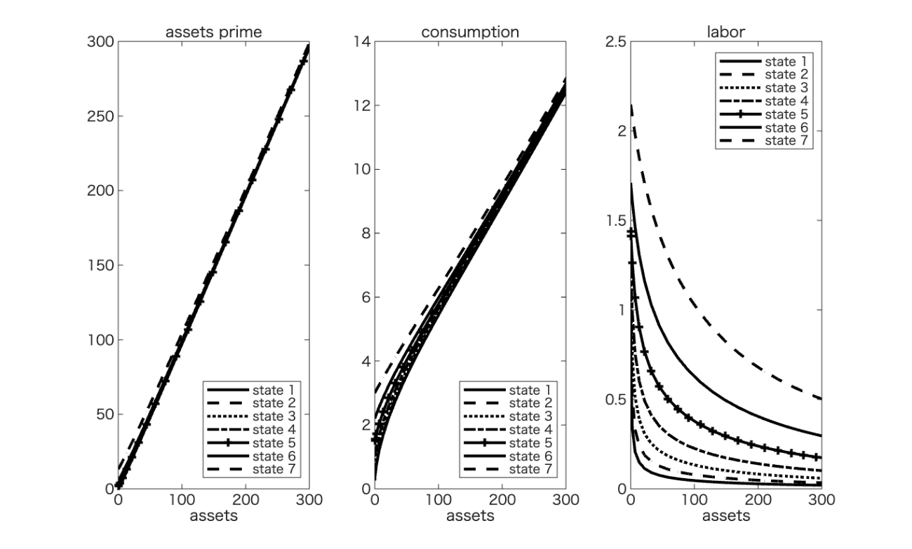

Note: State i (i=1,2,3,4,5,6,7) represents the ith income state.

Figure A3. Asset distribution in the steady state of endogenous labor supply model when $σ=3$
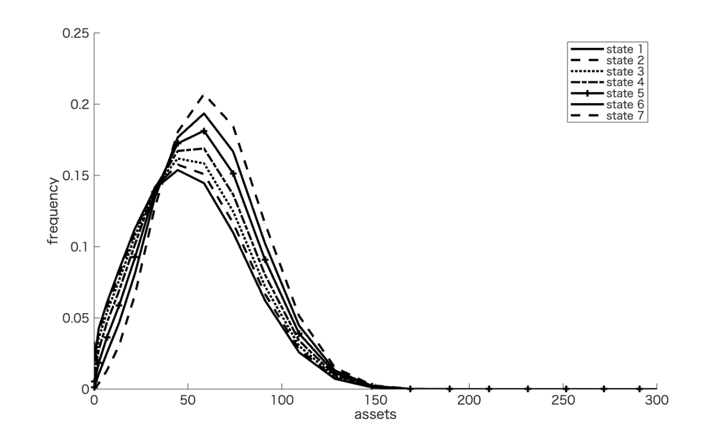

Note: State i (i=1,2,3,4,5,6,7) represents the ith income state.

Figure A4. Assets (left), consumption (middle), and labor (right) at the steady state in the endogenous labor supply model when $σ=3,η=1$
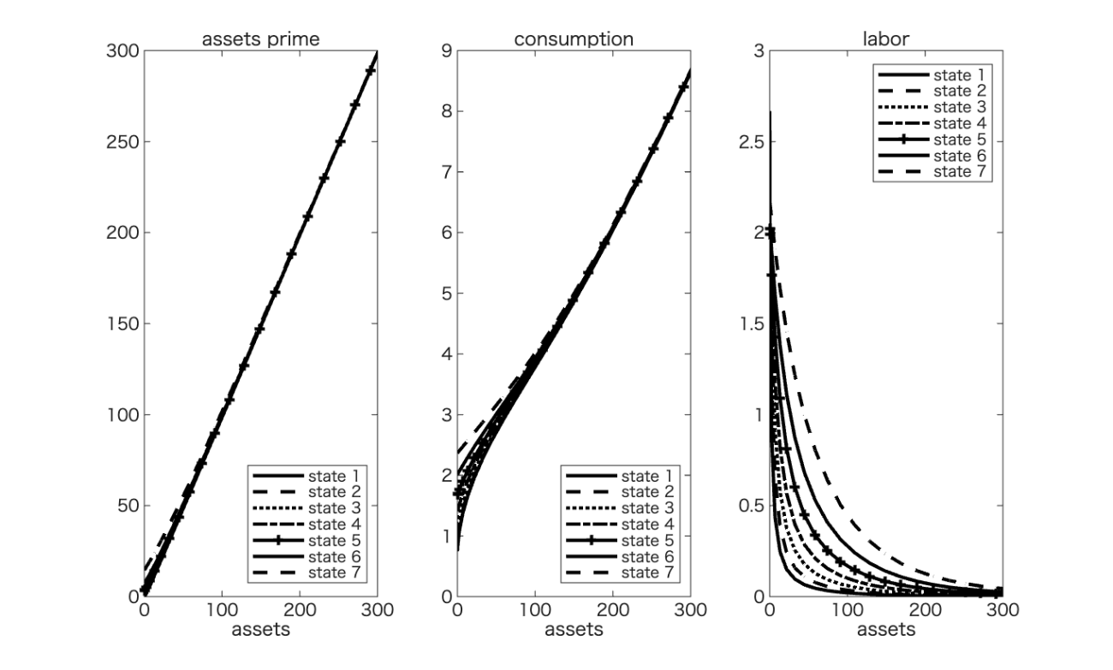

Note: State i (i=1,2,3,4,5,6,7) represents the ith income state.

Figure A5. Asset distribution in the steady state of endogenous labor supply model when $σ=2, η=0.5$
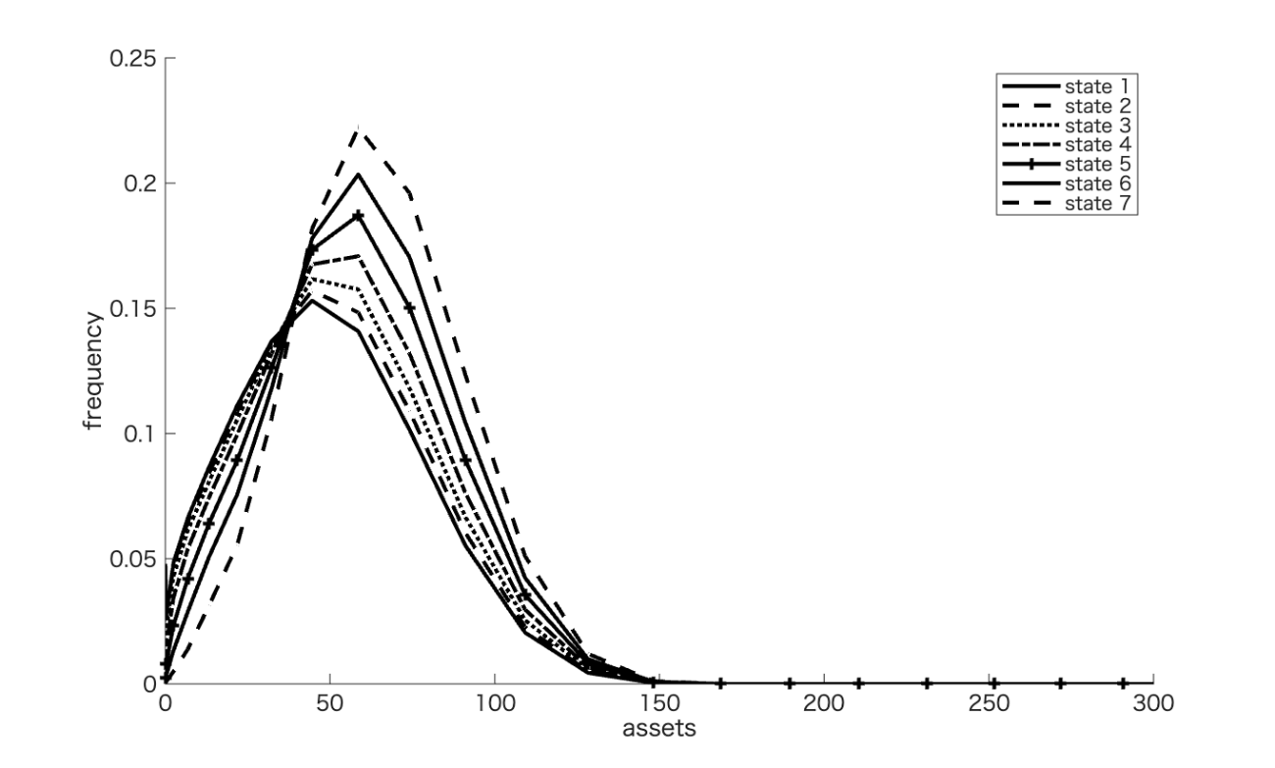

Note: State i (i=1,2,3,4,5,6,7) represents the ith income state.

Figure A6. Assets (left), consumption (middle), and labor (right) at the steady state in the endogenous labor supply model when $η=0.5$
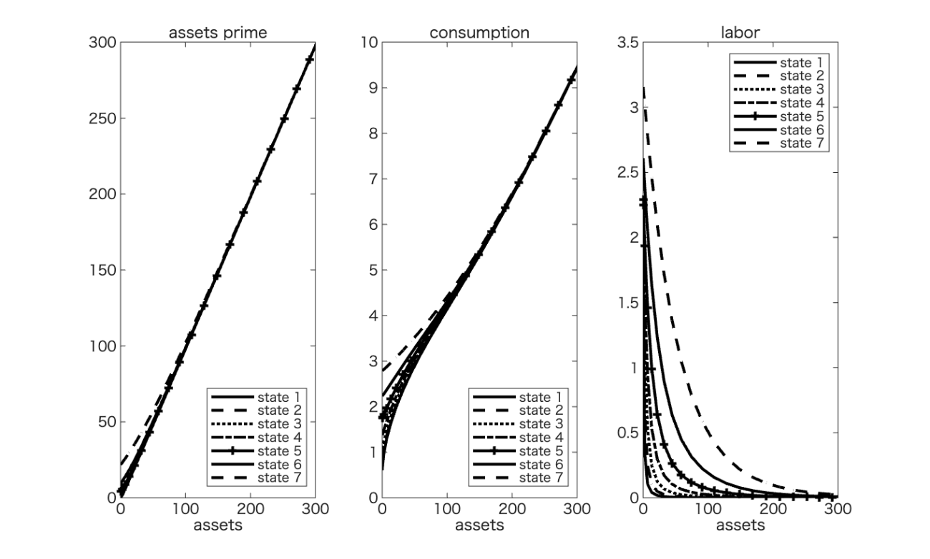

Note: State i (i=1,2,3,4,5,6,7) represents the ith income state.

Figure A7. Asset distribution in the steady state of endogenous labor supply model when $σ=2,η=2$
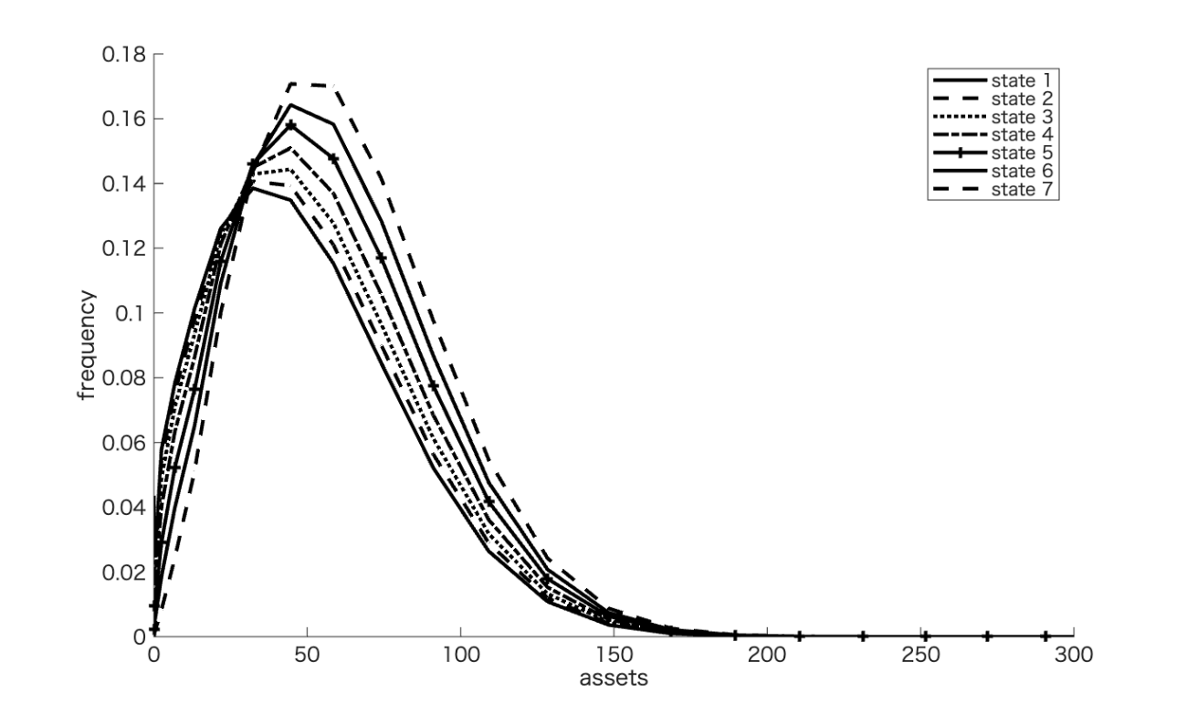

Note: State i (i=1,2,3,4,5,6,7) represents the ith income state.

Figure A8. Assets (left), consumption (middle), and labor (right) at the steady state in the endogenous labor supply model when $σ=2,η=2$
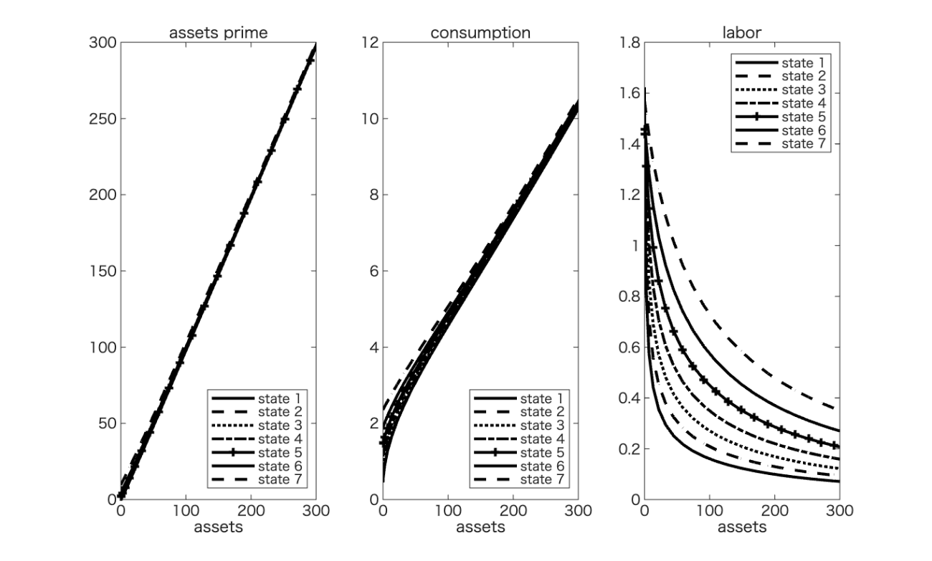

Note: State i (i=1,2,3,4,5,6,7) represents the ith income state.

We are grateful to Michio Suzuki, Makoto Nakajima, Toshihiko Mukoyama, Sagiri Kitao, Shinichi Nishiyama, Hitoshi Tsujiyama, Takashi Unayama, Selahattin İmrohoroğlu, and the participants of the JER Special Issue Conference. We acknowledge financial support from the Ministry of Education, Science, Sports, and Culture, Grant-in-Aid for Scientific Research (C) 23K01384. Our study is part of the Joint Research Project of the National Tax Agency titled “Tax data-based analysis of Japan’s income tax system.” In addition to our macro analysis group, the micro analysis group in this project is analyzing the distribution of top income, income redistribution with proportional estimates of deductions and social insurance contributions, and estimating the elasticity of taxable income (ETI). Additionally, this study utilizes individual data from the final tax return (FTR) data by the Japanese National Tax Agency and “Japanese Household Panel Survey (JHPS)” by the Panel Data Design and Analysis Center at Keio University.
School of Economics, Nihon University, email: gunji.hiroshi@nihon-u.ac.jp
Graduate School of Economics, Nagoya City University, email: khiraga@econ.nagoya-cu.ac.jp
Faculty of Economics, Hosei University, email: miya_ken@hosei.ac.jp
Form 1 (Dai 1 Pyou) of the tax return lists various income deductions (such as deductions for social insurance premiums, small-scale enterprise mutual aid premiums, life insurance premiums, earthquake insurance premiums, widows and single parents, working students and disabled persons, spouses (special), dependents, miscellaneous losses, medical expenses, and donations, as well as basic deductions) as amounts deducted from income.
When taxpayers sell assets other than land, buildings, or stocks, the capital gains they make are divided into two categories: long- and short-term, depending on how long they have owned the asset from the time they acquire it until the time they sell it. Long-term capital gains are those made when taxpayers have owned the asset for more than five years, while short-term capital gains are those made when they have owned the asset for five years or less.
If the Disaster Reduction and Exemption Law is applied, the amount of disaster reduction and exemption will be stated. Additionally, the amount of special income tax for recovery will be the standard income tax amount (which is the income tax amount after tax credit deduction) after deducting the disaster exemption amount, multiplied by 2.1%.
Following Kunieda and Yoneta (2023), the number of filings for the tax return is 21,812,717, and the average income is 3,437,917 yen in 2014. The total income (sum of all individuals) in the FTR data is approximately 75 trillion yen, which is approximately 19% of national income in the SNA.
However, JHPS data does not include higher incomes. For example, no person’s household annual income is larger than 60 million yen.
Those under the age of 25 are excluded from the analysis data because they are unlikely to be heads of households or full-time workers.
Business income refers to income derived from continuous and independent economic activities conducted for profit, including income from commercial, industrial, professional, and agricultural operations. It typically encompasses returns to labor, capital, and entrepreneurial effort within an organized business framework. Miscellaneous income denotes a residual category of income that does not fall under standard classifications such as wages, business income, or capital income. It usually includes irregular or secondary receipts arising from non-systematic activities, royalties, or incidental services. Occasional income captures income generated from infrequent, non-recurring events that are not part of the taxpayer’s regular economic activity, such as lottery winnings, prizes, or one-off asset disposals, and is characterized by its transitory and exceptional nature.
In the System of National Accounts (SNA), the labor share is calculated as the ratio of compensation of employees to national income in factor cost representation. Formally, $$\text{labor share}=\frac{\text{Compensation of Employees Income+}\text{labor share}\text{×Mixed Income}}{\text{National Income (in Factor Cost Representation)}}$$ $$\text{⇒}\text{labor share}=\frac{\text{Compensation of Employees Income}}{\text{National Income (in Factor Cost Representation)}\text{－}\text{Mixed Income}},$$ where compensation of employees includes wages, salaries, and employers’ social contributions.
Note that the ratio of zero income is approximately 8% in our data, while the full-sample data is approximately 25% (which includes women and retirees).
We also estimate the FTR data without zero income, while the tax progressivity remains almost linear $λ_{0}=0.012$ and $λ_{1}=0.041$.
To the best of our knowledge, no studies have estimated the income process in Japan using both JHPS and FTR data. Abe and Yamada (2011) estimate the income process using microdata from the National Survey of Family Income and Expenditure, but Abe and Yamada (2011) assume $ρ=1$.
To obtain the Markov transition matrix, which is approximated in Eq. (4), we take N grids as follows: $$ε_{i}∈Ε=\left\{ε_{1},ε_{2},⋯,ε_{N}\right\},$$ where $ε_{1}=\frac{-mσ_{v}}{\sqrt{1-ρ^{2}}}+\overline{ε},ε_{N}=\frac{mσ_{v}}{\sqrt{1-ρ^{2}}}+\overline{ε}$ and $ε_{i}=ε_{i-1}+d, for i=2,…,N-1.$ $\overline{ε}$ is the average of $ε_{i}$ and $d$ represents the distance between adjacent grids; that is, each grid is set at equal intervals within a range of $m$ times the standard deviation $σ_{ε}=\frac{σ_{v}}{\sqrt{1-ρ^{2}}}$. We set $m=1$ and $N=7$ to obtain the Markov transition matrix due to computational constraint. In this case, we set $d=\frac{σ_{v}}{6\sqrt{1-ρ^{2}}}.$ Therefore, using the estimated values of $ρ$ and $σ_{v}$ in Table 10, we set $d_{FTR}=0.186$ and $d_{JHPS}=0.223$.
In this study’s calibration, the tax rate is determined in a manner corresponding to labor efficiency.
For a detailed explanation of the computation method, see Appendix 3.
In our calibration, $\frac{K}{Y}=2.128$ in the exogenous model and $\frac{K}{Y}=3.981$ in the endogenous model, which are larger than the recent Japanese data ($\frac{K}{Y}=2.7$ on average from 2014–2019).
More precisely, we calculate the average tax rate by substituting the level of labor income in each state into the estimated disposable income function.
The values of assets on the horizontal axis in Figures 6–9 are theoretical values based on numerical calculations, and the level values themselves are not meaningful (although relative comparisons are possible).
Other parameter sets are the same as those used in the benchmark.

