Sonoma State University
Computer Science Department

CS 330 – Spring 2014 – Watts
Rules of The Vault

OBJECTIVE: Explore the rooms around you, find keys, and unlock doors.

GAME BOARD:
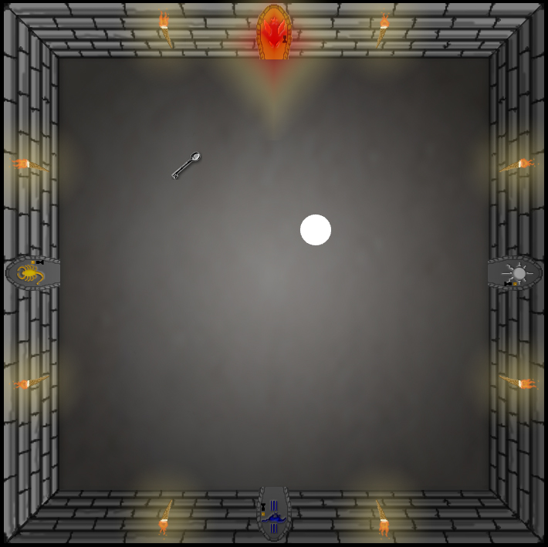
The player character, signified by a white circle, starts in a room with 4 doors leading off in different directions. There are keys that you find that sequentially open up another room.

RULES: You can inspect your immediate area with the ‘E’ key. This will allow you to inspect a locked door, pick up a key, or enter a passageway, etc.
 | The scroll area will display all text notifications gained from inspecting your surroundings. | 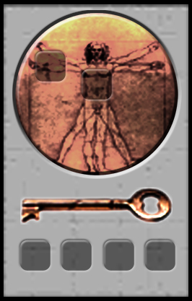 | Your inventory panel will show which keys you have found as well as if you have anything equipped.

WIN/LOSS: You win this version of the game by finding all four keys and unlocking the final door. There is loss condition outside failing to progress.

TIPS: Inspect rooms thoroughly and you should have no trouble.

