Sonoma State University

Computer Science Department

# CS 330 – Spring 2014 – Watts

**Rules of Tranceform**

**by Kenji Johnson**

OBJECTIVE: Score points while avoiding enemy fire.

GAMESCREEN:

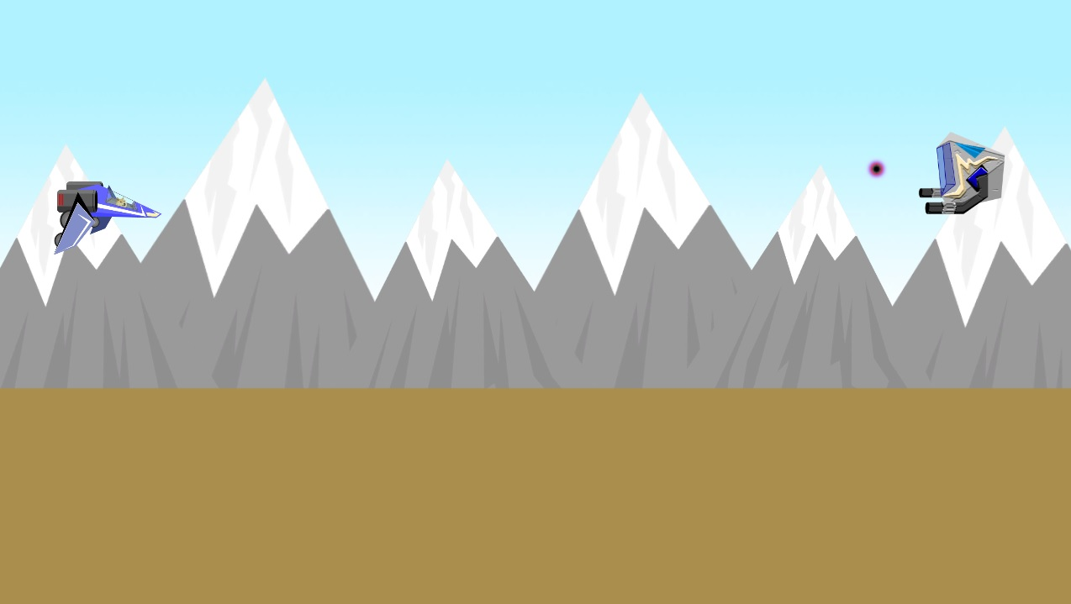

You, the player are on the left as the blue ship. Enemies spawn on the right.

RULES: With the ‘1’ ‘2’ and ‘3’ number keys, select which laser color to fire to hit the respectively colored randomly spawning enemy ships with the ‘Space’ or ‘Mouse Left Click’

|  |  |  |
| --- | --- | --- |
|  |  |  |
|  |  |  |

You move your ship with the ‘W, A, S, D’ keys to move up, left, down, and right respectively.

If you move towards the ground as the ship and hit the ‘Left Shift’ key you transform into a ground vehicle.

In ground form, hitting the fire button now launches a missile that will clear the entire screen of enemy ships and their plasma projectiles. Note, you only have three of these missiles at your disposal.

|  |  |
| --- | --- |
|  |  |

At any time, hit ‘Escape’ to quit the game directly.

WIN/LOSS: You lose by taking 5 enemy hits or by directly colliding with an enemy ship. Survive as long as you can and score the highest possible score!

TIPS: Use car mode to momentarily evade attacks until the end of the wave!