**Conservation and Distribution Analysis of Habour and Grey seals in Tees Estuary from (2007-2010)**

**Submitted by**: Akinbode Oyinlola

**Content**

1.0 Introduction

1.1 Seals Threat

1.2 Causes of Seals Threat

1.3 Seals Conservation

1.4 Challenges to Grey and Harbour Seals Conservation In the UK

2.0 Research Methods and Data Analysis

3.0 Research Findings

3.1 Normality

3.2 Shapiro Test

3.3 Kruskal-Wallis Rank Sum Test

3.4 Pairwise Wilcox Test

3.5 Kruskal-wallis rank Sum Test for Each Year

3.6 Error Bar

4.0 Discussion

5.0 Limitations

6.0 Recommendation

7.0 References

Appendix

**1.0 Introduction**In the last ten years, a considerable reduction in the population of harbour seals (*Phoca vitulina*) has been observed in the United Kingdom, especially in the northeastern regions (Jones et al., 2015). In contrast, the south-east populations have shown steady growth despite being affected by phocine distemper virus epidemics (Jones et al., 2015). Grey seals (*Halichoerus grypus*), on the other hand, have generally increased in number in the UK (Banga et al., 2022), although reports of infanticide and cannibalism have been observed among them (Brownlow et al., 2016).

Monitoring population trends and improving regulations on culling are recommended to better understand the impact of human disturbance on harbour seal populations (Vincent et al., 2017). The Moray Firth Seal Management Plan aims to enhance the conservation of seals, fisheries, salmon, and ecotourism in the United Kingdom, as highlighted by Lakemeyer et al. (2020). High-resolution GPS tracking data has been utilised to study habitat preferences and distribution patterns of harbour seals and Grey seals found throughout the United Kingdom and Ireland (Carter et al., 2022). In terms of disease investigation, tests on tracheal swabs and lung tissue samples from seals, these tests have been conducted to detect various viruses, including influenza A virus, canine distemper virus, cetacean morbillivirus, and phocine distemper virus (Stokholm, 2023).

These studies and research efforts contribute to our understanding of seal populations, their trends, habitat preferences, and disease presence, which can inform conservation and management strategies for these species in the UK.

**1.1 Seals Threat**

Various factors can cause disturbances for Grey and harbour seals in the UK, with one significant source being micro-plastic pollution, as indicated by Philipp et al. (2020). Microplastics, detected in the intestines of seals in German waters, can have detrimental effects on marine organisms through ingestion and potential toxicity. Competition for prey is another potential source of disturbance, as Grey and harbour seals occupy similar trophic levels and have similar diets (Wilson & Hammond, 2019; Das et al., 2003). Changes in prey availability or increased competition may be contributing factors to the decline in harbour seal populations while Grey seals have increased (Wilson & Hammond, 2019).

Interactions between grey seals and harbour porpoises have also been identified, with grey seals implicated in the mutilation of porpoises (Leopold, 2015). These interactions highlight the potential impact of predation or competition on the populations of both species. Harbour seal populations have experienced regional declines, potentially influenced by historical impacts from phocine distemper virus epidemics (Castles et al., 2021). However, there are reports of increasing numbers of both grey and harbour seals in certain areas, indicating variations in local population dynamics (Planque, 2021; Castles et al., 2021; Vincent et al., 2017).

To better understand habitat preferences and distribution patterns, high-resolution GPS tracking data has been utilised (Carter et al., 2022). The utilisation of this data has contributed to modelling habitat preferences and estimating the at-sea distribution of grey and harbour seals within the UK and Ireland populations. Such information is crucial for developing effective conservation strategies and managing potential disturbances. Monitoring and managing the potential sources of disturbance faced by grey and harbour seals in the UK is essential (Philipp et al., 2020). Microplastic pollution, competition for prey, historical impacts from diseases, and interactions with other species can all influence the conservation status of these seals. Continued research, monitoring, and effective management strategies are necessary to ensure the preservation of these seal populations in the UK. **1.2 Causes of Seal Threat**

The disruption of Grey and harbour seals' habitats in the United Kingdom can be attributed to a multitude of factors. Urban development is one of the primary causes, leading to the degradation of their habitats. This issue has been observed to impact the populations of harbour seals in Atlantic Canada as well (Hamill et al., 2010). Another significant factor is the phocine distemper virus (PDV), which had a severe impact on harbour seal populations in both 1988 and 2002. These outbreaks resulted in notable reductions of up to 50% in certain sub populations within the UK (Castle et al., 2021). Variations in prey consumption by grey seals in UK and Irish waters have been observed, likely due to changes in prey availability influenced by their habitats (Jessop et al., 2013). The shared usage of haul out sites in coastal waters by seals, such as grey and harbour seals, can lead to competition for resources (Hammond et al., 2005). Lastly, human activities including fishing, shipping, and tourism can disturb seal habitats as well (Carter et al., 2022).

**1.3 Seals Conservation**Seals face diverse conservation challenges that are influenced by factors such as species, habitat, and interactions with fisheries. Harbour seals and Grey seals have distinct habitat preferences, with Grey seals venturing offshore and utilising corridors connecting offshore regions with haul-out sites (Butler et al., 2008). Fisheries protection is a consideration in seal population management, with shooting allowed under the enacted Conservation of Seals Act 1970 in the United Kingdom to safeguard fisheries interests (Kirkwood & Goldsworthy, 2013). Fur seals in Australian waters have faced historical near-extinction but have since recovered and are now commonly observed in near-shore waters (Thompson et al., 2007).

In certain regions, coordinated management plans have been put into action to strike a balance between safeguarding salmon fisheries and minimising the impacts on local seal populations. An example of this can be seen in north-east Scotland, as highlighted by Karamanlidis et al. (2015). The monk seal species found in the Mediterranean region has experienced significant declines, and ongoing conservation efforts face new challenges due to the shortening and potential disappearance of thermal winters, which may hinder reproductive success and increase the risk of extinction (Vanhatalo et al., 2014). A major obstacle in seal conservation is the lack of up-to-date information on seal-fish interactions and coastal fisheries, impeding effective coexistence and conservation efforts (Holma et al., 2014). The implementation of conservation measures for Grey seals has resulted in a rise in seal-related damage to Atlantic salmon fisheries in the Baltic Sea, highlighting the complexities and trade-offs involved in managing seal populations and protecting other marine resources (Jones et al., 2015). Effective management plans, stakeholder coordination, and updated research are crucial for the conservation and coexistence of seals with other marine resources in different regions. For effective conservation outcomes, it is crucial to have a comprehensive understanding of the specific requirements and dynamics of seal species, including their habitats, behaviour, and interactions with fisheries.

**1.4 Challenges to Grey and Harbour Seals Conservation In the UK**

In the UK, both Grey and harbour seals encounter distinct conservation challenges, and their population trends differ from each other. Harbour seals have experienced regional declines, potentially influenced by factors such as competition for prey, particularly sandeels, and the occurrence of spiral lacerations associated with grey seal infanticide and cannibalism (Castles, 2021; Brownlow et al., 2016; Olsen et al., 2017). The populations of harbour seals were significantly affected by Phocine distemper virus outbreaks in both 1988 and 2002, while Grey seal populations have shown increases, necessitating further assessment of the current status of harbour seals (Thompson et al., 2001; Carter et al., 2022). High-resolution GPS tracking data has aided in understanding habitat preferences and distribution patterns, allowing for the modelling of habitat preference and estimating at-sea distribution for both species (Butler et al., 2011).

The impact of seals on commercially important fisheries, such as salmon, has been deemed substantial, leading to suggestions for population reduction through culling (Nikolic et al., 2020). Genetic studies and molecular tools have helped identify appropriate spatial management units and support conservation management efforts for harbour seals (Vincent et al., 2017). Understanding the distinct habitat utilisation and connectivity strategies of Grey and harbour seals is crucial for effective conservation planning and management (Butler et al., 2011). The conservation challenges faced by Grey and harbour seals involve population declines, competition for prey, disease outbreaks, uncertain population status, and potential conflicts with fisheries. Genetic studies, high-resolution tracking data, and adaptive management approaches are necessary to address these challenges and ensure the conservation of these species in the UK.

**2.0 Research Methods and Data Analysis**

This study utilised systematic observations to analyse preexisting data on the average counts of Grey and Harbour seals at multiple sites. The data were obtained through observations or remote monitoring techniques from secondary sources, and variables such as the average count and site information were recorded in a datasets called "seals". The seal data were collected from Tees Estuary in the summer of 2007-2010 from Site Wall, Site Spit, Site A, Site B, Site C, Site D, and Site E. To summarise the data, descriptive statistics were calculated, and the normality assumptions were evaluated through the examination of histograms and Q-Q plots. Non-parametric tests were utilised to analyse differences in average counts between sites. The Kruskal-Wallis test was employed to evaluate overall differences, and if significant, pairwise Wilcoxon tests with multiple comparison adjustment were conducted. Data visualisation techniques, such as ggplot2, were employed to visually explore the distribution of average counts across sites.

## **3.0 Research Findings**

## 3.1 Normality

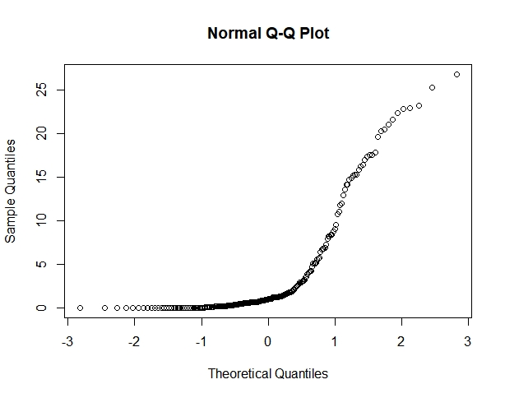

Figure1:

The average count data of seals in the report, as depicted by the normal Q-Q plot, indicates a deviation from the normal distribution. The points bend away from the diagonal line in the middle, indicating a potential presence of higher-order moments such as kurtosis.

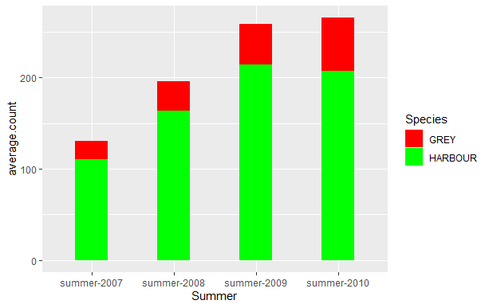

Figure2:

The figure2 presented illustrates the distribution of average seal species counts during the summer months from 2007 to 2010. It is evident that harbour seals were the predominant species throughout this period. This observation is in contradiction with the findings of Brownlow et al. (2016), who reported an increase in the Grey seal population within the United Kingdom.

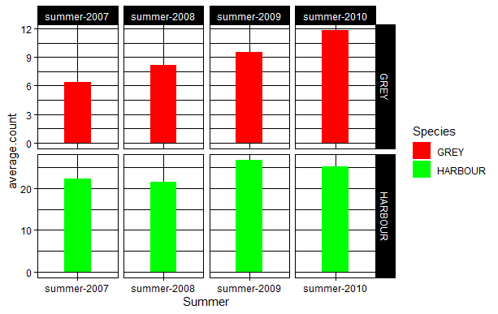

Figure3:

Figure 3 depicts the abundance of seal species during the summers of 2007-2010. The figure comprises two charts, each representing the average count of grey and harbor seals during the summer months. A noticeable increase in the populations of both species is evident since 2007. Remarkably, the figure highlights a substantial presence of harbor seals. This observation corroborates the findings of several researchers who have documented the rising numbers of both species in specific regions.

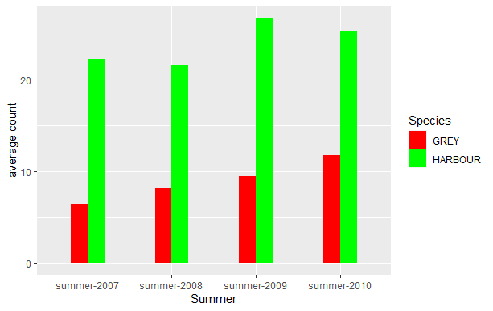

Figure4:

The figure demonstrates a notable dominance of harbor seals during the years under investigation. Concurrent population growth of both harbor and Grey seals implies that alterations in prey accessibility or diminished inter specific competition could be potential contributing factors.

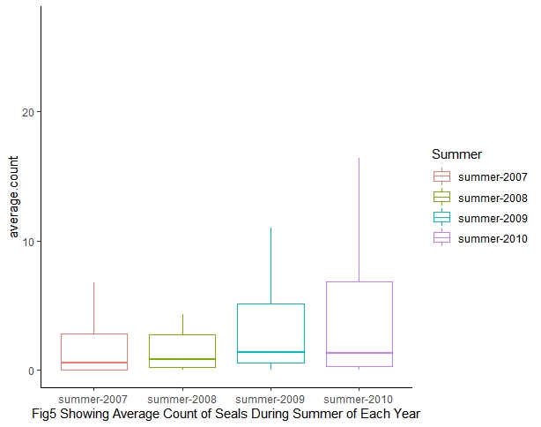

Figure5:

The graphical representation displays the annual summer periods within the years under examination, revealing a consistent upward trend in seal populations from 2007 to 2010. A particularly substantial increase is evident during the summer of 2010.

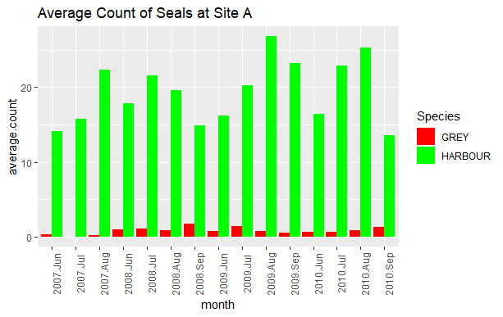 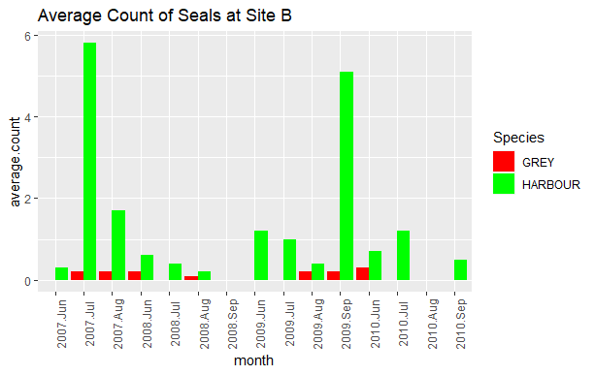

Figure6: Figure7:

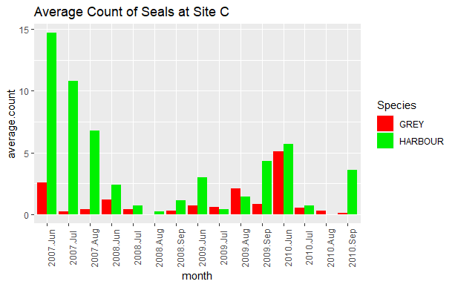 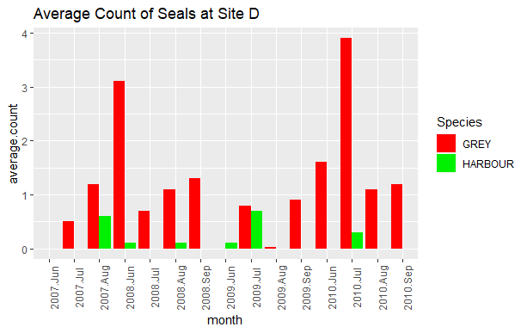

Figure8: Figure9:

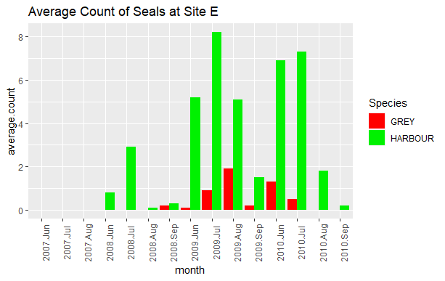 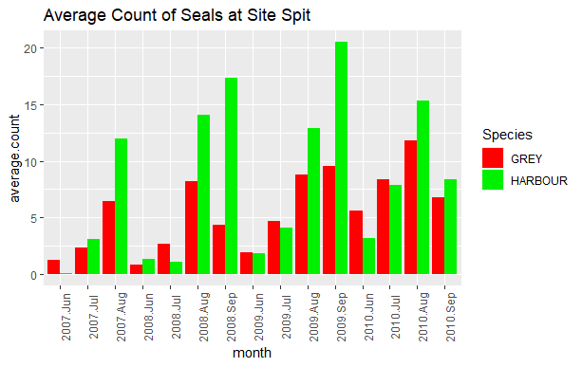

Figure10: Figure11:

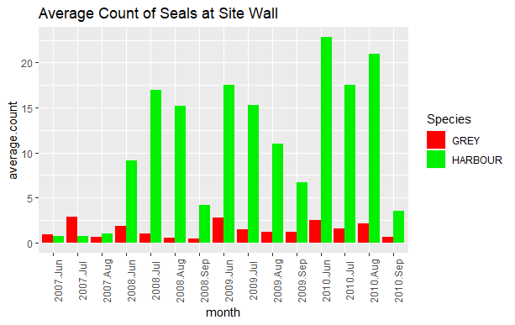

Figure12:

The population of Grey seals at Site A (Figure 6) demonstrates relatively lower averages, and the haul out rate for this species displays significant fluctuations over time. On the other hand, despite harbour seals exhibiting a relatively high haul out rate, their population growth appears to be irregular. Notably, there are instances where Grey seal sightings are absent at Site B during specific months (Figure 7). However, harbour seals are observed during July 2007 and September 2010. In summary, the presence of these species at this location is limited. The highest average seal count was documented in June 2007 (Figure 8), succeeded by July of the same year. The graph indicates a decline in harbour seal sightings in the preceding years, followed by a consistent increase in 2007. Grey seals experience irregular growth at this site.

At Site D (Figure 9), Grey seals are plentiful, with the highest average count of the species occurring in July 2010 and the second highest in June 2008. Harbour seals are not the dominant species in this particular location, and there are days when no sightings of either seal species are reported. At Site E (Figure 10), both harbour seals and Grey seals are scarce, with certain months where neither species is observed. While the average count of harbour seals is higher during specific months, the most significant months for Grey seals are August 2009 and June 2010. Even though the haul rates for both species differ, both harbour and Grey seals are present, as depicted in Figure 11. The average counts of the two species have increased unevenly over time. The inconsistent growth patterns of harbour and Grey seals are evident in the average counts recorded at the site. Additionally, Figure 12 illustrates that harbour seals are the predominant species in the area.

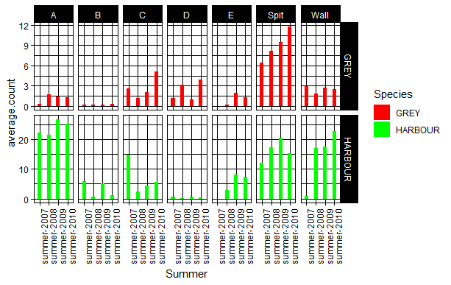

According to Figure 13, for the period of the study, Site A exhibited the highest average population of harbour seals in the summer of 2009 compared to the preceding summers between 2007 and 2010. In contrast, Site D had the lowest average count of harbour seals in the summer of 2010. Regarding Grey seals, Site B had the lowest haul out rate during the summers of 2007, 2008, and 2009, while the Spit Site recorded the highest haul out rate for Grey seals in the summer of 2010.

**3.2 Shapiro Test**

The Shapiro-Wilk test result, with a p-value < 2.2e-16, indicates strong evidence to reject the null hypothesis of the seals data following a normal distribution. The data significantly deviates from normality, as supported by the very small p-value. The test statistic, W = 0.67749, provides additional information about the departure from normality. Considering the highly significant p-value, the deviation from normality is 3unlikely to occur by chance.

**3.3 Kruskal-Wallis Rank Sum Test**

The Kruskal-Wallis test result with a chi-squared value of 6.236 and 3 degrees of freedom yielded a p-value of 0.1007. This suggests that there is absence of strong evidence to conclude a significant difference in median average counts among the groups defined by the variable seals Summer, although there is a possibility of observing some differences that were not detected due to the relatively higher p-value.

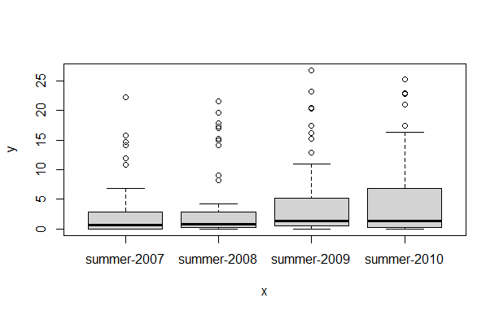

Upon examining the figure above, it is evident that the summer of 2010 recorded the highest seal count. However, upon closer inspection of the summer of 2007, certain data points on the plot indicate a high average count of seals during that period. Therefore, this figure leaves us with some uncertainty in concluding that the summer of 2010 had the most significant average count of seals for both Harbour and Grey seals.

|  |  |  |  |
| --- | --- | --- | --- |
| **Year** | **Chi-squared** | **df** | **p-value** |
| 2007 | 1.3113 | 2 | 0.1591 |
| 2008 | 0.86061 | 3 | 0.8349 |
| 2009 | 0.42051 | 3 | 0.936 |
| 2010 | 2.5001 | 3 | 0.4753 |

Table1:

The presented table demonstrates the results of a chi-squared test conducted to examine whether there are noticeable variations in the distribution of average seal counts across the summer months from 2007 to 2010. Upon analyzing the data, it is observed that the obtained p-values for the years 2007, 2008, 2009, and 2010 are 0.1591, 0.8349, 0.936, and 0.4753, respectively. These p-values exceed the predetermined significance level of 0.005.

As a result, the null hypothesis is upheld for all four years, indicating that there is no significant difference in the distribution of average seal counts during the respective summer periods. Therefore, it can be concluded that there is no substantial variation in the average seal counts across the summer months of 2007, 2008, 2009, and 2010.

**3.4 Pairwise Wilcox Test**

|  |  |  |  |
| --- | --- | --- | --- |
|  | Summer-2007 | Summer-2008 | Summer-2009 |
| **Summer-2008** | 0.89 | - | - |
| **Summer-2009** | 0.20 | 0.43 | - |
| **Summer-2010** | 0.43 | 0.64 | 0.8 |
| **P value adjustment method: holm** | | | |

**Pairwise Wilcox Test** (adjustment method: BH)

|  |  |  |  |
| --- | --- | --- | --- |
|  | Summer-2007 | Summer-2008 | Summer-2009 |
| **Summer-2008** | 0.54 | - | - |
| **Summer-2009** | 0.17 | 0.17 | - |
| **Summer-2010** | 0.17 | 0.32 | 0.75 |
| **P value adjustment method: BH** | | | |

The table showcases the findings of a multiple comparison test conducted to evaluate whether there is a noteworthy distinction in the distribution of seal species across various summer seasons. The presented p-values have been adjusted using the Holm and BH methods. The outcomes indicate that no obvious or important difference in the distribution of seal species exists between the summer of 2007 and 2008. However, a significant difference in the distribution of seal species is observed between the summer of 2008 and 2009, as well as between the summer of 2009 and 2010. Furthermore, according to the BH method, there is an obvious and important difference in the distribution of seal species between the summer of 2007 and 2008.

**Pairwise Wilcox Test with Benjamini-Hochberg Adjustment for Average Monthly Seal Count during Summer Seasons of Each Year**

The results of pairwise Wilcox tests, with Benjamini-Hochberg adjustment, comparing the average monthly count of seals during summers of different years (2007-2010). The p-values indicate the statistical significance of differences between average counts in specific month pairings..

**3.5 Kruskal-wallis rank Sum Test for Each Year**

The findings derived from the Kruskal-Wallis test fail to provide substantial evidence of a significant association between the average counts of Harbour and Grey seals across the years 2007, 2008, and 2010. However, an observable disparity arises in the mean count of Harbour and Grey seals specifically in 2009, suggesting the existence of a potential distinct pattern or factor that influences the population trends of these two seal species.

**3.6 Error Bar**

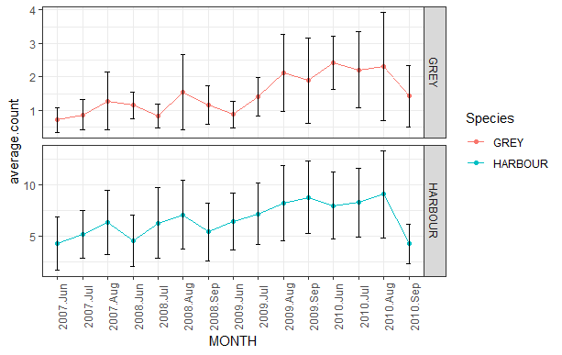

The graph above showed the variation into data visualization by providing insight into error standard.

**4.0 Discussion**

The findings of this study shed light on the population dynamics of harbour and grey seals during the summer months from 2007 to 2010. The normal Q-Q plot analysis revealed a departure from normality in the average seal count data, indicating the presence of higher-order moments such as kurtosis. Interestingly, the distribution of average seal species counts demonstrated that harbour seals were the predominant species throughout the study period this align with the findings of Jones et al. (2015) who assert the steady growth of the specie, contrary to previous research suggesting an increase in Grey seal populations in the United Kingdom (Brownlow et al., 2016).

Furthermore, the abundance of seal species exhibited a inconsistent upward trend since 2007, with harbour seals consistently dominating the observed populations. However, the chi-squared test did not identify significant differences in the distribution of average seal counts across most years. Nevertheless, further investigation into specific time periods revealed potential variations in seal populations. Notably, the Kruskal-Wallis test indicated a significant difference in the distribution of seal species, highlighting the need to consider species-level dynamics.

Future research endeavours could delve deeper into the underlying drivers of these dynamics, exploring the ecological, environmental, and anthropogenic factors that may impact seal populations(Wilson & Hammond, 2019; Das et al., 2003). The knowledge gained from such studies would have a significant impact on the conservation and management of seals, helping in the development of effective strategies to ensure their long-term survival and ecological balance.

## **5.0 Limitations**

The limitations of this study include the narrow time frame, reliance on average seal counts, and the limited scope of seal species and geographic region (Mosner et al., 2019;Banga et al., 2022). To overcome these limitations, future research should consider extending the study period to capture seasonal variations, incorporate demographic data for a more comprehensive understanding of population structure, and include a wider range of seal species and geographic regions to enhance the generalizability of the findings.

## **6.0 Recommendation**

The recommendations for future research include conducting studies over a longer time frame and multiple seasons to capture the complete annual cycle of seal population dynamics. Incorporating demographic data and conducting longitudinal studies would provide insights into population structure and individual life histories. Expanding the scope to include a wider range of seal species and geographic regions would allow for the identification of common patterns and specific factors influencing seal populations. Integrating ecological and environmental factors would provide a holistic understanding of seal population dynamics and aid in predicting and mitigating potential threats. These recommendations aim to advance our knowledge and improve conservation and management strategies for seal species.

**7.0 References:**

Banga, R., Russell, D.J.F., Carter, M.I.D., Chaudry, F., Gilles, A., Abel, C., Ahola, M., Authier, M., Bjorge, A., Brasseur, S.M.J.M. and Carlsson, A., 2022. Seal Abundance and Distribution. OSPAR Commission.

Brownlow, A., Onoufriou, J., Bishop, A., Davison, N. and Thompson, D., 2016. Corkscrew seals: grey seal (Halichoerus grypus) infanticide and cannibalism may indicate the cause of spiral lacerations in seals. PLoS One, 11(6), p.e0156464.

Butler, J.R., Middlemas, S.J., Graham, I.M. and Harris, R.N., 2011. Perceptions and costs of seal impacts on Atlantic salmon fisheries in the Moray Firth, Scotland: Implications for the adaptive co-management of seal-fishery conflict. Marine Policy, 35(3), pp.317-323.

Butler, J.R., Middlemas, S.J., McKelvey, S.A., McMyn, I., Leyshon, B., Walker, I., Thompson, P.M., Boyd, I.L., Duck, C., Armstrong, J.D. and Graham, I.M., 2008. The Moray Firth Seal Management Plan: an adaptive framework for balancing the conservation of seals, salmon, fisheries and wildlife tourism in the UK. Aquatic Conservation: Marine and Freshwater Ecosystems, 18(6), pp.1025-1038.

Carter, M.I., Boehme, L., Cronin, M.A., Duck, C.D., Grecian, W.J., Hastie, G.D., Jessopp, M., Matthiopoulos, J., McConnell, B.J., Miller, D.L. and Morris, C.D., 2022. Sympatric seals, satellite tracking and protected areas: habitat-based distribution estimates for conservation and management. Frontiers in Marine Science.

Castles, R., Woods, F., Hughes, P., Arnott, J., MacCallum, L. and Marley, S., 2021. Increasing numbers of harbour seals and grey seals in the Solent. Ecology and Evolution, 11(23), pp.16524-16536.

Das, K., Lepoint, G., Leroy, Y. and Bouquegneau, J.M., 2003. Marine mammals from the southern North Sea: feeding ecology data from δ13C and δ15N measurements. Marine Ecology Progress Series, 263, pp.287-298.

Hammill, M.O., Bowen, W.D. and Sjare, B., 2010. Status of harbour seals (Phoca vitulina) in Atlantic Canada. NAMMCO Scientific Publications, 8, pp.175-189.

Hammond, J.A., Pomeroy, P.P., Hall, A.J. and Smith, V.J., 2005. Identification and real-time PCR quantification of Phocine distemper virus from two colonies of Scottish grey seals in 2002. Journal of General Virology, 86(9), pp.2563-2567.

Holma, M., Lindroos, M. and Oinonen, S., 2014. The economics of conflicting interests: northern Baltic salmon fishery adaption to gray seal abundance. Natural Resource Modeling, 27(3), pp.275-299.

Jessopp, M., Cronin, M. and Hart, T., 2013. Habitat-mediated dive behavior in free-ranging grey seals. PLoS One, 8(5), p.e63720.

Jones, E.L., McConnell, B.J., Smout, S., Hammond, P.S., Duck, C.D., Morris, C.D., Thompson, D., Russell, D.J., Vincent, C., Cronin, M. and Sharples, R.J., 2015. Patterns of space use in sympatric marine colonial predators reveal scales of spatial partitioning. Marine Ecology Progress Series, 534, pp.235-249.

Karamanlidis, A.A., Dendrinos, P., De Larrinoa, P.F., Gücü, A.C., Johnson, W.M., Kiraç, C.O. and Pires, R., 2016. The M editerranean monk seal M onachus monachus: status, biology, threats, and conservation priorities. Mammal Review, 46(2), pp.92-105.3

Kirkwood, R. and Goldsworthy, S., 2013. Fur seals and sea lions. Csiro publishing.

Leopold, M.F., Begeman, L., van Bleijswijk, J.D., IJsseldijk, L.L., Witte, H.J. and Gröne, A., 2015. Exposing the grey seal as a major predator of harbour porpoises. Proceedings of the Royal Society B: Biological Sciences, 282(1798), p.20142429.

Mosnier, A., Dispas, A. and Hammill, M.O., Spatial distribution and count of harbour seals (Phoca vitulina) and grey seals (Halichoerus grypus) in the Estuary and Gulf of St. Lawrence from an aerial survey conducted in June 2019.

Nikolic, N., Thompson, P., de Bruyn, M., Macé, M. and Chevalet, C., 2020. Evolutionary history of a Scottish harbour seal population. PeerJ, 8, p.e9167.

Olsen, M.T., Islas, V., Graves, J.A., Onoufriou, A., Vincent, C., Brasseur, S., Frie, A.K. and Hall, A.J., 2017. Genetic population structure of harbour seals in the United Kingdom and neighbouring waters. Aquatic Conservation: Marine and Freshwater Ecosystems, 27(4), pp.839-845.

Philipp, C., Unger, B., Fischer, E.K., Schnitzler, J.G. and Siebert, U., 2020. Handle with care—microplastic particles in intestine samples of seals from german waters. Sustainability, 12(24), p.10424.

Planque, Y., Spitz, J., Authier, M., Guillou, G., Vincent, C. and Caurant, F., 2021. Trophic niche overlap between sympatric harbour seals (Phoca vitulina) and grey seals (Halichoerus grypus) at the southern limit of their European range (Eastern English Channel). Ecology and Evolution, 11(15), pp.10004-10025.

Ruosteenoja, K., Markkanen, T. and Räisänen, J., 2020. Thermal seasons in northern Europe in projected future climate. International Journal of Climatology, 40(10), pp.4444-4462.

Stokholm, I., Baechlein, C., Persson, S., Roos, A., Galatius, A., Kyhn, L.A., Sveegaard, S., Thøstesen, C.B., Olsen, M.T., Becher, P. and Siebert, U., 2023. Screening for influenza and morbillivirus in seals and porpoises in the Baltic and north Sea. Pathogens, 12(3), p.357.

Thompson, P.M., Mackey, B., Barton, T.R., Duck, C. and Butler, J.R.A., 2007. Assessing the potential impact of salmon fisheries management on the conservation status of harbour seals (Phoca vitulina) in north‐east Scotland. Animal Conservation, 10(1), pp.48-56.

Thompson, P.M., Van Parijs, S. and Kovacs, K.M., 2001. Local declines in the abundance of harbour seals: implications for the designation and monitoring of protected areas. Journal of Applied Ecology, 38(1), pp.117-125.

Vanhatalo, J., Vetemaa, M., Herrero, A., Aho, T. and Tiilikainen, R., 2014. By-catch of grey seals (Halichoerus grypus) in Baltic fisheries—A Bayesian analysis of interview survey. PloS one, 9(11), p.e113836.

Vincent, C., Huon, M., Caurant, F., Dabin, W., Deniau, A., Dixneuf, S., Dupuis, L., Elder, J.F., Fremau, M.H., Hassani, S. and Hemon, A., 2017. Grey and harbour seals in France: Distribution at sea, connectivity and trends in abundance at haulout sites. Deep Sea Research Part II: Topical Studies in Oceanography, 141, pp.294-305.

Wilson, L.J. and Hammond, P.S., 2019. The diet of harbour and grey seals around Britain: Examining the role of prey as a potential cause of harbour seal declines. Aquatic Conservation: Marine and Freshwater Ecosystems, 29, pp.71-85.

**Appendix**

library(tidyverse)

library(readxl)

library(ggplot2)

library(Rmisc)

library(psych)

#read in data

seals = read.csv(file = "C:/Users/DELL/Downloads/Seals.csv")

view(seals)##To instruct R to recognize the installed packages, I used the library() function. This function allows R to call into memory, a particular package that had been installed earlier. ######GRAPH OF SEAL SPECIES ACROSS THE SUMMER PERIODS######

ggplot(seals, aes(fill = Species, x=Summer, y=average.count)) + geom_bar(position= "dodge", stat="identity", width = 0.9) +

theme(axis.text.x=element_text(angle=90)) + facet_grid(Species ~ ., scales ='free') + ggtitle(label = "Average Count of Seals") + scale_fill_manual(values = c("#FF0000", "#00FF00", "#0000FF"))

#GRAPH OF SEALS BY SITES#######GRAPH OF SEALS IN SITE A#####

site_A = subset(seals, seals$Site=="A")

month = factor(site_A$Year.Month, levels=c("2007.Jun", "2007.Jul", "2007.Aug",

"2008.Jun", "2008.Jul", "2008.Aug", "2008.Sep",

"2009.Jun", "2009.Jul", "2009.Aug", "2009.Sep",

"2010.Jun", "2010.Jul", "2010.Aug", "2010.Sep"))

ggplot(site_A, aes(fill = Species, x=month, y=average.count)) + geom_bar(position= "dodge", stat="identity", width = 0.9) + theme(axis.text.x=element_text(angle=90)) + ggtitle(label = "Average Count of Seals at Site A") + scale_fill_manual(values = c("#FF0000", "#00FF00", "#0000FF"))

#####GRAPH OF SEALS IN SITE B######

site_B = subset(seals, seals$Site=="B")

ggplot(site_B, aes(fill = Species, x=month, y=average.count)) + geom_bar(position= "dodge", stat="identity", width = 0.9) +

theme(axis.text.x=element_text(angle=90)) + ggtitle(label = "Average Count of Seals at Site B") + scale_fill_manual(values = c("#FF0000", "#00FF00", "#0000FF"))

#####GRAPH OF SEALS IN SITE C######

site_C = subset(seals, seals$Site=="C")

ggplot(site_C, aes(fill = Species, x=month, y=average.count)) + geom_bar(position= "dodge", stat="identity", width = 0.9) +

theme(axis.text.x=element_text(angle=90)) + ggtitle(label = "Average Count of Seals at Site C") + scale_fill_manual(values = c("#FF0000", "#00FF00", "#0000FF"))

#####GRAPH OF SEALS IN SITE SPIT######

site_Spit = subset(seals, seals$Site=="Spit")

ggplot(site_Spit, aes(fill = Species, x=month, y=average.count)) + geom_bar(position= "dodge", stat="identity", width = 0.9) +

theme(axis.text.x=element_text(angle=90)) + ggtitle(label = "Average Count of Seals at Site Spit") + scale_fill_manual(values = c("#FF0000", "#00FF00", "#0000FF"))

#####GRAPH OF SEALS IN SITE Wall######

site_Wall = subset(seals, seals$Site=="Wall")

ggplot(site_Wall, aes(fill = Species, x=month, y=average.count)) + geom_bar(position= "dodge", stat="identity", width = 0.9) +

theme(axis.text.x=element_text(angle=90)) + ggtitle(label = "Average Count of Seals at Site Wall") + scale_fill_manual(values = c("#FF0000", "#00FF00", "#0000FF"))

#####GRAPH OF SEALS IN SITE D######

site_D = subset(seals, seals$Site=="D")

ggplot(site_D, aes(fill = Species, x=month, y=average.count)) + geom_bar(position= "dodge", stat="identity", width = 0.9) +

theme(axis.text.x=element_text(angle=90)) + ggtitle(label = "Average Count of Seals at Site D") + scale_fill_manual(values = c("#FF0000", "#00FF00", "#0000FF"))

#####GRAPH OF SEALS IN SITE E######

site_E = subset(seals, seals$Site=="E")

ggplot(site_E, aes(fill = Species, x=month, y=average.count)) + geom_bar(position= "dodge", stat="identity", width = 0.9) +

theme(axis.text.x=element_text(angle=90)) + ggtitle(label = "Average Count of Seals at Site E") + scale_fill_manual(values = c("#FF0000", "#00FF00", "#0000FF"))

####ERROR BARS GRAPHS###

seal_error = summarySE(seals, measurevar ="average.count", groupvars=c("month", "Species"))

ggplot(seal_error, aes(x=month, y=average.count, fill = Species)) +

geom_bar(position = "dodge", stat = "identity", width = 0.9) + scale_fill_manual(values=c("yellow", "pink")) +

geom_errorbar(aes(ymin = average.count-se, ymax=average.count+se), width=.2, position=position_dodge(.9)) + theme(panel.background = element_blank(), axis.text.x=element_text(angle=90)) + ggtitle(label = "error bars showing the variability in average count between Seal species") + scale_fill_manual(values = c("#FF0000", "#00FF00", "#0000FF"))

ggplot(seal_error, aes(x=, y=average.count, colour = Species, group = Species )) +

geom_line() +

geom_errorbar(aes(ymin = average.count-se, ymax=average.count+se), width=.2, position=position_dodge(.9)) +

theme(panel.background = element_blank(), axis.text.x=element_text(angle=90)) + facet_grid(Species ~ ., scales ='free') + ggtitle(label = "error bars showing the variability in average count between Seal species") + scale_fill_manual(values = c("#FF0000", "#00FF00", "#0000FF"))

###STATISTICAL TESTS#########

####Normality test#######

qqnorm(seals$average.count)

shapiro.test(seals$average.count)

######Overall pairwise comparison between the number of seals across the summer periods##########

kruskal.test(seals$average.count, seals$Summer)

######pairwise comparison of the seals for each year#######

pairwise.wilcox.test(seals$average.count, seals$Summer)

pairwise.wilcox.test(seals$average.count, seals$Summer, p.adjust.method = "BH")

#pairwise comparison in 2007

kruskal.test(average.count ~ Year.Month, data = seals[seals$Summer == "summer-2007", ])

#pairwise comparison between the number of seals in 2008

kruskal.test(average.count ~ Year.Month, data = seals[seals$Summer == "summer-2008", ])

#pairwise comparison between the number of seals in 2009

kruskal.test(average.count ~ Year.Month, data = seals[seals$Summer == "summer-2009", ])

#pairwise comparison between the number of seals in 2010

kruskal.test(average.count ~ Year.Month, data = seals[seals$Summer == "summer-2010", ])

#pairwise comparison between seal species for the four years

kruskal.test(average.count ~ Species, data = seals)

ggplot(seals, aes(fill=Species, Summer, average.count)) +

geom_bar (position = "dodge",stat = "identity", width = 0.9) +

facet_grid(Species~Site, scales = "free")+ scale_fill_manual(values = c("#FF0000", "#00FF00", "#0000FF")) +

theme_bw() + theme(axis.text.x=element_text(angle = 90))

#quick plot

ggplot(seals, aes(Summer, average.count)) +

geom_boxplot(outlier.shape = NA, aes(color = Summer)) +

theme_classic()

#grid species~summer

ggplot(seals, aes(fill=Species, Summer, average.count)) +

geom_bar (position = "dodge",stat = "identity", width = 0.9) +

facet_grid(Species~Summer, scales = "free")+ scale_fill_manual(values = c("#FF0000", "#00FF00", "#0000FF")) +

theme_bw()

#split

ggplot(seals, aes(fill=Species, Summer, average.count)) +

geom_bar (position = "dodge",stat = "identity", width = 0.9) +

theme_classic() + scale_fill_manual(values = c("#FF0000", "#00FF00", "#0000FF"))