STAT 550 Electric Vehicle Usage Report

Intro:

UBC fleet manages several electric vehicles and operates their charging infrastructure. In order to better understand the usage patterns of the assigned users and the demand for further development of the infrastructure, the log data of the charging stations is to be explored and we aim to build statistical models that are informative for infrastructural decisions.

Expanding the Current Infrastructure:

We analyze the expansion of the current infrastructure, but in order to do so, we should analyze the arrival rate (in number of cars per hour) and charging duration (in hours) as we include more cars in operation. Note that we will be using charging duration as opposed to session duration where the differences are highlighted in the section on Explore the Session Duration and Charging Duration. Also, intuitively speaking, including more cars into the system should increase the arrival rate. The problem we have to deal with is the occupancy of stations and queuing of cars waiting to be charged as the arrival rate of cars increase.

To understand why queuing occurs, imagine a scenario where there is only one possible charging station and cars arrive on average every 30 minutes, and it takes 20 minutes on average to finish charging. Say, car 1 arrives at time 0 minutes and begins charging. Next, cars 2 and 3 arrive (at times 5 and 10 minutes respectively) before car 1 is done charging. Therefore, cars 2 and 3 are put in a queue (a line in which cars wait to be charged). When car 1 finishes charging, car 2 begins charging while car 3 continues waiting in the queue. As we have mentioned, it makes sense that increasing the number of cars in operation certainly lengthens the wait time of cars in the queue as evident in this example.

The description of the above paragraph leads us to an important question of this project:

What are the consequences of including additional cars in operation in terms of station occupancy and queuing at the busiest times of the day (1:30 p.m. to 4 p.m. as depicted in Figure 1)?

The model we use is the M/M/c queuing model, because it provides answers to the above question such as:

* The probability the car enters the queue immediately upon arrival.
* How long cars have to wait in the queue before a station is available.
* The number of cars in the queue on average.

To obtain answers to the bullet points above, the M/M/c model requires two inputs: car arrival rate (in number of cars per hour) and charging duration (in hours). The car arrival rate describes how often a car arrives at the charging stations per hour, and the charging duration is how long it takes to charge a vehicle.

In order to keep the report concise and readable as a client report, we do not go into the details of the M/M/c model, but instead provide references where more information can be found [1,2].

Current Infrastructure:

Our analysis is based on data from 2013-05-02 to 2014-02-14, because only during this period of time do we have labels for the cars. We first analyze the current infrastructure which has 14 cars and 10 charging stations in total. Based on our data depicted in the highlighted portion of the histogram in Figure 1, we obtained an arrival rate of 1.17 cars per hour and a charging duration of 2.27 hours. We should also mention that there are 10 stations as opposed to the one station in the example given in the first paragraph of the section on Expanding the Current Infrastructure, so that cars only begin queuing up when all stations are occupied for charging. Using the arrival rate and charging duration, we found the following information on the current system:

* The probability a car enters the queue upon arrival is 0.0005.
* The amount of time a car waits in the queue is 0.5 minutes.
* The number of cars in the queue on average is approximately 0.

Arrival Rate with respect to Number of Cars:

Intuitively, it makes sense that the arrival rate would increase as the number of cars in operation increases. The assumption that we are going to make is that the relationship between the arrival rate and number of cars is linear. In other words, doubling the number of cars also doubles the arrival rate. For example, as the current arrival rate is 1.17 cars per hour for 14 cars, then 28 cars would have an arrival rate of 2.34. In addition we suspect that the increase in number of cars has no effect on the charging duration.

Queuing Results:

Figure 14 reveals that the chance a car enters the queue upon arrival is close to 0 % when the number of cars is less than 24 which is 10 more cars than the original 14. Even at a total of 36 cars (which is 22 more than the original), the chance of entering the queue is 20 %. However, the chance of entering the queue quickly rises after a total of 36 cars leading to a chance of 70 % of entering the queue at 49 cars (which is 35 more than the original).

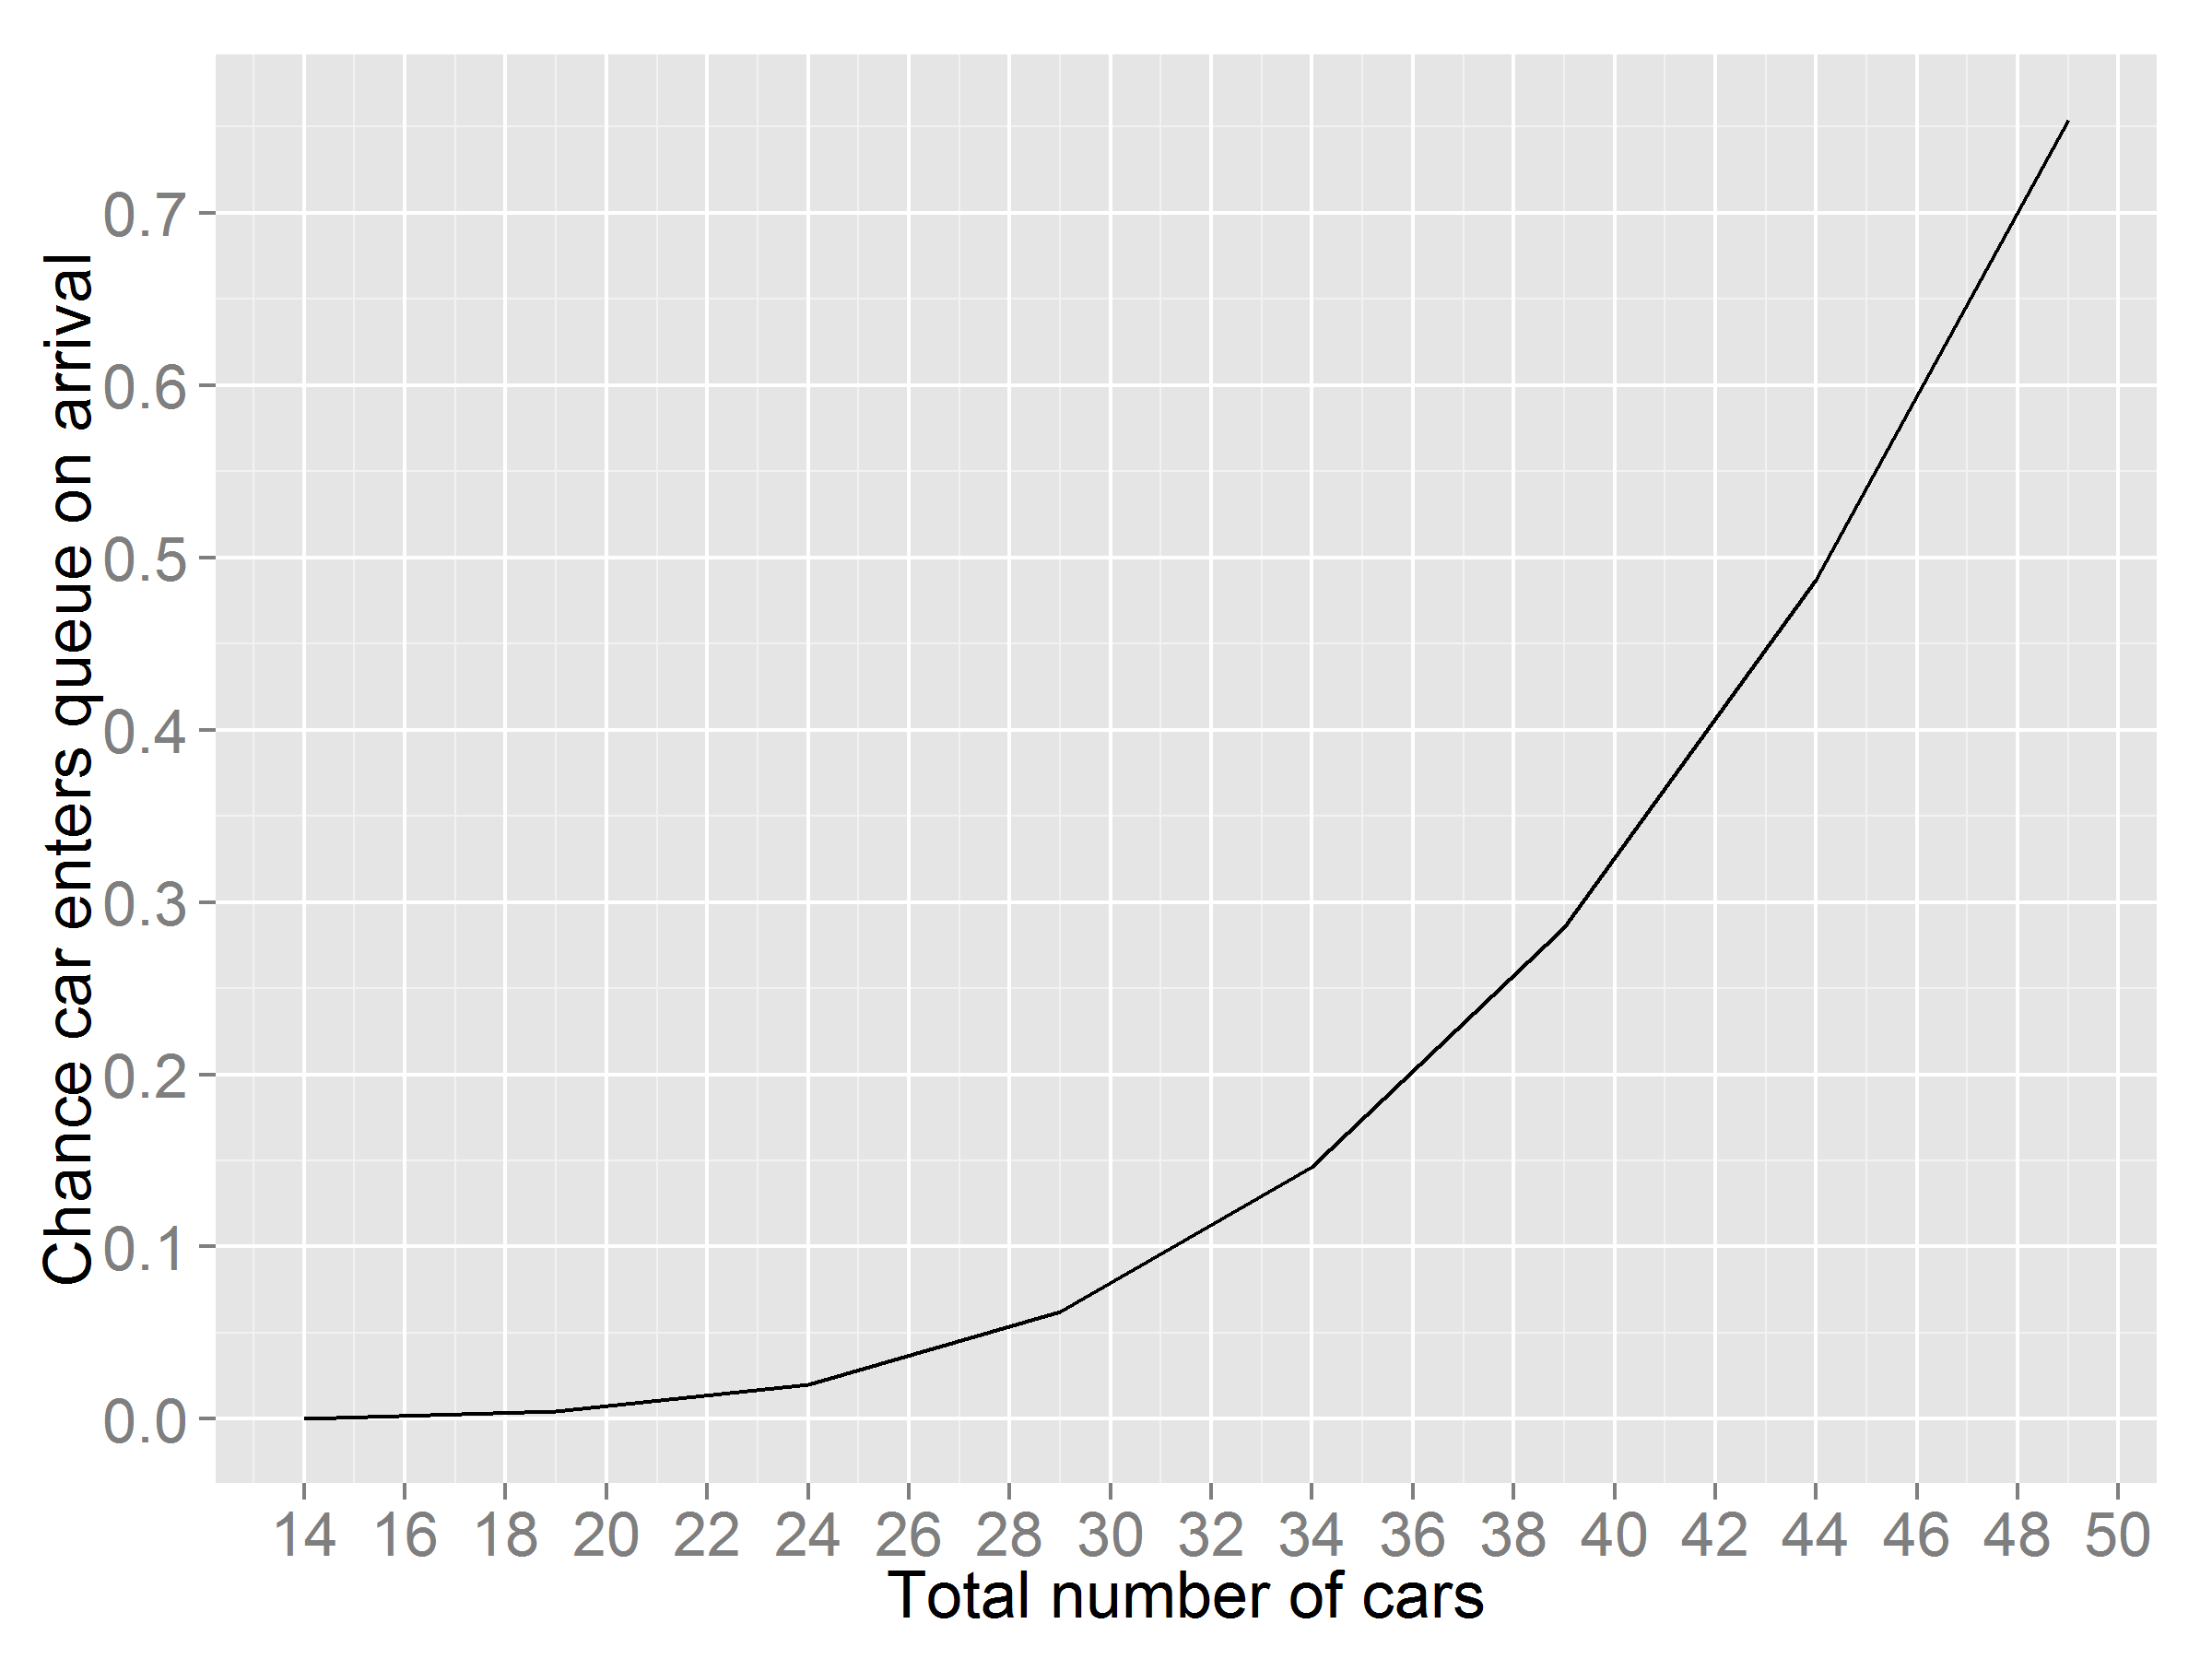

Figure 14: The chance a car enters queue upon arrival.

In addition, we find that the number of cars in the queue remain close to 0 even when there are 30 cars in operation (which is 16 more than the original) as shown in Figure 15 below. However, when the number of cars is greater than 34, the number of cars in queue appear to grow exponentially.

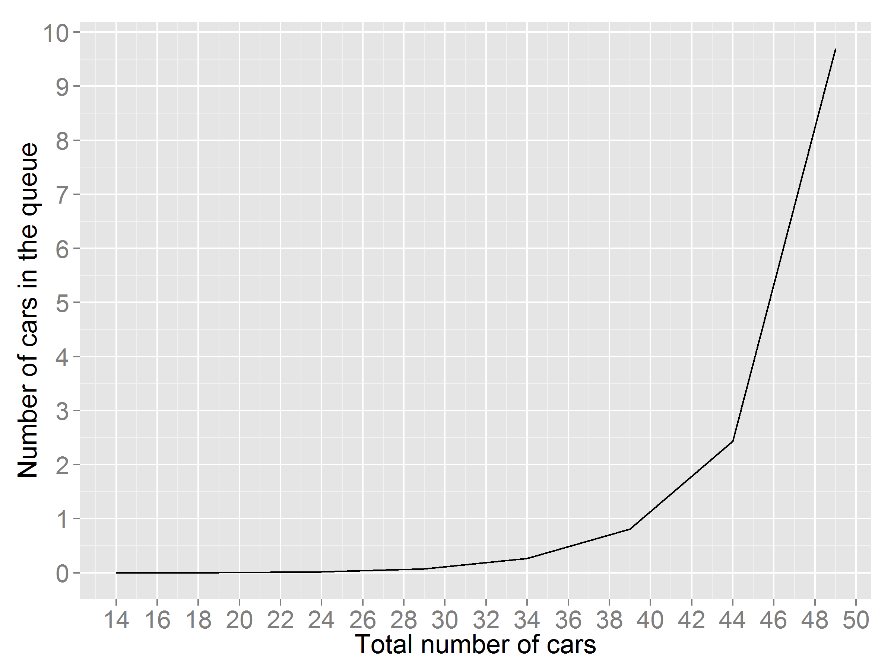

Figure 15: Number of cars in the queue on average.

Finally, Figure 16 reveals that the wait time in the queue has a similar pattern as the number of cars in the queue such that the wait time is approximately 0 minutes for a total number of cars less than 30 (16 more than the original), and that the wait time increase exponentially for more than 34 cars with a wait time of 120 minutes at 48 cars (34 more than the original).

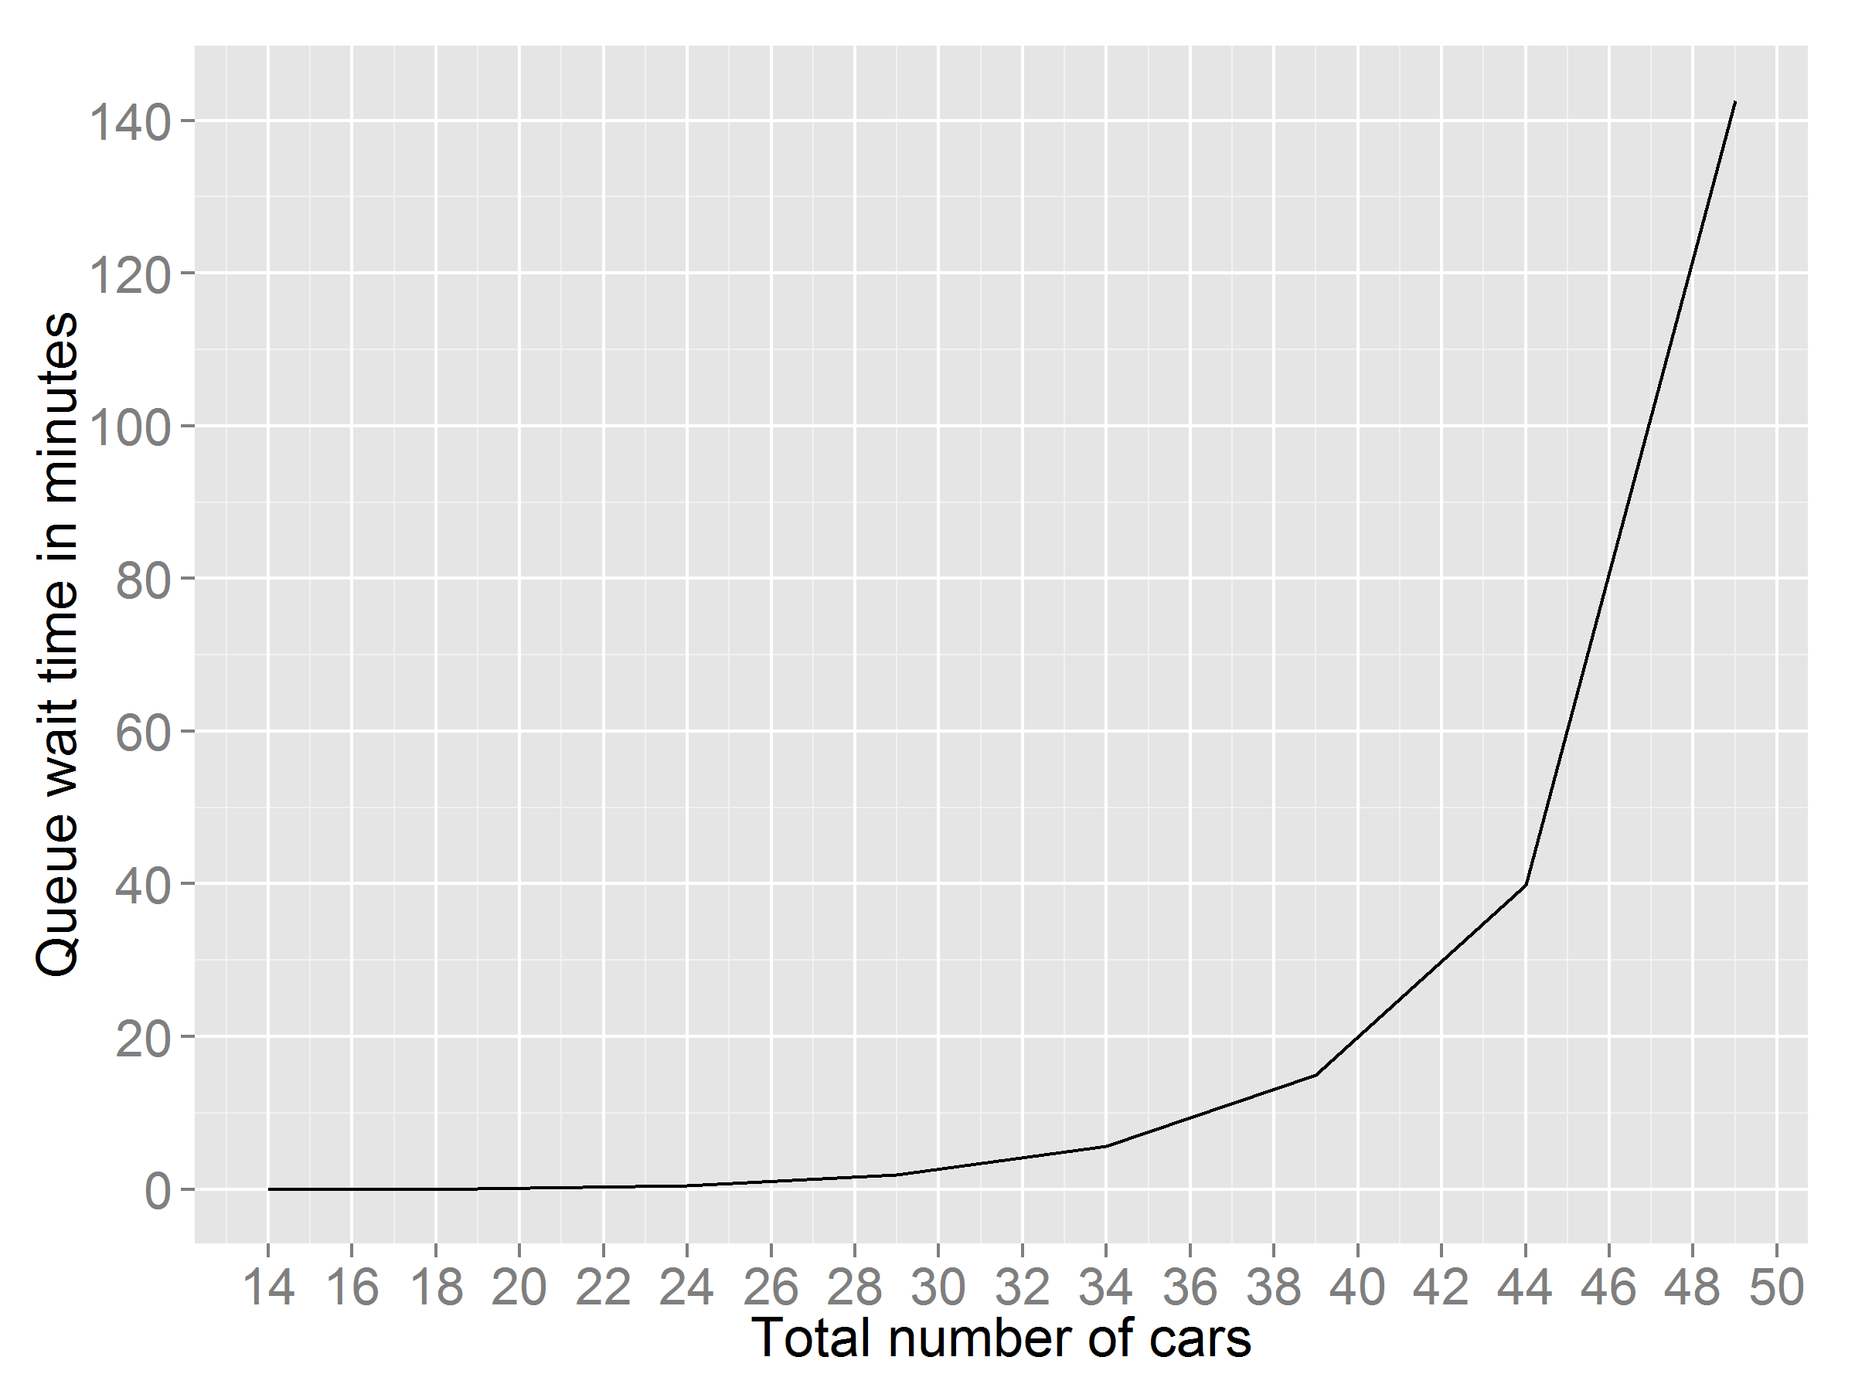

Figure 16: The average wait time in the queue.

Based on our analysis, given the number of cars in the current system is 14, adding 16 cars into the system for a total of 30 cars would have minimal impact on the queue wait time and number of cars in queue. However, if we decide to put more than 20 cars in operation, we should consider installing more stations as both wait time in the queue and number of cars in the queue increases rapidly.

References:

[1] Ross, Sheldon. *Introduction to Probability Models*. Academic Press, 2014.

[2] Sztrik, János. *Basic queueing theory*. University of Debrecen: Faculty of Informatics, 2011.