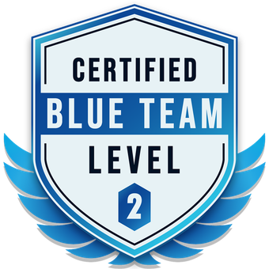

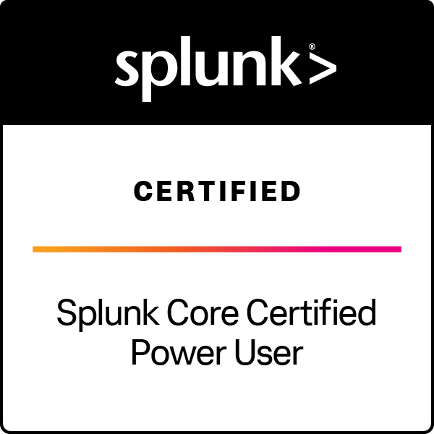
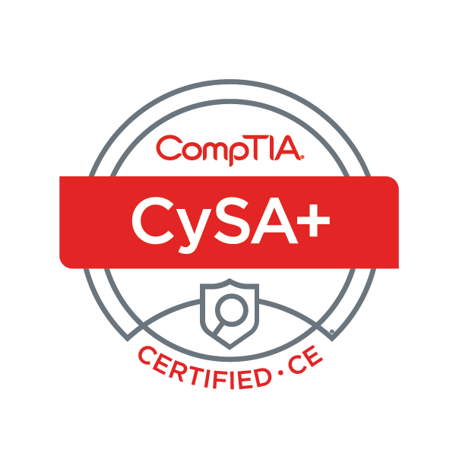
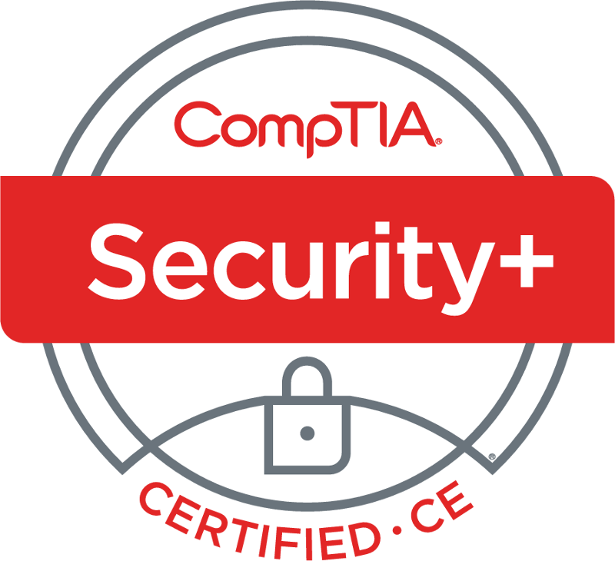
Ken Lee
(202) 290-4747 | cyber@kenleesecurity.com
https://www.kenleesecurity.com/

Cybersecurity leader with 7+ years of experience across the full cyber incident response lifecycle of investigation, containment, remediation, and recovery within a Microsoft-centric cloud environment (Azure / Entra ID, Microsoft 365, Defender XDR). Proven track record serving as the final escalation point for complex security incidents, authoring incident reports and technical documentation, and translating technical risk into clear, actionable guidance for stakeholders and clients.

WORK EXPERIENCE

Deloitte Touche Tohmatsu Limited April 2023 – Present
Lead Security Operations Analyst Arlington, VA
- Serve as the final escalation point for L1 and L2 analysts on sophisticated, cross-environment security incidents, leading investigation, containment, remediation, and recovery efforts while providing hands-on technical direction and risk-based decision-making under time pressure.
- Lead structured threat hunts and APT detection across Microsoft Defender XDR, Entra ID, and Microsoft 365, using KQL and SPL to identify patterns and outliers matching threat actor TTPs and post-compromise behavior, directly improving incident monitoring, detection, and response processes across the environment.
- Extend investigations into AWS and GCP by reviewing security logs in Splunk and accessing the AWS console through CyberHub, applying consistent pattern-of-life and anomaly analysis to support containment and remediation decisions across multi-cloud environments.
- Build and modify SIEM dashboards and develop incident reports and technical documentation that clearly scope findings, monitor anomalous activity, and communicate risk and impact to technical and non-technical stakeholders alike.
- Partner with SIEM detection engineers to develop standard operating procedures (SOPs) aligned to NIST, ISO 27001, and CIS standards that mature the Global SOC’s incident response readiness, reduce rework, and reinforce consistent best practices across the analyst team.
- Track completion of SOP development, threat hunt execution, and detection/response improvement work through Azure DevOps, giving leadership visibility into engagement progress and priorities.
- Provide hands-on mentoring of junior analysts, modeling collaborative behavior and supporting knowledge-sharing and technical ramp-up across distributed onshore and offshore (US, EMEA, US-India) teams.
- Maintain current awareness of cybersecurity trends, threat intelligence, and evolving TTPs to guide SOC-wide incident response, detection strategy, and client readiness.

Senior Security Operations Analyst July 2021 – April 2023
- Verified and acted on escalated security incidents using SIEM tooling, applying risk assessment to prioritize investigation, containment, remediation, and recovery across the environment.
- Used endpoint detection and response (EDR) tools to monitor and investigate malware activity on user workstations and servers.
- Investigated suspicious identity and access activity by correlating sign-on telemetry and timestamps against baseline behavior, directly applicable to Entra ID and cloud access governance.
- Authored advanced KQL and regex-based hunting queries to detect previously unidentified phishing campaigns.
- Developed YARA rules from IOCs to strengthen future detection coverage.
- Supported onboarding and technical ramp-up of newly hired analysts and interns, contributing to team readiness and knowledge continuity.

Junior Security Operations Analyst April 2020 – July 2021
- Performed sandbox analysis and detonation of phishing emails and malware to support incident triage.
- Reviewed user traffic and activity through enterprise web-filtering solutions to identify indicators of compromise.
- Leveraged open-source and internal threat intelligence to research and resolve unresolved incidents and IOCs.
- Used Splunk to analyze security-detection logs and support investigative findings.
- Triaged and documented security incidents and alerts through ServiceNow, ensuring accurate incident reports and case history for post-incident review and future reference.

LookingGlass Cyber Solutions August 2019 – April 2020
Associate Cyber Threat Analyst Reston, VA
- Supported a 24/7 SOC, following established procedures to verify, respond to, and report on security incidents including phishing, malware, brand/copyright infringement, and online impersonation.
- Tracked cases through the full incident response lifecycle using enterprise detection and response tooling, ensuring timely resolution or escalation.
- Used open-source intelligence platforms (VirusTotal, CentralOps) to collect evidence such as domains, IPs, URLs to close unresolved cases.

TECHNICAL SKILLS

Cloud & Identity | Threat Hunting | Detection & Response | Platforms
Microsoft Azure / Entra ID | Kusto Query Language (KQL) | Microsoft Defender XDR | Splunk
Microsoft 365 | Splunk Processing Language (SPL) | CrowdStrike Falcon | ServiceNow
AWS (Log Analysis, CyberHub) | APT Detection | Phishing Analysis | Cofense Triage
GCP (Log Analysis) | Event Monitoring | Incident Response (NIST/ISO 27001/CIS) | Azure DevOps

EDUCATION & CERTIFICATIONS

George Mason University Fairfax, VA
- Bachelor of Science, Information Technology
Claude Certified Associate – Foundations (CCAO-F)
Blue Team Level 2 (BTL2)
GIAC Certified Forensic Analyst (GCFA)
Splunk Core Certified Power User
CySA+ CE
Security+ CE

