CSCI222 Assignment 1 Report

Team Number : <C2>

 | Student Number | Name | Email Address
1 | 5987398 | Minton Yap Li Hui  (Team Leader) | Tel : 8688 4366  Email : ft_minton_yap@yahoo.com
2 | 5987544 | Wong Kai Xiong | Tel : 8828 6721  Email : kxiong1994@hotmail.com
3 | 5987477 | Chan Jie Jun, Cyrus | Tel : 9736 2776  Email : cyrusjiejun@gmail.com
4 | 5986825 | Ken Leong Kin Kiat | Tel : 9233 5489  Email : kenleongkinkiat@yahoo.com.sg
5 | 5654555 | Leaw Si Hui | Tel : 9644 6048  Email : sihuileaw@gmail.com
6 | 5987519 | Denise Chan | Tel : 8112 1401  Email : veralynchan@gmail.com

Table of Contents

1. Project Overview……………………….……………………….……… 3

2. Roles and responsibilities………………………………………….….. 7

3. Risk Analysis and Counter Measures………………………….…….. 8

4. Design Artefacts – Use Cases…………………………...….….…... 10

5. Design Artefacts – Activity Workflow…………………………….…. 12

6. Design Artefacts – Component Diagram……………………………. 14

7. Design Artefacts – Class Diagram…………………………………… 17

8. Design Artefacts – State Diagram………………………………….…18

9. Formal Meeting Records……………………………………………… 20

10. Individual Work Diaries……………………………………………...… 22

11. Evidence of using VCS………………………………………………... 35

Project Overview

BUSINESS CASE:

VISION

The aim of this project is to develop an inventory system where users are able to manage any incoming and outgoing stocks, as well as performing a query on specific stocks. This could help our target audiences to keep track of the stocks behaviours and it can also serve as a reminder if their stocks are running low.

TARGET AUDIENCE

Managers from warehouse / inventory-related industry.

PURPOSE

Warehouse Management Tool (WM Tool) will serve to managers managing the warehouse inventory. Managers would be able to interact with the system with a valid account, and it is provided with the basic features that all users would have access to, such as: modifying stocks amounts, searching for stocks, and viewing summary reports. Having access to such features will enable managers to make critical management decisions.

Project Detailed Plan

Tasks | Use Case Diagram/  Detailed use case | Gantt Chart | Risk Analysis | Activity Workflow | Component Diagram | Class Diagram
Minton |  | ✓ | ✓
Cyrus | ✓ |  |  | ✓
Ken |  | ✓ |  |  | ✓
Kai Xiong | ✓ |  | ✓
Denise | ✓ |  |  | ✓
Si Hui |  |  |  |  | ✓ | ✓

Gantt Chart

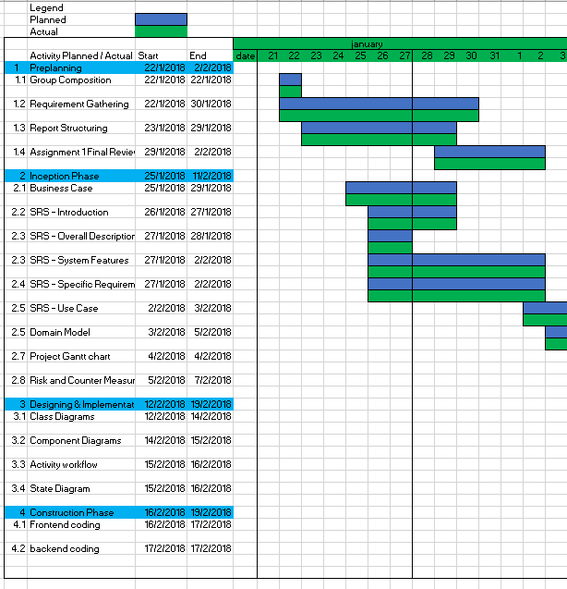
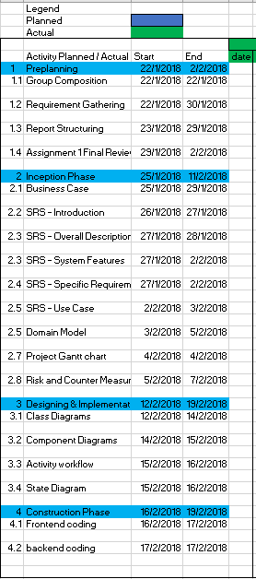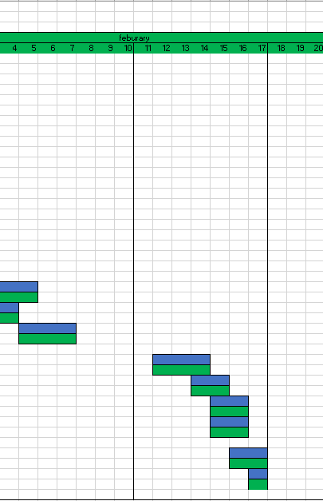

Meta Report

Group Structure - Roles and Responsibility

Team Number : <C2>

 | Student Name | Role | Artefacts
1 | Minton Yap | Manager | State Diagrams, Report, Gantt Chart, Risk Analysis
2 | Wong Kai Xiong | Integration and testing | Use Case Diagrams, Use Case Textual Description
3 | Cyrus Chan | Designer | Activity Work Flows, Use Case Diagrams, Use Case Textual Description
4 | Ken Leong | Integration and testing | Component Diagrams, Gantt Chart, Report , Version Control
5 | Leow Si Hui | Implementer | Class Diagrams, Component Diagrams, Report, Version Contorl
6 | Denise Chan | Documentation | Minutes Meeting, Activity Work Flows, Report

Risk Analysis and Counter Measures

Risk no. | Type of risk | Seriousness (%) | Occurance Rate (%) | WBS (affected work/task) | Description
1 | Corruption | 70 | 5 |  | Files got corrupted by accident
2 | Loss of data | 70 | 5 |  | Files got deleted by accident
3 | Hacker | 70 | 5 |  | Files got stolen/edited by hackers
4 | Manpower | 90 | 10 |  | Worker wants to quit halfway
5 | Budget | 80 | 5 |  | Workers sought for higher pay

 | Description | Proposed Solution | Probability of amount of risk reduced(%)
1 | Files got corrupted by accident | Keep a few backup copies | -90
2 | Files got deleted by accident | Keep a few backup copies | -90
3 | Files got stolen/edited by hackers | Keep a few backup copies | -90
4 | Worker wants to quit halfway | 1. Give them motivation by offering better rewards/incentives | -40
5 | Workers sought for higher pay | 1. Offer to pay the demanded amount  2. Fire those workers to warn the rest and outsource the task to schools or companies | 1. -40  2. -20

Design Artefacts - Use Cases (Iteration 1)

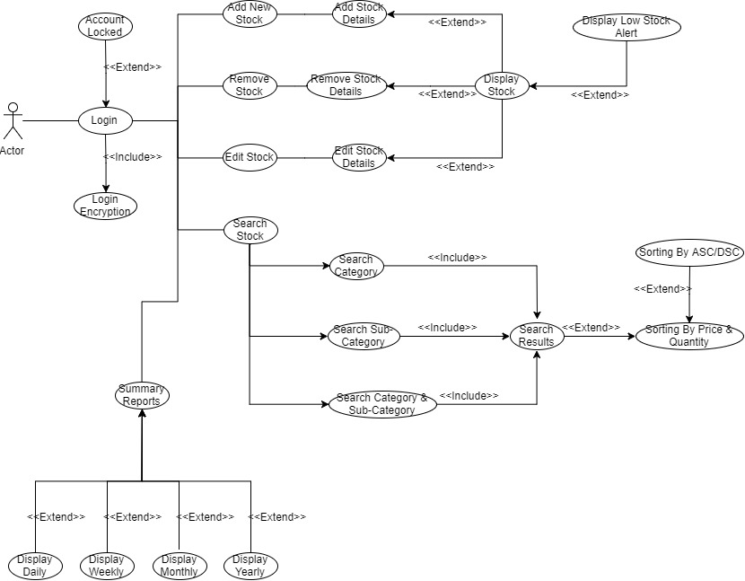

Design Artefacts - Use Cases (Iteration 2)

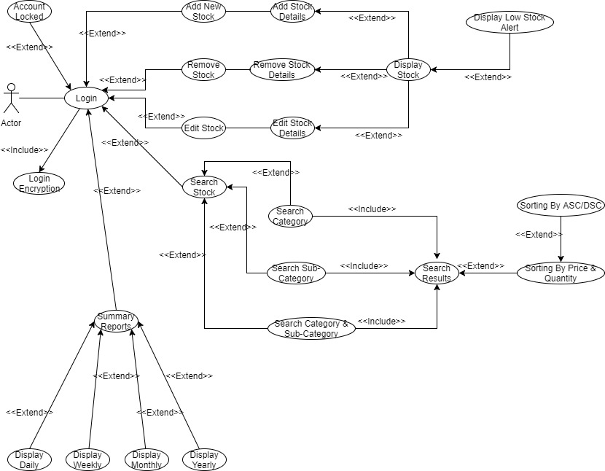

Design Artefacts - Activity Workflows (Iteration 1)

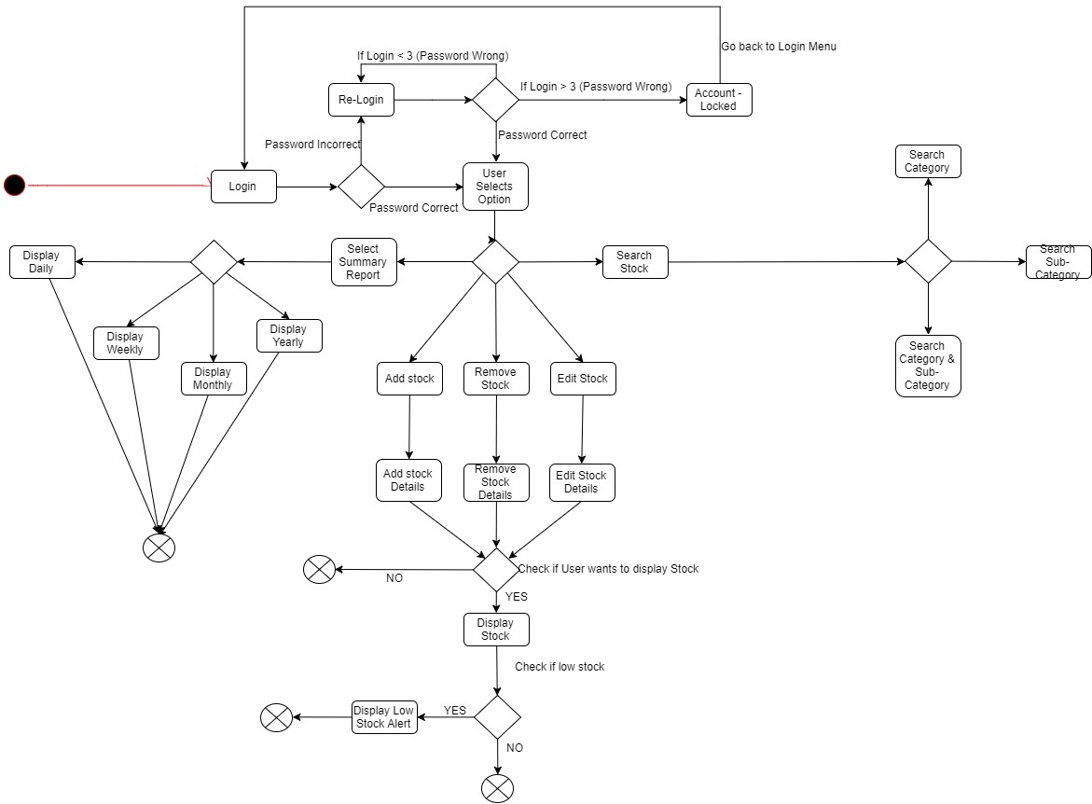

Design Artefacts - Activity Workflows (Iteration 2)

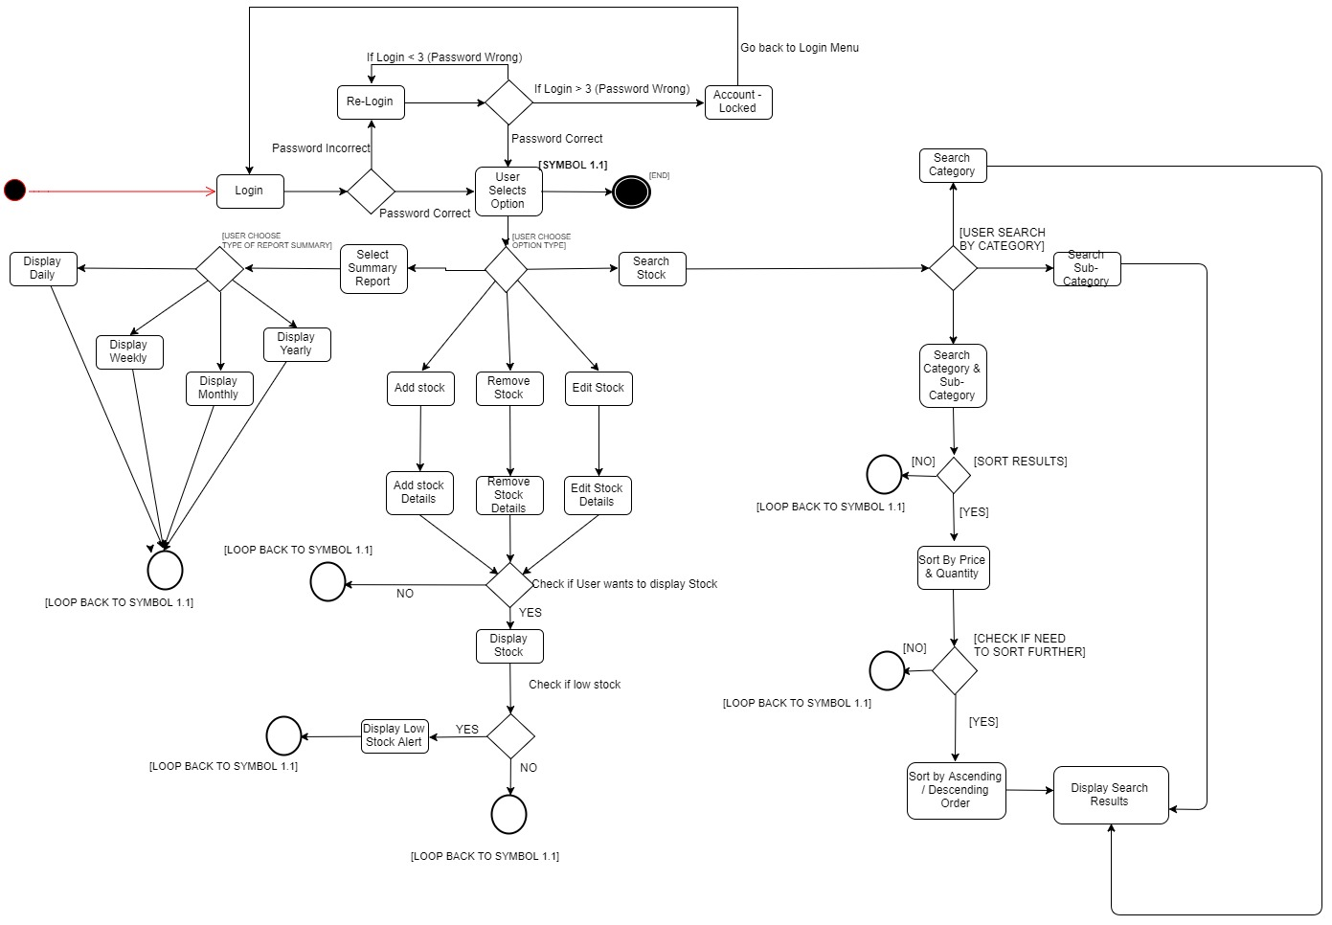

Design Artefacts - Component Diagrams (Iteration 1)

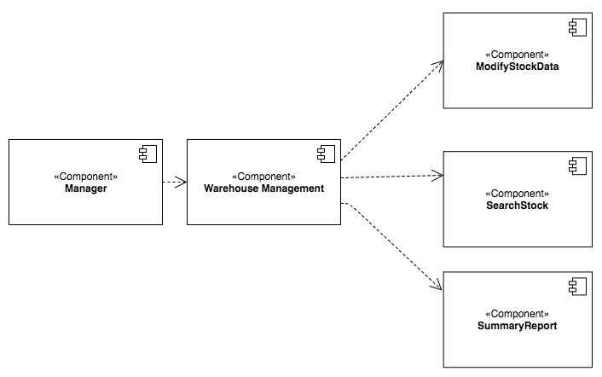

Design Artefacts - Component Diagrams (Iteration 2)

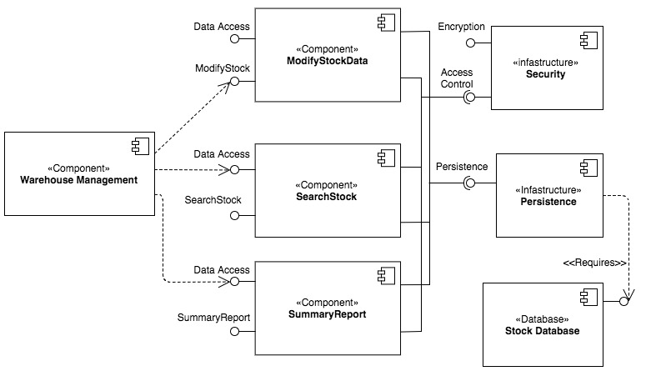

Design Artefacts - Class Diagrams (Iteration 1)

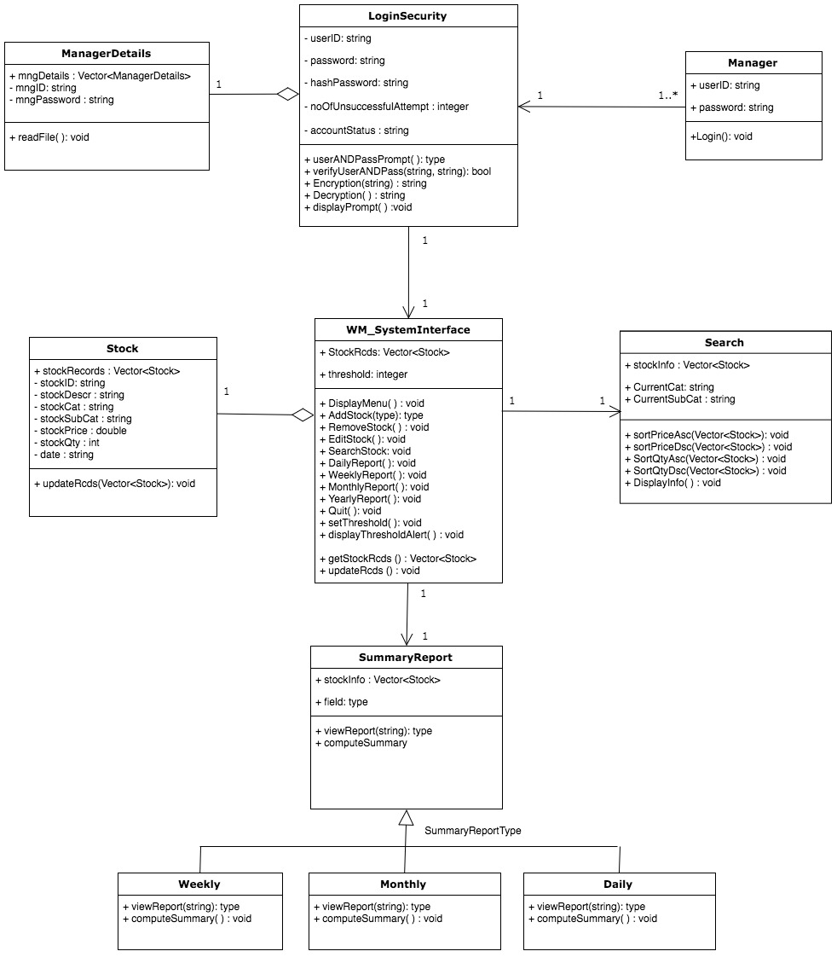

Design Artefacts - Class Diagrams (Iteration 2)

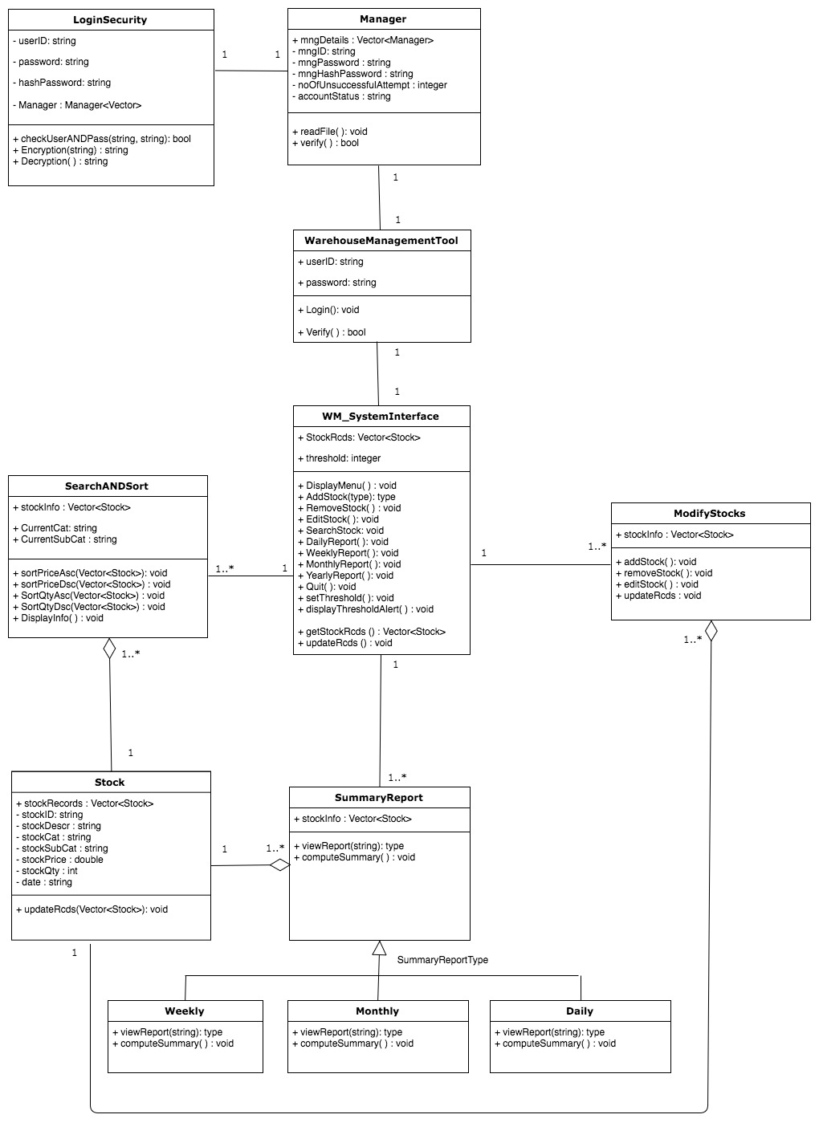

Design Artefacts - State Diagram (Iteration 1)

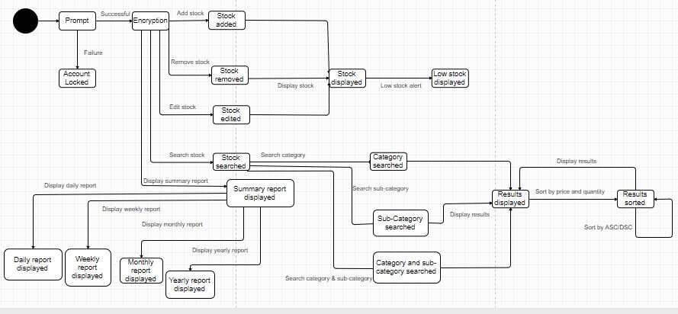

Design Artefacts - State Diagram (Iteration 2)

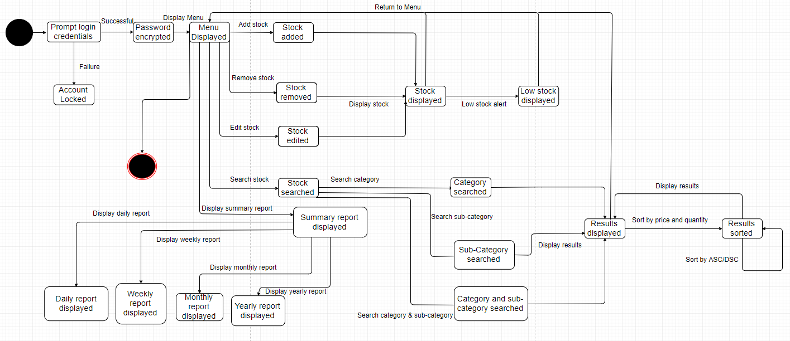

Appendix A - Formal Meeting Records

Inception Phase - Iteration 1

MEETING #1 – 22 JANUARY 2018

Summary
This is our group’s first meeting where we discuss the project structure, goals & assigned our individual roles.

We started off the project by planning our deadlines accordingly using the Gantt Chart.
As we have been familiarised with the various diagrams used through our previous lab exercise, we decided to start on the Use Case Diagram first as it will be used as the pillar of the project to ensure consistency throughout the other diagrams that we will be designing. In order to be efficient, Cyrus, Kai Xiong & Denise worked on finalising iteration 1 of the Use Case Diagram, where Sihui, Ken & Minton started on iteration 1 of the class diagram.

We concluded the meeting by discussing our goals for our 2nd meeting. Which is to finish up iteration 1 of all the diagrams and we will discuss further if any changes will be needed.

Agenda for next meeting:
- 1st iteration for diagrams
- Review diagrams

Report
Urgent Items
There were no urgent items to report in this meeting as this is the first meeting we held.

Non-urgent Items and Other Reports
There were no non-urgent items or other reports to report in this meeting as this is the first meeting we held.
Allocation of task:
Task | Est. no. of days to complete | Team member
Use Case Diagram | 7 Days | Cyrus,Kai Xiong
Class Diagram | 7 Days | Sihui, Ken, Minton
Activity Workflows | 7 Days | Denise, Cyrus
Component Diagrams | 7 Days | Sihui, Ken
Updating of report and gantt chart | 7 Days | Ken, Minton

Elaboration Phase - Iteration 1

MEETING #2 – 25 JANUARY 2018

Summary
In our 2nd meeting, we spent our time ensuring the consistency of all our diagrams that we have done. In order to make sure that happens, we sat down and went through each diagram one by one, voicing out our opinions and amending according to what we feel is right. We have also agreed to creating an extra diagram (state diagram) for this project which Minton will be handling.

We seek our lecturer’s advice on each of our diagrams and amended accordingly. After which, we distributed the tasks for each one of us to be done by the next meeting.

Agenda for next meeting
- Finalized report
- Rehearsal of Presentation
- Review final iterations for all diagrams

Report
Urgent Items:
- State Diagram
- Detailed Use Case
- Compiling everything into our report

Non-urgent Items and Other Reports:
--

Allocation of task:
Task | Est. no. of days to complete | Team member
Use Case Diagram 2nd Iteration | 7 Days | Cyrus, Kai Xiong
Use Case Textual Description | 7 Days | Cyrus, Kai Xiong
Class Diagram 2nd Iteration | 7 Days | Sihui
Activity Workflows 2nd Iteration | 7 Days | Denise, Cyrus
State Diagrams 1st Iteration | 7 Days | Minton
Component Diagrams 2nd Iteration | 7 Days | Sihui
Updating of report and using version control | 7 Days | Ken, Minton, Sihui, Denise, Cyrus, Kai Xiong

Elaboration Phase - Iteration 2

MEETING #3 – 9 February 2018

Summary
During this meeting, we reviewed and polished all of our diagrams to ensure it meets the project requirements. As this is our first time doing a state diagram as an extra feature, we spent a lot of time ensuring that the symbols and flow of the diagram tallies with the rest of our diagrams and also compiled everyone’s work into the report.

We’ve gone through the complete documentation with each member reviewing the work that they have done. Lastly, we spent the remaining time doing up the risk analysis and rehearsal of presentation.

Agenda
- -

Report
Urgent Items
--

Non-urgent Items and Other Reports
--

Allocation of task:
Task | Est. no. of days to complete | Team member
Using version control | 7 Days | Ken, Minton, Sihui, Denise, Cyrus, Kai Xiong
Updating Report and Gantt Chart | 7 Days | Ken, Minton, Kai XIong, SIhui
Presentation Slides | 3 Days | Minton

Appendix B - Individual Work Diaries

TEAM MEMBER 1 : Minton Yap

Inception Phase - Iteration 1

- Week 3 (22 January to 25 January 18)
Task to Complete | Planned Schedule |  | Actual Work Time | Completed?
Risk Analysis | 1 day |  | 1 day | Complete
State Diagram 1 | 1 day |  | 1 day | Complete
- Report on Defects and Countermeasures
Defects |  | Countermeasures
-- |  | --

Elaboration Phase - Iteration 1

Week 4 (29 January to 02 February 18)
Task to Complete | Planned Schedule | Actual Work Time | Completed?
Risk Analysis | 1 day | 1 day | Complete
Gantt Chart | 1 day | 1 day | Complete
State Diagram 2 | 1 day | 1 day | Complete
Report on Defects and Countermeasures
Defects |  | Countermeasures
-- |  | --

Elaboration Phase - Iteration 2

- Week 5 (02 February 18 to 09 February 18)
Task to Complete | Planned Schedule | Actual Work Time | Completed?
Writing report | 1 day | 1 day | Complete
Gantt Chart | 1 day | 1 day | Complete
Report on Defects and Countermeasures
Defects |  | Countermeasures
-- |  | --

TEAM MEMBER 2 : Leaw Si Hui

INCEPTION PHASE – ITERATION 1

Week 3 (22 January to 25 January 18)
Task to Complete | Planned Schedule | Actual Work Time | Completed
Component Diagram | 7 days | 1 day | Complete
Class Diagram | 7 days | 1 day | Complete
Report on Defects and Countermeasures
Defects |  | Countermeasures
-- |  | --

ELABORATION PHASE – ITERATION 1

Week 4 (29 January to 02 February 18)
Task to Complete | Planned Schedule | Actual Work Time | Completed
Component Diagram Iteration 2 | 7 days | 3 days | Complete
Class Diagram Iteration 2 | 7 days | 3 days | Complete
Final Report Format | 1 Day | 1 Day | Complete
Report on Defects and Countermeasures
Defects |  | Countermeasures
-- |  | --

ELABORATION PHASE – ITERATION 2

Week 5 (02 February 18 to 09 February 18)
Task to Complete | Planned Schedule | Actual Work Time | Completed
Using version control | 1 day | 1 day | Complete
Finalize on Report | 1 day | 1 day | Complete
Report on Defects and Countermeasures
Defects |  | Countermeasures
-- |  | --

TEAM MEMBER 3: Wong Kai Xiong

INCEPTION PHASE – ITERATION 1

Week 3 (22 January to 25 January 18)
Task to Complete | Planned Schedule | Actual Work Time | Completed
Use Case Diagram | 7 days | 1 day | Complete
Detailed Use Case Diagram | 7 days | 1 day | Complete
Report on Defects and Countermeasures
Defects |  | Countermeasures
-- |  | --

ELABORATION PHASE – ITERATION 1

Week 4 (29 January to 02 February 18)
Task to Complete | Planned Schedule | Actual Work Time | Completed
Use Case Diagram Iteration 2 | 7 days | 1 day | Complete
Detailed Use Case Diagram Iteration 2 | 7 days | 1 day | Complete
Report on Defects and Countermeasures
Defects |  | Countermeasures
-- |  | --

ELABORATION PHASE – ITERATION 2

Week 5 (02 February 18 to 09 February 18)
Task to Complete | Planned Schedule | Actual Work Time | Completed
Using version control | 1 day | 1 day | Complete
Finalize on Report | 1 day | 1 day | Complete
Risk Analysis | 1 day | 1 day | Complete
Report on Defects and Countermeasures
Defects |  | Countermeasures
-- |  | --

TEAM MEMBER 4 : Chan Jie Jun Cyrus

INCEPTION PHASE – ITERATION 1

Week 3 (22 January to 25 January 18)
Task to Complete | Planned Schedule | Actual Work Time | Completed
Use Case Diagram | 2 | 1 | Complete
Detailed Use Case | 1 | 1 | Complete
Activity Diagram | 7 days | 3 days | Complete
Report on Defects and Countermeasures
Defects |  | Counter Measures
- |  | -

ELABORATION PHASE – ITERATION 1

Week 4 (29 January to 02 February 18)
Task to Complete | Planned Schedule | Actual Work Time | Completed
Use Case Diagram iteration 2 | 2 | 1 | Complete
Detailed Use Case iteration 2 | 1 | 1 | Complete
Report on Defects and Countermeasures
Defects |  | Counter Measures
- |  | -

ELABORATION PHASE – ITERATION 2

Week 5 (02 February 18 to 09 February 18)
Task to Complete | Planned Schedule | Actual Work Time |  | Completed
Using Version Control | 1 | 1 |  | Complete
Finalized on Report | 1 | 1 |  | Complete
Report on Defects and Countermeasures
Week 4 (29 January 2018) – Week 5 (02 February 2018)
Defects |  |  | Counter Measures
- |  |  | -

TEAM MEMBER 5: Denise Chan

INCEPTION PHASE – ITERATION 1

Week 3 (22 January to 25 January 18)
Task to Complete | Planned Schedule | Actual Work Time | Completed
Use Case Diagram | 7 days | 1 day | Complete
Activity Diagram | 7 days | 3 days | Complete
Meeting Minutes 1 | 1 day | 1 day | Complete
Report on Defects and Countermeasures
Defects |  | Countermeasures
-- |  | --

ELABORATION PHASE – ITERATION 1

Week 4 (29 January to 02 February 18)
Task to Complete | Planned Schedule | Actual Work Time | Completed
Activity Diagram Iteration 2 | 7 days | 3 days | Complete
Meeting Minutes 2 | 1 day | 1 day | Complete
Report on Defects and Countermeasures
Defects |  | Countermeasures
-- |  | --

ELABORATION PHASE – ITERATION 2

Week 5 (02 February 18 to 09 February 18)
Task to Complete | Planned Schedule | Actual Work Time | Completed
Using version control | 1 day | 1 day | Complete
Meeting Minutes 3 | 1 day | 1 day | Complete
Report on Defects and Countermeasures
Defects |  | Countermeasures
-- |  | --

TEAM MEMBER 6 : Ken Leong Kin Kiat

INCEPTION PHASE – ITERATION 1

Week 3 (22 January to 25 January 18)
Task to Complete | Planned Schedule | Actual Work Time | Completed
Gantt Chart | 1 days | 1 day | Complete
Report Initial format | 1 days | 1 day | Complete
Component Diagram | 7 days | 1 day | Complete
Report on Defects and Countermeasures
Defects |  | Countermeasures
-- |  | --

ELABORATION PHASE – ITERATION 1

Week 4 (29 January to 02 February 18)
Task to Complete | Planned Schedule | Actual Work Time | Completed
Report format iteration 2 | 1 days | 1 day | Complete
Using version control | 3 days | 2 day | Complete
Report on Defects and Countermeasures
Defects |  | Countermeasures
-- |  | --

ELABORATION PHASE – ITERATION 2

Week 5 (02 February 18 to 09 February 18)
Task to Complete | Planned Schedule | Actual Work Time | Completed
Gantt Chart v2 | 1 days | 1 day | Complete
Using version control | 3 days | 2 day | Complete
Report on Defects and Countermeasures
Defects |  | Countermeasures
-- |  | --

Appendix C - Evidence of using VCS (Version Control Software)

Version Control Software used : Github

Screenshot #1 - Contents in the VCS's Root Folder containing all Repository Project Files

< Paste Screenshot #1 image here >

Screenshot #2 - VCS's listing of all the latest source files currently being managed

< Paste Screenshot #2 image here >

Screenshot #3 - Example using VCS's to check-out source files (it may be necessary to do >1 screen capture, depending on the software used)

< Paste Screenshot #3 image(s) here >

Screenshot #4 - Example using VCS's to check-in source files (it may be necessary to do >1 screen capture, depending on the software used)

< Paste Screenshot #4 image(s) here >

Screenshot #5 - Example using VCS's to display the change history / log (it may be necessary to do >1 screen capture, depending on the software used)

