Software Requirements Specification
for

WAREHOUSE MANAGEMENT TOOL

VERSION 1.0

Prepared by :

TEAM C2

Minton Yap
Cyrus Chan
Denise Chan
Ken Leong
Leaw Si Hui
Wong Kai Xiong

Table of Contents

Table of Contents.......................................................................... 2
1.Introduction................................................................................. 3
1.1 Purpose.................................................................................... 3
1.2 Target Audience...................................................................... 3
1.3 Project Scope ......................................................................... 4
2. Overall Description.................................................................... 4
2.1 Product Perspective ............................................................... 4
2.2 Product Features .................................................................... 4
2.4 Operating Environment............................................................ 4
2.5 Constraints............................................................................... 5
3.0 System Features...................................................................... 5
3.1 Description............................................................................. 5
3.2 System Features (SOFTWARE INTERFACES)..................... 6
3.2.1 Login Function................................................................... 6
3.2.2 Password Encryption..................................................…… 6
3.2.3 WM Tool Interface............................................................. 7
3.2.4 Add Stock.......................................................................... 8
3.2.5 Remove Stock................................................................... 8
3.2.6 Edit Stock.......................................................................... 9
3.2.7 Search Stock..................................................................... 9
3.2.8 Stock Summary Report. ................................................... 10
3.2.9 Option to encrypt .............................................................. 10
3.2.10 alertStockLow ................................................................. 11
3.2.11 setThreshold ................................................................... 12
3.2.12 quit .................................................................................. 12
4.0 Analysis Models ....................................................................... 13
4.1 Domain Model ........................................................................ 13
4.2 Use Case ............................................................................... 14
4.3 Activity Workflows ................................................................... 29
4.4 Component Diagram ............................................................... 31
4.5 Class Diagram ......................................................................... 33
4.6 State Diagram .......................................................................... 36

1.0 INTRODUCTION

1.1 VISION
The aim of this project is to develop an inventory system where users are able to manage any incoming and outgoing stocks, as well as performing a query on specific stocks. This could help our target audiences to keep track of the stocks behaviours and it can also serve as a reminder if their stocks are running low.

1.2 TARGET AUDIENCE
Managers from warehouse / inventory-related industry.

1.3 PROJECT SCOPE

Warehouse Management Tool will serve to managers managing the warehouse inventory. Managers are able to interact with the system with a valid account, and it is provided with the basic features that all users would have access to, such as: modifying stocks amounts, searching for stocks, and viewing summary reports.

The system flow starts from stocks assignment and stocks modifications, to stock summary reviews.

In order to better manage the functions that the systems provide, the Warehouse Management tool is divided into several subsystems:

- Option to encrypt or not to encrypt data obtained from Warehouse Management Tool via the Security System
- Security System encrypt and decrypt manager’s password registered with the Warehouse Management Tool.
- Modification of Stocks System manages any adding, removing and editing of stocks information that are being modified by managers.
- Search System manages query by managers
- Report Summary System generates summary reports based on number of ingoing and outgoing stocks

2.0 OVERALL DESCRIPTION

2.1 PRODUCT PERSPECTIVE
Warehouse Management (WM) Tool gives a better understanding of day-to-day operation with its summary information of how a warehouse is performing. Aside from this feature, managers can also modify the stocks in anyhow they deemed fit. The managers could also use this data for making critical management decisions.

2.2 PRODUCT FEATURES
Warehouse Management tool has several features for users to navigate:
- Security System is able to encrypt and decrypt manager’s password registered with the Warehouse Management Tool.
- Modification of Stocks System manages any adding, removing and editing of stocks information that are being modified by managers.
- Search System manages query by managers
- Report Summary System generates summary reports based on number of ingoing and outgoing stocks

2.3 SYSTEM INTERFACES
Our Warehouse Management Tool is developed as a desktop application that runs through localhost to provide stocks modifications related services.

Users can log in into the system from the PC . Our system provides basic services such as login, and search, as well as stocks modifications related services, like adding stocks, removing stocks, modifying stocks, and generating summary reports.

2.4 OPERATING ENVIRONMENT

Our system is able to run on these operating environments:
- Windows
- Mac OS
- Ubuntu

2.5 CONSTRAINTS

The system will be strictly implemented in C++.

3.0 SYSTEM FEATURES

3.1 DESCRIPTION

The main purpose of WM Tool is to allow users to add/remove/modify stocks with the ability to search through all the stock records and to generate summary reports.

WM Tool provides basic functionality accessible through the following basic functions:
- Add stock : Adds each stock to the records.
- Remove stock : Remove stock form the records.
- Modify stock : Modify the details from the records.
- Search stock : Search stock from the records.:
- View summary reports : Daily,Weekly and Monthly reports of inventory movements and total sales are recorded.

All functionalities included based on the business needs of a WM Tool, to allow more convenient way of viewing stocks inventory in a glance through summary reports.

3.2 SYSTEM FEATURES (SOFTWARE INTERFACES)

3.2.1 Login Function

3.2.1 Login Function
Requirement Type: Functional
PRIORITY: High
DESCRIPTION:

- User will login using their registered username and password.

3.2.2 Password Encryption

3.2.2 Password Encryption
Requirement Type: Non Functional - Security
PRIORITY: High
DESCRIPTION:

- System will first encrypt the password and see if it matches the password stored at Managers.txt
- If it matches, managers will be directed to WM tool menu page.
- Else, it will prompt him to enter user’s login details again.

3.2.3 WM Tool Interface

3.2.3 WM TOOL INTERFACE
Requirement Type: Functional
PRIORITY: High
DESCRIPTION:

- WM Tool will display a series of functions :
Add new stock
Remove stock
Edit stock item
Search stock item
Daily stock summary report
Weekly stock summary report
Monthly stock summary report
Yearly stock summary report
Quit

3.2.4 Add Stock
Requirement Type: Functional
PRIORITY: High
DESCRIPTION:

The ‘addStock’ feature is a key component in the warehouse inventory management system, the implementation of this feature would allow for the addition of unique stock by the Manager
Feature is of High Priority as it is required to allow Managers to manipulate the warehouse inventory.

Allow user to add a new stock item to the record. The user will be prompt for the following:
- Stock ID
- Stock name

3.2.4 Add Stock

3.2.5 Remove Stock

3.2.5 Remove Stock
Requirement Type: Functional
PRIORITY: High
DESCRIPTION:
The ‘removeStock’ feature is a key component in the warehouse inventory management system, the implementation of this feature would allow Managers to remove obsolete stocks

Allow user to remove existing stock item from the record. The user will be prompt for the following:
- Stock ID
- Stock name

3.2.6 Edit Stock
3.2.6 Edit Stock
Requirement Type: Functional
PRIORITY: High
DESCRIPTION:
The ‘editStock’ feature is a key component in the warehouse inventory management system, the implementation of this feature would allow for the editing of residual stock efficiently.

Allow user to modify existing stock item from the record. The user will be prompt for the following:
- Stock ID
- Stock name

User will then be redirected to another submenu that allows user to modify their desired category.

3.2.7 Search Stock
3.2.7 Search Stock
Requirement Type: Functional
PRIORITY: High
DESCRIPTION:
The ‘searchStock’ feature is a secondary component in the warehouse inventory management system, the implementation of this feature would allow users to view relevant and specific stock information

Allow user to search and sort existing stock item from the record. The user will be prompt for the following:
- Stock ID
- Stock name
- Stock Category

3.2.8 Stock Summary Report
3.2.8 Stock Summary Report
Requirement Type: Functional
PRIORITY: High
DESCRIPTION:
The ‘displaySummary’ feature is a key component in the warehouse inventory management system, the implementation of this feature would allow Managers to view and make critical day-to-day managerial decisions

Allow user to view the summary report from the record. The user will be asked for the following options:
- A) Daily
- B) Weekly
- C) Monthly
- D) Yearly

3.2.9 Option to Encrypt

3.2.1.8 alertStockLow

3.2.9 Option to Encrypt
3.2.9 Option to Encrypt
Requirement Type: Functional
PRIORITY: High
DESCRIPTION:

The ‘login Security’ feature is a key component in the warehouse inventory management system, the implementation of this feature prevent unauthorized access and help maintain data integrity

Allows user to choose to encrypt or not to encrypt data before exit

3.2.10 alertStockLow

3.2.10 alertStockLow
Requirement Type: Functional
PRIORITY: High
DESCRIPTION:

The ‘alertStockLow’ feature is a primary component in the warehouse inventory management system, the implementation of this feature helps to prevent stock from being depleted and disrupting operations
Feature is of High Priority as it prevents disruption to the warehouse’s operations by allowing the Manager to replenish stock before it depletes

– System checks to ensure that stock quantity is above the stipulated threshold
– System informs user in session if stock reaches threshold limit

3.2.11 setThreshold
Requirement Type: Functional
PRIORITY: High
DESCRIPTION:

The ‘setThreshold’ feature is a primary component in the warehouse inventory management system, the implementation of this feature enables manager to set the tolerance which enables the program to be versatile in helping managers make day-to-day decisions
Feature is of High Priority as it prevents disruption to the warehouse’s operations by allowing the Manager to set the tolerance before the notification is called
Manager selects the ‘setThreshold’ option is the main menu

– System request Manager enter a new threshold limit
– System performs data validation on new threshold limit
– System updates the existing threshold value with the new limit if successful

3.2.11 setThreshold

3.2.12 Quit
3.2.12 Quit
Requirement Type: Functional
PRIORITY: High
DESCRIPTION:
Allow user to quit the whole system.

4.0 ANALYSIS MODELS

4.1 DOMAIN MODEL

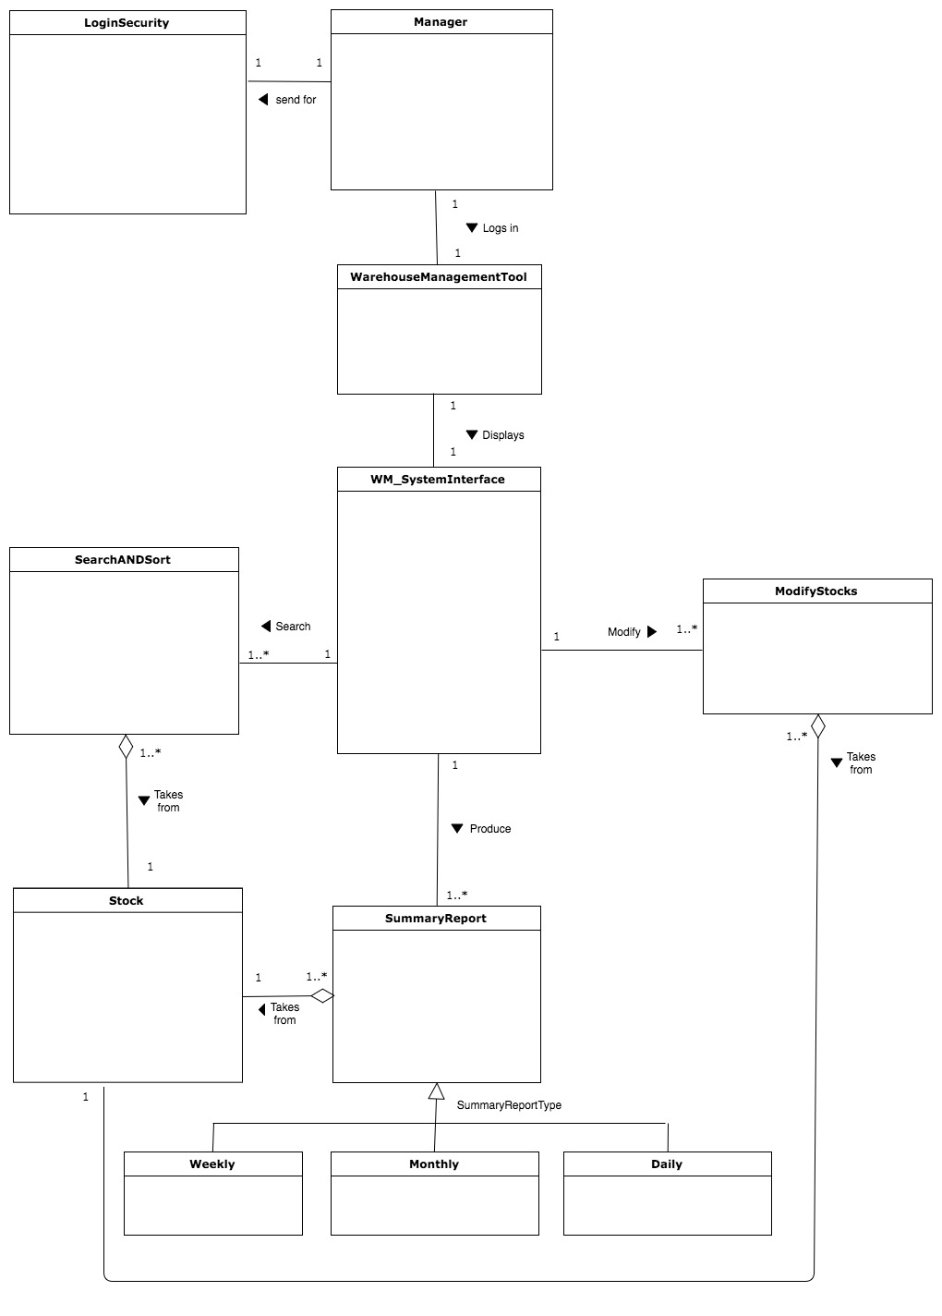

4.2 USE CASE DIAGRAM – INCEPTION PHASE

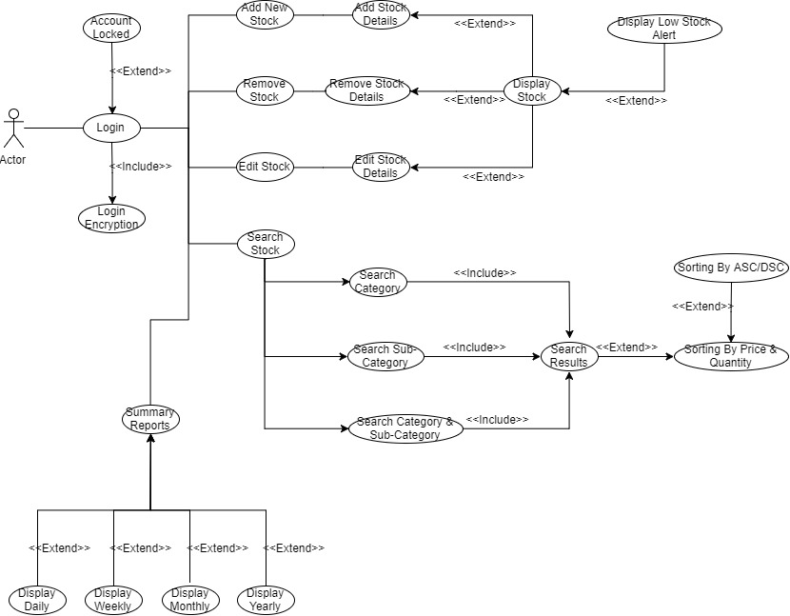

<Detailed Use Case Iteration 1>

Detailed Use Case (Scenario #1)

Use Case Textual Description
UC-ID | UC_WAREHOUSE_001
Name | User editing stock data.
Description | User wants to edit stock data into the system.
Actor(s) | User
Main Scenario | Step 1: User enters login credentials. If user enters incorrect credentials three times, the account will be locked. If user enters correct credentials, the login credentials will be encrypted.  Step 2: User selects stock data and system prompts user to edit the stock data.  Step 3: User fills in the required data and submits into the system.  Step 4: System will prompt user if the user wants to see the full details of the stock they just entered.  Step 5: After user are done with inspecting the full details of the stock, the system may prompt or inform the user if any stock is low or beneath a certain threshold.  Step 6: User quits the system or chooses another option.

Detailed Use Case (Scenario #2)
Use Case Textual Description
UC-ID | UC_WAREHOUSE_002
Name | Search Stock
Description | Allowing User to search for the stocks they want via Category, Sub-category or both. And allowing the user to sort them via price and quantity and further sort them via ascending or descending order.
User(s) | - User  - Database System
Main Scenario | Step 1: User login the system  Step 2: User chooses to search stocks  Step 3: User chooses the search via Category/ Sub-Category or via Category &  Sub-Category  Step 4: User receive the search results  Step 5: User will have a choice if he/she will want to sort the results  Step 6: User chooses to sort the results, sort by Price & Quantity  Step 7: User choose to sort by ascending or descending

4.2 USE CASE DIAGRAM – ELABORATION PHASE

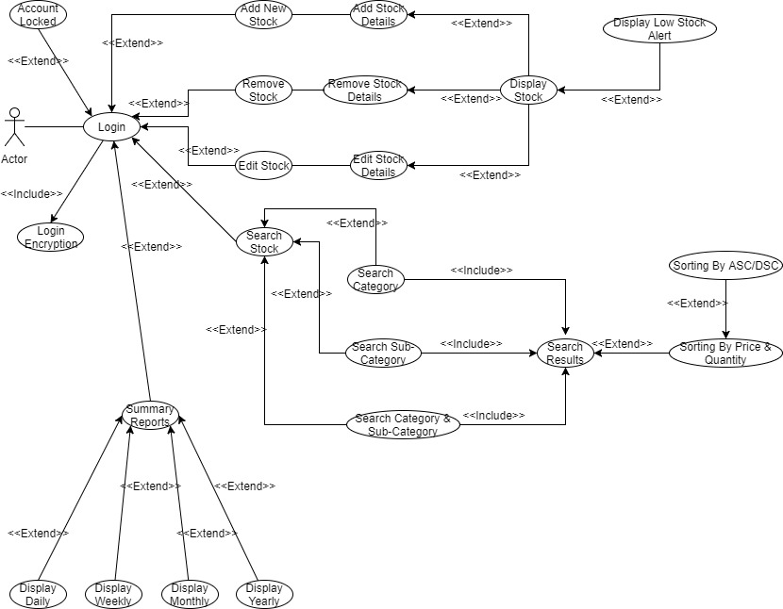

Detailed Use Case (Scenario #1)

Use Case Textual Description
UC-ID | UC_WAREHOUSE_001
Name | Add New Stock
Description | Allowing manager to login into the system to add the new stocks that is needed
Actor(s) | - Manager  - Database System
Main Scenario | Step 1: Manager login the system  Step 2: Manager chooses to add new stock.  Step 3: Manager keys in the stock details into the systems  Step 4: Manager will have a choice if he wants the system to display the stocks.  Step 5: Manager choose to display the stocks, he will be able to view the stocks  balance.  Step 6: Manager will have a choice if he wants the systems to display low stock  alert.  Step 7: Manager choose to display the low stocks, he will be able to view the stocks  balance.

Detailed Use Case (Scenario #2)

Use Case Textual Description
UC-ID | UC_WAREHOUSE_002
Name | Remove Stock
Description | Allowing manager to login into the system to remove stocks that is not needed
Actor(s) | - Manager  - Database System
Main Scenario | Step 1: Manager login the system  Step 2: Manager chooses to remove stock.  Step 3: Manager remove the stock details from the systems  Step 4: Manager will have a choice if he wants the system to display the stocks.  Step 5: Manager choose to display the stocks, he will be able to view the stocks  that was being removed.  Step 6: Manager will have a choice if he wants the systems to display low stock  alert.  Step 7: Manager choose to display the low stocks, he will be able to view the other  stocks balance.

Detailed Use Case (Scenario #3)

Use Case Textual Description
UC-ID | UC_WAREHOUSE_003
Name | Edit Stock
Description | Allowing manager to login into the system to edit stocks.
Actor(s) | - Manager  - Database System
Main Scenario | Step 1: Manager login the system  Step 2: Manager chooses to edit stock.  Step 3: Manager edit the stock details in the systems  Step 4: Manager will have a choice if he wants the system to display the stocks.  Step 5: Manager choose to display the stocks, he will be able to view the stocks  balance.  Step 6: Manager will have a choice if he wants the systems to display low stock  alert.  Step 7: Manager choose to display the low stocks, he will be able to view the stocks  balance.

Detailed Use Case (Scenario #4)

Use Case Textual Description
UC-ID | UC_WAREHOUSE_004
Name | Manager editing stock data.
Description | Manager wants to edit stock data into the system.
Actor(s) | - Manager  - Database System
Main Scenario | Step 1: Manager enters login credentials. If Manager enters incorrect credentials three times, the account will be locked. If Manager enters correct credentials, the login credentials will be encrypted.  Step 2: Manager selects stock data and system prompts Manager to edit the stock data.  Step 3: Manager fills in the required data and submits into the system.  Step 4: System will prompt Manager if the Manager wants to see the full details of the stock they just entered.  Step 5: After Manager are done with inspecting the full details of the stock, the system may prompt or inform the Manager if any stock is low or beneath a certain threshold.  Step 6: Manager will press a button to go back to the main menu to quit the program or do another option.

Detailed Use Case (Scenario #5)

Use Case Textual Description
UC-ID | UC_WAREHOUSE_005
Name | Search stock via Category
Description | Manager wants to search stock and sort by Category.
Actor(s) | - Manager  - Database System
Main Scenario | Step 1: Manager enters login credentials. If Manager enters incorrect credentials three times, the account will be locked. If Manager enters correct credentials, the login credentials will be encrypted.  Step 2: Manager selects Search Stock.  Step 3: Manager selects Search by Category then the program will output the Search Results.  Step 4: Program will prompt Manager if it wants to further sort the results by Price or Quantity.  Step 5: Program will prompt Manager again if it wants to further sort by Ascending or Descending. Afterwards, Manager will press a button to go back to the main menu to quit the program or do another option.

Detailed Use Case (Scenario #6)

Use Case Textual Description
UC-ID | UC_WAREHOUSE_006
Name | Search stock via Sub-Category
Description | Manager wants to search stock and sort by Sub-Category.
Actor(s) | - Manager  - Database System
Main Scenario | Step 1: Manager enters login credentials. If Manager enters incorrect credentials three times, the account will be locked. If Manager enters correct credentials, the login credentials will be encrypted.  Step 2: Manager selects Search Stock.  Step 3: Manager selects Search by Sub-Category then the program will output the Search Results.  Step 4: Program will prompt Manager if it wants to further sort the results by Price or Quantity.  Step 5: Program will prompt Manager again if it wants to further sort by Ascending or Descending. Afterwards, Manager will press a button to go back to the main menu to quit the program or do another option.

Detailed Use Case (Scenario #7)

Use Case Textual Description
UC-ID | UC_WAREHOUSE_007
Name | Search stock via Category and Sub-Category
Description | Manager wants to search stock and sort by Category and Sub-Category.
Actor(s) | - Manager  - Database System
Main Scenario | Step 1: Manager enters login credentials. If Manager enters incorrect credentials three times, the account will be locked. If Manager enters correct credentials, the login credentials will be encrypted.  Step 2: Manager selects Search Stock.  Step 3: Manager selects Search by Category and Sub-Category then the program will output the Search Results.  Step 4: Program will prompt Manager if it wants to further sort the results by Price or Quantity.  Step 5: Program will prompt Manager again if it wants to further sort by Ascending or Descending. Afterwards, Manager will press a button to go back to the main menu to quit the program or do another option.

Detailed Use Case (Scenario #8)
Use Case Textual Description
UC-ID | UC_WAREHOUSE_008
Name | Display Daily Report
Description | Manager wants to display Daily Report.
Actor(s) | - Manager  - Database System
Main Scenario | Step 1: Manager enters login credentials. If Manager enters incorrect credentials three times, the account will be locked. If Manager enters correct credentials, the login credentials will be encrypted.  Step 2: Manager selects Summary Reports. Program prompts which report that Manager wants to see.  Step 3: Manager selects Daily Report. Program displays Daily Report to the Manager. Afterwards, Manager will press a button to go back to the main menu to quit the program or do another option.

Detailed Use Case (Scenario #9)
Use Case Textual Description
UC-ID | UC_WAREHOUSE_009
Name | Display Weekly Report
Description | Manager wants to display Weekly Report.
Actor(s) | - Manager  - Database System
Main Scenario | Step 1: Manager enters login credentials. If Manager enters incorrect credentials three times, the account will be locked. If Manager enters correct credentials, the login credentials will be encrypted.  Step 2: Manager selects Summary Reports. Program prompts which report that Manager wants to see.  Step 3: Manager selects Weekly Report. Program displays Weekly Report to the Manager. Afterwards, Manager will press a button to go back to the main menu to quit the program or do another option.

Detailed Use Case (Scenario #10)
Use Case Textual Description
UC-ID | UC_WAREHOUSE_010
Name | Display Monthly Report
Description | Manager wants to display Monthly Report.
Actor(s) | - Manager  - Database System
Main Scenario | Step 1: Manager enters login credentials. If Manager enters incorrect credentials three times, the account will be locked. If Manager enters correct credentials, the login credentials will be encrypted.  Step 2: Manager selects Summary Reports. Program prompts which report that Manager wants to see.  Step 3: Manager selects Monthly Report. Program displays Monthly Report to the Manager. Afterwards, Manager will press a button to go back to the main menu to quit the program or do another option.

Detailed Use Case (Scenario #11)
Use Case Textual Description
UC-ID | UC_WAREHOUSE_011
Name | Display Yearly Report
Description | Manager wants to display Yearly Report.
Actor(s) | - Manager  - Database System
Main Scenario | Step 1: Manager enters login credentials. If Manager enters incorrect credentials three times, the account will be locked. If Manager enters correct credentials, the login credentials will be encrypted.  Step 2: Manager selects Summary Reports. Program prompts which report that Manager wants to see.  Step 3: Manager selects Yearly Report. Program displays Yearly Report to the Manager. Afterwards, Manager will press a button to go back to the main menu to quit the program or do another option.

4.3 Activity Workflows
(Inception Phase Iteration 1)

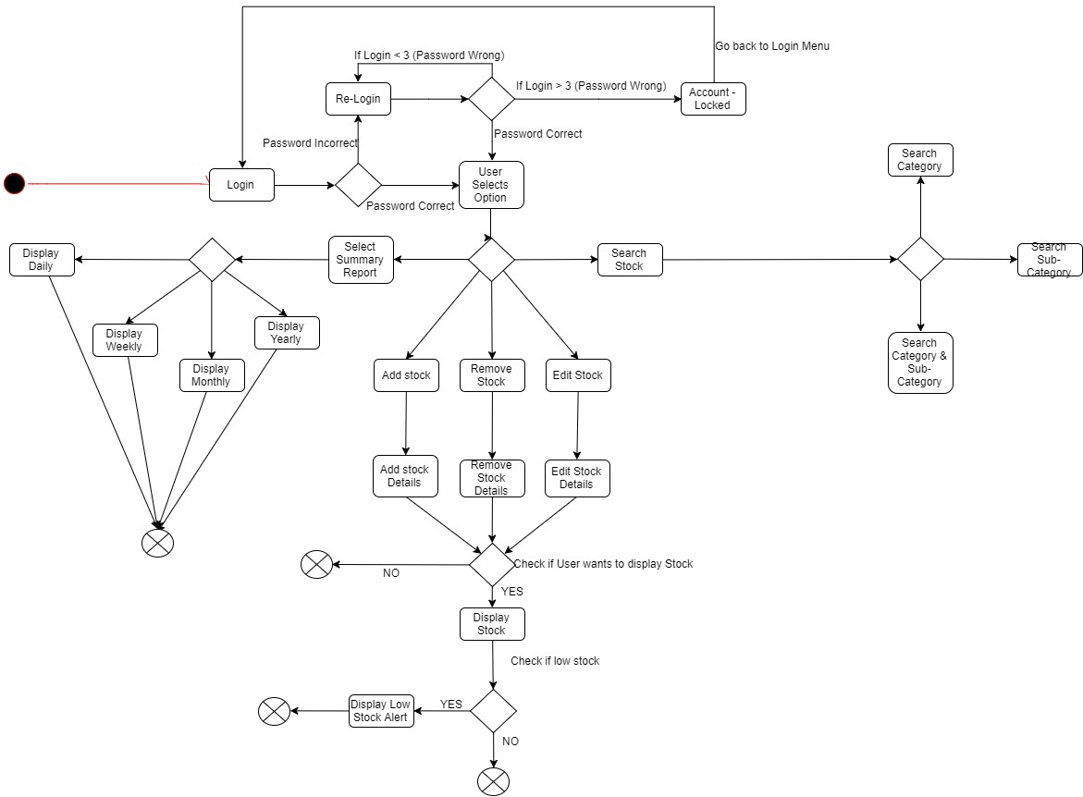

Activity Workflows
(Elaboration Phase Iteration 2)

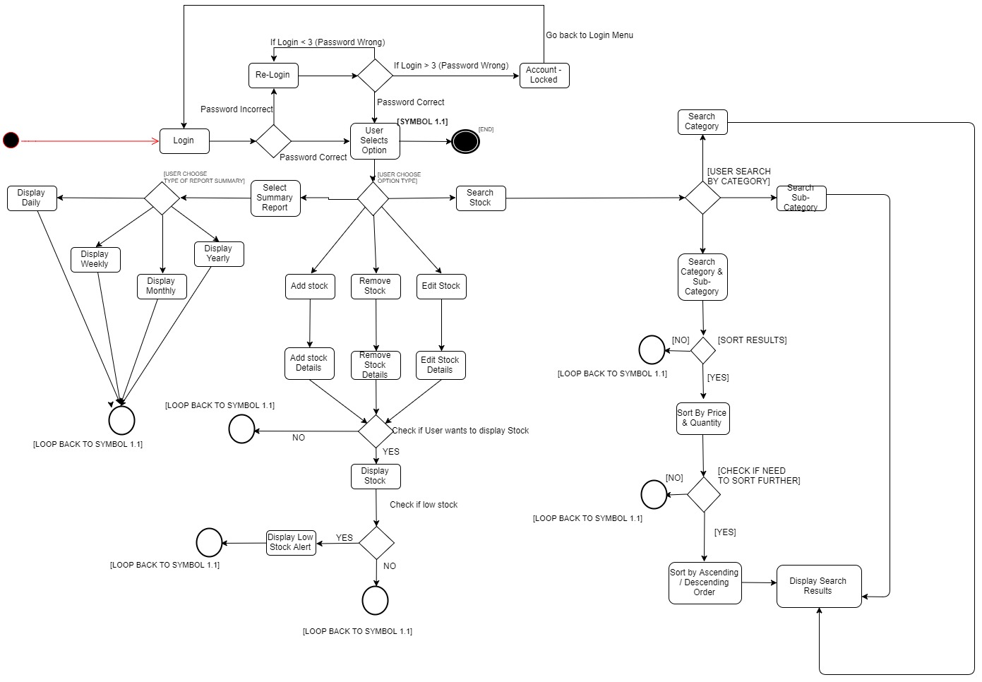

4.4 Component Diagrams
(Inception phase: Iteration 1)
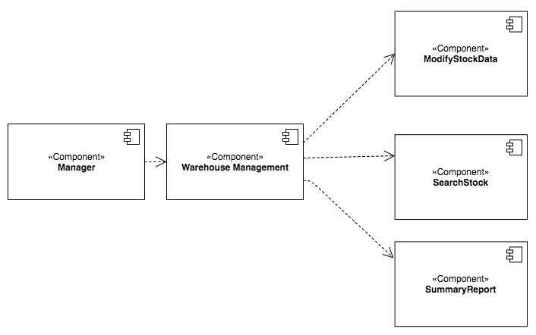
Component Diagrams
(Elaboration phase: Iteration 1)

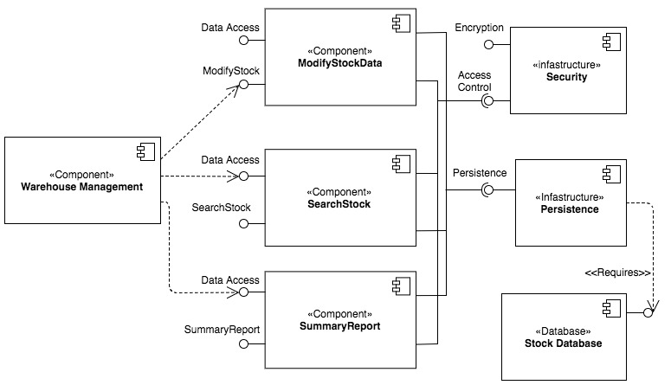

4.5 Class Diagrams
(Inception phase: Iteration 1)

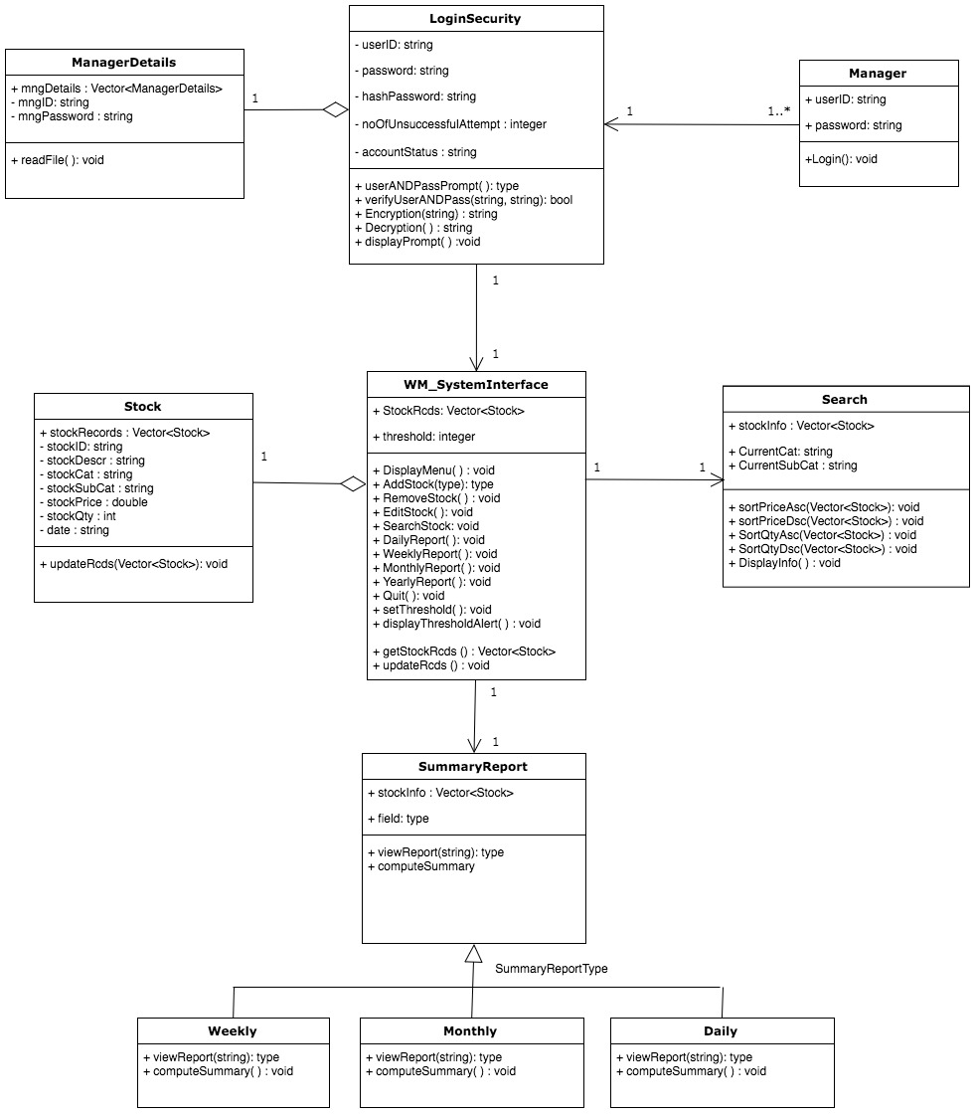

Class Diagrams
(Inception phase: Iteration 1)
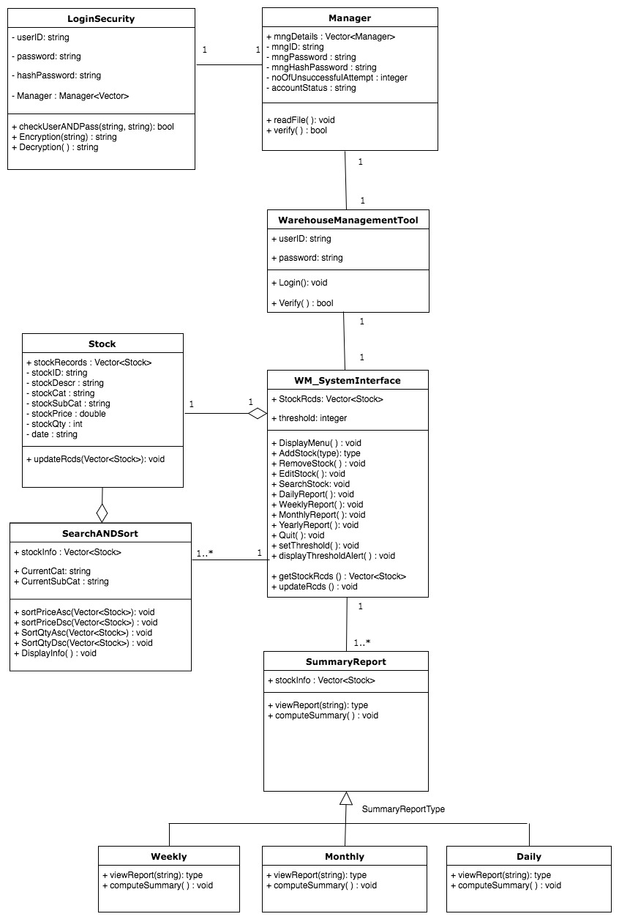
Class Diagrams
(Elaboration phase: Iteration 2)
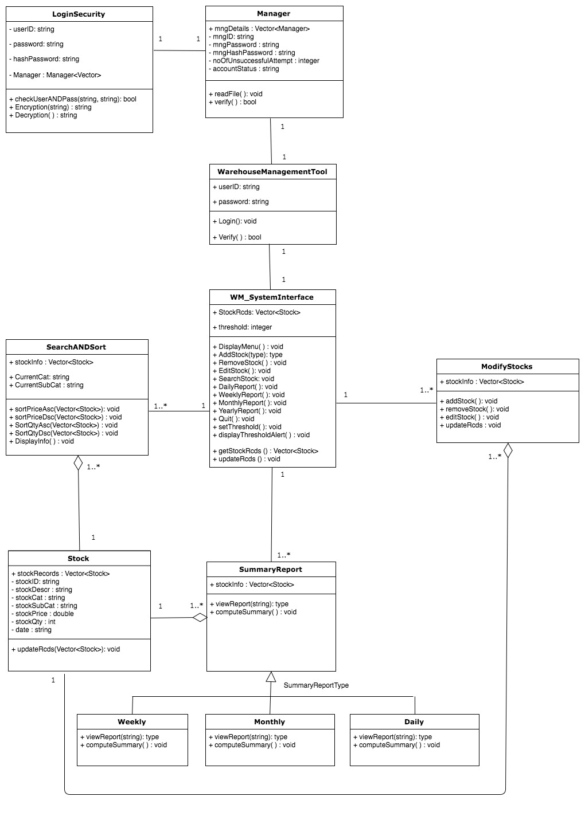
4.7 State Diagrams
(Inception phase: Iteration 1)

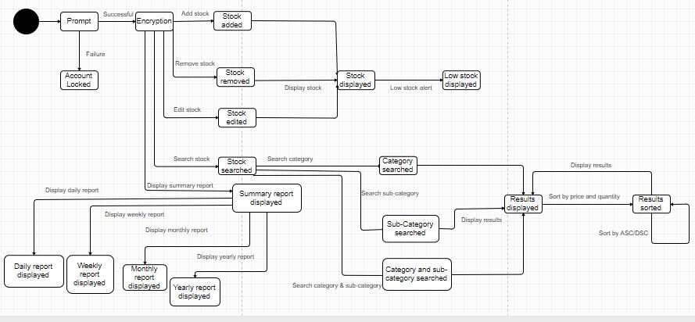
State Diagrams
(Elaboration phase: Iteration 1)



