CSCI212 Assignment 1 Test Cases

Name : Ken Leong Kin Kiat
Student No. : 5986825

General Instructions

- Prepare the following :

- Setup the exact same version of your program (submitted 1 day earlier via email) in Ubuntu

- Open up Excel document ‘Assn1_Checklist.xls ‘

- Perform test cases SEQUENTIALLY on your program, do not skip steps / sequence!

- FOR EACH test case :

  - Perform the test case on your program

  - If your program ‘pass’ the test case

- Do screen capture, and paste the image in ‘Assn1_TestCase.doc’, where indicated

- Update Assn1_Checklist.xls (select ‘yes’) at the row corresponding to your test case

Else // i.e. program ‘fails’ the test case

- No need for screen capture (leave the section blank)

- Update Assn1_Checklist.xls (select ‘no’) at the row corresponding to your test case

- Note : Please RESIZE your screen capture, Adjust the Spacing such that each
test case begins on a new page !!

Before you proceed to page 3 …

  - Download “BookDB_1.txt”

  - Rename “BookDB_1.txt” to “BookDB.txt”

  - Execute your program, reading in the file “BookDB.txt”

Test Case #1 – Display Menu

a) Startup your program

Expected Outcome :
Your program should display (at least) the following options :
- Add new book
- Remove existing book info
- Update book info
- Search for book by title/author
- Process a book sold
- Inventory summary report
- Quit
< Paste Screen Capture below >

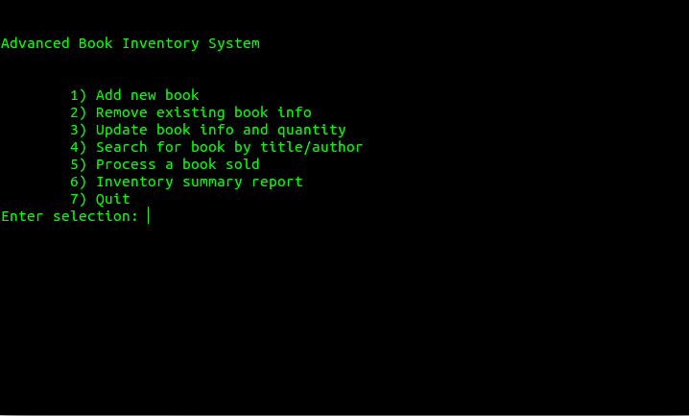

Test Case #2 – Verify data loaded correctly

a) Goto to Main Menu, choose 6) – Inventory Summary Report

Expected Outcome :
Your program should display exactly the following data :

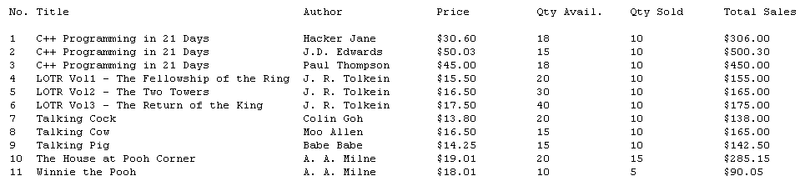

( Note : It is ok to have different sorting / display format / alignment, so long as all data is same as above ! )

< Paste Screen Capture below >

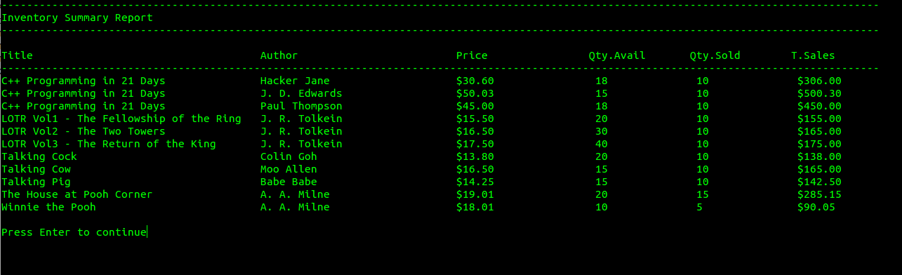

Test Case #3a – Search for book (title only)

a) Goto to Main Menu, choose 4) – Search for book by title/author

b) Key in the following data:

Title : C++ Programming in 21 Days
Author : <enter>

< Paste a screen capture (1) – Showing your data entry >

c) Press enter

Expected Outcome :
Your program should display exactly the following data :

Found 3 records :

C++ Programming in 21 Days, Hacker Jane, $30.60, 18, 10
C++ Programming in 21 Days, J. D. Edwards, $50.03, 15, 10
C++ Programming in 21 Days, Paul Thompson, $45.00, 18, 10

< Paste a screen capture (2) - search result >

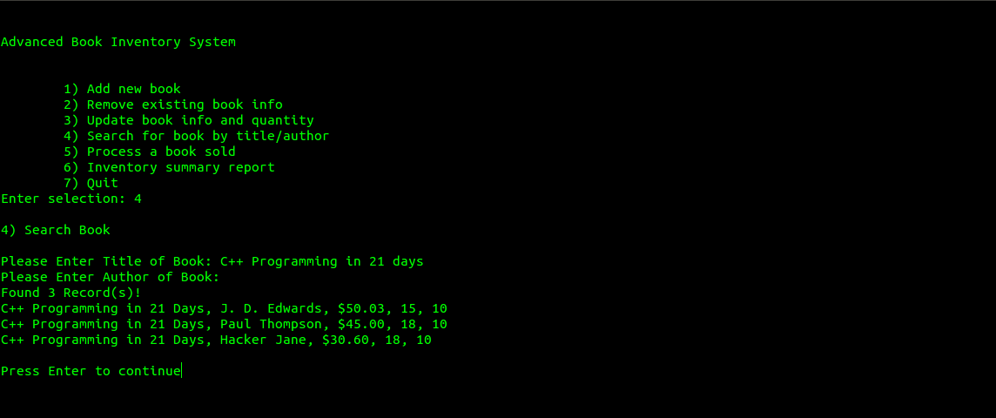

Test Case #3b – Search for book (title only)

a) Goto to Main Menu, choose 4) – Search for book by title/author

b) Key in the following data:

Title : Basic Java Programming
Author : <enter>

< Paste a screen capture (1) – Showing your data entry >

c) Press enter

Expected Outcome :
Your program should display the following message : Book not found!

< Paste a screen capture (2) - message >

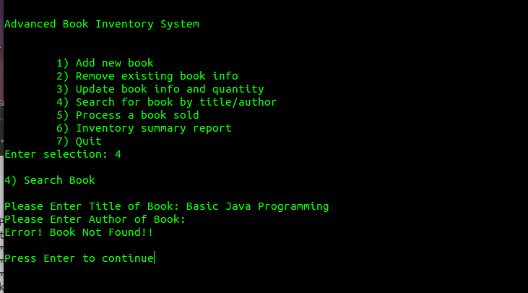

Test Case #3c – Search for book (author only)

a) Goto to Main Menu, choose 4) – Search for book by title/author

b) Key in the following data:

Title : <enter>
Author : J. R. Tolkein

< Paste a screen capture (1) – Showing your data entry >

c) Press enter

Expected Outcome :
Your program should display exactly the following data :

Found 3 records :

LOTR Vol1 – The Fellowship of the Ring, J. R. Tolkein, $15.50, 20, 10
LOTR Vol2 – The Two Towers, J. R. Tolkein, $16.50, 30, 10
LOTR Vol3 – The Return of the King, J. R. Tolkein, $17.50, 40, 10

< Paste a screen capture (2) - search result >

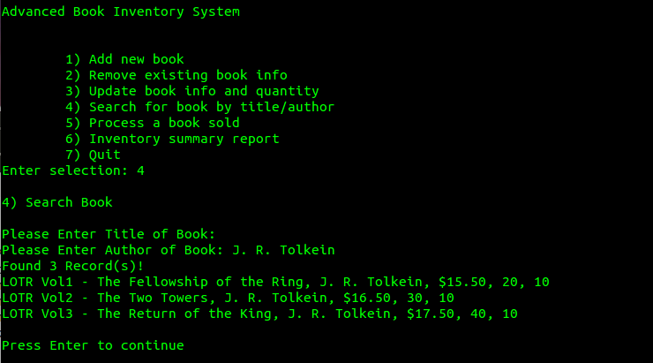

Test Case #3d – Search for book (author only)

a) Goto to Main Menu, choose 4) – Search for book by title/author

b) Key in the following data:

Title : <enter>
Author : Wacker Jim

< Paste a screen capture (1) – Showing your data entry >

c) Press enter

Expected Outcome :
Your program should display the following message : Book not found!

< Paste a screen capture (2) - message >

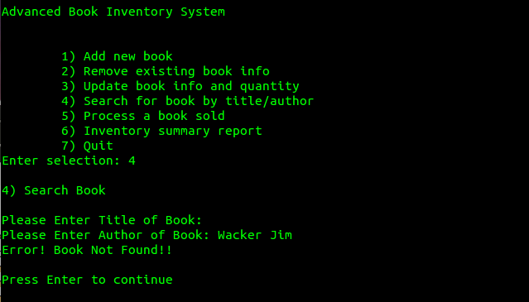

Test Case #3e – Search for book (title & author)

a) Goto to Main Menu, choose 4) – Search for book by title/author

b) Key in the following data:

Title : LOTR Vol1 – The Fellowship of the Ring
Author : J. R. Tolkein

< Paste a screen capture (1) – Showing your data entry >

c) Press enter

Expected Outcome :
Your program should display exactly the following data :

Found 1 record :

LOTR Vol1 – The Fellowship of the Ring, J. R. Tolkein, $15.50, 20, 10

< Paste a screen capture (2) - search result >

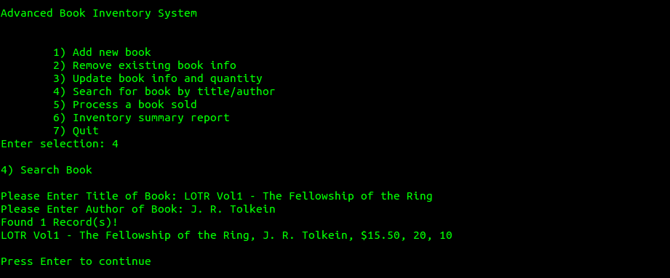

Test Case #3f – Search for book (title & author)

a) Goto to Main Menu, choose 4) – Search for book by title/author

b) Key in the following data:

Title : The House at Pooh Corner
Author : Wacker Jim

< Paste a screen capture (1) – Showing your data entry >

c) Press enter

Expected Outcome :
Your program should display the following message : Book not found!

< Paste a screen capture (2) - message >

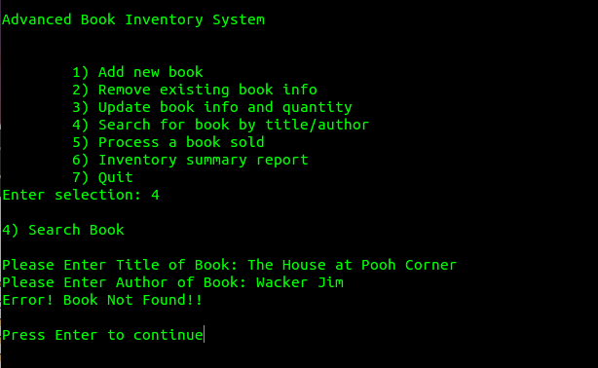

Test Case #4a – Add New Book (existing author & title)

a) Goto to Main Menu, choose 1) – Add New Book

b) Key in the following data:

Title : Talking Pig
Author : Babe Babe

< Paste a screen capture (1) – Showing your data entry >

c) Press enter

Expected Outcome :
Your program should display the following message : Error! Book already exists!

< Paste a screen capture (2) – Showing your error message >

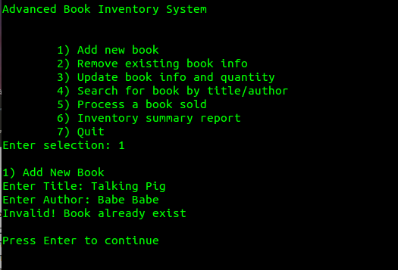

Test Case #4b – Add New Book (existing author, diff. title)

a) Goto to Main Menu, choose 1) – Add New Book

b) Key in the following data:

Title : Talking Bear
Author : Babe Babe
Price : 79.99
Qty Available : 80
Qty Sold : 1

< Paste a screen capture (1) – Showing your data entry >

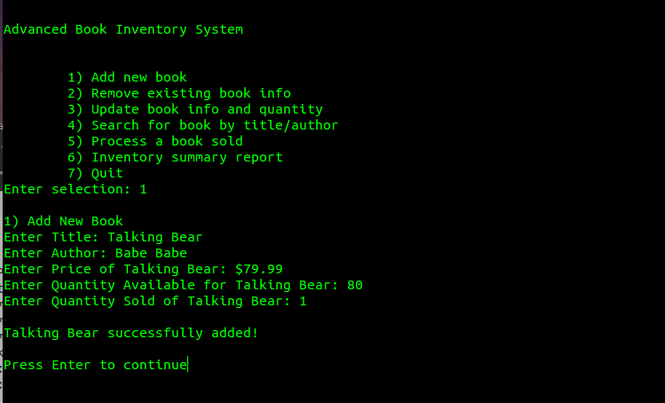

c) Press enter

Expected Outcome :
Your program should display the following message : Book title ‘Talking Bear’ added successfully!

d) Goto to Main Menu, choose 6) – Inventory Summary Report

< Paste a screen capture (2) – Output of Inventory Summary Report >

< Draw an arrow and point where the book was added … >

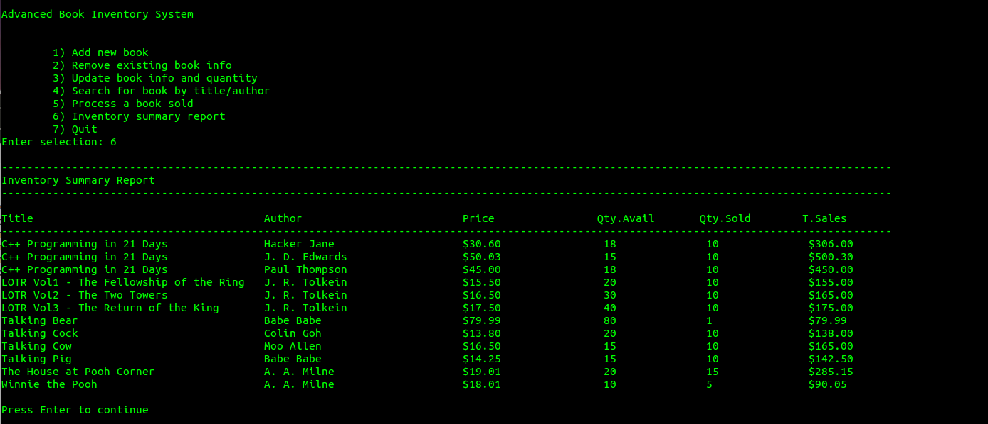

Test Case #4c – Add New Book (existing title, diff. author)

a) Goto to Main Menu, choose 1) – Add New Book

b) Key in the following data:

Title : Talking Pig
Author : Eric Cartman
Price : 89.99
Qty Available : 90
Qty Sold : 1

< Paste a screen capture (1) – Showing your data entry >

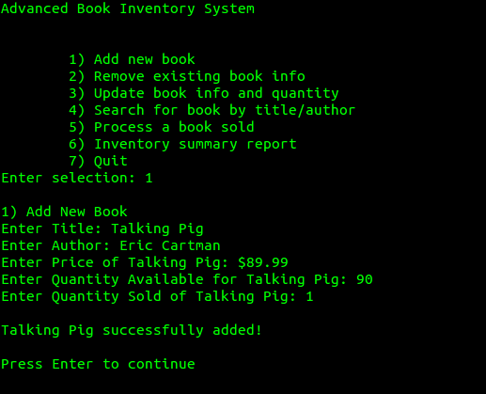

c) Press enter

Expected Outcome :
Your program should display the following message : Book title ‘Talking Pig’ added successfully!

d) Goto to Main Menu, choose 6) – Inventory Summary Report

< Paste a screen capture (2) – Output of Inventory Summary Report >

< Draw an arrow and point where the book with author ‘Eric Cartman’ was added … >

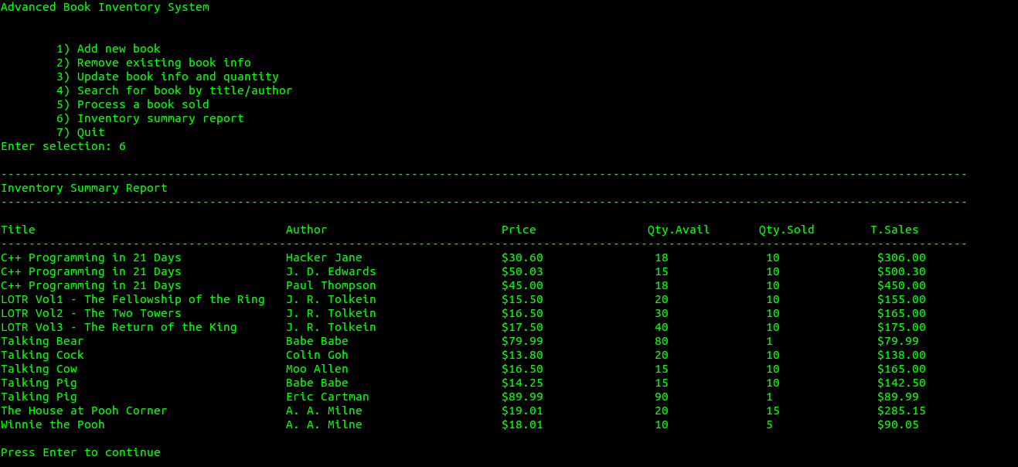

Test Case #4d – Add New Book (non-existing title & author)

a) Goto to Main Menu, choose 1) – Add New Book

b) Key in the following data:

Title : Star Wars 7 – Yoda Lives Again
Author : Luke SkyCrawler
Price : 35.50
Qty Available : 60
Qty Sold : 1

< Paste a screen capture (1) – Showing your data entry >

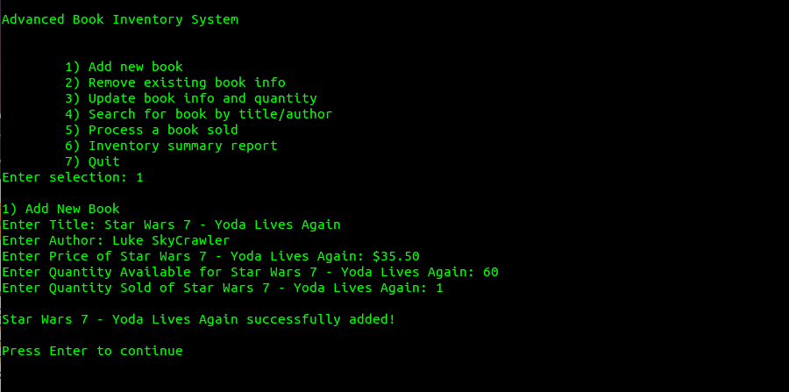

c) Press enter

Expected Outcome :
Your program should display the following message : Book title ‘Star Wars 7 – Yoda Lives Again’ added successfully!

d) Goto to Main Menu, choose 6) – Inventory Summary Report

< Paste a screen capture (2) – Output of Inventory Summary Report >

< Draw an arrow and point where the new book was added … >

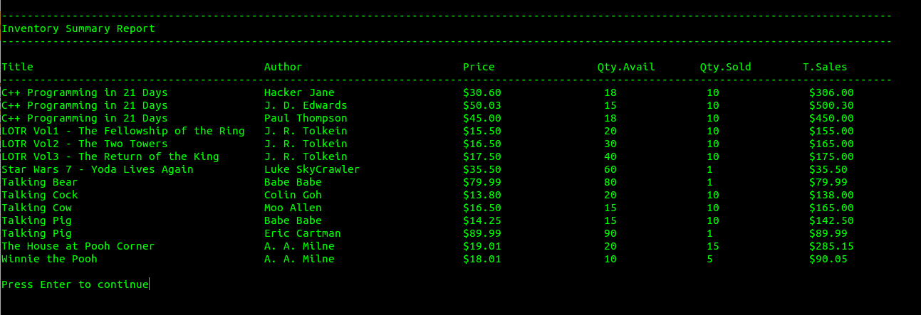

Test Case #5a – Update Book Info (non-existing author)

a) Goto to Main Menu, choose 3) – Update Book Info

b) Key in the following data:

Title : C++ Programming in 21 Days
Author : Donald Trump

< Paste a screen capture (1) – Showing your data entry >

c) Press enter

Expected Outcome :
Your program should display the following message : Error! Book does not exists!

< Paste a screen capture (2) – Showing your error message >

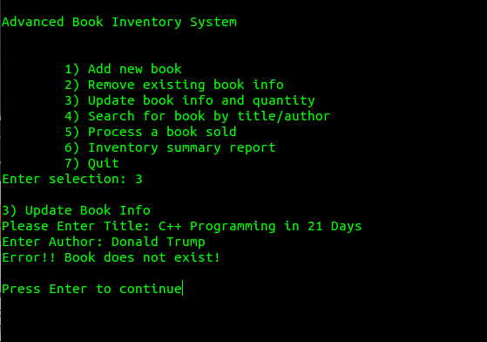

Test Case #5b – Update Book Info (non-existing title)

a) Goto to Main Menu, choose 3) – Update Book Info

b) Key in the following data:

Title : C++ Programming in 7 Days
Author : Hacker Jane

< Paste a screen capture (1) – Showing your data entry >

c) Press enter

Expected Outcome :
Your program should display the following message : Error! Book does not exists!

< Paste a screen capture (2) – Showing your error message >

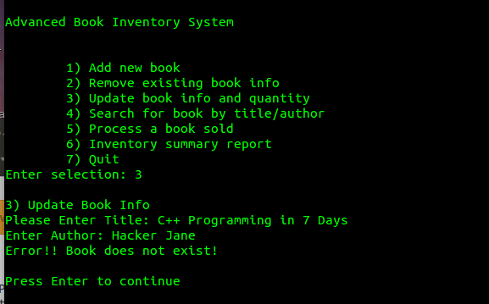

Test Case #5c – Update Book Info (non-existing title & author)

a) Goto to Main Menu, choose 3) – Update Book Info

b) Key in the following data:

Title : C++ Programming in 7 Days
Author : Donald Trump

< Paste a screen capture (1) – Showing your data entry >

c) Press enter

Expected Outcome :
Your program should display the following message : Error! Book does not exists!

< Paste a screen capture (2) – Showing your error message >

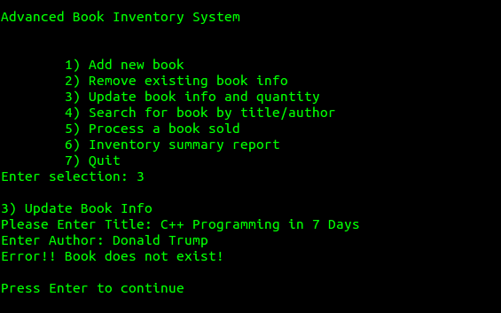

Test Case #5d – Update Book Info (existing title & author)

a) Goto to Main Menu, choose 3) – Update Book Info

b) Key in the following data:

Title : LOTR Vol2 – The Two Towers
Author : J. R. Tolkein

< Paste a screen capture (1) – Showing your data entry >

c) Press enter

Expected Outcome :
Your program should display a sub-menu, with at least the following options :
- Update Title
- Update Author
- Update Price
- Update Qty Available
- Update Qty Sold
- Back to main menu

< Paste a screen capture (2) – Showing your sub-menu >

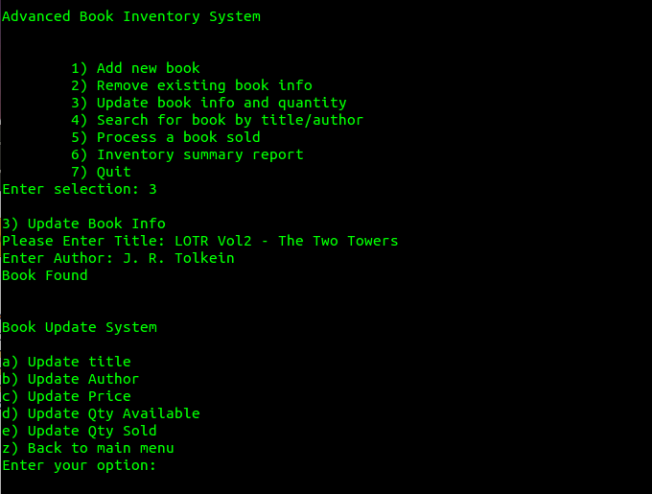

Test Case #5e – Update Book Info ( to another existing title )

a) Goto to Main Menu, choose 3) – Update Book Info

b) Key in the following data:

Title : LOTR Vol2 – The Two Towers
Author : J. R. Tolkein

c) In sub-menu, choose ‘Update Title’, key in the following data:

New Title : LOTR Vol3 – The Return of the King

< Paste a screen capture (1) – Showing your data entry >

d) Press enter

Expected Outcome :
Your program should display an error message, informing user that he is updating to a title & author that already exists in BooksDB !!

< Paste a screen capture (2) – Showing your error message >

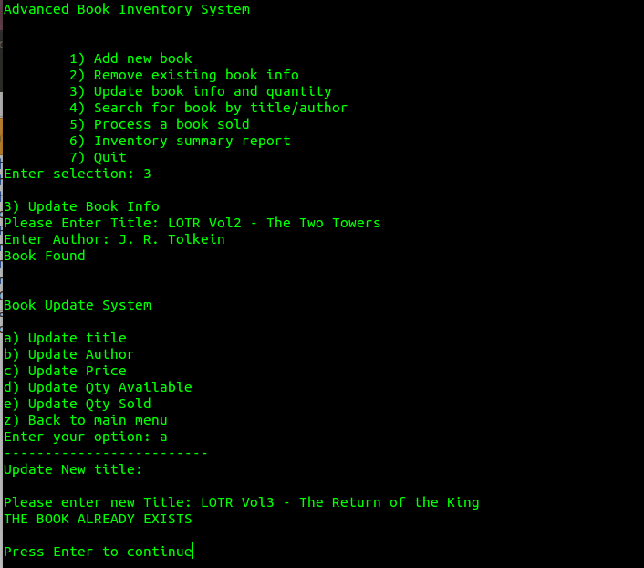

Test Case #5f – Update Book Info ( to another existing author )

a) Goto to Main Menu, choose 3) – Update Book Info

b) Key in the following data:

Title : C++ Programming in 21 Days
Author : Hacker Jane

c) In sub-menu, choose ‘Update Author’, key in the following data:

New Author : J. D. Edwards

< Paste a screen capture (1) – Showing your data entry >

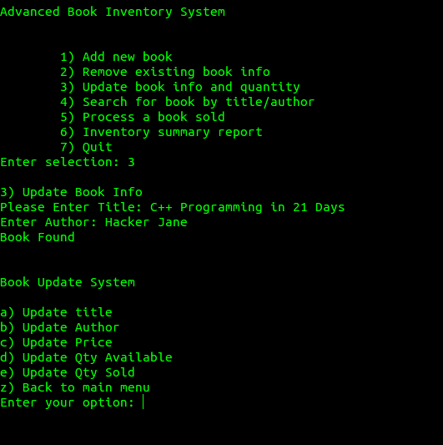

d) Press enter

Expected Outcome :
Your program should display an error message, informing user that he is updating to a title & author that already exists in BooksDB !!

< Paste a screen capture (2) – Showing your error message >

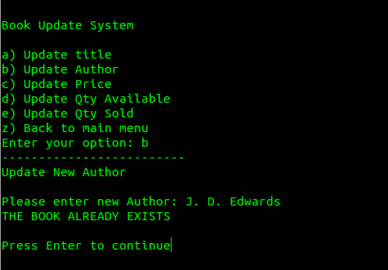

Test Case #5g – Update Book Info ( to another existing title )

a) Goto to Main Menu, choose 3) – Update Book Info

b) Key in the following data:

Title : Talking Cock
Author : Colin Goh

c) In sub-menu, choose ‘Update Title’, key in the following data:

New Title : C++ Programming in 21 Days

< Paste a screen capture (1) – Showing your data entry >

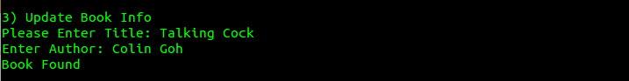

Expected Outcome :
Your program should display a confirmation message, informing user that book title is updated successfully.

d) In sub-menu, choose ‘Back to main menu’

e) In Main Menu, choose 6) – Inventory Summary Report

< Paste a screen capture (2) – Output of Inventory Summary Report >

< Draw an arrow and point where the book was updated (where author is Colin Goh) … >

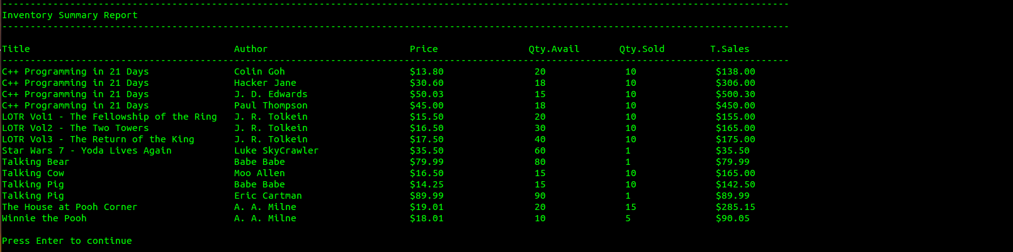

Test Case #5h – Update Book Info ( to another existing author )

a) Goto to Main Menu, choose 3) – Update Book Info

b) Key in the following data:

Title : Talking Cow
Author : Moo Allen

c) In sub-menu, choose ‘Update Author’, key in the following data:

New Author : Paul Thompson

< Paste a screen capture (1) – Showing your data entry >
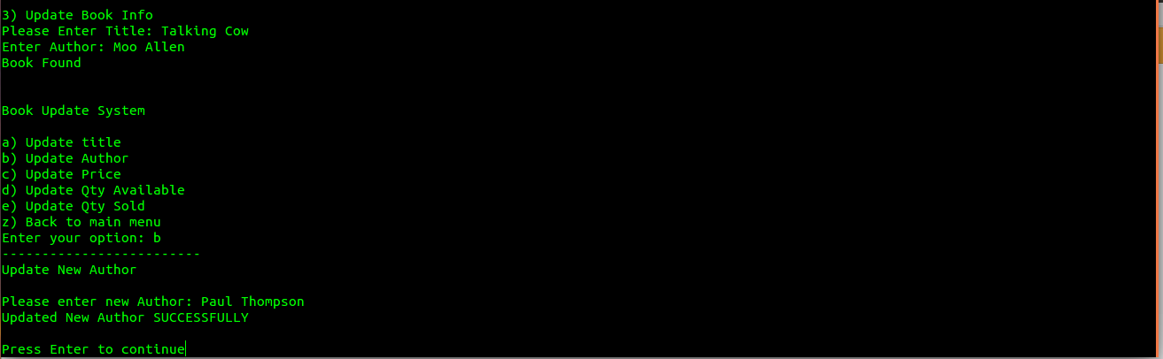

Expected Outcome :
Your program should display a confirmation message, informing user that book author is updated successfully.

d) In sub-menu, choose ‘Back to main menu’

e) In Main Menu, choose 6) – Inventory Summary Report

< Paste a screen capture (2) – Output of Inventory Summary Report >

< Draw an arrow and point where the book was updated (where title is Talking Cow) … >

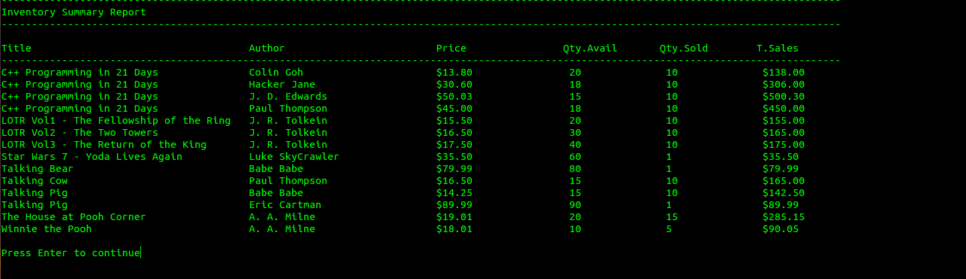

Test Case #5i – Update Book Info ( to a non-existing title & author! )

a) Goto to Main Menu, choose 3) – Update Book Info

b) Key in the following data:

Title : C++ Programming in 21 Days
Author : Hacker Jane

c) In sub-menu, choose ‘Update Title’, key in the following data:

New Title : Shell Programming in 21 Hours

d) In sub-menu, choose ‘Update Author’, key in the following data:

New Author : Packer John

< Paste a screen capture (1) – Showing your data entry >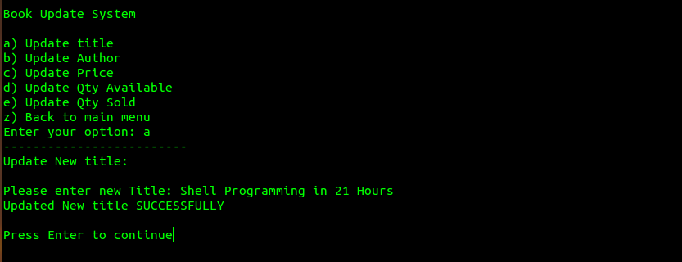

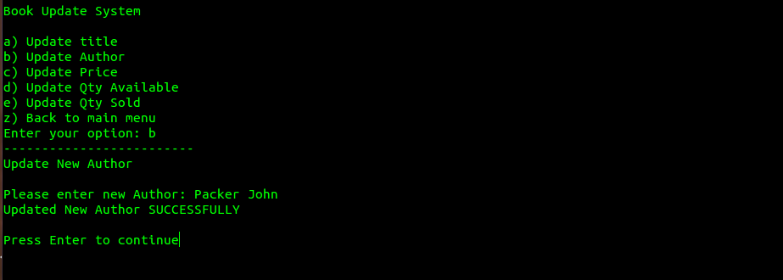

Expected Outcome :
Your program should display a confirmation message, informing user that book author is updated successfully.

e) In sub-menu, choose ‘Back to main menu’

f) In Main Menu, choose 6) – Inventory Summary Report

< Paste a screen capture (2) – Output of Inventory Summary Report >

< Draw an arrow and point where the book was updated (where author is Packer John) … >

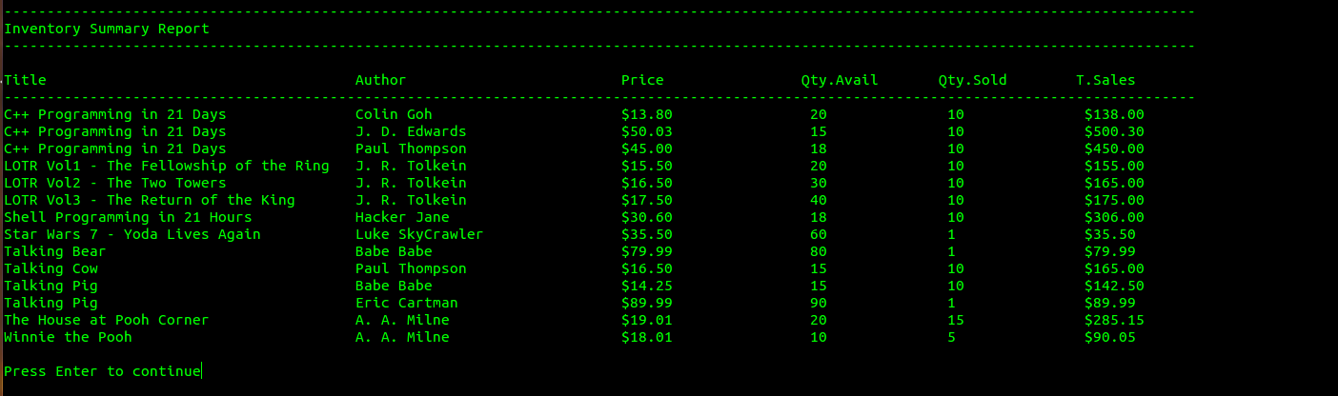

Test Case #6a – Process a Book Sold

a) Goto to Main Menu, choose 5) – Process a book sold

b) Key in the following data:

Title : LOTR Vol1 - The Fellowship of the Ring
Author : Frodo and Sam

< Paste a screen capture (1) – Showing your data entry >

c) Press enter

Expected Outcome :
Your program should display the following message : Error! Book does not exists!

< Paste a screen capture (2) – Showing your error message >

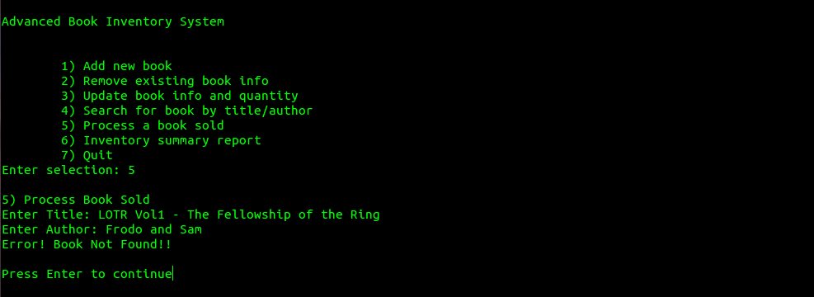

Test Case #6b – Process a Book Sold

a) Goto to Main Menu, choose 5) – Process a book sold

b) Key in the following data:

Title : LOTR Vol1 - The Fellowship of the Ring
Author : J. R. Tolkein
No. of copies sold : 3

< Paste a screen capture (1) – Showing your data entry >

c) Press enter

Expected Outcome :
Your program should display the following message :

Current book info :
LOTR Vol1 - The Fellowship of the Ring, J. R. Tolkein, $15.50, 20, 10

New book info :
LOTR Vol1 - The Fellowship of the Ring, J. R. Tolkein, $15.50, 17, 13

< Paste a screen capture (2) – Showing your confirmation message >

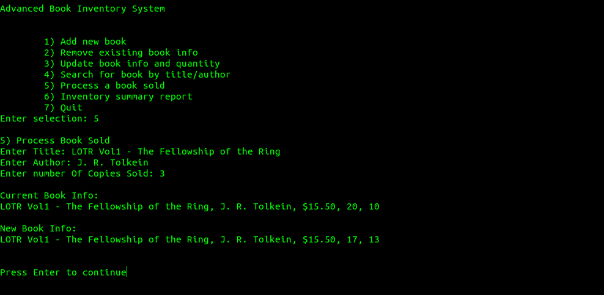

d) In Main Menu, choose 6) – Inventory Summary Report

Expected Outcome :
Your program should display the updated ‘Total Sales’ for the above book. (see eg. below)

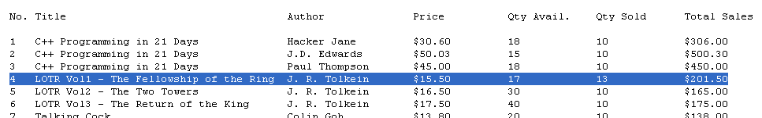

< Paste a screen capture (3) – Showing new Total Sales figure $201.50 >

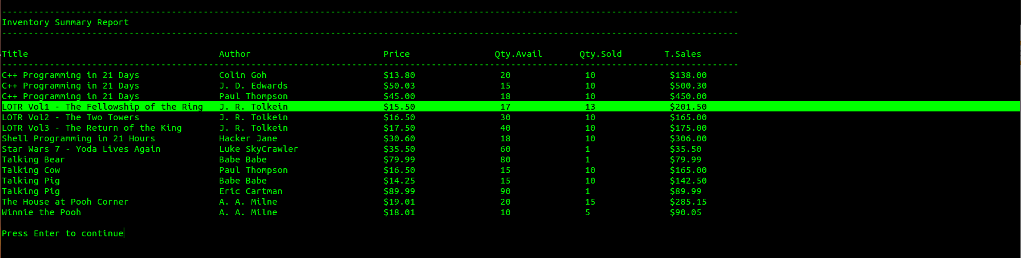

Test Case #7a – Remove existing book info (unknown author)

a) Goto to Main Menu, choose 2) – Remove existing book info

b) Key in the following data:

Title : C++ Programming in 21 Days
Author : Hacker Jim

< Paste a screen capture (1) – Showing your data entry >

c) Press enter

Expected Outcome :
Your program should display the following message : Error! Book does not exists!

< Paste a screen capture (2) – Showing your error message >
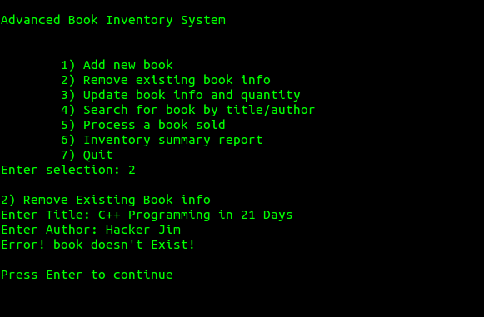

Test Case #7b – Remove existing book info (unknown title)

a) Goto to Main Menu, choose 2) – Remove existing book info

b) Key in the following data:

Title : C++ Programming in 31 Days
Author : Hacker Jane

< Paste a screen capture (1) – Showing your data entry >

c) Press enter

Expected Outcome :
Your program should display the following message : Error! Book does not exists!

< Paste a screen capture (2) – Showing your error message >

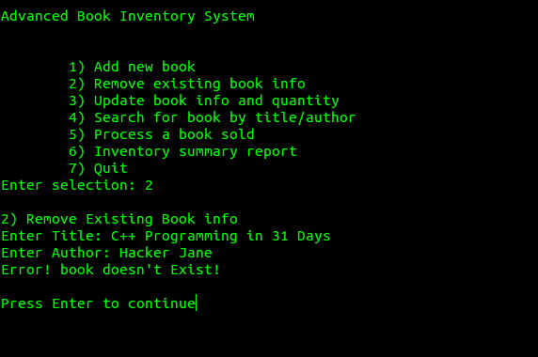

Test Case #7c – Remove existing book info (known author & title)

a) Goto to Main Menu, choose 2) – Remove existing book info

b) Key in the following data:

Title : Winnie the Pooh
Author : A. A. Milne

< Paste a screen capture (1) – Showing your data entry >

c) Press enter

Expected Outcome :
Your program should display the following message :
Book Title ‘Winnie the Pooh’ removed successfully!

< Paste a screen capture (2) – Showing your confirmation message >

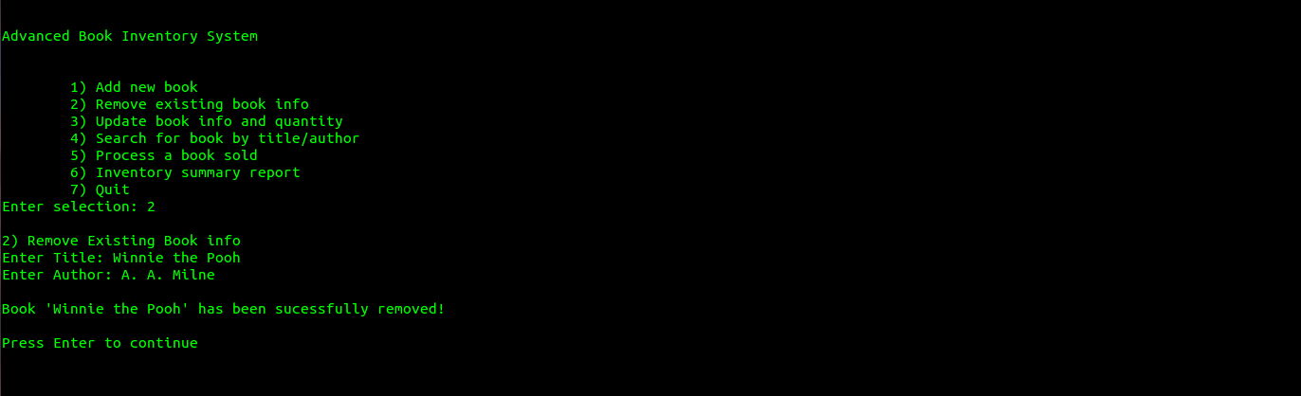

(Other Basic Error Handling … )

Test Case #8a – Search for book (title only)

a) Goto to Main Menu, choose 4) – Search for book by title/author

b) Key in the following data ( all alphabets are strictly lowercase! ) :

Title : c++ programming in 21 days
Author : <enter>

< Paste a screen capture (1) – Showing your data entry >

c) Press enter

Expected Outcome :
Your program should display exactly the following data :

Found 3 records :
C++ Programming in 21 Days, Colin Goh, $13.80, 20, 10
C++ Programming in 21 Days, J. D. Edwards, $50.03, 15, 10
C++ Programming in 21 Days, Paul Thompson, $45.00, 18, 10

< Paste a screen capture (2) - search result >

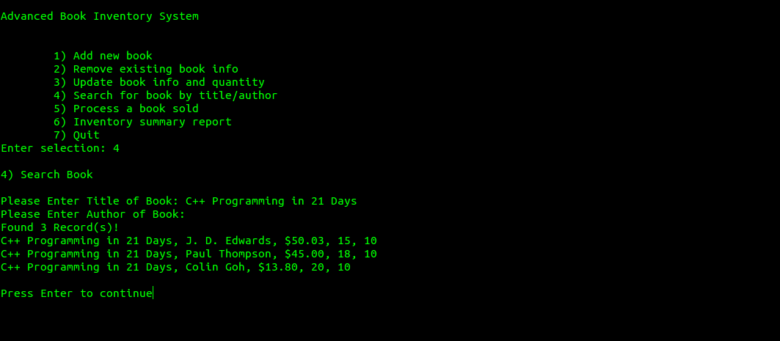

(Other Basic Error Handling … )

Test Case #8b – Search for book (author only)

a) Goto to Main Menu, choose 4) – Search for book by title/author

b) Key in the following data ( all alphabets are strictly UPPERCASE! ) :

Title : <enter>
Author : J. R. TOLKEIN

< Paste a screen capture (1) – Showing your data entry >

c) Press enter

Expected Outcome :
Your program should display exactly the following data :

Found 3 records :

LOTR Vol1 – The Fellowship of the Ring, J. R. Tolkein, $15.50, 17, 13
LOTR Vol2 – The Two Towers, J. R. Tolkein, $16.50, 30, 10
LOTR Vol3 – The Return of the King, J. R. Tolkein, $17.50, 40, 10

< Paste a screen capture (2) - search result >

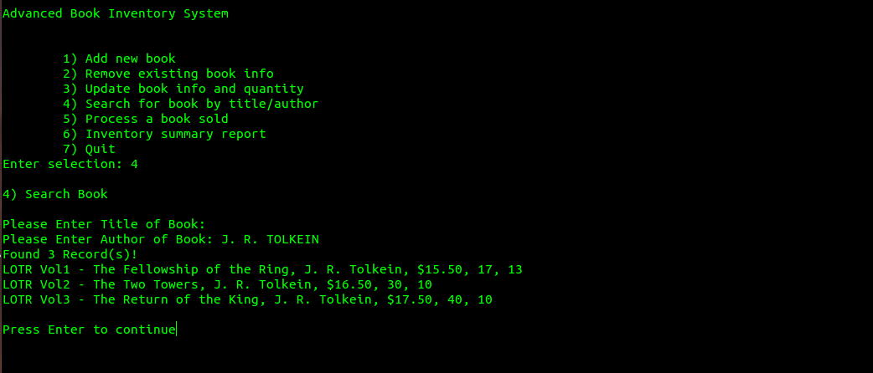

(Other Basic Error Handling … )

Test Case #9a - Add New Book (invalid number format)

a) Goto to Main Menu, choose 1) – Add New Book

b) Key in the following data:

Title : Star Wars 10 – Han Solo & Chewbacca should kiss and make up
Author : Luke Skywalker
Price : 35.50
Qty Available : 60
Qty Sold : 101.6389

< Paste a screen capture (1) – Showing your data entry >

c) Press enter

Expected Outcome :
Your program should output some error message like “Error, Qty Sold must be a positive integer!”

< Paste a screen capture (2) – Showing your error message >

(Other Basic Error Handling … )

Test Case #9b – Main Menu (invalid option)

a) Goto to Main Menu, Key in option ‘-5’

b) Press enter

Expected Outcome :
Your program should output some error message like “Error, Please enter a valid option (1 – 7) : “

< Paste a screen capture – Showing your error message >

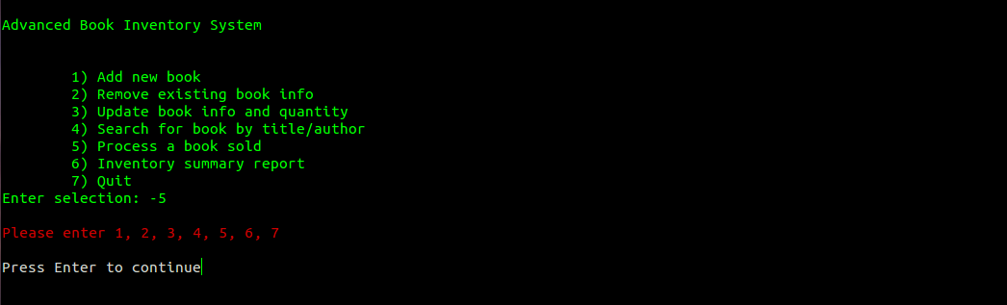

Test Case #10 – Quit

a) Goto to Main Menu, choose 6) – Inventory Summary Report

< Paste a screen capture (1) – Showing your Inventory Summary Report >

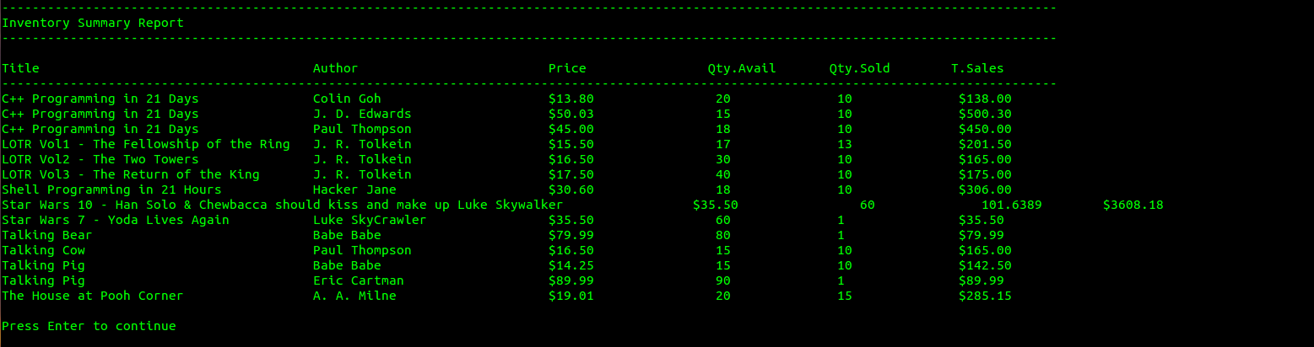

b) Goto to Main Menu, choose 7) – Quit

c) Using GEdit, open up your “BookDB.txt”

< Paste a screen capture (2) – Showing the data in ‘BookDB.txt’ >

Expected Outcome :
The data shown in Screen Capture (1), must match exactly those shown in Screen Capture (2) !!

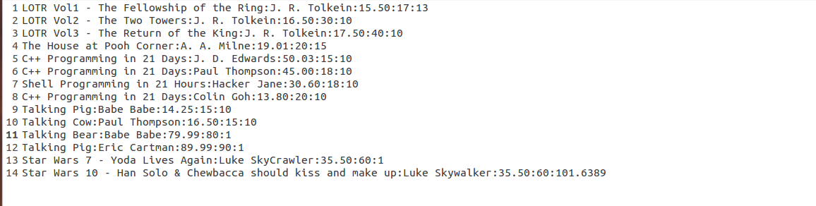

(Optional) Extra Feature / Functionality / Value Add

Description
(In the space below, type a short summary to describe the extra feature(s) implemented)

< Paste Screen Capture(s) below >

(In the space below, use as many screen captures, MS Word arrows, textboxes, as necessary, to show that your extra feature(s) works!)

