CSCI212 Assignment 1 (Evaluation Instructions)

- Login to Yahoo Groups, ‘sim_csci212’, navigate to Files > Assignments > Evaluation

- Download the following files, “BookDB_1.txt”, “Assn1_TextCase.doc”, “Assn1_Checklist.xls” and “CSCI212_Assn1_Eval_Instr.doc” (this doc)

- Read and follow the instructions in Assn1_TestCase.doc.

- If after completing the test cases, the final file size is too large, please follow instructions in Appendix A, to reduce file size of Assn1_Test_Cases.doc document

- When you’re done, zip up Assn1_TestCase.doc & Assn1_Checklist.xls in the following format :

<Name>_<Stud. No.>_Assn1_Eval.zip
( E.g. hellokitty_0123456_Assn1_Eval.zip )

- Email zip file to csci212@yahoo.com

To : tutor's email (see above)

Subject : FT Assn1 Eval 1234567 JohnDoeAnderson

- Please ensure the test results for each test case are updated correctly!

- Marks will be deducted if test case results in :

Assn1_TestCase.doc ≠ Assn1_Checklist.xls ≠
Your submitted program (1 day earlier) ≠

Appendix A

- The following works for MS Word 2003, ( by implication, the same kind of feature should be available for all MS Word versions later than this ! )

- V. IMPT. NOTE : you should compress picture ONLY for those test cases, where the textual info is not critical to the test case. If you are unsure, please raise your hand to consult your tutor.

- Right-click on the screen-capture picture, choose “Format Picture”

- Choose the “Picture” tab, and click on “Compress” button

- On the dialog box, make sure you specify the same settings as the Figure below:

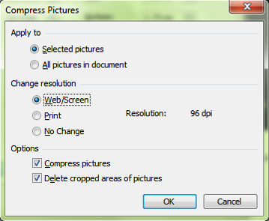

- Click on the “Ok” button to confirm the changes

