Approach for Subaims 1a and 1b
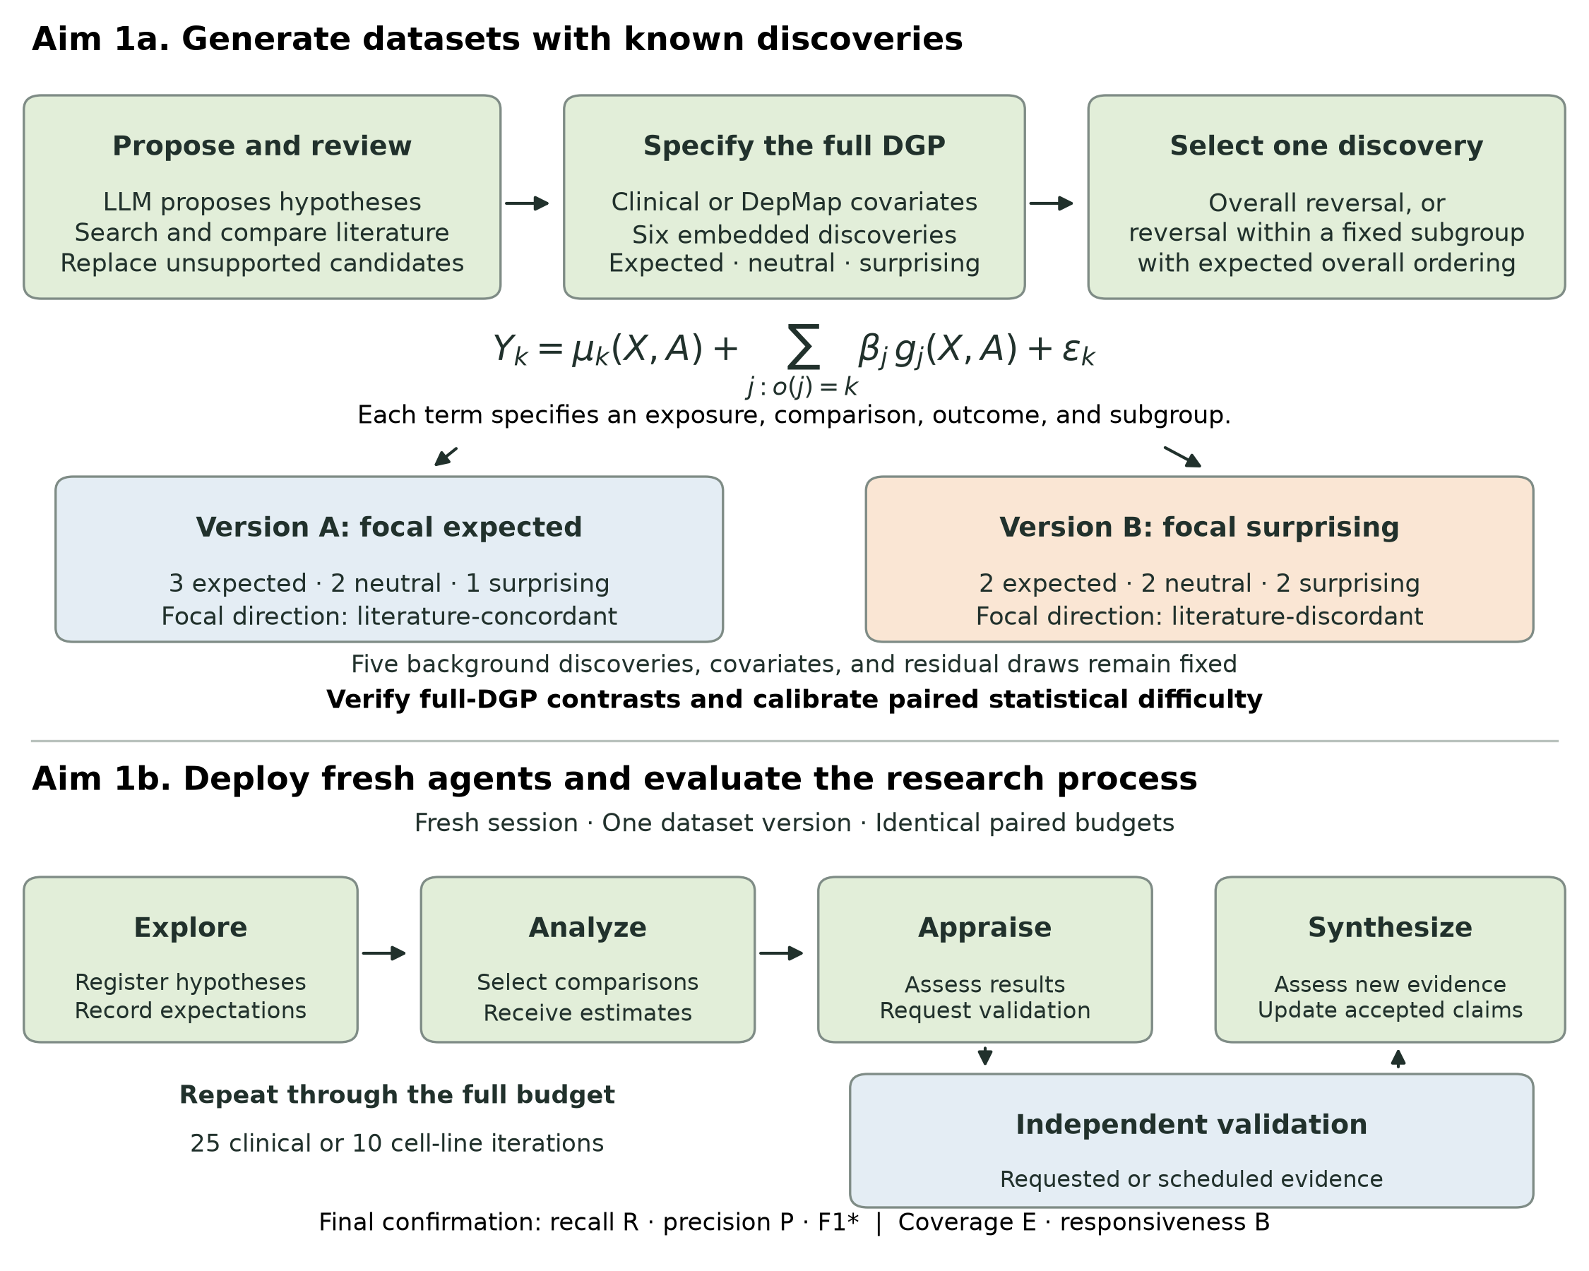
Figure 3. Aim 1 overview. Each base dataset contains six discoveries classified against the literature as expected, neutral, or surprising. The illustrated pair reverses one selected focal discovery; the other five discovery specifications, covariates, and residual draws remain fixed. Category mixes can vary across base datasets. Fresh agent sessions explore, analyze, appraise, and synthesize. Requested or scheduled independent validation arrives after appraisal and before synthesis. Agents judge effect sizes and conclusions themselves; reference cutoffs remain private to the evaluator. The primary comparison is the difference in exact, independently confirmed focal recovery between paired versions. Secondary measures describe recall (R), precision (P), their combined F1* score, exploration coverage (E), and evidence responsiveness (B).

Sub-aim 1a. Create clinical and perturbation-screen benchmarking tasks with expected, neutral, and surprising discoveries.
Overview. OCSB will include synthetic and semi-synthetic research datasets containing associations that AI co-scientists can identify through iterative hypothesis generation and data analysis. We will refer to these embedded associations as discoveries. Each dataset will contain three types of discovery, defined by their relationship to the published literature. Expected discoveries will be literature-concordant. For example, a simulated cohort of patients with advanced EGFR-mutant non-small cell lung cancer receiving first-line osimertinib monotherapy could reproduce the longer progression-free survival observed among patients with exon 19 deletions than among those with L858R mutations (Planchard et al., 2023). Surprising discoveries will be literature-discordant: in a second simulation, patients with L858R mutations could have longer progression-free survival than those with exon 19 deletions. Neutral discoveries will involve associations for which the literature provides no established directional expectation. An example would be a simulated treatment benefit restricted to patients aged 50–65 years who also have a platelet count of 200–300 × 10⁹/L and a high value of a newly constructed tumor-expression score. The particular covariate combinations used for neutral discoveries will be selected after review of the literature.
These tasks will enable evaluation of two related aspects of open-minded scientific discovery. First, a co-scientist must explore the hypothesis space sufficiently to encounter an embedded association. Second, it must interpret the resulting evidence and decide whether to accept the hypothesis, reject it, or pursue additional analyses. These processes may influence one another throughout an agentic rollout. For example, an agent may initially compare osimertinib outcomes by EGFR mutation subtype because it anticipates reproducing the published association. If it observes the reverse association, its response may include checking the analysis, examining potential confounding, or searching for subgroups that account for the result. We will therefore evaluate both recovery of the embedded discoveries and the sequence of hypotheses, analyses, and decisions through which recovery occurs.
Task construction. We will construct 24 base datasets, including six in each combination of clinical versus cancer cell-line gene-dependency research and fully synthetic versus plasmode-simulated data.³⁵ Each base dataset will contain six discoveries, with expected, neutral, and surprising discoveries represented. A generation LLM will propose candidate expected and neutral discoveries and develop search queries for supporting and potentially contradictory evidence. We will retrieve the corresponding literature and have the LLM compare each candidate with the reported population, exposure or perturbation, comparator, outcome, and direction. Candidates lacking adequate support will be replaced through further hypothesis generation and literature review. The retained candidates will be translated into explicit outcome-generation equations before paired datasets are simulated. Two domain experts will independently review the evidence supporting each discovery’s classification, specifying the relevant population, treatment or perturbation, comparator, and outcome. Disagreements will be adjudicated, and discoveries with ambiguous classifications will be reserved for secondary analyses. The literature review and category assignments will be dated and frozen before formal evaluation. The categories will describe the relationship to published evidence; the agent’s own anticipated direction will be recorded separately during each experiment.
Clinical and gene-dependency data generation. Clinical datasets will include cancer type and histology, disease characteristics, biomarkers, treatment histories, outcomes, comorbidities, and selected demographic variables. Embedded discoveries will include treatment-effect modification, prognostic interactions, and context-specific resistance to therapy. Fully synthetic clinical datasets will generally contain 20,000–50,000 observations. Clinical plasmodes will preserve observed covariate distributions and correlations from AACR GENIE BPC¹⁰ and replace outcomes with values generated from prespecified functions of these covariates. The initial reference tasks use fully observed progression-free survival on a natural-log scale. We will extend these tasks to binary outcomes and censored time-to-event outcomes, with explicit control of missingness and nuisance associations. Each extension will require validated reference analyses specifying the comparison, adjustment variables, and assumptions supporting an associational or causal interpretation.
Cancer cell-line datasets will similarly include fully synthetic and plasmode-simulated versions. These datasets will incorporate lineage, gene expression, somatic mutation, copy number, and screen-quality variables, with embedded discoveries involving lineage-specific dependencies and interactions among molecular characteristics. DepMap covariate data will provide the substrate for plasmode simulations, and observed gene-effect scores will calibrate the scale and residual variation of the simulated dependency outcomes.^{9,11,36–38} The reference analyses will account for batch and copy-number-related artifacts. For both clinical and cell-line tasks, the full data-generating process will be retained in a concealed answer key, allowing evaluation of the associations induced by overlapping subgroups.
Paired dataset versions. For each base dataset, we will select one discovery for a controlled comparison between two dataset versions. In one version, the selected discovery will be expected; in the other, the direction of the association will be reversed to make it surprising. This will produce 48 task instances. For example, a pair of clinical datasets could contain the same patient covariates, treatment assignments, and definitions of all six embedded discoveries, while differing in whether exon 19 deletion or L858R is associated with longer progression-free survival on osimertinib. The outcome-generation parameter for this selected discovery will change between versions, with the specifications for the other five discoveries held fixed. Simulation seeds will be shared across the paired versions wherever compatible with the outcome model. The distribution of discovery categories, and the numerical direction corresponding to an expected association, will be balanced across the full collection.
Twelve of the selected discoveries will reverse an association that can be identified through a familiar comparison, such as the overall EGFR mutation-subtype comparison above. The remaining twelve will involve a subgroup exception within a dataset whose overall association follows the published literature. For example, exon 19 deletion could remain associated with longer progression-free survival in the overall simulated cohort, while the L858R subgroup has longer progression-free survival among patients with a specified combination of additional characteristics. The paired version would preserve the expected direction within this same subgroup. These tasks will allow us to examine whether an agent continues to explore after an initial analysis reproduces an expected association. The additional discoveries in each dataset will also provide competing opportunities for investigation, allowing evaluation of how an early discovery influences subsequent analyses.
Benchmark validity. The paired comparisons will be calibrated to make the expected and surprising versions similar in statistical difficulty. We will consider subgroup prevalence, number of defining variables, effect magnitude, treatment balance, missingness, nuisance correlations, and visibility in marginal analyses. Because overlapping discoveries can reinforce or obscure one another, calibration will use the complete data-generating process. Large independent simulations will verify the direction and magnitude of each target association. Within a pair, absolute effect magnitude and the signal-to-noise ratio must agree within 10% on the prespecified analysis scale. A fixed statistical search procedure will then be applied to at least 1,000 development simulations, with identical search limits in both versions. Acceptance criteria will include recovery in at least 80% of simulations for each version and a difference in recovery of no more than five percentage points. Pairs that fail these criteria will be revised during development. The formal evaluation datasets will subsequently be generated with independent seeds and locked.
Discovery scoring. Each discovery will be represented in the answer key by its outcome, exposure and comparator, statistical contrast, direction, and subgroup definition. Co-scientists will submit hypotheses using corresponding structured fields, with scientific interpretations and references to analyses executed by the controller. Deterministic rules will recognize equivalent variable names, reversed coding, and logically equivalent subgroup definitions. Exact recovery will require the correct outcome, comparison, direction, and complete set of subgroup conditions, a valid discovery-sample analysis, and acceptance in the final report. Independently confirmed recovery will additionally require support in fresh data. Treatment-effect modification will require the relevant interaction; a marginal association alone will not establish that discovery.
We will also quantify near recovery, defined as recovery of all components except the conditions on one subgroup variable. For example, if a simulated treatment benefit is restricted to patients aged 50–65 years with a platelet count of 200–300 × 10⁹/L and a high tumor-expression score, identifying the same treatment benefit among patients meeting the age and platelet criteria would constitute a near match. Near recovery will apply to discoveries defined by at least two subgroup variables, and all retained conditions must be correct. We will separately record cases in which the omitted variable is the one that makes the discovery surprising. Hypotheses with additional restrictions or substituted variables will be recorded as other partial matches. A sensitivity analysis will allow approximate numerical cutoffs when the resulting subgroup has both precision and recall of at least 0.90 relative to the target subgroup in an independent reference sample. Exact recovery, near recovery, and other partial recovery will be reported separately. Duplicate hypotheses will be collapsed, and a deterministic assignment procedure will prioritize exact matches and count each discovery once. Each reported hypothesis will be assigned to at most one embedded discovery. Statistical support will be evaluated for the subgroup actually reported by the agent.
Task packaging. Each task package will contain a dataset with realistic variable names, a data dictionary, standardized instructions, and access to permitted analysis tools. Instructions will ask co-scientists to identify meaningful associations, assess effect sizes and uncertainty using their own judgment, and continue research within the iteration budget. Agents will receive outcome scales and numerical results, without a prescribed minimum effect size or rules telling them which conclusion earns credit. Generators, answer keys, literature categories, paired assignments, and evaluator cutoffs will remain private. The release will include versioned task-generation code, response schemas, reference analyses, scoring rules, and adapters that work through a common model-provider interface. Plasmode-derived materials will follow source-data terms.

Sub-aim 1b. Evaluate discovery, exploration, and responsiveness to evidence across closed- and open-weight models deployed within co-scientist harnesses.
Experimental design. The primary evaluation will comprise 5,760 experiments: 24 base datasets × two versions of the selected discovery × five model families × three harnesses × eight repeats. The model panel will include two closed-weight and three open-weight families. Model–harness compatibility will be established during setup, and the complete panel will be frozen before formal runs begin. Each repeat will start with a new agent session and an isolated workspace. Run order and assignment to the expected or surprising version will be randomized within dataset, model, and harness combinations. This design will provide a paired estimate of how changing an association’s relationship to the literature affects its probability of discovery.
Agentic research workflow. Each iteration will have four stages: explore, analyze, appraise, and synthesize. During exploration, the agent registers hypotheses, an anticipated direction or lack of expectation, and an initial assessment. During analysis, it selects up to 12 registered comparisons for the controller to execute on the discovery dataset. During appraisal, it assesses those results and may request independent validation. Requested or due scheduled validation is then released before synthesis, when the agent assesses the new evidence and updates its accepted findings. This order lets agents consider exploratory results before deciding what to validate.
Clinical runs will allow 25 iterations and cell-line runs 10, with equal token and tool budgets within each paired comparison. Broad exploration and focused follow-up will remain available throughout, without mandatory early or late phases or category quotas. The reference harness executes structured analysis requests; extensions to agent-written code or literature-search tools will require separately specified evaluations. Discovery analyses return 95% Welch confidence intervals and require at least 20 observations in each comparison cell.
The record will retain each hypothesis’s initial expectation, later accept/reject/unresolved assessments, whether investigation is active, deferred, or closed, and the evidence available at each decision. A revised comparison receives a new identifier linked to its parent and motivating results. Equivalent comparisons, including reversed coding or direction, share numerical evidence and cannot earn duplicate testing or validation credit. Initial expectations recorded after equivalent evidence was already seen will be distinguished from expectations formed before evidence. Agents may accept a finding before requesting validation; final benchmark confirmation occurs after the run.
Discovery endpoints. The primary endpoint will be exact, independently confirmed recovery of the selected focal discovery in the final report. We will report its absolute recovery probability in expected and surprising versions and their paired difference, defined as surprising minus expected. A lower probability in the surprising condition would support the hypothesis that established knowledge can impede discovery despite similar statistical recoverability. Secondary endpoints will include recovery of all six embedded discoveries by literature category, exact and near recovery over time, time to the first exact hypothesis, and retention in the final report.
Recall or recovery (R) will measure sensitivity to the embedded discoveries: the fraction tested, accepted, and independently confirmed within each literature category, averaged equally across expected, neutral, and surprising categories. Precision (P) will measure positive predictive value: the fraction of distinct final accepted claims that were tested on discovery data and pass final independent confirmation. Valid additional discoveries can contribute to precision even when absent from the six embedded targets. Untested accepted claims remain in its denominator. These are benchmark-relative measures because confirmation uses private reference criteria.
We will combine recall and precision as F1* = 200 × R × P / (R + P), using R and P on a 0–1 scale and F1* on a 0–100 scale. An empty accepted set gives zero recall and F1*, with precision unavailable because its denominator is zero. F1* is also zero whenever R + P = 0. The asterisk identifies an F1-style score: recall gives the three discovery categories equal weight, whereas precision includes additional discoveries, so they do not arise from one ordinary classification confusion matrix. F1* will supplement the primary paired focal-recovery comparison. Exact-or-near recovery will be a separate secondary score.
Exploration. Exploration coverage (E) will measure how broadly and how early the agent tests the embedded comparisons. At each iteration, we will calculate the fraction of target comparisons tested within each literature category, average the three category fractions equally, then average across the full iteration budget and multiply by 100. Earlier testing therefore earns more credit. A valid test counts regardless of the agent’s anticipated direction, acceptance, or the numerical result; an interaction target requires testing that interaction. Exact comparison coverage is primary, with exact-or-near coverage reported separately. If research ends early, achieved coverage carries forward through the remaining fixed budget.
We will also report newly proposed and tested hypotheses and broader lines of inquiry, grouping comparisons by outcome, exposure/comparator, contrast, and subgroup variables. Changes to a cutoff or direction can then be separated from exploring a new family of comparisons. Hypotheses outside the embedded inventory contribute to these descriptive exploration counts, while coverage E refers to the target comparisons.
Independent validation. Agents will have both voluntary and scheduled opportunities to receive independent evidence. Each run will permit up to ten voluntary validation requests, with at most one new comparison requested per iteration. A request must concern a comparison already tested successfully on discovery data. The service will draw fresh covariates and outcomes under the same synthetic model or plasmode distribution, using the discovery dataset’s sample size, and return an effect estimate, confidence interval, cell sizes, and diagnostics. Keeping these observations separate from discovery data addresses the dependence created by choosing later analyses in response to earlier results (Dwork et al., 2015).
Scheduled results will be released in clinical iterations 5, 12, and 20 and cell-line iterations 3, 6, and 8. One iteration before release, the evaluator will select and freeze a previously tested comparison before appraisal. Selection will rotate among discovery intervals above, below, or crossing the private reference cutoff, using a seeded order and fallback when a category is empty. It will never use target membership, literature category, or unseen validation results. An empty eligible pool will be recorded, without introducing a hypothesis the agent has not investigated.
If the agent requests a selected comparison before its scheduled delivery, that request also fulfills the scheduled opportunity. A shared cache will return the same independent result for repeated requests, opposite directions, and equivalent coding. Thus, ten voluntary and three scheduled slots permit at most 13 distinct validation comparisons. Confidence intervals will allocate error probability 0.05/13 to each comparison, regardless of unused slots or delivery route. Schedules, sample identities, request use, and unavailable opportunities will be logged. Agents will know that scheduled evidence can arrive, but individual selections will remain private until release.
Responsiveness to evidence. The agent will assess new validation evidence immediately and reassess the original claim at the end of the second subsequent iteration. Evidence received in iteration 5, for example, will be reassessed in iteration 7. The later assessment supplies the principal response score; the immediate assessment describes the initial reaction. Two iterations defines a scoring checkpoint, not a cap on investigation. Agents can remain unresolved, refine hypotheses, and keep investigating within the full run budget. A refined claim will have its own identity and cannot substitute for the required reassessment of its parent.
For scoring, the evaluator will compare the interval in the claimed direction with a private reference magnitude, δ: 0.10 on natural-log progression-free survival and 0.15 dependency-score units in the initial tasks. More negative dependency scores indicate greater dependency; results will be oriented to the claim before comparison. These cutoffs will not appear in agent instructions, task metadata, or returned evidence. The table defines agreement with this benchmark reference. An agent can reasonably judge a smaller effect to be meaningful; disagreement alone will not establish poor scientific judgment.
Independent validation interval | Private reference assessment | Scored at the later checkpoint
Lower bound is greater than δ. | Accept | 1 for agreement; 0 otherwise
Upper bound is less than δ. | Reject | 1 for agreement; 0 otherwise
Interval contains or touches δ. | Unresolved | 1 for agreement; 0 otherwise
Result fails a validity check. | No reference assessment | Excluded and reported separately
Evidence responsiveness (B) will average the delayed agreement rate separately for each of the three valid evidence categories and give those rates equal weight, on a 0–100 scale. We will report the category-specific counts and rates alongside changes from the pre-validation assessment. A missing assessment at a due checkpoint counts as disagreement. Invalid results, evidence received too late to allow two later iterations, and interrupted response windows will be excluded from this score and counted separately. If any of the three categories has no scorable example at a reporting level, B will be unavailable there. In particular, no ambiguous examples means no interval crossing or touching the cutoff with a completed response window; it does not imply that the agent avoided uncertainty.
Rejecting the private minimum-effect reference does not establish a zero effect or the opposite direction. We will show disagreement between discovery and validation results explicitly, without treating adaptively selected exploratory evidence as a fresh confirmatory sample. Validation from the same generating setting also provides no evidence of biological mechanism or generalizability to another population. Responsiveness will therefore be interpreted with the evidence actually encountered and the agent’s research history.
Exploration following new evidence. We will measure new lines of inquiry and refinements proposed and tested during the two iterations after both a first discovery result and independent validation. Results will be grouped by whether they agree with the agent’s recorded initial expectation, oppose it, or concern a hypothesis without a directional expectation; literature category will remain a separate variable. Linked records will distinguish subgroup changes, cutoff changes, and direction reversals. We will account for effect magnitude, interval width, cell sizes, comparison complexity, and remaining budget. These observational comparisons will describe how evidence relates to subsequent exploration; they will not alone establish that evidence caused a change in behavior.
Independent confirmation and additional discoveries. After each run, the benchmark will evaluate every distinct final accepted claim on further independent data inaccessible to the agent. With M accepted claims, intervals will allocate error probability 0.05/M. Confirmation will require a valid analysis and a lower bound in the reported direction exceeding the private reference magnitude. Credit toward recall or precision will also require a valid discovery-sample test. This final check applies whether or not the agent requested validation during research. We will report structural matches and independent confirmation separately; no accepted discoveries yields zero focal recovery, recall, and F1*, with precision unavailable.
Co-scientists may also identify valid associations induced by the combination of embedded discoveries and correlated covariates. We will evaluate these additional reported discoveries using the submitted statistical contrast under the full data-generating process, either analytically or through independent simulation with quantified Monte Carlo uncertainty. Reports will distinguish confirmed additional discoveries, claims contradicted by the data-generating process, claims lacking independent confirmation, and claims that cannot be adjudicated. Candidate relationships with zero effects and hypotheses that apply an association to an overly broad subgroup will provide opportunities to assess inappropriate acceptance. These analyses will help determine whether an increase in surprising discovery is accompanied by an increase in unsupported conclusions.
Statistical analysis. We will estimate paired focal-recovery differences within each base dataset, model, and harness, then average across the prespecified panel. For recall, precision, F1*, and coverage, repeated runs will first be averaged within each version, the two versions equally within each base dataset, and base datasets equally. For responsiveness, we will apply the same order within each evidence category among runs with scorable examples, then average the three category rates equally. The contributing runs and datasets can differ by evidence category, so we will report those denominators. A combined B score can be available even when individual runs lack a category, provided all three categories contribute at the combined level.
We will obtain 95% confidence intervals by resampling base datasets within the four combinations of task family and data source, retaining both paired versions and all repeated runs together and recomputing the scores. Intervals will be unavailable when too few base datasets contribute. Secondary mixed-effects models will examine variation by model, harness, task family, data source, and overall reversal versus subgroup exception, accounting for repeated observations within datasets and runs. Time-to-discovery analyses will censor unrecovered discoveries at the iteration or resource limit. Development simulations will assess power and precision under dataset heterogeneity and variation across repeated runs. False-discovery-rate adjustment will apply within prespecified families of secondary comparisons.
Controlled assessment of responsiveness. Scheduled validation reduces dependence on whether an agent asks for evidence, but eligible comparisons still depend on its search. We will therefore supplement the full runs with a planned controlled assessment in which each system receives the same numerical evidence for a specified hypothesis. Eight templates, balanced by task family and data source, will each have an expected and a surprising version and three evidence conditions: above, below, or crossing the private reference cutoff. Five model families, three harnesses, and four fresh repeats yield 2,880 brief experiments in addition to the 5,760 full runs. This separate assessment will compare responsiveness with the hypothesis and evidence held constant across systems.
Potential problems and alternative strategies. Statistical difficulty may remain heterogeneous despite calibration. We will report paired comparisons alongside reference recovery, subgroup prevalence, effect magnitude, and interaction complexity. Floor or ceiling performance will inform later task development. Responsiveness may be unavailable when few comparisons are investigated or an evidence category is absent. We will report validation use, source, eligibility, evidence-category counts, and discovery coverage, with the controlled assessment providing complementary information. Because agent-selected comparisons differ, B will describe response to encountered evidence and will not by itself support an unconditional ranking of scientific judgment.
Rigor and reproducibility. Formal evaluation will begin after task instances, the model–harness panel, prompts, resource allowances, validation policies, and scoring rules are frozen. Separate version identifiers will track the numerical generators, workflow, prompts, schemas, and scoring, allowing workflow changes to reuse identical dataset bytes. Messages, registered hypotheses, executed analyses, evidence, decisions, and errors will be retained with timestamps and reproducible sample seeds. Validation samples will be cached across technical retries so retries cannot obtain new evidence.
The reference workflow permits two technical retries per stage for malformed responses or contract violations. Scientific disagreement with the evaluator will never trigger a retry. Runs that exhaust retries will remain in the assigned denominator with zero primary focal recovery and F1*, alongside separate results using first attempts only; documented infrastructure outages will follow a prespecified policy. Access controls will separate agent workspaces from generators, answer keys, and confirmation samples. Provider adapters will keep the workflow independent of any testing server. Before formal evaluation, six-iteration smoke tests will check both task families and paired versions, using scheduled validation in iterations 2 and 4 and error probability 0.05/12. These shorter tests will verify execution and scoring; the full study will retain its 25- and 10-iteration budgets.
Additional references. Planchard D, Jänne PA, Cheng Y, et al. Osimertinib with or without chemotherapy in EGFR-mutated advanced NSCLC. N Engl J Med. 2023;389:1935–1948. doi:10.1056/NEJMoa2306434.
Dwork C, Feldman V, Hardt M, Pitassi T, Reingold O, Roth A. The reusable holdout: Preserving validity in adaptive data analysis. Science. 2015;349(6248):636–638. doi:10.1126/science.aaa9375.

