Approach for Subaims 1a and 1b
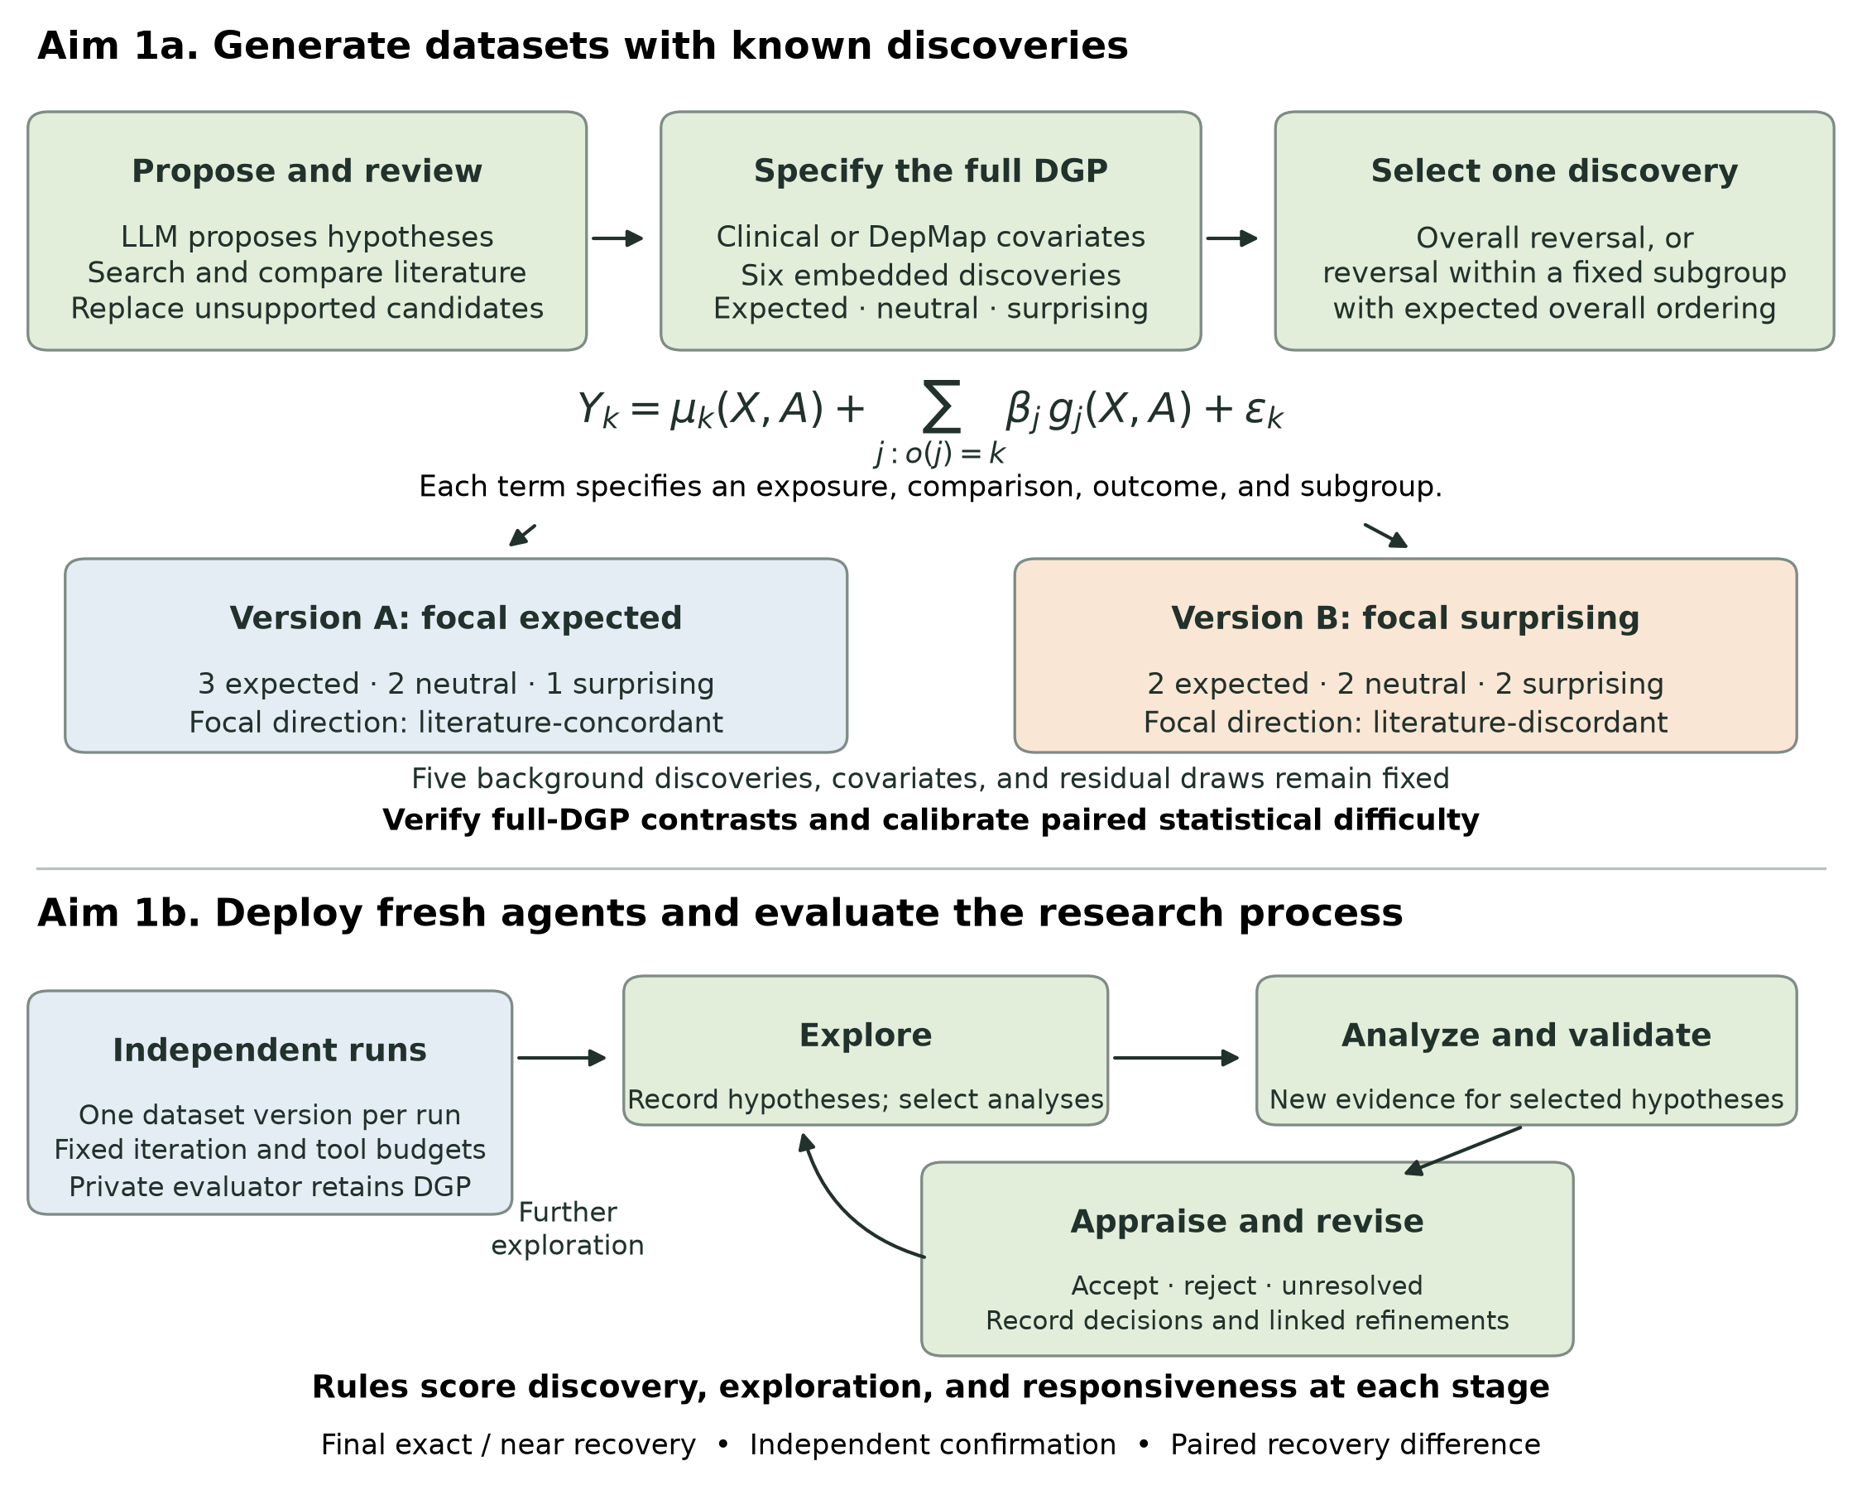
Figure 3. Aim 1 overview. Each base dataset contains six discoveries, including expected (literature-concordant), neutral, and surprising (literature-discordant) discoveries. In the illustrated pair, version A contains three expected, two neutral, and one surprising discovery. Reversing one selected focal discovery produces version B, with two expected, two neutral, and two surprising discoveries. The other five discovery specifications, covariates, and residual draws are held fixed. The category mix may vary among base datasets; version labels refer to the focal discovery. Independent agent runs provide stage-specific measures of exploration and responsiveness, followed by deterministic discovery scoring and independent confirmation.

Sub-aim 1a. Create clinical and perturbation-screen benchmarking tasks with expected, neutral, and surprising discoveries.
Overview. OCSB will include synthetic and semi-synthetic research datasets containing associations that AI co-scientists can identify through iterative hypothesis generation and data analysis. We will refer to these embedded associations as discoveries. Each dataset will contain three types of discovery, defined by their relationship to the published literature. Expected discoveries will be literature-concordant. For example, a simulated cohort of patients with advanced EGFR-mutant non-small cell lung cancer receiving first-line osimertinib monotherapy could reproduce the longer progression-free survival observed among patients with exon 19 deletions than among those with L858R mutations (Planchard et al., 2023). Surprising discoveries will be literature-discordant: in a second simulation, patients with L858R mutations could have longer progression-free survival than those with exon 19 deletions. Neutral discoveries will involve associations for which the literature provides no established directional expectation. An example would be a simulated treatment benefit restricted to patients aged 50–65 years who also have a platelet count of 200–300 × 10⁹/L and a high value of a newly constructed tumor-expression score. The particular covariate combinations used for neutral discoveries will be selected after review of the literature.
These tasks will enable evaluation of two related aspects of open-minded scientific discovery. First, a co-scientist must explore the hypothesis space sufficiently to encounter an embedded association. Second, it must interpret the resulting evidence and decide whether to accept the hypothesis, reject it, or pursue additional analyses. These processes may influence one another throughout an agentic rollout. For example, an agent may initially compare osimertinib outcomes by EGFR mutation subtype because it anticipates reproducing the published association. If it observes the reverse association, its response may include checking the analysis, examining potential confounding, or searching for subgroups that account for the result. We will therefore evaluate both recovery of the embedded discoveries and the sequence of hypotheses, analyses, and decisions through which recovery occurs.
Task construction. We will construct 24 base datasets, including six in each combination of clinical versus cancer cell-line gene-dependency research and fully synthetic versus plasmode-simulated data.³⁵ Each base dataset will contain six discoveries, with expected, neutral, and surprising discoveries represented. A generation LLM will propose candidate expected and neutral discoveries and develop search queries for supporting and potentially contradictory evidence. We will retrieve the corresponding literature and have the LLM compare each candidate with the reported population, exposure or perturbation, comparator, outcome, and direction. Candidates lacking adequate support will be replaced through further hypothesis generation and literature review. The retained candidates will be translated into explicit outcome-generation equations before paired datasets are simulated. Two domain experts will independently review the evidence supporting each discovery’s classification, specifying the relevant population, treatment or perturbation, comparator, and outcome. Disagreements will be adjudicated, and discoveries with ambiguous classifications will be reserved for secondary analyses. The literature review and category assignments will be dated and frozen before formal evaluation. The categories will describe the relationship to published evidence; the agent’s own anticipated direction will be recorded separately during each experiment.
Clinical and gene-dependency data generation. Clinical datasets will include cancer type and histology, disease characteristics, biomarkers, treatment histories, outcomes, comorbidities, and selected demographic variables. Embedded discoveries will include treatment-effect modification, prognostic interactions, and context-specific resistance to therapy. Fully synthetic clinical datasets will generally contain 20,000–50,000 observations. Clinical plasmodes will preserve observed covariate distributions and correlations from AACR GENIE BPC¹⁰ and replace outcomes with values generated from prespecified functions of these covariates. The data-generating processes will support binary, continuous, and time-to-event outcomes, with explicit control of effect size, censoring, missingness, and nuisance associations. Reference analyses will specify the comparison being estimated, the required adjustment variables, and the assumptions supporting an associational or causal interpretation.
Cancer cell-line datasets will similarly include fully synthetic and plasmode-simulated versions. These datasets will incorporate lineage, gene expression, somatic mutation, copy number, and screen-quality variables, with embedded discoveries involving lineage-specific dependencies and interactions among molecular characteristics. DepMap covariate data will provide the substrate for plasmode simulations, and observed gene-effect scores will calibrate the scale and residual variation of the simulated dependency outcomes.^{9,11,36–38} The reference analyses will account for batch and copy-number-related artifacts. For both clinical and cell-line tasks, the full data-generating process will be retained in a concealed answer key, allowing evaluation of the associations induced by overlapping subgroups.
Paired dataset versions. For each base dataset, we will select one discovery for a controlled comparison between two dataset versions. In one version, the selected discovery will be expected; in the other, the direction of the association will be reversed to make it surprising. This will produce 48 task instances. For example, a pair of clinical datasets could contain the same patient covariates, treatment assignments, and definitions of all six embedded discoveries, while differing in whether exon 19 deletion or L858R is associated with longer progression-free survival on osimertinib. The outcome-generation parameter for this selected discovery will change between versions, with the specifications for the other five discoveries held fixed. Simulation seeds will be shared across the paired versions wherever compatible with the outcome model. The distribution of discovery categories, and the numerical direction corresponding to an expected association, will be balanced across the full collection.
Twelve of the selected discoveries will reverse an association that can be identified through a familiar comparison, such as the overall EGFR mutation-subtype comparison above. The remaining twelve will involve a subgroup exception within a dataset whose overall association follows the published literature. For example, exon 19 deletion could remain associated with longer progression-free survival in the overall simulated cohort, while the L858R subgroup has longer progression-free survival among patients with a specified combination of additional characteristics. The paired version would preserve the expected direction within this same subgroup. These tasks will allow us to examine whether an agent continues to explore after an initial analysis reproduces an expected association. The additional discoveries in each dataset will also provide competing opportunities for investigation, allowing evaluation of how an early discovery influences subsequent analyses.
Benchmark validity. The paired comparisons will be calibrated to make the expected and surprising versions similar in statistical difficulty. We will consider subgroup prevalence, number of defining variables, effect magnitude, treatment balance, missingness, nuisance correlations, and visibility in marginal analyses. Because overlapping discoveries can reinforce or obscure one another, calibration will use the complete data-generating process. Large independent simulations will verify the direction and magnitude of each target association. Within a pair, absolute effect magnitude and the signal-to-noise ratio must agree within 10% on the prespecified analysis scale. A fixed statistical search procedure will then be applied to at least 1,000 development simulations, with identical search limits in both versions. Acceptance criteria will include recovery in at least 80% of simulations for each version and a difference in recovery of no more than five percentage points. Pairs that fail these criteria will be revised during development. The formal evaluation datasets will subsequently be generated with independent seeds and locked.
Discovery scoring. Each discovery will be represented in the answer key by its outcome, exposure and comparator, statistical contrast, direction, and subgroup definition. Co-scientists will submit hypotheses and proposed discoveries using corresponding structured fields, accompanied by their scientific interpretation and analysis code. Deterministic rules will compare these records with the answer key. The rules will recognize equivalent variable names, reversed coding of a comparison, and logically equivalent subgroup definitions. Exact recovery will require the correct outcome, comparison, direction, and complete set of subgroup conditions. For a discovery defined by treatment-effect modification, recovery will require the interaction specifying how the treatment association differs between subgroups.
We will also quantify near recovery, defined as recovery of all components except the conditions on one subgroup variable. For example, if a simulated treatment benefit is restricted to patients aged 50–65 years with a platelet count of 200–300 × 10⁹/L and a high tumor-expression score, identifying the same treatment benefit among patients meeting the age and platelet criteria would constitute a near match. Near recovery will apply to discoveries defined by at least two subgroup variables, and all retained conditions must be correct. We will separately record cases in which the omitted variable is the one that makes the discovery surprising. Hypotheses with additional restrictions or substituted variables will be recorded as other partial matches. A sensitivity analysis will allow approximate numerical cutoffs when the resulting subgroup has both precision and recall of at least 0.90 relative to the target subgroup in an independent reference sample. Exact recovery, near recovery, and other partial recovery will be reported separately. Duplicate hypotheses will be collapsed, and a deterministic assignment procedure will prioritize exact matches and count each discovery once. Each reported hypothesis will be assigned to at most one embedded discovery. Statistical support will be evaluated for the subgroup actually reported by the agent.
Task packaging. Each task package will contain a dataset with realistic variable names, a data dictionary, standardized instructions, and access to permitted analysis tools. Instructions will ask co-scientists to identify scientifically meaningful associations, evaluate them with reproducible code, interpret the results, and continue the research process through a specified iteration budget. Generators, answer keys, category assignments, and paired dataset versions will remain in a separate evaluation environment. The benchmark release will include versioned task-generation code, structured-output schemas, reference analyses, scoring rules, and harness adapters. Plasmode-derived materials will be distributed in accordance with source-data terms.

Sub-aim 1b. Evaluate discovery, exploration, and responsiveness to evidence across closed- and open-weight models deployed within co-scientist harnesses.
Experimental design. The primary evaluation will comprise 5,760 experiments: 24 base datasets × two versions of the selected discovery × five model families × three harnesses × eight repeats. The model panel will include two closed-weight and three open-weight families. Model–harness compatibility will be established during setup, and the complete panel will be frozen before formal runs begin. Each repeat will start with a new agent session and an isolated workspace. Run order and assignment to the expected or surprising version will be randomized within dataset, model, and harness combinations. This design will provide a paired estimate of how changing an association’s relationship to the literature affects its probability of discovery.
Agentic research workflow. Each experiment will proceed through repeated stages of hypothesis generation, analysis, critique, and synthesis. One pass through these stages will constitute an iteration. Clinical experiments will allow 25 iterations and gene-dependency experiments 10, with the same generated-token and tool-call allowances across the paired conditions within each task family. The agent will continue until it completes the iteration budget or reaches a prespecified resource limit. At each stage, the harness will record the hypotheses under consideration, the analyses selected and executed, and the conclusions drawn from their results. Before a selected analysis, the agent will specify the comparison it proposes to test, its anticipated direction or lack of a directional expectation, and its current assessment of the hypothesis. After the analysis, it will record acceptance, rejection, or continued uncertainty, with a reference to the supporting result. Revised hypotheses will retain links to their earlier versions, allowing reconstruction of the research process.
Discovery endpoints. The primary endpoint will be exact, independently confirmed recovery of the selected discovery in the final report. For each paired comparison, we will estimate the probability of recovery when the discovery is surprising and when it is expected, and calculate the difference between those probabilities. A lower probability of recovery in the surprising condition would support the hypothesis that established knowledge can impede discovery even when an association is statistically recoverable. Secondary endpoints will include the number and proportion of all six embedded discoveries recovered in each category; exact and near recovery at successive iterations; iterations to the first exact hypothesis; and retention of an intermediate discovery in the final report. These measures will show whether a co-scientist identifies an association during exploration but subsequently omits or rejects it.
Exploration. Exploration will be measured from the hypotheses recorded at each stage of the rollout. We will count newly proposed hypotheses, the cumulative number of distinct hypotheses considered, and the cumulative number evaluated through successfully executed analyses. Equivalent formulations of the same hypothesis will be counted once. We will additionally group hypotheses by outcome, exposure/comparator, statistical contrast, and the set of subgroup variables, so that repeated changes to a cutoff or predicted direction can be recognized as refinement of an existing line of inquiry. The principal measure of exploration will be the proportion of embedded discoveries addressed by analyses that meet the exact or near matching criteria, regardless of the agent’s anticipated direction or the statistical result. For an interaction-based discovery, this will require an analysis that estimates the relevant interaction. We will report coverage separately for expected, neutral, and surprising discoveries, together with the overall number of hypotheses proposed and tested. Hypotheses outside the answer-key inventory will contribute to the overall measures of exploration.
Responsiveness to evidence. To evaluate responsiveness, we will provide opportunities for the agent to obtain new data bearing on hypotheses it selects during the research process. Each experiment will permit up to ten requests for validation, with at most one request per iteration. The agent will submit the hypothesis and analysis specification before the validation result is generated. A shared analysis service will then draw a new sample from the prespecified synthetic model or empirical plasmode covariate distribution and independently generate its outcomes. Each validation sample will contain the same number of observations as the task’s discovery dataset. The service will return the estimated effect, confidence interval, sample sizes, and diagnostic information. This design will provide independent replication results for adaptively selected hypotheses, addressing the dependence that arises when later analyses are chosen in response to earlier results (Dwork et al., 2015).
A validation request will specify a directional hypothesis that the effect exceeds a minimum magnitude, δ. The threshold will be defined for each endpoint during task development and included in the general analysis instructions. For example, a hypothesis might assert that a subgroup has at least a one-month improvement in restricted mean progression-free survival over a prespecified follow-up interval. The validation service will calculate a 99.5% confidence interval for the effect in the hypothesized direction, allocating an error probability of 0.05/10 to each of the ten possible requests. Sample-size requirements, overlap, model diagnostics, and confidence-interval coverage will be checked against prespecified reference procedures. Immediately after receiving the result, the agent will record whether it accepts the hypothesis, rejects it, or considers the evidence inconclusive. The following rules will score that response.
Validation result | Response supported by the evidence | Score
The lower confidence bound exceeds δ. | Accept the hypothesis that the directional effect exceeds the specified minimum magnitude. | 1 for this response; 0 otherwise
The upper confidence bound is below δ. | Reject the hypothesis that the directional effect exceeds the specified minimum magnitude. | 1 for this response; 0 otherwise
The confidence interval includes δ. | Retain uncertainty and consider further evidence necessary to resolve the hypothesis. | 1 for this response; 0 otherwise
The analysis fails a prespecified validity check. | Record an analysis failure and evaluate the cause during subsequent critique. | Reported separately
Responsiveness will be calculated as the proportion of valid validation results followed by an evidence-consistent decision. We will also report acceptance, rejection, and uncertainty separately. Among results that support changing the pre-analysis assessment, we will calculate the proportion followed by the indicated change; maintenance of an assessment supported by the new evidence will be reported separately. For example, if an agent anticipates longer progression-free survival for exon 19 deletion but a valid replication result supports a sufficiently large advantage for L858R, an appropriate response would be to reject its original directional hypothesis and consider the reverse association. Results that remain compatible with both clinically meaningful benefit and smaller effects would support continued uncertainty. A missing decision after a valid returned result will receive a score of zero. For experiments with no valid validation results, responsiveness will be unavailable, and the number of requests and analysis failures will be reported.
Exploration following new evidence. We will examine how responses to evidence influence subsequent exploration by measuring new hypotheses and refinements proposed and tested during the two iterations following a validation result. These analyses will compare results that agree with the agent’s recorded expectation, results that oppose it, and results for hypotheses without a recorded directional expectation. They will include validation results returned with at least two iterations remaining in the research budget. Links among successive hypotheses will allow us to identify sequences in which an initial association prompts subgroup refinement, additional testing, and eventual discovery. Together with the recovery endpoints, these trajectories will characterize the extent to which new evidence opens additional lines of inquiry or leads the agent to concentrate on an emerging explanation.
Independent confirmation and additional discoveries. At the end of each experiment, all distinct hypotheses accepted in the final report will be evaluated in a further independent sample generated under the same data-generating process. This sample will remain inaccessible during the rollout. With M accepted hypotheses, confidence intervals will use an error probability of 0.05/M. Confirmation will require the lower confidence bound for the effect in the reported direction to exceed δ. Experiments yielding no accepted discoveries will receive a primary recovery score of zero. We will retain both structural recovery and independent confirmation in the reported results, allowing assessment of whether the agent identified the correct association and whether the association it reported was supported in new data.
Co-scientists may also identify valid associations induced by the combination of embedded discoveries and correlated covariates. We will evaluate these additional reported discoveries using the submitted statistical contrast under the full data-generating process, either analytically or through independent simulation with quantified Monte Carlo uncertainty. Reports will distinguish confirmed additional discoveries, claims contradicted by the data-generating process, claims lacking independent confirmation, and claims that cannot be adjudicated. Candidate relationships with zero effects and hypotheses that apply an association to an overly broad subgroup will provide opportunities to assess inappropriate acceptance. These analyses will help determine whether an increase in surprising discovery is accompanied by an increase in unsupported conclusions.
Statistical analysis. Primary analyses will estimate the difference in recovery probability between the surprising and expected versions within each dataset, model, and harness combination, averaging across the prespecified panel. We will obtain 95% confidence intervals by resampling base datasets within the four combinations of task family and data source, preserving both paired versions and all repeats in each resampled dataset. Secondary mixed-effects models will evaluate variation by model, harness, task family, data source, and whether a discovery involves an overall reversal or a subgroup exception. Dataset effects will account for dependence among repeated experiments; analyses of repeated observations within a rollout will additionally include run effects. Time-to-discovery analyses will censor unrecovered discoveries at the iteration or resource limit. Power and precision calculations will use development simulations incorporating dataset-level heterogeneity and stochastic variation across repeats. False-discovery-rate adjustment will be applied within prespecified families of secondary comparisons.
Controlled assessment of responsiveness. The evidence available during an agentic rollout depends on the analyses the agent selects. We will therefore supplement the full experiments with a controlled assessment in which each system receives the same numerical evidence for a specified hypothesis. Eight hypothesis templates, balanced by task family and data source, will each have an expected and a surprising version, with validation results that support, refute, or leave the hypothesis unresolved. The five model families and three harnesses will each receive four fresh repeats of these conditions, yielding 2,880 brief experiments in addition to the 5,760 full rollouts. This assessment will estimate differences in responsiveness when the hypothesis and strength of evidence are held constant across systems.
Potential problems and alternative strategies. Statistical difficulty may remain heterogeneous across datasets despite calibration. We will therefore report the paired comparisons alongside reference recovery, subgroup prevalence, effect magnitude, and interaction complexity, and examine whether the expected–surprising difference varies with these characteristics. Experiments may also reach floor or ceiling performance; these results will guide additional task development for later benchmark releases. Agents may differ in how often they request validation, so responsiveness will be reported together with validation use and discovery coverage. The controlled assessment will provide complementary evidence for systems that generate few validation results during autonomous exploration.
Rigor and reproducibility. Formal evaluation will begin after the task instances, model–harness panel, prompts, resource allowances, scoring rules, and statistical analysis plan have been frozen. All hypotheses, messages, code, tool outputs, errors, and reports will be timestamped and retained. Runs that fail to meet the research protocol will remain in the assigned denominator and receive no primary recovery credit; documented infrastructure outages will be handled under a prespecified retry policy. Access controls will separate agent workspaces from task generators, answer keys, and final evaluation samples. The resulting release will provide reproducible task packages and measures of discovery, exploration, and responsiveness that can be carried forward into the coordination and mitigation experiments in Aims 2 and 3.
Additional references. Planchard D, Jänne PA, Cheng Y, et al. Osimertinib with or without chemotherapy in EGFR-mutated advanced NSCLC. N Engl J Med. 2023;389:1935–1948. doi:10.1056/NEJMoa2306434.
Dwork C, Feldman V, Hardt M, Pitassi T, Reingold O, Roth A. The reusable holdout: Preserving validity in adaptive data analysis. Science. 2015;349(6248):636–638. doi:10.1126/science.aaa9375.

