Data Structure and Algorithm

Laboratory Activity No. 6

Singly Linked Lists

|  |  |
| --- | --- |
| *Submitted by:* | *Instructor:* |
| Manogsong, Ken R. | Engr. Maria Rizette H. Sayo |

08/23/2025

# Objectives

Introduction

A linked list is an organization of a list where each item in the list is in a separate node. Linked lists look like the links in a chain. Each link is attached to the next link by a reference that points to the next link in the chain. When working with a linked list, each link in the chain is called a Node. Each node consists of two pieces of information, an item, which is the data associated with the node, and a link to the next node in the linked list, often called next.

This laboratory activity aims to implement the principles and techniques in:

* Writing algorithms using Linked list
* Writing a python program that will perform the common operations in a singly linked list

# Methods

* Write a Python program to create a singly linked list of prime numbers less than 20. By iterating through the list, display all the prime numbers, the head, and the tail of the list. (using Google Colab)
* Save your source codes to GitHub

# Results

**CODE SNIPPET:**

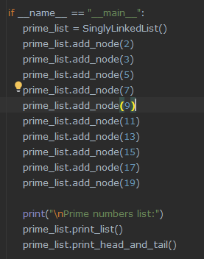

**RESULT:**

# Conclusion

In conclusion, the program explore/and teach me to understand about the basics of singly linked list. This program shows the addition of new data to the existing node that has been created, it also shows the function of setting the head element up until the tail element. As shown in the results, it successfully executes the necessary functions of singly linked list by printing the ‘prime number list’ the ‘head’ and the ‘tail’ elements of the list.

**References**

[1] Co Arthur O.. “University of Caloocan City Computer Engineering Department Honor Code,” UCC-CpE Departmental Policies, 2020.