Data Structure and Algorithm
Laboratory Activity No. 13

Tree Algorithm

Submitted by: | Instructor:
MANONGSONG, KEN R. | Engr. Maria Rizette H. Sayo

11/08/2025

Objectives
Introduction
An abstract non-linear data type with a hierarchy-based structure is a tree. It is made up of links connecting nodes (where the data is kept). The root node of a tree data structure is where all other nodes and subtrees are connected to the root.

This laboratory activity aims to implement the principles and techniques in:
- To introduce Tree as Non-linear data structure
- To implement pre-order, in-order, and post-order of a binary tree
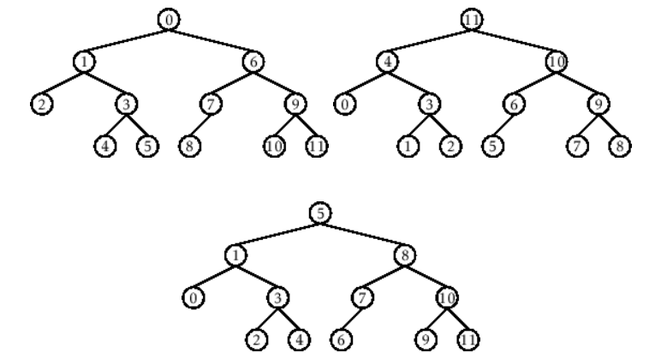

- Figure 1. Pre-order, In-order, and Post-order numberings of a binary tree

Methods
  - Copy and run the Python source codes.
  - If there is an algorithm error/s, debug the source codes.
  - Save these source codes to your GitHub.
  - Show the output

    - Tree Implementation

class TreeNode:
def __init__(self, value):
self.value = value
self.children = []

def add_child(self, child_node):
self.children.append(child_node)

def remove_child(self, child_node):
self.children = [child for child in self.children if child != child_node]

def traverse(self):
nodes = [self]
while nodes:
current_node = nodes.pop()
print(current_node.value)
nodes.extend(current_node.children)

def __str__(self, level=0):
ret = " " * level + str(self.value) + "\n"
for child in self.children:
ret += child.__str__(level + 1)
return ret

# Create a tree
root = TreeNode("Root")
child1 = TreeNode("Child 1")
child2 = TreeNode("Child 2")
grandchild1 = TreeNode("Grandchild 1")
grandchild2 = TreeNode("Grandchild 2")

root.add_child(child1)
root.add_child(child2)
child1.add_child(grandchild1)
child2.add_child(grandchild2)

print("Tree structure:")
print(root)

print("\nTraversal:")
root.traverse()

Questions:
- When would you prefer DFS over BFS and vice versa?
- What is the space complexity difference between DFS and BFS?
- How does the traversal order differ between DFS and BFS?
- When does DFS recursive fail compared to DFS iterative?

Results
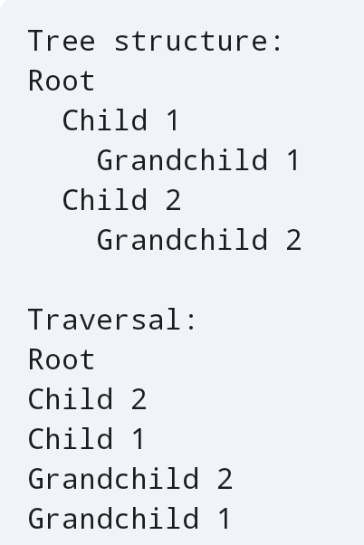

Prefer DFS when the goal node is likely to be deep in the tree, or when memory is limited for wide graphs, as it explores one branch fully before backtracking. Prefer BFS when you need to find the shortest path in an unweighted tree/graph, as it explores all neighbors at the current level first, guaranteeing optimality.
DFS is generally more space-efficient for wide trees, with a space complexity proportional to the depth of the tree. BFS is less space-efficient for wide trees, with a space complexity proportional to the maximum width of the tree, since it must store all nodes at the current level.
DFS traversal prioritizes depth, exploring a path as far as possible before moving to a sibling. Its order can be pre-order, in-order, or post-order. BFS traversal prioritizes breadth, exploring the tree level by level, visiting all nodes at depth k before any node at depth k+1.
Recursive DFS fails on trees with very large depths by causing a "Stack Overflow" error, as it relies on the limited system function call stack. Iterative DFS, which uses an explicit stack, is constrained only by the much larger available heap memory, making it more robust for deep structures.

Conclusion
This laboratory activity successfully introduced the tree as an abstract non-linear data type with a hierarchy-based structure. The objective was met by implementing tree principles and techniques, specifically the goal to introduce the Tree as a non-linear data structure and implement pre-order, in-order, and post-order of a binary tree. Analysis confirmed that DFS and BFS have distinct applications and performance profiles, particularly in space complexity and traversal order. DFS is depth-focused and space-efficient for wide trees, while BFS is crucial for shortest path determination due to its level-by-level exploration. Ultimately, iterative DFS is superior to recursive DFS for extremely deep trees to prevent stack overflow errors.

References
[1] Co Arthur O.. “University of Caloocan City Computer Engineering Department Honor Code,” UCC-CpE Departmental Policies, 2020.

