Data Structure and Algorithm
Laboratory Activity No. 14

Tree Structure Analysis

Submitted by: | Instructor:
MANONGSONG, KEN R. | Engr. Maria Rizette H. Sayo

11/08/2025

Objectives
Introduction
An abstract non-linear data type with a hierarchy-based structure is a tree. It is made up of links connecting nodes (where the data is kept). The root node of a tree data structure is where all other nodes and subtrees are connected to the root.

This laboratory activity aims to implement the principles and techniques in:
- To introduce Tree as Non-linear data structure
- To implement pre-order, in-order, and post-order of a binary tree
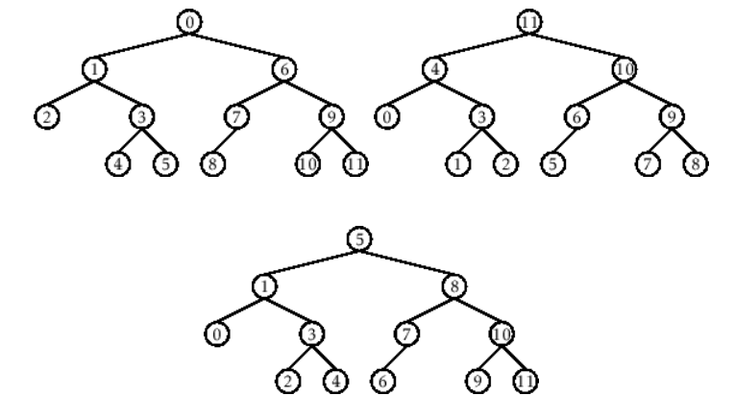

- Figure 1. Pre-order, In-order, and Post-order numberings of a binary tree

Methods
  - Copy and run the Python source codes.
  - If there is an algorithm error/s, debug the source codes.
  - Save these source codes to your GitHub.
  - Show the output

    - Tree Implementation

class TreeNode:
def __init__(self, value):
self.value = value
self.children = []

def add_child(self, child_node):
self.children.append(child_node)

def remove_child(self, child_node):
self.children = [child for child in self.children if child != child_node]

def traverse(self):
nodes = [self]
while nodes:
current_node = nodes.pop()
print(current_node.value)
nodes.extend(current_node.children)

def __str__(self, level=0):
ret = " " * level + str(self.value) + "\n"
for child in self.children:
ret += child.__str__(level + 1)
return ret

# Create a tree
root = TreeNode("Root")
child1 = TreeNode("Child 1")
child2 = TreeNode("Child 2")
grandchild1 = TreeNode("Grandchild 1")
grandchild2 = TreeNode("Grandchild 2")

root.add_child(child1)
root.add_child(child2)
child1.add_child(grandchild1)
child2.add_child(grandchild2)

print("Tree structure:")
print(root)

print("\nTraversal:")
root.traverse()

Questions:
- What is the main difference between a binary tree and a general tree?
- In a Binary Search Tree, where would you find the minimum value? Where would you find the maximum value?
- How does a complete binary tree differ from a full binary tree?
- What tree traversal method would you use to delete a tree properly? Modify the source codes.

Results

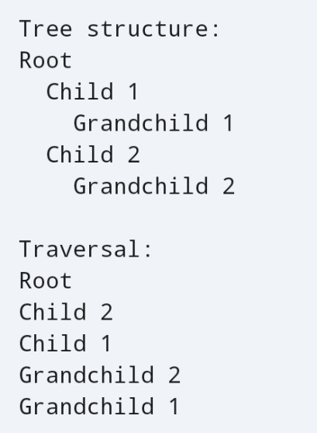

A general tree has no restriction on the number of children a node can have. A binary tree is a specialized form of a general tree where every node can have a maximum of two children (a left child and a right child).

In a Binary Search Tree (BST), the minimum value is always found at the leftmost node of the tree. The maximum value is always found at the rightmost node of the tree.

A full binary tree is one where every node has either zero or two children. A complete binary tree is one where all levels are completely filled, except possibly the last level, and the last level must be filled from the left.

Use the Post-order Traversal method to properly delete a tree. Post-order ensures that a node’s children are deleted before the node itself, preventing “dangling pointers” and correctly freeing memory from the bottom up.

Class TreeNode:

Def delete_tree(self):
For child in self.children:
Child.delete_tree()

Print(f”Deleting node: {self.value}”)
Del self

Conclusion
This laboratory activity successfully met its objectives to implement and analyze the tree data structure, an abstract non-linear type defined by a hierarchical structure and linked nodes. The analysis clearly distinguished a binary tree (max two children) from a general tree (unlimited children). Key properties of a Binary Search Tree (BST) were confirmed: the minimum value is at the leftmost node, and the maximum is at the rightmost node. Furthermore, the difference between a full binary tree (all nodes have zero or two children) and a complete binary tree (levels are filled, left-to-right) was established. The exercise reinforced that Post-order Traversal is the correct method for complete tree deletion as it ensures children are processed before their parent, which is essential for proper memory management. Overall, the activity provided a practical understanding of fundamental tree properties, structures, and traversal techniques.

References
[1] Co Arthur O.. “University of Caloocan City Computer Engineering Department Honor Code,” UCC-CpE Departmental Policies, 2020.

