STAT 626 Project - Version 3

Ken Marciel

7/30/2021

### Packages

library(readxl) # for read_excel function  
library(astsa) # for time series functions

### Data

# Read data from Excel file (compiled by Jack Kramer)  
setwd("C:/Users/keoka/OneDrive - Texas A&M University/Courses/STAT_626/Project/Data Analysis/Jack/")  
data = read.csv("consolidated_data.csv")  
class(data) # data frame  
dim(data) # 460 rows, 41 columns  
head(data) # preview the first six rows of data set  
names(data) # display the column names of data set  
  
# Keep only the columns desired for analysis  
match("year", colnames(data)) # column 41  
match("month", colnames(data)) # column 40  
match("total.red.meat", colnames(data)) # column 7  
match("total.poultry", colnames(data)) # column 16  
match("Population_Millions", colnames(data)) # column 21  
match("Personal.Income", colnames(data)) # column 19  
data = data[,c(41,40,7,16,21,19)]  
  
# Change column names to have a consistent format  
colnames(data) = c("Year", "Month","Red_Meat", "Poultry", "Population",  
 "Personal_Income")  
  
# Review structure of the data set  
class(data) # data frame  
dim(data) # 460 rows, 6 columns  
head(data) # preview the first six rows of reduced data set  
str(data)  
  
# Create variables to store data columns  
year = data[,1]  
mont = data[,2]  
meat = data[,3] # total U.S. red meat production in millions of pounds  
poul = data[,4] # total U.S. poultry production in millions of pounds  
popu = data[,5] # U.S. population in millions  
inco = data[,6] # U.S. personal income in billions of dollars  
  
# Range of observations for the Great Depression  
data[which(data$Year==2007 & data$Month==12),] # row 300  
data[which(data$Year==2009 & data$Month==6),] # row 318  
  
# Start of observations for the COVID-19 Pandemic  
data[which(data$Year==2020 & data$Month==3),] # row 447

### Exploratory Data Analysis: Time Series Plotted Separately

par(mfrow=c(4,1))  
tsplot(meat, main="U.S. Total Red Meat Production (in Millions of Pounds)",  
 col="red", ylab="")  
tsplot(poul, main="U.S. Total Poultry Production (in Millions of Pounds)",  
 col="orange", ylab="")  
tsplot(popu, main="U.S. Population (in Millions)",  
 col="blue", ylab="")  
tsplot(inco, main="U.S. Personal Income (in Billions of Dollars)",  
 col="green", ylab="")

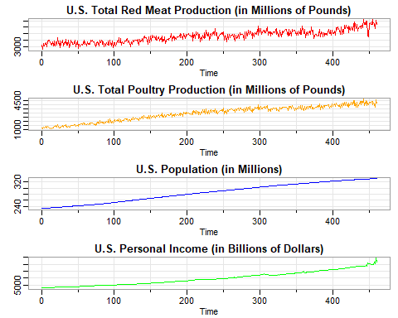

Note the upward trend in all of the series, and the apparent seasonality in the meat and poultry series.

### Exploratory Data Analysis: Time Series Plotted Together

tsplot(meat, main="", ylab="", col="red")  
lines(poul, col="orange")  
abline(v=c(300,318,447))

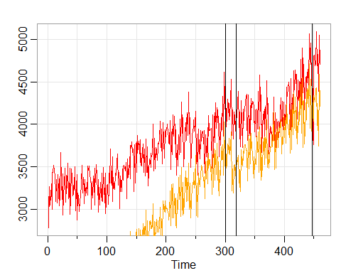

Note that poultry has a steeper upward trend than red meat. Both series display a downard trend during the Great Recession (December 2007 to June 2009), and a leveling off during the COVID-19 pandemic (March 2020 to present). Both series have similar seasonality.

#### Exploratory Data Analysis: Scatterplot Matrix

# Code from page 43 of textbook: Shumway, Stoffer (2019)  
panel.cor = function(x, y, ...){  
 usr = par("usr"); on.exit(par(usr))  
 par(usr = c(0,1,0,1))  
 r = round(cor(x, y), 2)  
 text(0.5, 0.5, r, cex=1.75)  
}  
pairs(cbind(RedMeat=meat, Poultry=poul, Population=popu, Income=inco), lower.panel=panel.cor)

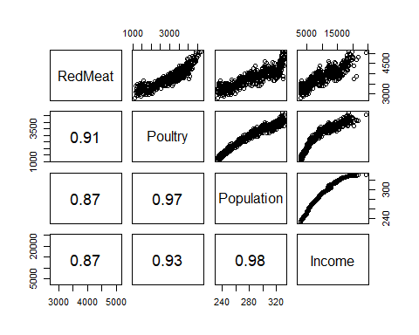

The scatterplot matrix indicates that red meat is nonlinearly related to population and income, and the same is true for poultry. Population and income are highly correlated, and have nearly identical correlation coefficients for red meat and poultry.

For ease, let $M_{t}$ denote total red meat production, $P_{t}$ denote total poultry production, $L_{t}$ denote total population, and $I_{t}$ denote total personal income. Also, let $L.$ and $I.$ denote the mean of population, and the mean of personal income, respectively.

#### Exploratory Data Analysis: Collinearity

par(mfrow=2:1)  
plot(popu, popu^2) # collinear  
cor(popu, popu^2)

## [1] 0.9990233

pop = popu - mean(popu) # center population  
pop2 = pop^2  
plot(pop, pop2) # not collinear

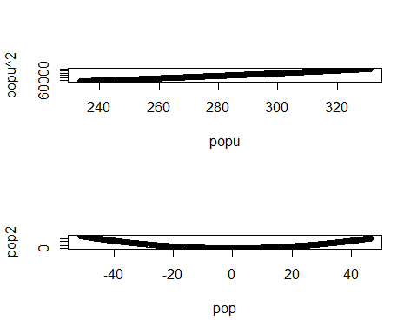

cor(pop, pop2)

## [1] -0.1503336

par(mfrow=2:1)  
plot(inco, inco^2) # collinear  
cor(inco, inco^2)

## [1] 0.9763314

inc = inco - mean(inco) # center income  
inc2 = inc^2  
plot(inc, inc2)

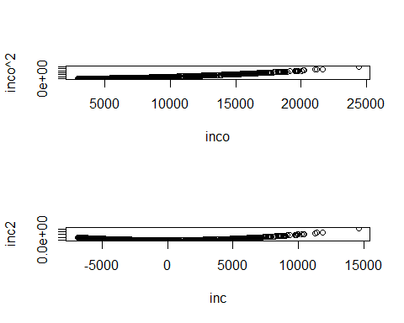

cor(inc, inc2)

## [1] 0.4068634

For this data set, $L_{t}$ and $L_{t}^{2}$ are highly collinear, but $L_{t}−L.$ and $(L_{t}−L.)^{2}$ are not. Similarly, $I_{t}$ and $I_{t}^{2}$ are highly collinear, while $I_{t}−I.$ and $(I_{t}−I.)^{2}$ are moderately collinear. Therefore, it is better to include $L_{t}$ instead of $I_{t}$ in the model.

### Model Formulation: Multiple Linear Regression

Based on the scatterplot, three models will be entertained for each of red meat and poultry. They are

M1: $M_{t}=β_{0}+β_{1}+w_{t}$  
M2: $M_{t}=β_{0}+β_{1}+β_{2}(L_{t}−L.)+w_{t}$  
M3: $M_{t}=β_{0}+β_{1}+β_{2}(L_{t}−L.)+β_{3}(L_{t}−L.)^{2}+w_{t}$

P1: $P_{t}=β_{0}+β_{1}+w_{t}$  
P2: $P_{t}=β_{0}+β_{1}+β_{2}(L_{t}−L.)+w_{t}$  
P3: $P_{t}=β_{0}+β_{1}+β_{2}(L_{t}−L.)+β_{3}(L_{t}−L.)^{2}+w_{t}$

where we adjust population for its mean, $L.$, to avoid collinearity problems.

Note that M1 and P1 are trend only models, M2 and P2 add a linear population term, M3 and P3 add a curvilinear population term.

### Multiple Linear Regression: Total Meat Production

trend_m = time(meat)  
num_m = length(meat) # 460 observations  
  
# Model M1  
fit_m1 = lm(meat ~ trend_m, na.action=NULL)  
(m1_out = summary(fit_m1))

##   
## Call:  
## lm(formula = meat ~ trend_m, na.action = NULL)  
##   
## Residuals:  
## Min 1Q Median 3Q Max   
## -687.72 -146.80 13.56 166.01 634.52   
##   
## Coefficients:  
## Estimate Std. Error t value Pr(>|t|)   
## (Intercept) 3.109e+03 2.105e+01 147.68 <2e-16 ***  
## trend_m 2.991e+00 7.914e-02 37.79 <2e-16 ***  
## ---  
## Signif. codes: 0 '***' 0.001 '**' 0.01 '*' 0.05 '.' 0.1 ' ' 1  
##   
## Residual standard error: 225.4 on 458 degrees of freedom  
## Multiple R-squared: 0.7572, Adjusted R-squared: 0.7567   
## F-statistic: 1428 on 1 and 458 DF, p-value: < 2.2e-16

summary(aov(fit_m1))

## Df Sum Sq Mean Sq F value Pr(>F)   
## trend_m 1 72568456 72568456 1428 <2e-16 ***  
## Residuals 458 23268197 50804   
## ---  
## Signif. codes: 0 '***' 0.001 '**' 0.01 '*' 0.05 '.' 0.1 ' ' 1

AIC(fit_m1)/num_m - log(2*pi)

## [1] 11.84442

BIC(fit_m1)/num_m

## [1] 13.70923

rss_m1 = m1_out$sigma  
  
# Model M2  
fit_m2 = lm(meat ~ trend_m + pop, na.action=NULL)  
(m2_out = summary(fit_m2))

##   
## Call:  
## lm(formula = meat ~ trend_m + pop, na.action = NULL)  
##   
## Residuals:  
## Min 1Q Median 3Q Max   
## -682.01 -146.13 15.06 164.16 639.33   
##   
## Coefficients:  
## Estimate Std. Error t value Pr(>|t|)   
## (Intercept) 3171.069 274.895 11.536 <2e-16 ***  
## trend_m 2.722 1.192 2.284 0.0228 *   
## pop 1.179 5.206 0.226 0.8210   
## ---  
## Signif. codes: 0 '***' 0.001 '**' 0.01 '*' 0.05 '.' 0.1 ' ' 1  
##   
## Residual standard error: 225.6 on 457 degrees of freedom  
## Multiple R-squared: 0.7572, Adjusted R-squared: 0.7562   
## F-statistic: 712.7 on 2 and 457 DF, p-value: < 2.2e-16

summary(aov(fit_m2))

## Df Sum Sq Mean Sq F value Pr(>F)   
## trend_m 1 72568456 72568456 1425.444 <2e-16 ***  
## pop 1 2609 2609 0.051 0.821   
## Residuals 457 23265587 50909   
## ---  
## Signif. codes: 0 '***' 0.001 '**' 0.01 '*' 0.05 '.' 0.1 ' ' 1

AIC(fit_m2)/num_m - log(2*pi)

## [1] 11.84865

BIC(fit_m2)/num_m

## [1] 13.72245

rss_m2 = m2_out$sigma  
  
# Model M3  
fit_m3 = lm(meat ~ trend_m + pop + pop2, na.action=NULL)  
(m3_out = summary(fit_m3))

##   
## Call:  
## lm(formula = meat ~ trend_m + pop + pop2, na.action = NULL)  
##   
## Residuals:  
## Min 1Q Median 3Q Max   
## -680.54 -147.82 14.43 161.39 638.49   
##   
## Coefficients:  
## Estimate Std. Error t value Pr(>|t|)   
## (Intercept) 3.411e+03 3.805e+02 8.964 <2e-16 ***  
## trend_m 1.607e+00 1.706e+00 0.942 0.347   
## pop 6.106e+00 7.499e+00 0.814 0.416   
## pop2 1.808e-02 1.980e-02 0.913 0.362   
## ---  
## Signif. codes: 0 '***' 0.001 '**' 0.01 '*' 0.05 '.' 0.1 ' ' 1  
##   
## Residual standard error: 225.7 on 456 degrees of freedom  
## Multiple R-squared: 0.7577, Adjusted R-squared: 0.7561   
## F-statistic: 475.3 on 3 and 456 DF, p-value: < 2.2e-16

summary(aov(fit_m3))

## Df Sum Sq Mean Sq F value Pr(>F)   
## trend_m 1 72568456 72568456 1424.925 <2e-16 ***  
## pop 1 2609 2609 0.051 0.821   
## pop2 1 42465 42465 0.834 0.362   
## Residuals 456 23223123 50928   
## ---  
## Signif. codes: 0 '***' 0.001 '**' 0.01 '*' 0.05 '.' 0.1 ' ' 1

AIC(fit_m3)/num_m - log(2*pi)

## [1] 11.85117

BIC(fit_m3)/num_m

## [1] 13.73395

rss_m3 = m3_out$sigma  
  
# Comparison of M1 (reduced) to M2 (full) model using residual sums of squares  
((rss_m1 - rss_m2)/(3-2))/(rss_m2/(460-3-1)) # 4.1159 significant

## [1] -0.4725471

qf(.05, 3-2, 460-3-1, lower.tail=FALSE) # 3.8619

## [1] 3.861932

# Comparison of M1 (reduced) to M3 (full) model using residual sums of squares  
((rss_m1 - rss_m3)/(4-2))/(rss_m3/(460-4-1)) # 2.1425 nonsignificant

## [1] -0.2770796

qf(.05, 3-2, 460-3-1, lower.tail=FALSE) # 3.8619

## [1] 3.861932

R-squared is nearly the same for all three models for meat production. M1 has the lowest AIC and BIC scores of the three models. Both of the estimated coefficients for M1 are statistically significant. Comparison of M1 (reduced) to M2 (full) models using residual sums of squares produced a statistically significant F-test, whereas comparison of M1 to M3 did not. However, the estimated coefficients of the linear and quadradtic terms, in M2 and M3, were not statistically significant. Therefore, M1 does the best of the three models.

### Multiple Linear Regression: Total Poultry Production

trend_p = time(poul)  
num_p = length(poul)  
  
# Model P1  
fit_p1 = lm(poul ~ trend_p, na.action=NULL)  
(p1_out = summary(fit_p1))

##   
## Call:  
## lm(formula = poul ~ trend_p, na.action = NULL)  
##   
## Residuals:  
## Min 1Q Median 3Q Max   
## -704.93 -185.50 -3.61 177.14 629.47   
##   
## Coefficients:  
## Estimate Std. Error t value Pr(>|t|)   
## (Intercept) 1.448e+03 2.163e+01 66.96 <2e-16 ***  
## trend_p 6.546e+00 8.131e-02 80.50 <2e-16 ***  
## ---  
## Signif. codes: 0 '***' 0.001 '**' 0.01 '*' 0.05 '.' 0.1 ' ' 1  
##   
## Residual standard error: 231.6 on 458 degrees of freedom  
## Multiple R-squared: 0.934, Adjusted R-squared: 0.9339   
## F-statistic: 6481 on 1 and 458 DF, p-value: < 2.2e-16

summary(aov(fit_p1))

## Df Sum Sq Mean Sq F value Pr(>F)   
## trend_p 1 347532050 347532050 6481 <2e-16 ***  
## Residuals 458 24559260 53623   
## ---  
## Signif. codes: 0 '***' 0.001 '**' 0.01 '*' 0.05 '.' 0.1 ' ' 1

AIC(fit_p1)/num_p - log(2*pi)

## [1] 11.89842

BIC(fit_p1)/num_p

## [1] 13.76324

rss_p1 = p1_out$sigma  
  
# Model P2  
fit_p2 = lm(poul ~ trend_p + pop, na.action=NULL)  
(p2_out = summary(fit_p2))

##   
## Call:  
## lm(formula = poul ~ trend_p + pop, na.action = NULL)  
##   
## Residuals:  
## Min 1Q Median 3Q Max   
## -508.45 -135.67 4.86 134.34 589.22   
##   
## Coefficients:  
## Estimate Std. Error t value Pr(>|t|)   
## (Intercept) 4278.504 249.275 17.164 < 2e-16 ***  
## trend_p -5.733 1.081 -5.305 1.76e-07 ***  
## pop 53.759 4.721 11.387 < 2e-16 ***  
## ---  
## Signif. codes: 0 '***' 0.001 '**' 0.01 '*' 0.05 '.' 0.1 ' ' 1  
##   
## Residual standard error: 204.6 on 457 degrees of freedom  
## Multiple R-squared: 0.9486, Adjusted R-squared: 0.9484   
## F-statistic: 4216 on 2 and 457 DF, p-value: < 2.2e-16

summary(aov(fit_p2))

## Df Sum Sq Mean Sq F value Pr(>F)   
## trend_p 1 347532050 347532050 8301.8 <2e-16 ***  
## pop 1 5428313 5428313 129.7 <2e-16 ***  
## Residuals 457 19130947 41862   
## ---  
## Signif. codes: 0 '***' 0.001 '**' 0.01 '*' 0.05 '.' 0.1 ' ' 1

AIC(fit_p2)/num_p - log(2*pi)

## [1] 11.65298

BIC(fit_p2)/num_p

## [1] 13.52678

rss_p2 = p2_out$sigma  
  
# Model P3  
fit_p3 = lm(poul ~ trend_p + pop + pop2, na.action=NULL)  
(p3_out = summary(fit_p3))

##   
## Call:  
## lm(formula = poul ~ trend_p + pop + pop2, na.action = NULL)  
##   
## Residuals:  
## Min 1Q Median 3Q Max   
## -445.65 -109.53 0.46 105.22 598.55   
##   
## Coefficients:  
## Estimate Std. Error t value Pr(>|t|)   
## (Intercept) 1603.4964 294.0508 5.453 8.13e-08 ***  
## trend_p 6.6791 1.3184 5.066 5.91e-07 ***  
## pop -1.1104 5.7947 -0.192 0.848   
## pop2 -0.2013 0.0153 -13.158 < 2e-16 ***  
## ---  
## Signif. codes: 0 '***' 0.001 '**' 0.01 '*' 0.05 '.' 0.1 ' ' 1  
##   
## Residual standard error: 174.4 on 456 degrees of freedom  
## Multiple R-squared: 0.9627, Adjusted R-squared: 0.9625   
## F-statistic: 3927 on 3 and 456 DF, p-value: < 2.2e-16

summary(aov(fit_p3))

## Df Sum Sq Mean Sq F value Pr(>F)   
## trend_p 1 347532050 347532050 11428.9 <2e-16 ***  
## pop 1 5428313 5428313 178.5 <2e-16 ***  
## pop2 1 5264801 5264801 173.1 <2e-16 ***  
## Residuals 456 13866146 30408   
## ---  
## Signif. codes: 0 '***' 0.001 '**' 0.01 '*' 0.05 '.' 0.1 ' ' 1

AIC(fit_p3)/num_p - log(2*pi)

## [1] 11.33547

BIC(fit_p3)/num_p

## [1] 13.21826

rss_p3 = p3_out$sigma  
  
# Model P4  
fit_p4 = lm(poul ~ trend_p + pop2, na.action=NULL)  
(p4_out = summary(fit_p4))

##   
## Call:  
## lm(formula = poul ~ trend_p + pop2, na.action = NULL)  
##   
## Residuals:  
## Min 1Q Median 3Q Max   
## -446.8 -109.6 0.4 106.0 600.6   
##   
## Coefficients:  
## Estimate Std. Error t value Pr(>|t|)   
## (Intercept) 1659.71755 19.78891 83.87 <2e-16 ***  
## trend_p 6.42678 0.06149 104.52 <2e-16 ***  
## pop2 -0.19919 0.01061 -18.77 <2e-16 ***  
## ---  
## Signif. codes: 0 '***' 0.001 '**' 0.01 '*' 0.05 '.' 0.1 ' ' 1  
##   
## Residual standard error: 174.2 on 457 degrees of freedom  
## Multiple R-squared: 0.9627, Adjusted R-squared: 0.9626   
## F-statistic: 5903 on 2 and 457 DF, p-value: < 2.2e-16

summary(aov(fit_p4))

## Df Sum Sq Mean Sq F value Pr(>F)   
## trend_p 1 347532050 347532050 11453.0 <2e-16 ***  
## pop2 1 10691997 10691997 352.4 <2e-16 ***  
## Residuals 457 13867263 30344   
## ---  
## Signif. codes: 0 '***' 0.001 '**' 0.01 '*' 0.05 '.' 0.1 ' ' 1

AIC(fit_p4)/num_p - log(2*pi)

## [1] 11.33121

BIC(fit_p4)/num_p

## [1] 13.20501

rss_p4 = p4_out$sigma  
  
# Comparison of P1 (reduced) to P2 (full) model using residual sums of squares  
((rss_p1 - rss_p2)/(3-2))/(rss_p2/(460-3-1)) # 4.1159 significant

## [1] 60.09494

qf(.05, 3-2, 460-3-1, lower.tail=FALSE) # 3.8619

## [1] 3.861932

# Comparison of P1 (reduced) to P3 (full) model using residual sums of squares  
((rss_p1 - rss_p3)/(4-2))/(rss_p3/(460-4-1)) # 2.1425 nonsignificant

## [1] 74.60703

qf(.05, 3-2, 460-3-1, lower.tail=FALSE) # 3.8619

## [1] 3.861932

P3 has the highest R-squared, as well as the lowest AIC and BIC of the three poultry models. The income term, $I$, in the P3 model has an estimated coefficient that is not statistically significant. However, when a fourth model was fitted with that term removed, there is essentially no change in R-squared, AIC, or BIC. Therefore, I will leave the linear term in the model and select P3 from the three poultry models.

### Model Formulation: Total Meat Production

plot(fit_m1)

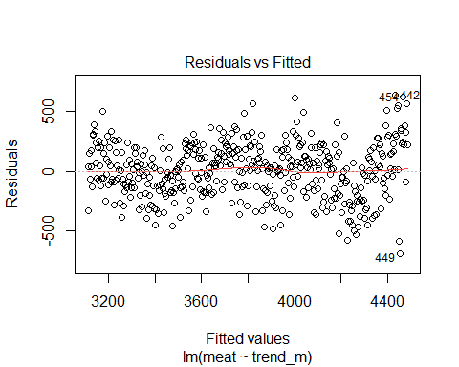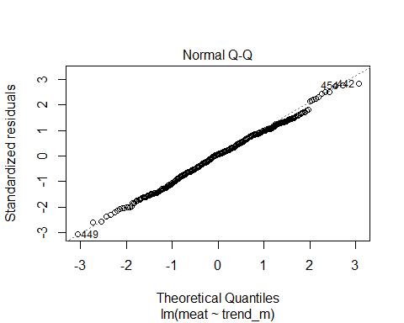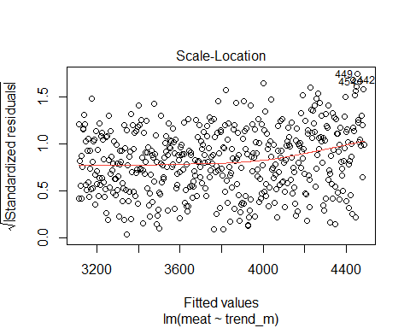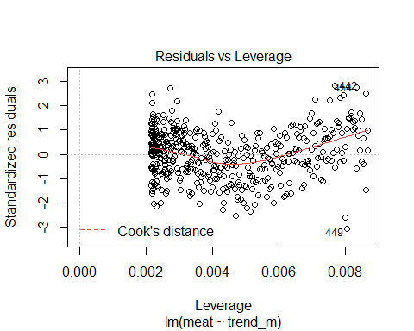

tsplot(resid(fit_m1))

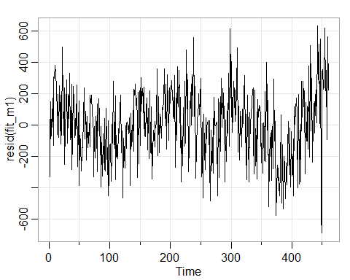

acf2(resid(fit_m1), max.lag=50)

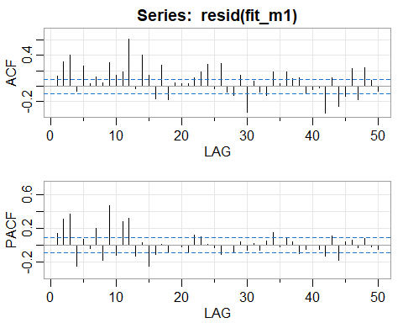

The residual plots for the M2 model show that the assumption of constant variance is valid. Tne Q-Q plot shows that the assumption of normality is valid. There are three outliers, but none have high leverage based on Cook’s distance. Therefore, log transformation of the series may not be necessary. The time series plot suggests that the data alternate between upward and downward trends. Therefore, differencing is indicated to detrend the data.

The time series plot suggests the possibility of a seasonal pattern in the data, and therefore autocorrelated errors. The correlograms confirm the presence of significant autocorrelation (within a confidence band of two standard errors).

**Seasonal:** It appears that at the seasons (s = 12) the ACF is tailing off at lags 1s, 2s, 3s, 4s. This slow decay indicates seasonal differencing. Typically, differencing of order one is sufficient to obtain seasonal stationarity. The PACF appears to cut off after lag 1s. These results imply an SAR(1), *P* = 1, *D* = 1, *Q* = 0, in the seasonal component.

**Non-Seasonal:** Inspecting the sample ACF and PACF at the first few lags, it appears as though the ACF tails off, whereas the PACF cuts off at lag 3. This suggests an AR(3) within the seasons, *p* = 3 and *q* = 0.

Therefore, I would choose the following model:

ARIMA(3,1,0)x(1,1,0) $​_{12}$

### Model Estimation: Total Meat Production

sarima(meat, 3,1,3, 1,1,1,12, xreg=cbind(trend_m+pop+pop2))

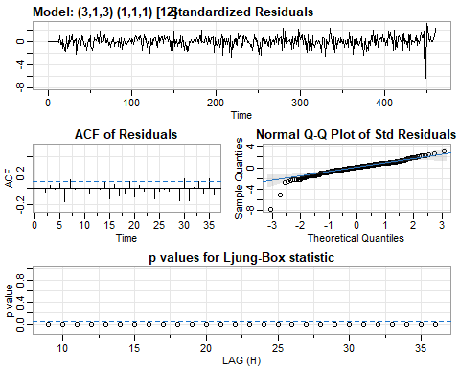

The plot of standardized residuals displays no obvious pattern. The ACF plot of residuals suggests that most of the autocorrelation is nonsignificant. the Q-Q plot suggests that the normality assumption is valid, despite the presence of four outliers which were previously not found to have problematic leverage. The q-statistic has *p*-values that are all significant, leading to rejection of the null hypothesis that the residuals are white.

### Forecasting: Total Meat Production

# End of data set  
data[which(data$Year==2021 & data$Month==4),] # row 460  
meat = ts(meat, start = c(1983,1), frequency = 12)  
sarima.for(meat, 60, 3,1,0, 1,1,0,12)  
abline(v=460)

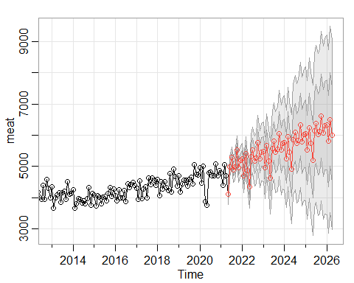 The forecasts out five years for total meat production is shown above.

### Model Formulation: Total Poultry Production

plot(fit_p3)

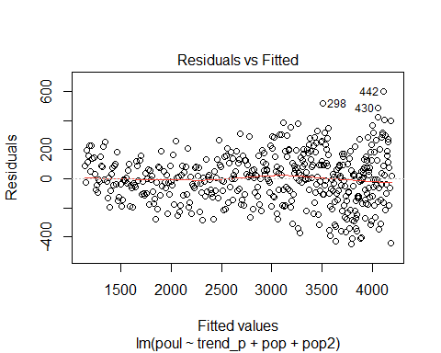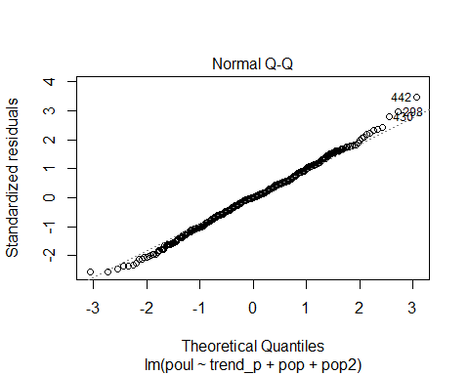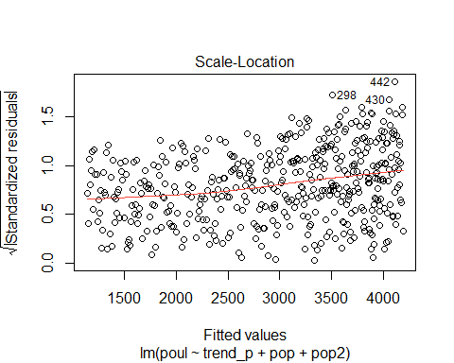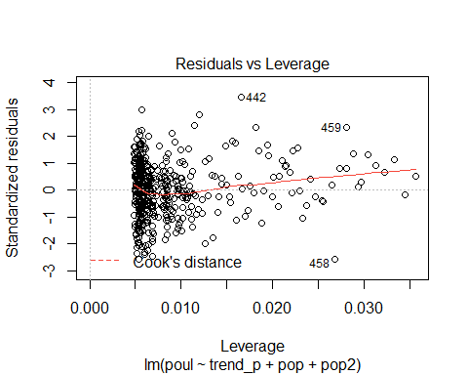

tsplot(resid(fit_p3))

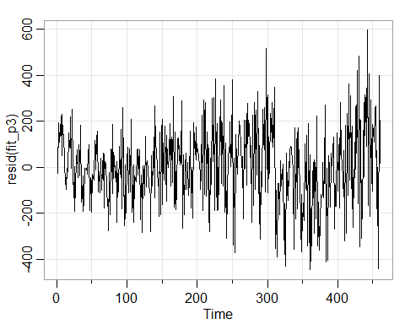

acf2(resid(fit_p3), max.lag=50)

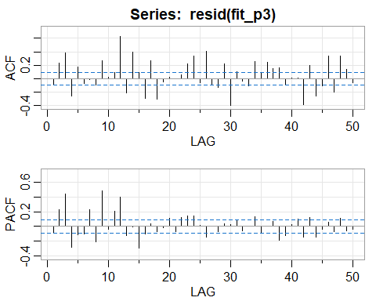

The residual plots for the P3 model suggest that the variance is nonconstant. Tne Q-Q plot shows that the assumption of normality is valid. There is a high-leverage outlier at month 459, corresponding to an unusual rise and fall in production for February and March 2021. The time series plot suggests a shifting trend, and therefore a lack of stationarity. Therefore, the data can be logged to stabilize the variance, then differenced to remove the trend.

The time series plot suggests the possibility of a seasonal pattern in the data, and therefore autocorrelated errors. The correlograms confirm the presence of significant autocorrelation (within a confidence band of two standard errors).

#### Transformations: Total Poultry Production

poul_dl = diff(log(poul)) # apply logarithm, then difference  
plot(poul_dl)

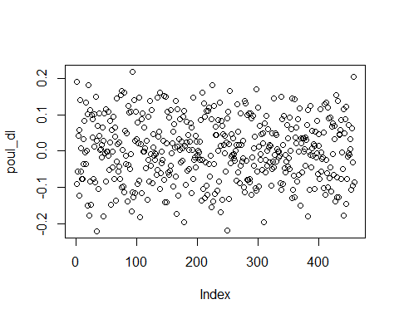

tsplot(poul_dl)

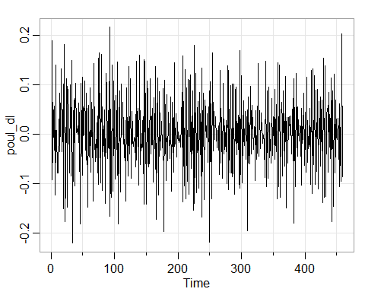

acf2(poul_dl, max.lag=50)

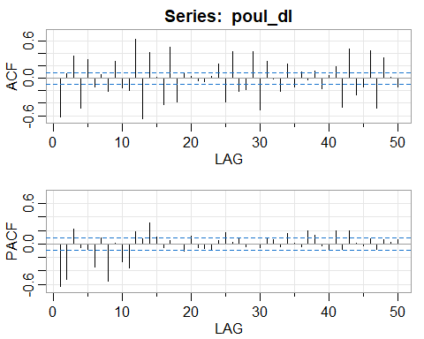

**Seasonal:** It appears that at the seasons (s = 12) the ACF is tailing off at lags approximately near 1s, 2s, 3s, 4s. This slow decay indicates seasonal differencing. Typically, differencing of order one is sufficient to obtain seasonal stationarity. The PACF appears to cut off after about lag 1s. These results imply an SAR(1), *P* = 1, *D* = 1, *Q* = 0, in the seasonal component.

**Non-Seasonal:** Inspecting the sample ACF and PACF at the first few lags, it appears as though the ACF tails off, whereas the PACF cuts off at lag 2. This suggests and ARMA(2,0) within the seasons, *p* = 2 and *q* = 0.

Therefore, I would choose the following model:

ARIMA(2,1,0)x(1,1,0) $​_{12}$

### Model Estimation: Total Poultry Production

sarima(log(poul), p=2,d=0,q=0, P=1,D=1,Q=0,S=11, xreg=cbind(trend_p, pop, pop2))

## Warning in sqrt(diag(fitit$var.coef)): NaNs produced  
  
## Warning in sqrt(diag(fitit$var.coef)): NaNs produced

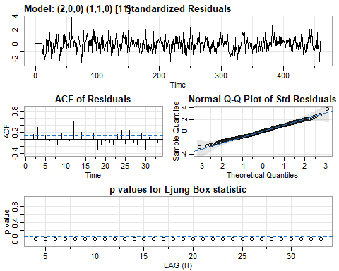

## Warning in sqrt(diag(x$var.coef)): NaNs produced

The plot of standardized residuals displays no obvious pattern. The ACF plot of residuals shows the presence of significant autocorrelation. the Q-Q plot suggests that the normality assumption is valid. The q-statistic has *p*-values that are all significant, leading to rejection of the null hypothesis that the residuals are white.

### Forecasting: Total Poultry Production

sarima.for(log(poul), 60, 3,1,0, 1,1,0,12)  
abline(v=460)

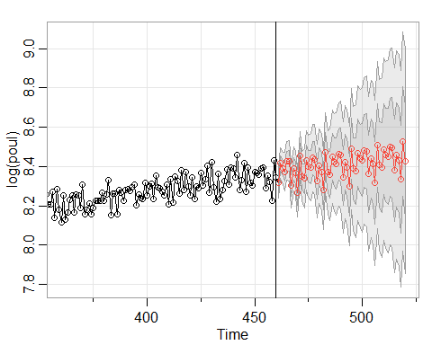

The forecasts out five years for the log of total poultry production is shown above.