STAT 685 - Project in Statistics

Ken Marciel

2/7/2022

# Predicting the Incidence of Postoperative Nausea and Vomiting (PONV)

The incidence of post-operative nausea and vomiting (PONV) is generally in the range of 20-40% (Apfel *et al*). This condition has negative effects on the health and well-being of patients, and is financially costly to healthcare providers. The tradeoff is that preventive therapy has negative side effects and financial costs. So, the challenge is to develop a scoring system that most accurately recommends prophylaxis for the patients at high risk of PONV. In other words, a predictive model that is neither to conservative nor too liberal in determining which patients should be prescribed prophylaxis. This balancing act has been described in the medical literature as the prevent-or-cure dilemma.

There are several well-documented models for predicting PONV, to help guide prudent administration of anti-emetic prophylaxis. These models are typically developed using logistic regression and stepwise backward elimination for variable selection. The most common measures of validity are discrimination and calibration. The most common measure of discriminating power is AUC, the area under the receiver operating characteristic curve (ROC). Calibration is most commonly assessed using the slope and squared correlation ($R^{2}$) for the line in a calibration plot. In the literature, AUC values range from 0.61 to 0.785 (Apfel *et al*, Sinclair *et al*), calibration slopes range from 0.3 to 1.71 (Apfel *et al*, Eberhart *et al*), and squared correlation ranges from 0.763 to 0.99 (Apfel *et al*).

This investigation analyzed a data set of 461 patients from anesthesiologist Jelena Velickovic, MD, in Belgrade, Serbia. The purpose was to develop a predictive model for PONV with performance comparable to or better than models previously published in the literature.

## Methods

Data analysis was performed using the R statistical computing software through the R Markdown interface, with the following additional packages installed to R.

## Packages

library(dplyr) # rename variables  
library(alr4) # marginal model plots  
library(leaps) # regression subset plots  
library(car) # regression subset plots  
library(rms) # logistic regression  
library(pROC) # ROC curve  
library(caret) # data splitting, resampling

## Data set

The raw data set has 916 rows and 26 columns. None of the rows have missing values. After removing the 93 duplicates, the cleaned data set has 823 rows and 26 columns.

## Sample size

After removing the 362 records of patients who received prophylaxis, the data set now has 461 rows and 26 columns.

## Variables in data set

Next, we will make sure that the original 26 variables are properly encoded for data analysis.

The 26 variables from the original data set consist of the ID variable, 9 response variables, and 16 predictor variables.

## Variables considered for analysis of PONV incidence within 24 hours

Response variable selected:

$Y$ = PONV0to24 (binary) = incidence of PONV within 24 hours of operation

For the purpose of developing a predictive model for PONV, we exclude the eight predictor variables corresponding to anesthetic and postoperative patient risk factors. In the full model, we consider the remaining eight predictor variables corresponding to the preoperative patient risk factors:

$x_{1}$ = Age (integer) $x_{2}$ 
 = Gender (binary) $x_{3}$ 
 … $x_{27}$ = Diagnosis (categorical with 26 levels) $x_{28}$ 
 … $x_{34}$ = Surgery (categorical with 8 levels) $x_{35}$ 
 = BMI (real) $x_{36}$ 
 = Nonsmoker (binary) $x_{37}$ 
 = Kinetosis history (binary) $x_{38}$ 
 = PONV history (binary)

The model includes 25 dummy variables for the 26 levels of *Diagnosis*, and 7 dummy variables for the 8 levels of *Surgery*. This is a total of 38 variables, when the factors with more than two levels are taken into full account.

The 10 variables in the data set for the full model consist of the ID variable, the response variable, and 8 predictor variables. The observed incidence of PONV for this data set is 0.37.

## Full model for logistic regression

We begin by considering the following generalized linear model for the binary response variable:

$Y=g\left(β_{0}+β_{1}x_{1}+β_{2}x_{2}+β_{3}x_{3}+...+β_{27}x_{27}+β_{28}x_{28}+...+β_{34}x_{34}+β_{35}x_{35}+β_{36}x_{36}+β_{37}x_{37}+β_{38}x_{38}+e\right)$

where *e* ~ iid $N\left(0,1\right)$.

To model the binary response variable through a generalized linear model, we use the log odds ratio (logit) as the link function as follows:

$g^{−1}\left(Y\right)=\text{log}\left(\frac{θ\left(Y\right)}{1−θ\left(Y\right)}\right)=β_{0}+β_{1}x_{1}+β_{2}x_{2}+β_{3}x_{3}+...+β_{27}x_{27}+β_{28}x_{28}+...+β_{34}x_{34}+β_{35}x_{35}+β_{36}x_{36}+β_{37}x_{37}+β_{38}x_{38}+e$

$θ$ is the parameter of the binomial distribution, which is related to a transformation of the logit as follows:

$θ\left(Y\right)=\frac{\text{exp}\left(Y\right)}{1+\text{exp}\left(Y\right)}=\frac{1}{1+\text{exp}\left(−Y\right)}$

For this analysis, our $θ$ of interest is the proportion of patients diagnosed with PONV within the 24 hours following surgery.

The logistic regression model is fitted using the generalized linear method of least squares:

##   
## Call:  
## glm(formula = PONV0to24 ~ Age + Gender + Diagnosis + Surgery +   
## BMI + Nonsmoker + KinetosisHistory + PONVhistory, family = binomial,   
## data = ponv)  
##   
## Deviance Residuals:   
## Min 1Q Median 3Q Max   
## -1.7753 -0.9663 -0.5579 1.1567 2.3369   
##   
## Coefficients:  
## Estimate Std. Error z value Pr(>|z|)   
## (Intercept) -1.817e+01 1.171e+03 -0.016 0.9876   
## Age -3.662e-03 8.834e-03 -0.415 0.6785   
## Gender1 8.547e-01 3.217e-01 2.656 0.0079 **   
## Diagnosis1 9.179e-01 6.314e-01 1.454 0.1460   
## Diagnosis2 1.079e+00 5.780e-01 1.868 0.0618 .   
## Diagnosis3 1.081e+00 7.968e-01 1.357 0.1748   
## Diagnosis4 1.108e+00 6.124e-01 1.809 0.0705 .   
## Diagnosis5 -1.851e-01 8.955e-01 -0.207 0.8362   
## Diagnosis6 1.136e+00 9.282e-01 1.224 0.2211   
## Diagnosis7 1.493e+00 1.674e+00 0.892 0.3726   
## Diagnosis8 -7.698e-01 1.217e+00 -0.632 0.5272   
## Diagnosis9 -6.555e-01 1.450e+00 -0.452 0.6513   
## Diagnosis10 1.634e+00 2.022e+00 0.808 0.4191   
## Diagnosis11 -1.439e+01 2.400e+03 -0.006 0.9952   
## Diagnosis12 -1.392e+01 1.696e+03 -0.008 0.9935   
## Diagnosis13 -3.879e-02 8.915e-01 -0.044 0.9653   
## Diagnosis14 1.801e+01 1.223e+03 0.015 0.9883   
## Diagnosis15 6.021e-01 8.127e-01 0.741 0.4587   
## Diagnosis16 7.782e-01 9.200e-01 0.846 0.3976   
## Diagnosis17 -1.397e+01 1.340e+03 -0.010 0.9917   
## Diagnosis18 1.664e+01 2.400e+03 0.007 0.9945   
## Diagnosis19 5.787e-01 9.616e-01 0.602 0.5473   
## Diagnosis20 8.271e-01 1.384e+00 0.598 0.5500   
## Diagnosis23 1.838e+01 2.400e+03 0.008 0.9939   
## Diagnosis24 -1.458e+01 2.400e+03 -0.006 0.9952   
## Diagnosis25 1.896e+01 2.400e+03 0.008 0.9937   
## Surgery1 1.530e+01 1.171e+03 0.013 0.9896   
## Surgery2 1.522e+01 1.171e+03 0.013 0.9896   
## Surgery3 3.240e+01 2.670e+03 0.012 0.9903   
## Surgery4 1.548e+01 1.171e+03 0.013 0.9894   
## Surgery5 -2.295e+00 1.693e+03 -0.001 0.9989   
## Surgery7 1.426e+01 1.171e+03 0.012 0.9903   
## BMI 2.241e-02 2.415e-02 0.928 0.3536   
## Nonsmoker1 5.353e-01 2.454e-01 2.181 0.0292 *   
## KinetosisHistory1 8.598e-02 4.972e-01 0.173 0.8627   
## PONVhistory1 1.432e+00 3.414e-01 4.194 2.74e-05 ***  
## ---  
## Signif. codes: 0 '***' 0.001 '**' 0.01 '*' 0.05 '.' 0.1 ' ' 1  
##   
## (Dispersion parameter for binomial family taken to be 1)  
##   
## Null deviance: 609.06 on 460 degrees of freedom  
## Residual deviance: 522.95 on 425 degrees of freedom  
## AIC: 594.95  
##   
## Number of Fisher Scoring iterations: 15

Three of the predictors in the full model have estimated coefficients that are statistically significant. In descending order of significance, these are PONV history, gender, and nonsmoker.

### Plots of standardized deviance residuals

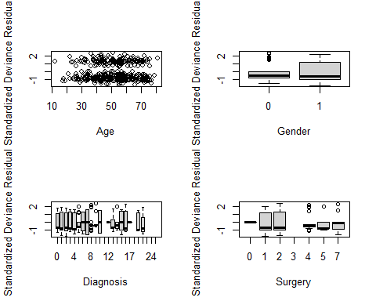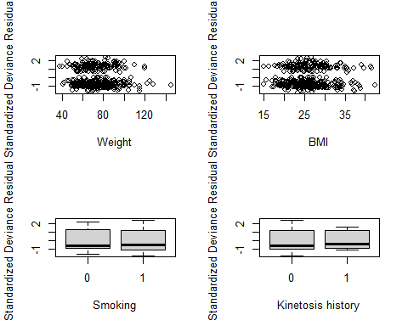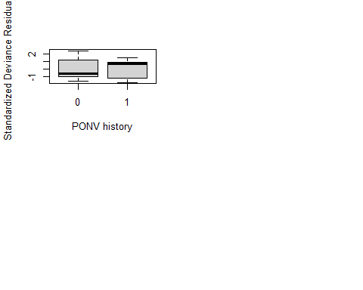

Skewness is present in all of the predictors, most of which are right-skewed. This suggests that the log odds may depend on each skewed predictor through both a linear function and a log transformation. However, residual plots are difficult to interpret for binary data, so we will examine marginal model plots instead.

### Marginal model plots for the continuous predictors

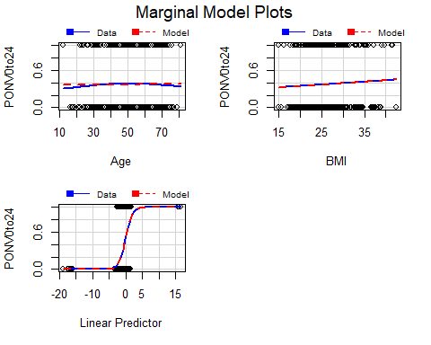

There is reasonable agreement between the two fits in each of the marginal model plots for BMI and the linear predictor. Due to the lack of fit for Age, and the presence of parabolic curvature for the observed response, one possible approach is to consider adding a quadratic term for Age.

$g^{−1}\left(Y\right)=\text{log}\left(\frac{θ\left(Y\right)}{1−θ\left(Y\right)}\right)=β_{0}+β_{1}x_{1}+β_{2}x_{2}^{2}+β_{3}x_{3}+β_{4}x_{4}+...+β_{28}x_{28}+β_{29}x_{29}+...+β_{35}x_{35}+β_{36}x_{36}+β_{37}x_{37}+β_{38}x_{38}+β_{39}x_{39}+e$

##   
## Call:  
## glm(formula = PONV0to24 ~ Age + I(Age^2) + Gender + Diagnosis +   
## Surgery + BMI + Nonsmoker + KinetosisHistory + PONVhistory,   
## family = binomial, data = ponv)  
##   
## Deviance Residuals:   
## Min 1Q Median 3Q Max   
## -1.8339 -0.9581 -0.5420 1.1239 2.3112   
##   
## Coefficients:  
## Estimate Std. Error z value Pr(>|z|)   
## (Intercept) -1.994e+01 1.168e+03 -0.017 0.9864   
## Age 7.853e-02 5.507e-02 1.426 0.1539   
## I(Age^2) -8.170e-04 5.392e-04 -1.515 0.1298   
## Gender1 8.152e-01 3.223e-01 2.529 0.0114 *   
## Diagnosis1 8.950e-01 6.322e-01 1.416 0.1569   
## Diagnosis2 1.077e+00 5.786e-01 1.862 0.0627 .   
## Diagnosis3 1.053e+00 7.991e-01 1.318 0.1875   
## Diagnosis4 1.189e+00 6.157e-01 1.932 0.0534 .   
## Diagnosis5 -1.127e-01 8.928e-01 -0.126 0.8996   
## Diagnosis6 1.204e+00 9.253e-01 1.301 0.1933   
## Diagnosis7 1.488e+00 1.688e+00 0.882 0.3780   
## Diagnosis8 -8.362e-01 1.218e+00 -0.687 0.4924   
## Diagnosis9 -8.259e-01 1.453e+00 -0.568 0.5697   
## Diagnosis10 2.031e+00 2.040e+00 0.996 0.3193   
## Diagnosis11 -1.348e+01 2.400e+03 -0.006 0.9955   
## Diagnosis12 -1.376e+01 1.696e+03 -0.008 0.9935   
## Diagnosis13 -4.460e-02 8.909e-01 -0.050 0.9601   
## Diagnosis14 1.822e+01 1.220e+03 0.015 0.9881   
## Diagnosis15 5.787e-01 8.139e-01 0.711 0.4771   
## Diagnosis16 9.297e-01 9.279e-01 1.002 0.3164   
## Diagnosis17 -1.398e+01 1.336e+03 -0.010 0.9916   
## Diagnosis18 1.680e+01 2.400e+03 0.007 0.9944   
## Diagnosis19 7.261e-01 9.649e-01 0.753 0.4517   
## Diagnosis20 7.744e-01 1.380e+00 0.561 0.5746   
## Diagnosis23 1.851e+01 2.400e+03 0.008 0.9938   
## Diagnosis24 -1.479e+01 2.400e+03 -0.006 0.9951   
## Diagnosis25 1.888e+01 2.400e+03 0.008 0.9937   
## Surgery1 1.535e+01 1.168e+03 0.013 0.9895   
## Surgery2 1.532e+01 1.168e+03 0.013 0.9895   
## Surgery3 3.246e+01 2.669e+03 0.012 0.9903   
## Surgery4 1.563e+01 1.168e+03 0.013 0.9893   
## Surgery5 -2.504e+00 1.689e+03 -0.001 0.9988   
## Surgery7 1.415e+01 1.168e+03 0.012 0.9903   
## BMI 1.406e-02 2.485e-02 0.566 0.5716   
## Nonsmoker1 5.910e-01 2.495e-01 2.368 0.0179 *   
## KinetosisHistory1 1.241e-02 4.976e-01 0.025 0.9801   
## PONVhistory1 1.409e+00 3.430e-01 4.106 4.02e-05 ***  
## ---  
## Signif. codes: 0 '***' 0.001 '**' 0.01 '*' 0.05 '.' 0.1 ' ' 1  
##   
## (Dispersion parameter for binomial family taken to be 1)  
##   
## Null deviance: 609.06 on 460 degrees of freedom  
## Residual deviance: 520.59 on 424 degrees of freedom  
## AIC: 594.59  
##   
## Number of Fisher Scoring iterations: 15

After adding a squared term for age to the full model, three of the predictors have estimated coefficients that are statistically significant. In descending order of significance, these are PONV history, gender, and nonsmoker. This is the same result obtained without the squared term for age.

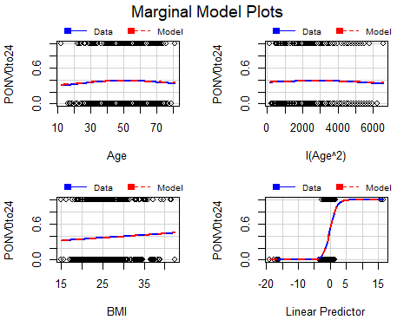

After adding the quadratic term for age, there is reasonable agreement between the two fits (observed and predicted) in each of the marginal model plots for $Age$, $Age^{2}$, $BMI$, and the linear predictor. This indicates that the current model is an adequate fit for the data.

### Leverage values and standardized deviance residuals

As a final validity check, we examine leverage values and standardized deviance residuals.

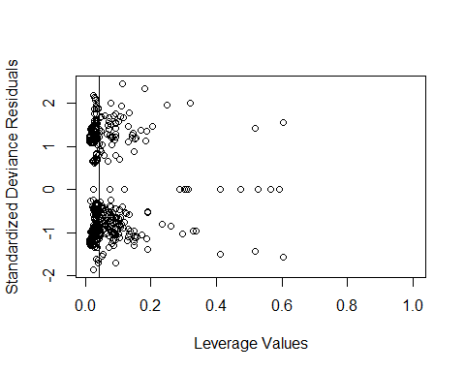

## integer(0)

A plot of leverage values and standardized deviance residuals reveals that none of the leverage points exceed 2.5 standard deviations. Six of the points exceed two standard deviations and should be investigated. However, since these points comprise only 1% of the 461 values in the data set, we will continue with the assumption that the current model is an adequate fit for the data. Therefore, we next proceed to variable selection.

## Variable selection using all possible subsets

### Plots of $R_{adj}^{2}$ against subset size for the best subset of each size

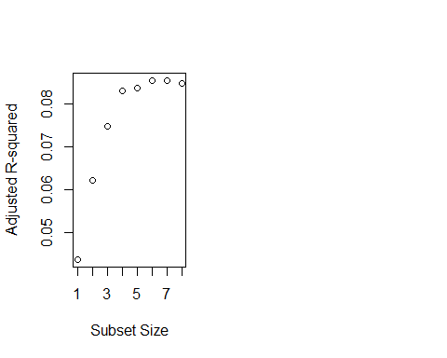

The plot of adjusted $R^{2}$ values shows the best predictor subsets to be as follows:

1 predictor: PONVhistory  
2 predictors: PONVhistory, Surgery  
3 predictors: PONVhistory, Surgery, Gender  
4 predictors: PONVhistory, Surgery, Gender, Nonsmoker  
5 predictors: PONVhistory, Surgery, Gender, Nonsmoker, Age $​^{2}$ 
6 predictors: PONVhistory, Surgery, Gender, Nonsmoker, Age $​^{2}$, BMI  
7 predictors: PONVhistory, Surgery, Gender, Nonsmoker, Age $​^{2}$, BMI, Age  
8 predictors: PONVhistory, Surgery, Gender, Nonsmoker, Age $​^{2}$, BMI, Age, KinetosisHistory

The maximum value of $R^{2}$ corresponds to the predictor subset of size seven. This is expected since $R^{2}$ increases (without penalty) as the number of predictors added to the model increases. This may lead to overfitting of the model to the data that it is trained on.

Viewing the results of the adjusted $R^{2}$ plot another way, the number of models that include each variable is as follows:

8 models: PONVhist  
7 models: Surgery  
6 models: Gender  
5 models: Nonsmoker  
4 models: Age $​^{2}$ 
3 models: BMI  
2 models: Age  
1 model: KinetosisHist

### Values of $R_{adj}^{2}$, AIC, AIC $​_{C}$, and BIC for the best subset of each size

The predictor with the smallest *p*-value for its estimated coefficient is added to each subset to obtain the next subset.

# Subset size = 1  
om1 <- glm(PONV0to24 ~ PONVhistory, family = binomial, data = ponv)  
# Subset size = 2  
om2 <- glm(PONV0to24 ~ PONVhistory + Surgery, family = binomial, data = ponv)  
# Subset size = 3  
om3 <- glm(PONV0to24 ~ PONVhistory + Surgery + Gender, family = binomial,   
 data = ponv)  
# Subset size = 4  
om4 <- glm(PONV0to24 ~ PONVhistory + Surgery + Gender + Nonsmoker,   
 family = binomial, data = ponv)  
# Subset size = 5  
om5 <- glm(PONV0to24 ~ PONVhistory + Surgery + Gender + Nonsmoker + I(Age^2),   
 family = binomial, data = ponv)  
# Subset size = 6  
om6 <- glm(PONV0to24 ~ PONVhistory + Surgery + Gender + Nonsmoker + I(Age^2)   
 + BMI, family = binomial, data = ponv)  
# Subset size = 7  
om7 <- glm(PONV0to24 ~ PONVhistory + Surgery + Gender + Nonsmoker + I(Age^2)   
 + BMI + Age, family = binomial, data = ponv)  
# Subset size = 8  
om8 <- glm(PONV0to24 ~ PONVhistory + Surgery + Gender + Nonsmoker + I(Age^2)   
 + BMI + Age + KinetosisHistory, family = binomial, data = ponv)  
# Subset size = 9  
om9 <- glmFit2

### Calculate AIC

extractAIC(om1, k = 2)

## [1] 2.000 592.694

extractAIC(om2, k = 2)

## [1] 8.0000 581.4326

extractAIC(om3, k = 2)

## [1] 9.0000 575.9521

extractAIC(om4, k = 2)

## [1] 10.000 574.025

extractAIC(om5, k = 2)

## [1] 11.0000 575.1732

extractAIC(om6, k = 2)

## [1] 12.0000 575.3149

extractAIC(om7, k = 2)

## [1] 13.0000 575.9791

extractAIC(om8, k = 2)

## [1] 14.0000 577.3641

extractAIC(om9, k = 2)

## [1] 37.0000 594.5913

The minimum value of AIC corresponds to the predictor subset of size four: PONVhistory, Surgery, Gender, and Nonsmoker.

### Calculate AIC $​_{C}$

npar.1 <- length(om1$coefficients) + 1  
npar.2 <- length(om2$coefficients) + 1  
npar.3 <- length(om3$coefficients) + 1  
npar.4 <- length(om4$coefficients) + 1  
npar.5 <- length(om5$coefficients) + 1  
npar.6 <- length(om6$coefficients) + 1  
npar.7 <- length(om7$coefficients) + 1  
npar.8 <- length(om8$coefficients) + 1  
npar.9 <- length(om9$coefficients) + 1  
  
extractAIC(om1, k = 2) + 2 * npar.1 * (npar.1 + 1) / (n - npar.1 - 1)

## [1] 2.052516 592.746551

extractAIC(om2, k = 2) + 2 * npar.2 * (npar.2 + 1) / (n - npar.2 - 1)

## [1] 8.399113 581.831722

extractAIC(om3, k = 2) + 2 * npar.3 * (npar.3 + 1) / (n - npar.3 - 1)

## [1] 9.488889 576.440946

extractAIC(om4, k = 2) + 2 * npar.4 * (npar.4 + 1) / (n - npar.4 - 1)

## [1] 10.58797 574.61297

extractAIC(om5, k = 2) + 2 * npar.5 * (npar.5 + 1) / (n - npar.5 - 1)

## [1] 11.69643 575.86968

extractAIC(om6, k = 2) + 2 * npar.6 * (npar.6 + 1) / (n - npar.6 - 1)

## [1] 12.81432 576.12925

extractAIC(om7, k = 2) + 2 * npar.7 * (npar.7 + 1) / (n - npar.7 - 1)

## [1] 13.9417 576.9208

extractAIC(om8, k = 2) + 2 * npar.8 * (npar.8 + 1) / (n - npar.8 - 1)

## [1] 15.07865 578.44275

extractAIC(om9, k = 2) + 2 * npar.9 * (npar.9 + 1) / (n - npar.9 - 1)

## [1] 44.0237 601.6150

The minimum value of AIC $​_{C}$ also corresponds to the predictor subset of size four: PONVhistory, Surgery, Gender, and Nonsmoker.

### Calculate BIC

extractAIC(om1, k = log(n))

## [1] 2.0000 600.9608

extractAIC(om2, k = log(n))

## [1] 8.0000 614.4998

extractAIC(om3, k = log(n))

## [1] 9.0000 613.1526

extractAIC(om4, k = log(n))

## [1] 10.000 615.359

extractAIC(om5, k = log(n))

## [1] 11.0000 620.6406

extractAIC(om6, k = log(n))

## [1] 12.0000 624.9157

extractAIC(om7, k = log(n))

## [1] 13.0000 629.7133

extractAIC(om8, k = log(n))

## [1] 14.0000 635.2317

extractAIC(om9, k = log(n))

## [1] 37.000 747.527

The minimum value of BIC corresponds to the predictor subset of size two: PONVhistory and Surgery.

### Parsimonious model selection

The minimum AIC and AIC $​_{C}$ values each correspond to the predictor subset of size four. This subset consists of all three predictors having statistically significant coefficients in the full logistic regression model, both before and after adding the squared term for Age. These are PONVhistory, Gender, and Nonsmoker. The fourth variable of the subset is Surgery. Furthermore, the predictor subset of size four has a higher $R^{2}$ value than the predictor subset of size two. Therefore, we choose the predictor subset of size three as our parsimonious logistic regression model:

$Y=g\left(β_{0}+β_{1}PONVhistory+β_{2}Gender+β_{3}Nonsmoker+β_{4}Surgery+e\right)$

where *e* ~ iid $N\left(0,1\right)$.

As before, we use the logit function to model the binary response variable:

$g^{−1}\left(Y\right)=\text{log}\left(\frac{θ\left(Y\right)}{1−θ\left(Y\right)}\right)=β_{0}+β_{1}PONVhist+β_{2}Gender+β_{3}Nonsmoker+β_{4}Surgery+e$

where $θ\left(Y\right)=\frac{\text{exp}\left(Y\right)}{1+\text{exp}\left(Y\right)}=\frac{1}{1+\text{exp}\left(−Y\right)}$

##   
## Call:  
## glm(formula = PONV0to24 ~ PONVhistory + Gender + Nonsmoker +   
## Surgery, family = binomial, data = ponv)  
##   
## Deviance Residuals:   
## Min 1Q Median 3Q Max   
## -1.6459 -1.0281 -0.6627 1.2687 2.1106   
##   
## Coefficients:  
## Estimate Std. Error z value Pr(>|z|)   
## (Intercept) -16.3253 727.6988 -0.022 0.98210   
## PONVhistory1 1.2680 0.3185 3.981 6.85e-05 ***  
## Gender1 0.7592 0.2880 2.637 0.00838 **   
## Nonsmoker1 0.4329 0.2205 1.963 0.04960 *   
## Surgery1 14.9211 727.6988 0.021 0.98364   
## Surgery2 14.7712 727.6988 0.020 0.98381   
## Surgery3 30.6992 1627.1839 0.019 0.98495   
## Surgery4 13.4529 727.6989 0.018 0.98525   
## Surgery5 14.0466 727.6997 0.019 0.98460   
## Surgery7 14.3985 727.6990 0.020 0.98421   
## ---  
## Signif. codes: 0 '***' 0.001 '**' 0.01 '*' 0.05 '.' 0.1 ' ' 1  
##   
## (Dispersion parameter for binomial family taken to be 1)  
##   
## Null deviance: 609.06 on 460 degrees of freedom  
## Residual deviance: 554.02 on 451 degrees of freedom  
## AIC: 574.02  
##   
## Number of Fisher Scoring iterations: 14

The lrm function is very similar to the glm function, with identical output for the regression coefficient estimates. The glm function also provides a summary of the deviance residuals. The lrm function also provides results of the model likelihood ratio test, as well as indices for discrimination and rank discrimination.

## Logistic Regression Model  
##   
## lrm(formula = PONV0to24 ~ PONVhistory + Gender + Nonsmoker +   
## Surgery, data = ponv)  
##   
## Model Likelihood Discrimination Rank Discrim.   
## Ratio Test Indexes Indexes   
## Obs 461 LR chi2 55.03 R2 0.153 C 0.681   
## 0 289 d.f. 9 g 0.975 Dxy 0.363   
## 1 172 Pr(> chi2) <0.0001 gr 2.652 gamma 0.423   
## max |deriv| 0.0008 gp 0.172 tau-a 0.170   
## Brier 0.208   
##   
## Coef S.E. Wald Z Pr(>|Z|)  
## Intercept -9.0549 31.6581 -0.29 0.7749   
## PONVhistory=1 1.2680 0.3185 3.98 <0.0001   
## Gender=1 0.7592 0.2880 2.64 0.0084   
## Nonsmoker=1 0.4329 0.2205 1.96 0.0496   
## Surgery=1 7.6508 31.6574 0.24 0.8090   
## Surgery=2 7.5008 31.6581 0.24 0.8127   
## Surgery=3 16.1977 71.9096 0.23 0.8218   
## Surgery=4 6.1826 31.6600 0.20 0.8452   
## Surgery=5 6.7762 31.6771 0.21 0.8306   
## Surgery=7 7.1281 31.6629 0.23 0.8219   
##

The chosen model has three estimated coefficients that are statistically significant, which are the same three that are statistically significant in the full model. In descending order of significance, these are PONVhistory, Gender, and Nonsmoker. The fourth predictor in the model is Surgery, but none of the estimated coefficients for this factor predictor variable are statistically significant.

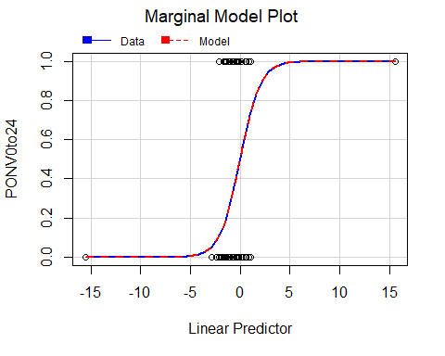

Since the chosen model has only factor predictor variables, a marginal model plot could only be obtained for the linear fit. There is reasonable agreement between the two fits (actual and predicted) in the marginal model plot for the linear fit. This indicates that the model is an adequate fit for the data.

As a final validity check, we next look at leverage values versus standardized deviance residuals.

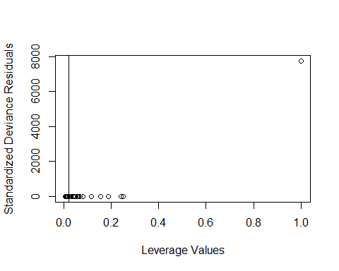

## integer(0)

The plot of leverage values and standardized deviance residuals consists of a single extreme leverage point, while the remaining points that are all clustered closer to a standard deviation of zero. Recall that none of the coefficients for Surgery were statistically significant. Furthermore, all have high standard errors, with one being more than double the value of the others. Finally, the predictor subsets of three and four have comparable $R^{2}$. So we will next remove the Surgery variable to give us the predictor subset of three as our parsimonious model:

$Y=g\left(β_{0}+β_{1}PONVhistory+β_{2}Gender+β_{3}Nonsmoker+e\right)$

where *e* ~ iid $N\left(0,1\right)$.

As before, we use the logit function to model the binary response variable:

$g^{−1}\left(Y\right)=\text{log}\left(\frac{θ\left(Y\right)}{1−θ\left(Y\right)}\right)=β_{0}+β_{1}PONVhist+β_{2}Gender+β_{3}Nonsmoker+e$

where $θ\left(Y\right)=\frac{\text{exp}\left(Y\right)}{1+\text{exp}\left(Y\right)}=\frac{1}{1+\text{exp}\left(−Y\right)}$

##   
## Call:  
## glm(formula = PONV0to24 ~ PONVhistory + Gender + Nonsmoker, family = binomial,   
## data = ponv)  
##   
## Deviance Residuals:   
## Min 1Q Median 3Q Max   
## -1.588 -1.023 -0.721 1.340 1.929   
##   
## Coefficients:  
## Estimate Std. Error z value Pr(>|z|)   
## (Intercept) -1.6911 0.3027 -5.587 2.32e-08 ***  
## PONVhistory1 1.3029 0.3132 4.160 3.19e-05 ***  
## Gender1 0.8401 0.2803 2.997 0.00273 **   
## Nonsmoker1 0.4766 0.2159 2.208 0.02724 *   
## ---  
## Signif. codes: 0 '***' 0.001 '**' 0.01 '*' 0.05 '.' 0.1 ' ' 1  
##   
## (Dispersion parameter for binomial family taken to be 1)  
##   
## Null deviance: 609.06 on 460 degrees of freedom  
## Residual deviance: 573.95 on 457 degrees of freedom  
## AIC: 581.95  
##   
## Number of Fisher Scoring iterations: 4

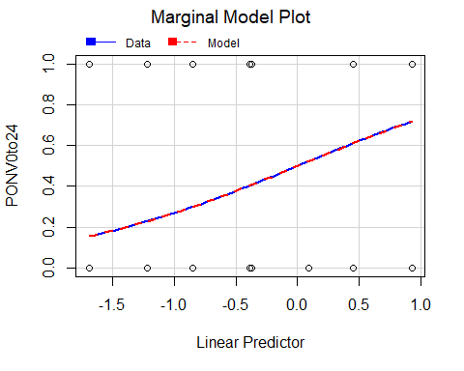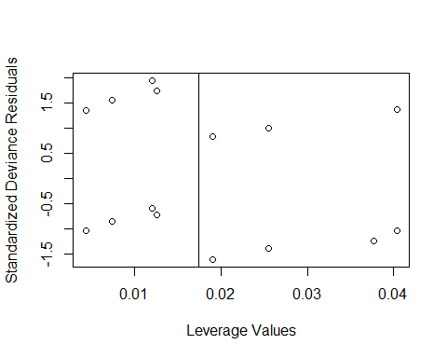

## integer(0)

In the current model, the intercept and all three predictors are statistically significant. The marginal model plot shows reasonable agreement between the two fits (actual and predicted) for the linear fit. This indicates that the model is an adequate fit for the data. The plot of leverage values and standardized deviance residuals consists of points that are all within two standard deviations, which means there are no bad leverage points.

We next proceed to assess the predictive ability of this model.

## Confusion Matrix and Statistics  
##   
## Reference  
## Prediction 0 1  
## 0 272 138  
## 1 17 34  
##   
## Accuracy : 0.6638   
## 95% CI : (0.6186, 0.7068)  
## No Information Rate : 0.6269   
## P-Value [Acc > NIR] : 0.05527   
##   
## Kappa : 0.1619   
##   
## Mcnemar's Test P-Value : < 2e-16   
##   
## Sensitivity : 0.9412   
## Specificity : 0.1977   
## Pos Pred Value : 0.6634   
## Neg Pred Value : 0.6667   
## Prevalence : 0.6269   
## Detection Rate : 0.5900   
## Detection Prevalence : 0.8894   
## Balanced Accuracy : 0.5694   
##   
## 'Positive' Class : 0   
##

## Setting levels: control = 0, case = 1

## Setting direction: controls < cases

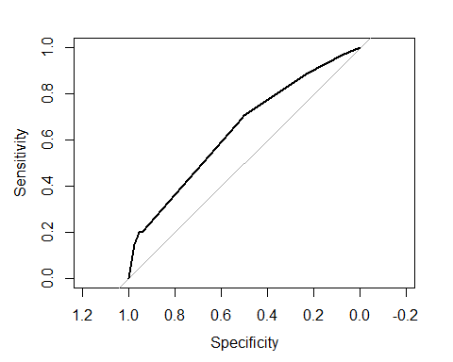

##   
## Call:  
## roc.default(response = PONV0to24, predictor = glmFit4$fitted.values, plot = TRUE)  
##   
## Data: glmFit4$fitted.values in 289 controls (PONV0to24 0) < 172 cases (PONV0to24 1).  
## Area under the curve: 0.6391

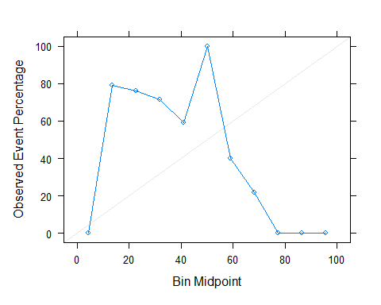

The area under the ROC curve (AUC) is 0.639. Since the ROC curve is a function of both sensitivity and specificity, the curve is insensitive to class imbalance. With a sensitivity of 0.94 and a specificity of 0.20, the model is good at classifying high risk patients, but poor at classifying low risk patients. This is reflected in the calibration plot, which has a slope that underestimates patients with low PONV risk, and overestimates patients with high PONV risk.

## Resampling techniques

### *k*-fold cross-validation

We next perform logistic regression using five repeats of 10-fold cross-validation, to generate 50 different holdout sets for estimating model accuracy. With *k* chosen to be 10, each training set contains 90% of the entire data set, while each test set contains the other 10% of the data.

set.seed(1)  
  
## Resampling specification is 5 repetitions of 10-fold cross-validation  
# Make syntactically valid names for the factor levels of the response variable  
logisticReg <- train(make.names(PONV0to24) ~ Age + Age^2 + Gender +   
 Diagnosis + Surgery + BMI +   
 Nonsmoker + KinetosisHistory + PONVhistory,   
 data = ponv,   
 method = "glm",  
 trControl = trainControl(method = "repeatedcv",  
 number = 10,  
 repeats = 5))  
  
## Summary and results  
logisticReg

## Generalized Linear Model   
##   
## 461 samples  
## 8 predictor  
## 2 classes: 'X0', 'X1'   
##   
## No pre-processing  
## Resampling: Cross-Validated (10 fold, repeated 5 times)   
## Summary of sample sizes: 416, 414, 415, 415, 414, 415, ...   
## Resampling results:  
##   
## Accuracy Kappa   
## 0.6380699 0.155806

summary(logisticReg)

##   
## Call:  
## NULL  
##   
## Deviance Residuals:   
## Min 1Q Median 3Q Max   
## -1.7753 -0.9663 -0.5579 1.1567 2.3369   
##   
## Coefficients:  
## Estimate Std. Error z value Pr(>|z|)   
## (Intercept) -1.817e+01 1.171e+03 -0.016 0.9876   
## Age -3.662e-03 8.834e-03 -0.415 0.6785   
## Gender1 8.547e-01 3.217e-01 2.656 0.0079 **   
## Diagnosis1 9.179e-01 6.314e-01 1.454 0.1460   
## Diagnosis2 1.079e+00 5.780e-01 1.868 0.0618 .   
## Diagnosis3 1.081e+00 7.968e-01 1.357 0.1748   
## Diagnosis4 1.108e+00 6.124e-01 1.809 0.0705 .   
## Diagnosis5 -1.851e-01 8.955e-01 -0.207 0.8362   
## Diagnosis6 1.136e+00 9.282e-01 1.224 0.2211   
## Diagnosis7 1.493e+00 1.674e+00 0.892 0.3726   
## Diagnosis8 -7.698e-01 1.217e+00 -0.632 0.5272   
## Diagnosis9 -6.555e-01 1.450e+00 -0.452 0.6513   
## Diagnosis10 1.634e+00 2.022e+00 0.808 0.4191   
## Diagnosis11 -1.439e+01 2.400e+03 -0.006 0.9952   
## Diagnosis12 -1.392e+01 1.696e+03 -0.008 0.9935   
## Diagnosis13 -3.879e-02 8.915e-01 -0.044 0.9653   
## Diagnosis14 1.801e+01 1.223e+03 0.015 0.9883   
## Diagnosis15 6.021e-01 8.127e-01 0.741 0.4587   
## Diagnosis16 7.782e-01 9.200e-01 0.846 0.3976   
## Diagnosis17 -1.397e+01 1.340e+03 -0.010 0.9917   
## Diagnosis18 1.664e+01 2.400e+03 0.007 0.9945   
## Diagnosis19 5.787e-01 9.616e-01 0.602 0.5473   
## Diagnosis20 8.271e-01 1.384e+00 0.598 0.5500   
## Diagnosis23 1.838e+01 2.400e+03 0.008 0.9939   
## Diagnosis24 -1.458e+01 2.400e+03 -0.006 0.9952   
## Diagnosis25 1.896e+01 2.400e+03 0.008 0.9937   
## Surgery1 1.530e+01 1.171e+03 0.013 0.9896   
## Surgery2 1.522e+01 1.171e+03 0.013 0.9896   
## Surgery3 3.240e+01 2.670e+03 0.012 0.9903   
## Surgery4 1.548e+01 1.171e+03 0.013 0.9894   
## Surgery5 -2.295e+00 1.693e+03 -0.001 0.9989   
## Surgery7 1.426e+01 1.171e+03 0.012 0.9903   
## BMI 2.241e-02 2.415e-02 0.928 0.3536   
## Nonsmoker1 5.353e-01 2.454e-01 2.181 0.0292 *   
## KinetosisHistory1 8.598e-02 4.972e-01 0.173 0.8627   
## PONVhistory1 1.432e+00 3.414e-01 4.194 2.74e-05 ***  
## ---  
## Signif. codes: 0 '***' 0.001 '**' 0.01 '*' 0.05 '.' 0.1 ' ' 1  
##   
## (Dispersion parameter for binomial family taken to be 1)  
##   
## Null deviance: 609.06 on 460 degrees of freedom  
## Residual deviance: 522.95 on 425 degrees of freedom  
## AIC: 594.95  
##   
## Number of Fisher Scoring iterations: 15

## Confusion matrix  
CM <- confusionMatrix(logisticReg); CM

## Cross-Validated (10 fold, repeated 5 times) Confusion Matrix   
##   
## (entries are percentual average cell counts across resamples)  
##   
## Reference  
## Prediction X0 X1  
## X0 52.3 25.8  
## X1 10.4 11.5  
##   
## Accuracy (average) : 0.6382

## Sensitivity  
print("Sensitivity:")

## [1] "Sensitivity:"

CM$table[4]/(CM$table[3]+CM$table[4])

## [1] 0.3093023

## Specificity  
print("Specificity:")

## [1] "Specificity:"

CM$table[1]/(CM$table[1]+CM$table[2])

## [1] 0.83391

## ROC curve  
YhatTestProb = predict(logisticReg, ponv, type = 'prob')  
roc <- roc(as.factor(as.numeric(PONV0to24)-1),  
 as.numeric(unlist(YhatTestProb[,2])))

## Setting levels: control = 0, case = 1

## Setting direction: controls < cases

roc$auc

## Area under the curve: 0.7358

plot(roc)

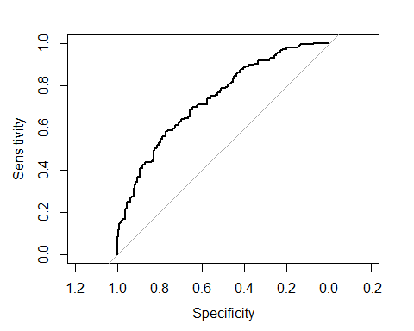

## Calibration plot  
calibProbs = calibration(as.factor(as.numeric(PONV0to24)-1) ~   
 as.numeric(unlist(YhatTestProb[,2])))  
xyplot(calibProbs)

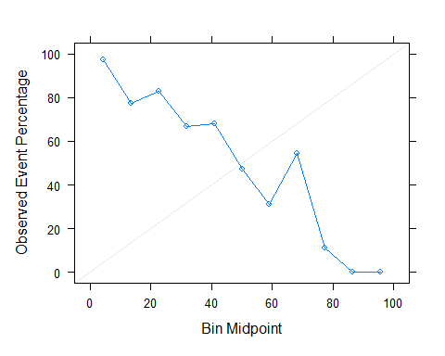

Repeated 10-fold cross-validation resulted in a logistic regression model with an AUC of 0.74, which is an improvement over the AUC of 0.64 obtained for our baseline model developed from all possible subets. With a sensitivity of 0.31 and a specificity of 0.83, the model is poor at classifying high risk patients, but good at classifying low risk patients.

The choice of *k* to be 10 for *k*-fold cross-validation avoids the high bias of smaller values of *k*, as well as the computational burden of higher values of *k*. *k*-fold cross-validation generally has high variance compared to other methods. The potential issues with bias and variance become negligible for large training sets. Applying 10-fold cross-validation to our data set resulted in training sets each having a sample size between 414 and 416, which may be considered reasonably large. Furthermore, repeating the *k*-fold cross-validation procedure is known as an effective way to increase the precision of the estimates and still maintain a small bias.

Three of the predictors in the full model have estimated coefficients that are statistically significant at the level or lower. In descending order of significance, these are PONV history, gender, and nonsmoker. These match the subset of predictors obtained from the model fitted using all possible subsets on the full data set.

We next look at the bootstrap technique of resampling.

### The bootstrap

A random sample equal to the size of the data set is taken *with replacement*. This is repeated 25 times to fit the full logistic regression model.

bootStrap <- train(make.names(PONV0to24) ~ Age + I(Age^2) + Gender +   
 Diagnosis + Surgery + BMI +   
 Nonsmoker + KinetosisHistory + PONVhistory,   
 data = ponv,   
 method = "glm",   
 metric = "ROC",   
 trControl = trainControl(method = "boot",  
 classProbs = TRUE))  
  
## Summary and results  
bootStrap # summary and results

## Generalized Linear Model   
##   
## 461 samples  
## 8 predictor  
## 2 classes: 'X0', 'X1'   
##   
## No pre-processing  
## Resampling: Bootstrapped (25 reps)   
## Summary of sample sizes: 461, 461, 461, 461, 461, 461, ...   
## Resampling results:  
##   
## Accuracy Kappa   
## 0.6293991 0.1629926

summary(bootStrap) # coefficient estimates

##   
## Call:  
## NULL  
##   
## Deviance Residuals:   
## Min 1Q Median 3Q Max   
## -1.8339 -0.9581 -0.5420 1.1239 2.3112   
##   
## Coefficients:  
## Estimate Std. Error z value Pr(>|z|)   
## (Intercept) -1.994e+01 1.168e+03 -0.017 0.9864   
## Age 7.853e-02 5.507e-02 1.426 0.1539   
## `I(Age^2)` -8.170e-04 5.392e-04 -1.515 0.1298   
## Gender1 8.152e-01 3.223e-01 2.529 0.0114 *   
## Diagnosis1 8.950e-01 6.322e-01 1.416 0.1569   
## Diagnosis2 1.077e+00 5.786e-01 1.862 0.0627 .   
## Diagnosis3 1.053e+00 7.991e-01 1.318 0.1875   
## Diagnosis4 1.189e+00 6.157e-01 1.932 0.0534 .   
## Diagnosis5 -1.127e-01 8.928e-01 -0.126 0.8996   
## Diagnosis6 1.204e+00 9.253e-01 1.301 0.1933   
## Diagnosis7 1.488e+00 1.688e+00 0.882 0.3780   
## Diagnosis8 -8.362e-01 1.218e+00 -0.687 0.4924   
## Diagnosis9 -8.259e-01 1.453e+00 -0.568 0.5697   
## Diagnosis10 2.031e+00 2.040e+00 0.996 0.3193   
## Diagnosis11 -1.348e+01 2.400e+03 -0.006 0.9955   
## Diagnosis12 -1.376e+01 1.696e+03 -0.008 0.9935   
## Diagnosis13 -4.460e-02 8.909e-01 -0.050 0.9601   
## Diagnosis14 1.822e+01 1.220e+03 0.015 0.9881   
## Diagnosis15 5.787e-01 8.139e-01 0.711 0.4771   
## Diagnosis16 9.297e-01 9.279e-01 1.002 0.3164   
## Diagnosis17 -1.398e+01 1.336e+03 -0.010 0.9916   
## Diagnosis18 1.680e+01 2.400e+03 0.007 0.9944   
## Diagnosis19 7.261e-01 9.649e-01 0.753 0.4517   
## Diagnosis20 7.744e-01 1.380e+00 0.561 0.5746   
## Diagnosis23 1.851e+01 2.400e+03 0.008 0.9938   
## Diagnosis24 -1.479e+01 2.400e+03 -0.006 0.9951   
## Diagnosis25 1.888e+01 2.400e+03 0.008 0.9937   
## Surgery1 1.535e+01 1.168e+03 0.013 0.9895   
## Surgery2 1.532e+01 1.168e+03 0.013 0.9895   
## Surgery3 3.246e+01 2.669e+03 0.012 0.9903   
## Surgery4 1.563e+01 1.168e+03 0.013 0.9893   
## Surgery5 -2.504e+00 1.689e+03 -0.001 0.9988   
## Surgery7 1.415e+01 1.168e+03 0.012 0.9903   
## BMI 1.406e-02 2.485e-02 0.566 0.5716   
## Nonsmoker1 5.910e-01 2.495e-01 2.368 0.0179 *   
## KinetosisHistory1 1.241e-02 4.976e-01 0.025 0.9801   
## PONVhistory1 1.409e+00 3.430e-01 4.106 4.02e-05 ***  
## ---  
## Signif. codes: 0 '***' 0.001 '**' 0.01 '*' 0.05 '.' 0.1 ' ' 1  
##   
## (Dispersion parameter for binomial family taken to be 1)  
##   
## Null deviance: 609.06 on 460 degrees of freedom  
## Residual deviance: 520.59 on 424 degrees of freedom  
## AIC: 594.59  
##   
## Number of Fisher Scoring iterations: 15

## Confusion matrix  
CM <- confusionMatrix(bootStrap); CM

## Bootstrapped (25 reps) Confusion Matrix   
##   
## (entries are percentual average cell counts across resamples)  
##   
## Reference  
## Prediction X0 X1  
## X0 49.2 23.7  
## X1 13.4 13.7  
##   
## Accuracy (average) : 0.629

## Sensitivity  
print("Sensitivity:")

## [1] "Sensitivity:"

CM$table[4]/(CM$table[3]+CM$table[4])

## [1] 0.3670246

## Specificity  
print("Specificity:")

## [1] "Specificity:"

CM$table[1]/(CM$table[1]+CM$table[2])

## [1] 0.7854449

## ROC curve  
YhatTestProb = predict(bootStrap, ponv, type = 'prob')  
roc <- roc(as.factor(as.numeric(PONV0to24)-1),  
 as.numeric(unlist(YhatTestProb[,2])))

## Setting levels: control = 0, case = 1

## Setting direction: controls < cases

roc$auc

## Area under the curve: 0.7408

plot(roc)

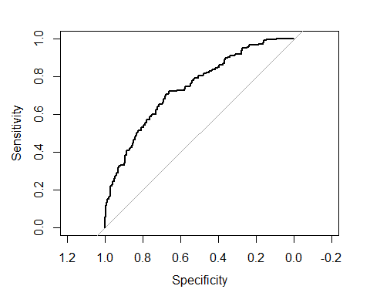

## Calibration plot  
calibProbs = calibration(as.factor(as.numeric(PONV0to24)-1) ~   
 as.numeric(unlist(YhatTestProb[,2])))  
xyplot(calibProbs)

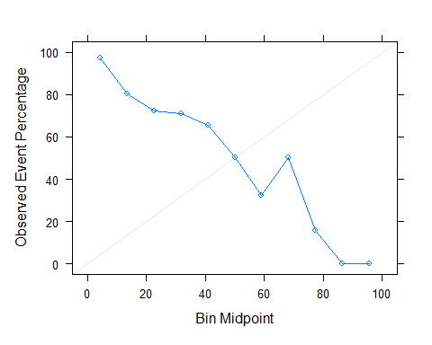

Bootstrapping resulted in a logistic regression model with an AUC of 0.74, which is an improvement over our two preceding models. With a sensitivity of 0.34 and a specificity of 0.78, this model provides the most reasonable balance of our three models.

Three of the predictors in the full model have estimated coefficients that are statistically significant at the level or lower. In descending order of significance, these are PONV history, gender, and nonsmoker. These match the subset of predictors obtained from the preceding two models.

## Predictions

We will next make predictions of PONV for some examples of hypothetical patients. Our logistic regression model obtained from all possible subsets consists of three predictors which are all binary variables. Since it lacks the numerous dummy variables of the two models trained with resampling techniques, we choose it as the parsimonious model to make our predictions.

mean(predict(glmFit4, data.frame(PONVhistory="1", Gender="1", Nonsmoker="1"),type="response"))

## [1] 0.7167777

mean(predict(glmFit4, data.frame(PONVhistory="1", Gender="1", Nonsmoker="0"),type="response"))

## [1] 0.6110923

mean(predict(glmFit4, data.frame(PONVhistory="1", Gender="0", Nonsmoker="1"),type="response"))

## [1] 0.5221021

mean(predict(glmFit4, data.frame(PONVhistory="1", Gender="0", Nonsmoker="0"),type="response"))

## [1] 0.4041599

mean(predict(glmFit4, data.frame(PONVhistory="0", Gender="1", Nonsmoker="1"),type="response"))

## [1] 0.407475

mean(predict(glmFit4, data.frame(PONVhistory="0", Gender="1", Nonsmoker="0"),type="response"))

## [1] 0.2992145

mean(predict(glmFit4, data.frame(PONVhistory="0", Gender="0", Nonsmoker="1"),type="response"))

## [1] 0.2289091

mean(predict(glmFit4, data.frame(PONVhistory="0", Gender="0", Nonsmoker="0"),type="response"))

## [1] 0.15563

As expected, the more significant predictors that a patient has, the more likely the patient will have PONV. A patient with all three risk factors in the parsimonious model has a 72% probability of experiencing PONV, while a patient with none of the three risk factors has a 16% probability of experiencing PONV. Having previously determined that this is a valid predictive model, it may have practical application for patient populations with characteristics like the data set we investigated. In choosing a threshold for prescription of prophylaxis, healthcare professionals could select one of the two hypothetical predictions in our example having a probability greater than 50%.

## References

Apfel, C. C., Kranke, P., Eberhart, L. H. J., Roos, A., and Roewer, N. (2002), “Comparison of Predictive Models for Postoperative Nausea and Vomiting,” *British Journal of Anaesthesia*, 88 (2), 234-40.

Eberhart, L. H. J., Hogel, J., Seeling, W., Staack, A.M., Geldner, G., and Georgieff, M. (2000), “Evaluation of Three Risk Scores to Predict Postoperative Nausea and Vomiting,” *Acta Anaesthesiologica Scandinavica*, 44, 480–488.

James, G., Witten, D., Hastie, T., and Tibshirani, R. (2021), *An Introduction to Statistical Learning* (2nd ed.), New York, NY: Springer Science+Business Media, LLC.

Kuhn, M., and Johnson, K. (2013), *Applied Predictive Modeling*, New York , NY: Springer Science+Business Media, LLC.

Pampel, F. C. (2021), *Logistic Regression* (2nd ed.), Thousand Oaks, CA: SAGE Publications, Inc.

Sheather, S. J. (2009), *A Modern Approach to Regression with R*, New York, NY: Springer Science+Business Media, LLC.

Sinclair, D. R., Chung, F., and Mezei, G. (1999), “Can Postoperative Nausea and Vomiting Be Predicted?” *Anesthesiology*, 91, 109-118.

Thomas, R., Jones, N. A., and Strike, P. (2002), “The Value of Risk Scores for Predicting Postoperative Nausea and Vomiting when Used to Compare Patient Groups in a Randomised Controlled Trial,” *Anaesthesia*, 57, 1119-1128.

van den Bosch, J.E., Kalkman, C. J., Vergouwe, Y., Van Klei, W. A., Bonsel, G. J., Grobbee, D. E., and Moons, K. G. M. (2005), “Assessing the Applicability of Scoring Systems for Predicting Postoperative Nausea and Vomiting,” *Anaesthesia*, 60, 323-331.

Vidakovic, B. (2017), *Engineering Biostatistics*, Hoboken, NJ: John Wiley & Sons Ltd.