Mr
Eng. Ultimate Joinery Ultimate Joinery
Upper Floor Unit 22 Turnpike Road , Bal
D22
Customer number: 7
Telephone No.: 00353868110093
Offer number: 20150066
Clerk in charge:
Telephone No.:
EMail:

Offer Date: 08.05.2015
Ken McCullagh

Home Pure / UPVC/aluminium windows KF200  I-tec glazing - continuous all around fixing of glass pane:  Higher stability, better thermal and sound insulation, increased burglary security and maximum functioning security over its entire life span  Triple gasket system for reliable protection against driving rain and high permeability as well as thermal and sound insulation  Upon request:  Concealed locking - no visible hardware parts, easier to clean and nicer to look at  Shortened aluminium clad - for thermo-technically optimised construction connection | Symbolic photo

Your elements have the following common characteristics:
Glass spacer: Aluminium
Glass coating: Light

Glazing: | triple 36mm coated clear glass 4b/12Ar/4/12Ar/b4 (3NK)  Ug value: 0,7 W/m²K  dB value: 31

handle inside: designer handle G80 in F1 cylinder keyhole cover plate 14mm (36404)

colour inside: Edelweiss (EW)
colour outside: Signal grey RAL7004 matt (HM704)

Thermal insulation value window: 1,00 W/m²K
Sound insulation value window: 33 dB
According to standard EN ISO 12567 or 10077 referring to a standard test window size of 1230x1480.
Georgian/feature bars, thresholds etc. are not taken into consideration.

Deviations to this information are listed in the positions descriptions!
________________________________________________________________________________________________________________________________________________________

ALUMINIUM HOUSE ENTRANCE DOOR – AT200  Internorm aluminium house entrance door with the following characteristics:  • Thermal insulation UD up to 1.2 W/m2K  • Sound insulation up to 40 dB  • 5 point lock as standard  • Profile construction depth 80 mm  • Triple gasket construction  • High quality aluminium door range in soft-line appearance  • Thermally broken 3 chamber threshold  • 3 chamber frame profile with foam insulation core | Symbolic photo

Information concerning performance parameters of door system – please see your quote for exact values!
Depicted door systems are for illustration only.
________________________________________________________________________________________________________________________________________________________

UPVC lift-and-slide-door KS430  • Standard triple security glazing with 48 mm glazing thickness for best  thermal insulation  • Modern, square-edged appearance inside and outside  • Large-scale elements easy lifting and sliding of the sash up to 400 kg  sash weight  • Highly thermally insulating glass fibre threshold for optimum thermal  insulation and stability  • Guide rail concealed in frame with integrated bump stop for perfect  appearance, smooth running and optimum burglary protection | Symbolic photo

Information concerning performance parameters of door system – please see your quote for exact values!
Depicted door systems are for illustration only.
________________________________________________________________________________________________________________________________________________________

Pos. Quantity Description
________________________________________________________________________________________________________________________________________________________
100 | 1,00 | Pcs. | Passion Kanto Design 1-piece
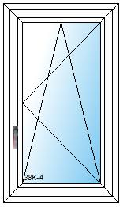 |  |  | Home Pure / UPVC aluminium window KF200  frame width: 700mm, frame height: 1200mm,  frame system: normal frame,  internal sash design chamfered version (glass bead and striking plate),  installation type adjusted for wall anchor hardware,  installation height: altitude up to 900 m,  CF sash 1:  Hardware: tilt-turn sash concealed, Opening direction: right, handle height from sash bottom bead: 395mm, installation for sash: triple 40mm coated clear glass 4b/14Ar/4/14Ar/b4 (38K, 0,6W/m².K),  Uw value (EN ISO 12567 / EN ISO 10077): 0,96 W/(m².K),

110 | 1,00 | Pcs. | Passion Kanto Design 1-piece
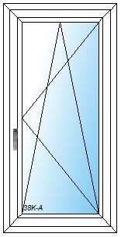 |  |  | Home Pure / UPVC aluminium window KF200  frame width: 700mm, frame height: 1400mm,  frame system: normal frame,  internal sash design chamfered version (glass bead and striking plate),  installation type adjusted for wall anchor hardware,  installation height: altitude up to 900 m,  CF sash 1:  Hardware: tilt-turn sash concealed, Opening direction: right, handle height from sash bottom bead: 570mm, installation for sash: triple 40mm coated clear glass 4b/14Ar/4/14Ar/b4 (38K, 0,6W/m².K),  Uw value (EN ISO 12567 / EN ISO 10077): 0,96 W/(m².K),

120 | 1,00 | Pcs. | Passion Kanto Design 1-piece fix
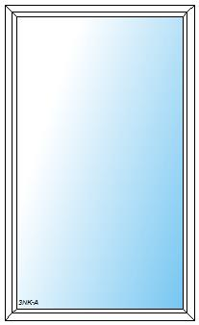 |  |  | UPVC aluminium window KF200  frame width: 1200mm, frame height: 2000mm,  frame system: normal frame,  internal sash design chamfered version (glass bead and striking plate),  installation type adjusted for wall anchor hardware,  installation height: altitude up to 900 m,  fixed part 1:

130 | 1,00 | Pcs. | Passion Kanto Design 1-piece fix
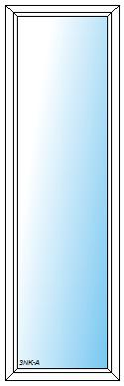 |  |  | UPVC aluminium window KF200  frame width: 700mm, frame height: 2300mm,  frame system: normal frame,  internal sash design chamfered version (glass bead and striking plate),  installation type adjusted for wall anchor hardware,  installation height: altitude up to 900 m,  fixed part 1:

140 | 1,00 | Pcs. | Passion Kanto Design 1-piece
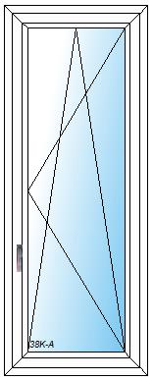 |  |  | Home Pure / UPVC aluminium window KF200  frame width: 700mm, frame height: 1800mm,  frame system: normal frame,  internal sash design chamfered version (glass bead and striking plate),  installation type adjusted for wall anchor hardware,  installation height: altitude up to 900 m,  CF sash 1:  Hardware: tilt-turn sash concealed, Opening direction: right, handle height from sash bottom bead: 570mm, installation for sash: triple 40mm coated clear glass 4b/14Ar/4/14Ar/b4 (38K, 0,6W/m².K),  Uw value (EN ISO 12567 / EN ISO 10077): 0,96 W/(m².K),

150 | 2,00 | Pcs. | Passion Kanto Design 1-piece
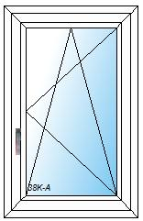 |  |  | Home Pure / UPVC aluminium window KF200  frame width: 700mm, frame height: 1100mm,  frame system: normal frame,  internal sash design chamfered version (glass bead and striking plate),  installation type adjusted for wall anchor hardware,  installation height: altitude up to 900 m,  CF sash 1:  Hardware: tilt-turn sash concealed, Opening direction: right, handle height from sash bottom bead: 395mm, installation for sash: triple 40mm coated clear glass 4b/14Ar/4/14Ar/b4 (38K, 0,6W/m².K),  Uw value (EN ISO 12567 / EN ISO 10077): 0,96 W/(m².K),

160 | 1,00 | Pcs. | Passion Kanto Design 1-piece
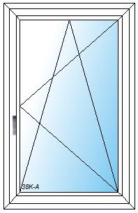 |  |  | Home Pure / UPVC aluminium window KF200  frame width: 900mm, frame height: 1400mm,  frame system: normal frame,  internal sash design chamfered version (glass bead and striking plate),  installation type adjusted for wall anchor hardware,  installation height: altitude up to 900 m,  CF sash 1:  Hardware: tilt-turn sash concealed, Opening direction: right, handle height from sash bottom bead: 570mm, installation for sash: triple 40mm coated clear glass 4b/14Ar/4/14Ar/b4 (38K, 0,6W/m².K),  Uw value (EN ISO 12567 / EN ISO 10077): 0,96 W/(m².K),

170 | 1,00 | Pcs. | Passion Kanto Design 2-piece left fix
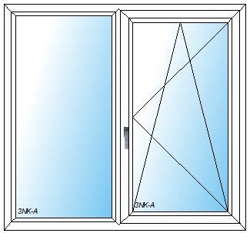 |  |  | Home Pure / UPVC aluminium window KF200  frame width: 1500mm, frame height: 1400mm,  frame system: normal frame, vertical division 2-piece sym. 1/1:  internal sash design chamfered version (glass bead and striking plate),  installation type adjusted for wall anchor hardware,  installation height: altitude up to 900 m,  fixed part 1:  CF sash 2:  Hardware: tilt-turn sash concealed, Opening direction: right, handle height from sash bottom bead: 570mm,

180 | 1,00 | Pcs. | Passion Kanto Design 2-piece left fix
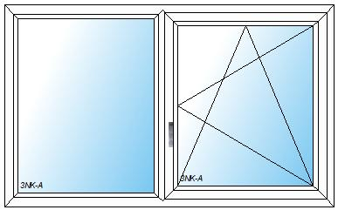 |  |  | Home Pure / UPVC aluminium window KF200  frame width: 1800mm, frame height: 1100mm,  frame system: normal frame, vertical division 2-piece sym. 1/1:  internal sash design chamfered version (glass bead and striking plate),  installation type adjusted for wall anchor hardware,  installation height: altitude up to 900 m,  fixed part 1:  CF sash 2:  Hardware: tilt-turn sash concealed, Opening direction: right, handle height from sash bottom bead: 395mm,

190 | 1,00 | Pcs. | Passion Kanto Design 2-piece left fix
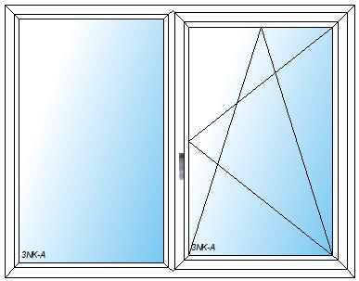 |  |  | Home Pure / UPVC aluminium window KF200  frame width: 1800mm, frame height: 1400mm,  frame system: normal frame, vertical division 2-piece sym. 1/1:  internal sash design chamfered version (glass bead and striking plate),  installation type adjusted for wall anchor hardware,  installation height: altitude up to 900 m,  fixed part 1:  CF sash 2:  Hardware: tilt-turn sash concealed, Opening direction: right, handle height from sash bottom bead: 570mm,

200 | 1,00 | Pcs. | Passion Kanto Design 2-piece right fix
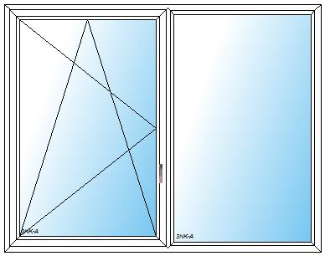 |  |  | Home Pure / UPVC aluminium window KF200  frame width: 2300mm, frame height: 1800mm,  frame system: normal frame, vertical division 2-piece sym. 1/1:  internal sash design chamfered version (glass bead and striking plate),  installation type adjusted for wall anchor hardware,  installation height: altitude up to 900 m,  CF sash 1:  Hardware: tilt-turn sash concealed, Opening direction: left, handle height from sash bottom bead: 570mm,  fixed part 2:

210 | 1,00 | Pcs. | Passion Kanto Design 2-piece right fix
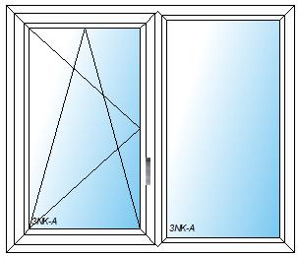 |  |  | Home Pure / UPVC aluminium window KF200  frame width: 1400mm, frame height: 1200mm,  frame system: normal frame, vertical division 2-piece sym. 1/1:  internal sash design chamfered version (glass bead and striking plate),  installation type adjusted for wall anchor hardware,  installation height: altitude up to 900 m,  CF sash 1:  Hardware: tilt-turn sash concealed, Opening direction: left, handle height from sash bottom bead: 395mm,  fixed part 2:

220 | 1,00 | Pcs. | Passion Kanto Design 3-piece centre element fix
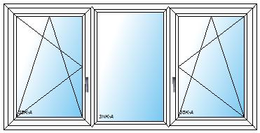 |  |  | Home Pure / UPVC aluminium window KF200  frame width: 2200mm, frame height: 1100mm,  frame system: normal frame, vertical division 3-piece sym. 1/1/1:  internal sash design chamfered version (glass bead and striking plate),  installation type adjusted for wall anchor hardware,  installation height: altitude up to 900 m,  CF sash 1:  Hardware: tilt-turn sash concealed, Opening direction: left, handle height from sash bottom bead: 395mm, installation for sash: triple 40mm coated clear glass 4b/14Ar/4/14Ar/b4 (38K, 0,6W/m².K),  fixed part 2:  CF sash 3:  Hardware: tilt-turn sash concealed, Opening direction: right, handle height from sash bottom bead: 395mm, installation for sash: triple 40mm coated clear glass 4b/14Ar/4/14Ar/b4 (38K, 0,6W/m².K),

230 | 2,00 | Pcs. | Passion Kanto Design 2-piece left fix
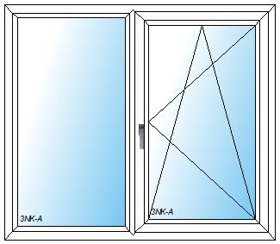 |  |  | Home Pure / UPVC aluminium window KF200  frame width: 1500mm, frame height: 1300mm,  frame system: normal frame, vertical division 2-piece sym. 1/1:  internal sash design chamfered version (glass bead and striking plate),  installation type adjusted for wall anchor hardware,  installation height: altitude up to 900 m,  fixed part 1:  CF sash 2:  Hardware: tilt-turn sash concealed, Opening direction: right, handle height from sash bottom bead: 570mm,

240 | 1,00 | Pcs. | Passion Kanto Design construction model
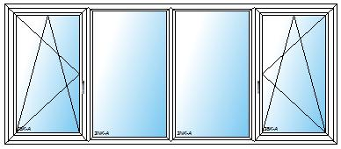 |  |  | Home Pure / UPVC aluminium window KF200  width: 3300mm, height: 1400mm,  Form: rectangular construction,  frame system: NR - frame 76mm,  division: 3 mullions or flying mullions, vertical division 1: 825,0, vertical division 2: 825,0, vertical division 3: 825,0, vertical division 4: 825,0,  installation type: adjusted for wall anchor hardware,  installation height: altitude up to 900 m,  internal sash design: chamfered version (glass bead and striking plate),  CF sash 1:  Hardware: tilt-turn sash concealed, Opening direction: left, handle height from sash bottom bead: 570mm, installation for sash: triple 40mm coated clear glass 4b/14Ar/4/14Ar/b4 (38K, 0,6W/m².K),  fixed part 2:  fixed part 3:  CF sash 4:  Hardware: tilt-turn sash concealed, Opening direction: right, handle height from sash bottom bead: 570mm, installation for sash: triple 40mm coated clear glass 4b/14Ar/4/14Ar/b4 (38K, 0,6W/m².K),  Warning:  For constructions, angular and arched models only a minimum test is available.  Please test your model using the current product information.

250 | 1,00 | Pcs. | Passion Kanto Design construction model
Width 1.800 Height 2.500
Warning:
For constructions, angular and arched models only a minimum test is available.
Please test your model using the current product information.
For improved load transfer, a Purenit connection bead is recommended.
Take note of regional effective regulations for the application of safety glass!

D1 | 1,00 | Pcs. | Alu HET(entrance door) AT200 BASIC
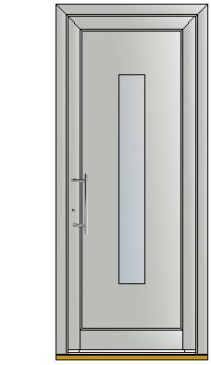 |  |  | element width: 1000mm, element height: 2300mm,  frame system: Door frame Kanto, colour inside: Traffic white RAL 9016 matt (M916), outside: Signal grey RAL7004 matt (HM704),  Glass characteristics: Spacer: Aluminium, Coating: Light, obscure glass: Satinato white,  door sash: Opening direction: left, Hardware: multi-lock, installation for sash: Model E without alunox glass surround (BAE1), glass: double 24mm coated obscured glass 4btoughened/16Ar/#4toughened (2RK),  operation: handle outside: bar handle stainless steel HS11 (HS10), Cylinder ring PR21 stainless steel (PR21), handle inside: handle GD15 stainless steel (GD15), stainless steel key hole cover plate (MR13), cylinder: AZ profile 50/35 keyed to differ (ZA9BV), hinges: 3,

D1W | 1,00 | Pcs. | Passion Kanto Design 1-piece
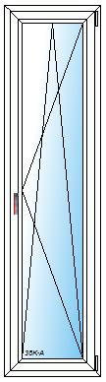 |  |  | Home Pure / UPVC aluminium window KF200  frame width: 600mm, frame height: 2300mm,  frame system: normal frame,  frame colour inside: White (W),  internal sash design chamfered version (glass bead and striking plate),  installation type adjusted for wall anchor hardware,  installation height: altitude up to 900 m,  CF sash 1:  Hardware: tilt-turn door sash exp., Opening direction: right, handle height from sash bottom bead: 1070mm,  colour inside: White (W),  installation for sash: triple 40mm coated clear glass 4b/14Ar/4/14Ar/b4 (38K, 0,6W/m².K),  Uw value (EN ISO 12567 / EN ISO 10077): 0,96 W/(m².K),  Warning:  Take note of regional effective regulations for the application of safety glass!

280 | 1,00 | Pcs. | Passion Kanto Design 1-piece fix
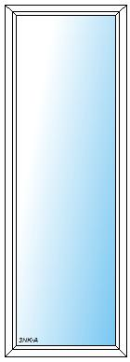 |  |  | UPVC aluminium window KF200  frame width: 800mm, frame height: 2300mm,  frame system: normal frame,  internal sash design chamfered version (glass bead and striking plate),  installation type adjusted for wall anchor hardware,  installation height: altitude up to 900 m,  fixed part 1:

SL1 | 1,00 | Pcs. | Lift-slide door 2 pieces right
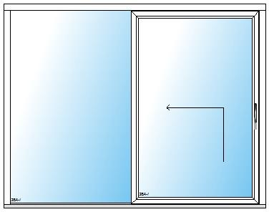 |  |  | system: KS430, frame width: 3200mm, frame height: 2500mm,  frame system: normal frame, vertical division: vertical division 2-piece sym.1/1 fr.,  frame colour inside: Edelweiss (EW), outside: Signal grey RAL7004 matt (HM704),  installation type predrilled f. screw hardware 3-sided,  Glass characteristics: Spacer: ISO, Coating: Light, installation height: altitude up to 900 m, transport: Special transport (SONDER),  fixed part 1:  colour inside: Edelweiss (EW), outside: Signal grey RAL7004 matt (HM704),  installation for sash: triple 48mm coated clear glass 6btoughened/16Ar/5/15Ar/b6toughened (36A, 0,6W/m².K, 37dB),  door sash profile 2:  Hardware: lifting/sliding door (HST), Opening direction: right,  colour inside: Edelweiss (EW), outside: Signal grey RAL7004 matt (HM704),  installation for sash: triple 48mm coated clear glass 6btoughened/16Ar/5/15Ar/b6toughened (36A, 0,6W/m².K, 37dB),  accessories fitting: small external pull handle: 36413, designer handle inside: 36412,  Extras frame: glazing seal outside: black,  dB value (EN ISO 717-1): 33 dB,  Uw value (EN ISO 12567 / EN ISO 10077): 0,73 W/(m².K),  Warning:  Take note of regional effective regulations for the application of safety glass!  Only special transport is available for this size! Clarify transport costs!  At least one glass weight amounts to 155 kg. Please ensure that you have sufficient loading staff. The delivery state is "before unloading".  Please ensure that careful unloading can be guaranteed. (Storage, occupational safety, loading staff, etc.).

________________________
Sub total € 23,813.98
________________________
Sub total € 23,813.98
13,50 % VAT € 3,214.88
________________________
SUM total € 27,028.86
============

We would like to thank you for your enquiry

