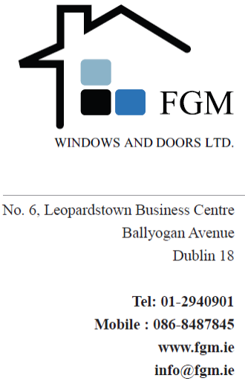

Att: Ken McCullagh

Date: 27th April 2016
REF: FGM-01-20-15D
Re: House at Clonlea Lodge

Thank you for your recent enquiry and we have pleasure in enclosing our quotation for the Supply and Installation of triple glazed Aluwood External Windows and Doors for the above project to the sum of:

- W20-24 and D04: Supply and Installation: €4,050 (Excluding VAT)

- Remaining Units: Supply and Installation: €27,745 (Excluding VAT)

Our quotation is based on the following information:
Our letter dated 27.04.2015 including attached Product Data Sheet.
Drawings: as per your drawings received on 21.04.2015

Specification:

- IdealCombi “Futura+” composite Aluminium / Wood system generally to windows and doors, 50 x 149mm frame with finger joints, incorporating our standard ironmongery.

- IdealCombi “Nation” composite Aluminium / Wood system generally to windows and doors, 50 x 122mm frame with finger joints, incorporating our standard ironmongery.

- Glass: Provision of our Low E coated and argon gas filled standard double glazing units. Laminated and/or toughened glass to be provided where indicated on the drawings and/or in doors/next to doors and below 800mm from FFL.

- Specialist Glazing: We have allowed Matt Laminated glass to Bathroom.

- Ironmongery: The following non standard ironmongery is available at an extra over cost:
Trickle Vents;
Restrictors;
Key lockable handles to windows.

- Colour: Externally to one of our standard RAL colours. Internally to one of our standard RAL colours or clear lacquer. Metallic paint is available at an extra cost.

- We have excluded from our price the provision of secondary steelwork. It has been assumed that the external walls/structure will provide direct bearing for the fixing of our units.

- Powder coated aluminium cills are excluded.

- Flashings generally: Excluded. Internal pine claddings are excluded.

- Roof lights: Excluded.

- Mastic sealing included.

Exclusions
Secondary steel: We have assumed that the building fabric will provide support to all side of our units for direct fixings and that no secondary steel other than standard fixing straps will be required. In regard to glazed elements we have not allowed for any secondary steelwork that may be required between/behind our units for structural stability and/or in order to comply with wind loading requirements. On receipt of further information in relation to the relevant wind loadings on structure we can progress design and advise on associated costs of this design.

Specific Conditions:

Our price is based on the understanding that:
- Delivery will be on a 40’ truck for offloading by others. A HiAb truck which will crane the units on to the ground can be arranged at extra cost.
- Scaffolding, where required, will be supplied by the Customer / Builder.
- Removal of existing/disposal units and making good of opes – by others.
- Protection of windows and doors after installation is not included.

Price:

- Excludes VAT.
- Excludes MCD.
- From the information provided we have ascertained sizes, configurations and quantities of units and enclose a breakdown of the units included within our quotation.
We would ask that you verify that our understanding of the information provided is
correct, as any adjustments thereto will constitute a variation to our quotation.
4. Prices are held firm for 2 months from date of Quotation.

Payment Terms:

- 50% deposit to be paid on placing of order.
- 50% due to be paid on delivery of goods to site.
- Orders for less than €5000 – 100% payment on placing of order.

Retention of Title: Goods remain in the ownership of FGM Window and Doors Limited until payment has been received in full.
The above quotation is subject to our Standard Terms and Conditions, a copy of which is available upon request. Acceptance of our quotation is deemed to include acceptance of our Standard Terms and Conditions.

We thank you for the opportunity of quoting your project and if you require any further information please contact us.

Yours faithfully

Finbar Lannin
Managing Director
FGM Windows and Doors Ltd
Tel: 01-2940901/086-8487845.
Web: www.fgm.ie

