Ken Merrell Website & CRM Guide
Welcome to the Ken Merrell author platform. This guide explains how to manage your books, read reviews, and update the website content using the built-in Content Management System (CRM).

1. The Books Section
Where it appears on the live website: Books are featured prominently on the homepage and have their own dedicated detail pages. The cover image, banner image, formats, ISBN, and direct purchase links (Amazon/Audible) are displayed to visitors.

How to edit in the CRM: Navigate to the 'Books' tab on the left sidebar. Click 'Add a Book' or click an existing book to edit it.
• Use the toggles to set if it is 'Available' or 'Coming Soon', feature it in the homepage banner, or show the 'NEW' ribbon.
• Upload your cover and optional wide banner.
• Paste your Amazon and Audible links so readers can click to buy.

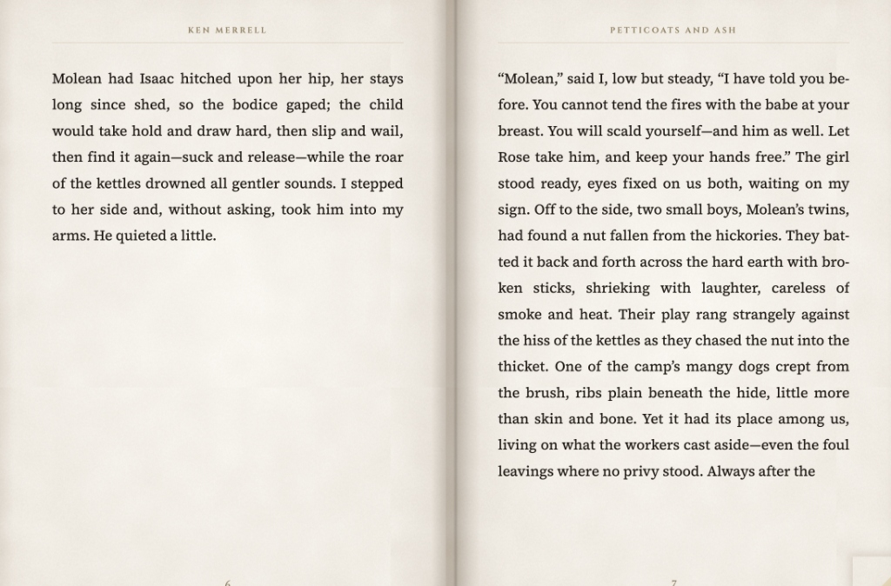

2. The 3D Flipbook Sample Chapters
Where it appears on the live website: On every book's detail page, visitors can open an interactive 3D Flipbook reader to read a free sample chapter.

How to edit in the CRM: In the 'Books' tab, while editing a book, scroll down to the 'Sample Chapter' section.
• You can directly upload a Word document (.docx), PDF file (.pdf), or Text file (.txt).
• Alternatively, you can paste the text directly into the box.
• The system automatically packs the text to fit exactly 16 lines per page perfectly.

[ Image not found: C:/Users/Yasir/.gemini/antigravity-ide/brain/64175491-e72d-4e10-8eed-4935cb5d96b7/.user_uploaded/media_1791389086695.png ]

3. Reader Reviews & Professional Praise
Where it appears on the live website: Towards the bottom of each book's detail page, there is a 'What readers are saying' section displaying professional reviewer quotes and 5-star cards from actual readers.

[ Image not found: C:/Users/Yasir/.gemini/antigravity-ide/brain/64175491-e72d-4e10-8eed-4935cb5d96b7/.user_uploaded/media_1791389089852.png ]

How to edit in the CRM: In the 'Books' tab, while editing a book, scroll to the 'Details & praise' and 'Reader Reviews' sections.
• Quotes: Add up to three professional reviewer quotes. These are displayed directly under the book formats.
• Reader Reviews: When a reader submits a review on the live site, it will appear here in the CRM. You can review them, approve them, or delete them.

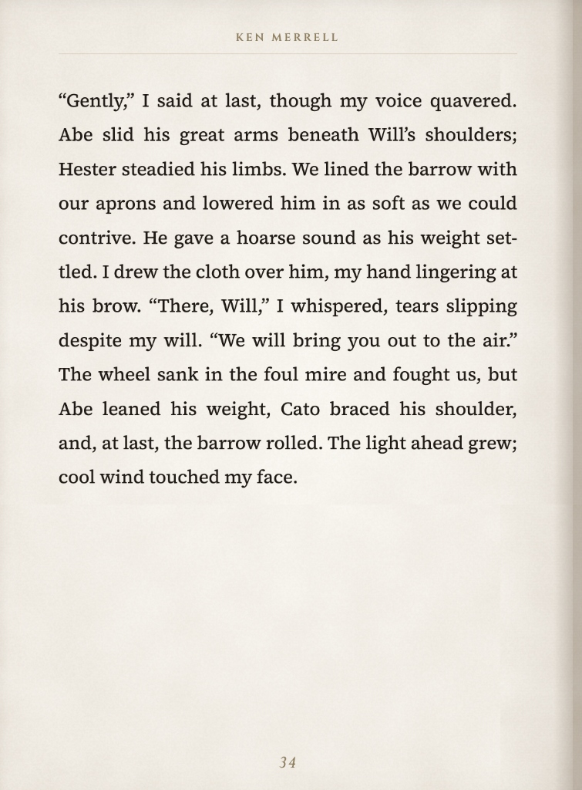

4. The About Section (Author & Bio)
Where it appears on the live website: This controls the large 'About Ken' section, the Author Photo, the sweeping quote carousel on the homepage, and the social/external links.

How to edit in the CRM: Navigate to the 'Author & bio' tab on the left sidebar.
• Author Photo: Upload your professional headshot.
• About Ken: Edit the short 'Pull Quote' and the longer 'Bio' text.
• Homepage quotes: Add up to 6 quotes that sweep automatically under the homepage banner.

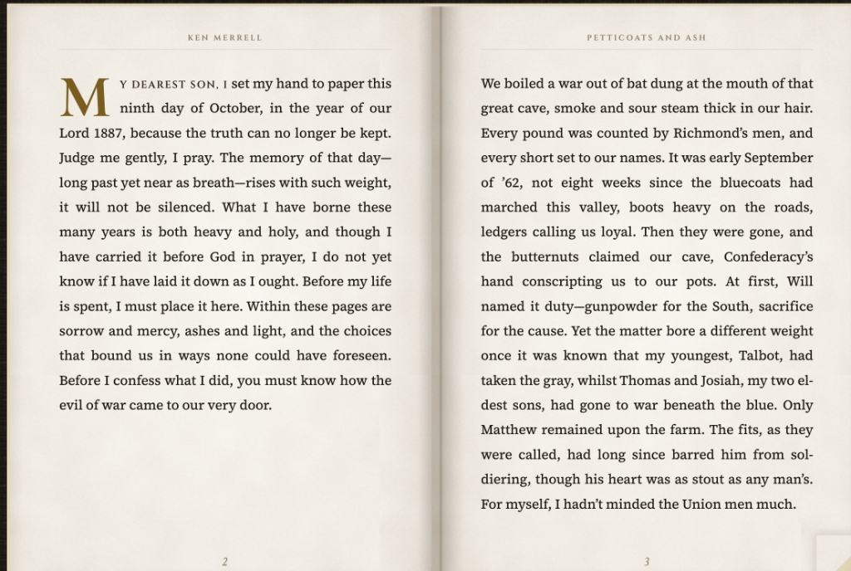

5. Publishing Changes
Whenever you make changes anywhere in the CRM, look for the green 'Save Changes' button (usually at the top right or bottom).
• Click this button to instantly push your changes to the live website.
• If you visit the website and don't immediately see your changes, perform a 'Hard Refresh' in your browser (Ctrl+F5 on Windows, or Cmd+Shift+R on Mac) to clear your local browser cache.

