**COMMCURIOSITY. Communication Curiosity.July 2016**

# Table of Contents

Table of Contents i

List of Figures ii

1.0. Introduction 1

1.1. Purpose 1

1.2. Scope of Project 1

1.3. Glossary 2

1.4. References 2

1.5. Overview of Document 2

2.0. Overall Description 4

2.1 System Environment 4

2.3 User Characteristics 15

2.4 Non-Functional Requirements 15

3.0. Requirements Specification 17

3.1 External Interface Requirements 17

3.2 Functional Requirements 17

# List of Figures

# Chapter 1. Introduction

## Purpose

The purpose of this document is to present a detailed description of **COMMCURIOSITY of the Department of Communications, Linguistics, and Literature.** It will explain the purpose and features of the system, the interfaces of the system, what the system will do, the constraints under which it must operate and how the system will react to external stimuli. This document is intended for both the stakeholders and the developers of the system.

## Scope of the Project

This software system will be a **COMMCURIOSITY of the Department of Communications, Linguistics, and Literature**. The website application will support the need of the faculties and staff of the said department.

There are administrator(s) of the system and their tasks is to provide information so that the client can easily find preferred houses.

## Glossary

## References

EEE. IEEE Std 830-1998 IEEE Recommended Practice for Software Requirements Specifications. IEEE Computer Society, 1998.

## Overview of the Document

The next chapter, the Overall Description section, of this document gives an overview of the functionality of the product. It describes the informal requirements and is used to establish a context for the technical requirements specification in the next chapter.

The third chapter, Requirements Specification section, of this document is written primarily for the developers and describes in technical terms the details of the functionality of the product.

Both sections of the document describe the same software product in its entirety, but are intended for different audiences and thus use different language.

# Chapter 2. Overall Description

## System Environment

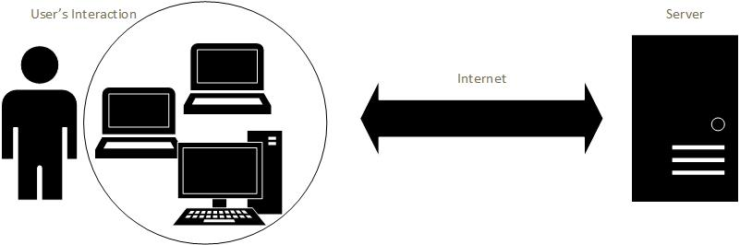

**COMMCURIOSITY’S** system environment composes of the interaction of the users through laptops, desktop computers. The system the uses the specified web browsers such as **Google Chrome and Mozilla Firefox** due to the usability and easy access for the users.

**The developers are not responsible for any bugs found in other web browsers.**

## Functional Requirement Specification

## Users Characteristics

## Nonfunctional Requirements

# Chapter 3. Requirements Specification

## External Interface Requirements

### User Interface

This section we defined the designs of each functionalities and contents of the website named Communication Curiosity. The content of this section is agreed by the developer and the owner of the website.

### Homepage

#### Header



Communication Curiosity. It’s not just what you say it, but how you say it.

* **Main Menus**. The color of active link will be #bf168a (Magenta) and inactive links will be #224144. Line bar will be displayed in every active link.
* Home
* Blogs
* Community Stories
* Literary
* Events
* About Us
* **Search Option**. The search option will help the user(s) to easily find articles of the entire sites.
* **Drop Bar**. The drop bar will display the login page. The background color of drop barwill be #224144 the same to the color of the logo and inactive main menus.

#### Slider

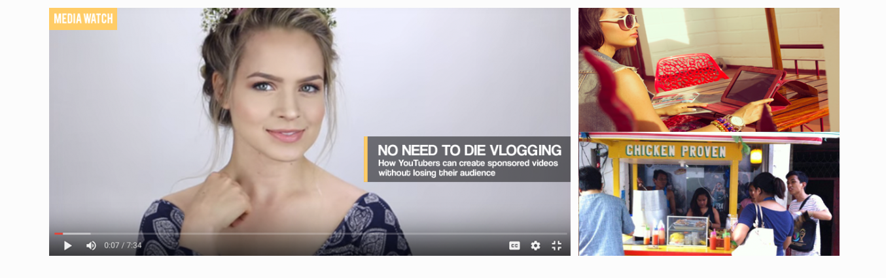

* **Left Side: Latest Posts.** Latest posts are reviewed articles with the approval of the admin of the website. The slider will limit up to 5 slides. Each slide has 5 seconds before it changes to another slide. The slider will pause if the user points the mouse on the current slide. If the user clicks the content or title, then it will redirect to read content page. Category Link for example the MEDIA WATCH with orange background redirects to the categories such as:
  + **MEDIA WATCH**
  + **COMMUNITY STORIES**
  + **SAY IT RIGHT**
  + **STUDENT SURVIVAL**
* **Right Side: Featured Articles.** Reviewed Articles which has featured status. Only two featured articles will be placed at the same time. Featured articles design is not a slider.

#### Sections­

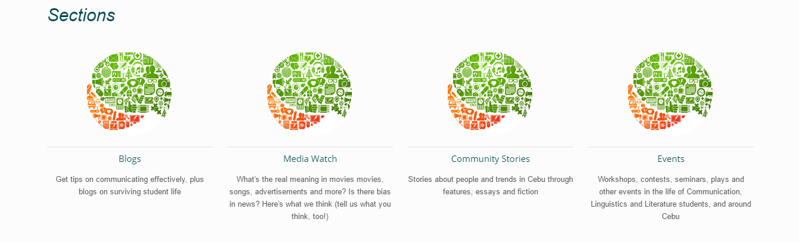

Each picture is a link to its category.

#### Latest Posts

#### Footer

### Database

## Functional Requirements

## Detailed Nonfunctional Requirements

## Security

# Appendices