Makenna Gunter

Project Proposal

CIT 230: Section 2

Website Plan

**Description**

I will be designing a website for my dad’s business, Gunter Exteriors Inc.

**Project Purpose**

I will be doing my website for my dad’s business, Gunter Exteriors Inc, This website will provide information about the business, what services they provide, ways to contact them, pictures of their current and finished projects, how to schedule a bid and much more.

**The Audience**

The audience will most likely pertain to homeowners who are looking to upgrade the exterior of their home or need repairs to their windows, roofs, gutters, and most of all siding. The audience looking at this page could also be contractors who are looking for someone to complete multiple projects for them. The audience will be needing to see what services they can offer and if they do good quality work on their projects. They will also want to know an estimate of prices and also how long that the projects can take.

**Web Pages**

For my website I will use 5 pages;

* **Home page:** This page will basically just provide an overview of the business and what they are all about. It will also provide info for other pages on the site and easy navigation to them. This site will contain a video about the company.
* **Services Page:** This page will tell about all the services they offer, such as siding, roofing, gutters, windows, and repairs. It will also provide info about how long the process takes.
* **Product Page:** This page will basically just show the different products they use and that you can choose from. Every service that is offered, has different materials that can be used to provide a different look, for example you can choose vinyl siding, or smart side siding. This page will include the JSON.
* **Project Page:** This site will basically just have images of current and finished projects, maybe even before and after pictures. And a little description of the process and styles used.
* **Contact Page:**  This page will include information on how to set up a bid, all the contact information for the business.

**Wireframe Sketches**

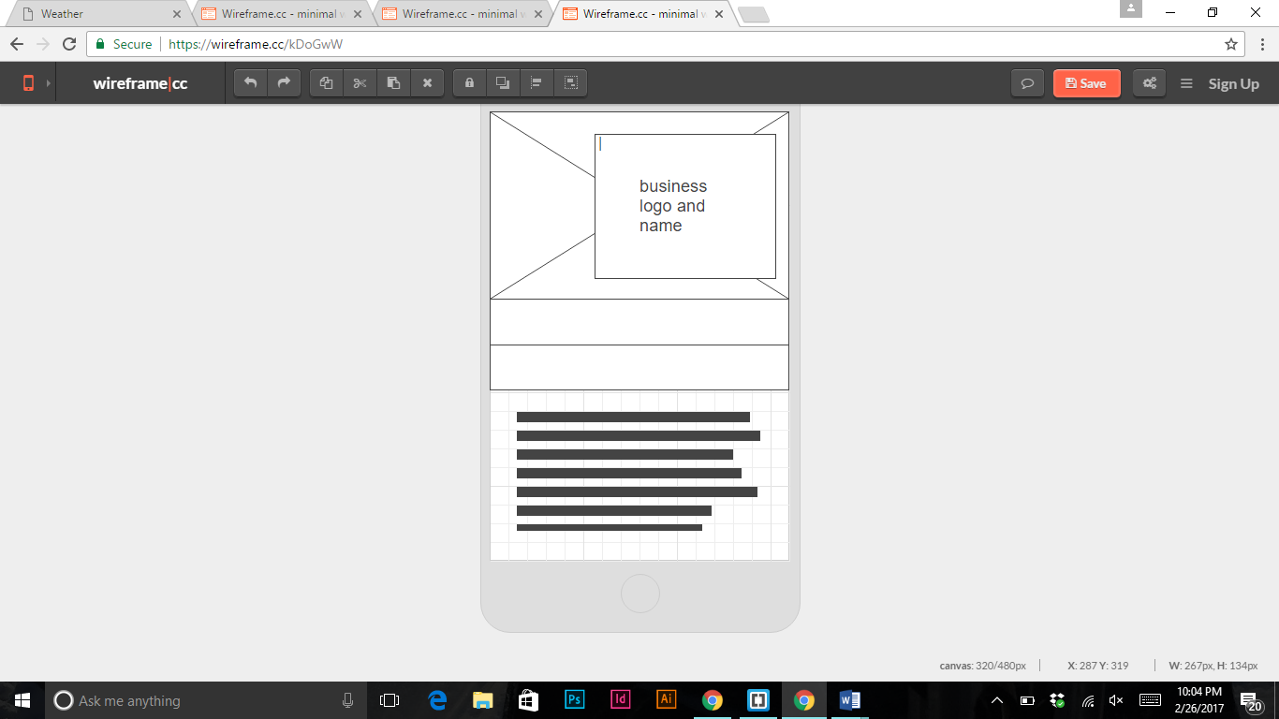

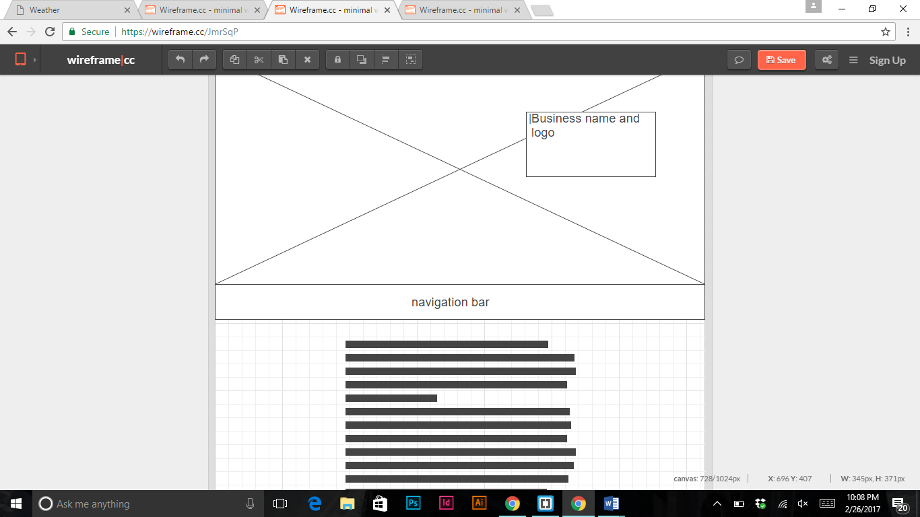

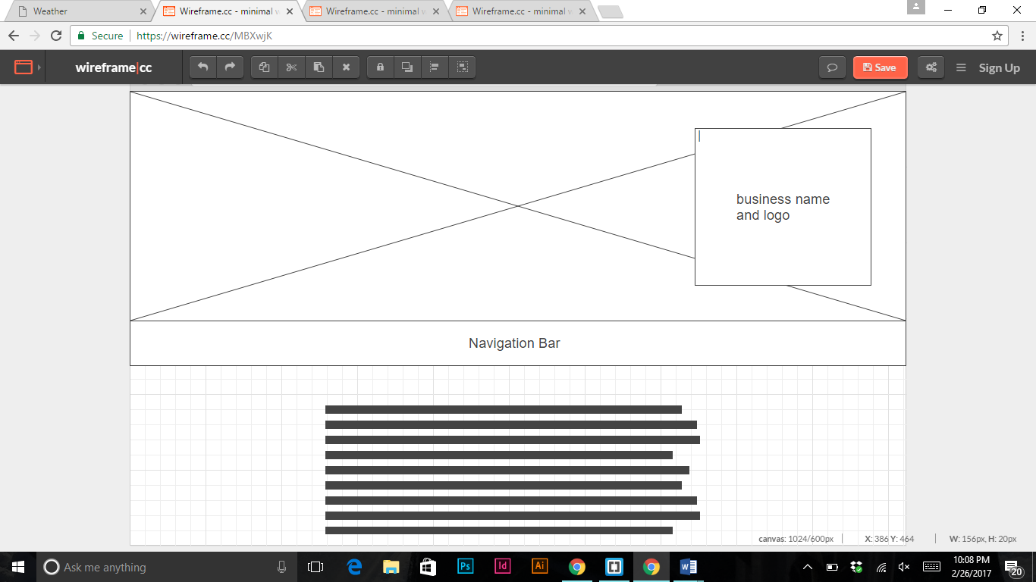

Another wireframe for resubmission.

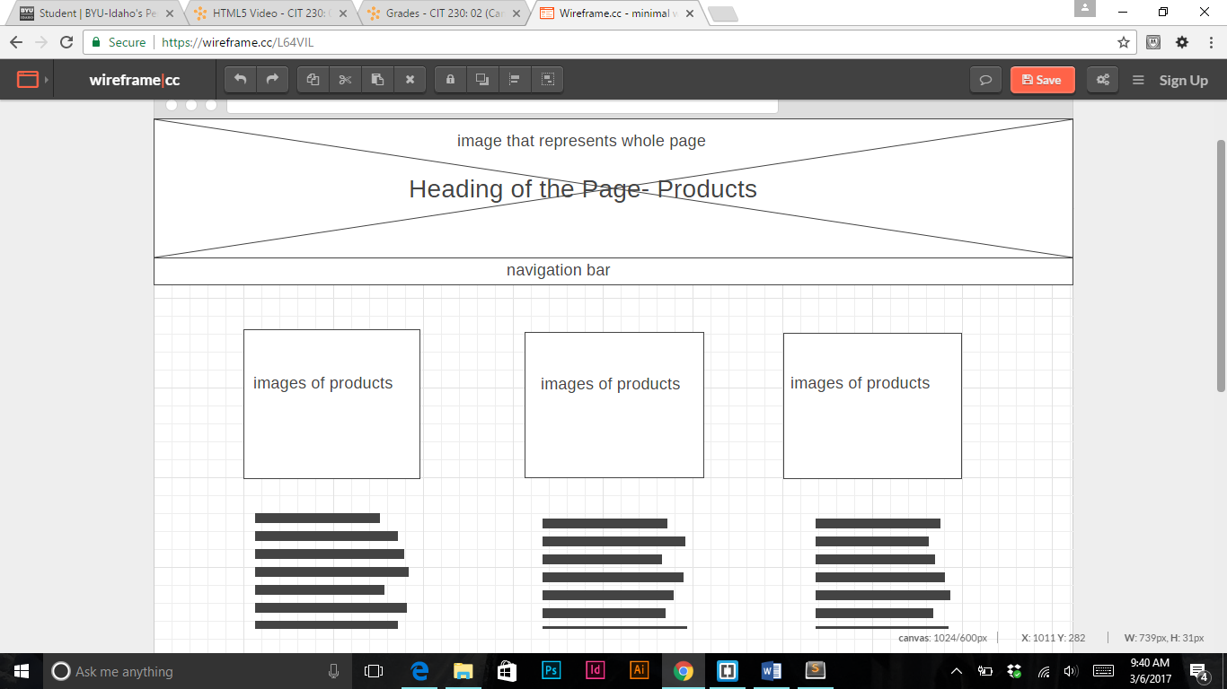

**Usability Concepts**

I definitely want the site to have a very user friendly mobile site, that anyone can look at on the go. I will use media queries to do that, when the page gets smaller I will make the navigation bar in a column, and I also want the images to transfer to a column too, and the information to transform with it.I also will modularize so that I make my page repetitious but in an easy way. I will use a json to put a lot of the description information along with prices.