**Proposal for Research for a Comparison of Selling Goods on eBay versus Amazon**

Prepared by Tate Kennedy on June 24, 2018

INTRODUCTION

In 2014, a husband and wife team started a home-based business as a way to generate secondary income from profits earned by buying and re-selling items online. The couple started their venture by selling any products they believed they could earn a profit. In addition, the couple sold exclusively online through eBay. The visual below captures the couple’s profits between Q1 2014 and Q2 2016 amongst the various product categories they sold in:

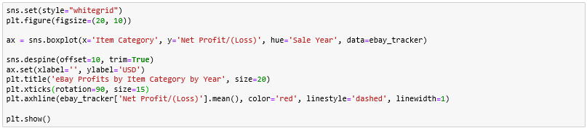

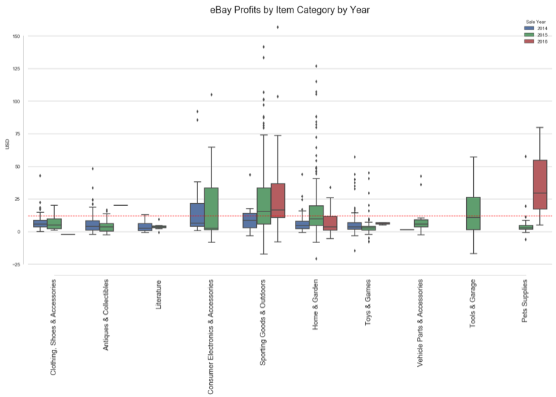

BACKGROUND / PROBLEM STATEMENT

After a two year hiatus, the couple is ready to re-start their home-based online re-sell business. Part of their business plan is to address or improve upon what they considered to be a low average profit line. Throughout their previous experience, the couple averaged $12.14 in profits on all items sold.

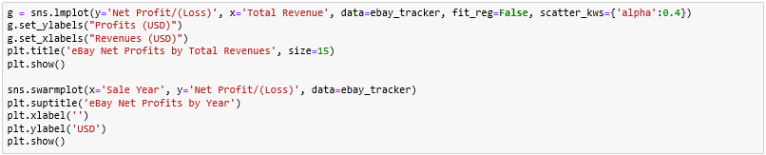

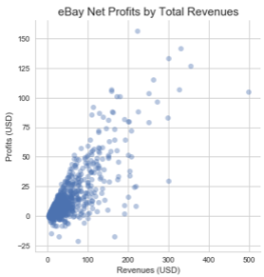 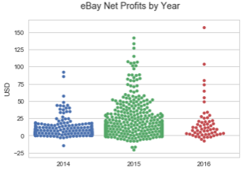

The couple’s focus going into this next phase of their online re-sell business is to use their time and resources more efficiently and effectively to drive higher profit lines. Thus, the couple has decided to focus their items for sale on product categories that experienced higher average profits such as Consumer Electronics and Outdoor Sporting Goods.



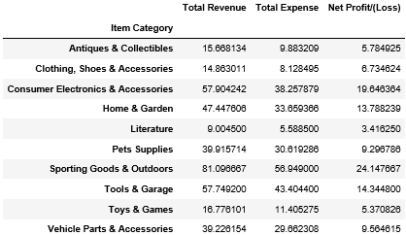

RESEARCH EXPERIMENT / HYPOTHESIS

In addition to narrowing their product catalog to help drive higher net profits, the couple is also considering whether or not they should change from the online platform in which they sell their goods. The couple believes that selling their items on Amazon will produce higher net profits than what they achieve on eBay.

RESEARCH DESIGN

The couple will list items for sale on Amazon and eBay within each product category they intend to concentrate their business. The variable of interest, or key metric, will be the net profit of items sold on Amazon as compared to items sold on eBay. This will be an A/B experiment or test where items are sold either on eBay, as they couple has been, or on Amazon, as the couple is proposing.

Because the couple typically sells more than one of a product, the products listed will be the same for each site allowing for an exact comparison. For example, if the couple lists a Thule 815 Kayak Cradle on eBay they will list the same product on Amazon. This will allow us to eliminate potential for sampling or selection bias as the populations will be replicated on each platform.

Items will be sold on each platform during the same time period. This will avoid potential timing conflicts that can arise from selling one population of products during a peak shopping period, such as Black Friday, while the other population does not share the same experience.

We will track the net profits for each item sold over a two month period as items on eBay can be listed in either 3, 5 or 7 day auction windows. Since we cannot control how many of each product is sold on either platform, we will compute the average net profit for each product type and the average net profit for all items sold.

If average net profits from items sold on Amazon exceed that of items sold on eBay (for both individual product types and all items sold) by 10%, we will conclude that Amazon produces higher net profits and the couple will transition their business to selling on Amazon exclusively. If average net profits exceeds 10% for only certain products but is less than 10% for all products, we will continue the experiment for one additional month before reaching a conclusion. If average net profits for items sold on Amazon does not exceed that of items sold on eBay, the couple will continue to run their business using eBay as their exclusive selling platform.

EVALUATION PLAN

Upon completion of the experiment or study, we will collect the following pieces of information:

1. The means of each population, items that sold on eBay and items that sold on Amazon, in terms of net profits;
2. The standard deviations of each population, items that sold on eBay and items that sold on Amazon, in terms of net profits;
3. The size of each population, items that sold on eBay and items that sold on Amazon;

Using the measurements captured above we will calculate the t-test to attain the t-value to determine if the difference between these averages are meaningful. Will the couples experience on Amazon, as it pertains to profits, really be different than that of eBay?

And finally, we will calculate the p-value as the culmination of testing the couple’s hypothesis. In our case, since there are only two possible outcomes, either selling on Amazon will be more profitable (the hypothesis) or selling on Amazon will not be more profitable (the null hypothesis), we can use the p-value to conclude whether our hypothesis is acceptable because the p-value leads us to reject the null hypothesis.

OTHER OBSERVATIONS

It is important to note there are two other outcomes that can be measured through this experiment:

1. We will be able to calculate the volume of items sold between the two platforms which compliments the opportunity for increased profits;
2. We will also be able to measure the impact in the difference in seller fees between the two platforms and how that detracts from the couple’s hopes for increased profits on Amazon;