Supplemental Materials for: English-hearing toddlers learn words from consistent and variable labels

Kennedy Casey and Casey Lew-Williams
Department of Psychology, Princeton University

Author Note
Kennedy Casey https://orcid.org/0000-0001-5326-3080
Casey Lew-Williams https://orcid.org/0000-0002-8781-4458
Correspondence concerning this article should be addressed to Kennedy Casey, Department of Psychology, Princeton University, 40 Woodlands Way, Princeton, NJ 08544, Email: kcasey@princeton.edu

Supplemental Materials for: English-hearing toddlers learn words from consistent and variable labels

Results

Word recognition measured by gaze behavior
Our primary analysis examined whether children successfully learned novel-word object mappings across conditions. Using the brms package (Bürkner, 2017), we fit mixed-effects zero-one inflated beta regression models to examine the effects of condition and age on children’s novel word-recognition accuracy (i.e., proportion looking to the target object). Models included fixed effects for condition (atypical variation vs. consistent vs. typical variation) and mean-centered age, along with the maximal random effects structure (by-participant and by-item random slopes and intercepts). We used weakly informative priors (standard normal distributions) and fitted the model using Hamiltonian Monte Carlo sampling (four chains, four cores) implemented in Stan (Stan Development Team, 2025). All $\hat{R}$ values were 1.00, indicating good convergence. Effective sample sizes (Bulk ESS: 614–6,520; Tail ESS: 999–3,586) were sufficiently large, indicating stable and reliable posterior estimates.
Children’s performance was reliably above chance overall as well as in both critical windows across all conditions, except for the first critical window—the primary target of analysis in the vast majority of LWL studies (e.g., Fernald et al., 2008)—for the atypical variation condition, where children’s looking behavior was at chance level (M=0.54, 89% CrI [0.48, 0.60]). Across both critical windows, model-predicted accuracy was highest in the typical variation condition (M=0.62, 89% CrI [0.57, 0.67]), followed by the consistent condition (M=0.57, 89% CrI [0.52, 0.63]), and lowest in the atypical variation condition (M=0.56, 89% CrI [0.51, 0.61]). Figure 1 shows model-predicted accuracy across conditions for the two critical windows. Table 2 shows all model parameter estimates for fixed effects, and below, we break down the key results that are of theoretical interest.
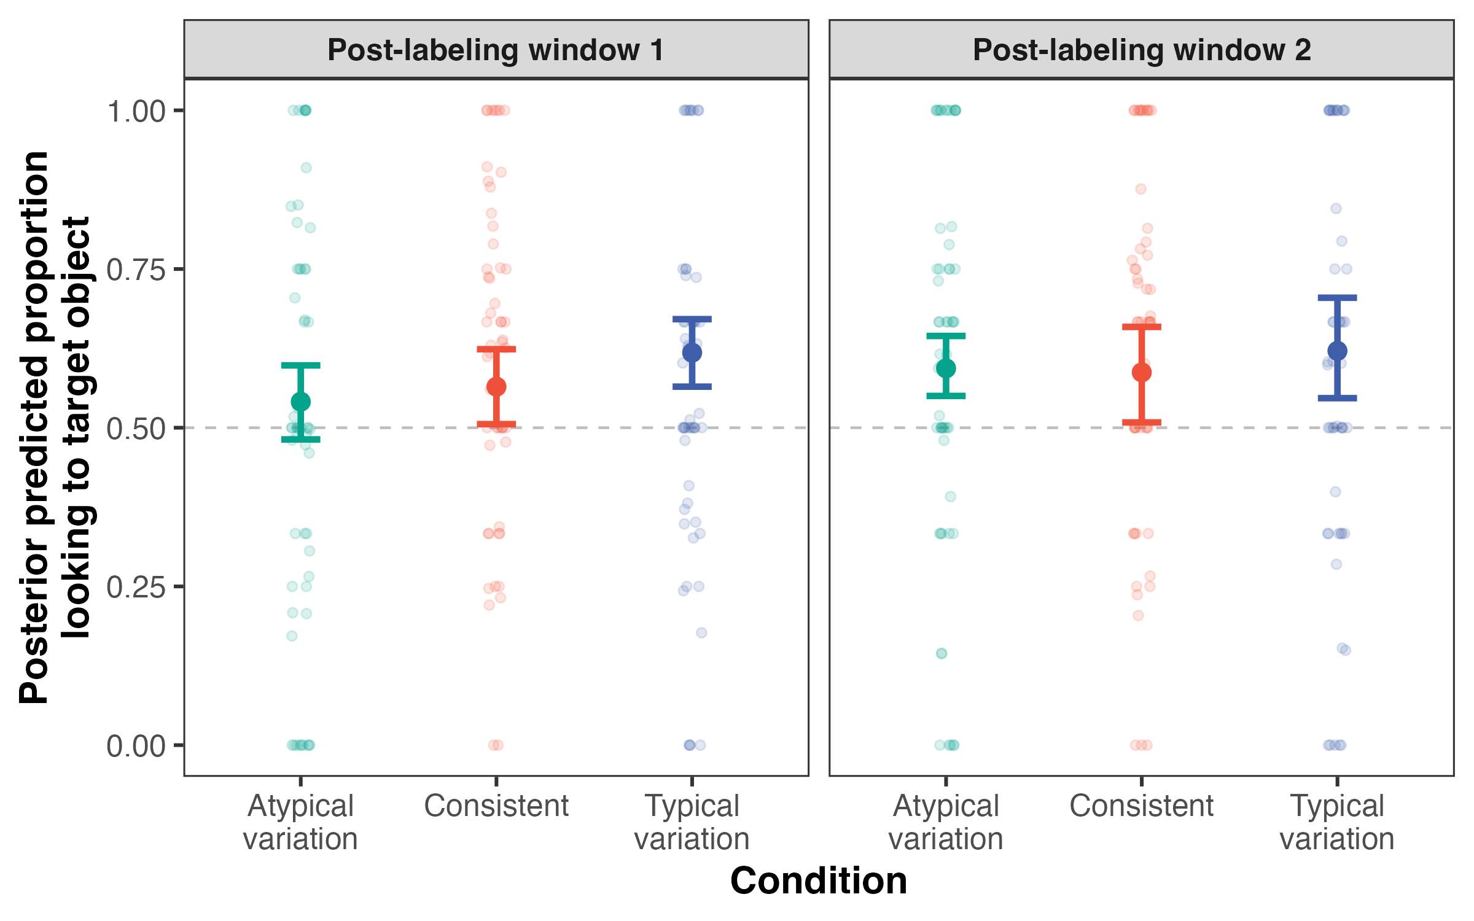
Figure 1. Posterior predicted accuracy by condition across both post-labeling time windows. Point ranges reflect posterior means with 89% credible intervals. Jittered dots show raw means for individual participants. Dotted line at 0.5 indicates chance looking.
The beta ($μ$) component of the model, which estimates effects on the mean outcome for non-boundary values (i.e., proportions between but not including 0 or 1), showed positive effects for both the typical variation condition (β=0.07, 89% CrI: [-0.19, 0.32]) and the consistent condition (β=0.18, 89% CrI: [-0.04, 0.40]), relative to the atypical variation condition. Although the credible intervals include zero, the direction and magnitude of these effects suggest a possible learning advantage for both typical variation and consistency over atypical variation. The effect of mean-centered age was negligible (β=0.08, 89% CrI: [-0.03, 0.19]).
The conditional one-inflation (coi) component, which estimates, among boundary values, the probability of being 1 (vs. 0), also showed similar trends for the effect of condition. Participants were more likely to respond at ceiling for both the typical variation condition (β=0.06, 89% CrI: [-0.36, 0.48]) and consistent condition (β=0.33, 89% CrI: [-0.11, 0.78]), relative to the atypical variation condition. While these condition effects remain uncertain given the credible interval overlap with zero, their alignment with estimates from the $μ$ component suggests additional evidence for an advantage of both typical variation and consistency over atypical variation. The effect of age was clearly positive (β=0.34, 89% CrI: [0.15, 0.53]), indicating that older children were more likely to demonstrate 100% looking to the target object during the critical analysis windows.
Table 2. Posterior means and 89% credible intervals for each effect across models.
Effect | Overall | Window 1 | Window 2
μ: condition (typical variation) | 0.07 [-0.19, 0.32] | 0.11 [-0.10, 0.31] | -0.13 [-0.39, 0.17]
μ: condition (consistent) | 0.18 [-0.04, 0.40] | 0.12 [-0.07, 0.29] | 0.15 [-0.10, 0.35]
μ: age | 0.08 [-0.03, 0.19] | 0.01 [-0.09, 0.12] | 0.13 [0.01, 0.33]
zoi: condition (typical variation) | -0.21 [-0.56, 0.14] | 0.22 [-0.27, 0.71] | 0.17 [-0.56, 0.93]
zoi: condition (consistent) | -0.31 [-0.65, 0.03] | -0.33 [-0.78, 0.13] | -0.67 [-1.19, -0.11]
zoi: age | -0.33 [-0.48, -0.18] | -0.06 [-0.26, 0.13] | -0.28 [-0.48, -0.11]
coi: condition (typical variation) | 0.06 [-0.36, 0.48] | 0.09 [-0.32, 0.50] | -0.02 [-0.35, 0.33]
coi: condition (consistent) | 0.33 [-0.11, 0.78] | 0.40 [-0.02, 0.81] | 0.15 [-0.29, 0.53]
coi: age | 0.34 [0.15, 0.53] | 0.40 [0.23, 0.57] | 0.12 [-0.07, 0.25]
Note. The overall model includes both post-labeling windows (averaged accuracy) and the window-specific models include proportion estimates for 300–2,000ms following each target word onset. The μ component models the predicted accuracy (i.e., proportion looking to the target object) for non-boundary values (values between but not including 0 or 1). The zoi (zero-one inflation) component models the likelihood of accuracy being a boundary value—floor (0) or ceiling (1). The coi (conditional-one inflation) component models the probability of ceiling responses (1s) among boundary values.

We fit a Bayesian zero-one inflated beta regression model (Liu & Eugenio, 2018) to examine the effects of input condition and age on children’s accuracy of novel word recognition (i.e., proportion looking to the target object), using the brms package (Bürkner, 2017). The model included fixed effects for condition (atypical variation vs. typical variation vs. consistent) and mean-centered age, along with the maximal random effects structure (by-participant and by-item random slopes and intercepts). All R-hat values were 1.00, indicating good convergence. Effective sample sizes (Bulk ESS: 614–6520; Tail ESS: 999–3586) were sufficiently large, indicating stable and reliable posterior estimates.
Following our pre-registered analysis plan, we tested whether including an interaction between condition and age improved model fit—we compared the model with the interaction term to the simpler additive model using approximate leave-one-out cross-validation (Yao et al., 2017). This analysis suggested no reliable difference in predictive accuracy, providing no strong evidence that the interaction term improved model fit (ΔELPD = -1.35, ΔSE = 3.53).
The beta component of the model, which estimates the effects on the mean outcome for non-boundary outcomes (i.e., values between but not including 0 or 1) showed small positive effects for both the natural variation condition (β = 0.07, 89% CrI: [-0.19, 0.32]) and the consistent condition (β = 0.18, 89% CrI: [-0.04, 0.40]), relative to the unnatural variation condition. Given that the credible intervals include zero, the results do not provide strong evidence for a condition effect. The effect of centered age was negligible (β = 0.08, 89% CrI: [-0.03, 0.19])
The conditional one-inflation (coi) component, which predicts—among zero/one responses—the probability of being 1 (vs. 0), also showed similar trends for condition. The effect of the typical variation condition relative to atypical variation was weakly positive, and the credible intervals include zero (β = 0.06, 89% CrI: [-0.36, 0.48]). The effect of the stable condition relative to the atypical variation condition was stronger but still uncertain given the credible interval overlap with zero. (β = 0.33, 89% CrI: [-0.11, 0.78]). The effect of age was clearly positive (β = 0.34, 89% CrI: [0.15, 0.53]), indicating that older children were more likely to perform at ceiling (i.e., demonstrate 100% looking to the target object during the critical analysis window).
Condition effects were weakly positive but uncertain. For the typical variation condition, the estimated effect was 0.105, SD = 0.134, with a 89% credible interval from -0.109 to 0.319. For the consistent condition, the estimate was 0.117, SD = 0.12, 89% CI [-0.075, r round(stable_ub, 3)]. The effect of age was small (0.012, SD = 0.069), 89% CI [-0.099, 0.122].
Posterior probabilities that each effect was greater than zero were: 0.81 for the effect of the typical variation condition (relative to atypical variation condition), 0.86 for the effect of the consistent condition (relative to the atypical variation condition), and 0.56 for the effect of age. These results suggest limited evidence that either input condition or age significantly affected performance, though the posterior distributions for all three predictors leaned slightly positive.
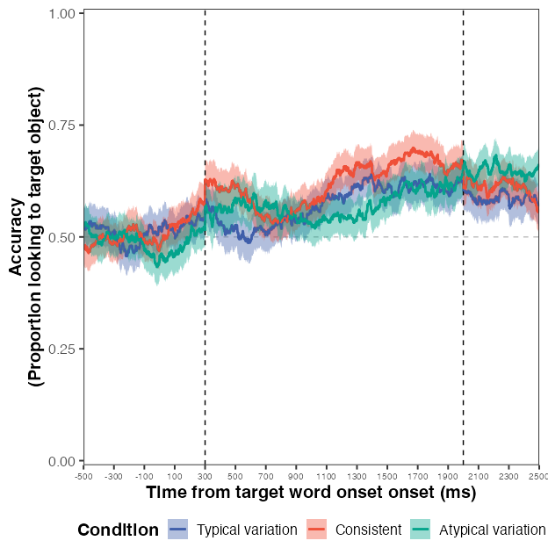
Figure 1: Timecourse of participants’ looks during test trials with shaded standard error regions. The gray dashed line at 0.5 represents chance looking. The black dashed lines indicate the critical analysis window (300-2000ms) following target word onset.

Window effects
In the early time window, there were no strong condition effects. The posterior estimate for the typical variation condition relative to atypical variation was β = 0.11 (89% CrI: [-0.10, 0.31]). Similarly, the consistent condition estimate was β = 0.12 (89% CrI: [-0.07, 0.29]). These effects were small, and their credible intervals included zero.
In the later window, condition effects were descriptively stronger. The estimate for the typical variation condition relative to atypical variation was β = -0.13 (89% CrI: [-0.39, 0.17]), and for the consistent condition: β = 0.15 (89% CrI: [-0.10, 0.35]). Though credible intervals still overlapped zero, the magnitude and direction of the effects in this window were more consistent with our hypotheses.
Our primary analysis examines whether children successfully learned the novel word-object mappings in our experiment and compares performance across three different exposure conditions. We used mixed-effects zero-one-inflated beta regression to model the effects of condition (atypical variation vs. consistent vs. typical variation) on accuracy (proportion looking to the target object relative to the total time looking at either the target or distractor object) during the critical analysis window (300-2000ms following target word onset). Age (scaled) was included as an additional fixed effect. We also included the maximal random effects structure (by-child and by-item intercepts and slopes). Beta regression was chosen to model the proportional dependent variable [CITE]. We used a zero-one-inflated model since 0s and 1s are possible values in our data [CITE]. This particular modeling approach requires a Bayesian framework to interpret.
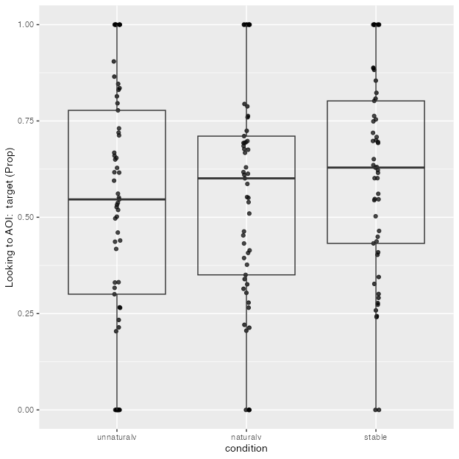
Linear mixed model fit by REML. t-tests use Satterthwaite's method [
lmerModLmerTest]
Formula: Prop ~ condition + age_c + (1 | pid)
Data: response_window_agg_by_sub
REML criterion at convergence: 50.1
Scaled residuals:
Min 1Q Median 3Q Max
-2.53636 -0.56438 0.01679 0.67712 1.88258
Random effects:
Groups Name Variance Std.Dev.
pid (Intercept) 0.02292 0.1514
Residual 0.05492 0.2343
Number of obs: 163, groups: pid, 58
Fixed effects:
Estimate Std. Error df t value Pr(>|t|)
(Intercept) 0.52164 0.03691 137.06732 14.132 < 2e-16 ***
conditionnaturalv 0.03796 0.04500 105.64160 0.843 0.40086
conditionstable 0.08749 0.04500 105.62268 1.944 0.05456 .
age_c 0.07686 0.02746 56.02469 2.799 0.00702 **
---
Signif. codes: 0 '***' 0.001 '**' 0.01 '*' 0.05 '.' 0.1 ' ' 1
Correlation of Fixed Effects:
(Intr) cndtnn cndtns
condtnntrlv -0.583
conditnstbl -0.582 0.477
age_c -0.009 0.016 -0.019
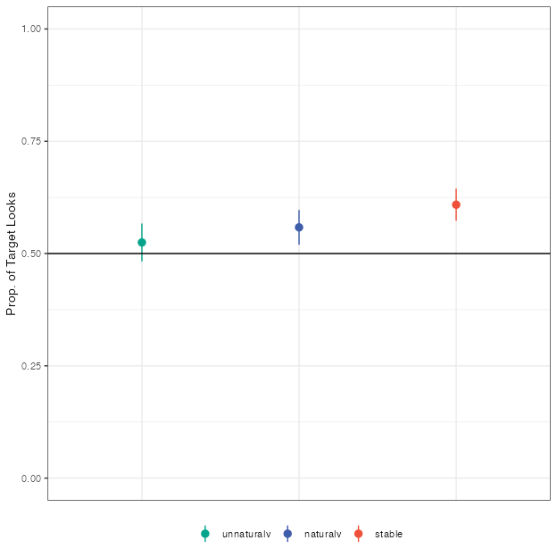
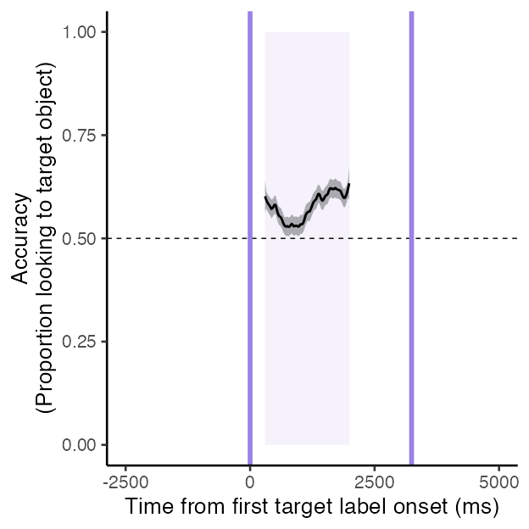
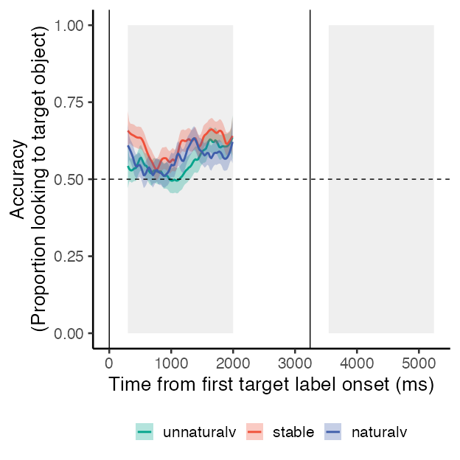
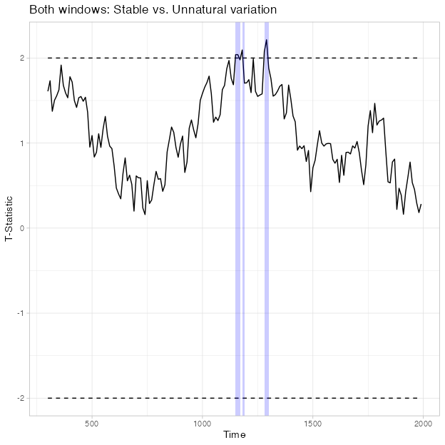

Moment-by-moment attention measured by pupil size synchrony

Comparing pupil size synchrony across conditions
Following Nencheva et al. (2021), we used dynamic time-warping distance [DTW; Tormene et al. (2009)] to quantify the temporal alignment of participants’ pupil responses when hearing individual exposure sentences or words (normalized for duration). This DTW measure quantifies the dissimilarity between two time series of pupil fluctuations. To transform these values into synchrony scores, we subtracted DTW distance scores from the maximum distance between two participants on each trial. To compare pupil size synchrony across conditions, we computed pairwise synchrony scores for all possible pairs of participants (for each exposure sentence or word per condition).
A one-way ANOVA revealed a significant main effect of condition on pupil size synchrony [F(2, 261.1966453) = 4, p = 0.0195].
Follow-up pairwise comparisons using Tukey’s HSD correction indicated that pupil size synchrony was significantly higher in the typical variation condition compared to the atypical variation condition (ΔM = -0.28, p = 0.024, Cohen’s d = -0.37). No other pairwise comparisons were statistically significant (_p_s > 0.05).
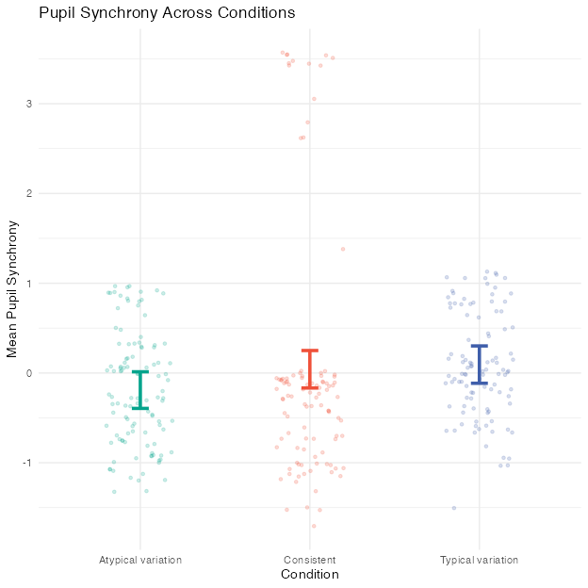
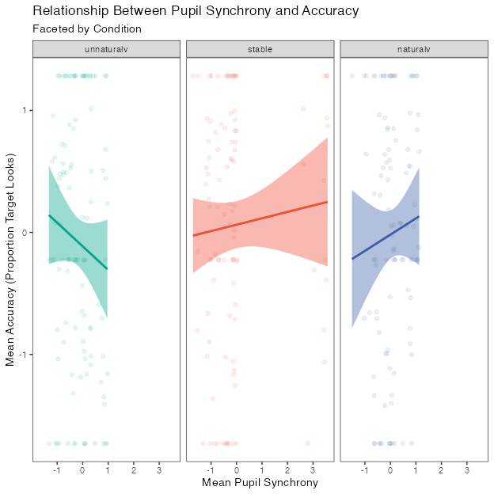
Data: combined_data
Models:
m_null: acc_z ~ condition + (1 | pid)
m_sync: acc_z ~ condition + sync_z + (1 | pid)
npar AIC BIC logLik deviance Chisq Df Pr(>Chisq)
m_null 5 899.94 918.69 -444.97 889.94
m_sync 6 901.76 924.26 -444.88 889.76 0.1821 1 0.6695
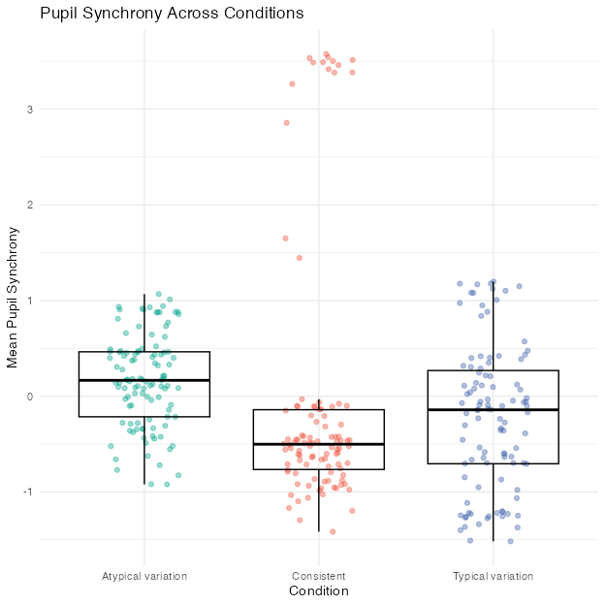
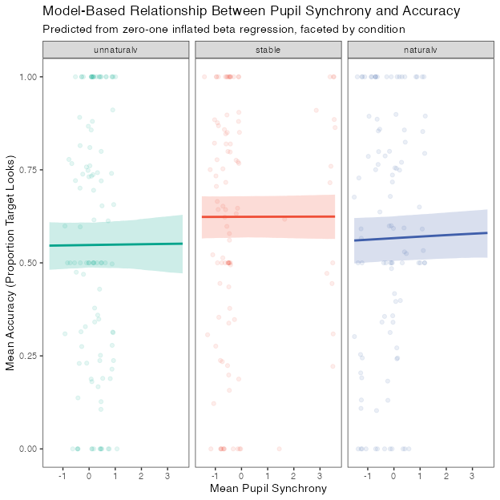
We also examined pupil size synchrony at the word level. A one-way ANOVA revealed a significant main effect of condition on pupil size synchrony [F(2, 314) = 4.43, p = 0.013]. Follow-up pairwise comparisons using Tukey’s HSD correction indicated that, relative to the consistent condition, pupil size synchrony was significantly lower in the atypical variation condition condition (ΔM = 0.21, p = 0.247, Cohen’s d = 0.22) and marginally lower in the typical variation condition (ΔM = -0.18, p = 0.371, Cohen’s d = 0.19). There was no difference in synchrony between the atypical variation condition and the typical variation condition (p > 0.05).
Brooks, M. E., Kristensen, K., van Benthem, K. J., Magnusson, A., Berg, C. W., Nielsen, A., Skaug, H. J., Maechler, M., & Bolker, B. M. (2017). glmmTMB balances speed and flexibility among packages for zero-inflated generalized linear mixed modeling. The R Journal, 9(2), 378–400. https://doi.org/10.32614/RJ-2017-066
Bürkner, P.-C. (2017). Brms: An r package for bayesian multilevel models using stan. Journal of Statistical Software, 80, 1–28.
Cribari-Neto, F., & Zeileis, A. (2010). Beta regression in r. Journal of Statistical Software, 34(1), 1–24.
Fernald, A. E., Zangl, R., Portillo, A. L., & Marchman, V. A. (2008). Looking while listening: Using eye movements to monitor spoken language comprehension by infants and young children. In Developmental psycholinguistics: On-line methods in children’s language processing (pp. 97–135). John Benjamins Publishing Company.
Liu, F., & Eugenio, E. C. (2018). A review and comparison of bayesian and likelihood-based inferences in beta regression and zero-or-one-inflated beta regression. Statistical Methods in Medical Research, 27(4), 1024–1044.
Nencheva, M. L., Piazza, E. A., & Lew-Williams, C. (2021). The moment-to-moment pitch dynamics of child-directed speech shape toddlers’ attention and learning. Developmental Science, 24(1), e12997.
Stan Development Team. (2025). RStan: The R interface to Stan. https://mc-stan.org/
Tormene, P., Giorgino, T., Quaglini, S., & Stefanelli, M. (2009). Matching incomplete time series with dynamic time warping: An algorithm and an application to post-stroke rehabilitation. Artificial Intelligence in Medicine, 45(1), 11–34.
Yao, Y., Vehtari, A., Simpson, D., & Gelman, A. (2017). Using stacking to average bayesian predictive distributions. Bayesian Analysis. https://doi.org/10.1214/17-BA1091

Beta regression was chosen to model the proportional dependent variable (Cribari-Neto & Zeileis, 2010). Specifically, we used zero-one-inflated models since 0s and 1s were common values in our data (Liu & Eugenio, 2018). Note that this particular modeling approach requires a Bayesian framework to interpret. Importantly, this analytic approach allows us to quantify evidence in support of the null hypothesis, not simply against it. A frequentist beta regression using the glmmTMB package (Brooks et al., 2017) roughly approximated the same trend, but this approach is limited in two key ways: (1) this model cannot accurately capture boundary values (see Liu & Eugenio, 2018 for relevant discussion), and (2) the model fails to converge with the maximal random effects structure, which forced us to remove the random slope for condition and thus reduced our ability to detect within-subject effects of condition.
Following our pre-registered analysis plan, we tested whether including an interaction between condition and age improved model fit—we compared the model with the interaction term to the simpler additive model using approximate leave-one-out cross-validation (LOO, Yao et al., 2017). This analysis suggested no reliable difference in predictive accuracy, providing no strong evidence that the interaction term improved model fit (ΔELPD=-1.35, ΔSE=3.53).

