Name | Shane Kennedy
Student Number | 24252940
Module | 2425 – CT5170 Principles of Machine Learning - Online
Assignment | Assignment 2
Due Date | November 13th 2024

Understanding the Dataset (1 Mark)
Explore the dataset and understand its features
- The dataset was explored using Python, as outlined in the attached Jupyter notebook. Online resources were used to help during this analysis (datacarpentry, 2024)
- The data was read in, first few rows inspected, data structure analyzed, data types analyzed, continuous and categorical variables identified, distribution of each variable assessed, examined for outliers, pair plots created to see relationships between variables, correlation matrix created

Explain why clustering is an appropriate unsupervised learning technique for this problem, particularly in assessing cardiac health risks.
- Clustering can be described as “the process of organizing objects into groups whose members are similar in some way” (Jain, 2010). This technique can be applied to this dataset which has unlabeled data.
- It is particularly useful in assessing cardiac health risks as it can help group individuals together who may have similar risk profiles and would benefit from similar levels of treatment. This risk segmentation can ensure that appropriate care is provided in a cost-efficient manner and improve overall health care outcomes.

Identify which features are likely to have more influence on cluster formation, such as age, ejection fraction, and the presence of diabetes.
- Pairwise plots provide us with a good understanding of the distributions for continuous variables (as see in Jupyter notebook)
- We also see some potential patterns emerge, for example, some variables display clusters when plotted with other variables: creatinine phosphokinase, platelets, serum creatinine, serum sodium
- This indicates that these variables are likely to have more influence on cluster formation

Data Pre-Processing (1 Mark)
Handle missing values, feature scaling, and any other necessary transformations to prepare the dataset for clustering.
- Data pre-processing steps are provided in the attached Jupyter notebook. We can see that there are missing values in the data, with 29 rows in each column (except patient ID) with missing values.
- We also see that they are not the same 29 records (if they were, we might consider removing all 29 but this is not the case)
- For continuous variables (e.g., age, creatinine phosphokinase) I assigned the mean value to missing entries
- For categorical variables (e.g., anemia, sex, smoker) I assigned random categorical values based on the distribution. Another option would have been to assign the mode value.
- Distributions were then assessed to ensure that they remained unchanged after the above amendments
- No obvious outliers were discovered. Some large values are present, but not large enough to deem them as input errors
- Feature scaling is applied to the independent continuous variables to mitigate bias when fitting models. Scaling prevents features from dominating the ML process due to the magnitude of their values.

Provide justification for the transformations and explain their importance, particularly in maintaining data integrity and ensuring accurate cluster formation.
- Handling Missing values: Replacing continuous variables with the mean, and replacing categorical variables with random values from the existing distribution was done to ensure that the overall distribution remained unchanged, maintaining data integrity, while keeping important information in the records with missing entries
- Feature Scaling: Feature scaling (Coşgun, 2023) is applied to mitigate bias when fitting models. Scaling prevents features from dominating the ML process due to the magnitude of their values.
- Standard Scaler was used for the continuous variables since it works well when variables are normally distributed, like we have with some of our continuous variables (e.g. age). MinMaxScaler was also considered, which brings all the variables to a range [0,1], making it consistent with the categorical variables. However, this was not considered necessary since we do not expect the clustering algorithms we will be using to be sensitive to the type of scale we use (unlike Neural Networks for example).

Applying Clustering Algorithms (5 Marks)

Apply two different clustering algorithms (e.g., K-Means and Hierarchical Clustering) to the dataset.
K- Means model was fitted for values of k in the range (1,10). Elbow and Silhouette methods were then used to select the optimal value of k/number of clusters. Hierarchical Clustering model was fitted, then a dendrogram visualized and Silhouette used to select optimal number of clusters. Please see Jupyter notebook for further details.

Describe how each algorithm works and compare their suitability for this dataset.
K-Means:
K-Means clustering is an unsupervised learning algorithm which groups unlabeled data into different clusters. The goal of the algorithm is to divide the data into (K) groups so that each group is more comparable to one another and different from the data points in the other groups. We randomly initialize k points (means or clusters), then categorize each item to its closest mean using a distance-based similarity measurement. I have used the Euclidean measurement but others can also be used (e.g., Manhattan, Minkowski). We then update the mean’s co-ordinates to be average of the data points in that cluster. We then repeat the process for a few iterations until the clusters converge (geeksforgeeks, 2024).

Hierarchical Clustering:
Hierarchical Clustering is another popular method of grouping unlabeled data into different clusters (Patlolla, 2018). The most common approach is Agglomerative, or bottom-up which starts with each data point as its own cluster, then at each iteration similar clusters merge. This can be computationally intensive but works well with smaller data sets like we have here. Another approach is Divisive, or top-down, where the entire data set is viewed as a cluster, then at each iteration it is divided up, separating out clusters which are not similar. This approach is less common. There are various ways of calculating similarity between clusters. I have used Ward’s method, which aims to minimize the growth in sum-of-squares between clusters (Shalizi, 2009).
Suitability for this dataset
- Computational Costs: Agglomerative Hierarchical Clustering can be computationally intensive. However, for this relatively small dataset this is not a problem. K-Means is less computationally intensive so if the data set were larger, it may be more appropriate to use.
- Interpretability: In Hierarchical Clustering you can visually view the clusters in a dendrogram, making it more interpretable
- Prior knowledge requirement: In K-Means we need to predefine the number of clusters. This can be more difficult without prior knowledge of the dataset. This is less problematic in Hierarchical clustering where we can build a dendrogram, visualize it, and decide on what the appropriate number of clusters should be

Overall, Hierarchical clustering may be more appropriate for this dataset. However, if the dataset were significantly larger, then K-Means may be more suitable due to it being faster and more efficient.

Visualize the clusters using methods such as specifically 2D plots
K-Means: Elbow Method | Hierarchical Clustering: Dendrogram
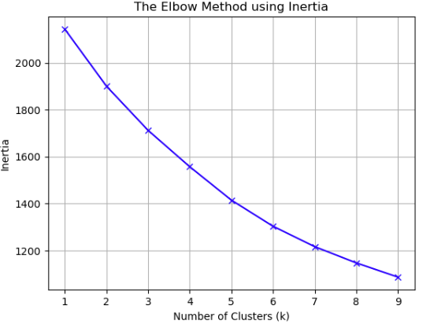 | 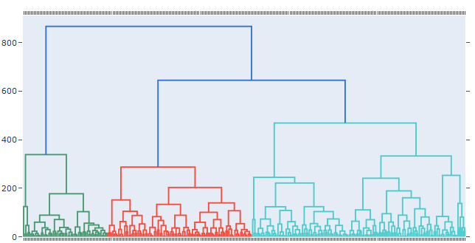

K-Means: Silhouette Method | Hierarchical Clustering: Silhouette Method
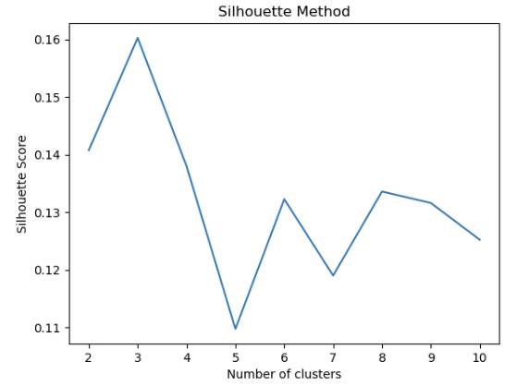 | 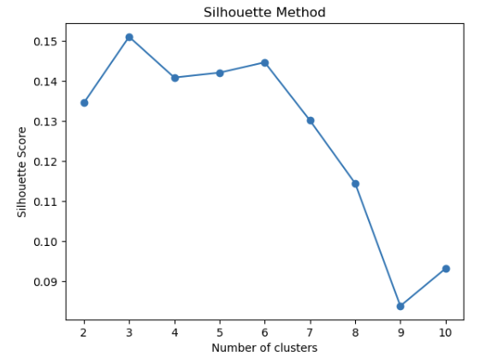

Visualize the clusters using methods such as cluster heatmaps with techniques like PCA for dimensionality reduction if necessary.
K-Means: Principal Component Analysis (PCA) | Hierarchical Clustering: Principal Component Analysis (PCA)
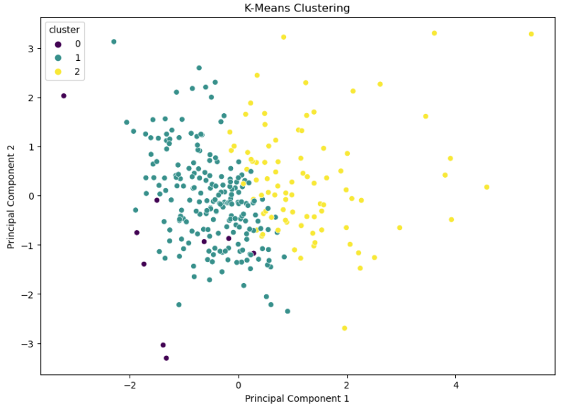 | 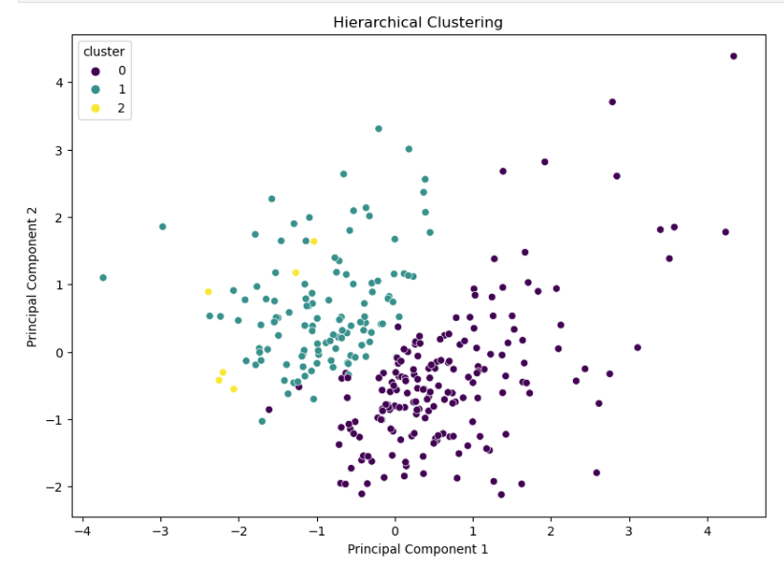

K-Means: Cluster Heatmap
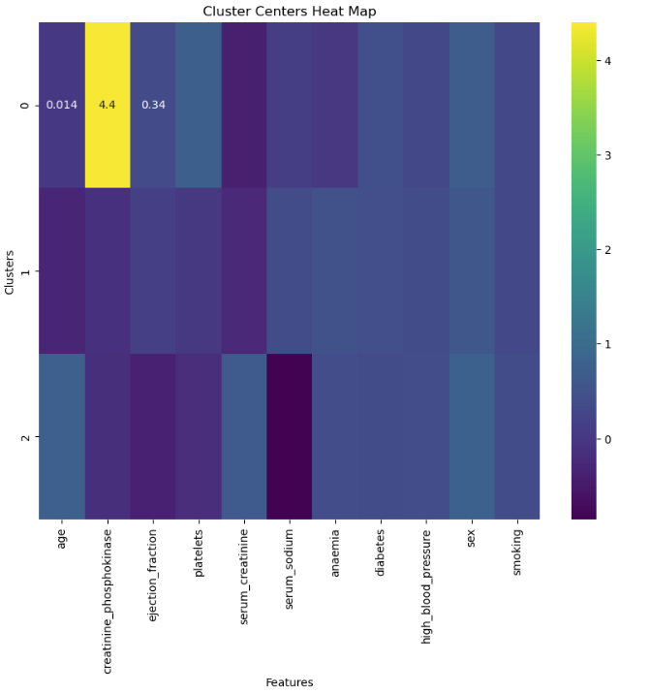

Cluster Evaluation (2 Marks)
Evaluate the clusters using appropriate evaluation metrics (e.g., silhouette score).
Elbow Method, Silhouette method & Dendrogram
- We can see from the above that the Elbow Method does not help us select an optimal number of clusters (k) in K-Means.
- We therefore use the Silhouette method which indicates that the optimal number of clusters is 3
- When visually inspecting the Dendrogram in Hierarchical clustering, we also see that there are 3 main clusters. Choice of 3 clusters for Hierarchical clustering is confirmed using the Silhouette method

Principal Components Analysis (PCA):
K-Means:
- Using visual inspection of PCA charts, we see that the data is reasonably well separated out into two distinct groups
- However, there is some overlap between the purple and green clusters which indicates that the clusters are not well defined for the third group
Hierarchical clustering:
- Using visual inspection of PCA charts, we see that the data is reasonably well separated out into two distinct groups
- However, there is significant overlap between the yellow and green clusters which indicates that the clusters are not as well defined for the third group
Cluster Heatmap:
- K-Means cluster heatmap shows variation in (scaled) values across clusters for each feature.
- This shows that there is material variation in some features across clusters, with creatine phosphokinase being the most obvious example indicating that it is a key driver in cluster formation. This is consistent with our observations in part 1 when we performed pair plots. For some other features the variation is less obvious across clusters e.g., high blood pressure, diabetes, smoking
Provide a comparative analysis of the clusters generated by both algorithms. Are the clusters similar or significantly different? What do the clusters suggest about the underlying data structure, especially regarding cardiac health risks?
Both methods indicated that 3 clusters were appropriate. We can also see from the PCA graphs that, using both methods, we have two main clusters with one minor cluster. The minor cluster is less well defined and shows some overlap with one of the main clusters. Overall, both methods have provided similar results.

The clusters indicate that there are at least 2, but possibly 3, distinct groups within the dataset, with potentially different risk profiles across groups. One of the key drivers in differences is creatinine phosphokinase levels.

Interpretation & Usefulness (1 Mark)
Reflect on the interpretability of the clusters. Can the clusters provide meaningful insights into cardiac health risks?
The clusters identify groups with potentially different cardiac health risk profiles. Analysis, including the heatmap above, can then highlight what the key drivers are in these differences. This can help stratify individuals into different cardiac health risk categories, allowing more targeted treatment to be provided.

Discuss how clustering could be used in real-world applications, particularly in healthcare, to identify high-risk patients and tailor intervention strategies.
In the real world there may be significant advantages to using clustering to separate groups into different risk segments, as defined by the clusters, for the purpose of designing different treatment plans. By clustering patients in terms of diseases, risk factors, lifestyles, or other relevant factors, clustering results can help physicians gain insights into patients’ needs and provide personalized treatments (Yang, 2023). This could result in improvements in health care outcomes for individuals and potentially overall health care cost savings due to more targeted and efficient resource allocation. This can be used to drive forward Population Health Management initiatives at a large scale. This can be used to identify groups of high-risk patients who require specialist intervention plans.

APPENDIX

Bibliography
Coşgun, H. H., 2023. which-data-scaling-technique-should-i-use. [Online]
Available at: https://medium.com/@hhuseyincosgun/which-data-scaling-technique-should-i-use-a1615292061e
[Accessed 10 2024].
datacarpentry, 2024. starting-with-data. [Online]
Available at: https://datacarpentry.org/python-ecology-lesson/02-starting-with-data.html
[Accessed 2024].
geeksforgeeks, 2024. k-means-clustering-introduction. [Online]
Available at: https://www.geeksforgeeks.org/k-means-clustering-introduction/
[Accessed November 2024].
Jain, A. K., 2010. Data Clustering: 50 years beyond K-Means. pp. 651-666.
Patlolla, C. R., 2018. Towards Data Science. [Online]
Available at: https://towardsdatascience.com/understanding-the-concept-of-hierarchical-clustering-technique-c6e8243758ec
Shalizi, C., 2009. DistancesbetweenClustering,Hierarchical. [Online]
Available at: https://www.stat.cmu.edu/~cshalizi/350/lectures/08/lecture-08.pdf
Yang, L. L. L. H. P., 2023. Using Medical Data and Clustering Techniques for a Smart Healthcare System. Multidisciplinary Digital Publishing Institute, Issue https://www.mdpi.com/2079-9292/13/1/140#:~:text=The%20clustering%20technique%20is%20one,a%20hospital%20for%20medical%20treatment..

