Name | Shane Kennedy
Student Number | 24252940
Module | 2425 – CT5170 Principles of Machine Learning - Online
Assignment | Assignment 1
Due Date | October 20th 2024

Understanding the Dataset (1 Mark)

Explore the dataset and understand the problem statement
- Detailed analysis of the dataset was performed, as can be seen in the associated Jupyter notebook. Online resources were used to help during this analysis (datacarpentry, 2024)
- This included reading in the data, inspecting the first few lines, checking to see what data structure we were provided with, checking the data types for each column, inspecting the categories with the Object ‘Type’, getting a description of each numerical variable (count, mean, std, min, max, percentiles)
- The objective is to build a machine learning model to predict the Perinatal health risk level based on the parameters included in the data set

Identify the independent and dependent variables.
- The variable "Type" is a categorical variable, containing three distinct levels: high risk, low risk, mid risk. This is the target, response, output, or dependent variable
- The other variables are numeric, and these are the independent, or explanatory, variables
- During this exercise we are being asked to use machine learning models to predict the risk level (dependent variable) using Age, SystolicBP, DiastolicBP, BS, Body Temperature and Heart Rate (independent variables) as inputs, or predictors

Briefly explain why classification is the appropriate machine learning category for this problem
- This is a supervised learning problem where the dependent variable is a discrete output (risk level) containing three categories or classes
- As a result, this is a classification problem, rather than a regression problem (which would be applicable if the dependent variable was a continuous numeric value)

Data Exploration and Pre-Processing (2 Marks)

Data pre-processing
- Data pre-processing was carried out, as shown in the associated Jupyter notebook, including checking for missing values and assessing for outliers.
- No missing values were discovered, however in the HeartRate variable, outliers were discovered and assumed to be typo/errors. They were replaced with the mean value.
- Feature scaling (Coşgun, 2023) is applied to the independent variables to mitigate bias when fitting models. Scaling prevents features from dominating the ML process due to the magnitude of their values. To prevent data leakage, the feature scaling is fitted on the training dataset, then applied to the test dataset.
- There are several scaling techniques we could use. "Standard Scaler (scikit-learn, 2024) has been chosen due its simplicity. It is suitable when we are not concerned about outliers and believe that normal distribution is a reasonable assumption for the features. As we have seen above, any outliers have been dealt with therefore not a concern.

Analyze the distribution of data between the training and testing sets.
- Data is split into training and test sets with a 70/30 split.
- An 80/20 split was also considered however it was believed that this would result in too small of a test set and less likely to have a distribution consistent with the training set
- Summary statistics are calculated for independent variables in both training and test sets, comparing mean, stdev, min and max values. This confirms that summary statistics are similar between train and test sets.
- Similar analysis performed for the dependent variables, comparing the distribution of each category. This confirms that distribution of categories is similar between train and test sets.
- Kolmogorov – Smirnov (stats.stackexchange, 2023), (Bobbitt, 2020) test is performed to check if there is any statistical difference in the distribution of each independent variable in the train and test sets
- Correlation matrices are developed for both train and test sets
- Conclusion is that there is no significant difference in the distribution of data in training and test sets

Determine whether the dataset is imbalanced. Provide a brief explanation.
- We assess the distribution of classes in the dependent variable to assess if the data set is imbalanced. For three categories, a 33.33% split in each category would represent a perfectly balanced distribution.
- There is some element of imbalance since the low-risk category has 40% split and the high-risk category has a 27% split. However, this is only considered to be a slight to moderate level of imbalance.

Algorithm Selection and Application (4 Marks)

Choose two classification algorithms (e.g., Decision Tree, Random Forest, or any other suitable algorithms).
- Decision Trees, K-Nearest Neighbors and Random Forest were all assessed
- For this assignment, K-Nearest Neighbors and Random Forest chosen as the two classification algorithms

Apply both algorithms to the pre-processed dataset.
- K-Nearest Neighbors: The model was fitted to the training set for numerous values of k
- Random Forest: The model was fitted to the training set for numerous values of n estimators

Provide clear descriptions of both algorithms, citing your sources.
K-Nearest Neighbors (geeksforgeeks, 2024):
K-NN is a supervised learning method, using labeled data to make predictions on new, unseen data.
It is also a similarity-based learning technique, where distance is used to measure the similarity of data points. Different distance metrics can be used (Euclidean, Manhattan, Minkowski). I have used Euclidean in this assignment and works well unless datasets are very large (in which case computation costs can be high). The simplest K-NN algorithm is when K=1. However, using K=1 can result in overfitting and is not recommended. It is also recommended to select k values using uneven numbers as this results in a more balanced and unbiased classification. (scikit-learn, n.d.)

When a new data point is provided to a K-NN model, the distance is compared to all stored cases and the nearest K nearest neighbors are chosen. The K neighbors vote on the classification of the data point, with the prediction being the majority class. Having uneven number of K will ensure there is no draw.

Random Forest (geeksforgeeks, 2024):
Random Forest is also a supervised learning method and can be used for classification and regression problems. Random Forests work well with large and complex datasets, and high-dimensional feature spaces. It is an ensemble algorithm where a set of decision trees are created from a randomly selected subset of the training set. For classification problems, it collects the votes from all the decision trees and the final prediction is based on the majority vote.

This approach, known as bagging (Bootstrap Aggregation), prevents dominance of any single feature and reduces overfitting resulting in a more robust model. When creating the decision trees, the best feature at each node point is selected based on a given criterion (scikit-learn, n.d.) (gini, entropy, log_loss). Gini is used for the purpose of this exercise since it is computationally simpler and faster to calculate due to its linear characteristics.

Hyperparameter Tuning (1 Mark): Perform hyperparameter tuning for at least one algorithm. Discuss how tuning the hyperparameters affected your model’s performance.

K-Nearest Neighbors: Accuracy levels were plotted for each value of k fitted. | Random Forest: Grid search was used to fit models with different max_depth and n_estimators values, using 5 fold cross validation.
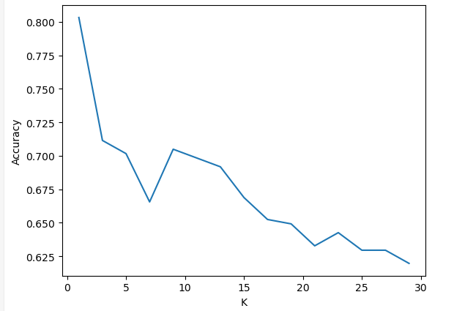 | 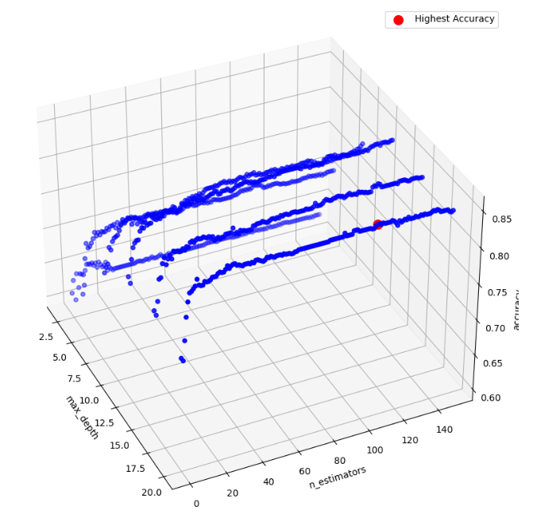

- K-NN: Accuracy level is highest for k = 1, however, this is likely to result in overfitting. As a result, k = 3 is chosen even though it results in lower accuracy level.
- Random Forest: The accuracy level is highest in cross validation for max_depth = 20 and n_estimators = 107, therefore these were selected as hyper parameters. max_depth represents the maximum depth of a (decision) tree while n_estimators represents the number of (decision) trees in the (random) forest.

Model Evaluation and Comparative Analysis (2 Marks)
Train and test your chosen algorithms using the training and testing sets.
Sklearn python package was used to do this. Please see Jupyter notebook for details.

Evaluate the models using appropriate performance metrics (e.g., accuracy, confusion matrix).
Sklearn python package was used to evaluate the model performance using confusion matrix, accuracy, precision, recall, F1 score and Receiver Operating Characteristic (ROC). Please see Jupyter notebook for details.

Present the results, including any visualizations or graphs that help demonstrate performance differences.
K-Nearest Neighbors | Random Forest
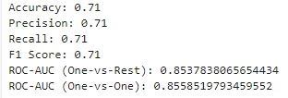 | 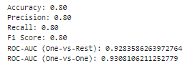
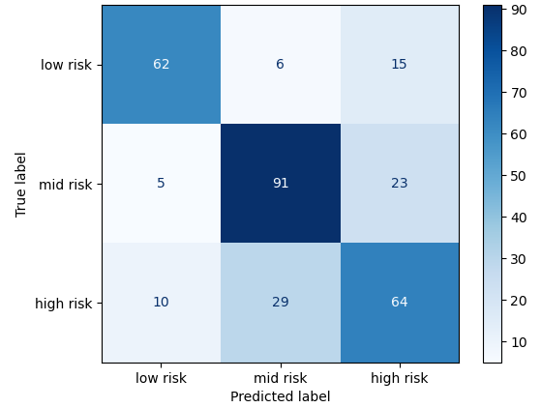 | 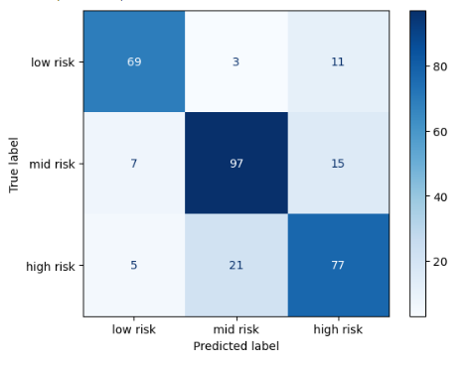

Compare both models' performances. Discuss whether the models provided similar or significantly different results and explain why.

As can be seen above, Random Forest performs best for all metrics. This is not surprising since Random Forests are considered more robust and less prone to over fitting. It is possible to obtain higher metrics using K-NN when K = 1, however this is not recommended since it will significantly increase the likelihood of overfitting.

In a healthcare setting like this, it may be important to reduce false negatives e.g., classifying somebody as being low risk when they are in fact mid or high – in this scenario they may not receive the necessary care. It may be less of an issue to have false positives e.g., classifying somebody as being high risk when they are in fact mid or low – in this scenario they may be assessed further by a physician who then determines that they are low risk. Therefore, recall (proportion of true positives correctly identified) and ROC-AUC (ability to distinguish between classes) are an important metrics. In K-NN, 10 high risk cases were classified as being low risk. With Random Forest, this error is reduced by 50% to only 5.

Ethical Considerations (1 Mark)
Reflect on the ethical implications of using machine learning models in healthcare, particularly in the context of predicting maternal health risks.
While ML models can help identify high risk individuals, and have targeted interventions, it does not come without risks and ethical concerns. In this specific example, it is important to ensure that the ML models do not inadvertently result in inequitable healthcare provision (Chen, 2021). Explainable AI is particularly important in a healthcare setting to ensure that the risk of inequity is mitigated.

Discuss potential biases, risks, and ethical concerns associated with using these models in real-world healthcare settings.
Care must be taken when social determinants of health (World Health Organization, n.d.) are used as explanatory variables due to the influence they can have on health inequities. For example, if a cohort currently has poor access to healthcare and existing risks/conditions have not been well documented as a result, the data may indicate that this cohort is relatively healthy. The ML model may then unfairly assign additional medical attention away from that group, exacerbating the inequity.

Various methods can be used to mitigate against such bias in health care settings (Vokinger, 2021). These include ensuring that the training/test set includes diverse patient cohorts, is representative, ensuring that models are explainable, and the logic is understood, monitoring model performance and re-training/adjusting to rectify issues.

APPENDIX

Bibliography
Bobbitt, Z., 2020. kolmogorov-smirnov-test-python. [Online]
Available at: https://www.statology.org/kolmogorov-smirnov-test-python/
[Accessed 10 2024].
Chen, P. R. J. F. G., 2021. Ethical Machine Learning in Healthcare. Annual Review of Biomedical Data Science, Volume 4:123-144 .
Coşgun, H. H., 2023. which-data-scaling-technique-should-i-use. [Online]
Available at: https://medium.com/@hhuseyincosgun/which-data-scaling-technique-should-i-use-a1615292061e
[Accessed 10 2024].
datacarpentry, 2024. starting-with-data. [Online]
Available at: https://datacarpentry.org/python-ecology-lesson/02-starting-with-data.html
[Accessed 2024].
EUROPEAN INFORMATION TECHNOLOGIES CERTIFICATION ACADEMY, 2023. introduction-to-classification-with-k-nearest-neighbors. [Online]
Available at: https://eitca.org/artificial-intelligence/eitc-ai-mlp-machine-learning-with-python/programming-machine-learning/introduction-to-classification-with-k-nearest-neighbors/examination-review-introduction-to-classification-with-k-nearest-neighbors/why-is-it-re
[Accessed 10 2024].
geeksforgeeks, 2024. how-does-knn-handle-multi-class-classification-problems. [Online]
Available at: https://www.geeksforgeeks.org/how-does-knn-handle-multi-class-classification-problems/
[Accessed 10 2024].
geeksforgeeks, 2024. random-forest-classifier-using-scikit-learn. [Online]
Available at: https://www.geeksforgeeks.org/random-forest-classifier-using-scikit-learn/
[Accessed 10 2024].
scikit-learn, 2024. sklearn.preprocessing.StandardScaler. [Online]
Available at: https://scikit-learn.org/stable/modules/generated/sklearn.preprocessing.StandardScaler.html
[Accessed 10 2024].
scikit-learn, n.d. sklearn.ensemble.RandomForestClassifier. [Online]
Available at: https://scikit-learn.org/stable/modules/generated/sklearn.ensemble.RandomForestClassifier.html
[Accessed 10 2024].
scikit-learn, n.d. sklearn.neighbors.KNeighborsClassifier. [Online]
Available at: https://scikit-learn.org/dev/modules/generated/sklearn.neighbors.KNeighborsClassifier.html
[Accessed 10 2024].
stats.stackexchange, 2023. how-to-compare-the-data-distribution-of-2-datasets. [Online]
Available at: https://stats.stackexchange.com/questions/354035/how-to-compare-the-data-distribution-of-2-datasets
[Accessed 10 2024].
Vokinger, F. K., 2021. Mitigating bias in machine learning for medicine. [Online]
Available at: https://www.nature.com/articles/s43856-021-00028-w
[Accessed 10 2024].
World Health Organization, n.d. social-determinants-of-health. [Online]
Available at: https://www.who.int/health-topics/social-determinants-of-health#tab=tab_1
[Accessed 10 2024].

