A SECURE RESEARCH DATA MANAGEMENT SYSTEM FOR PROTECTING SENSITIVE UNIVERSITY RESEARCH INFORMATION
SYSTEM DOCUMENTATION

SUBMITTED BY,
KENNEDY MWANGI
REG NO: DCF-01-0107/2026
A SYSTEM DOCUMENTATION SUBMITTED IN PARTIAL FULFILMENT FOR THE AWARD OF DIPLOMA IN INFORMATION TECHNOLOGY BY ZETECH UNIVERSITY
AUGUST 2026

DECLARATION
I declare that this system documentation is my original work and has not been submitted to any other institution for any academic award. All sources of information used in this documentation have been acknowledged through appropriate referencing.
Student's Name: KENNEDY MWANGI
Signature: _______________________________ Date: _______________________
Supervisor's Name: _______________________________
Signature: _______________________________ Date: _______________________

DEDICATION
This project is dedicated to my family for their constant support, encouragement and understanding throughout my academic journey. Their motivation and belief in my abilities gave me the strength to complete this project successfully.
It is also dedicated to all students and researchers who value the protection of intellectual property and the secure management of research data in academic institutions.

ABSTRACT
Universities increasingly rely on shared digital platforms to store and manage research information. Although these platforms improve collaboration, they also expose sensitive research data to security threats such as unauthorised access, unauthorised duplication of files, suspicious login attempts and potential theft of intellectual property. This project implements a Secure Research Data Management System incorporating Multi-Factor Authentication (MFA), Role-Based Access Control (RBAC), data encryption and audit logging to strengthen confidentiality, integrity and availability while improving user accountability.
The system was developed using PHP 8 for server-side logic, HTML, CSS and JavaScript for the user interface, and MySQL for the database. It provides secure storage, controlled access based on user roles, encrypted file handling, comprehensive audit trails, security alerts and summary reports for administrators. Testing confirmed that authentication, authorisation, encryption and audit functions operate as intended. The system improves the protection of sensitive university research information and supports institutional compliance with information security requirements.

DEFINITION OF KEY TERMS
Access Control: A security mechanism that regulates who can view, use or modify information and system resources based on assigned permissions.
Audit Logging: The process of recording user and system activities to provide a chronological record for monitoring, accountability and security investigations.
Authentication: The process of verifying the identity of a user before granting access to an information system.
Authorisation: The process of determining the level of access and permissions granted to an authenticated user.
Data Encryption: The process of converting readable information into an unreadable format using cryptographic techniques to protect it from unauthorised access.
Information Security: The protection of information and information systems against unauthorised access, disclosure, modification, destruction or disruption while ensuring confidentiality, integrity and availability.
Intellectual Property: Original research outputs, inventions, software, publications and other creations of the mind that are legally protected from unauthorised use or duplication.
Multi-Factor Authentication (MFA): A security method that requires users to provide two or more forms of verification before accessing a system.
Research Data: Information collected, generated, observed or analysed during research activities, including documents, datasets, reports and experimental results.
Research Data Management System: A computerised information system designed to securely collect, store, organise, manage, retrieve and protect research data throughout its lifecycle.
Role-Based Access Control (RBAC): An access control model that grants system permissions according to the roles and responsibilities assigned to individual users within an organisation.
Security Alert: A notification generated by the system when suspicious or failed activity requires review by an administrator.

ABBREVIATIONS AND ACRONYMS
Abbreviation | Meaning
AES | Advanced Encryption Standard
API | Application Programming Interface
CIA | Confidentiality, Integrity and Availability
CSS | Cascading Style Sheets
CSRF | Cross-Site Request Forgery
DBMS | Database Management System
DLP | Data Loss Prevention
HTML | Hypertext Markup Language
HTTP | Hypertext Transfer Protocol
HTTPS | Hypertext Transfer Protocol Secure
ISO | International Organization for Standardization
MFA | Multi-Factor Authentication
NIST | National Institute of Standards and Technology
OTP | One-Time Password
OWASP | Open Worldwide Application Security Project
PDO | PHP Data Objects
PHP | PHP: Hypertext Preprocessor
RBAC | Role-Based Access Control
RDMS | Research Data Management System
SIEM | Security Information and Event Management
SQL | Structured Query Language
UI | User Interface
URL | Uniform Resource Locator

TABLE OF CONTENTS
DECLARATION 2
DEDICATION 3
ABSTRACT 4
DEFINITION OF KEY TERMS 5
ABBREVIATIONS AND ACRONYMS 6
LIST OF FIGURES 10
LIST OF TABLES 10
CHAPTER ONE: PROJECT PLANNING AND ANALYSIS 11
1.1 Statement of Problem 11
1.2 Study Justification 11
1.3 System Objectives 11
1.3.1 General Objective 11
1.3.2 Specific Objectives 12
1.4 Functional and Non-Functional Requirements 12
1.4.1 Functional Requirements 12
1.4.2 Non-Functional Requirements 12
1.5 Breakdown of Tools and Resources 13
1.6 Project Schedule Breakdown (Gantt Chart) 13
1.7 Ethical and Legal Considerations 14
CHAPTER TWO: DESIGN AND MODELING 15
2.1 Introduction to Modelling 15
2.2 User Interface Models 15
2.2.1 Login page / Sign-in 15
2.2.2 Research data management dashboard 15
2.2.3 Audit logging and user accountability 16
2.2.4 Security reports 17
2.3 Logic Models 17
2.3.1 Login process flowchart 17
2.3.2 System flowchart 18
2.3.3 Data flow diagrams 19
2.3.4 Entity relationship diagram 20
2.3.5 Use case diagram 20
2.3.6 Class diagram 21
CHAPTER THREE: SYSTEM IMPLEMENTATION 22
3.1 Introduction 22
3.2 User Interface Development 22
3.2.1 Login Page 22
3.2.2 Multi-Factor Authentication 23
3.2.3 Dashboard 23
3.2.4 Research File Management 24
3.2.5 Audit Logs 25
3.2.6 Security Alerts 26
3.2.7 Security Reports 27
3.2.8 User Management 28
3.3 Logic Development 29
3.3.1 Routing and Application Entry Point 29
3.3.2 Database Connection and Schema 30
3.3.3 Shared Security Helpers 34
3.3.4 Authentication and Multi-Factor Authentication 37
3.3.5 Research File Workflow 40
3.3.6 Dashboard, Audit, Alerts and Reports 43
3.3.7 User Management 47
3.3.8 Presentation Layer 49
3.4 Testing 59
3.5 Deployment 60
CHAPTER FOUR: CONCLUSION AND RECOMMENDATION 61
4.1 Conclusion 61
4.2 Recommendation 61
REFERENCES 62
APPENDIX A: PROJECT REPOSITORY AND SETUP 63

LIST OF FIGURES
Figure | Title
Figure 2.2.1 | Login page (design mock-up)
Figure 2.2.2 | Research data management dashboard (design mock-up)
Figure 2.2.3 | Audit logging and user accountability (design mock-up)
Figure 2.2.4 | Security reports (design mock-up)
Figure 2.3.1 | Login process flowchart
Figure 2.3.2 | Secure research data management system flowchart
Figure 2.3.3 | Data flow diagrams (context and level 1)
Figure 2.3.4 | Entity relationship diagram
Figure 2.3.5 | Use case diagram
Figure 2.3.6 | Class diagram
Figure 3.2.1 | Login page implementation
Figure 3.2.2 | MFA verification screen
Figure 3.2.3 | Administrator dashboard
Figure 3.2.4 | Research file management interface
Figure 3.2.5 | Audit log interface
Figure 3.2.6 | Security alerts interface
Figure 3.2.7 | Security reports interface
Figure 3.2.8 | User management interface
Figures 3.3.1â€“3.3.33 | Complete source-code screenshots for all application files

LIST OF TABLES
Table | Title
Table 1.4.1 | Functional requirements
Table 1.4.2 | Non-functional requirements
Table 1.5.1 | Project tools and resources
Table 1.6.1 | Project schedule (Gantt chart)
Table 3.4.1 | Test cases and results

CHAPTER ONE: PROJECT PLANNING AND ANALYSIS

1.1 Statement of Problem
A university research department stored sensitive project data on shared servers. Initially, access was restricted, but anomalies soon appeared. On one occasion, a project folder was copied multiple times, with versions appearing in locations that no one had authorised. On another occasion, login attempts were recorded from accounts belonging to staff who were on leave. Researchers felt uneasy about whether their intellectual property was secure, while administrators worried about compliance with funding requirements. The recurring issues with unauthorised duplication and suspicious logins created stress, inefficiency and declining confidence in the department's ability to safeguard research data.
There is therefore a critical need for a centralised Secure Research Data Management System that enforces strong authentication, role-based permissions, encryption of stored research files and comprehensive audit logging so that every access and modification is traceable.

1.2 Study Justification
This project is justified by the need to implement a secure approach to managing sensitive research information stored on shared servers. Technologies such as role-based access control, multi-factor authentication, encryption, audit logging and automated monitoring can strengthen information security. The proposed system restricts unauthorised access, protects data integrity, improves accountability, protects intellectual property, detects suspicious login attempts and supports compliance with institutional information security requirements.
From a management perspective, the system eliminates reliance on weakly controlled shared folders and provides administrators with clear visibility into who accessed what and when. This shifts the research department from a reactive posture to a proactive, evidence-based security posture. The implementation also demonstrates how open-source tools can deliver enterprise-style controls at minimal cost, making the solution suitable for a university environment.

1.3 System Objectives

1.3.1 General Objective
To implement a Secure Research Data Management System for protecting sensitive university research information.

1.3.2 Specific Objectives
- To develop a secure system that stores, manages and protects sensitive research data through authentication, access control, encryption and audit logging.
- To implement user authentication and role-based access control mechanisms that verify user identities and restrict access to research information based on authorised roles and responsibilities.
- To generate security audit reports that monitor user activities, detect suspicious login attempts, record file access events and support accountability and compliance with institutional information security requirements.

1.4 Functional and Non-Functional Requirements

1.4.1 Functional Requirements
User | User Activities | Features
Administrator | Sign in with username, password and a one-time MFA code; create users and assign roles; activate or deactivate accounts; review audit logs and security alerts; generate security reports. | Login and MFA; user management; audit log viewer; alert centre; reports dashboard
Researcher | Sign in with MFA; upload research documents with metadata; view and download only the files assigned to their account. | Login and MFA; encrypted upload form; personal file list; authorised download
Viewer | Sign in with MFA; view and download research files permitted by the access policy; no upload or administrative access. | Login and MFA; read-only repository; authorised download
System | Encrypt files before storage; record every significant action; generate alerts for repeated failed logins and failed MFA attempts; enforce role checks on every protected page. | AES-256-CBC encryption; audit logging; security alerts; RBAC middleware; CSRF protection

Table 1.4.1 Functional requirements

1.4.2 Non-Functional Requirements
Requirement | Description
Security | The system shall protect research information using password hashing, MFA, role-based access control, encryption and audit logging.
Performance | The system shall authenticate users and retrieve research information within an acceptable response time on a standard campus network.
Reliability | The system shall operate consistently with minimal downtime and maintain the accuracy of research records and audit events.
Availability | Authorised users shall be able to access the system whenever required, subject to scheduled maintenance.
Usability | The system shall provide a simple, consistent and responsive interface for researchers, viewers and administrators.
Scalability | The system shall support additional users, departments and research projects without structural redesign.
Maintainability | The system shall be modular so that security rules, pages and database objects can be updated without affecting unrelated functions.

Table 1.4.2 Non-functional requirements

1.5 Breakdown of Tools and Resources
The project was implemented entirely with open-source or freely available tools, as summarised below.
Tool / Resource | Purpose | Cost (KSh.)
PHP 8 | Server-side programming, session handling, MFA logic and encryption | 0 (Open Source)
MySQL / MariaDB | Relational database for users, research records, audit logs, alerts and MFA codes | 0 (Open Source)
Apache (XAMPP) | Web server used for local development and testing | 0 (Freeware)
HTML, CSS, JavaScript | Responsive user interface and client-side form behaviour | 0 (Open Source)
Visual Studio Code | Writing, reviewing and debugging the source code | 0 (Freeware)
Git and GitHub | Version control, backup and publication of the project repository | 0 (Freeware)
Google Chrome / Microsoft Edge | Testing the interface and capturing implementation screenshots | 0 (Already acquired)
Laptop | Development, testing and documentation | 0 (Already acquired)

Table 1.5.1 Project tools and resources
Human resources comprised the student developer, the project supervisor and classmates who acted as test users. The application runs on a standard LAMP stack (Linux, Apache, MySQL and PHP) and can be demonstrated locally using XAMPP on Windows.

1.6 Project Schedule Breakdown (Gantt Chart)
The project was completed over an eleven-week implementation period, as shown in the schedule below.
Activity / Milestone | W1â€“2 | W3â€“4 | W5â€“6 | W7â€“8 | W9â€“10 | W11
Requirements analysis and plan refinement | âœ“ | âœ“
System and database design |  | âœ“ | âœ“
User interface design |  | âœ“ | âœ“
System development (coding) |  |  | âœ“ | âœ“ | âœ“
Database integration |  |  |  | âœ“ | âœ“
Security implementation (MFA, RBAC, encryption, audit) |  |  |  | âœ“ | âœ“
Testing and debugging |  |  |  |  | âœ“ | âœ“
System documentation |  |  |  |  | âœ“ | âœ“
User evaluation and improvement |  |  |  |  |  | âœ“
Final report and presentation |  |  |  |  |  | âœ“

Table 1.6.1 Project schedule (Gantt chart)

1.7 Ethical and Legal Considerations
The system is designed to discourage and help detect misuse such as unauthorised alteration of data and improper access to other researchers' materials. Users should be clearly informed about the data collected by the system itself, including login events, file activity and IP addresses. This supports the ethical norms of openness, respect for persons and transparency.
Operations of the system must remain aligned with institutional research-ethics policies, data-protection procedures and applicable law. Researchers, students and staff have a legitimate expectation that sensitive research materials and personal details will not be disclosed without proper authority. Access to audit information is therefore restricted to administrators, and demonstration data must not contain real personal or research information.

CHAPTER TWO: DESIGN AND MODELING

2.1 Introduction to Modelling
This chapter presents the system designs and models developed to visualise the proposed Secure Research Data Management System before implementation. The diagrams and models illustrate how users interact with the system, how research data is managed, how security controls are applied and how data flows between system processes and storage components. Modelling the system before development helped clarify requirements, identify potential challenges early and provide a structured blueprint for implementation.

2.2 User Interface Models

2.2.1 Login page / Sign-in
The login page is a secure interface where authorised users enter their username and password and then complete Multi-Factor Authentication before accessing the research data management system. The design keeps the form minimal so that attention is focused on credential entry and security messaging.
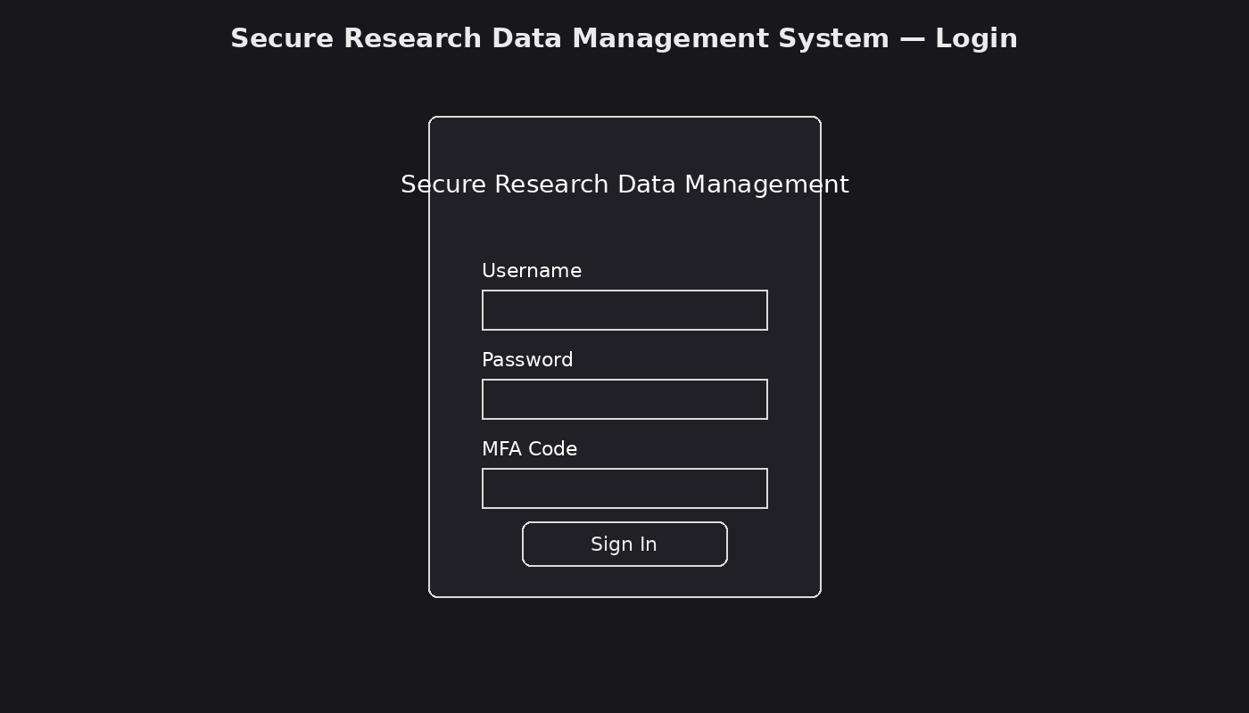
Figure 2.2.1 Login page (design mock-up)

2.2.2 Research data management dashboard
The dashboard provides authorised users with access to core functions such as uploading research documents, viewing authorised files, updating research information, downloading authorised files, reviewing audit logs, viewing security alerts and generating security reports. Summary cards give administrators an immediate view of system activity.
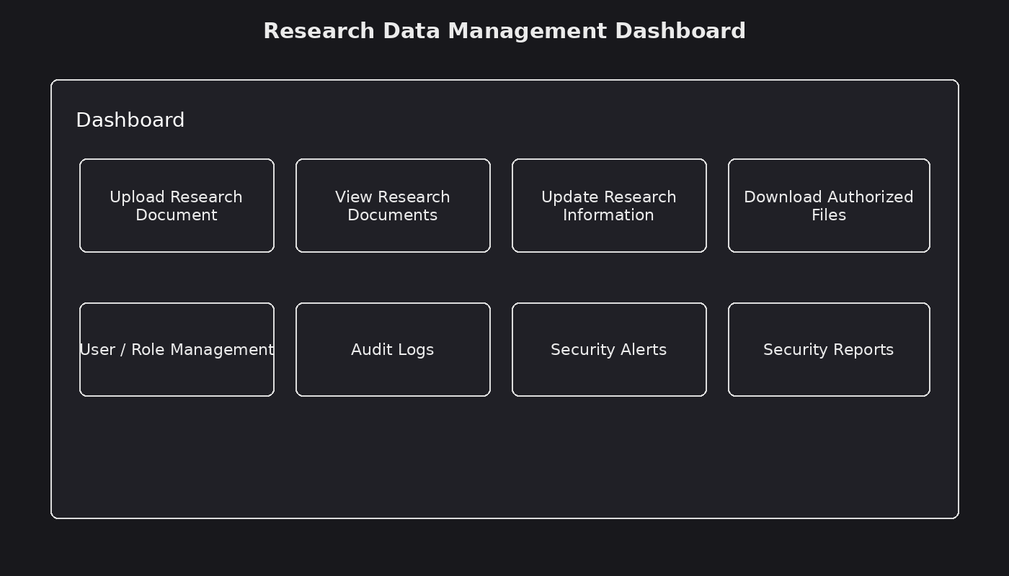
Figure 2.2.2 Research data management dashboard (design mock-up)

2.2.3 Audit logging and user accountability
The audit logging interface records activities such as user logins, file access, uploads, downloads and modifications. The records support user accountability, security investigations and monitoring of suspicious activities.
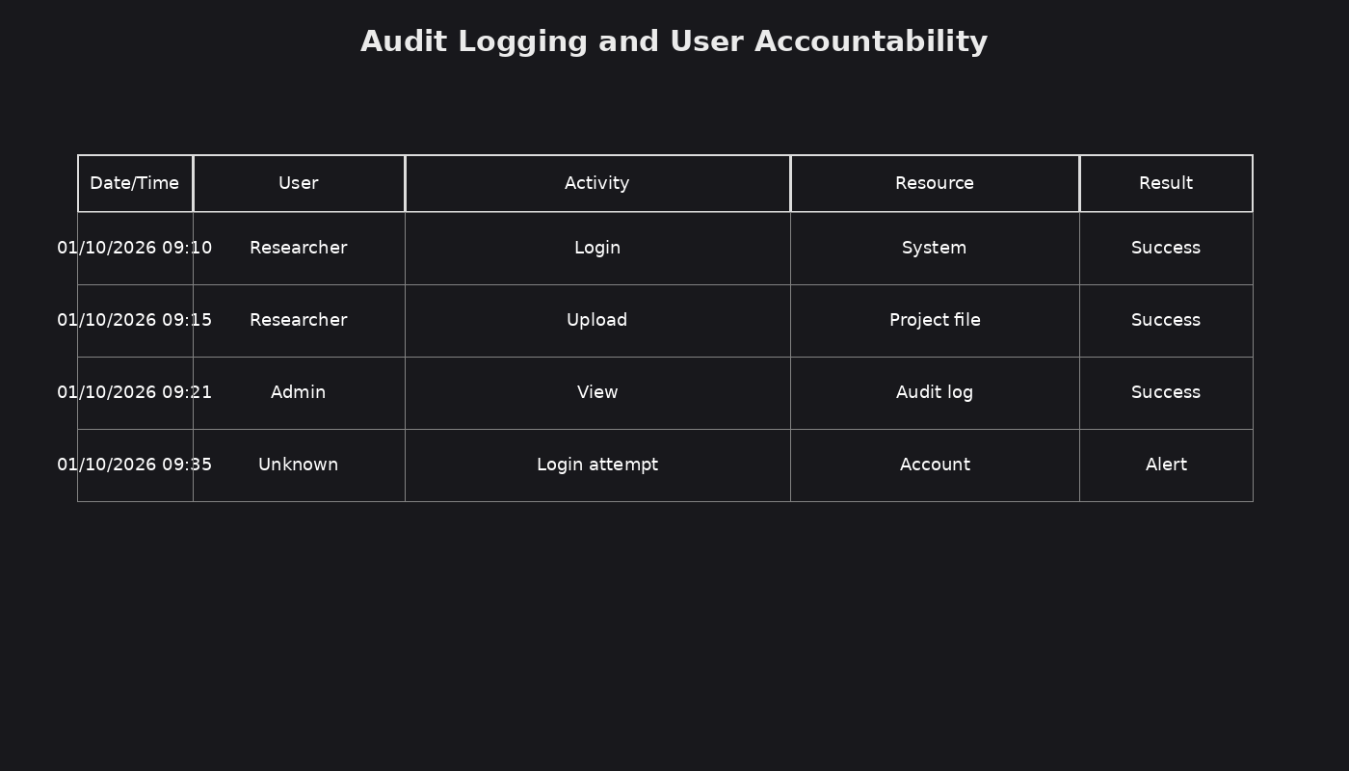
Figure 2.2.3 Audit logging and user accountability (design mock-up)

2.2.4 Security reports
The security reporting interface enables administrators to generate audit and access reports that summarise user activities and security events, supporting accountability and compliance with institutional information security requirements.
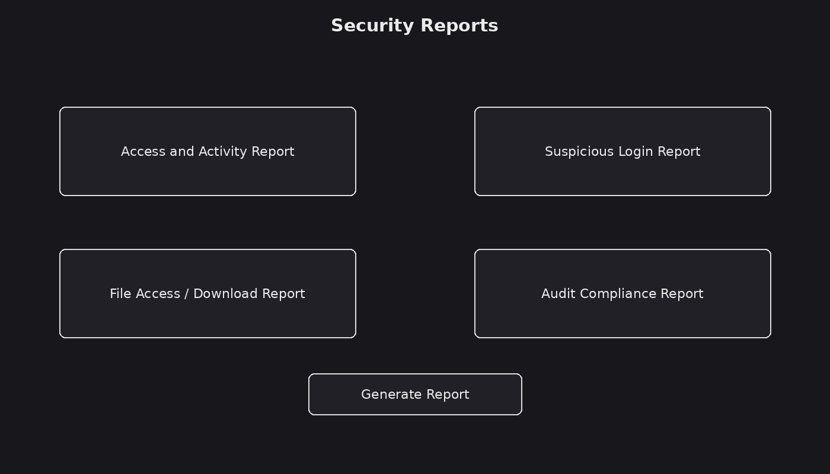
Figure 2.2.4 Security reports (design mock-up)

2.3 Logic Models

2.3.1 Login process flowchart
This flowchart illustrates the login process. A user enters the required credentials, the system validates the credentials and Multi-Factor Authentication is completed. Valid authentication grants access to the dashboard, while invalid or suspicious attempts are denied and recorded for security monitoring.
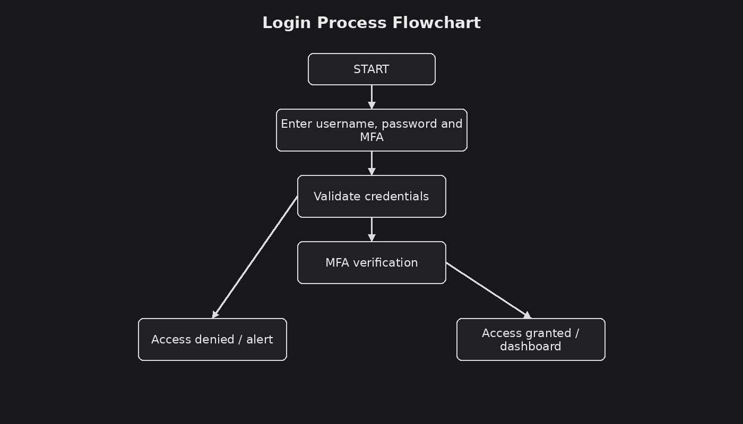
Figure 2.3.1 Login process flowchart

2.3.2 System flowchart
The system flowchart illustrates the main operation of the system. The process begins with authentication, followed by access to the dashboard. An authorised user can upload, view, update or download research information according to assigned permissions. System activities are recorded in audit logs, suspicious login attempts generate security alerts and administrators can generate security reports.
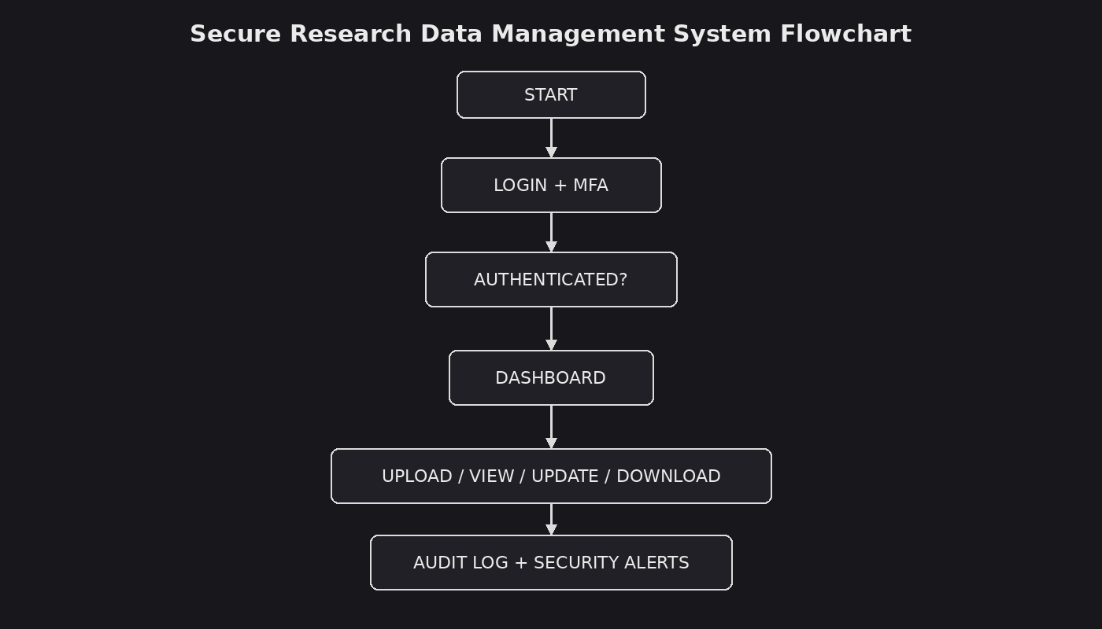
Figure 2.3.2 Secure research data management system flowchart

2.3.3 Data flow diagrams
The data flow diagrams illustrate how researchers and administrators exchange credentials, research files, requests and reports with the Secure Research Data Management System. The system communicates with user, research data and audit-log data stores to authenticate users, manage research information, record activities and support security reporting.
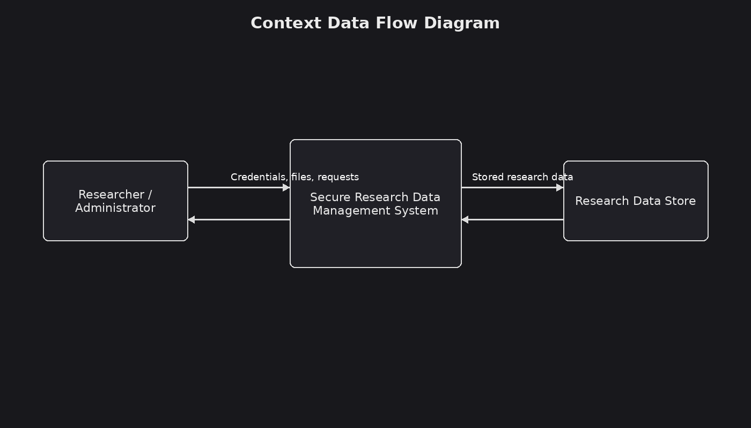
Figure 2.3.3 Data flow diagrams (context and level 1)
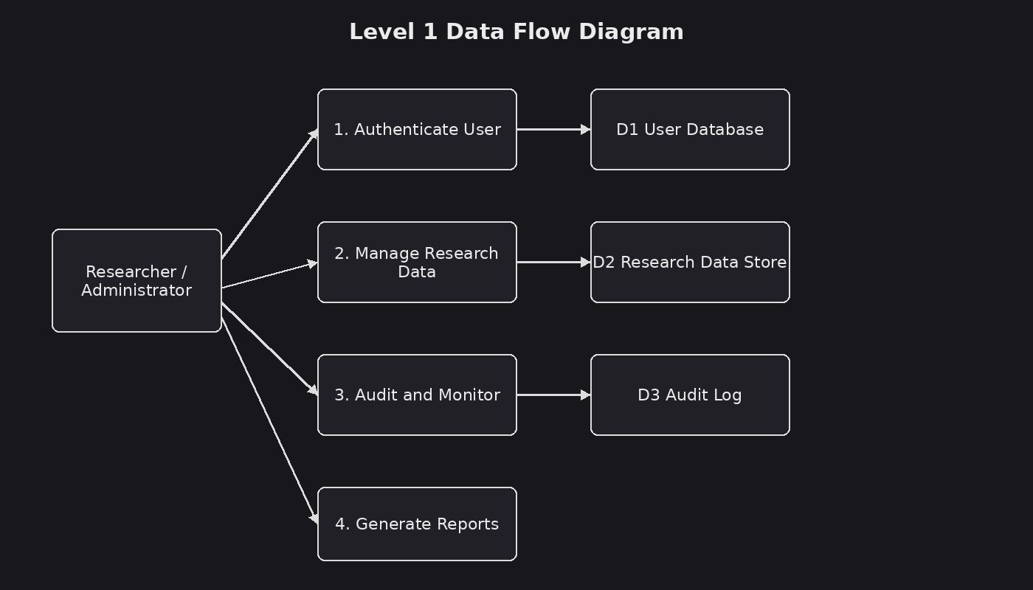
Figure 2.3.3 (continued) Level 1 data flow diagram

2.3.4 Entity relationship diagram
The Entity Relationship Diagram represents the main database structure of the system. The User entity stores identity and role information. The ResearchData entity stores project and file information, while the AuditLog entity records user activities and security events. Additional entities store MFA codes, security alerts and login attempts.
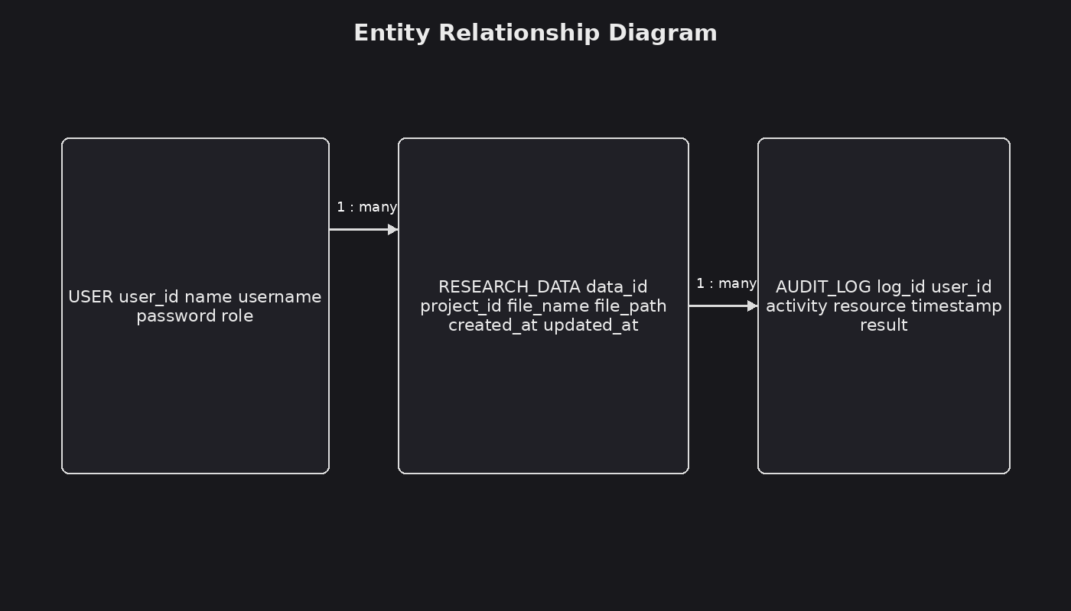
Figure 2.3.4 Entity relationship diagram

2.3.5 Use case diagram
The use case diagram illustrates interactions between researchers, viewers, administrators and the system. Users authenticate through login and MFA and perform authorised research-data activities. Administrators manage users and roles, review audit logs, respond to security alerts and generate security reports.
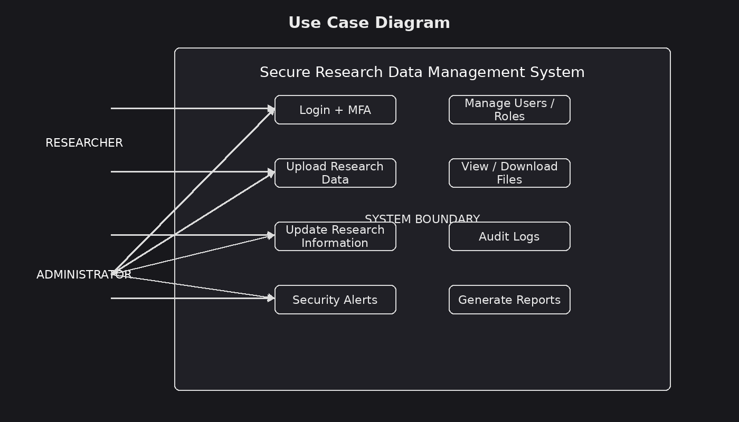
Figure 2.3.5 Use case diagram

2.3.6 Class diagram
The class diagram shows the main classes and their relationships. The User class represents system users and their roles. The ResearchData class represents stored research information and supports upload, view, update and download operations. The AuditLog class records activities and supports reporting.
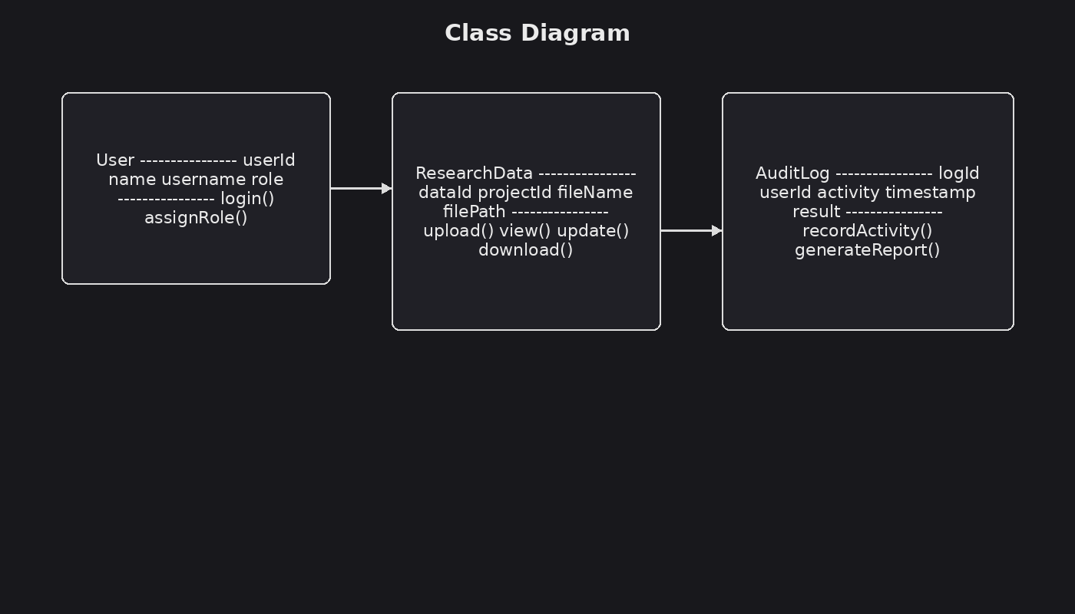
Figure 2.3.6 Class diagram

CHAPTER THREE: SYSTEM IMPLEMENTATION

3.1 Introduction
This chapter describes how the design was transformed into a working application. It covers the development environment, the user interface, the security logic, testing and deployment. The system was implemented in PHP 8 using MySQL for data storage and a responsive HTML/CSS interface. All source files are included in the project repository, and every file that runs the system is reproduced in this chapter as a numbered code screenshot.

3.2 User Interface Development

3.2.1 Login Page
The login form captures the username and password and submits them with a CSRF token. Credentials are checked against a password hash; a failed attempt produces a clear error and is recorded in the audit log.
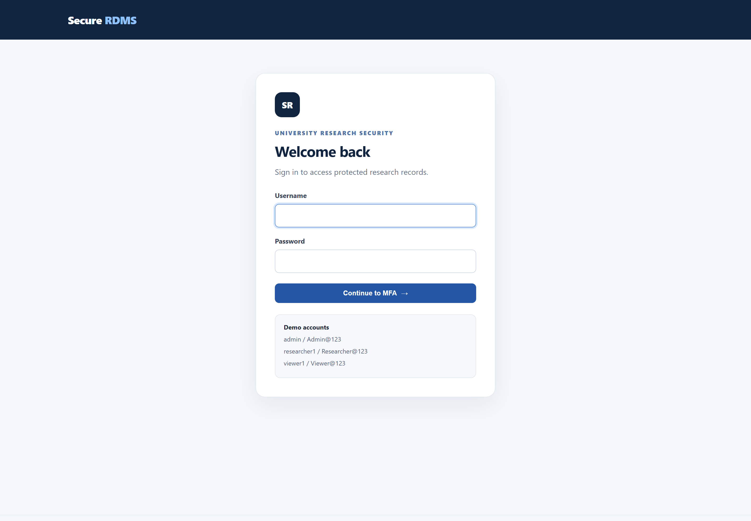
Figure 3.2.1 Login page implementation

3.2.2 Multi-Factor Authentication
After the password is accepted, the system issues a six-digit one-time code that expires after five minutes. The code is displayed on screen in this local demonstration. A correct code establishes the authenticated session.
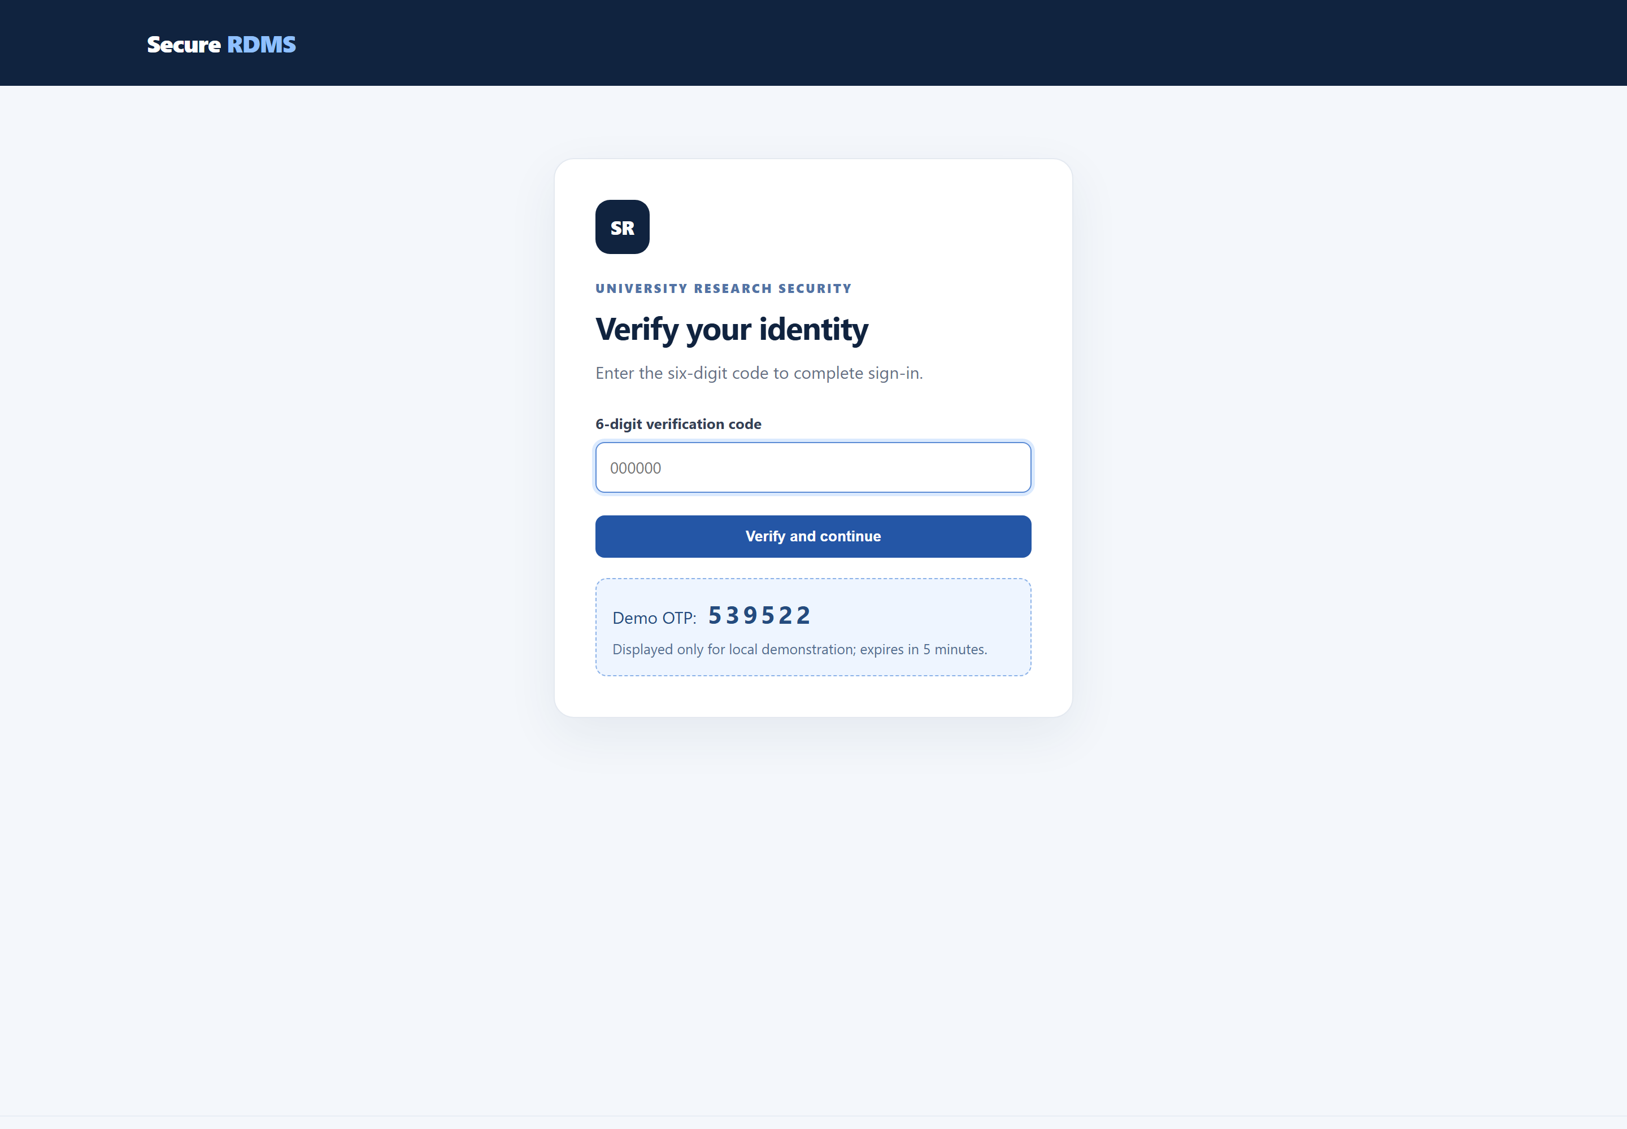
Figure 3.2.2 MFA verification screen

3.2.3 Dashboard
The dashboard provides an overview of research files, active users, today's audit events and open security alerts, followed by the most recent files and audit activity. Researchers see a reduced view containing only their own files.
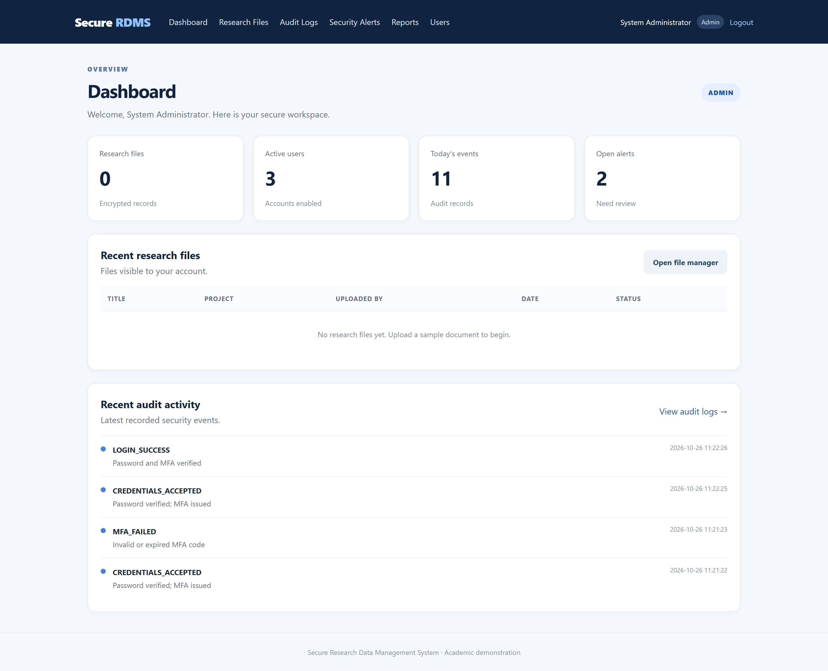
Figure 3.2.3 Administrator dashboard

3.2.4 Research File Management
Researchers and administrators can upload a titled file with a project code and description. The file is encrypted before it is written to disk. The table lists only the documents the signed-in user is permitted to see and offers an authorised download action.
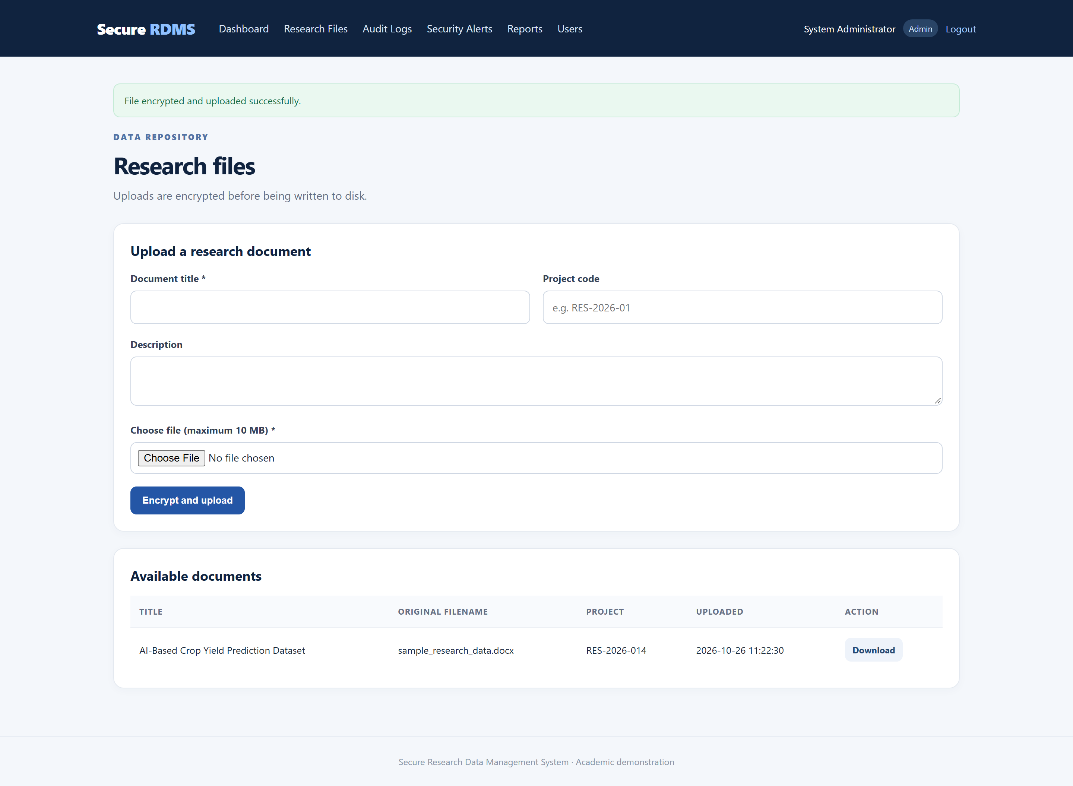
Figure 3.2.4 Research file management interface

3.2.5 Audit Logs
Administrators can review a chronological list of logins, uploads, downloads, role changes and access failures. Events can be filtered by action keyword and by success or failure status.
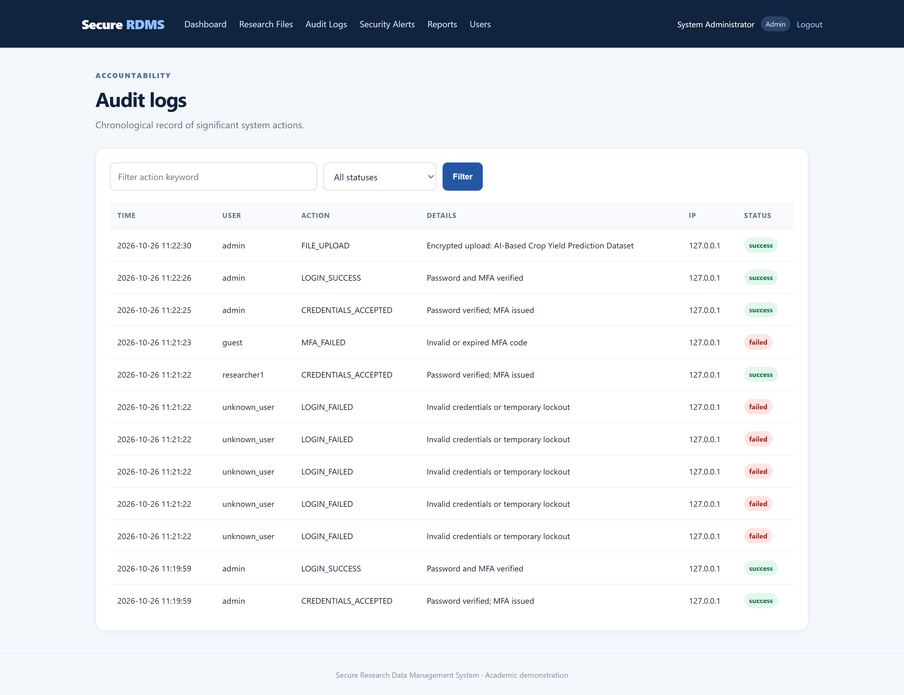
Figure 3.2.5 Audit log interface

3.2.6 Security Alerts
Suspicious authentication activity is presented as an alert with a severity rating. Repeated failed logins generate a high-severity brute-force alert, while invalid MFA codes generate a medium-severity alert. Administrators can mark alerts as resolved.
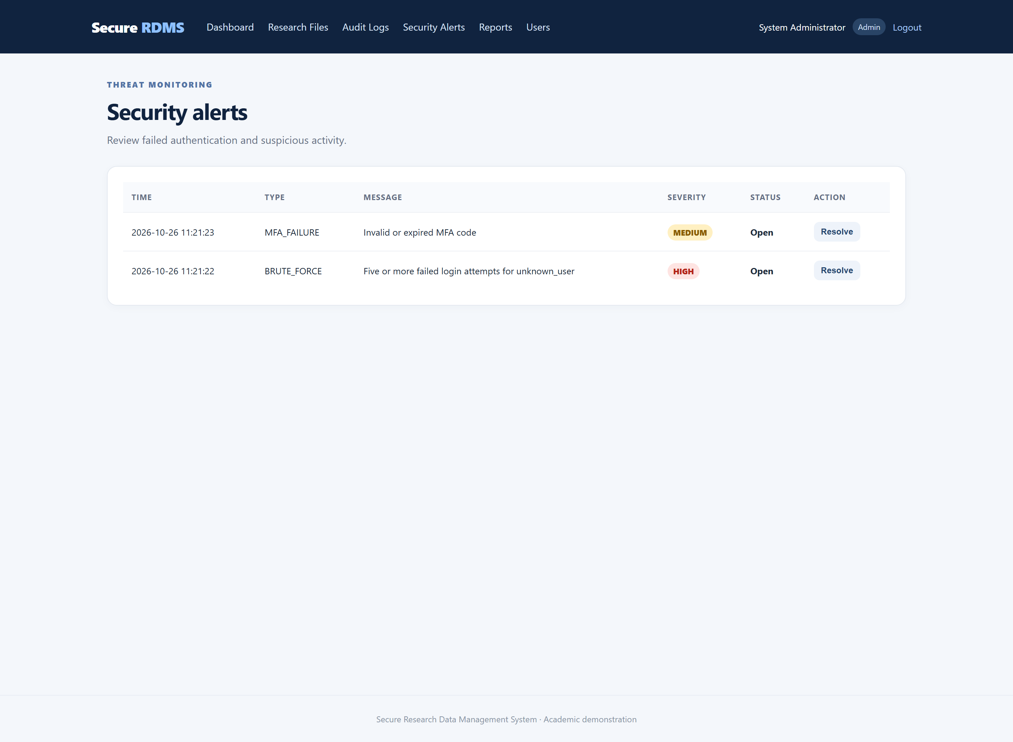
Figure 3.2.6 Security alerts interface

3.2.7 Security Reports
The reports page aggregates successful and failed logins, file uploads and downloads, MFA failures and open alerts. It also ranks the most active users and breaks activity down by action type.
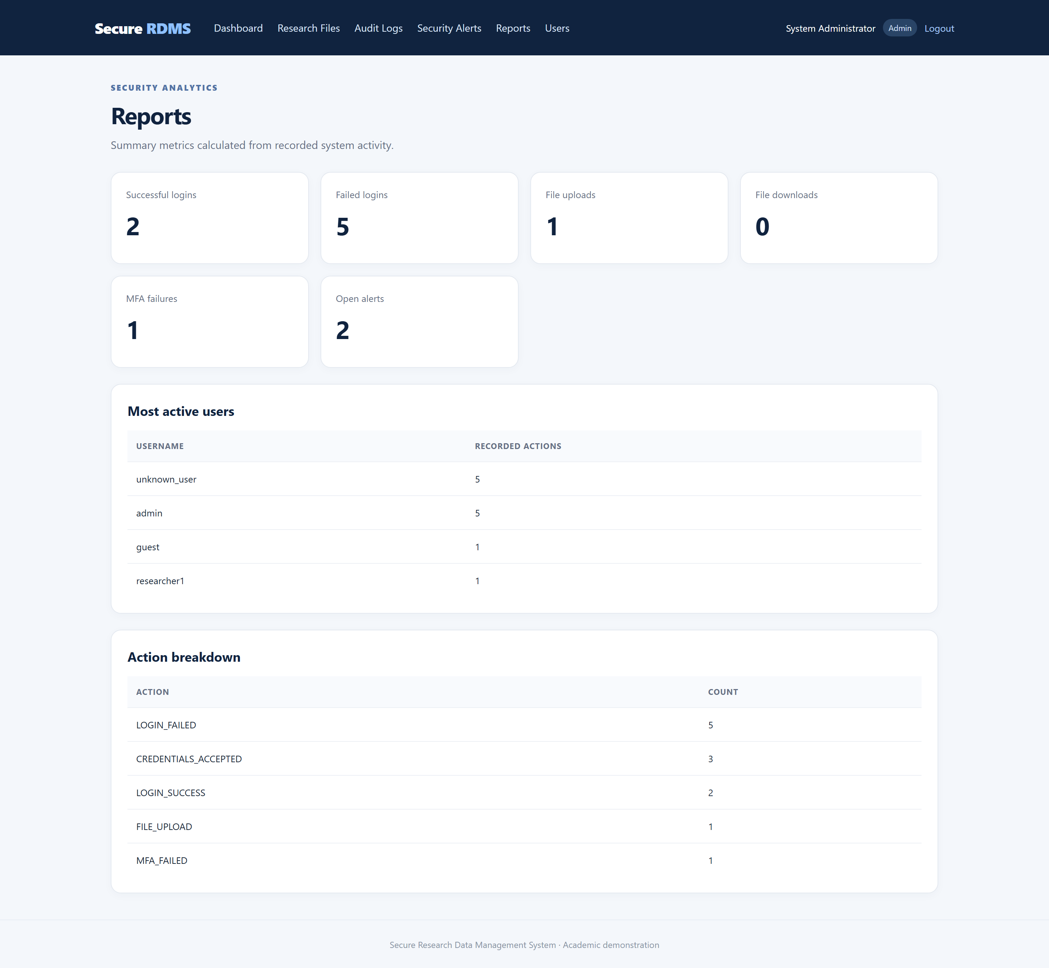
Figure 3.2.7 Security reports interface

3.2.8 User Management
Administrators can create accounts, assign one of the three roles and activate or deactivate an account. Password length and role values are validated before insertion, and the current administrator cannot deactivate their own account.
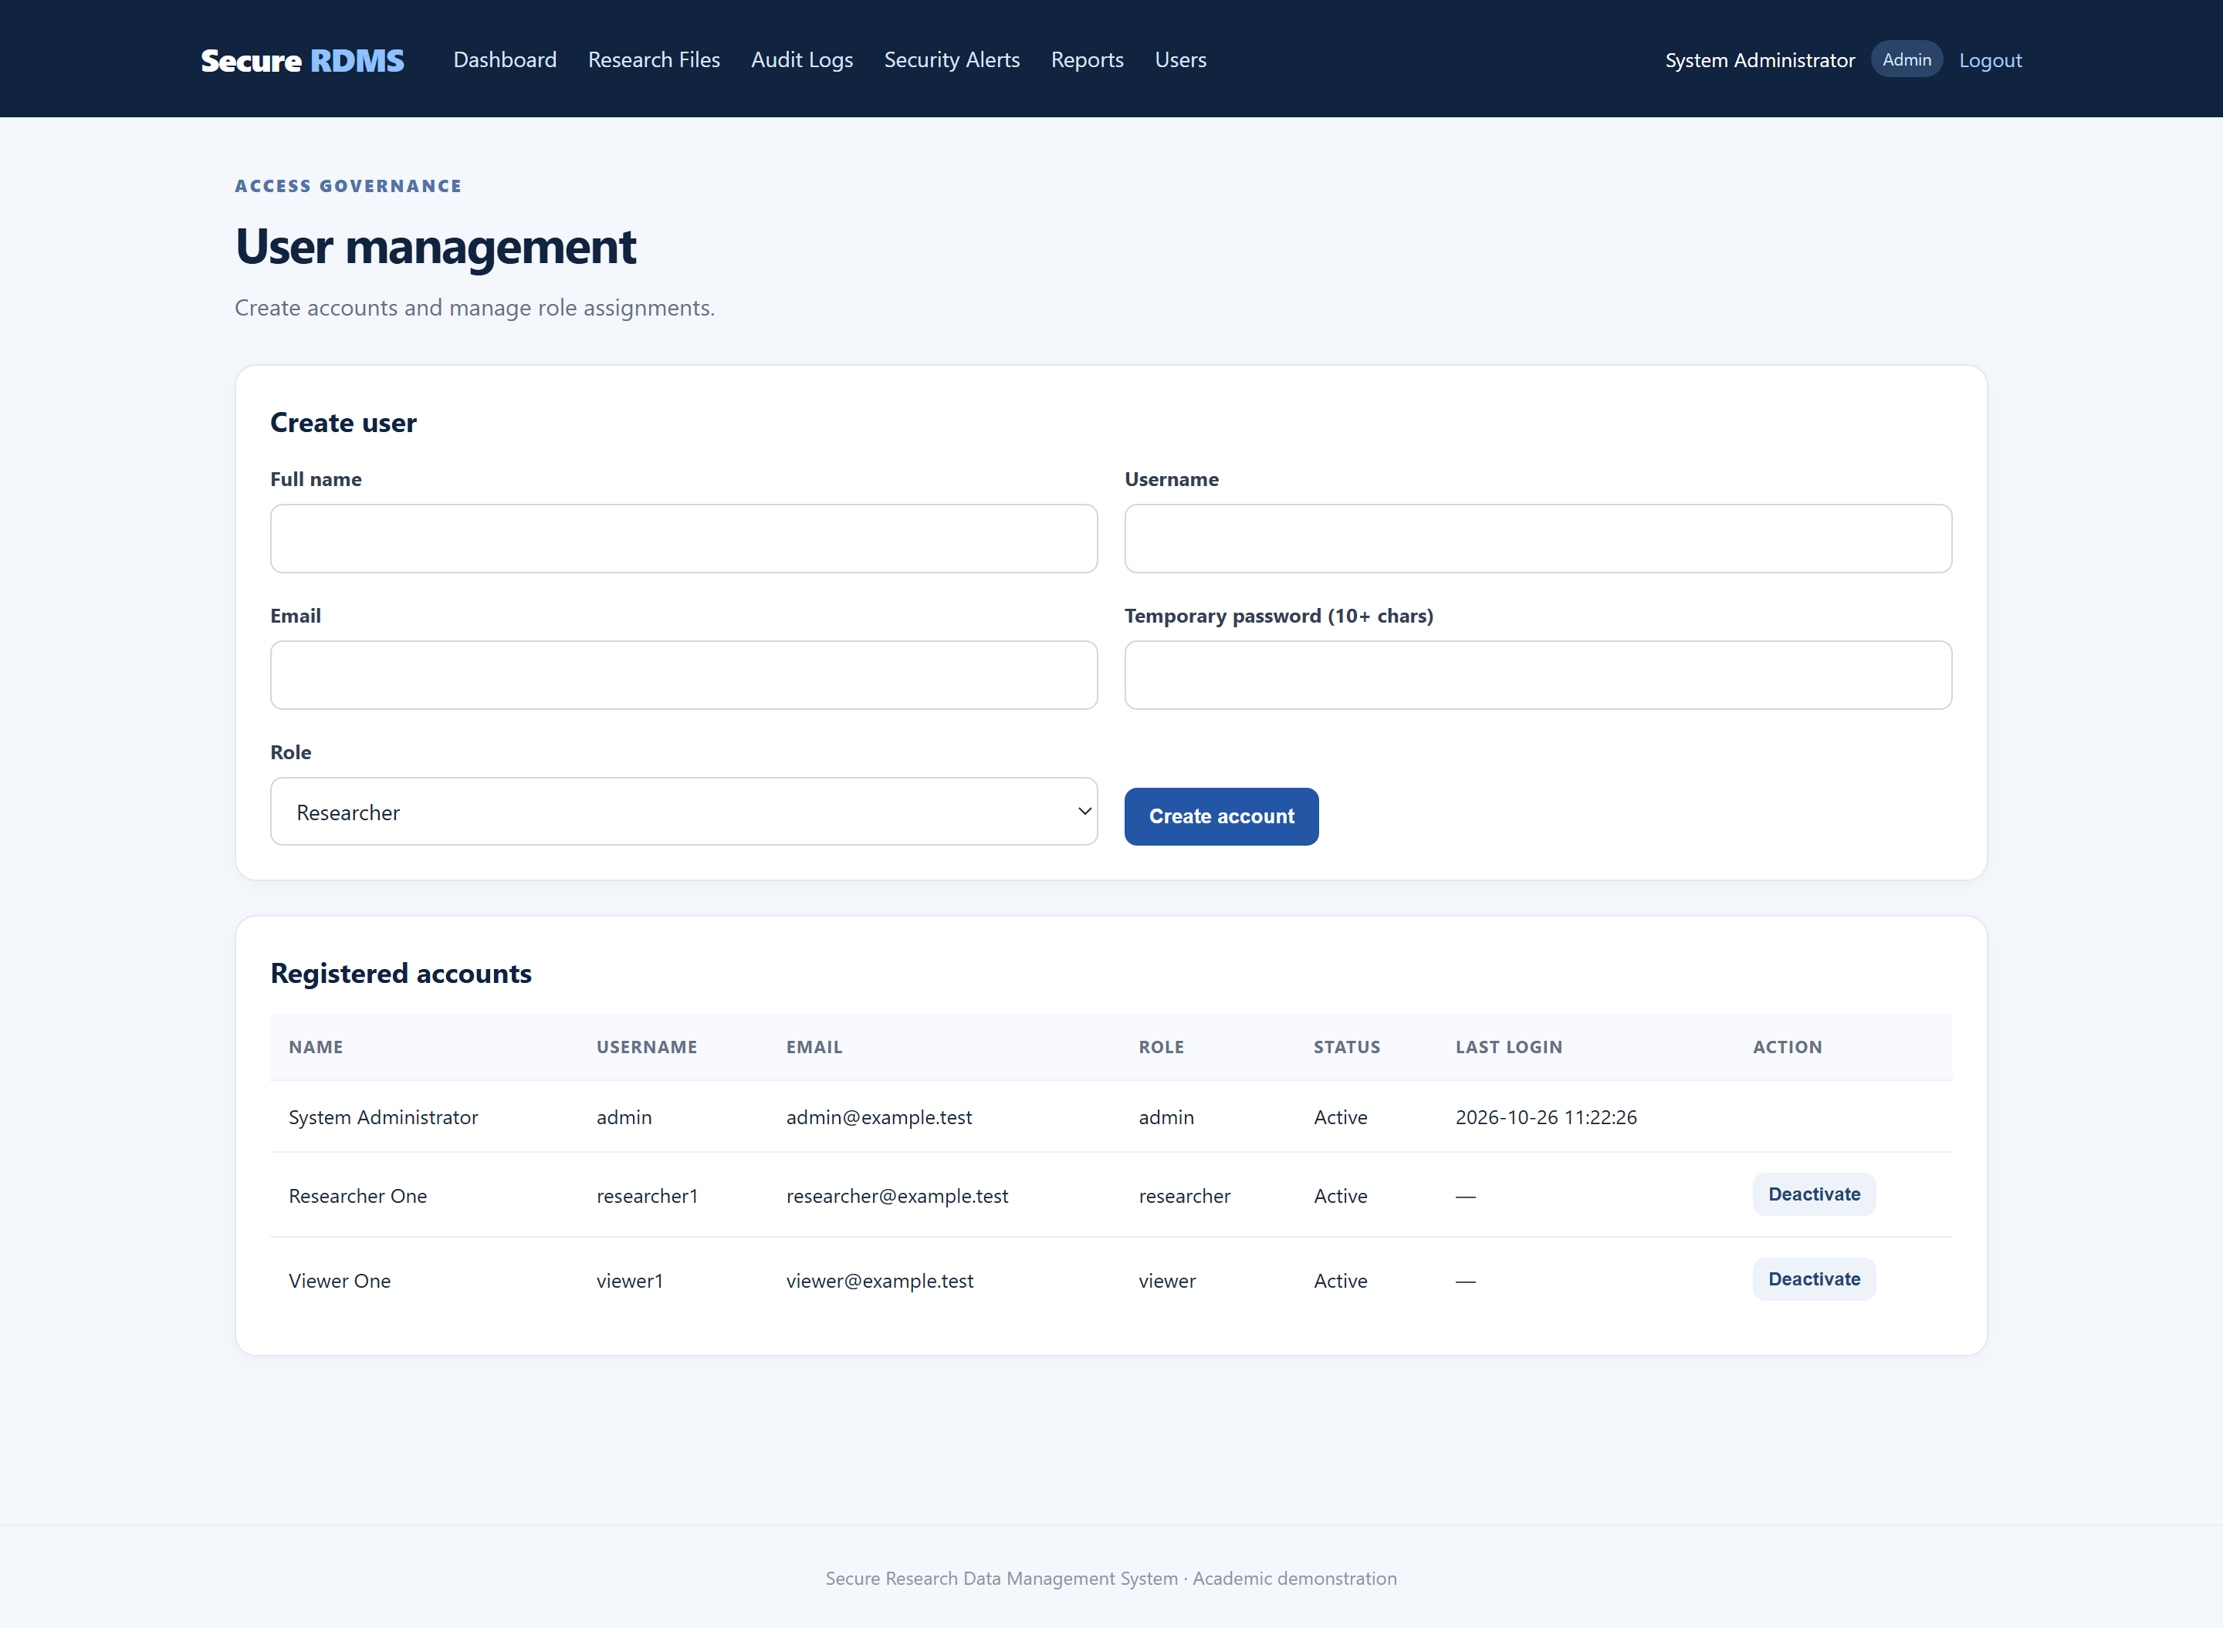
Figure 3.2.8 User management interface

3.3 Logic Development
The application follows a simple front-controller pattern. Each page includes a shared helper file that starts the session, connects to MySQL, provides CSRF protection, enforces roles, encrypts files and writes audit events. The following sections present the logic and the complete source code. Every screenshot is taken directly from the files in the project repository.

3.3.1 Routing and Application Entry Point
index.php is the entry point. It loads the shared helpers and redirects an authenticated user to the dashboard and a guest to the login page.
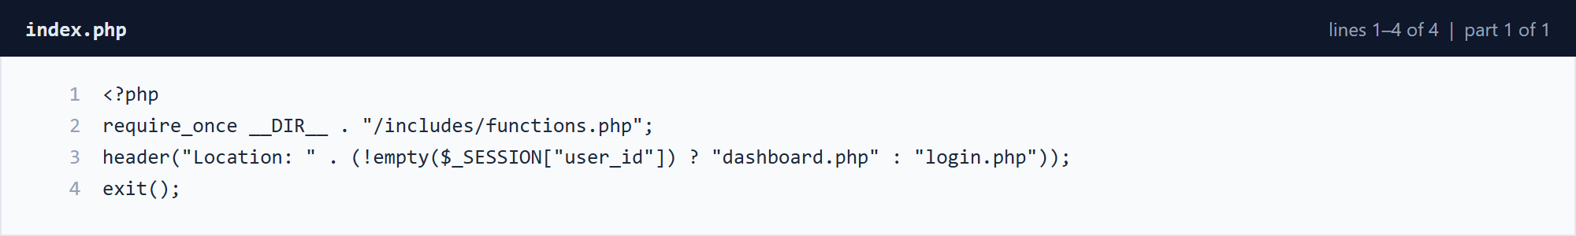
Figure 3.3.1 index.php â€” lines 1â€“4 (part 1 of 1)

3.3.2 Database Connection and Schema
The database layer connects to MySQL, creates the database if it does not exist, creates the six application tables and seeds three demonstration accounts on first run. The SQL schema is also provided as a standalone import file for phpMyAdmin or the mysql client.
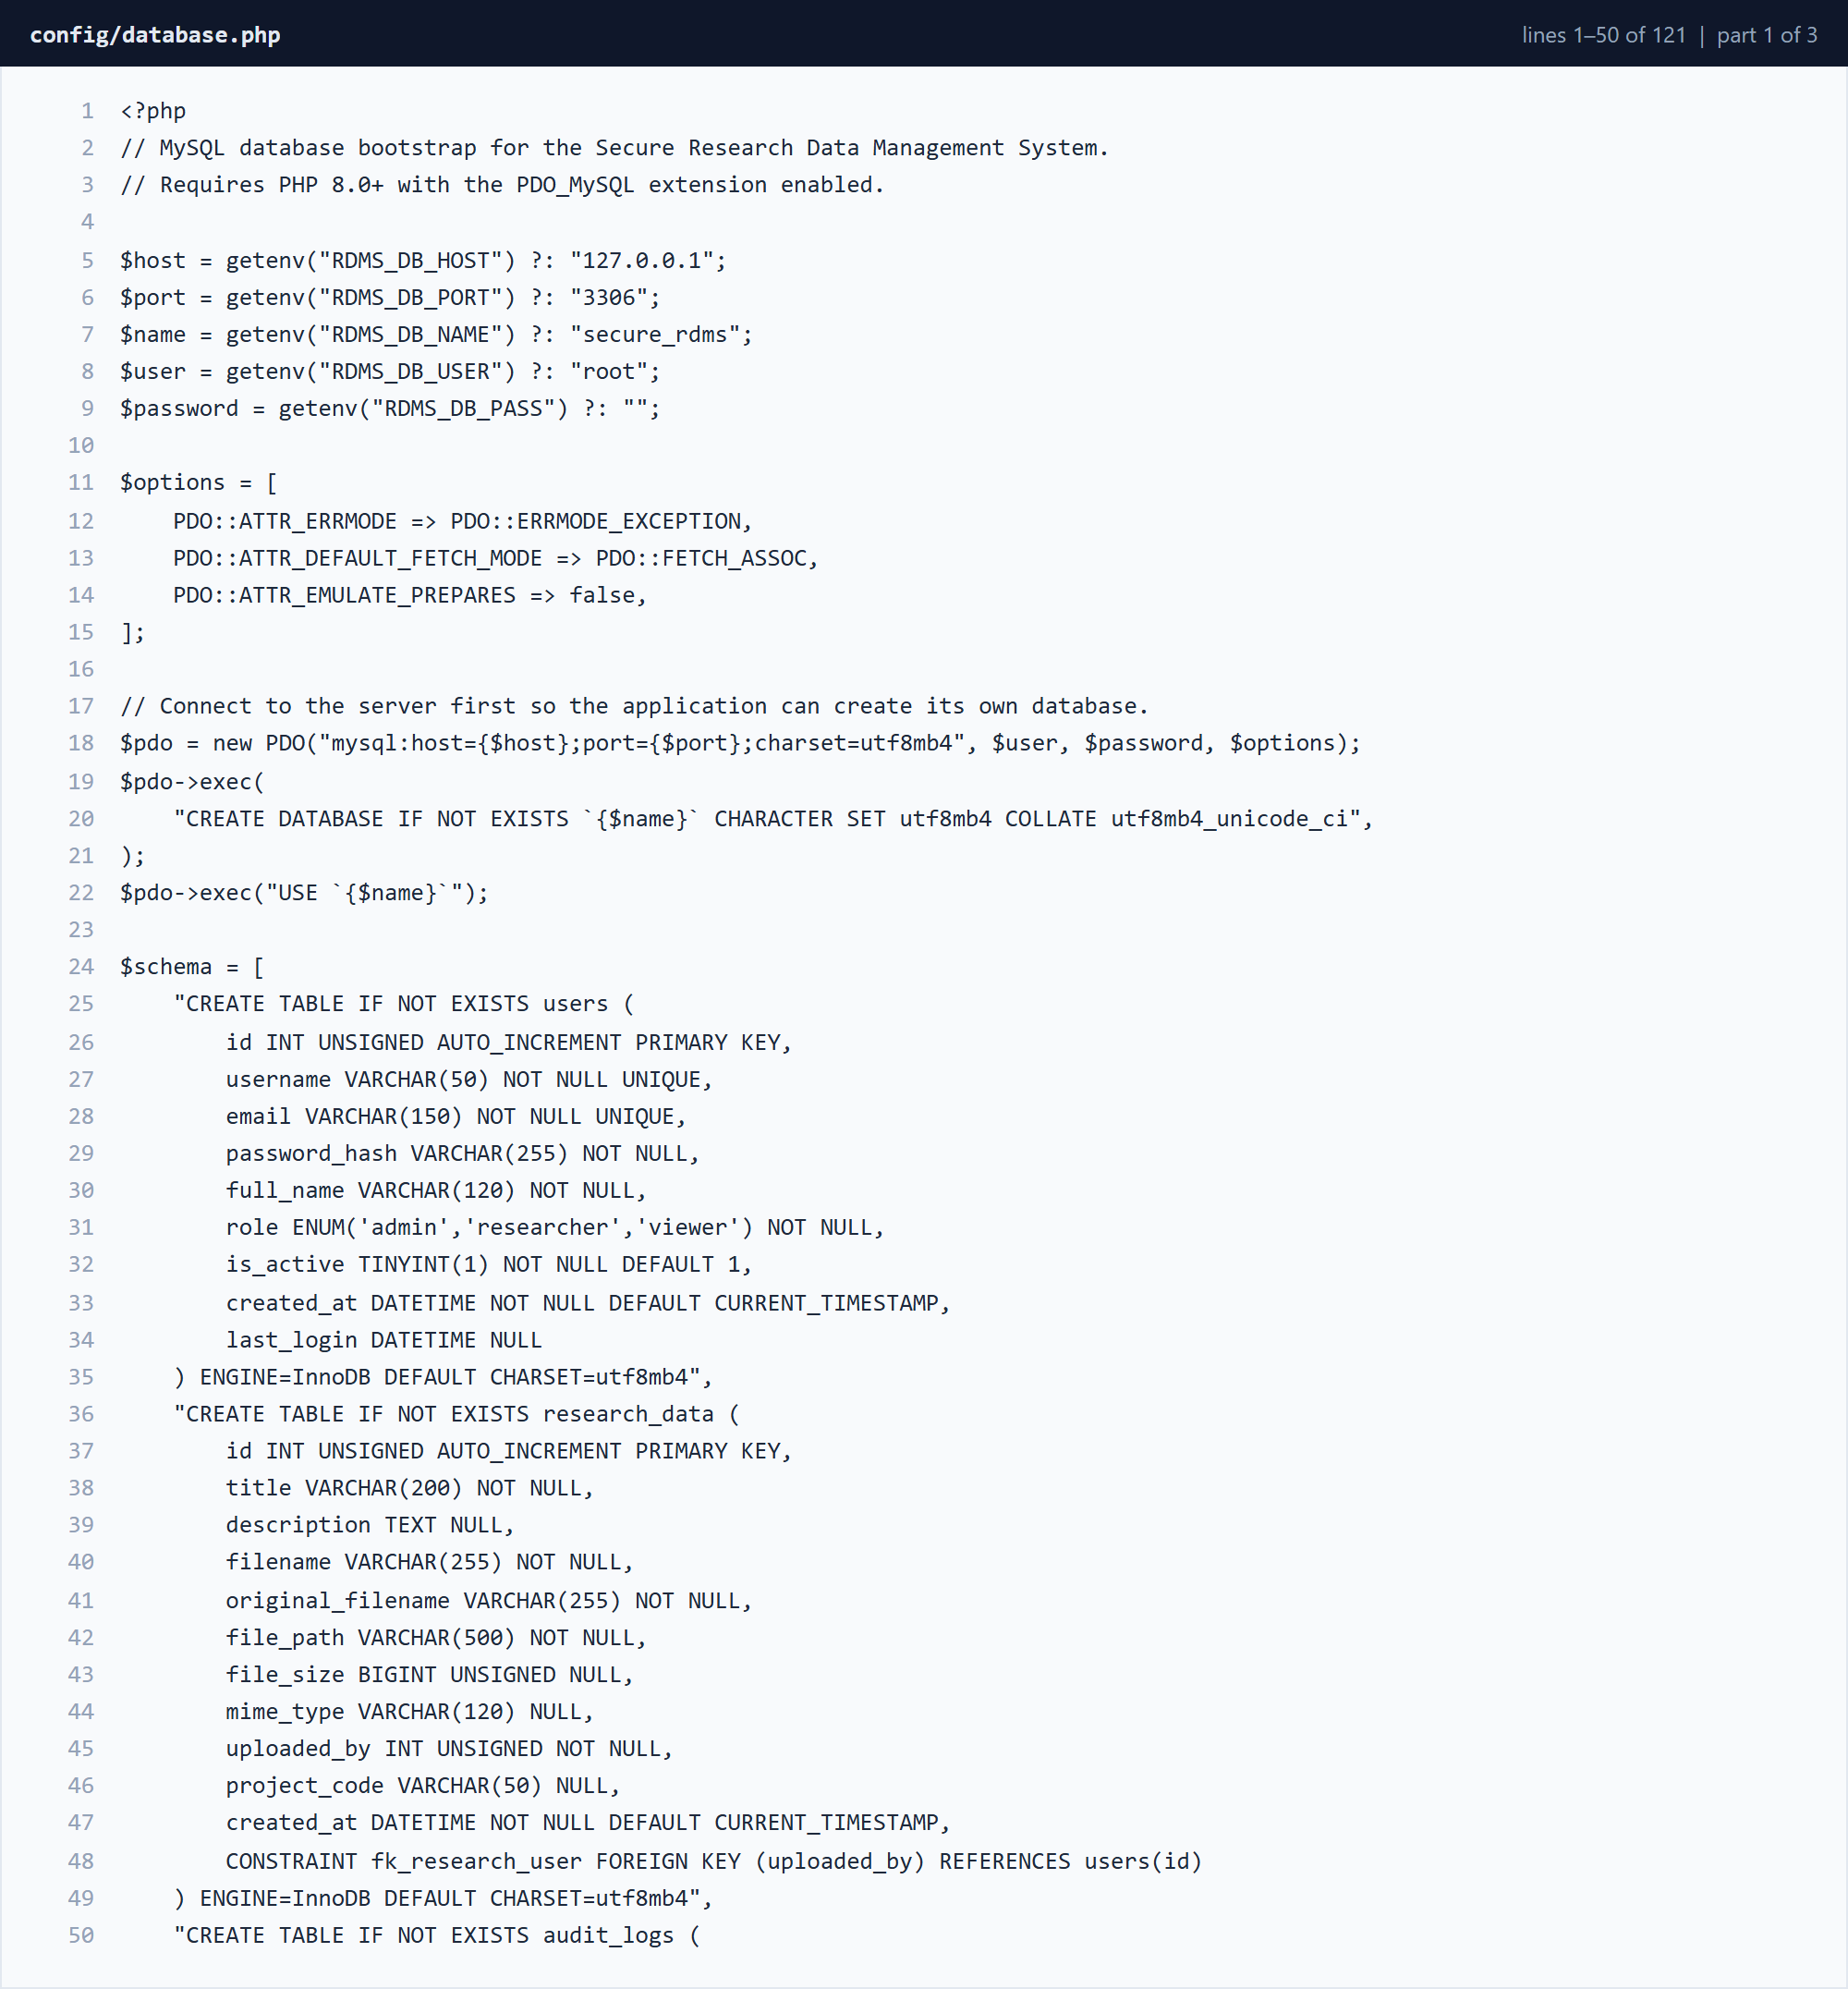
Figure 3.3.2 config/database.php â€” lines 1â€“50 (part 1 of 3)
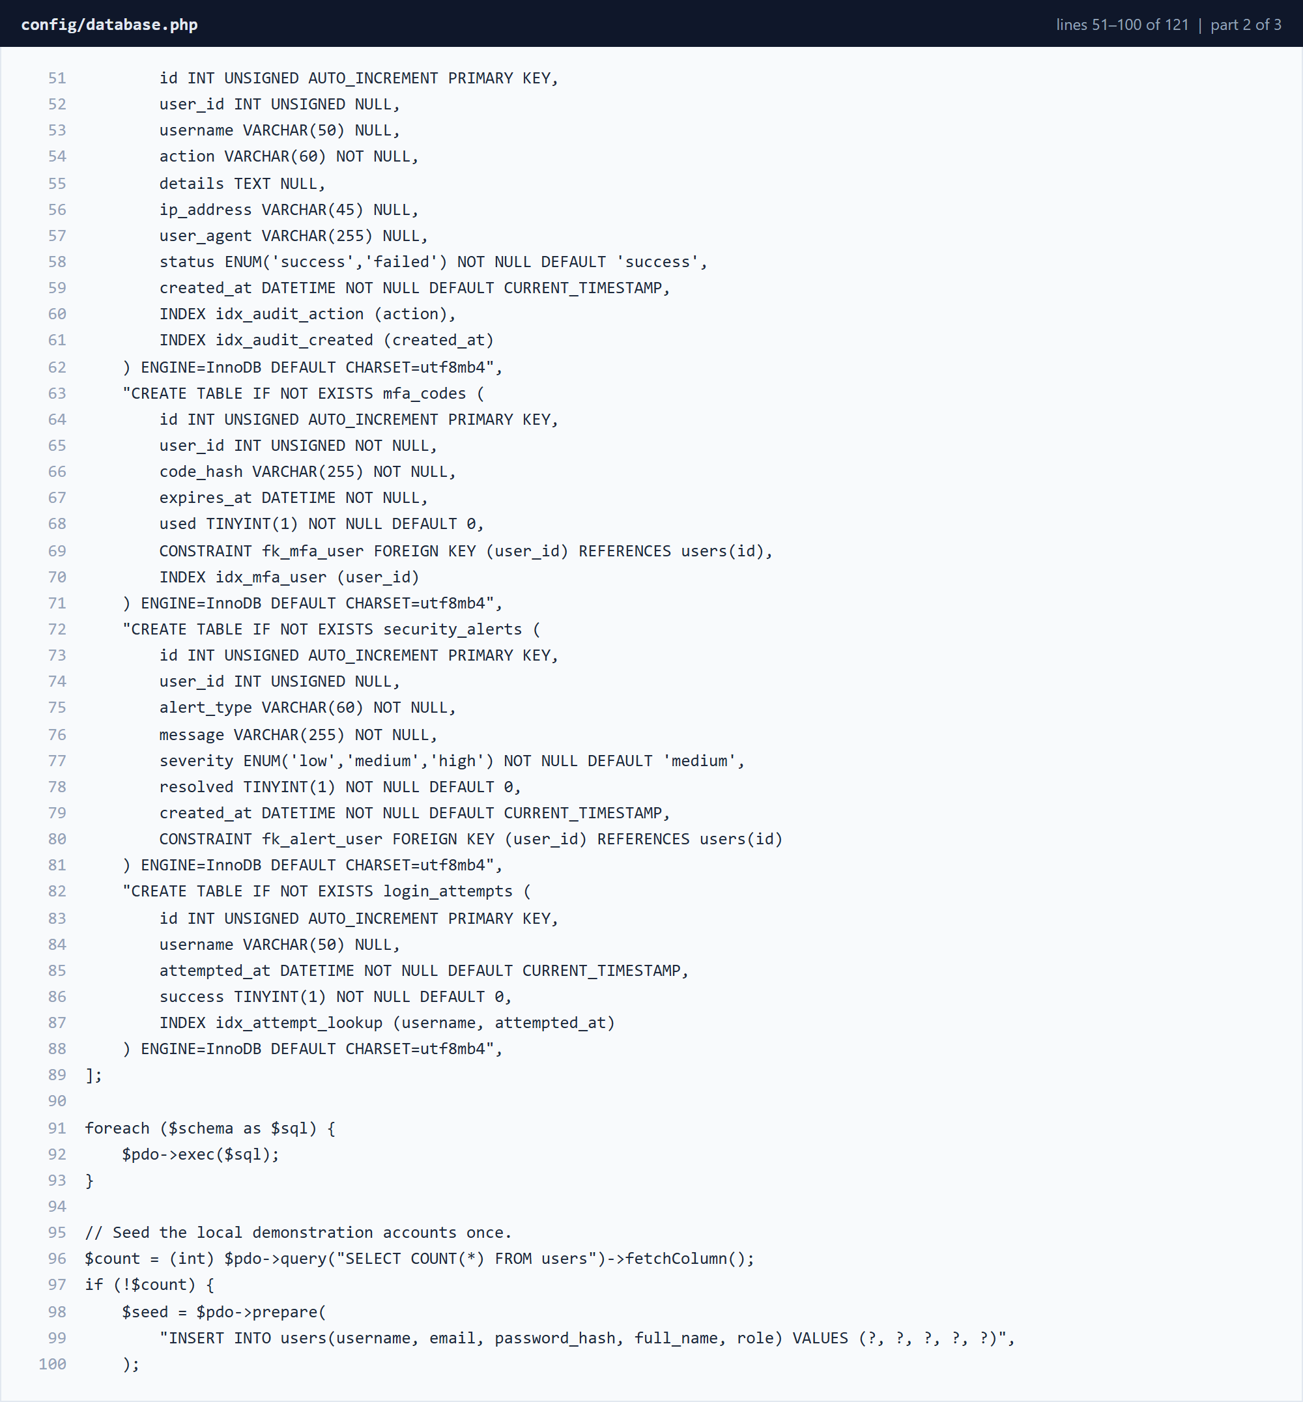
Figure 3.3.3 config/database.php â€” lines 51â€“100 (part 2 of 3)
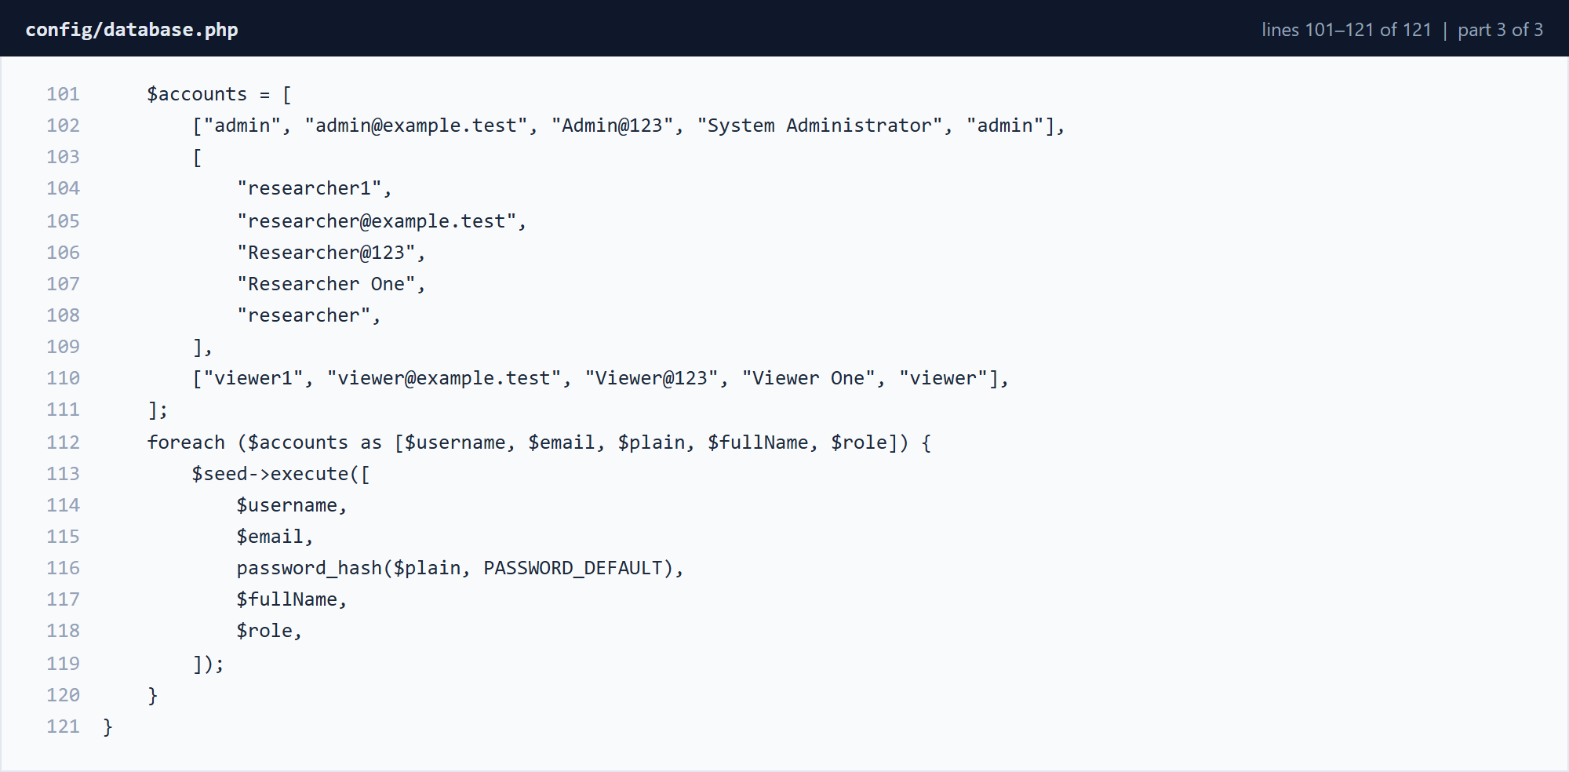
Figure 3.3.4 config/database.php â€” lines 101â€“121 (part 3 of 3)
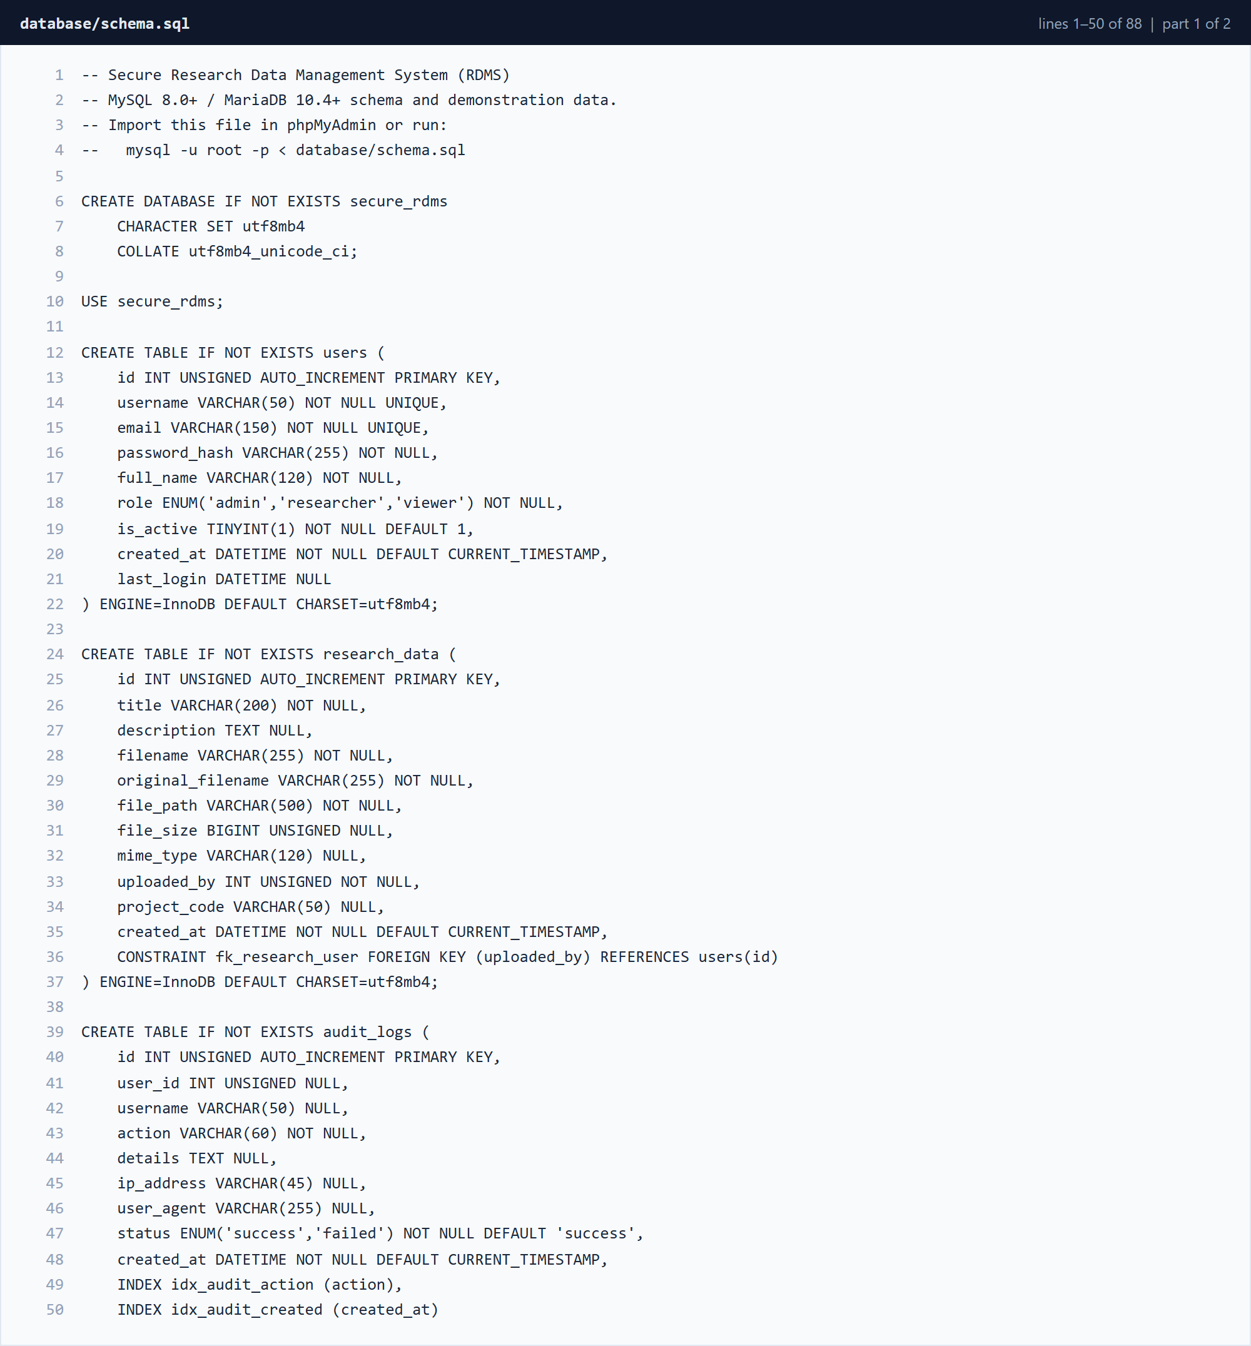
Figure 3.3.5 database/schema.sql â€” lines 1â€“50 (part 1 of 2)
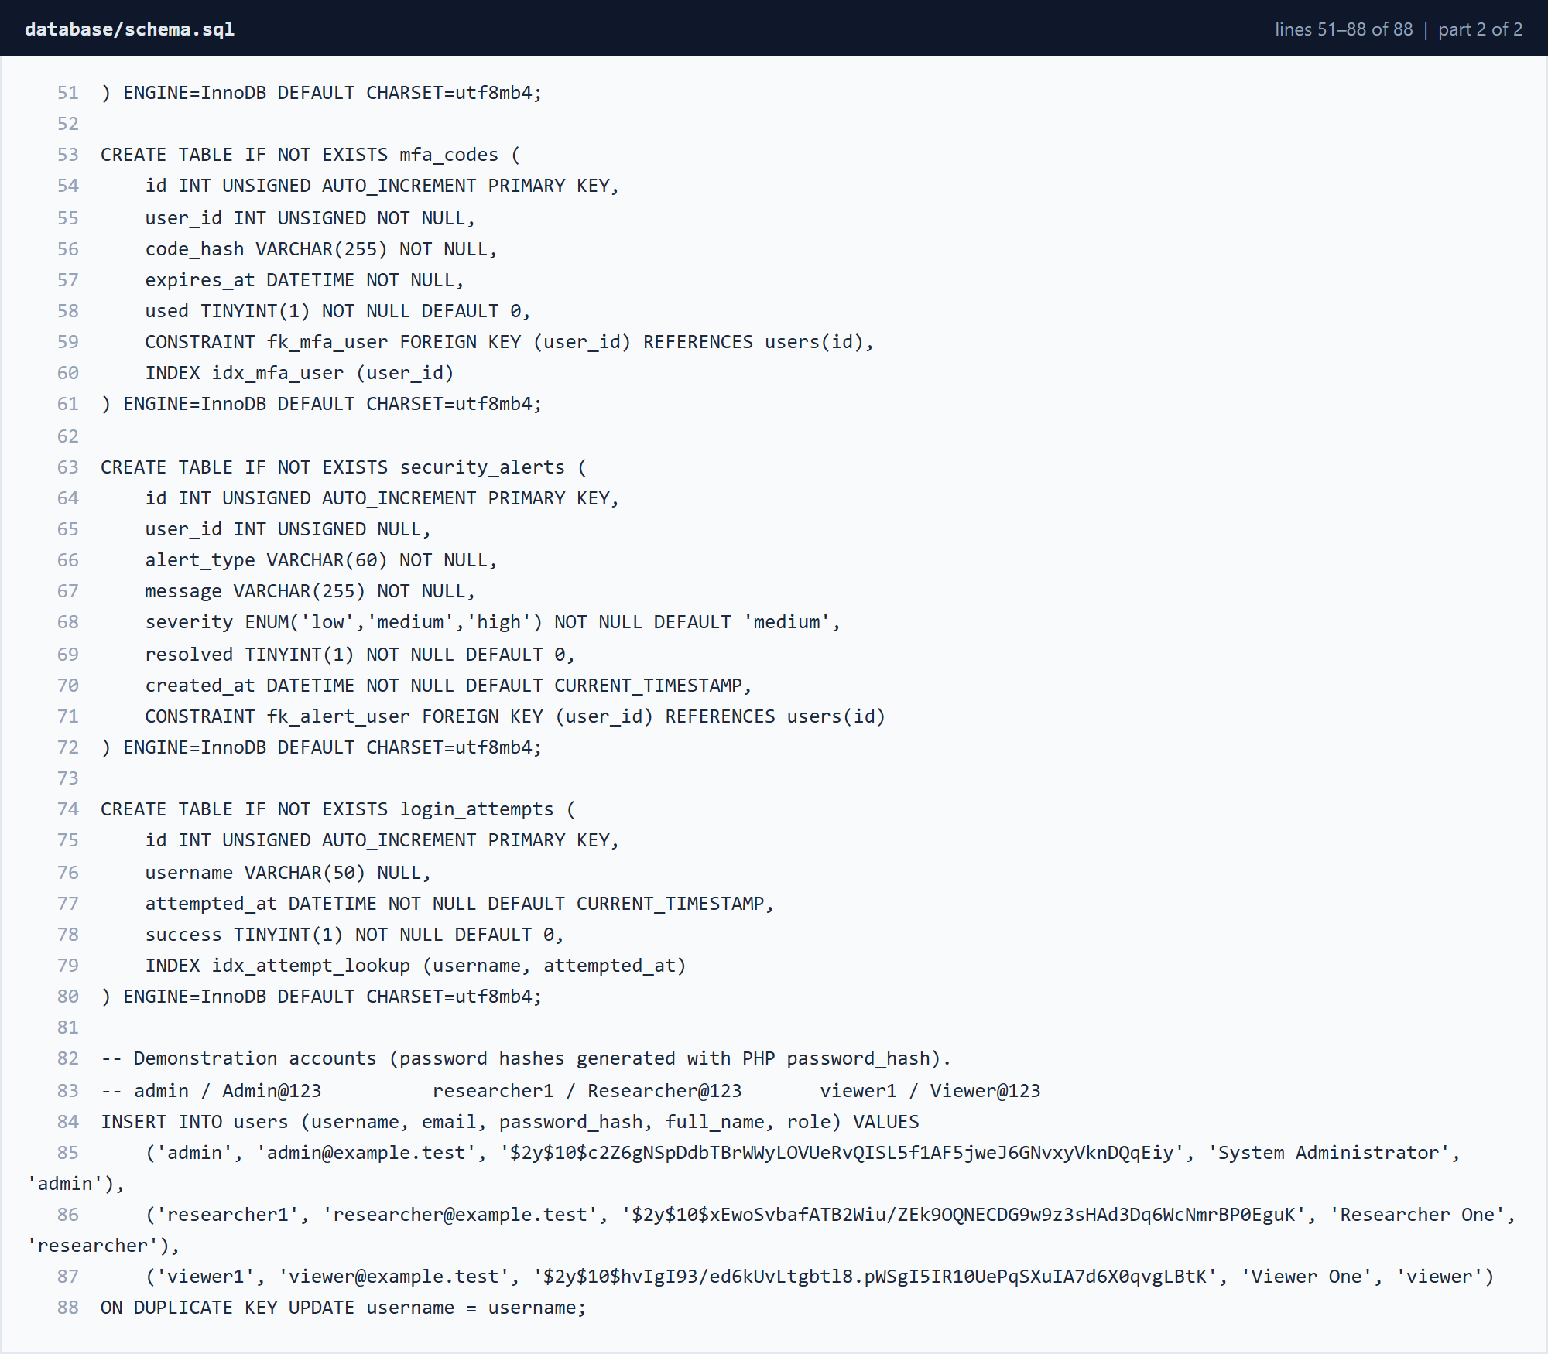
Figure 3.3.6 database/schema.sql â€” lines 51â€“88 (part 2 of 2)

3.3.3 Shared Security Helpers
includes/functions.php centralises the security controls used by every page: session naming, HTML escaping, audit logging, security alerts, login and role checks, CSRF token generation and verification, AES-256-CBC file encryption and decryption, and the shared page layout.
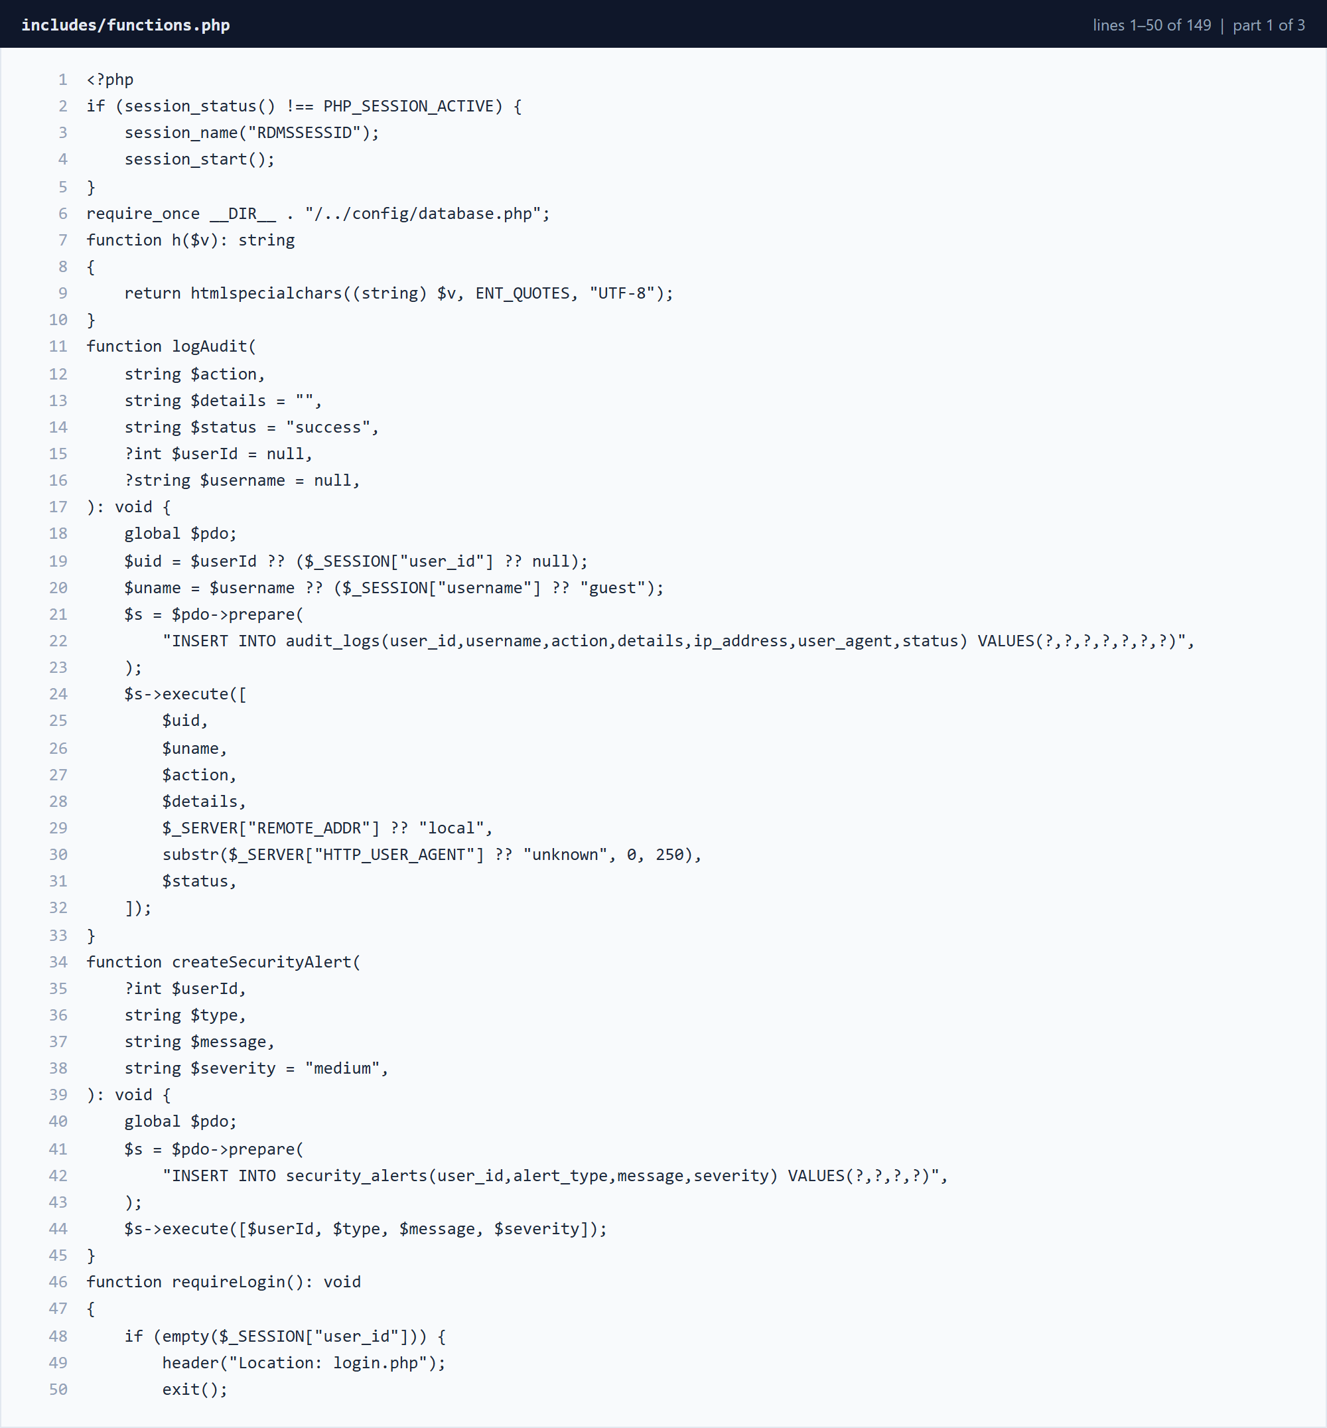
Figure 3.3.7 includes/functions.php â€” lines 1â€“50 (part 1 of 3)
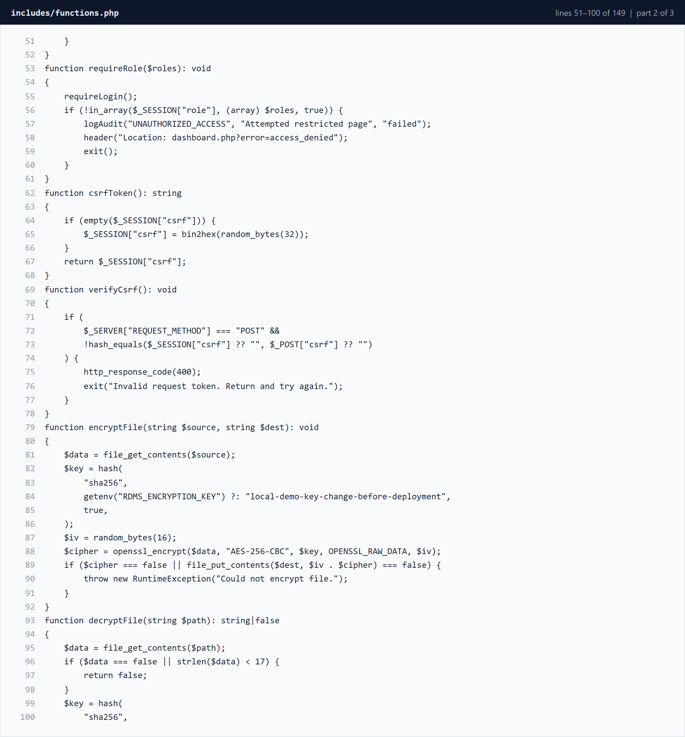
Figure 3.3.8 includes/functions.php â€” lines 51â€“100 (part 2 of 3)
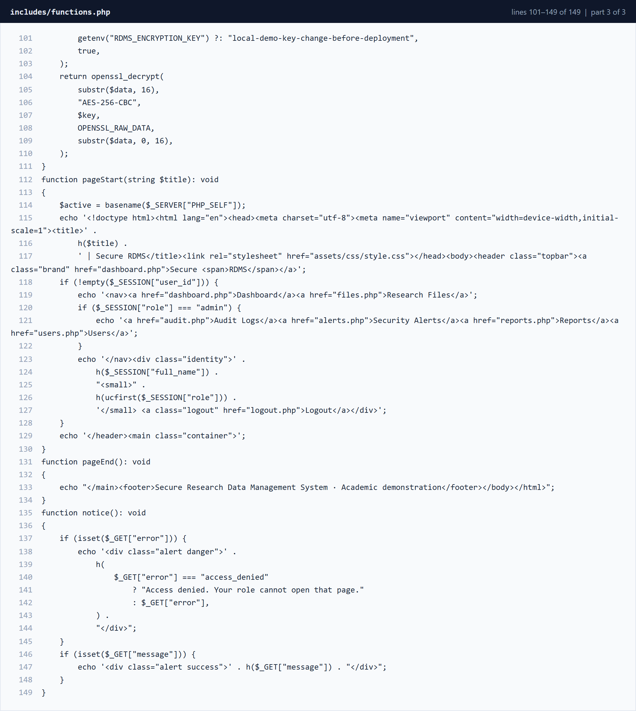
Figure 3.3.9 includes/functions.php â€” lines 101â€“149 (part 3 of 3)

3.3.4 Authentication and Multi-Factor Authentication
login.php verifies the password hash, counts recent failures, issues a five-minute one-time code and only creates the authenticated session after the code is verified. logout.php records the sign-out and destroys the session.
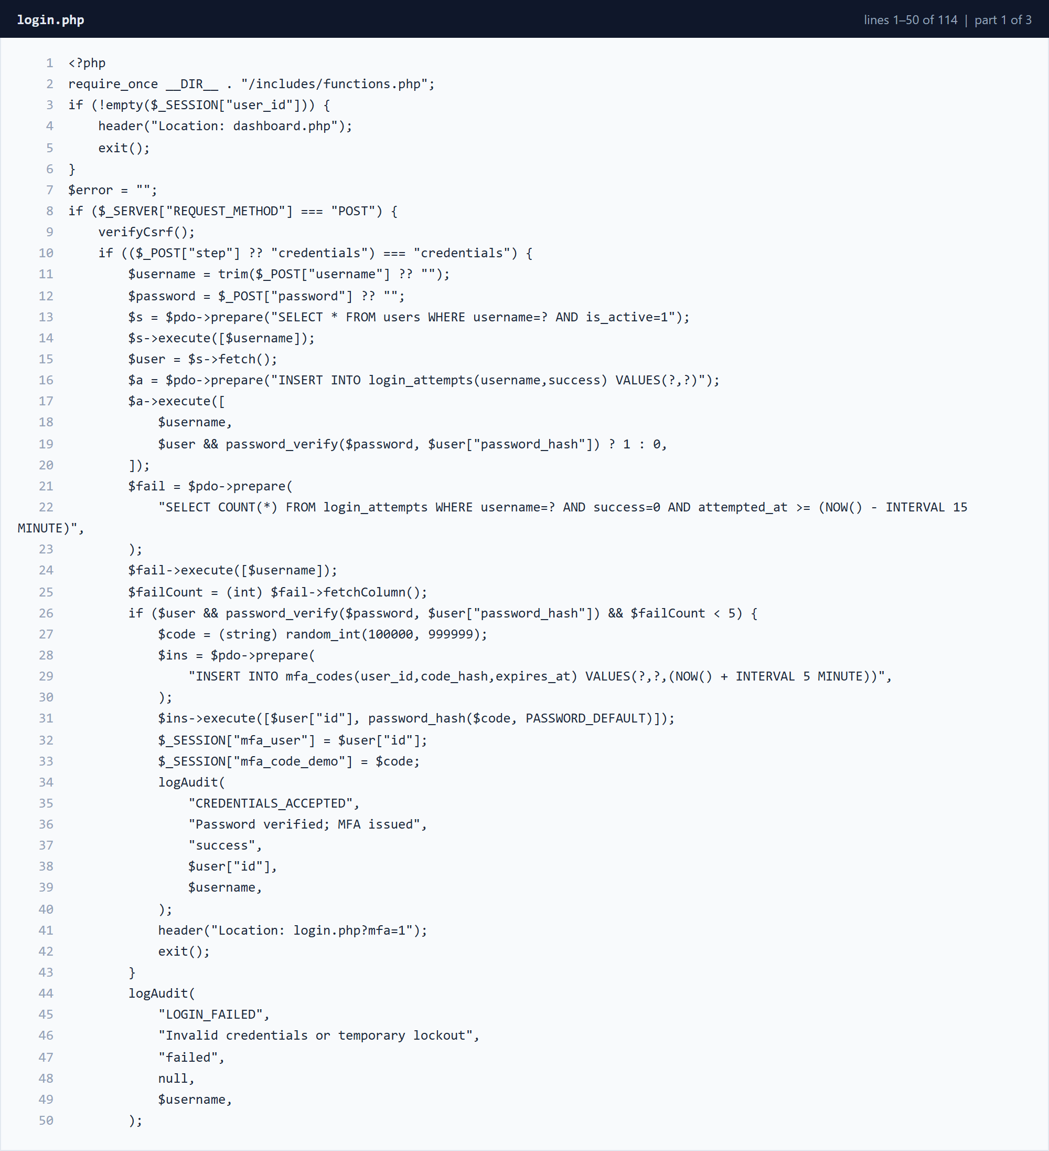
Figure 3.3.10 login.php â€” lines 1â€“50 (part 1 of 3)
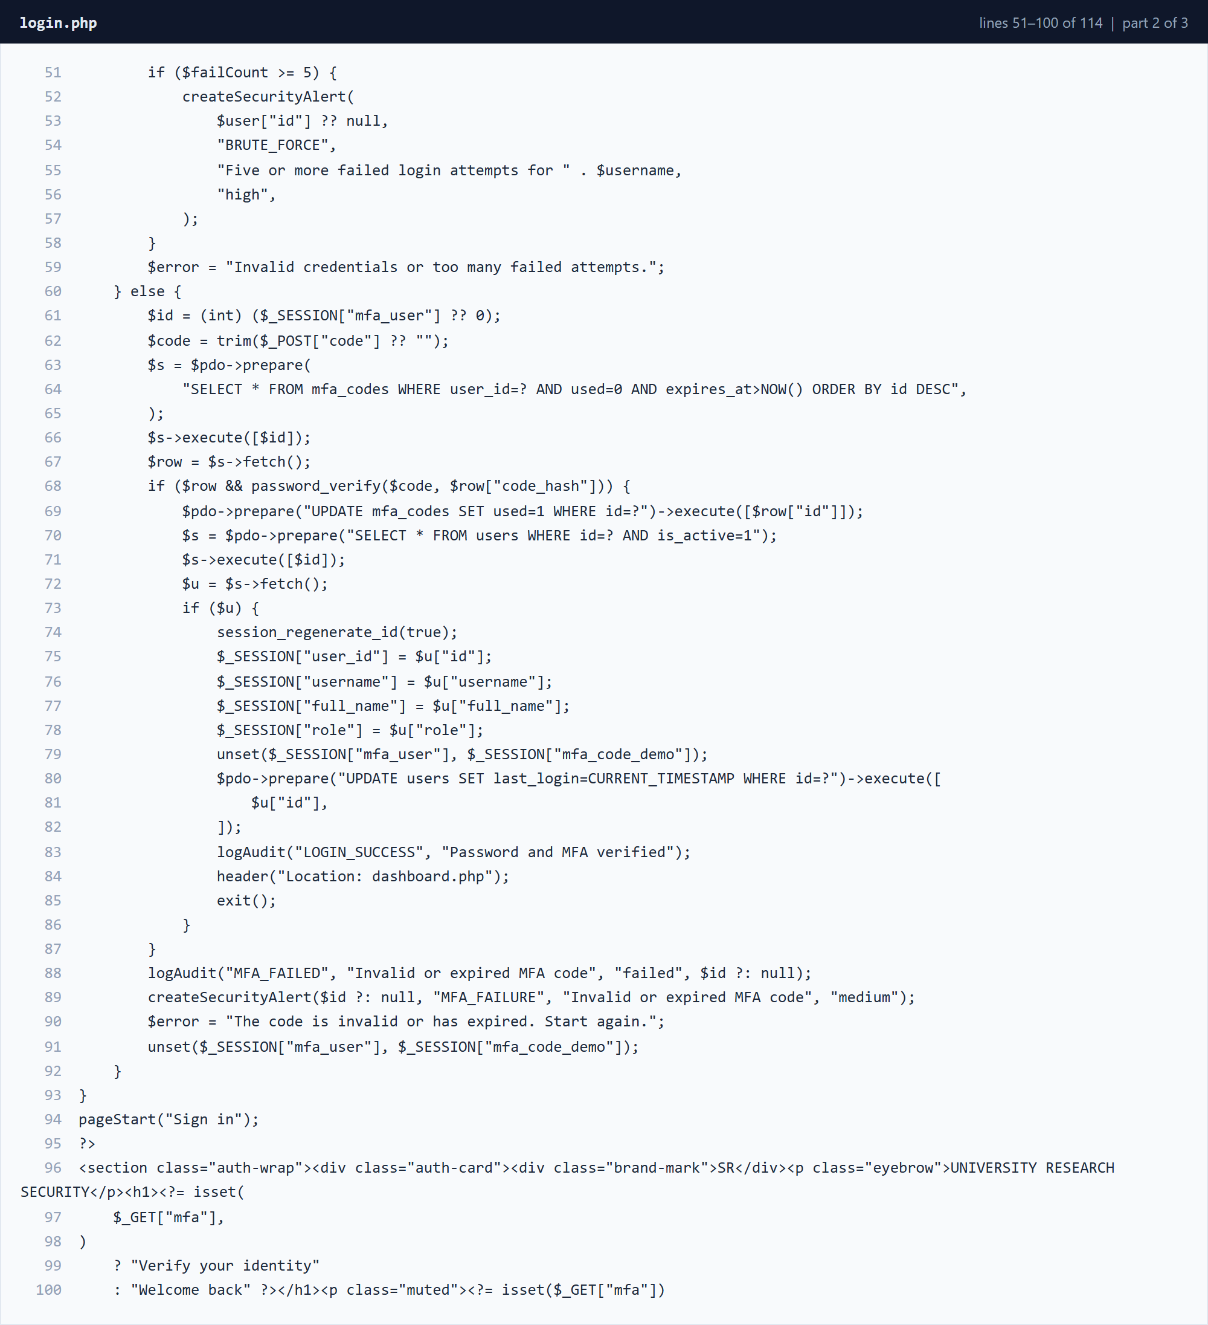
Figure 3.3.11 login.php â€” lines 51â€“100 (part 2 of 3)
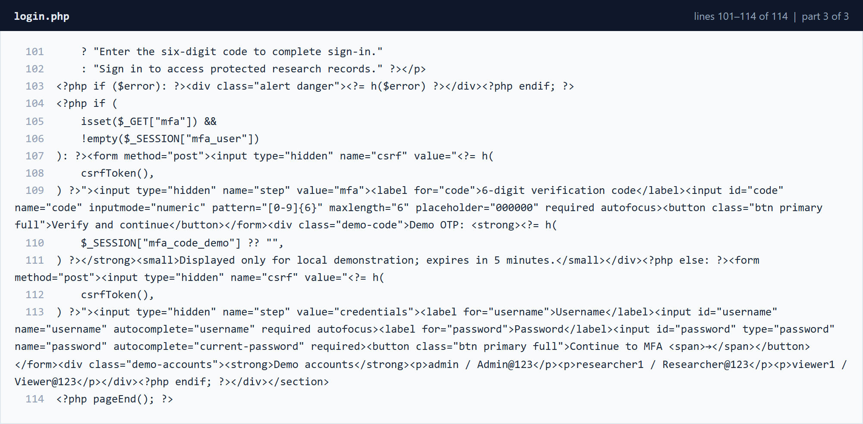
Figure 3.3.12 login.php â€” lines 101â€“114 (part 3 of 3)
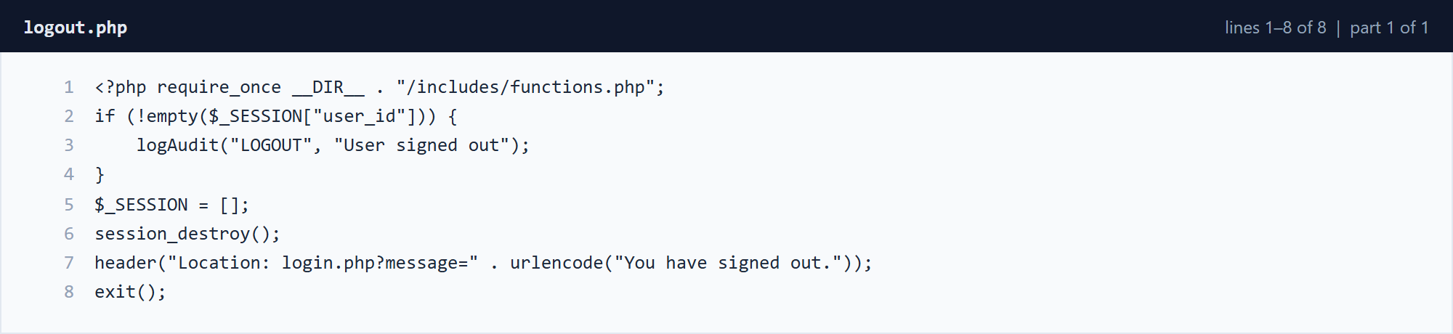
Figure 3.3.13 logout.php â€” lines 1â€“8 (part 1 of 1)

3.3.5 Research File Workflow
files.php validates uploads, encrypts the bytes before writing them to the uploads directory, stores metadata in MySQL and decrypts a file only after the role and ownership checks succeed.
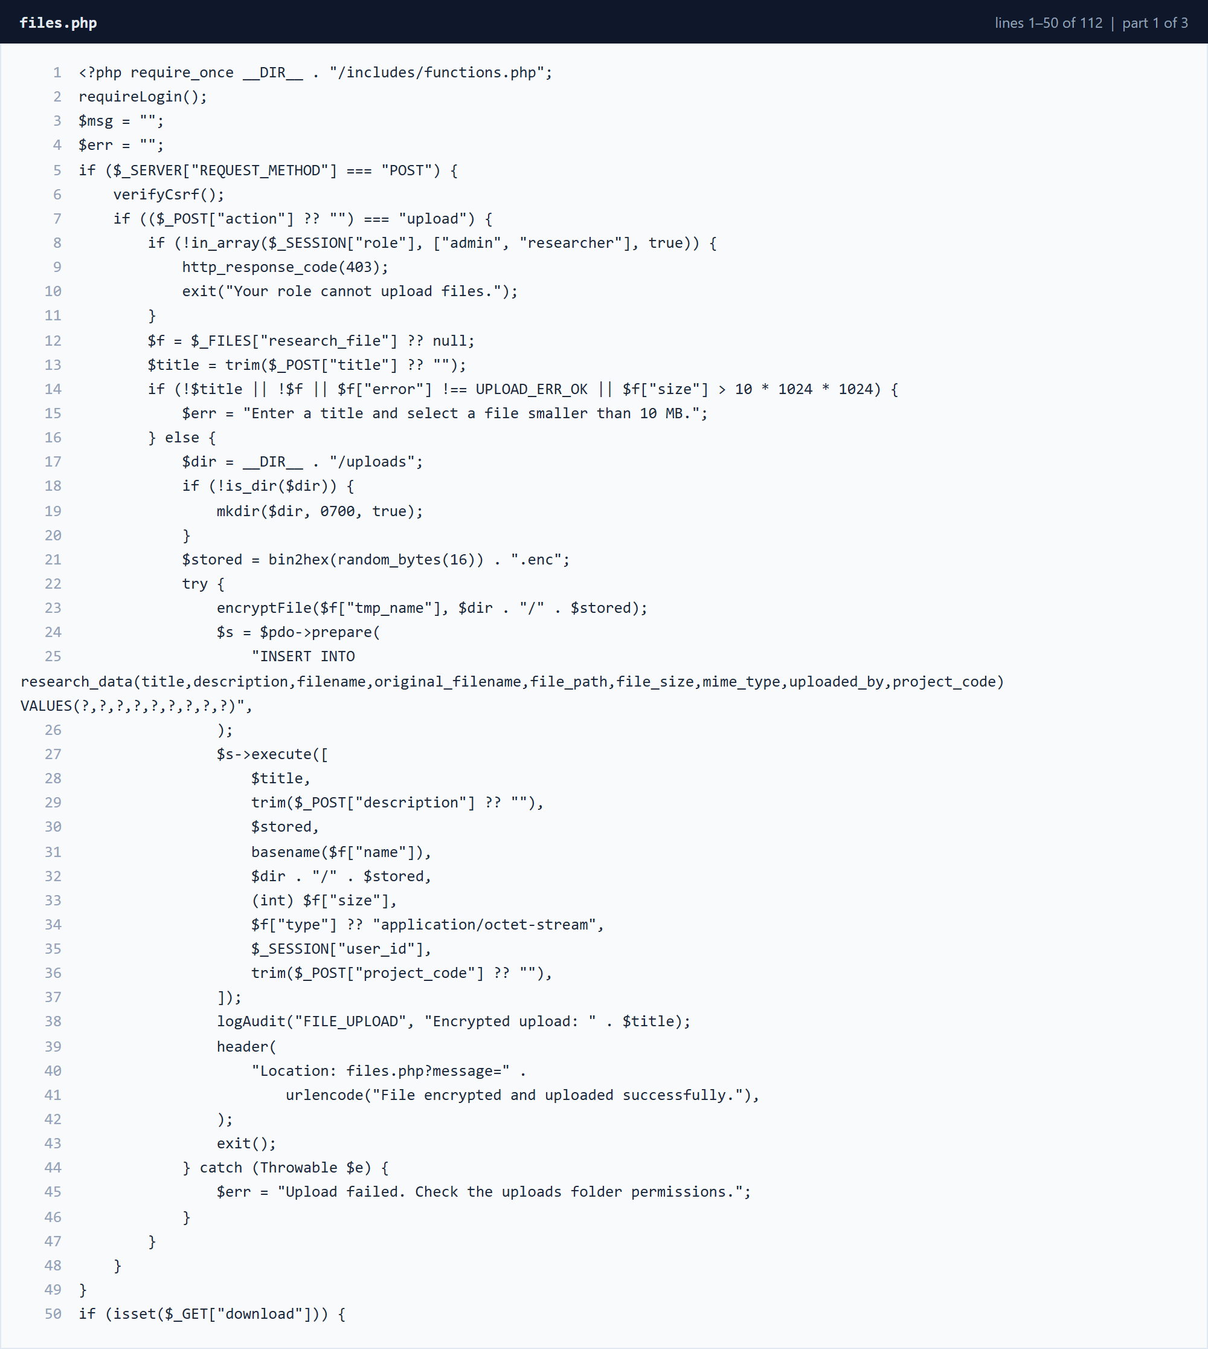
Figure 3.3.14 files.php â€” lines 1â€“50 (part 1 of 3)
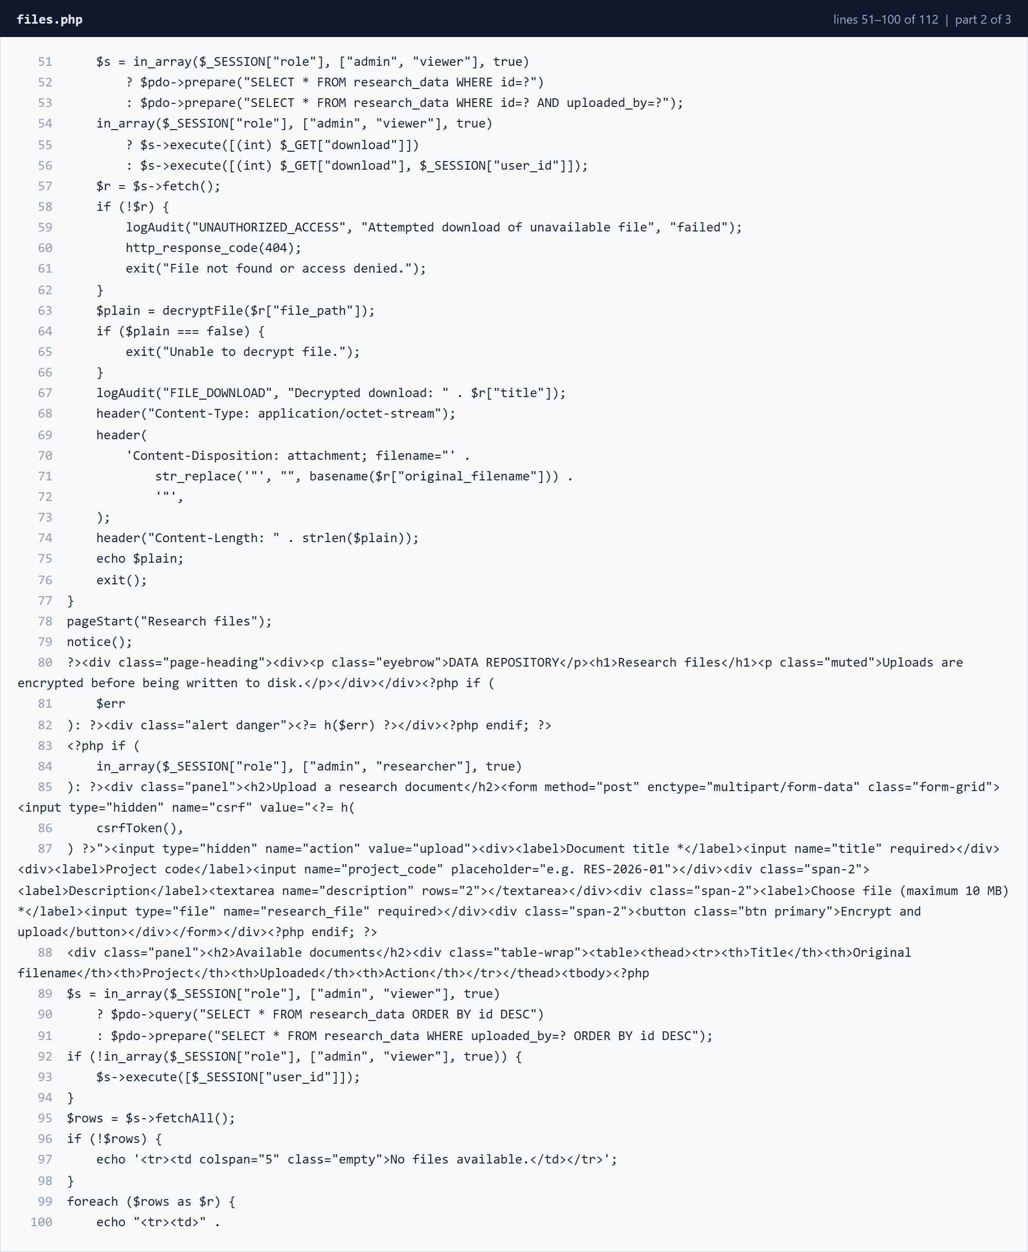
Figure 3.3.15 files.php â€” lines 51â€“100 (part 2 of 3)
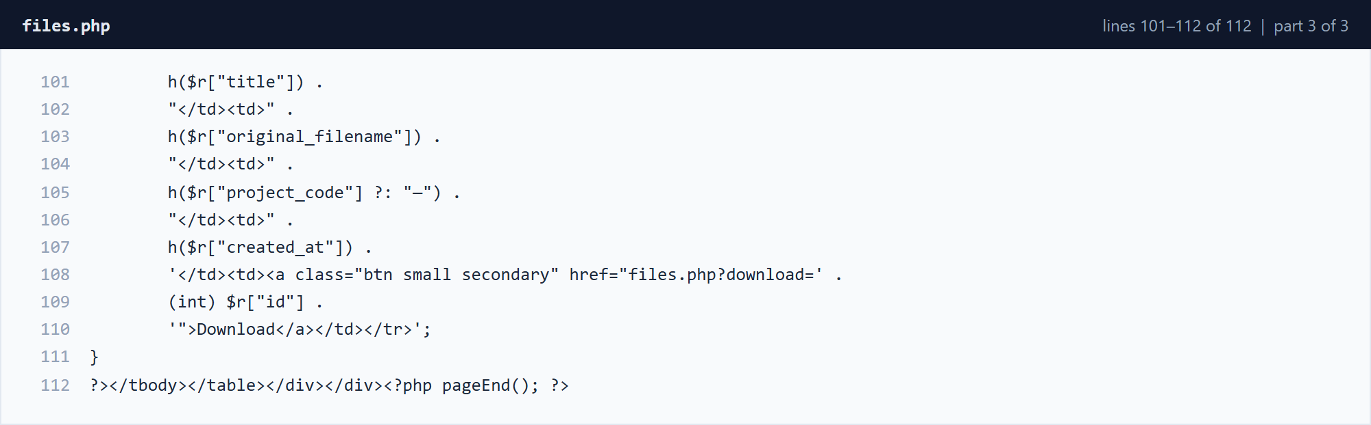
Figure 3.3.16 files.php â€” lines 101â€“112 (part 3 of 3)

3.3.6 Dashboard, Audit, Alerts and Reports
These pages present the operational and security information. dashboard.php provides role-aware summaries; audit.php supports event filtering; alerts.php allows an administrator to resolve alerts; and reports.php aggregates security metrics.
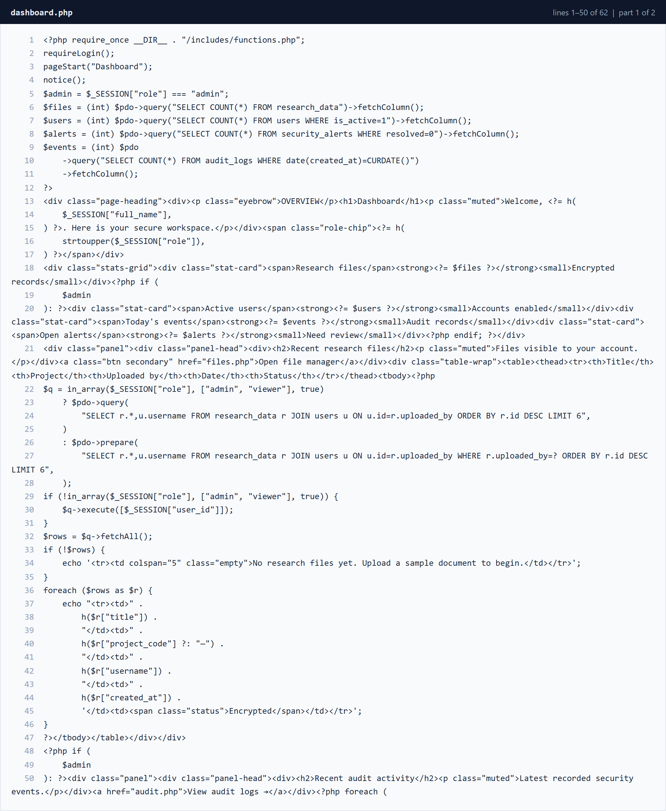
Figure 3.3.17 dashboard.php â€” lines 1â€“50 (part 1 of 2)
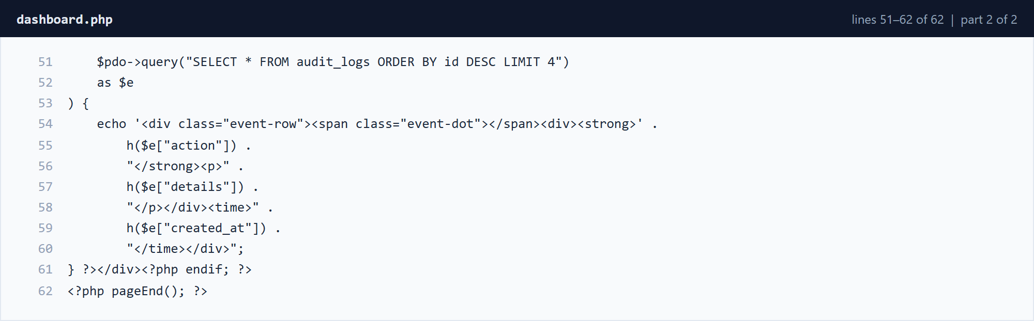
Figure 3.3.18 dashboard.php â€” lines 51â€“62 (part 2 of 2)
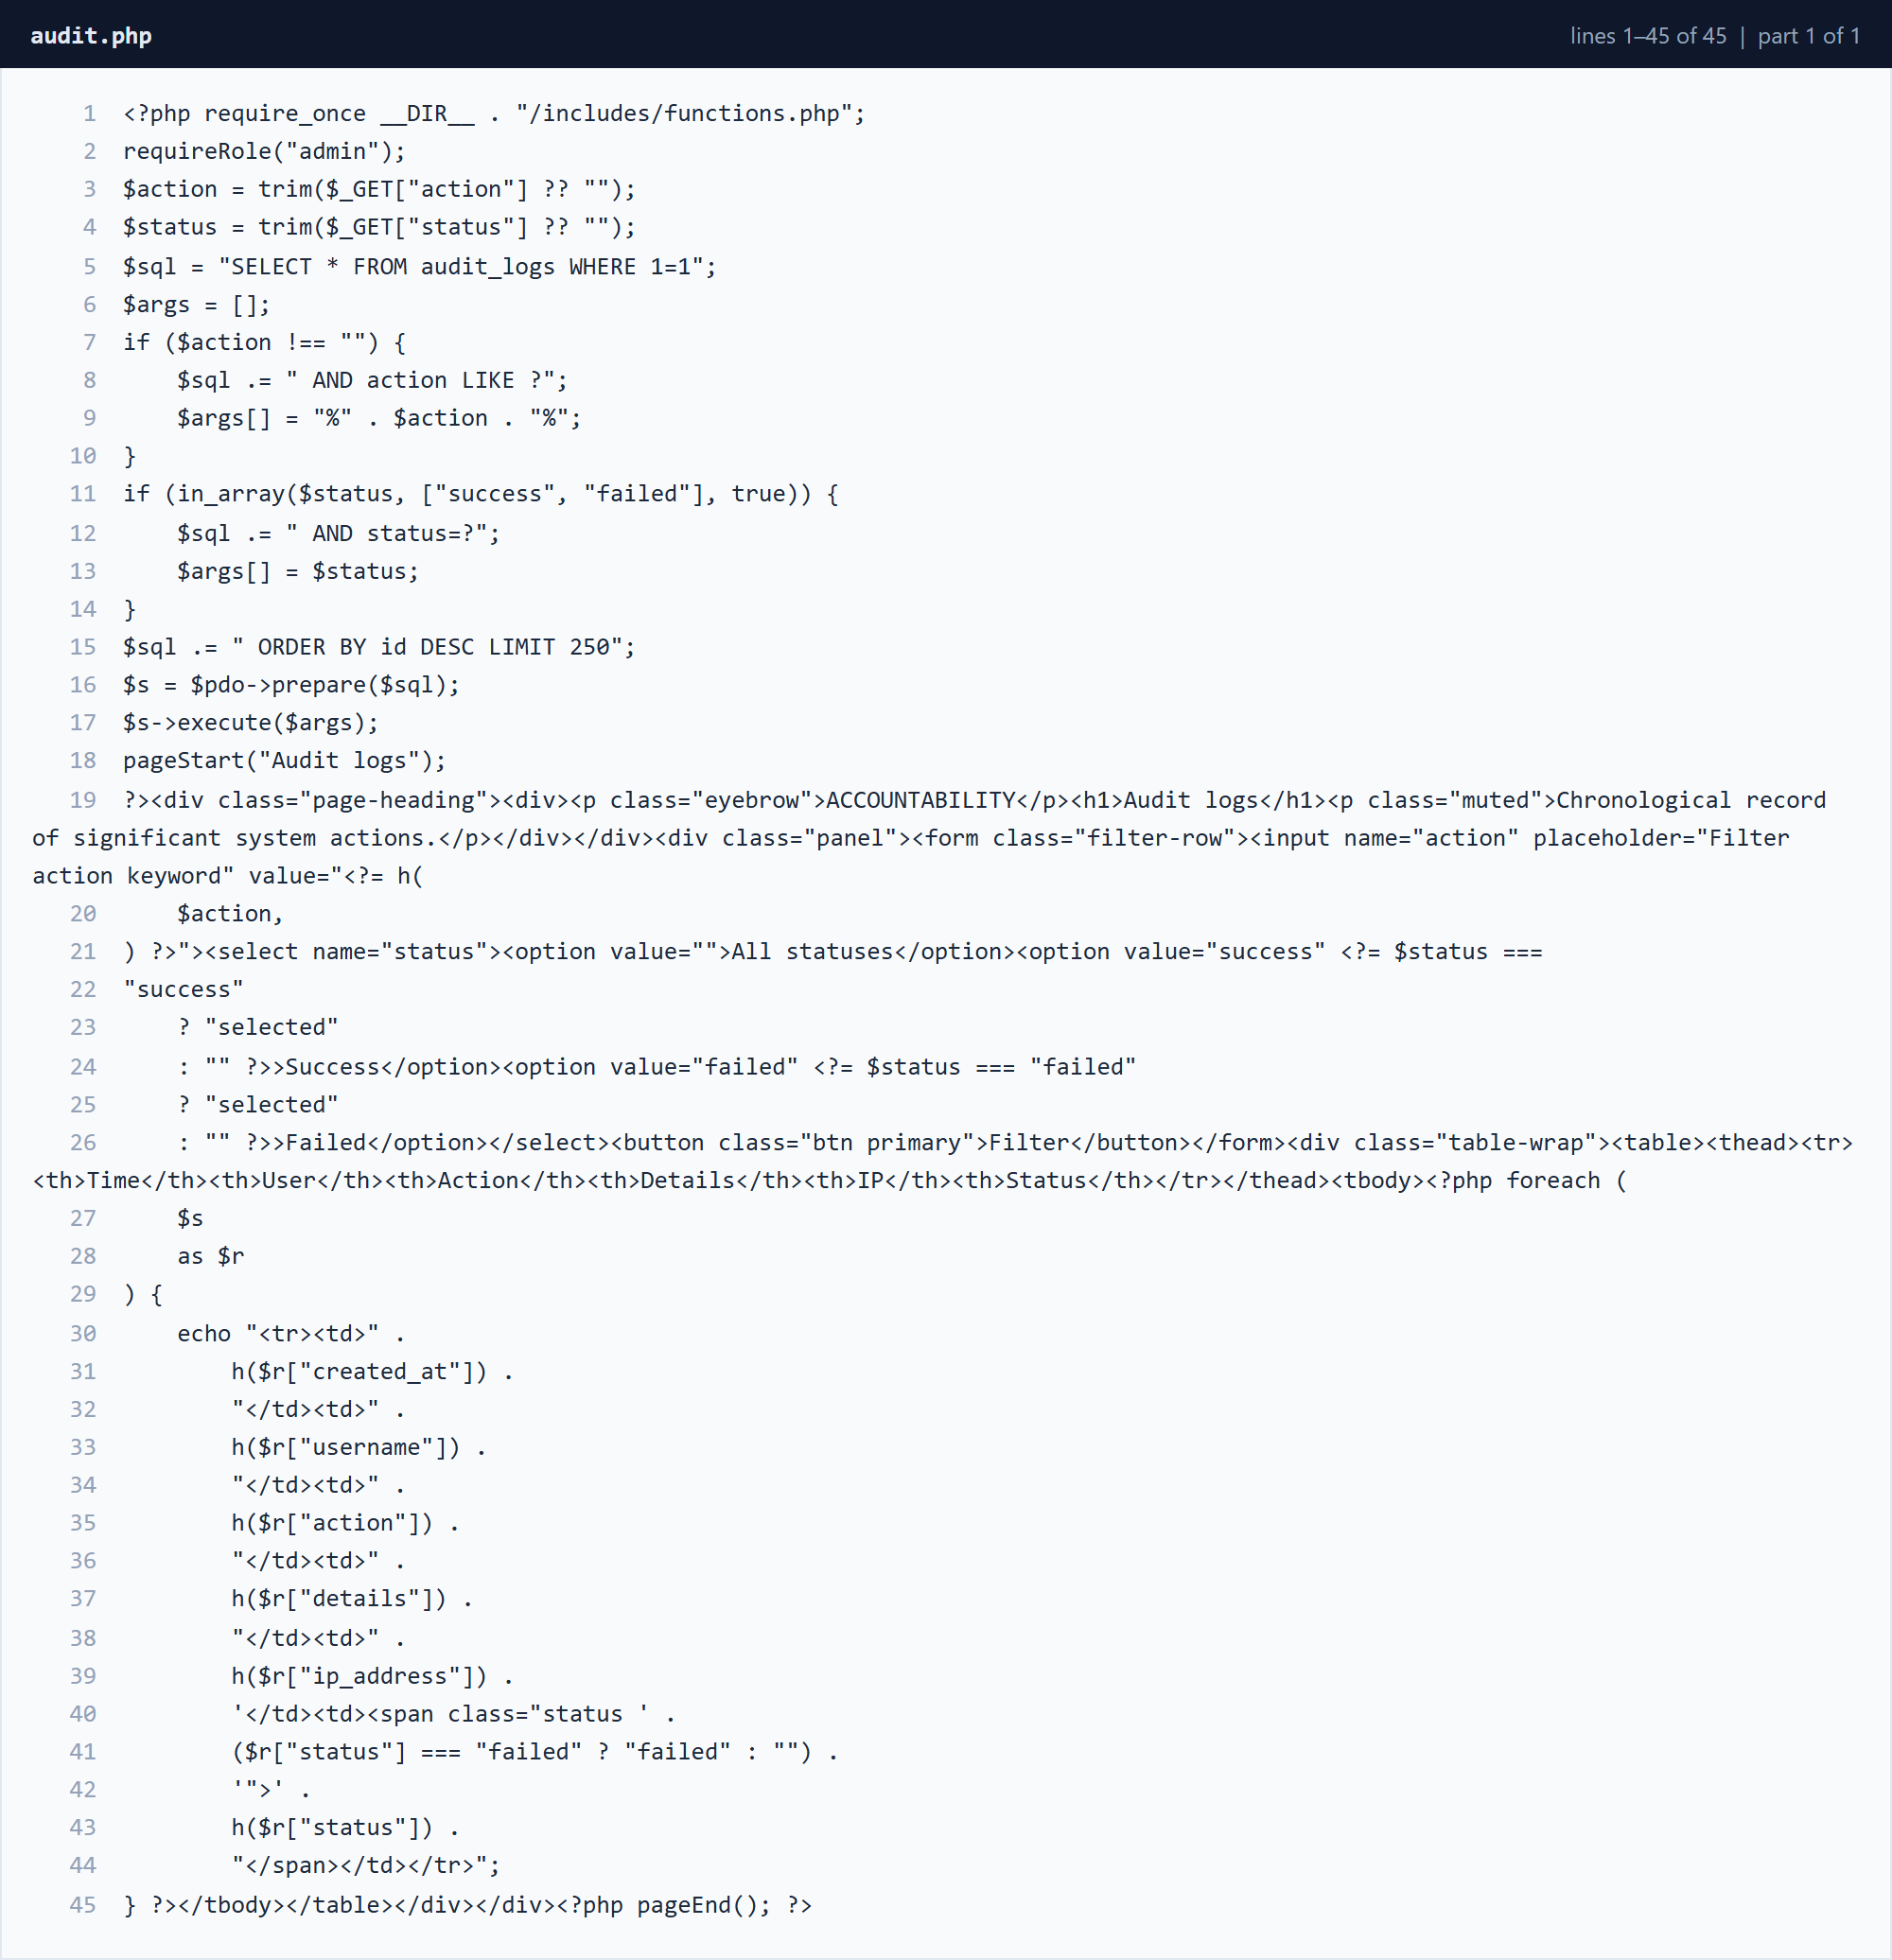
Figure 3.3.19 audit.php â€” lines 1â€“45 (part 1 of 1)
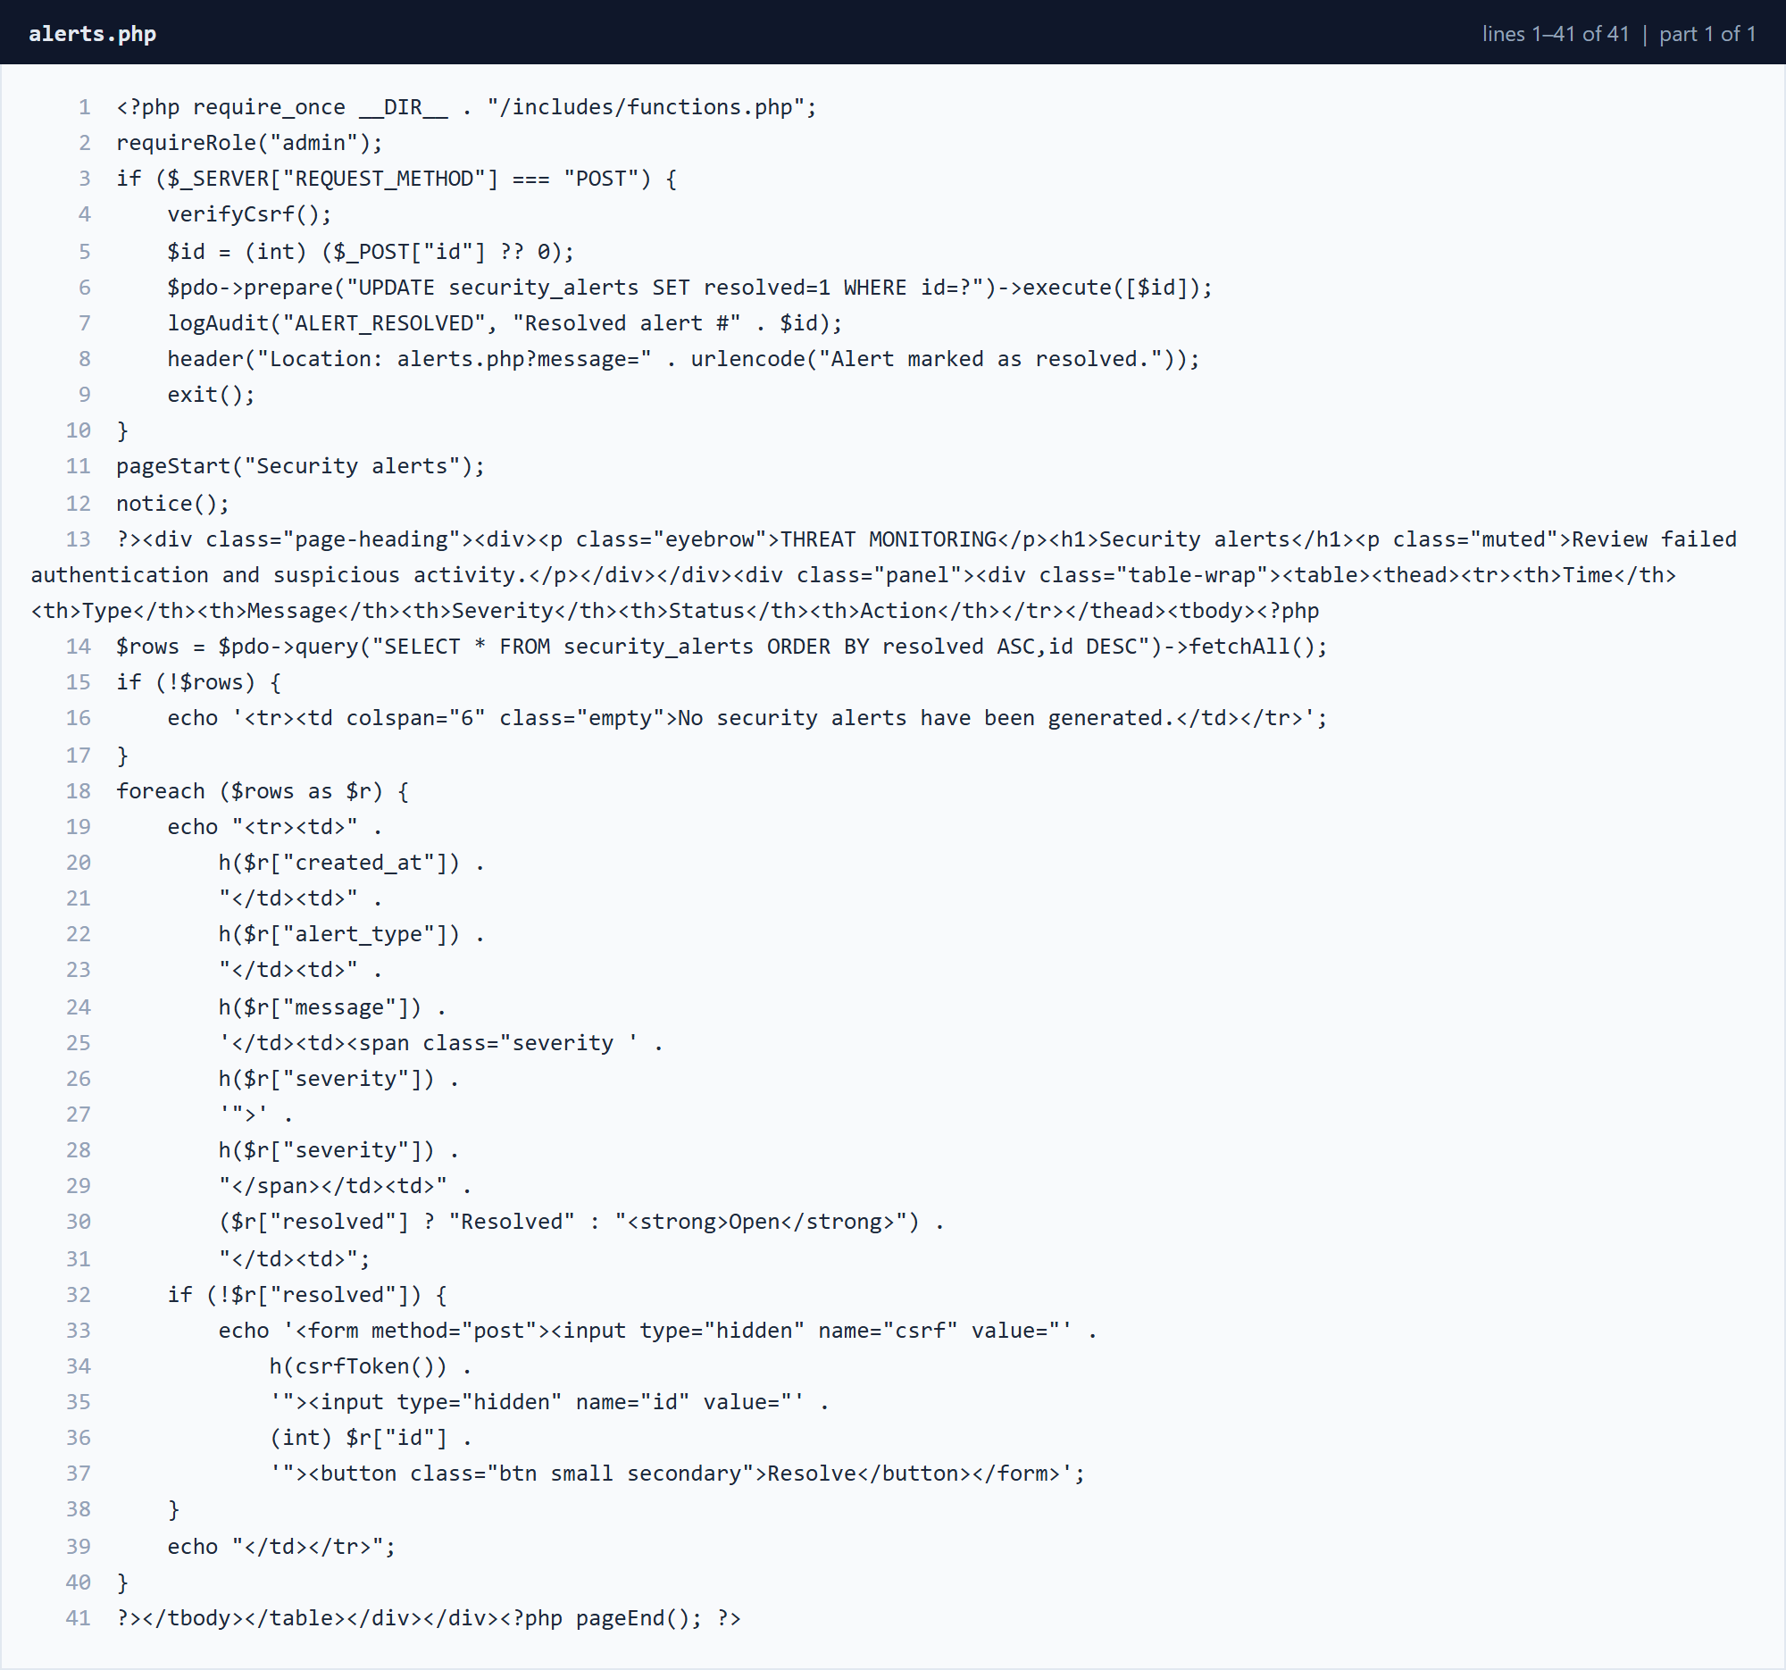
Figure 3.3.20 alerts.php â€” lines 1â€“41 (part 1 of 1)
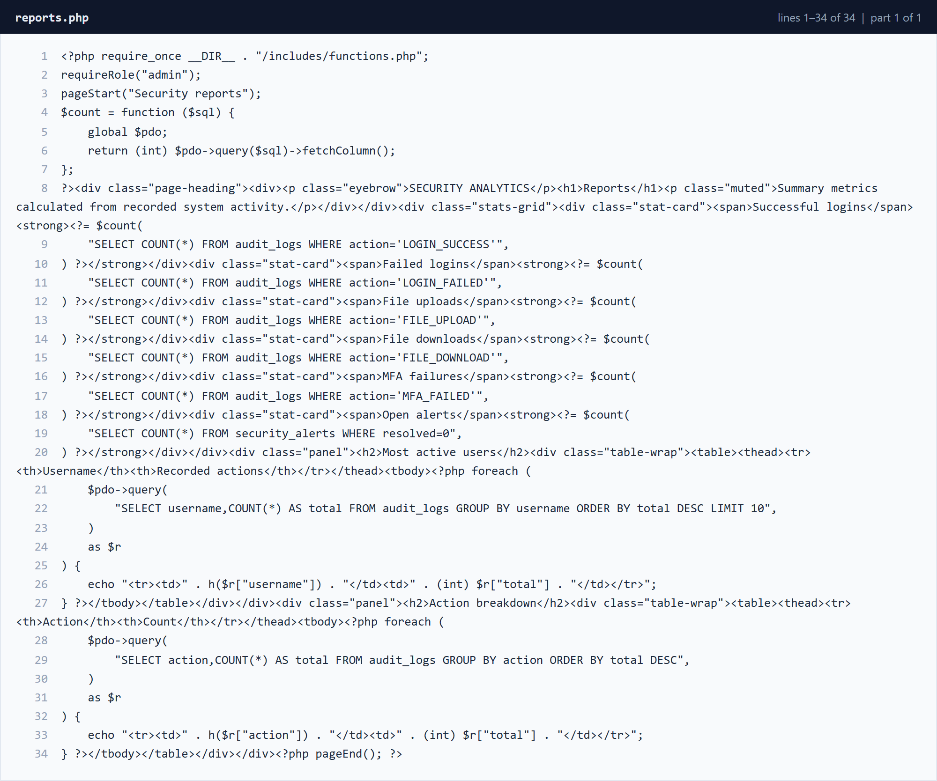
Figure 3.3.21 reports.php â€” lines 1â€“34 (part 1 of 1)

3.3.7 User Management
users.php allows an administrator to create accounts with validated details, assign a role and toggle account status. New passwords are hashed before storage.
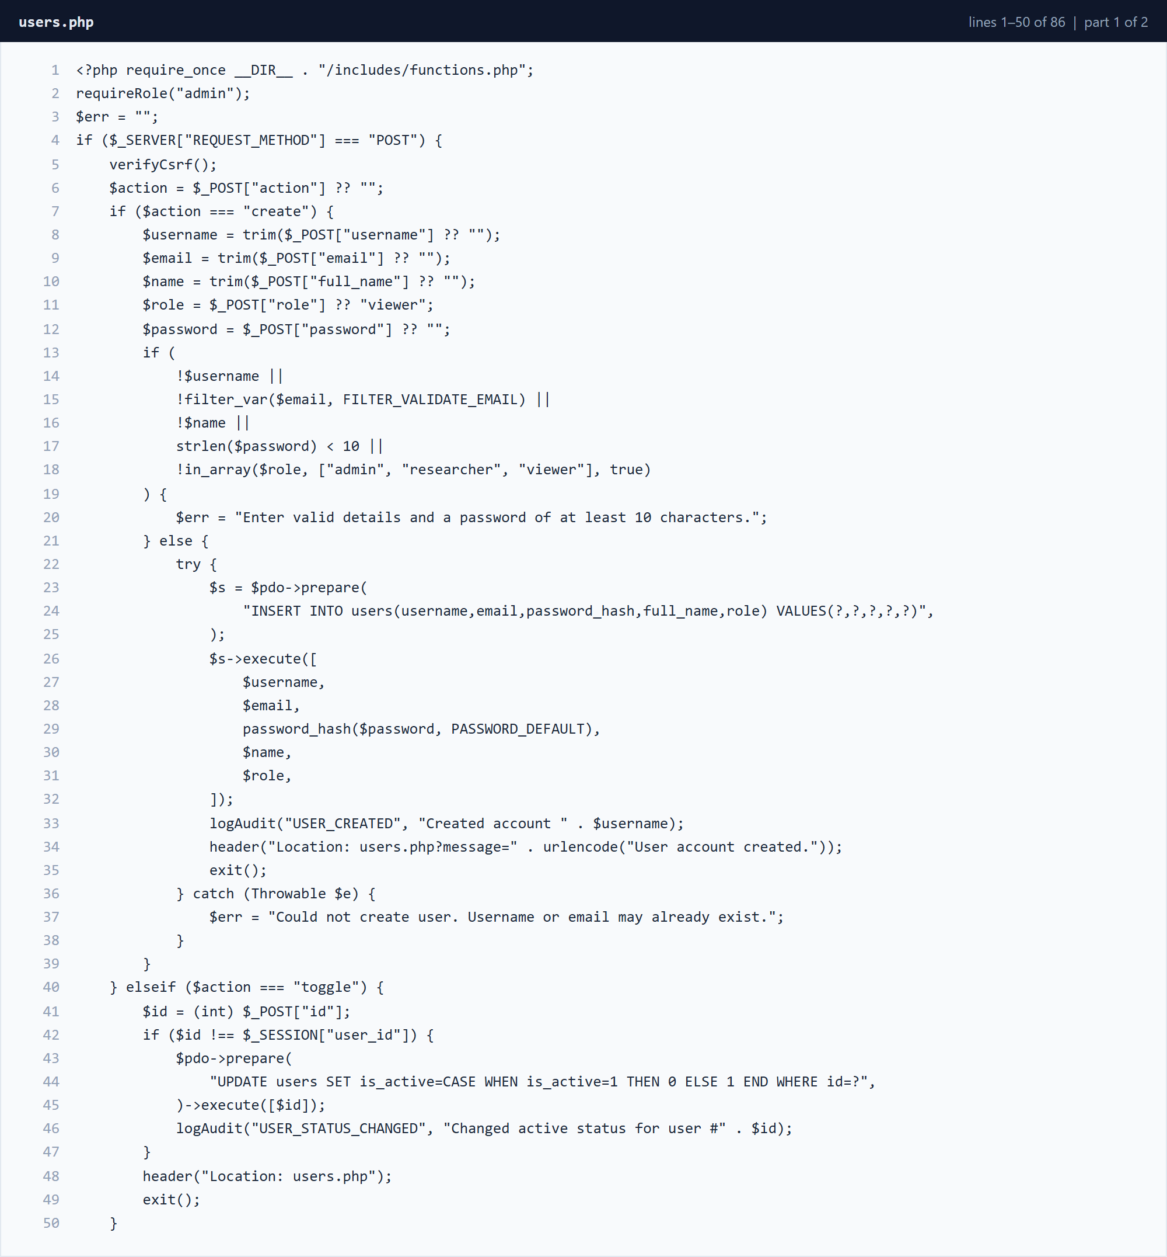
Figure 3.3.22 users.php â€” lines 1â€“50 (part 1 of 2)
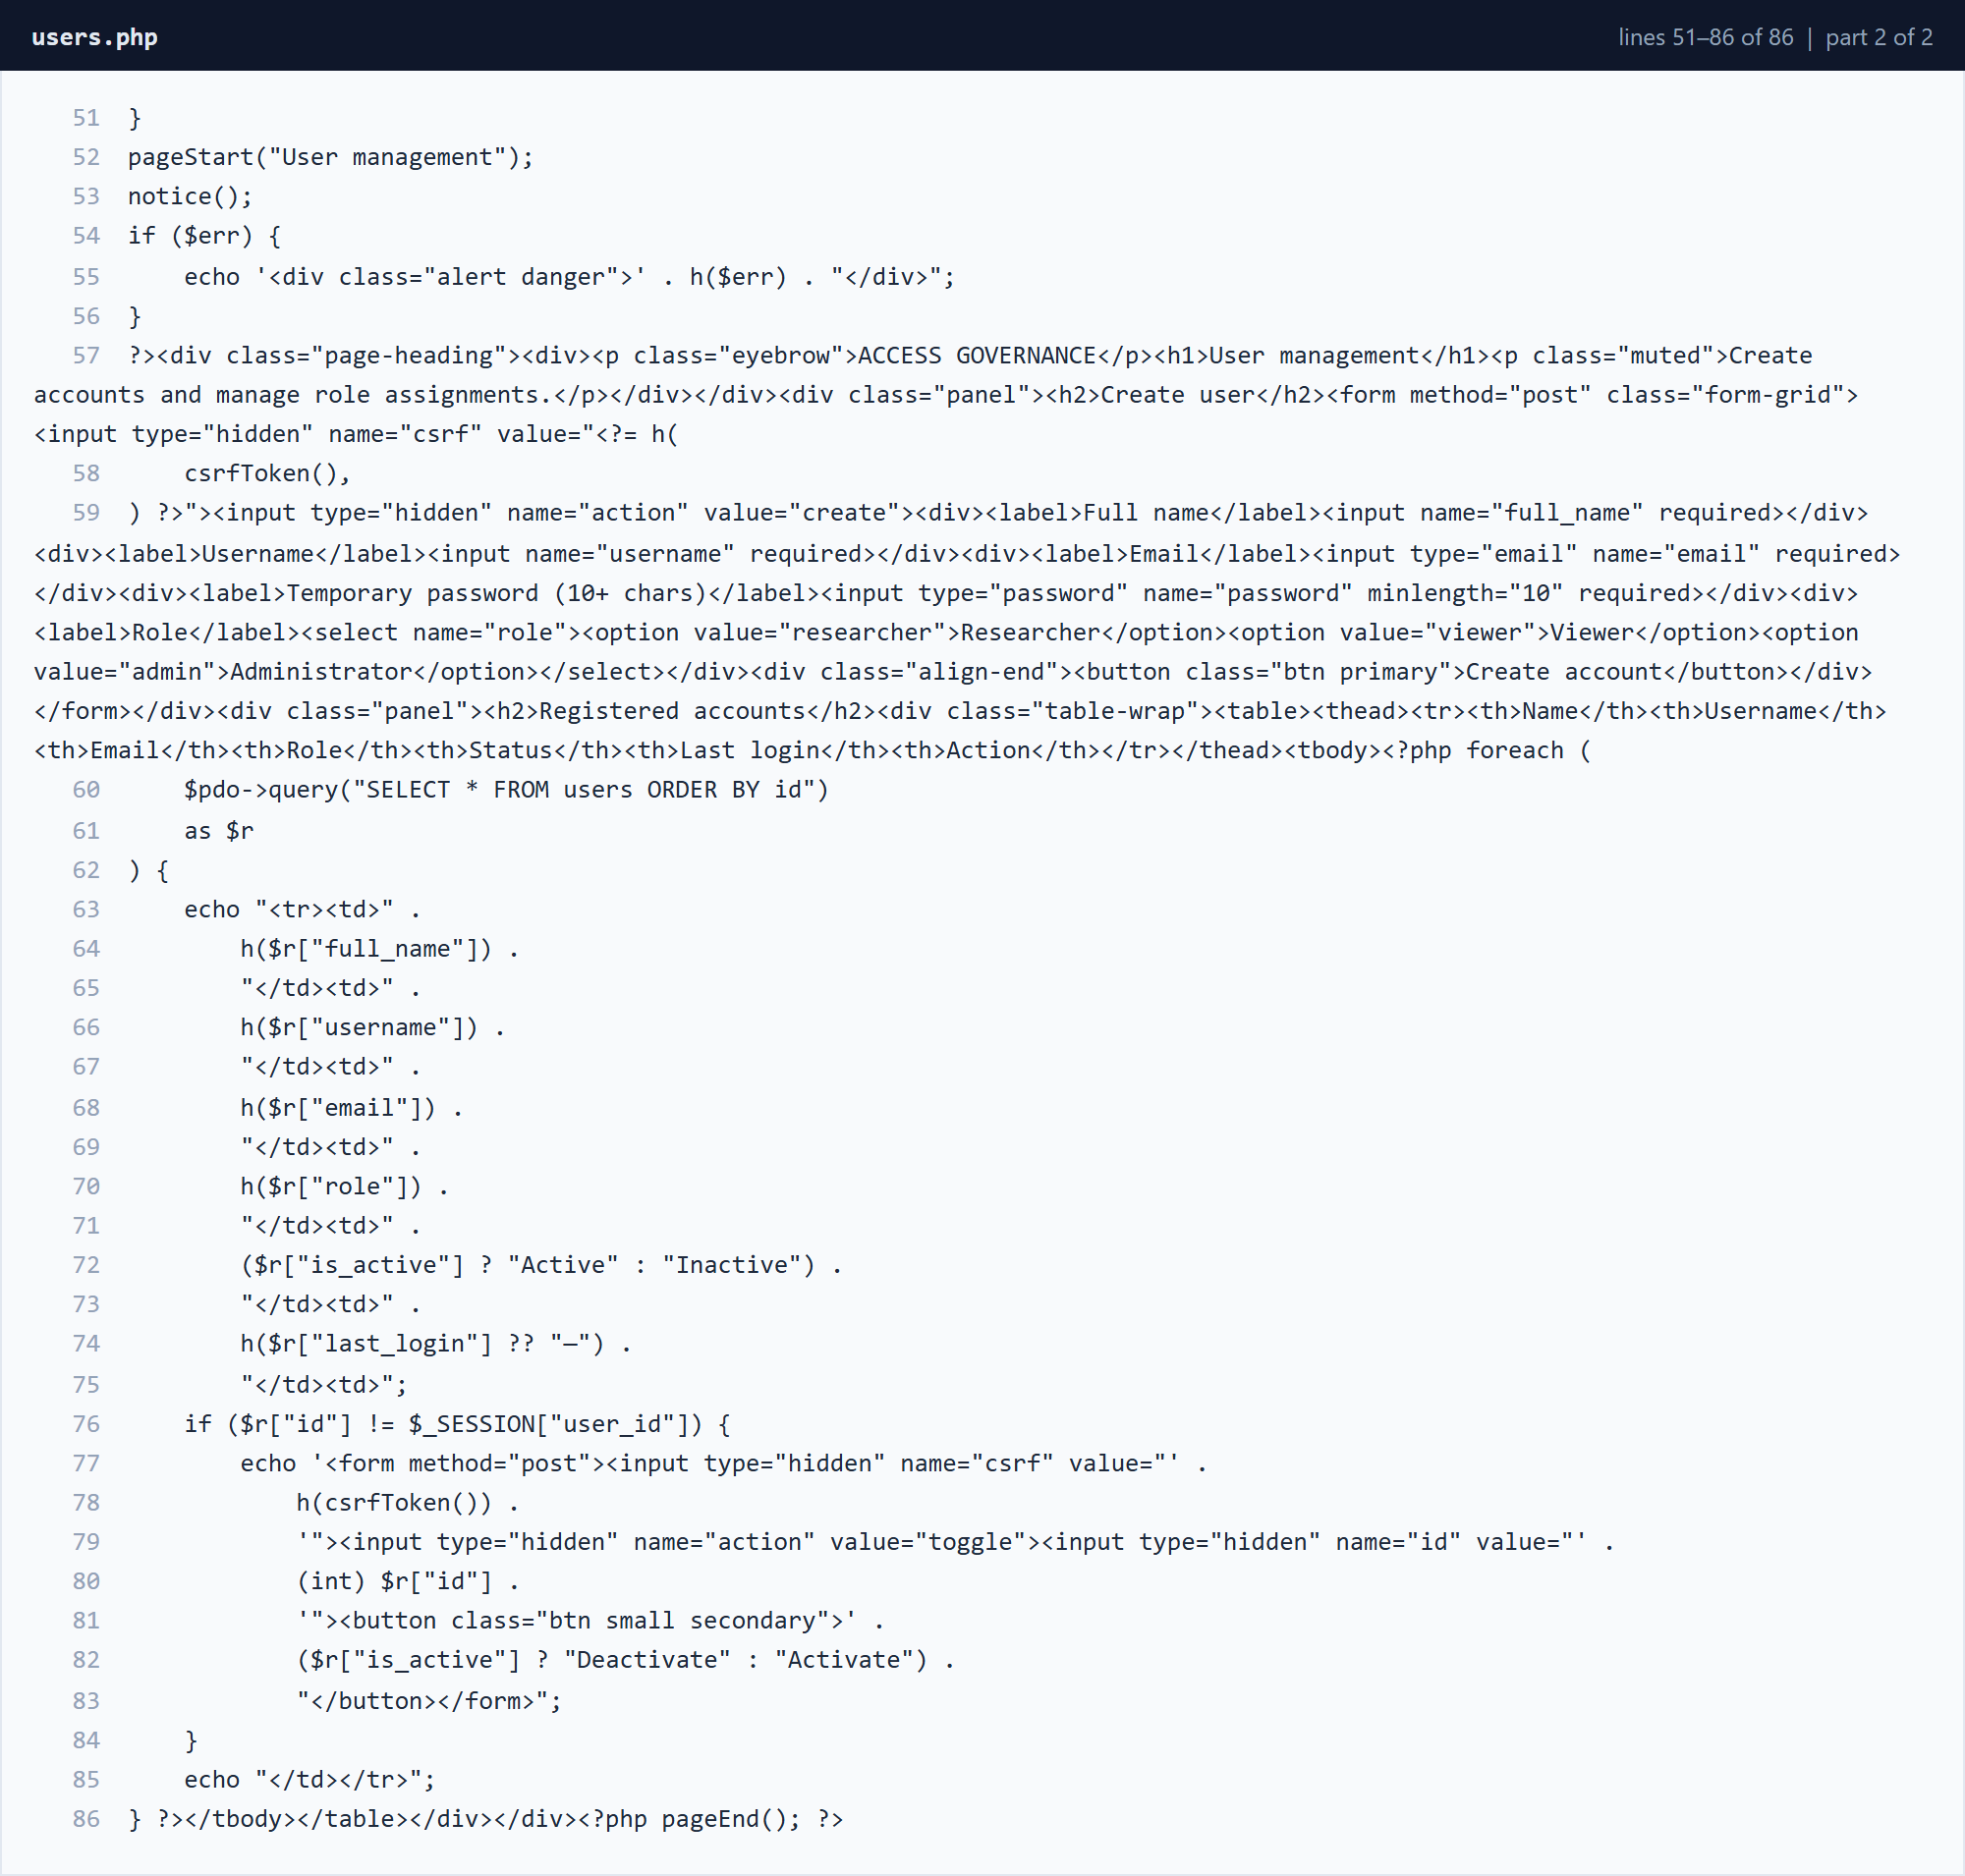
Figure 3.3.23 users.php â€” lines 51â€“86 (part 2 of 2)

3.3.8 Presentation Layer
style.css defines the responsive layout, navigation, cards, tables and form styling used throughout the application.
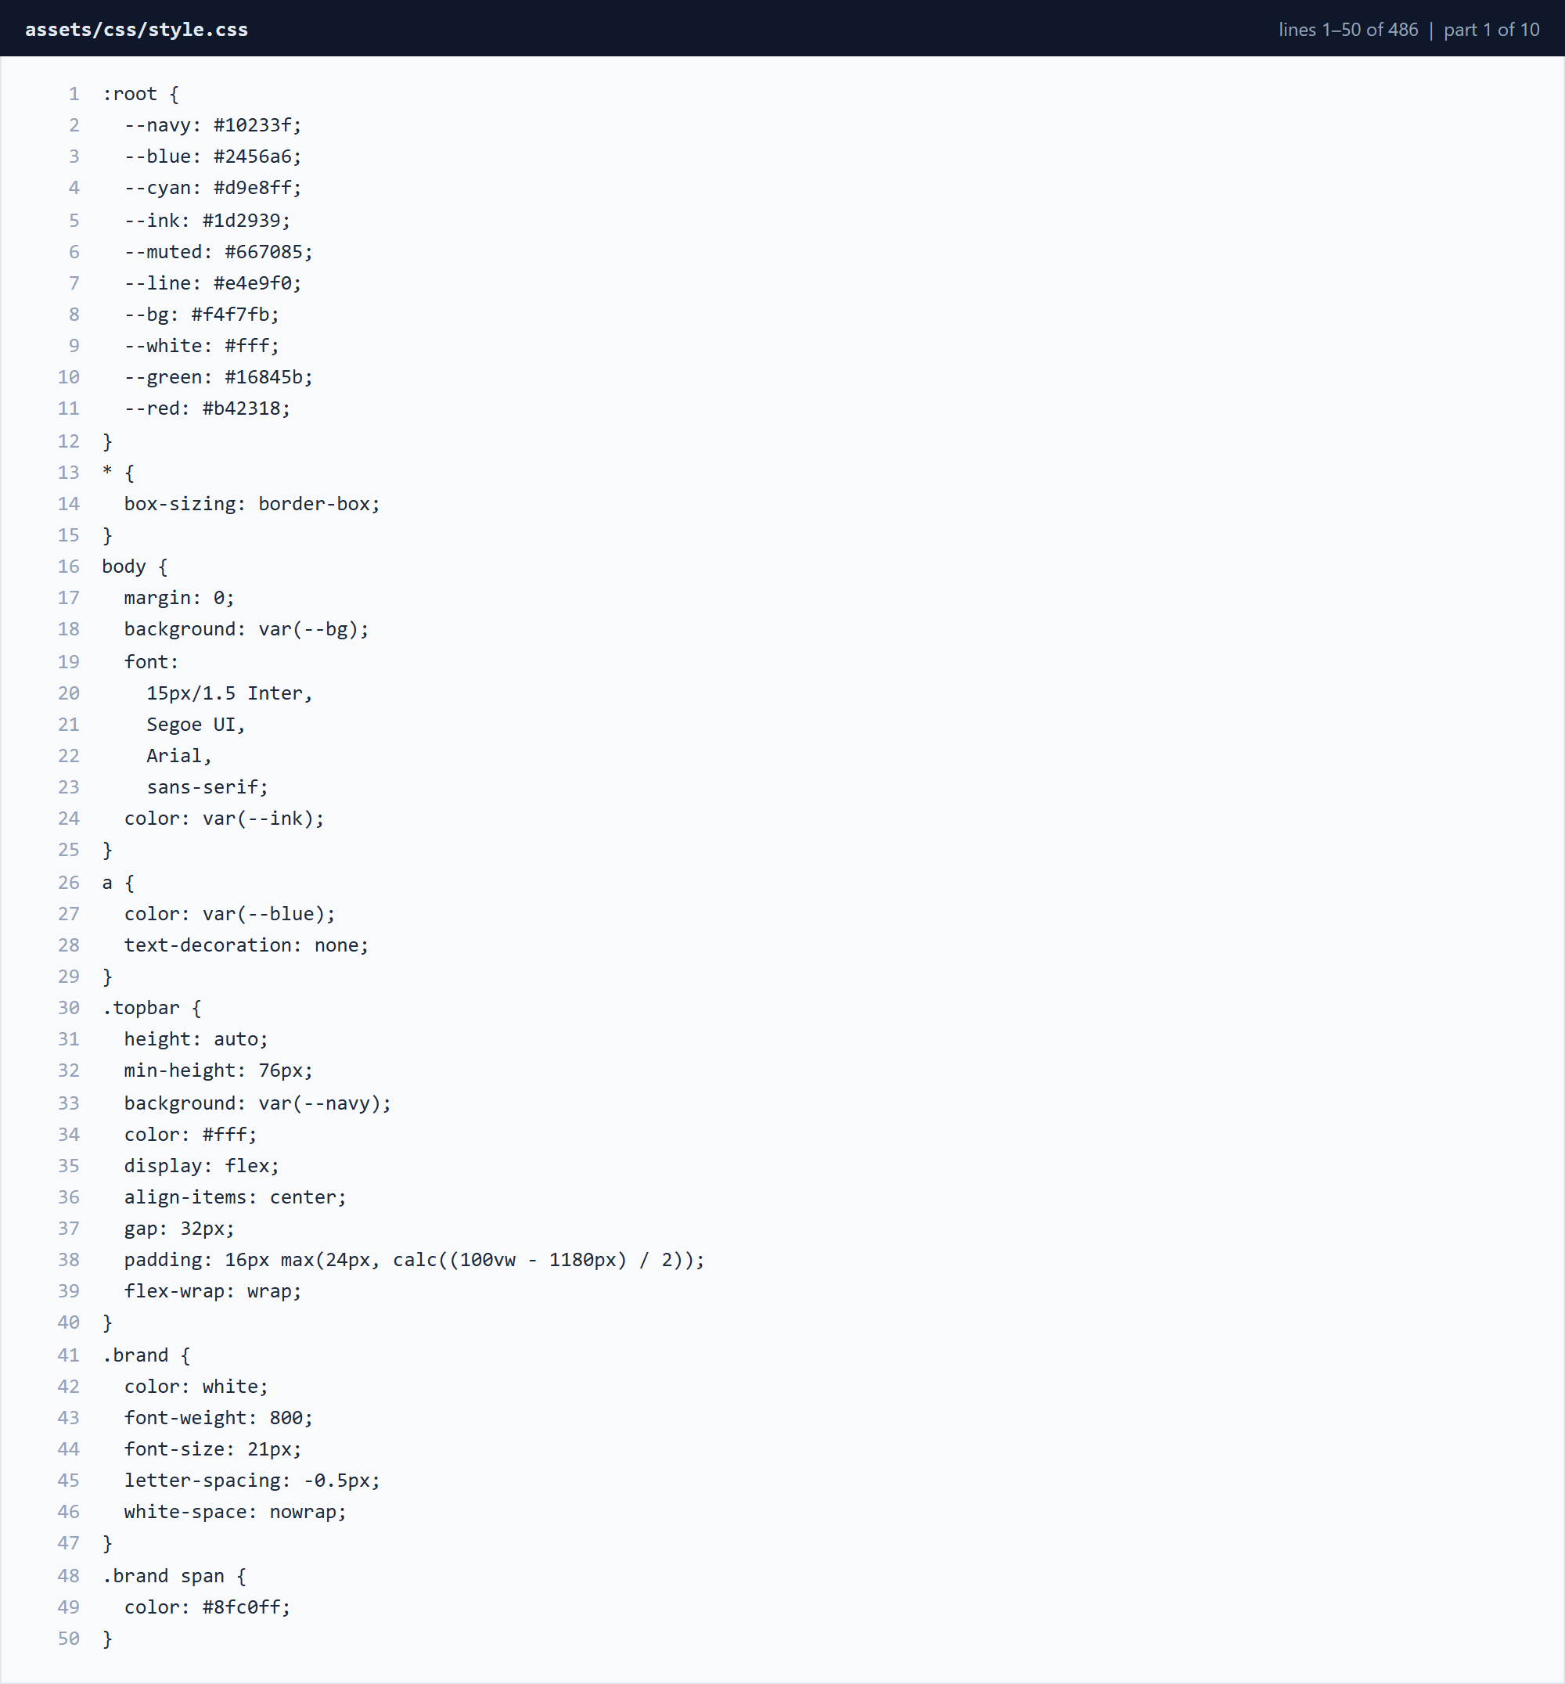
Figure 3.3.24 assets/css/style.css â€” lines 1â€“50 (part 1 of 10)
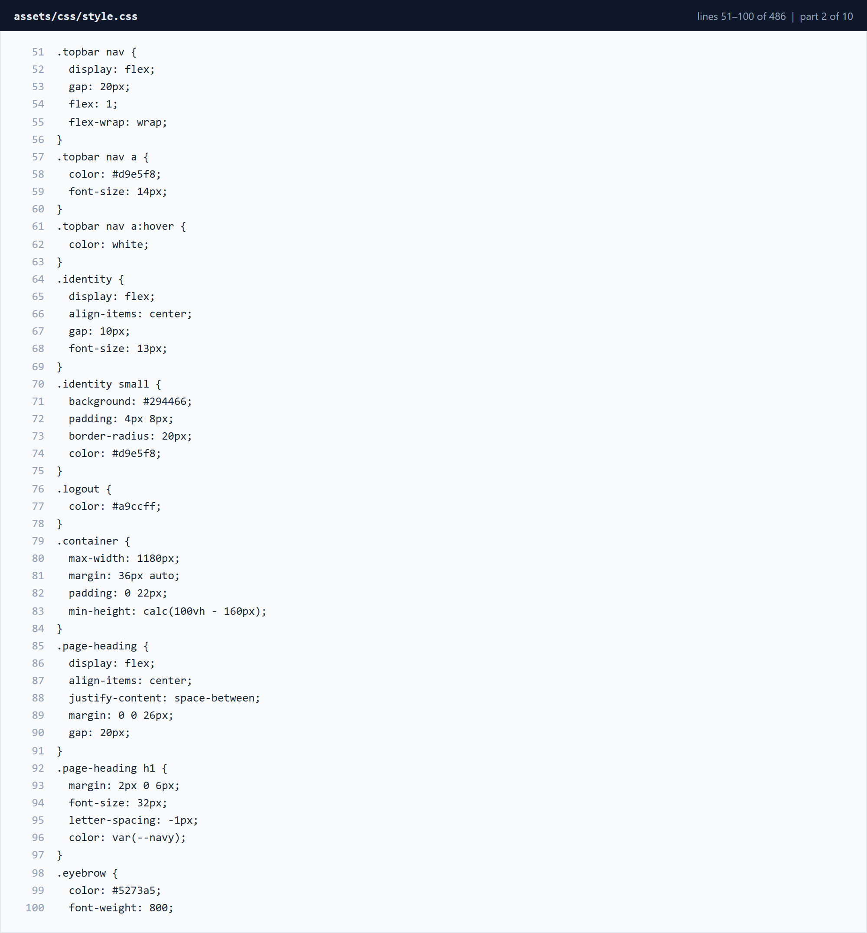
Figure 3.3.25 assets/css/style.css â€” lines 51â€“100 (part 2 of 10)
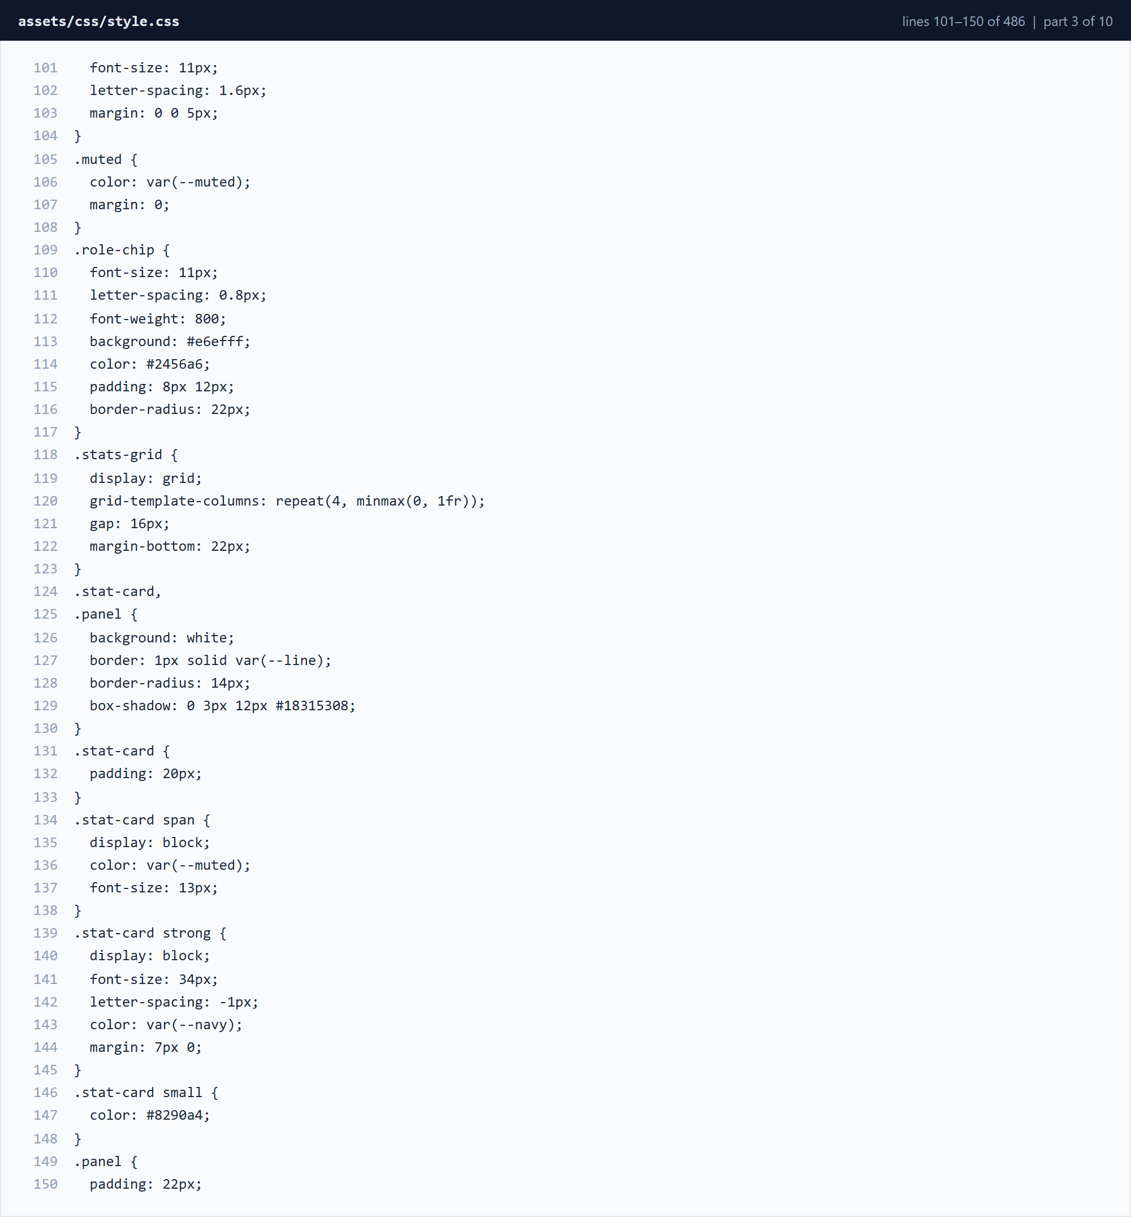
Figure 3.3.26 assets/css/style.css â€” lines 101â€“150 (part 3 of 10)
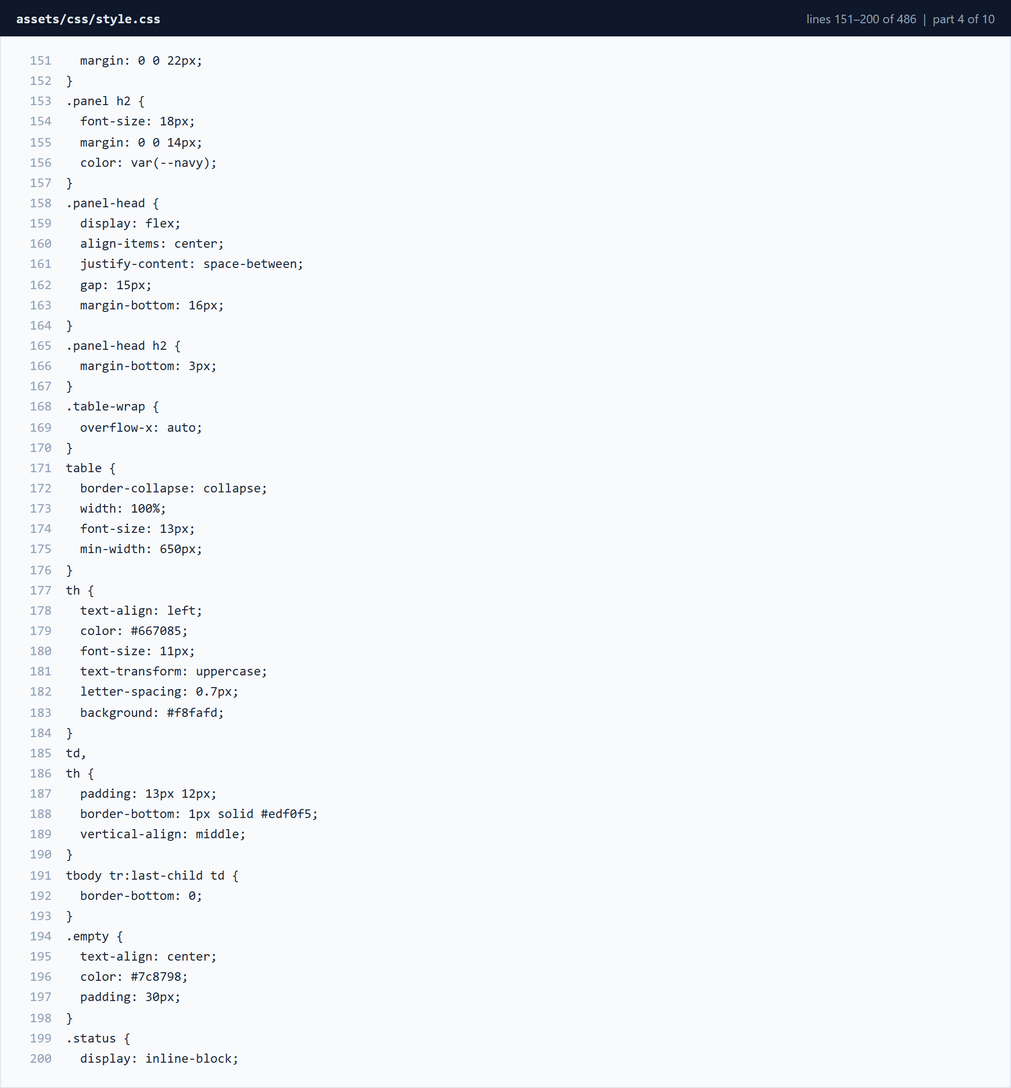
Figure 3.3.27 assets/css/style.css â€” lines 151â€“200 (part 4 of 10)
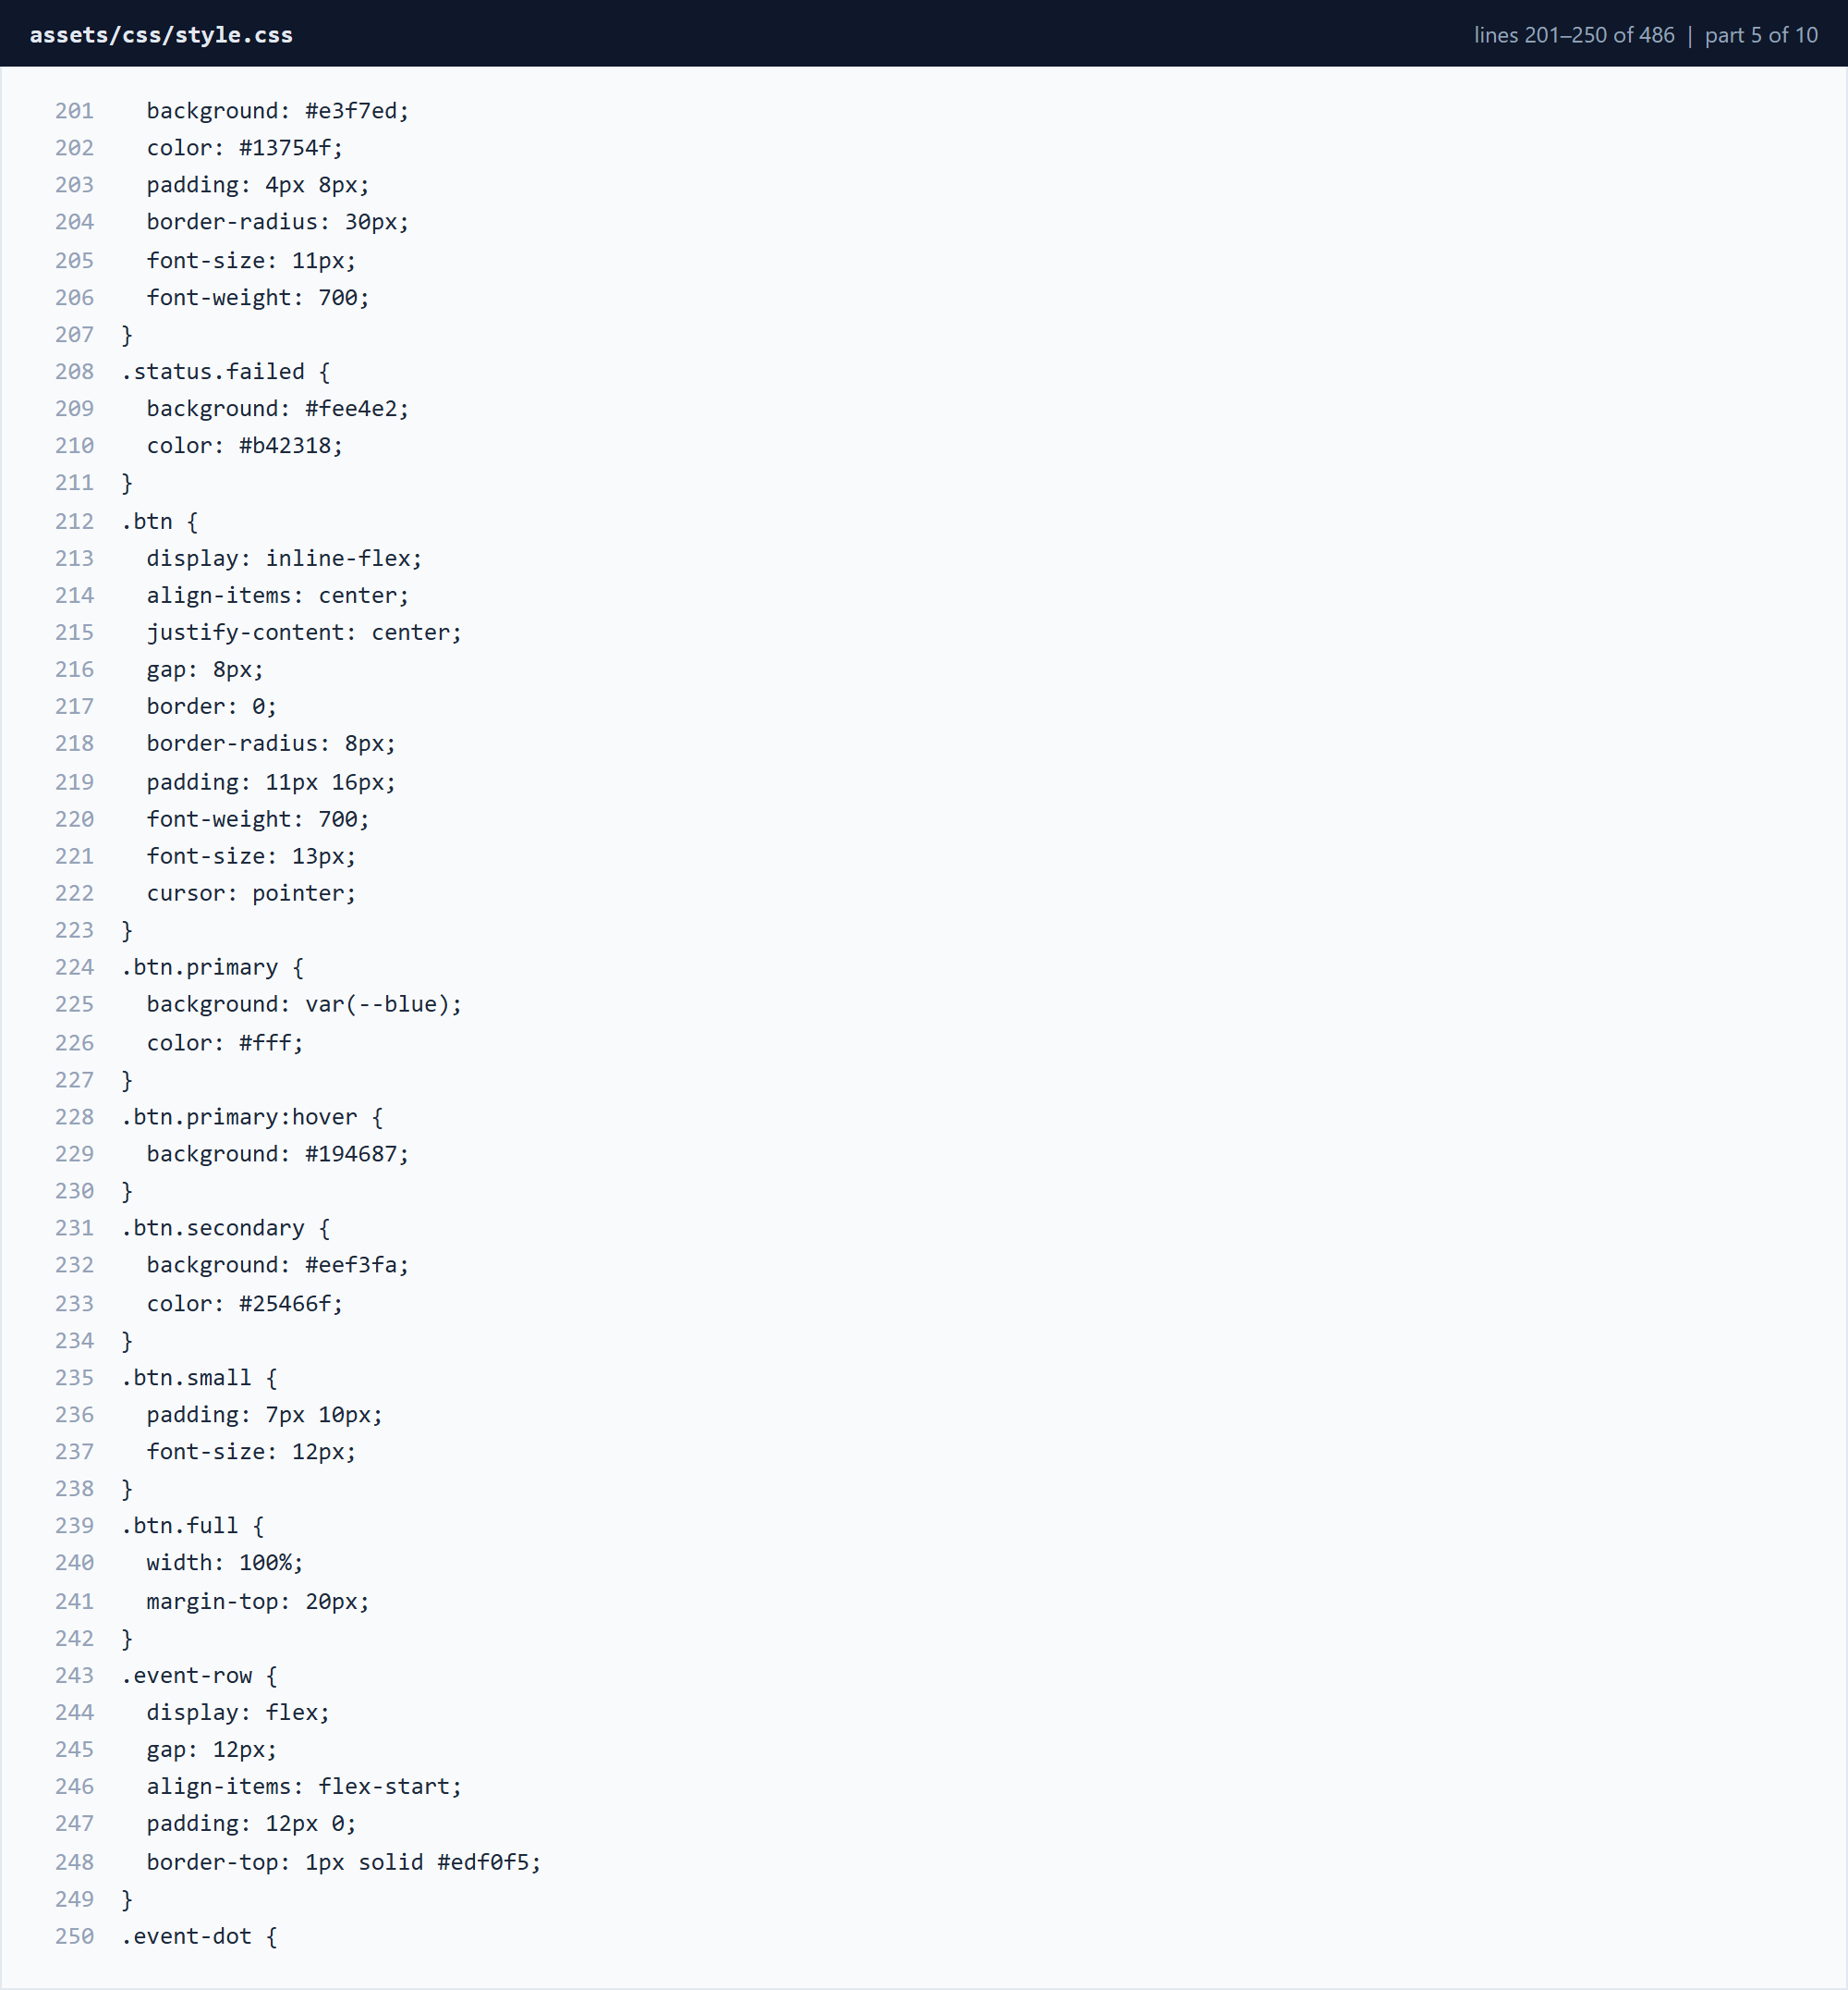
Figure 3.3.28 assets/css/style.css â€” lines 201â€“250 (part 5 of 10)
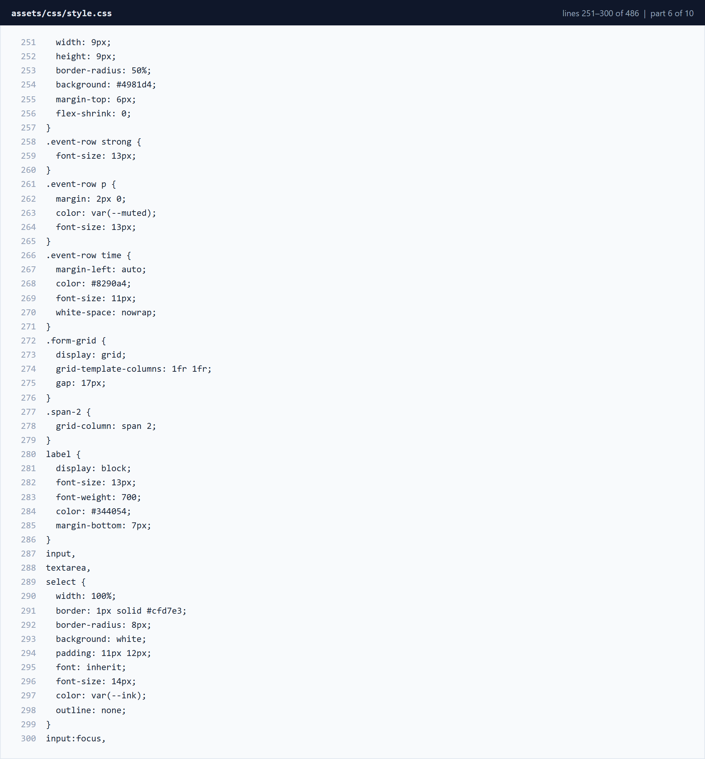
Figure 3.3.29 assets/css/style.css â€” lines 251â€“300 (part 6 of 10)
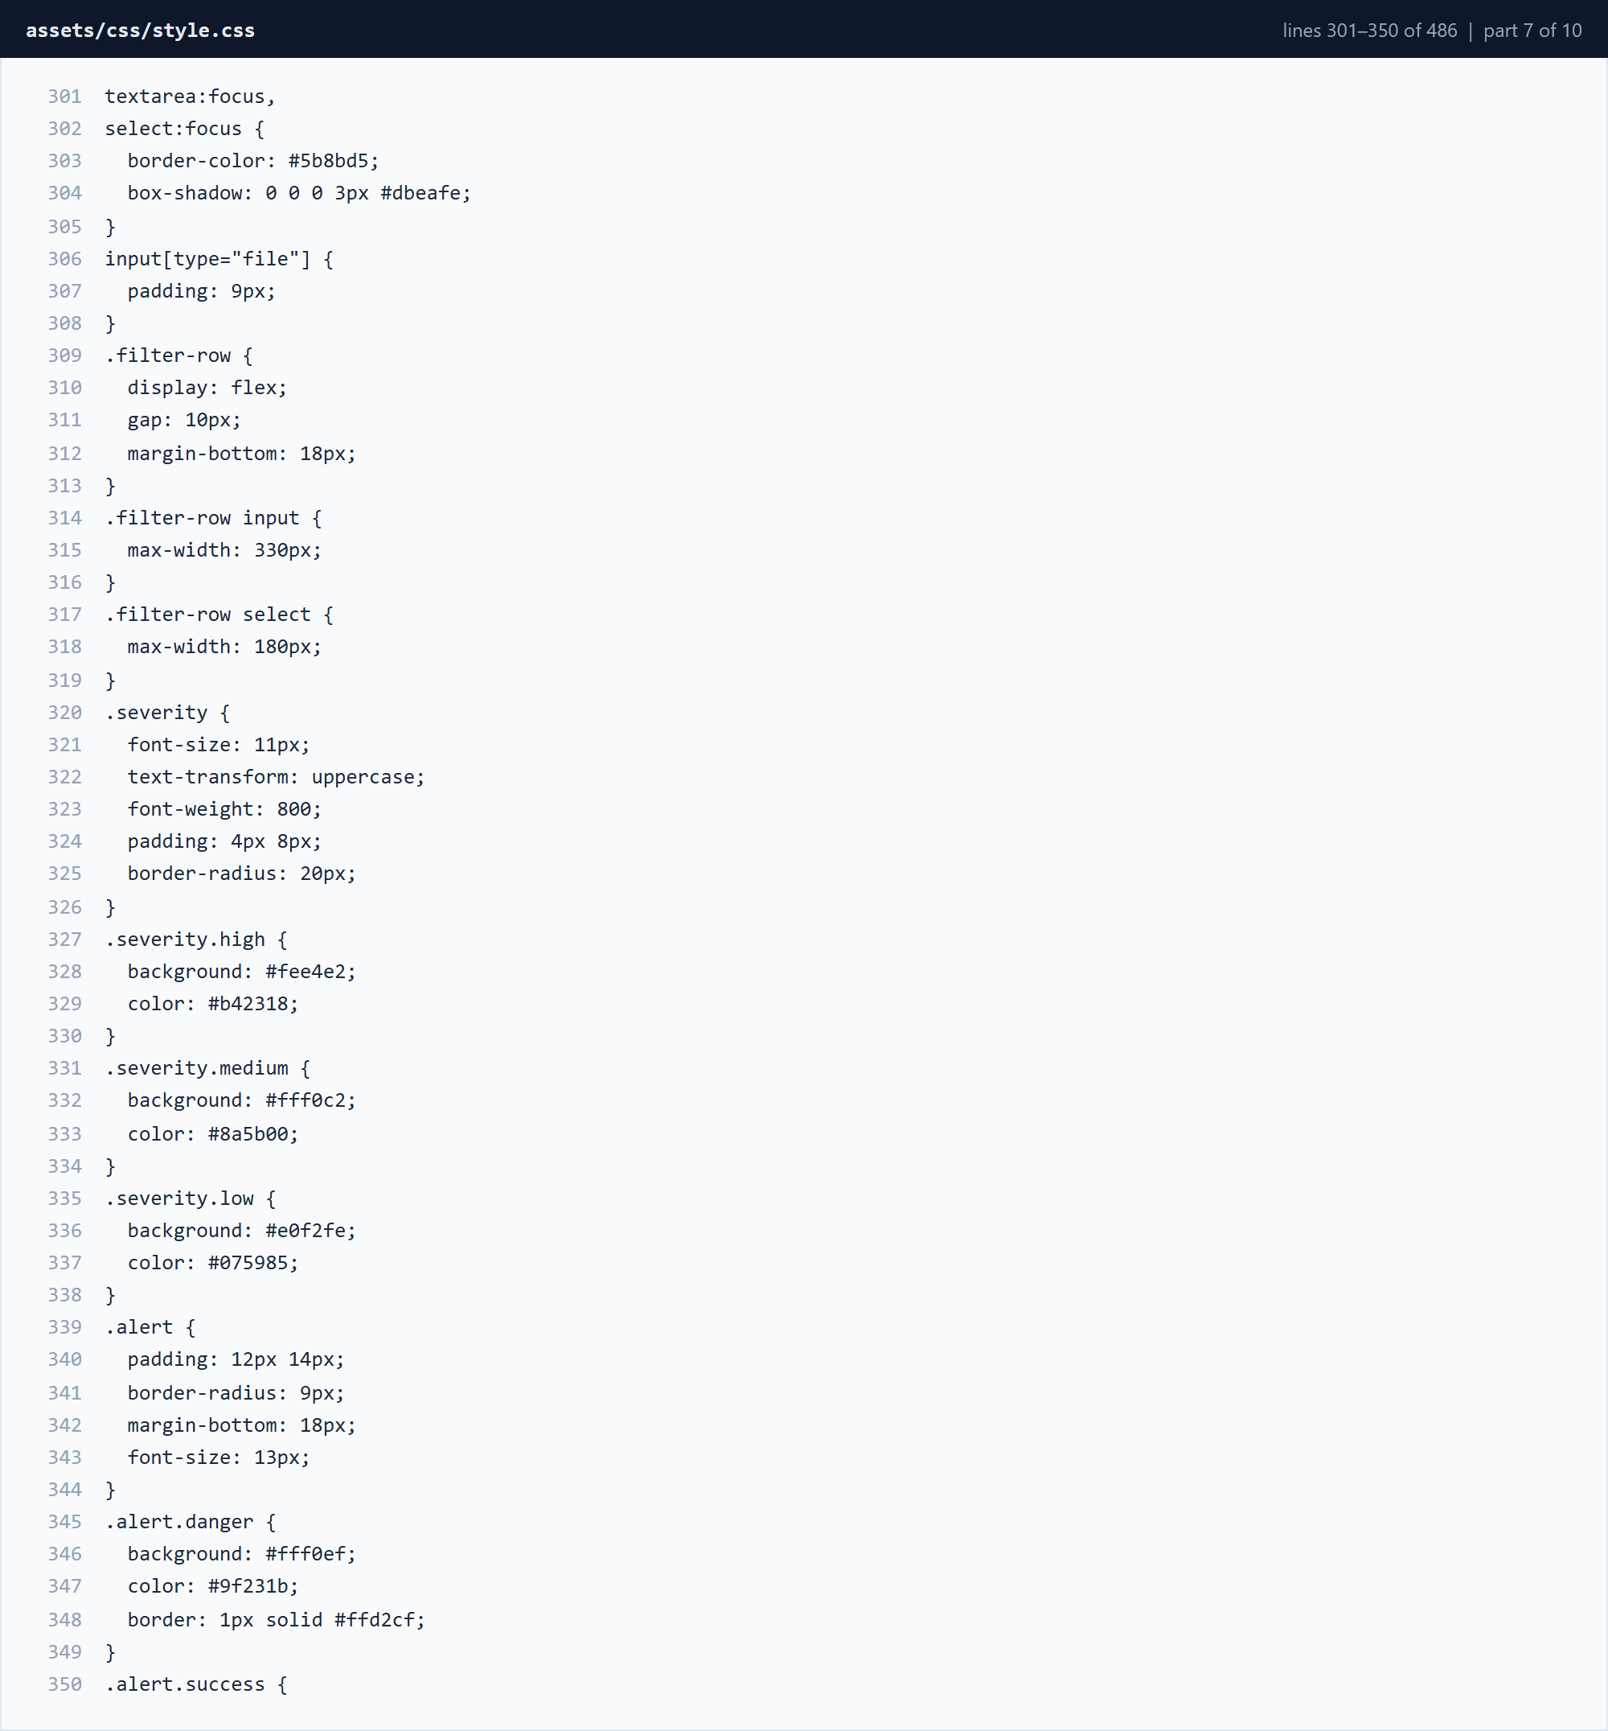
Figure 3.3.30 assets/css/style.css â€” lines 301â€“350 (part 7 of 10)
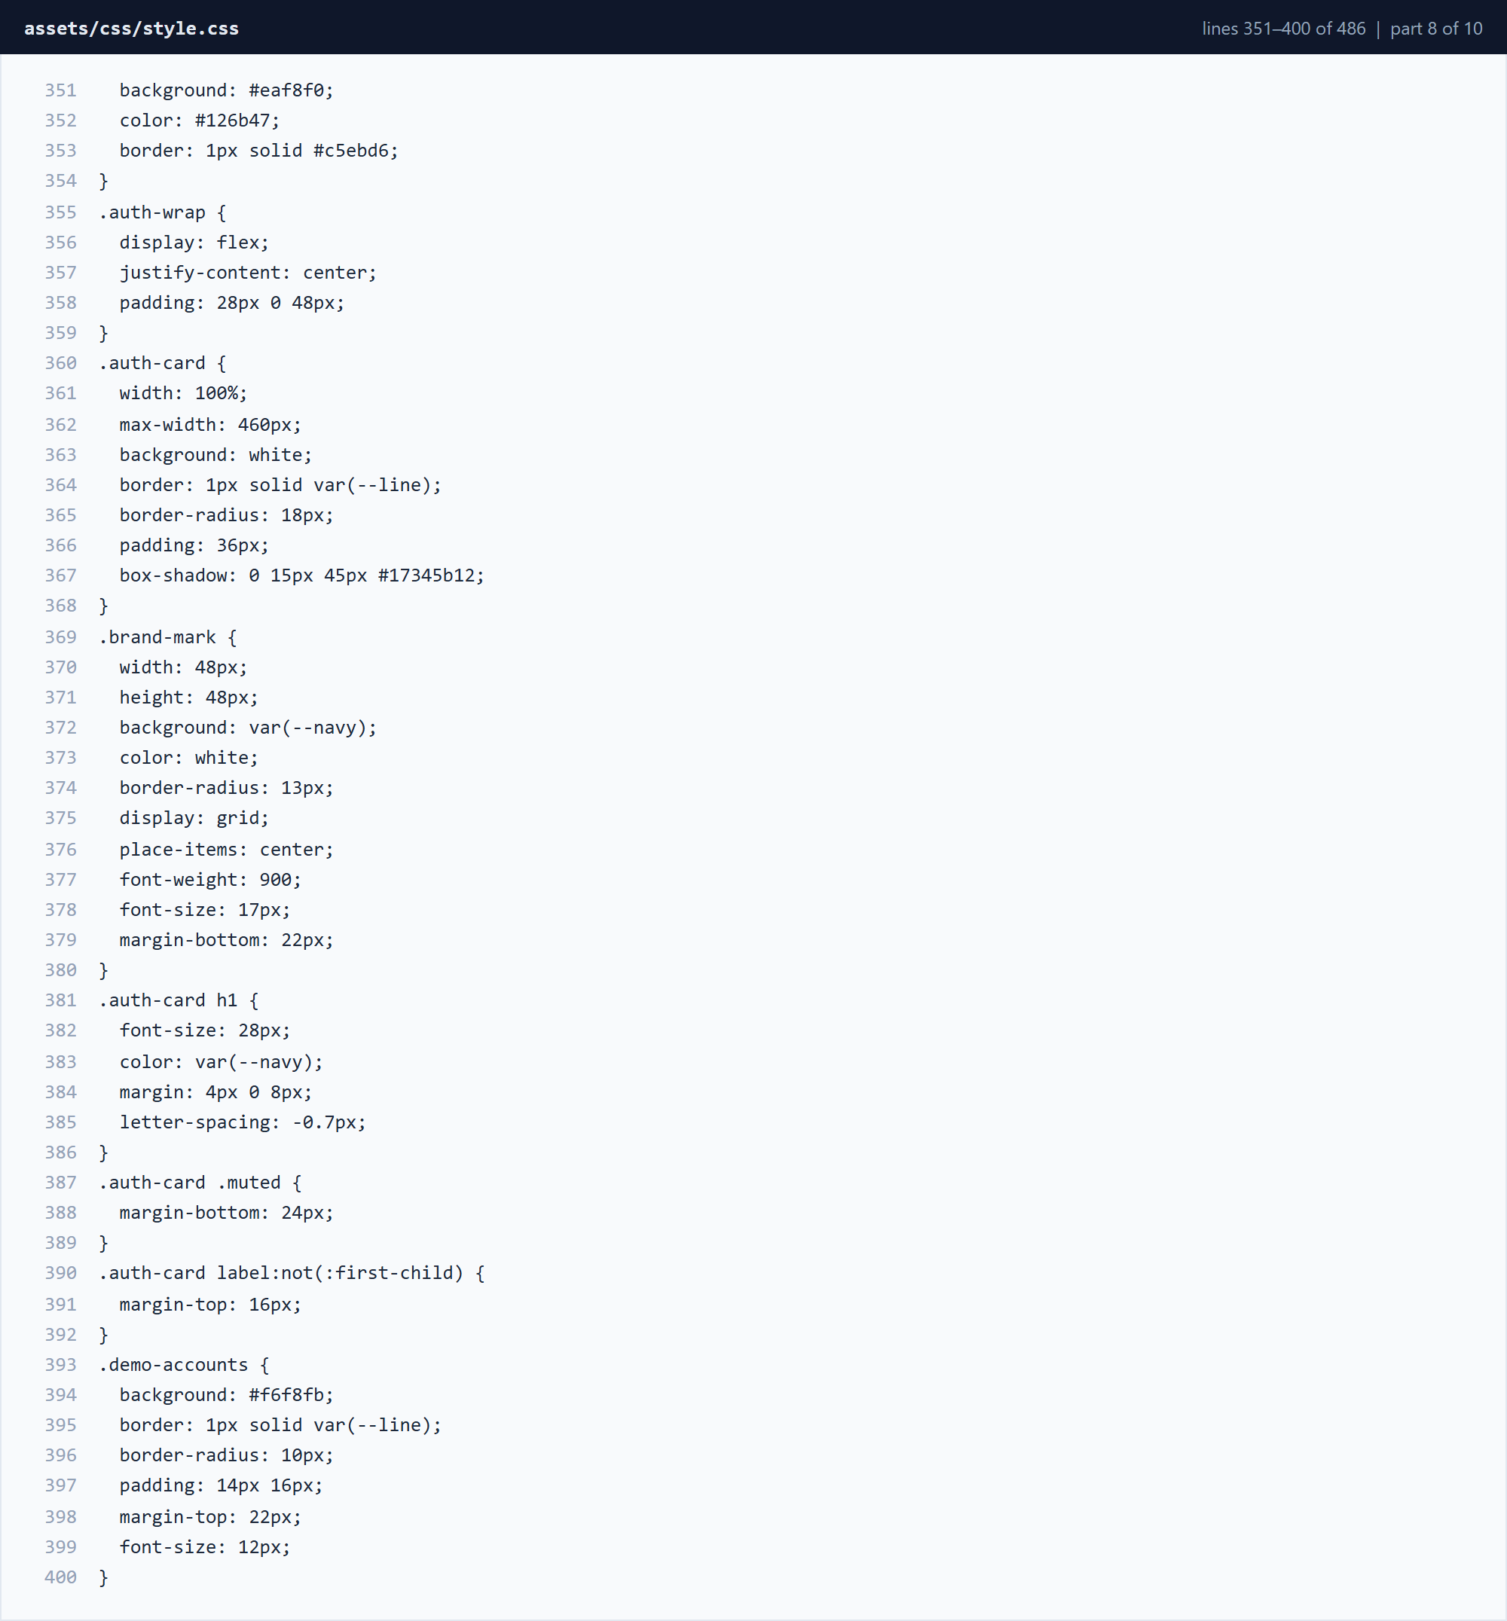
Figure 3.3.31 assets/css/style.css â€” lines 351â€“400 (part 8 of 10)
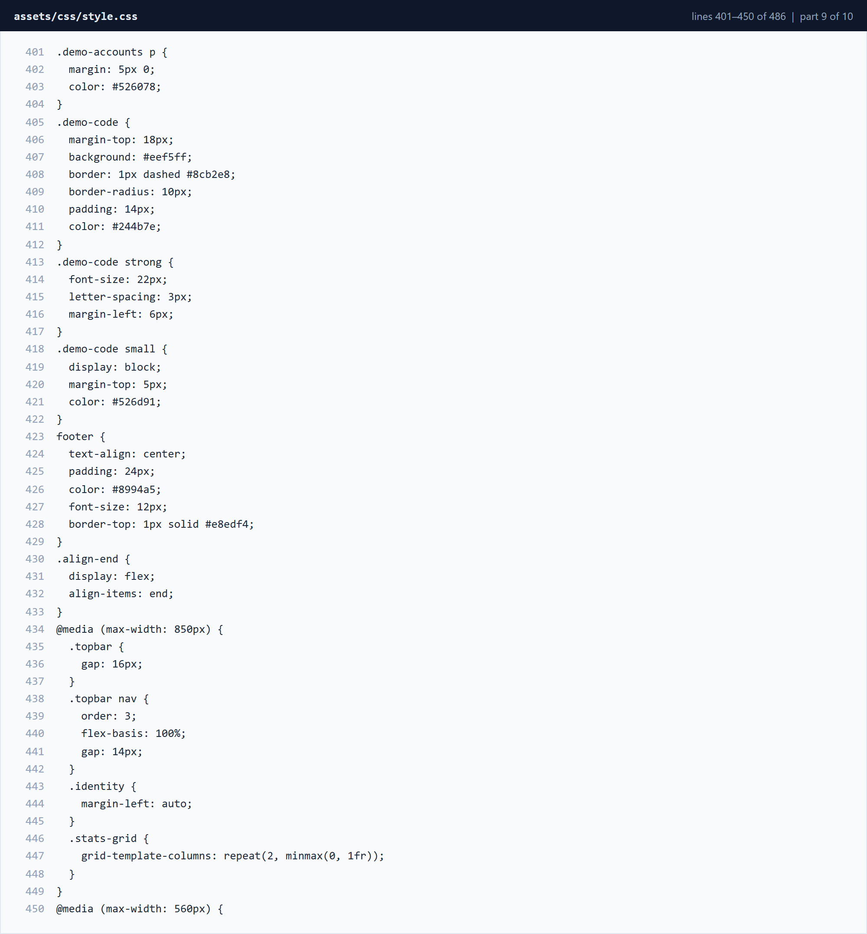
Figure 3.3.32 assets/css/style.css â€” lines 401â€“450 (part 9 of 10)
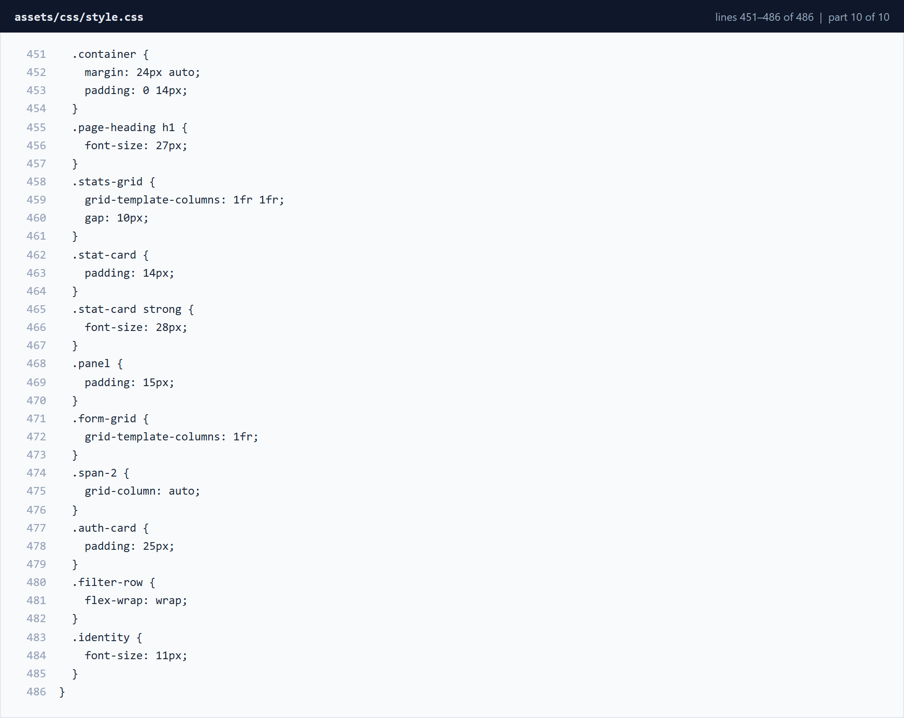
Figure 3.3.33 assets/css/style.css â€” lines 451â€“486 (part 10 of 10)

3.4 Testing
The system was tested functionally after the database and security controls were integrated. Each test exercised a complete user journey rather than an isolated function, so that authentication, authorisation, encryption and logging were verified together.
Test | Action | Result | Correction
Login and MFA | Attempted login with valid and invalid passwords and with correct and incorrect MFA codes. | Valid credentials plus a valid code granted access; invalid cases displayed errors and were logged. | Added clearer error messages, a five-failure check and a five-minute code expiry.
Role-based access | Signed in as researcher, viewer and administrator and attempted to open restricted pages and files. | Researchers and viewers could not open administrator pages; unauthorised attempts were logged and redirected. | Applied requireRole() to every protected page and re-checked ownership before downloads.
File upload and encryption | Uploaded a sample research document and inspected the stored file; attempted a download as a different user. | The stored file contained ciphertext, and only authorised users could decrypt and download it. | Confirmed that decryption occurs after the authorisation check, not before.
Audit logs and reports | Performed logins, uploads, downloads and failed attempts, then reviewed audit logs and reports. | All expected events appeared and the summary counts matched the recorded activity. | Corrected the date filter for today's events to use the database server date.
Security alerts | Triggered five failed logins and an invalid MFA code. | A high-severity brute-force alert and a medium-severity MFA alert were created and displayed. | Added alert creation to both the credential and MFA failure paths.
Navigation and interface | Navigated every menu and form as each role on desktop and mobile widths. | All links resolved and role-appropriate menus were displayed; layouts remained usable on small screens. | Adjusted table scrolling and form spacing for narrow viewports.

Table 3.4.1 Test cases and results

3.5 Deployment
The application can be deployed on a standard LAMP or LEMP stack (Linux, Apache or Nginx, MySQL and PHP 8). For local demonstration, XAMPP is sufficient. The tested environment used Apache, PHP 8.0.30 and MariaDB 10.4 on Windows.
Recommended deployment steps:
- Install PHP 8.0 or newer with the PDO_MySQL and OpenSSL extensions, and start MySQL.
- Copy the project folder to the web server document root (for example, htdocs/secure-rdms).
- Import database/schema.sql, or allow config/database.php to create the database and tables on first request.
- Set RDMS_DB_HOST, RDMS_DB_NAME, RDMS_DB_USER, RDMS_DB_PASS and RDMS_ENCRYPTION_KEY as environment variables.
- Enable HTTPS, set secure and HttpOnly session cookies, and store encryption keys outside the web root.
- Create the initial administrator account, sign in and test MFA enrolment before uploading real data.
For the demonstration, the application was served locally at http://127.0.0.1:8080 using PHP's built-in server. The source code and this documentation are published in the project's GitHub repository (see Appendix A). A public demonstration URL can be added after hosting the application on a university server or a PHP hosting provider.
Security note: this is an academic demonstrator. AES-CBC does not authenticate ciphertext, so a production deployment should use authenticated encryption such as AES-GCM, a managed key service, HTTPS, secure cookies, stronger rate limiting and an independent security review. The demonstration encryption-key fallback must not be used with real research data.

CHAPTER FOUR: CONCLUSION AND RECOMMENDATION

4.1 Conclusion
The aim of this project was to develop a Secure Research Data Management System that protects sensitive university research information. Chapter One discussed the problem statement, justification and objectives, highlighting the risks of unauthorised access, file duplication and weak accountability on shared research servers. Chapter Two focused on the design and modelling of the system using data flow diagrams, an entity relationship diagram, use case and class diagrams, and interface models. Chapter Three described the implementation of the interface, the security logic (MFA, RBAC, encryption and audit logging), testing and deployment.
The developed system successfully automates and secures important research-data operations, including authenticated access, role-restricted file management, encrypted storage, security alerts and comprehensive audit trails. The project also provided practical experience in PHP web development, MySQL database design, cryptographic protection of files and the application of multi-factor authentication and role-based access control. Challenges such as correctly ordering authorisation checks and ensuring audit completeness improved problem-solving and security-oriented programming skills.

4.2 Recommendation
Although the system functions effectively, the following improvements are recommended for future development:
- Replace the demonstration one-time code with an authenticator application or hardware token using a standard TOTP library.
- Move from AES-CBC to authenticated encryption such as AES-GCM and store keys in a dedicated key-management service.
- Add data-loss-prevention controls that detect and block bulk downloads of sensitive research packages.
- Forward audit events to a central SIEM or structured log service for correlation and long-term retention.
- Implement automated anomaly detection for unusual login times or locations, with real-time administrator notifications.
- Support object storage with server-side encryption and finer-grained project or team permissions for larger institutions.
- Conduct formal penetration testing and align the controls with ISO/IEC 27001 and NIST-based institutional policies.

REFERENCES
International Telecommunication Union. (2023). Measuring digital development: Facts and figures 2023. https://www.itu.int/
ISO/IEC 27001:2022. Information security, cybersecurity and privacy protection â€” Information security management systems â€” Requirements. International Organization for Standardization.
Laudon, K. C., & Laudon, J. P. (2022). Management information systems: Managing the digital firm (17th ed.). Pearson Education.
National Institute of Standards and Technology. (2020). Digital identity guidelines (NIST SP 800-63B). https://pages.nist.gov/800-63-3/
OWASP Foundation. (2021). OWASP Top 10 â€“ 2021. https://owasp.org/Top10/
OWASP Foundation. (2021). OWASP Application Security Verification Standard 4.0.3. https://owasp.org/www-project-application-security-verification-standard/
PHP Group. (2024). PHP manual: PDO and OpenSSL. https://www.php.net/manual/
Oracle Corporation. (2024). MySQL 8.0 reference manual. https://dev.mysql.com/doc/

APPENDIX A: PROJECT REPOSITORY AND SETUP
The complete source code, SQL schema, screenshots and this document are maintained in a GitHub repository. The repository is structured so that the system can be cloned, configured and run on any computer with PHP 8 and MySQL.
Repository address:
https://github.com/kennedythuitai132-bit/secure-rdms
Clone and run:
git clone https://github.com/kennedythuitai132-bit/secure-rdms.git
cd secure-rdms
mysql -u root -p < database/schema.sql
php -S 127.0.0.1:8080
Demonstration accounts:
Role | Username | Password
Administrator | admin | Admin@123
Researcher | researcher1 | Researcher@123
Viewer | viewer1 | Viewer@123

These credentials are for local demonstration only and must be changed before any shared or production deployment. The repository also contains a README with environment-variable configuration, security limitations and the push instructions used to publish the project.

