A SECURE RESEARCH DATA MANAGEMENT SYSTEM FOR PROTECTING SENSITIVE UNIVERSITY RESEARCH INFORMATION

SYSTEM DOCUMENTATION

SUBMITTED BY,
KENNEDY MWANGI

REG NO: DCF-01-0107/2026

A SYSTEM DOCUMENTATION SUBMITTED IN PARTIAL FULFILMENT FOR THE AWARD OF DIPLOMA IN INFORMATION TECHNOLOGY BY ZETECH UNIVERSITY

AUG, 2026

DECLARATION
I declare that this system documentation is my original work and has not been submitted to any other institution for academic award. All sources of information used in this documentation have been acknowledged through appropriate referencing.
Student's Name: KENNEDY MWANGI
Signature: ______________________
Date: ______________________

DEDICATION

ABSTRACT
Universities increasingly rely on shared digital platforms to store and manage research information. Although these platforms improve collaboration, they also expose sensitive research data to security threats such as unauthorized access, unauthorized duplication of files, suspicious login attempts, and potential theft of intellectual property. This project proposes the implementation of a Secure Research Data Management System incorporating Multi-Factor Authentication (MFA), Role-Based Access Control (RBAC), data encryption, and audit logging to strengthen confidentiality, integrity, and availability while improving user accountability and protecting intellectual property.

DEFINITION OF KEY TERMS
Access Control: A security mechanism that regulates who can view, use, or modify information and system resources based on assigned permissions.
Audit Logging: The process of recording user and system activities to provide a chronological record for monitoring, accountability, and security investigations.
Authentication: The process of verifying the identity of a user before granting access to an information system.
Authorization: The process of determining the level of access and permissions granted to an authenticated user.
Data Encryption: The process of converting readable information into an unreadable format using cryptographic techniques to protect it from unauthorized access.
Information Security: The protection of information and information systems against unauthorized access, disclosure, modification, destruction, or disruption while ensuring confidentiality, integrity, and availability.
Intellectual Property: Original research outputs, inventions, software, publications, and other creations of the mind that are legally protected from unauthorized use or duplication.
Multi-Factor Authentication (MFA): A security method that requires users to provide two or more forms of verification before accessing a system.
Research Data: Information collected, generated, observed, or analyzed during research activities, including documents, datasets, reports, and experimental results.
Research Data Management System: A computerized information system designed to securely collect, store, organize, manage, retrieve, and protect research data throughout its lifecycle.
Role-Based Access Control (RBAC): An access control model that grants system permissions according to the roles and responsibilities assigned to individual users within an organization.
Audit Log: A chronological record of system events such as logins, file access, uploads, downloads, and modifications.

ABBREVIATIONS AND ACRONYMS
CIA - Confidentiality, Integrity and Availability
DLP - Data Loss Prevention
IDS - Intrusion Detection System
IPS - Intrusion Prevention System
ISO - International Organization for Standardization
MFA - Multi-Factor Authentication
NIST - National Institute of Standards and Technology
RBAC - Role-Based Access Control
SIEM - Security Information and Event Management
ISMS - Information Security Management System

LIST OF FIGURES
Figure 2.2.1 Login page
Figure 2.2.2 Research data management dashboard
Figure 2.2.3 Audit logging and user accountability
Figure 2.2.4 Security reports
Figure 2.3.1 Login process flowchart
Figure 2.3.2 Secure research data management system flowchart
Figure 2.3.3 Data flow diagrams
Figure 2.3.4 Entity relationship diagram
Figure 2.3.5 Use case diagram
Figure 2.3.6 Class diagram

LIST OF TABLES
Table 3.5 Project Tools and Resources
Table Functional Requirements Table
Table Non-Functional Requirements Table
Table Project Schedule Gantt Chart

CHAPTER ONE: PROJECT PLANNING AND ANALYSIS
  - Statement of problem
A university research department stored sensitive project data on shared servers. Initially, access was restricted, but soon anomalies appeared. On one occasion, a project folder was copied multiple times, with versions appearing in locations no one had authorized. Another time, login attempts were recorded from accounts belonging to staff who were on leave. Researchers felt uneasy about whether their intellectual property was secure, while administrators worried about compliance with funding requirements. The recurring issues with unauthorized duplication and suspicious logins created stress, inefficiency, and declining confidence in the department’s ability to safeguard research data.

1.2 Study Justification
This project is justified by the need to implement a secure approach to managing sensitive research information stored on shared servers. The research established that technologies such as role-based access control, multi-factor authentication, encryption, audit logging, intrusion detection, and automated monitoring can strengthen information security. The proposed implementation focuses on suitable software security mechanisms that can restrict unauthorized access, protect data integrity, improve accountability, protect intellectual property, detect suspicious login attempts, and support compliance with institutional information security requirements. The implementation therefore translates the findings and feasibility assessment of the research phase into a practical Secure Research Data Management System for the university research environment.
1.3 Objectives
1.3.1 General Objective
To implement a Secure Research Data Management System for protecting sensitive university research information.
1.3.2 Specific Objectives
- To develop a secure system that stores, manages, and protects sensitive research data through authentication, access control, encryption, and audit logging.
- To implement user authentication and role-based access control mechanisms that verify user identities and restrict access to research information based on authorized roles and responsibilities.
- To generate security audit reports that monitor user activities, detect suspicious login attempts, record file access events, and support accountability and compliance with institutional information security requirements.

1.4 Project Tools and Resources

The table below lists the tools and resources required for implementation of the project, guided by the project objectives stated above.
Tool/Resource | Purpose | Cost (KSh.)
Laptop | System development, testing, and documentation | 0 (Already acquired)
Visual Studio Code | Writing and editing the application source code | 0 (Freeware)
PHP | Server-side programming and implementation of system logic | 0 (Open Source)
HTML, CSS & JavaScript | Developing the user interface | 0 (Open Source)
MySQL | Database implementation and management of research data | 0 (Open Source)
XAMPP | Local web server for developing and testing the system | 0 (Freeware)
Git & GitHub | Version control and source code management | 0 (Freeware)
Web Browser (Google Chrome/Microsoft Edge) | Testing and accessing the web application | 0 (Already acquired)
Table 3.5 Project Tools and Resources

1.5 Project Functional Requirements and Non-Functional Requirements
Functional requirements are the specific features the system should have so that it directly serves a user and works as prescribed in the specific objectives above, while non-functional requirements are background considerations that support how the system works without necessarily being visible to the user. Both are mapped from the specific objectives stated above.

1.5.1 Functional Requirements
Specific Objective | Functional Requirements
I. To develop a secure system that stores, manages, and protects sensitive research data through authentication, access control, encryption, and audit logging. | Store user information securely in the database
III. To generate security audit reports that monitor user activities, detect suspicious login attempts, record file access events, and support accountability and compliance with institutional information security requirements. | Log into the system; authenticate users using username, password, and Multi-Factor Authentication; assign user roles; grant permissions based on RBAC
 | Display only research files that the authenticated user is authorized to access
 | Upload research documents and store research files securely using encryption
 | Update research information and maintain updated research records
 | Verify user authorization before allowing downloads
 | Generate audit logs for logins, file access, uploads, downloads, and modifications
 | Generate security alerts for suspicious login attempts
 | Produce audit and access reports for administrators
 | Notification and alerts feature
iii. To deploy the system for use by bank staff and customers. | No functional requirements
Table Functional Requirements Table

1.5.2 Non-functional Requirements
Specific Objective | Non-Functional Requirements
I. To develop a secure system that stores, manages, and protects sensitive research data through authentication, access control, encryption, and audit logging. | Security: The system shall protect research information using authentication, role-based access control, encryption, and audit logging.
I. To implement user authentication and role-based access control mechanisms that verify user identities and restrict access to research information based on authorized roles and responsibilities. | Performance: The system shall authenticate users and retrieve research information within an acceptable response time.
 | Reliability: The system shall operate consistently with minimal downtime and maintain data accuracy.
 | Availability: Authorized users shall be able to access the system whenever required, subject to system maintenance schedules.
 | Usability: The system shall provide a simple and user-friendly interface for researchers and administrators.
III. To generate security audit reports that monitor user activities, detect suspicious login attempts, record file access events, and support accountability and compliance with institutional information security requirements. | Scalability: The system shall support future expansion to accommodate additional users, departments, and research projects.
 | Maintainability: The system shall be easy to update, maintain, and enhance without affecting existing functionality.
Table Non-Functional Requirements Table

1.6 Project Schedule Breakdown (Gantt Chart)
The table below presents the project schedule for the Sep-Dec 2026 semester, mapping each specific objective to the project activities required to achieve it across an eleven-week implementation period.

Plan refinement | Plan refinement | Week 11
Plan refinement | Plan refinement | ✓ | ✓
Requirements analysis |  | ✓ | ✓
S01: Develop a secure system | System design |  | ✓ | ✓
S01: Develop a secure system | Database design |  |  | ✓ | ✓
S01: Develop a secure system | User interface design |  |  | ✓ | ✓
S03: Generate security audit reports | System development (coding) |  |  |  | ✓ | ✓ | ✓ | ✓
S03: Generate security audit reports | Database integration |  |  |  |  | ✓ | ✓
S03: Generate security audit reports | Security implementation (MFA, RBAC, Encryption & Audit Logging) |  |  |  |  | ✓ | ✓ | ✓
S03: Generate security audit reports | System testing and debugging |  |  |  |  |  | ✓ | ✓
S03: Generate security audit reports | System documentation |  |  |  |  |  |  | ✓ | ✓ | ✓
S03: Generate security audit reports | User evaluation and system improvement |  |  |  |  |  |  |  | ✓ | ✓
S03: Generate security audit reports | Final report writing / project submission and presentation |  |  |  |  |  |  |  |  |  | ✓ | ✓
S03: Generate security audit reports | Logout
S03: Generate security audit reports | Customer cheque status checking portal
S03: Generate security audit reports | Notification and alerts feature
S03: To deploy the system for use by bank staff and customers | Host, deploy and conduct user acceptance testing
Table Project Schedule Gantt Chart

CHAPTER TWO: DESIGN AND MODELING

Introduction to Modelling
This chapter presents the system designs and models developed to visualize the proposed Secure Research Data Management System before implementation. The diagrams and models illustrate how users interact with the system, how research data is managed, how security controls are applied, and how data flows between system processes and storage components. Modeling the system before development helps clarify the requirements identified in the research and project work plan, identify potential challenges early, and provide a structured blueprint for implementation.

User Interface Models

Login page
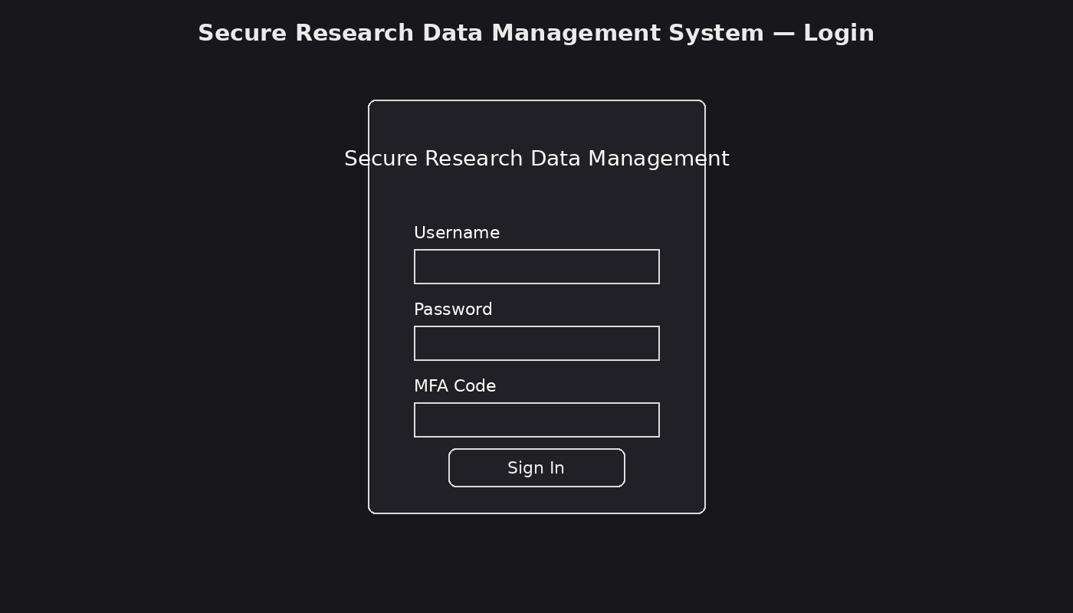
Figure 2.2.1 Login page

The login page illustrates a secure interface where authorized users enter their username and password and complete Multi-Factor Authentication before accessing the research data management system.

Research data management dashboard
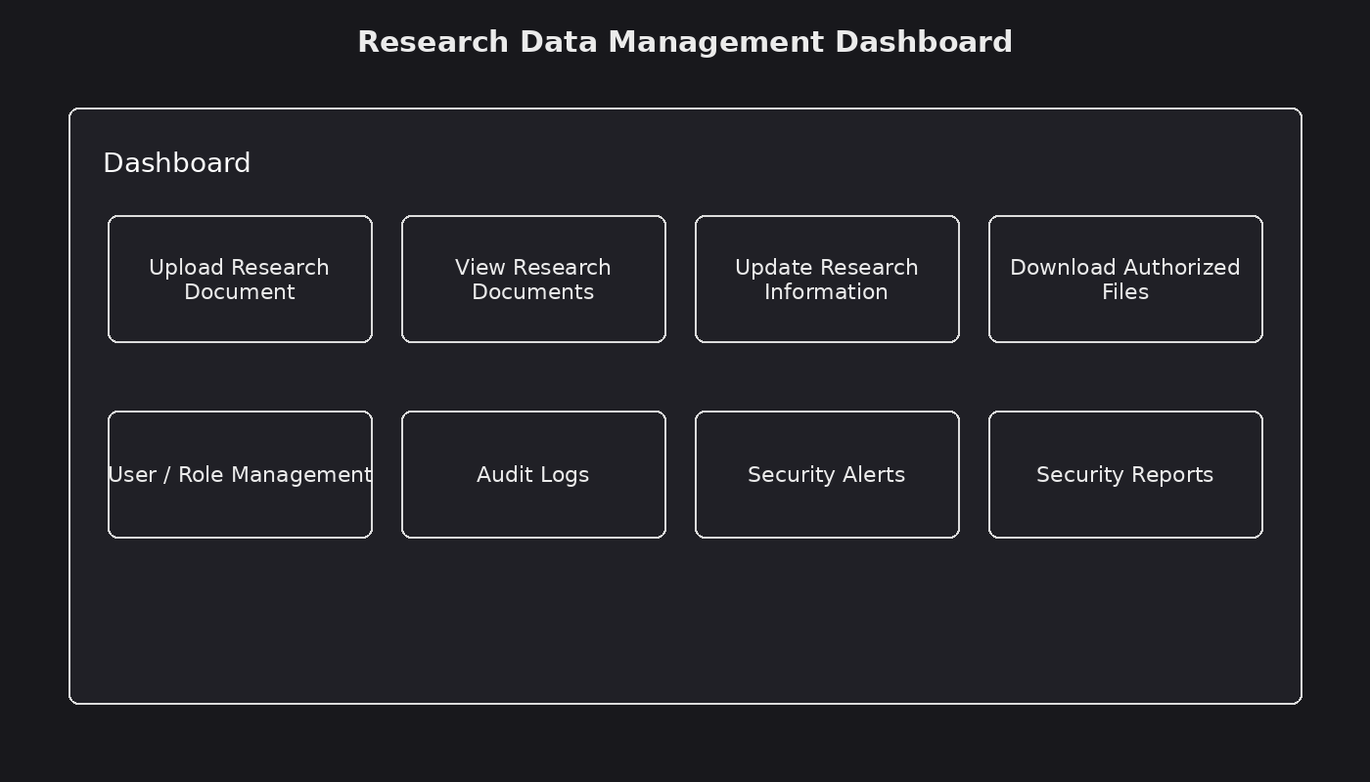
Figure 2.2.2 Research data management dashboard
The research data management dashboard provides authorized users with access to core functions such as uploading research documents, viewing authorized files, updating research information, downloading authorized files, reviewing audit logs, viewing security alerts, and generating security reports.

Audit logging and user accountability
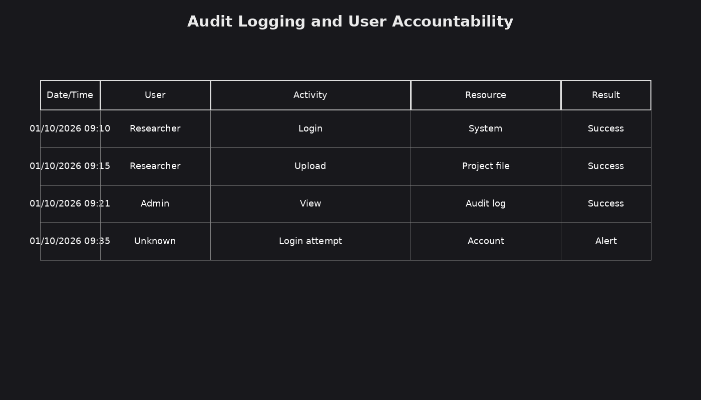
Figure 2.2.3 Audit logging and user accountability
The audit logging interface records activities such as user logins, file access, uploads, downloads, and modifications. The records support user accountability, security investigations, and monitoring of suspicious activities.

Security reports
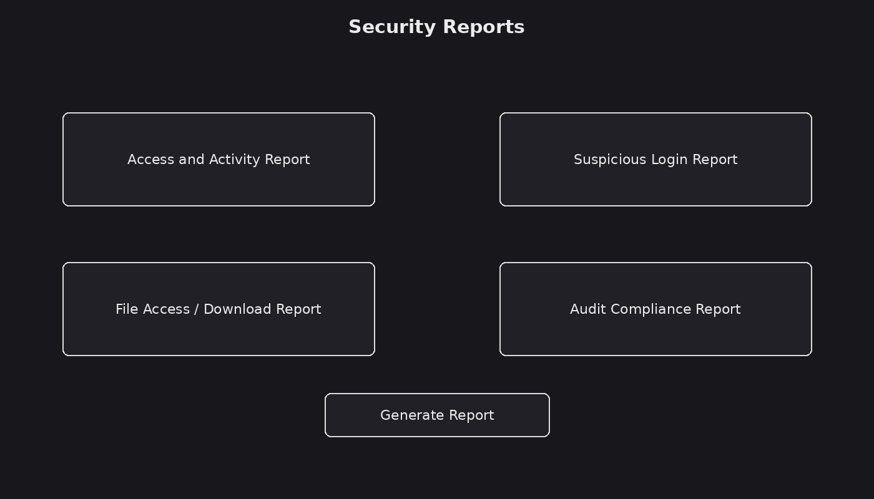
Figure 2.2.4 Security reports
The security reporting interface enables administrators to generate audit and access reports that summarize user activities and security events, supporting accountability and compliance with institutional information security requirements.

Logic Models

Log in process flowchart.
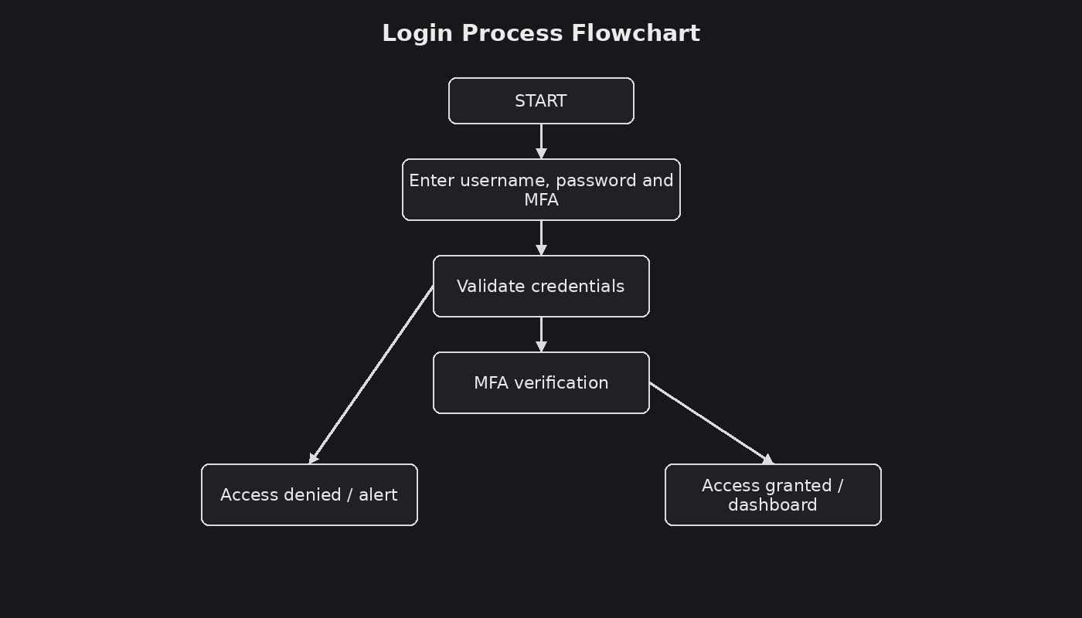
Figure 2.3.1 Login process flowchart
This flowchart illustrates the login process. A user enters the required credentials, the system validates the credentials, and Multi-Factor Authentication is completed. Valid authentication grants access to the dashboard, while invalid or suspicious attempts are denied and recorded for security monitoring.

    - System flow chart
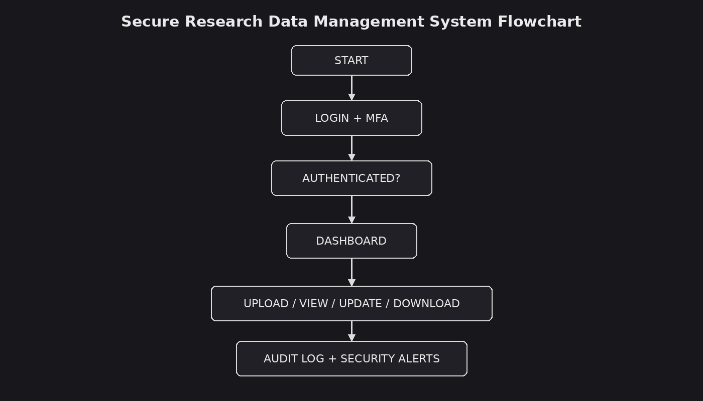
Figure 2.3.2 Secure research data management system flowchart

The system flowchart illustrates the main operation of the Secure Research Data Management System. The process begins with authentication, followed by access to the dashboard. An authorized user can upload, view, update, or download research information according to assigned permissions. System activities are recorded in audit logs, suspicious login attempts generate security alerts, and administrators can generate security reports.

Data flow diagrams
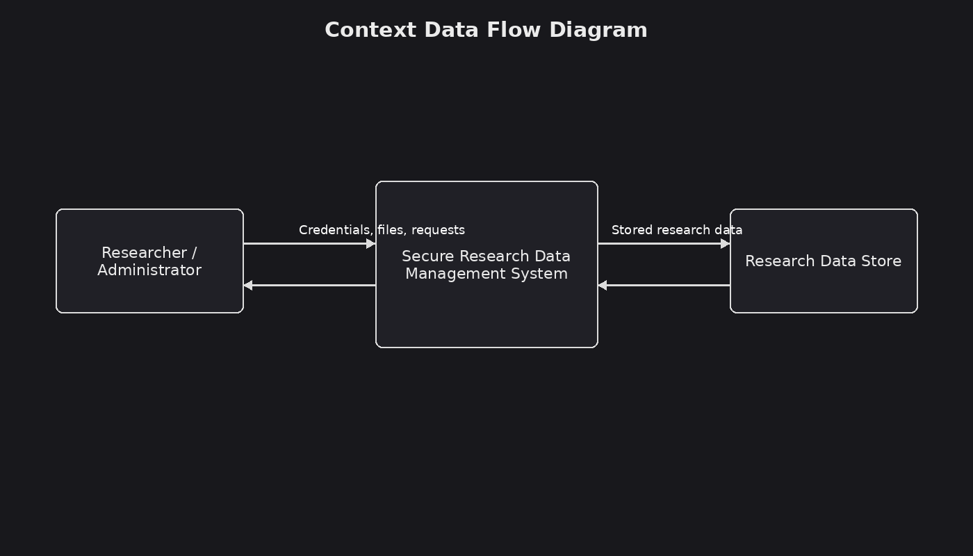
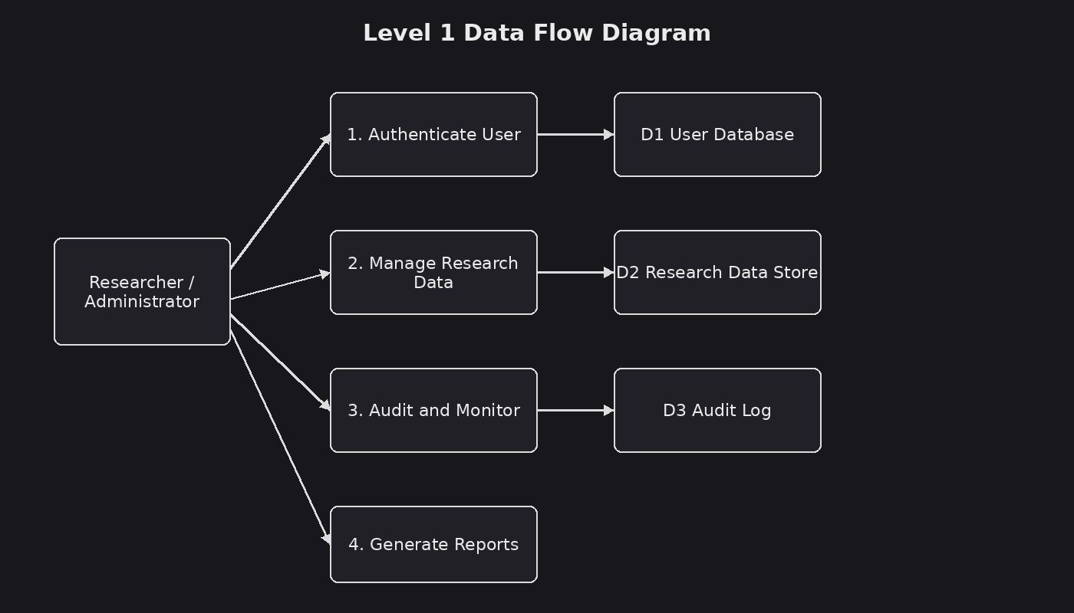
Figure 2.3.3 Data flow diagrams

The data flow diagrams illustrate how researchers and administrators exchange credentials, research files, requests, and reports with the Secure Research Data Management System. The system communicates with user, research data, and audit-log data stores to authenticate users, manage research information, record activities, and support security reporting.

Entity relationship diagram
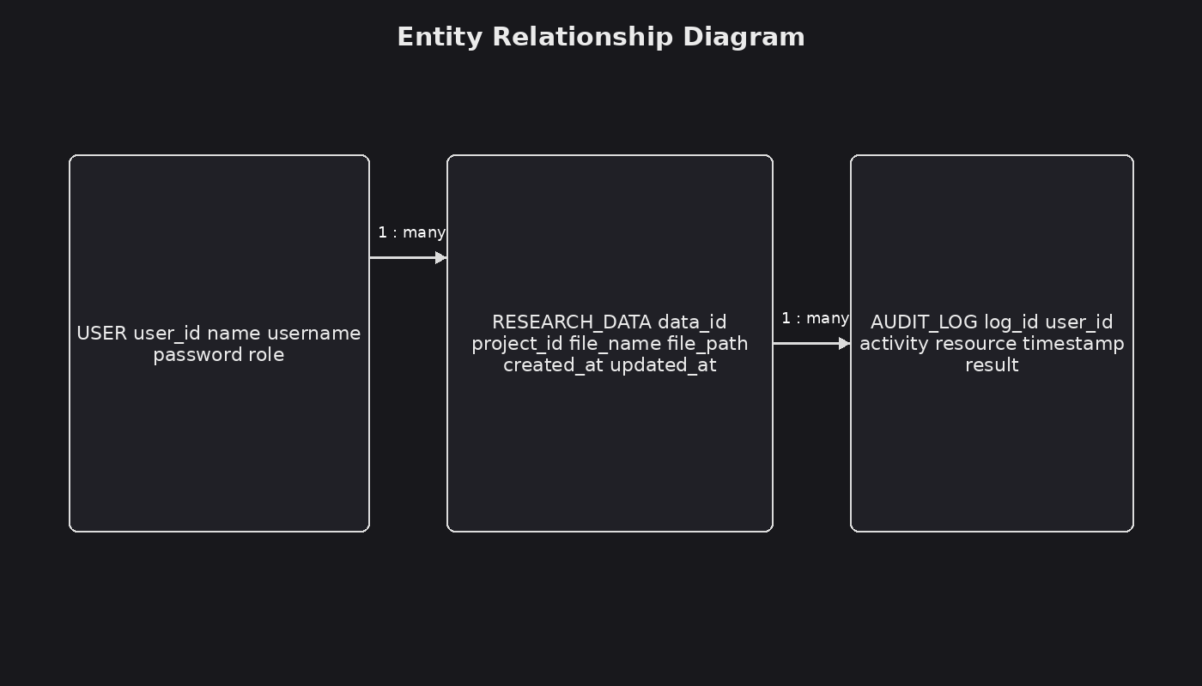
Figure 2.3.4 Entity relationship diagram

The Entity Relationship Diagram (ERD) represents the main database structure of the proposed system. The User entity stores user identity and role information. The ResearchData entity stores research project and file information, while the AuditLog entity records user activities and security events. Relationships between these entities support controlled access, research data management, and accountability.

Use case diagram
The use case diagram for the Secure Research Data Management System illustrates interactions between researchers, administrators, and the system. Users can authenticate through login and MFA and perform authorized research-data activities. Administrators can manage users and roles, review audit logs, respond to security alerts, and generate security reports. The diagram provides a visual representation of the major functions identified in the project functional requirements.

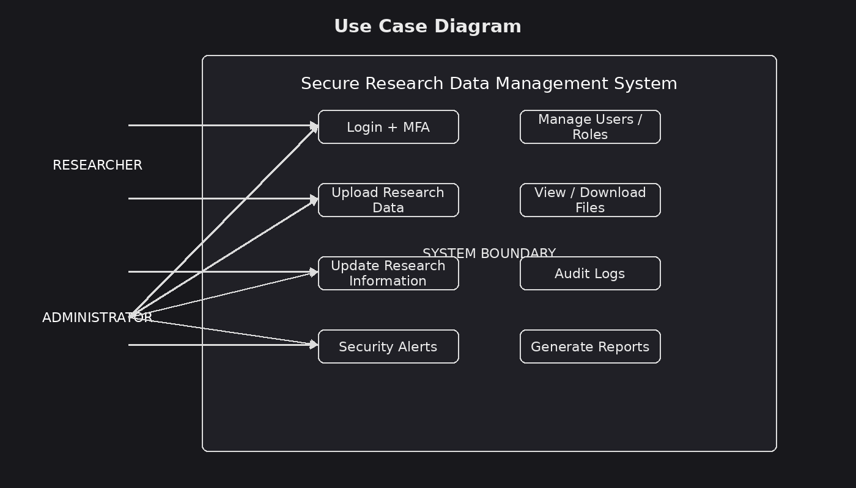
Figure 2.3.5 Use case diagram

Class diagrams
The class diagram for the Secure Research Data Management System shows the main classes and their relationships. The User class represents system users and their roles. The ResearchData class represents stored research information and supports upload, view, update, and download operations. The AuditLog class records activities and supports reporting. These relationships provide a structured model for implementing the database and system logic.

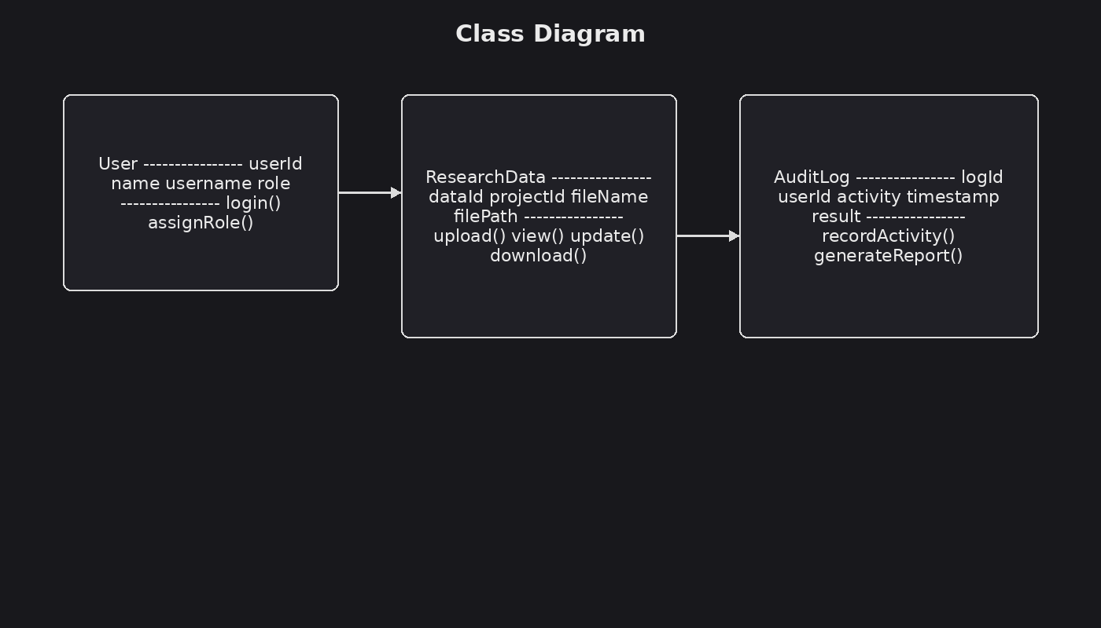
Figure 2.3.6 Class diagram

