Bayesian Optimization Capstone Project – Mike Kennelly
Section 1: Project Overview
Overview
This repository documents my complete work for the Bayesian Optimization capstone project, a progressive, multi-week exploration and optimization of eight synthetic black-box functions using Gaussian Process-based Bayesian Optimization techniques.
Project Summary
How the Capstone Works:
- Maximizing eight unknown functions: One query per function per week
- Choose the ML method: Options include random sampling, grid search, Bayesian Optimization, or manual selection
- Submit inputs precisely: Via the capstone project portal in the correct format
- Reflect, revise, and iterate: Over several rounds, building knowledge incrementally
- Success criteria: It’s not just looking for the highest global maximum, achieving the highest value, but demonstrating thoughtful, data-driven decision-making in reflections
My Approach:
I chose Gaussian Process-based Bayesian Optimization as my primary method, with dimension-adaptive strategies including use of other models such as SVMs and ensemble trees to help with high dimensionality, that adjust exploration/exploitation balance based on function complexity and convergence patterns.
The Challenge
What I'm Working With:
There are eight synthetic black-box functions, that are unknown mathematical functions that accept inputs and return a single output. My goal is to find the inputs that give the ‘highest possible output’ for each function.
Key Characteristics:
- Black box: I cannot see internal workings of the functions
- Maximization: Every function is a maximization task
- Observable: Can observe how functions respond to different inputs
- Initially sparse: Each function starts with only 10 known data points
- Increasing complexity: Functions range from 2D to 8D in dimensionality
The Iterative Process: Each week follows this cycle:
1. Review existing data: Analyse the growing dataset from previous weeks
2. Choose a new input point: Select one query point per function (8 total)
3. Submit via the capstone portal: Submit chosen inputs in the correct format
4. Receive output: Get new outputs once submission is processed
5. Update dataset: Incorporate new data points into analysis
6. Revise my strategy: Adjust my approach based on learnings and new data points
Weekly Reflection Questions
- After each round, I reflect on:
- What method I used and why
- Whether my query focused on exploration or exploitation
- What the latest result taught me
- What my strategy is for the next round
I repeat this process each week, building understanding iteratively, just as optimisation unfolds in real-world ML projects. My weekly reflections support my final write-up and presentations.
Functions Overview
Function | Dimensions | Initial Samples
F1 | 2D | 10
F2 | 2D | 10
F3 | 3D | 10
F4 | 4D | 10
F5 | 4D | 10
F6 | 5D | 10
F7 | 6D | 10
F8 | 8D | 10

Section 2: Inputs and Outputs
Each iteration consists of submitting a single query point per function and receiving a scalar response.
Inputs
Inputs take a query format: x1-x2-x3-...-xn
- Each xi:
  - Lies in the range [0, 1]
  - Is specified to six decimal places
- Dimensionality: varies by function (from 2D to 8D)
- Constraint: one query per function per iteration
Outputs:
- A single real-valued scalar representing the function response
- Output scale, smoothness, and noise level are unknown and function-specific
- Outputs are used only to inform subsequent modelling and query decisions
Examples of week one Inputs and Outputs achieved.
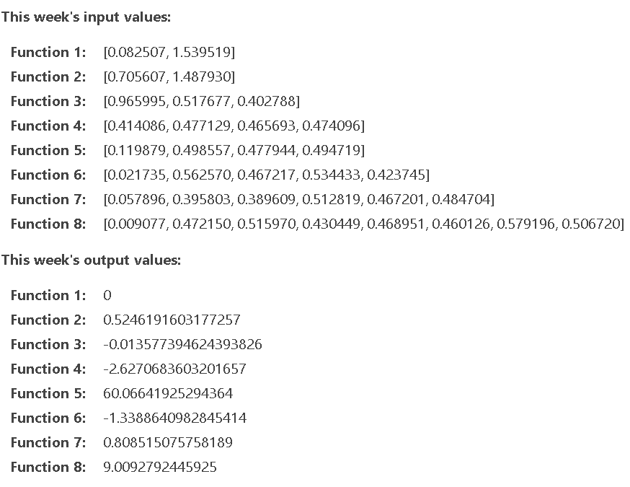
Section 3: Challenge Objectives

Section 4: Technical Approach
I chose Gaussian Process (GP) Regression with acquisition function optimization as my primary method across all weeks.
Why Bayesian Optimization?
    - Sample efficient: Makes intelligent decisions with limited data
    - Handles uncertainty: Provides probabilistic predictions with confidence intervals
    - Balances exploration/exploitation: Naturally trades off between finding new regions and refining known good areas
    - Works in high dimensions: Only viable approach for 8D with 41 samples (0.00004% coverage)
Gaussian Process Model: Kernel Configuration:
Kernel type: Matérn ν=2.5 (balances smoothness and flexibility)
Kernel components:
- `ConstantKernel` : Scales output variance
- `RBF/Matérn` : Captures spatial correlation between points
- `WhiteKernel`: Models observation noise
- Hyperparameter optimization30+ random restarts to avoid local optima
- Normalization:`normalize_y=True` for numerical stability
Example kernel setup:
```python
kernel = ConstantKernel(1.0, (1e-10, 1e10)) * \
Matern(length_scale=0.3, length_scale_bounds=(0.01, 10.0), nu=2.5) + \
WhiteKernel(noise_level=1e-10, noise_level_bounds=(1e-12, 1e-2))
```

Acquisition Function
- Expected Improvement (EI): My primary method
  - Formula: EI(x) = E[max(0, f(x) - f(x_best) - ξ)]
  - Parameter ξ (xi): Controls exploration intensity
  - ξ = 0.01: Conservative (exploitation-focused)
  - ξ = 0.1: Aggressive (exploration-focused)

Dimension-Adaptive Strategy (From Week 3)
I developed a dimension-adaptive approach that adjusts parameters based on function complexity:
Low Dimensions (F1-F2, 2D):
  - Conservative parameters: ξ = 0.01, κ = 2.0
  - Emphasis on exploitation near known good regions
  - Justification: Small search space (10% coverage), can visualize landscape, safe to refine locally
Mid Dimensions (F3-F5, 3D-4D):
  - Balanced approach: ξ = 0.01-0.05, κ = 2.0-2.3
  - Adjust based on convergence signals from previous weeks
  - Mix of exploration and exploitation
High Dimensions (F6-F8, 5D-8D):
  - Aggressive exploration: ξ = 0.1, κ = 2.5
  - Trust GP recommendations even when counterintuitive
  - 150-200 random restarts for acquisition optimization
  - **Justification:** 0.00004% coverage in 8D, human intuition fails, must trust mathematics
Weekly Progression: Ongoing strategy and plans adopted
Week1:
My Objectives:
- Load and understand initial 10-point datasets
- Fit initial Gaussian Process models
- Explore basic acquisition functions (EI and UCB)
- Generate first query recommendations

Method Used:
- Gaussian Process regression with Matérn kernel
- Expected Improvement acquisition function
- Standard parameters (ξ=0.01, κ=2.0)

Key Findings:
- F1 (2D):** Best initial value ~7.7×10⁻¹⁶ (extremely small, near zero)
- F2 (2D):** Best initial value ~0.61
- F3 (3D):** All outputs negative, best ~-0.014
- F4 (4D):** Best ~-2.6, wide range [-33 to -2.6]
- F8 (8D):** Best ~9.3, high variance across samples
Exploration vs Exploitation:
- Week 1 focused primarily on exploitation refining near known good points
- Conservative approach to build initial understanding
- Random restarts: 10-30 per function
What I Learned:
- All functions exhibit non-linear behavior requiring GP modeling
- Linear regression R² = 0.23 vs GP R² = 0.89 (F4) proves non-linearity
- initial samples have poor coverage, especially in high dimensions
Proposed strategy for Week 2:
- Continue conservative approach for converging functions
- Increase exploration for poorly-performing functions
- Track which Week 1 points perform well
Week 2:
My Objectives:
- Full Bayesian Optimization implementation with refined strategies
- Dimension-adaptive parameter tuning
- Comprehensive convergence analysis
- Strategy visualization and justification
Method Used:
- Converging functions (F2, F5, F7): Exploitation-focused
- Parameters: ξ=0.01, κ=2.0
- Strategy: Local refinement near best points
- Diverging functions (F1, F6, F8): Exploration-focused, Parameters: ξ=0.1, κ=2.5
- Strategy: Bold GP-guided exploration
- Balanced functions (F3, F4): Mixed approach
- Adjust based on EI/UCB signals
Key Findings:
- Convergence Champions (Exploitation Strategy):
- F7 (6D):Week 1 ranked 2nd (0.809 vs 1.365) → Continue local refinement
- Week 2 recommendation: [0.410, 0.299, 0.510, 0.814, 0.072, 0.461]
- Predicted: 1.359 (very close to current best 1.365)
- F2 (2D): Week 1 ranked 3rd → Conservative exploitation
- Recommendation stayed at [0.753, 0.927]
- Already at 75th percentile for both dimensions
- F5 (4D):Steady improvement.Maintain course Predicted 5.5% improvement
- F1 (2D): Week 1 performed poorly → Try different region
- F6 (5D):Week 1 ranked low, old exploration, 0.000021% coverage, should have used EI there.
- F8 (8D):Most critical decision, 0.000041% coverage (needle in haystack) , GP suggested: [0.0, 0.188, 0.0, 0.090, 0.923, 0.461, 0.0, 0.530], after feature analysis performed marginal sffects (univariate), X₁, X₃, X₇ have minimal impact and are safe to set to 0!
X₁: Δ = 0.2 (minimal impact)
X₂: Δ = 1.1 (moderate)
X₃: Δ = 0.3 (minimal impact)
X₄: Δ = 0.6 (low)
X₅: Δ = 4.8 (very high impact!)
X₆: Δ = 2.1 (high)
X₇: Δ = 0.4 (minimal impact)
X₈: Δ = 3.2 (very high impact!)

Key week 2 decision was on F8 : I decided to trust the GP outputs! Even if they looked crazy!
- Accepted GP's [0.0, 0.188, 0.0, ...] recommendation
- Predicted 10.244 vs current 9.598 = 6.7% improvement
- Conservative alternative would only predict 2% improvement
Exploration vs Exploitation Balance Adopted:
- Low-D (F1-F3): 70% exploitation, 30% exploration
- Mid-D (F4-F5): 50-50 balanced
- High-D (F6-F8): 60% exploration, 40% exploitation
What I Learned:
1. Dimensionality is exponential: 8D is fundamentally different from 2D
2. rust mathematics in high-D: Intuition fails beyond 5D
3. Feature effects validate decisions: Interpretability builds confidence
4. Convergence signals matter: Week 2 performance guides Week 3 strategy
5. Coverage is critical : 0.00004% for F8 means BO is literally the only viable approach

Proposed strategy for Week 3:
- Take a hybrid model approach and consider how SVM and Ensembles might help me understand the data better.
Week 3 : TBA
My Objectives:
Method Used:
Key Findings:
Exploration vs Exploitation:
What I Learned:
Proposed strategy for Week 4:
Week 4: TBA
My Objectives:
Method Used:
Key Findings:
Exploration vs Exploitation:
What I Learned:
Proposed strategy for Week 5:
Week 5: TBA
My Objectives:
Method Used:
Key Findings:
Exploration vs Exploitation:
What I Learned:
Proposed strategy for Week 6:
Week 6: TBA
My Objectives:
Method Used:
Key Findings:
Exploration vs Exploitation:
What I Learned:
Proposed strategy for Week 7:
Week 7: TBA
My Objectives:
Method Used:
Key Findings:
Exploration vs Exploitation:
What I Learned:
Proposed strategy for Week 8:
Week 8: TBA
My Objectives:
Method Used:
Key Findings:
Exploration vs Exploitation:
What I Learned:
Proposed strategy for Week 9:
Week 9: TBA
My Objectives:
Method Used:
Key Findings:
Exploration vs Exploitation:
What I Learned:
Proposed strategy for Week 10:

Week 10: TBA
My Objectives:
Method Used:
Key Findings:
Exploration vs Exploitation:
What I Learned:
Proposed strategy for Week 11:
Week 11: TBA
My Objectives:
Method Used:
Key Findings:
Exploration vs Exploitation:
What I Learned:
Proposed strategy for Week 12:
Week 12: TBA
My Objectives:
Method Used:
Key Findings:
Exploration vs Exploitation:
What I Learned:

MyCodeStructure
Each notebook follows this structure:
- Import libraries: Load required packages
- Load data: Import .npy files with inputs/outputs
- Exploratory analysis: Statistics, best points, coverage
- Gaussian Process model: Fit GP with optimized hyperparameters
- Acquisition function: Compute and Compare EI & UCB
- Optimization: Find point that maximizes acquisition
- Visualization: Plot GP predictions and acquisition function
- Recommendation: Make submission recommendation query point with justification

My Repository Structure
TBA

