# Introduction

This document has system specifications and instructions to create the Vetter pet care web application with server, database and file storage set up.

# System Specification

Here are the system requirements to set up system:

EC2:

* Instance t2.medium
* Ubuntu 14.04.6 LTS (GNU/Linux 3.13.0-125-generic x86_64)
* Size 15GB

RDS:

* Instance Class db.t2.small
* MySQL 5.7.44
* Size 10GB

PHP:

* PHP 5.5.9-1ubuntu4.29 (cli)
* Here is the list of packages need to be installed

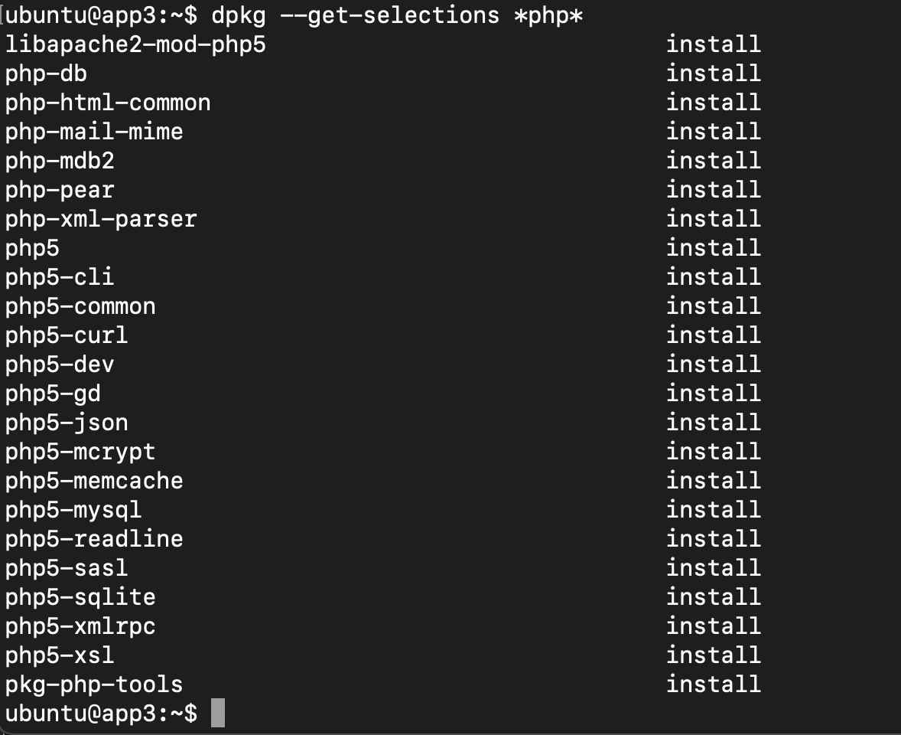

Apache:

* Apache/2.4.7 (Ubuntu)

# AWS set up

## EC2 server

Restore Vetter Web Application server from image.

AMI location: <https://vetterpc-ami.s3.amazonaws.com/ami-09a2119aa701a70ce.bin>

Following “Restore an AMI from an S3 bucket” instructions to restore from AMI image from S3 <https://docs.aws.amazon.com/AWSEC2/latest/UserGuide/ami-store-restore.html#work-with-ami-store-restore>

Or follow this instructions to install LAMP in server <https://www.digitalocean.com/community/tutorials/how-to-install-linux-apache-mysql-php-lamp-stack-on-ubuntu-14-04>

Do `git clone` command to clone project in the server.

Run:

git clone git@gitlab.com:vpctacdev/vetter-pet-care.git

## RDS server

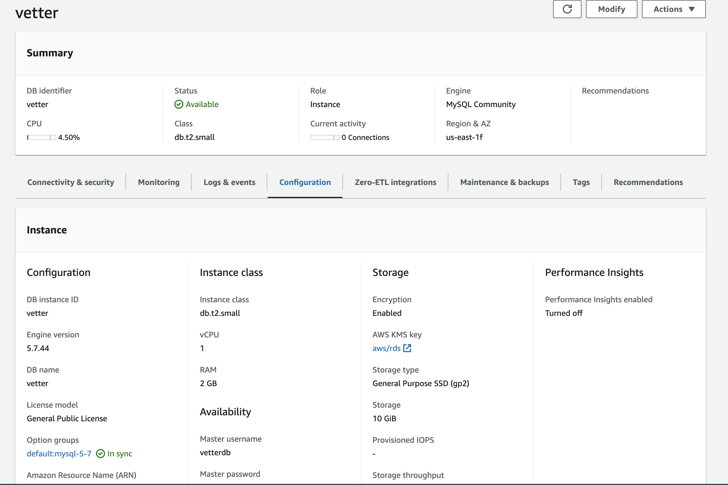

MySQL 5.7.44

Using MySQL command to import DB to MySQL

mysql --host=<db host name> --user=<admin username> --password=<password> --port=3306 --protocol=tcp < /tmp/.sql

# Pull code from GitLab

The latest code is <https://gitlab.com/vpctacdev/vetter-pet-care> project. In gitlab.com

Project owner @vpctacdev (VPC TacDev) [VPCTacDev@gmail.com](mailto:VPCTacDev@gmail.com) (using google account login to login to gitlab.com)

# Files Storage

All files are stored in S3 and have been exported to Google Drive <https://drive.google.com/drive/folders/1-hVAZPOAODEbCQcp8bvTLOfKkqHK59KU>

# Deploy System

We use OpsWorks and Chef script to deploy code to the server. However, OpsWorks no longer be available after May 26, 2024. If the client would like to deploy the application in EC2. I recommend configuring CloudFormation and CodeDeploy to deploy the server.