Kenneth Meyer
CSE 382M HW2
writeup for coding questions

1. The results appear to be slightly better using method A when checking the angle between the 1000 vectors in 100-d space. The plots below show this, these are histograms of the angle between each pair of 1000 vectors that were projected into 100-d space in a) and randomly generated in 100-d space in b).
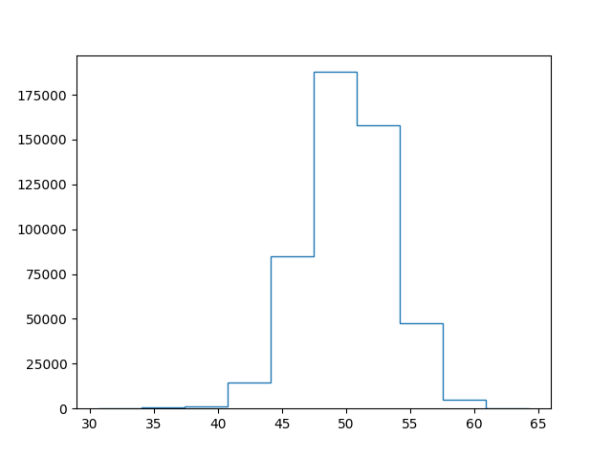

histogram of angles (x-axis) for A)

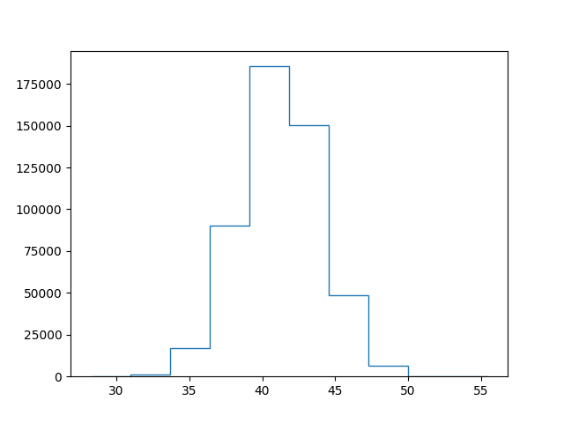

histogram of angles (x-axis) between vectors for part B)

2-5: see hand-written writeup
6. see submitted code for the methods.
6a. first singular vector was computed to be:

v1 = [0.31975067 0.36962508 0.39811313 0.40391891 0.38728041 0.34995866
0.2951262 0.22716232 0.15136859 0.0736236 ]

when the method was given a tolerance of 1e-6.

Convergence occurred in 11 iterations.

6b.
The first four singular vectors were computed to be:
first 4 singular vectors =
[[-0.3197506 -0.45784552 0.42415456 0.39363205]
[-0.36962502 -0.3936509 0.24288284 0.02849264]
[-0.39811309 -0.25497036 -0.07043603 -0.36151889]
[-0.4039189 -0.06980555 -0.33936334 -0.38322635]
[-0.38728043 0.12450888 -0.41233765 -0.01440812]
[-0.3499587 0.2887672 -0.2477534 0.37382027]
[-0.29512626 0.38972804 0.06268814 0.39083362]
[-0.22716239 0.40675711 0.34546459 0.01997999]
[-0.15136864 0.33594883 0.44265159 -0.364639 ]
[-0.07362363 0.19090282 0.30058612 -0.37499697]]

A similar level of tolerance was used (4e-6 for the sum of distances between singular vectors between each iteration)

To extend my code to compute the first k singular vectors, the implementation of the method in python can be kept the exact same with the addition of an argument specifying the number of singular vectors to compute. First select k randomly generated vectors, find an orthonormal basis for the space they span, multiply the vectors by AA^T, and find a new orthonormal basis for the space spanned by the resulting k vectors. The first k singular vectors will then be computed.

7.
a) Images of a cat, a 256 x 256 greyscale image, with singular value decompositions using 1, 4, 16, and 32 singular values and vectors:
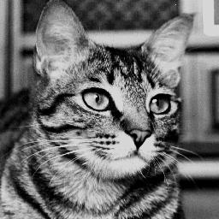Figure 1: original, full image of greyscale cat, 256x256
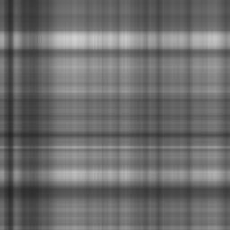Figure 2: Cat - 1 singular vector

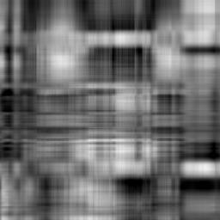Figure 3: Cat - 4 singular vectors
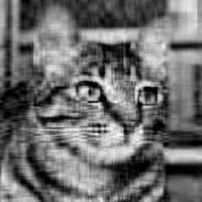Figure 4: Cat - 16 singular values

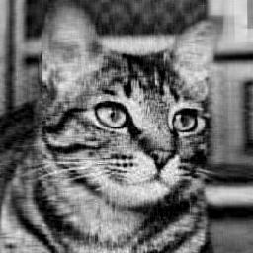Figure 5: Cat - 32 singular vectors!

b) percent of frobenius norm captured with 1, 4, 16, and 32 singular values, respectively:
[0.891097 0.94418707 0.98291085 0.99259788]

c) images of a “white noise” image. Note: the software I used used a greyscale scale of [0,256]. So I scaled each of the entries of the randomly generated 256x256 image by 256 to achieve a white noise image, otherwise all images that were generated where completely black.

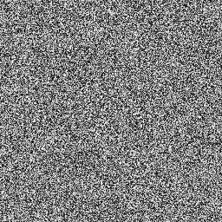Figure 6: white noise, full

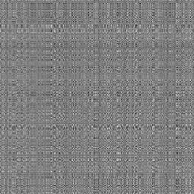Figure 8: white noise - 4 singular values
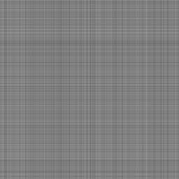Figure 7: white noise - 1 singular value

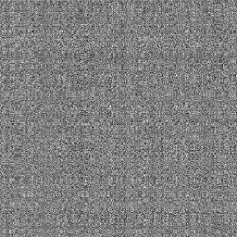Figure 9: white noise - 16 singular values
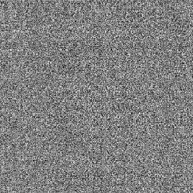Figure 10: white noise - 32 singular values

Frobenius norms in the white noise case:
[0.86684696 0.87323843 0.89501811 0.91816199]

Plots of the singular values for each distribution are shown below:
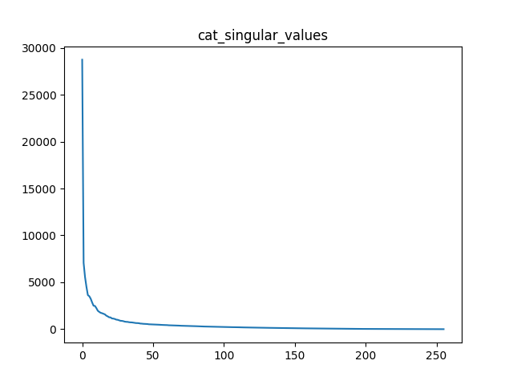

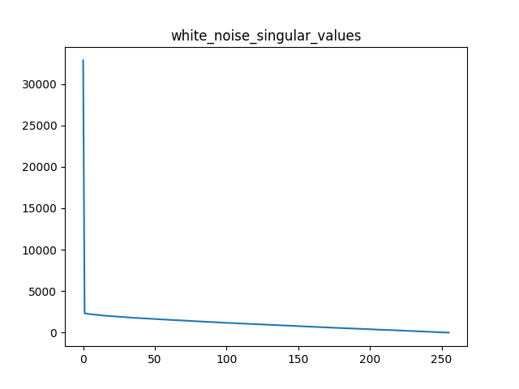

As seen above, the singular values in the cat image decrease more smoothly and rapidly than the singular values in the white noise image. It’s a little hard to see in the plots above, so here are other plots showing singular values 3-256:

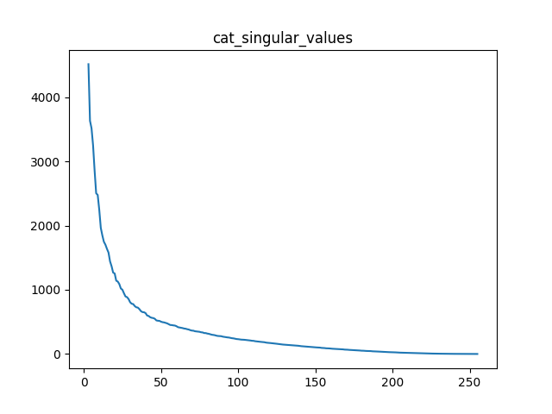

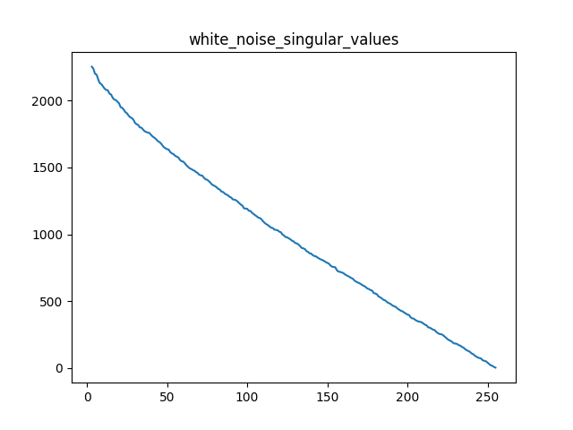

Now, it is more obvious that there is more separation in the singular values of the image in the cat than in the white noise image. This makes sense as the white image is randomly generated from a gaussian distribution, while the cat is simply a non-random image. The percentage of the frobenius norm captured by the image reconstruction using the SVD with [1,4,16,32] singular values in the white noise is less than the percentage captured in the cat case, which makes sense when the singular values of these greyscale images are examined.

