Final Project: Item Loan
CS 493: Cloud Application Development
Fall 2023
Oregon State University
Kenneth Tucker

Change log
Version | Change | Date
1.0 | Initial version. | Dec 9, 2023

Deploy URL
https://fp-tuckkenn.wl.r.appspot.com
Here is evidence of the tests passing for this URL:
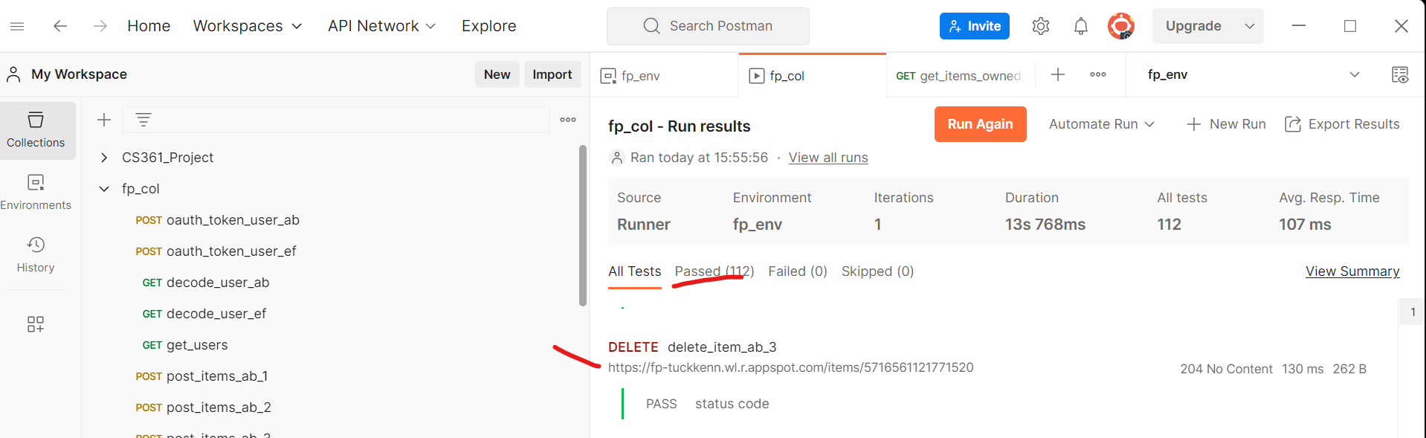

Account Creation/Login URL
https://fp-tuckkenn.wl.r.appspot.com
Here is evidence of account creation working for this URL:
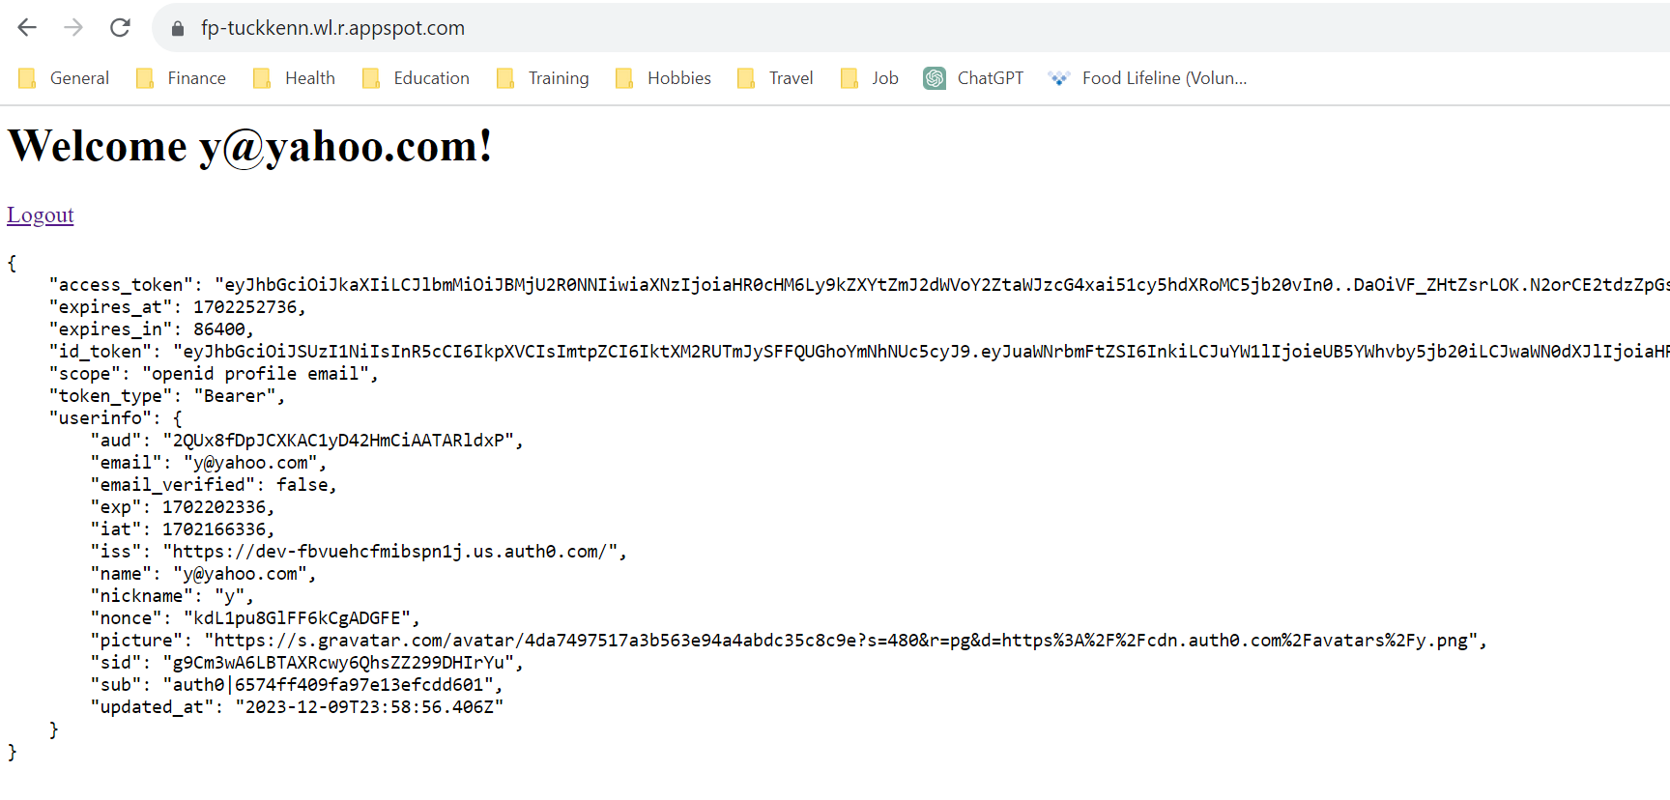

Design Overview
The app allows neighbors to loan each other items like snow shovels and lawn mowers. Secondarily, It also allows people to keep track of what they own, so they can, for example, get insurance payment for property loss due to a fire.
A user creates an entry for each item they own including the item’s name, a description, and its value in USD. They also specify if the item is “loanable”. If so, the item is publicly searchable/viewable and can be loaned to other users. If not, the item is private and can only be seen by that user.
A loan involves one user borrowing one item from its owner. The loan is created with an agreed upon due date for when the item should be returned to the owner. A loan is opened by the borrower (via an exchange process not implemented in this initial prototype) and the loan entity is “owned” by the borrower.
While an item is on loan, it cannot be modified or deleted, to prevent owners scamming borrowers. An open loan can only be extended or closed by the item owner, to prevent borrowers scamming owners. The loan is closed by the item owner when they agree their item has been returned, replaced, paid for, or they forgive any damage or loss. Closed loan records are retained by the borrower, until the borrower decides to delete the record. Loan records are visible to both the item owner and the borrower, but the item owner looses access when they delete their item or when the borrower deletes the closed loan record.
It’s important to note that the requirement “Endpoints are provided to create and remove relationship between non-user entities” is accomplished by the endpoints for creating and deleting loans.
Users are associated to items and loans using the “sub” Auth0 property. This is obtained by validating the JWT bearer token of the request and extracting from the payload object from Auth0.

Testing Clarification
The following Auth0 users are in the Postman tests:

ab@cd.com
abcd1234!

ef@ef.com
efgh1234!

The jwt1 variable is called “ab_token” and jwt2 variable is called “ef_token”. These variables are created/updated by running “oauth_token_user_ab” and “oauth_token_user_ef” tests at the beginning of the test collection. New users can also be created manually, and I verified this worked (see screenshot above). The list of users can be obtained by running the “get_users” test.
All CRUD operations are tested, for both the item and loan entities. Status codes are verified, and some body content is verified. User ownership of entities is tested throughout, for example, it is verified that items can only be modified by their owner. The relationships between items and loans are tested, for example, it is verified that items are not modifiable while an open loan of that item exists. All test requirements have been accomplished.

Data Model
The app stores three kinds of entities in Datastore: Users, Items, and Loans.

Users
Property | Data Type | Notes
id | Integer | The id of the user. Datastore automatically generates it.
name | String | The “name” Auth0 property for the user, it is the user email.
sub | String | The “sub” Auth0 property for the user, which is used to relate non-user entities to users.

Items
Property | Data Type | Notes
id | Integer | The id of the item. Datastore automatically generates it.
owner | String | The “sub” property for the user that created the item.
name | String | Name of the item. Must be 1 to 63 characters.
description | String | A description of the item. Must be 0 to 255 characters.
value | Integer | The value of the item in USD. Must be 1 to 999.
loanable | Boolean | If true, the item is publicly visible and can be loaned to other users. If false, the item is private.

Loans
Property | Data Type | Notes
id | Integer | The id of the loan. Datastore automatically generates it.
borrower | String | The “sub” property for the user that created the loan.
item | Integer | The ID (foreign key) of the item being borrowed. Required at loan creation and not modifiable afterwards.
start_date | String | The date the loan was created “YYYY-MM-DD”. This is generated by the app. Required at loan creation and not modifiable afterwards.
due_date | String | The date the item should be returned “YYYY-MM-DD”. Must be after the start date. Required at loan creation and can only be extended by the item owner.
end_date | String | The date the loan was closed by the item owner “YYYY-MM-DD”. It is null initially and populated when the loan is closed. It is generated by the app.
end_type | String | The status for a closed loan. It is null initially and populated when the loan is closed. Valid options are 'returned', 'replaced', 'paid', 'forgiven'.

Create an Item
Create a new item. Requires a valid JWT.
POST /items

Request

Path Parameters
None

Request Body
Required

Request Body Format
JSON

Request JSON Attributes
Name | Description | Required?
name | The name of the item. (Note: see data model for valid values) | Yes
description | A description of the item. | Yes
value | Value of the item in USD. | Yes
loanable | True if public and loanable, false if private. | Yes

Request Body Example
{
"name": "Leaf Blower",
"description": "Electric",
"value": 200,
"loanable": false
}

Response

Response Body Format
JSON

Response Statuses
Outcome | Status Code | Notes
Success | 201 | Item created.
Failure | 400 | If the request is missing any of the attributes or they have invalid values.
Failure | 401 | Invalid JWT.
Failure | 406 | Invalid Accept header.
Failure | 415 | Invalid Content-Type.

Response Examples
- Datastore will automatically generate an ID and store it with the entity being created.

Success
Status: 201

{
"name": "Leaf Blower",
"description": "Electric",
"value": 200,
"loanable": false,
"owner": "auth0|65567c3738308f9afdb75899",
"id": 6232102555090944,
"self": "https://fp-tuckkenn.wl.r.appspot.com/items/6232102555090944"
}

Failure
Status: 400

{
"Error": "The request object has invalid attributes"
}

Status: 401

{
"code": "invalid_header",
"description": "Invalid header. Use an RS256 signed JWT Access Token"
}

Status: 406

{
"Error": "Not Acceptable"
}

Status: 415

{
"Error": "Server only accepts application/json data."
}

Get Items
If a valid JWT is provided, list all items for the user. Otherwise, list all “loanable” items for all users.
GET /items

Request

Path Parameters
Limit and offset, for pagination.

Request Body
None

Request Body Format
None

Request JSON Attributes
None

Request Body Example
None

Response

Response Body Format
JSON

Response Statuses
Outcome | Status Code | Notes
Success | 200 | Success
Failure | 406 | Invalid Accept header.

Response Examples

Success
Status: 200

{
"items": [
{
"description": "Wood and plastic",
"value": 15,
"owner": "auth0|65567c3738308f9afdb75899",
"name": "Rake",
"loanable": true,
"id": 4792220137816064,
"self": "https://fp-tuckkenn.wl.r.appspot.com/items/4792220137816064"
},
{
"value": 10,
"name": "Snow Shovel",
"owner": "auth0|65567c3738308f9afdb75899",
"loanable": true,
"description": "Plastic shovel",
"id": 5077875795427328,
"self": "https://fp-tuckkenn.wl.r.appspot.com/items/5077875795427328"
},
{
"loanable": false,
"name": "Weed Wacker",
"value": 199,
"description": "Electric",
"owner": "auth0|65567c3738308f9afdb75899",
"id": 5667525748588544,
"self": "https://fp-tuckkenn.wl.r.appspot.com/items/5667525748588544"
},
{
"loanable": false,
"name": "Mower",
"description": "Gas powered push mower",
"value": 305,
"owner": "auth0|65567c3738308f9afdb75899",
"id": 5716561121771520,
"self": "https://fp-tuckkenn.wl.r.appspot.com/items/5716561121771520"
},
{
"loanable": true,
"owner": "auth0|65567c3738308f9afdb75899",
"name": "Car Jack",
"description": "Metal with rotating hand crank",
"value": 75,
"id": 5735810494103552,
"self": "https://fp-tuckkenn.wl.r.appspot.com/items/5735810494103552"
}
],
"next": "https://fp-tuckkenn.wl.r.appspot.com/items?limit=5&offset=5"
}

Failure

Status: 406

{
"Error": "Not Acceptable"
}

Get an Item
If a valid JWT is provided or the item is “loanable”.
GET /items/<item_id>

Request

Path Parameters
item_id

Request Body
None

Request Body Format
None

Request JSON Attributes
None

Request Body Example
None

Response

Response Body Format
JSON

Response Statuses
Outcome | Status Code | Notes
Success | 200 | Success
Failure | 403 | Item is not loanable and the current user is not the owner.
Failure | 404 | Invalid item_id.
Failure | 406 | Invalid Accept header.

Response Examples

Success
Status: 200

{
"name": "Rake",
"description": "Wood and plastic",
"loanable": true,
"value": 15,
"owner": "auth0|65567c3738308f9afdb75899",
"id": 4792220137816064,
"self": "https://fp-tuckkenn.wl.r.appspot.com/items/4792220137816064"
}

Failure

Status: 403

{
"Error": "Item not available"
}

Status: 404

{
"Error": "No item with this item_id exists"
}

Status: 406

{
"Error": "Not Acceptable"
}

Delete an Item
Delete an item. Requires a valid JWT.
DELETE /items/<item_id>

Request

Path Parameters
item_id

Request Body
None

Request Body Format
None

Request JSON Attributes
None

Request Body Example
None

Response

Response Body Format
JSON

Response Statuses
Outcome | Status Code | Notes
Success | 204 | Item deleted.
Failure | 401 | Invalid JWT.
Failure | 403 | Attempted to delete an item that is on loan.
Failure | 403 | Attempted to delete an item the current user doesn’t own.
Failure | 404 | Invalid item_id.

Response Examples

Success
Status: 204

Failure

Status: 401

{
"code": "invalid_header",
"description": "Invalid header. Use an RS256 signed JWT Access Token"
}

Status: 403

{
"Error": "Cannot delete loaned item"
}

Status: 403

{
"Error": "Item not owned"
}

Status: 404

{
"Error": "No item with this item_id exists"
}

Edit an Item (all attributes)
Update an existing item. Requires a valid JWT.
PUT /items/<item_id>

Request

Path Parameters
None

Request Body
Required

Request Body Format
JSON

Request JSON Attributes
Name | Description | Required?
name | The name of the item. (Note: see data model for valid values) | Yes
description | A description of the item. | Yes
value | Value of the item in USD. | Yes
loanable | True if public and loanable, false if private. | Yes

Request Body Example
{
"name": "Weed Destroyer 2000",
"description": "Nuclear powered, lead shielded",
"value": 999,
"loanable": true
}

Response

Response Body Format
JSON

Response Statuses
Outcome | Status Code | Notes
Success | 200 | Item updated.
Failure | 400 | If the request is missing any of the attributes or they have invalid values.
Failure | 401 | Invalid JWT.
Failure | 403 | Attempted to edit an item that is on loan.
Failure | 403 | Attempted to edit an item the current user doesn’t own.
Failure | 404 | Invalid item_id.
Failure | 406 | Invalid Accept header.
Failure | 415 | Invalid Content-Type.

Response Examples

Success
Status: 200

{
"owner": "auth0|65567c3738308f9afdb75899",
"name": "Weed Destroyer 2000",
"value": 999,
"loanable": true,
"description": "Nuclear powered, lead shielded",
"id": 5667525748588544,
"self": "https://fp-tuckkenn.wl.r.appspot.com/items/5667525748588544"
}

Failure
Status: 400

{
"Error": "The request object has invalid attributes"
}

Status: 401

{
"code": "invalid_header",
"description": "Invalid header. Use an RS256 signed JWT Access Token"
}

Status: 403

{
"Error": "Cannot modify a loaned item"
}

Status: 403

{
"Error": "Item not owned"
}

Status: 406

{
"Error": "Not Acceptable"
}

Status: 415

{
"Error": "Server only accepts application/json data."
}

Edit an Item (some attributes)
Update an existing item. Requires a valid JWT.
PATCH /items/<item_id>

Request

Path Parameters
None

Request Body
Required

Request Body Format
JSON

Request JSON Attributes
Name | Description | Required?
name | The name of the item. (Note: see data model for valid values) | No
description | A description of the item. | No
value | Value of the item in USD. | No
loanable | True if public and loanable, false if private. | No

Request Body Example
{
"loanable": true
}

Response

Response Body Format
JSON

Response Statuses
Outcome | Status Code | Notes
Success | 200 | Item updated.
Failure | 400 | If the request is missing any of the attributes or they have invalid values.
Failure | 401 | Invalid JWT.
Failure | 403 | Attempted to edit an item that is on loan.
Failure | 403 | Attempted to edit an item the current user doesn’t own.
Failure | 404 | Invalid item_id.
Failure | 406 | Invalid Accept header.
Failure | 415 | Invalid Content-Type.

Response Examples

Success
Status: 200

{
"name": "Mower",
"description": "Gas powered push mower",
"value": 305,
"loanable": true,
"owner": "auth0|65567c3738308f9afdb75899",
"id": 5716561121771520,
"self": "https://fp-tuckkenn.wl.r.appspot.com/items/5716561121771520"
}

Failure
Status: 400

{
"Error": "The request object has invalid attributes"
}

Status: 401

{
"code": "invalid_header",
"description": "Invalid header. Use an RS256 signed JWT Access Token"
}

Status: 403

{
"Error": "Cannot modify a loaned item"
}

Status: 403

{
"Error": "Item not owned"
}

Status: 406

{
"Error": "Not Acceptable"
}

Status: 415

{
"Error": "Server only accepts application/json data."
}

Create a Loan
Create a new loan. Requires a valid JWT.
POST /loans

Request

Path Parameters
None

Request Body
Required

Request Body Format
JSON

Request JSON Attributes
Name | Description | Required?
item | The ID of the item. | Yes
due_date | Date the item should be returned. | Yes

Request Body Example
{
"item": 6232102555090944,
"due_date": "2028-01-30"
}

Response

Response Body Format
JSON

Response Statuses
Outcome | Status Code | Notes
Success | 201 | Loan created.
Failure | 400 | If the request is missing any of the attributes or they have invalid values.
Failure | 401 | Invalid JWT.
Failure | 403 | Loan is invalid. Reasons for this include an invalid item ID, the item not being loanable, or someone trying to loan an item to themselves.
Failure | 403 | The item is already on loan, it is not available.
Failure | 406 | Invalid Accept header.
Failure | 415 | Invalid Content-Type.

Response Examples
- Datastore will automatically generate an ID and store it with the entity being created.

Success
Status: 201

{
"item": 6232102555090944,
"borrower": "auth0|6557a25df8a0974357311bc8",
"start_date": "2023-12-09",
"due_date": "2028-01-30",
"end_date": null,
"end_type": null,
"id": 5709113312935936,
"self": "https://fp-tuckkenn.wl.r.appspot.com/loans/5709113312935936"
}

Failure
Status: 400

{
"Error": "The request object has invalid attributes"
}

Status: 401

{
"code": "invalid_header",
"description": "Invalid header. Use an RS256 signed JWT Access Token"
}

Status: 403

{
"Error": "Invalid loan"
}

Status: 403

{
"Error": "Item not available"
}

Status: 406

{
"Error": "Not Acceptable"
}

Status: 415

{
"Error": "Server only accepts application/json data."
}

Get Loans
List this users loan history. Requires a valid JWT.
GET /loans

Request

Path Parameters
Limit and offset, for pagination.

Request Body
None

Request Body Format
None

Request JSON Attributes
None

Request Body Example
None

Response

Response Body Format
JSON

Response Statuses
Outcome | Status Code | Notes
Success | 200 | Success
Failure | 406 | Invalid Accept header.

Response Examples

Success
Status: 200

{
"loans": [
{
"borrower": "auth0|6557a25df8a0974357311bc8",
"end_date": null,
"start_date": "2023-12-09",
"due_date": "2028-07-20",
"end_type": null,
"item": 4792220137816064,
"id": 4788074152198144,
"self": "https://fp-tuckkenn.wl.r.appspot.com/loans/4788074152198144"
},
{
"end_date": null,
"item": 6232102555090944,
"start_date": "2023-12-09",
"due_date": "2028-01-30",
"end_type": null,
"borrower": "auth0|6557a25df8a0974357311bc8",
"id": 5709113312935936,
"self": "https://fp-tuckkenn.wl.r.appspot.com/loans/5709113312935936"
}
]
}

Failure

Status: 406

{
"Error": "Not Acceptable"
}

Get a Loan
View a single loan as either the lender or the borrower. Requires a valid JWT.
GET /loans/<loan_id>

Request

Path Parameters
loan_id

Request Body
None

Request Body Format
None

Request JSON Attributes
None

Request Body Example
None

Response

Response Body Format
JSON

Response Statuses
Outcome | Status Code | Notes
Success | 200 | Success
Failure | 403 | The loan is not visible to the current user. The borrower can always view their loan. The lender can view the loan only if the item that was lent still exists.
Failure | 404 | Invalid loan_id.
Failure | 406 | Invalid Accept header.

Response Examples

Success
Status: 200

{
"end_type": null,
"due_date": "2028-01-30",
"borrower": "auth0|6557a25df8a0974357311bc8",
"item": 6232102555090944,
"start_date": "2023-12-09",
"end_date": null,
"id": 5709113312935936,
"self": "https://fp-tuckkenn.wl.r.appspot.com/loans/5709113312935936"
}

Failure

Status: 403

{
"Error": "Loan not available"
}

Status: 404

{
"Error": "No loan with this loan_id exists"
}

Status: 406

{
"Error": "Not Acceptable"
}

Delete a Closed Loan
Delete a closed loan record. Requires a valid JWT.
DELETE /loans/<loan_id>

Request

Path Parameters
loan_id

Request Body
None

Request Body Format
None

Request JSON Attributes
None

Request Body Example
None

Response

Response Body Format
JSON

Response Statuses
Outcome | Status Code | Notes
Success | 204 | Loan record deleted.
Failure | 401 | Invalid JWT.
Failure | 403 | Attempted to delete an open loan.
Failure | 403 | Attempted to delete a loan where the current user isn’t the borrower.
Failure | 404 | Invalid loan_id.

Response Examples

Success
Status: 204

Failure

Status: 401

{
"code": "invalid_header",
"description": "Invalid header. Use an RS256 signed JWT Access Token"
}

Status: 403

{
"Error": "Open loans cannot be deleted"
}

Status: 403

{
"Error": "Loan never held"
}

Status: 404

{
"Error": "No loan with this loan_id exists"
}

Extend a Loan Due Date
Update an existing loan with a later due date, as the item owner. Requires a valid JWT.
PUT /loans/<loan_id>

Request

Path Parameters
None

Request Body
Required

Request Body Format
JSON

Request JSON Attributes
Name | Description | Required?
due_date | The new due date. It must be later than the existing due date. | Yes

Request Body Example
{
"due_date": "2028-10-31"
}

Response

Response Body Format
JSON

Response Statuses
Outcome | Status Code | Notes
Success | 200 | Loan updated.
Failure | 400 | If the request is missing any of the attributes or they have invalid values. Includes due dates that are before the existing due date.
Failure | 401 | Invalid JWT.
Failure | 403 | Attempted to edit a loan of an item when not the owner of the item.
Failure | 404 | Invalid loan_id.
Failure | 406 | Invalid Accept header.
Failure | 415 | Invalid Content-Type.

Response Examples

Success
Status: 200

{
"end_date": null,
"borrower": "auth0|6557a25df8a0974357311bc8",
"end_type": null,
"due_date": "2028-10-31",
"item": 6232102555090944,
"start_date": "2023-12-09",
"id": 5709113312935936,
"self": "https://fp-tuckkenn.wl.r.appspot.com/loans/5709113312935936"
}

Failure
Status: 400

{
"Error": "Due date only extendable"
}

Status: 401

{
"code": "invalid_header",
"description": "Invalid header. Use an RS256 signed JWT Access Token"
}

Status: 403

{
"Error": "Item not owned"
}

Status: 403

{
"Error": "Item not owned"
}

Status: 406

{
"Error": "Not Acceptable"
}

Status: 415

{
"Error": "Server only accepts application/json data."
}

End a Loan
End an open loan, as the item owner. Requires a valid JWT.
PATCH /loans/<loan_id>

Request

Path Parameters
None

Request Body
Required

Request Body Format
JSON

Request JSON Attributes
Name | Description | Required?
end_type | The end state of the loan (e.g. returned) | Yes

Request Body Example
{
"end_type": “returned”
}

Response

Response Body Format
JSON

Response Statuses
Outcome | Status Code | Notes
Success | 200 | Loan ended.
Failure | 400 | If the request is missing any of the attributes or they have invalid values.
Failure | 401 | Invalid JWT.
Failure | 403 | Attempted to end a loan where the current user doesn’t own the item or the loan was already ended previously.
Failure | 404 | Invalid loan_id.
Failure | 406 | Invalid Accept header.
Failure | 415 | Invalid Content-Type.

Response Examples

Success
Status: 200

{
"borrower": "auth0|6557a25df8a0974357311bc8",
"due_date": "2028-10-31",
"end_date": "2023-12-09",
"start_date": "2023-12-09",
"item": 6232102555090944,
"end_type": "returned",
"id": 5709113312935936,
"self": "https://fp-tuckkenn.wl.r.appspot.com/loans/5709113312935936"
}

Failure
Status: 400

{
"Error": "The request object has invalid attributes"
}

Status: 401

{
"code": "invalid_header",
"description": "Invalid header. Use an RS256 signed JWT Access Token"
}

Status: 403

{
"Error": "Cannot end loan"
}

Status: 406

{
"Error": "Not Acceptable"
}

Status: 415

{
"Error": "Server only accepts application/json data."
}

