Contents
1. Introduction 2
2. System Design 2
2.1. Technology Stack 2
2.2. Design Rationale 3
2.3. Network Topology and Data Model 4
3. System Implementation 5
3.1. Agent Implementation 5
3.1.1. Manager Agent 5
3.1.2. Vehicle Agent 6
3.1.3. Vehicle Routing System 6
3.2. DT Implementation 7
3.2.1. Protocol Translation 8
3.2.2. State Buffering and History Management 9
3.2.3. Monitoring Capabilities 9
3.3. Communication Protocol Specification 9
4. Startup Sequence and Dependency Management 12

DT & MAS for Vehicle Routing: Implementation and Architecture

Introduction
This implementation addresses the challenge of coordinating multiple vehicles across a network while maintaining accurate digital representations of their physical states. The critical question this project explores is: how can we combine MAS with DT technology to enable distributed, autonomous and heterogenous decision-making while preserving coordination and real-time synchronization?
The system aims to achieve three primary objectives: (i) develop a functional MAS where autonomous vehicle agents collaborate through structured negotiation protocols, (ii) integrating DT that maintain bidirectional synchronization to bridge operational gaps between high-level planning and low-level execution, and (iii) demonstrating distributed, multi-criteria path optimization where different vehicles prioritize distinct objectives. The system addresses a realistic transportation scenario where heterogeneous vehicles and operators with different capabilities and interests must be coordinated. Each vehicle possesses different speeds and routing priorities, requiring the system to account for these differences during task allocation. The challenge extends beyond simple routing by ensuring accurate digital representations throughout task execution. The system architecture for this mini project, shown in Figure 1, builds on the framework proposed in the previous chapter.
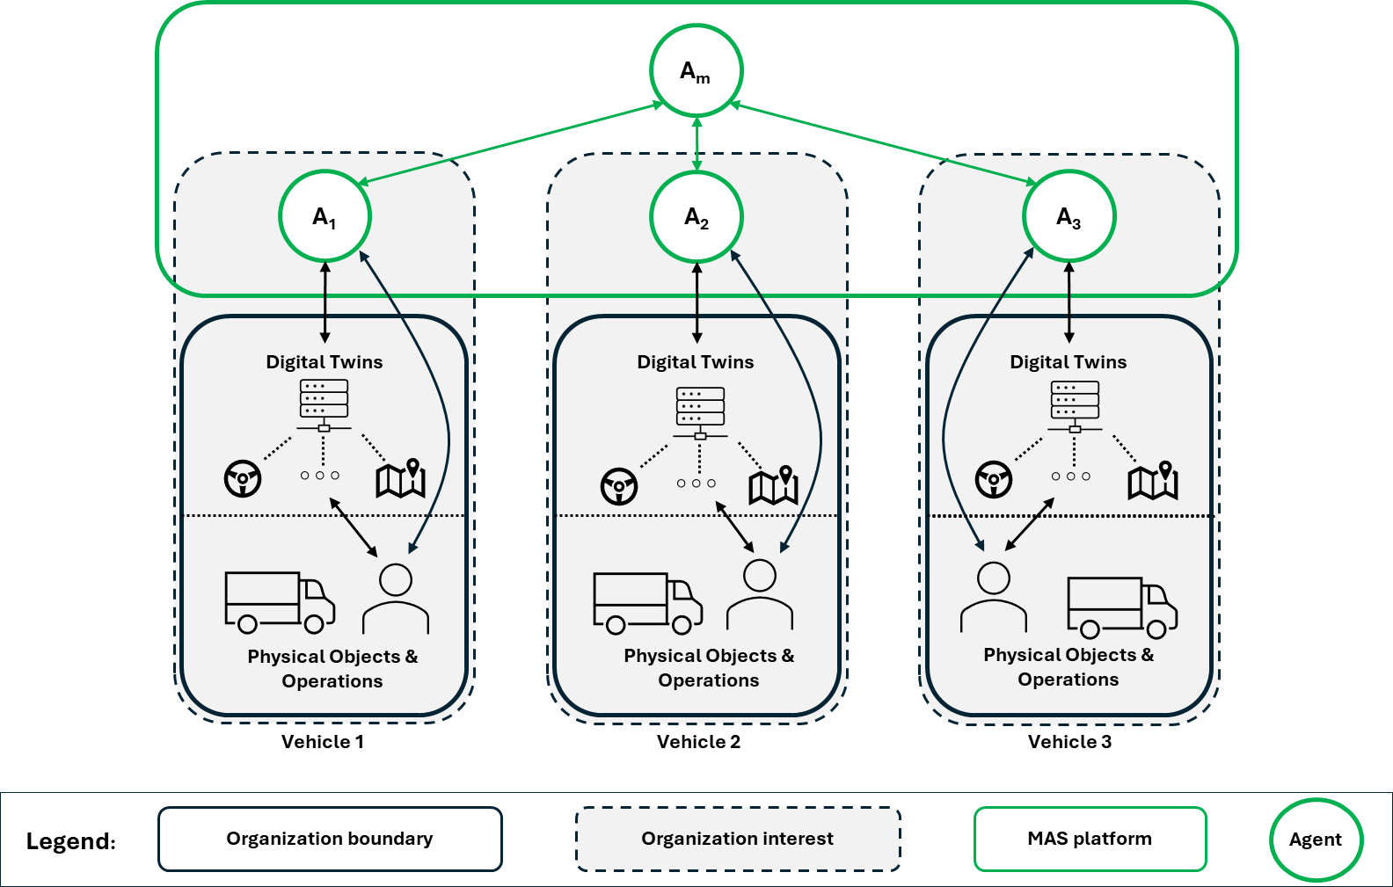
Figure 1: System architecture with manager agent (A_{m}) coordinating vehicle agents (A₁, A₂, A₃), each connected to DTs bridging agent decisions with physical operations.

System Design

Technology Stack
The implementation uses Python 3 with asyncio for asynchronous I/O, a choice driven by the need to handle multiple concurrent operations efficiently. Each component must manage concurrent concerns: vehicle agents simultaneously maintain DT connections (blocking on TCP reads), listen for manager messages (event-driven callbacks), and execute multi-waypoint routes. Traditional multi-threading would introduce complexity around shared state protection, race conditions, and debugging difficulties. The asyncio event loop model enables efficient handling of these concerns within single-threaded processes, avoiding threading overhead.
The Fetch.ai uAgents framework provides foundational infrastructure for the MAS. First, it implements robust message-passing with automatic serialization and deserialization of Pydantic models, ensuring type safety across all agent communications and preventing entire classes of bugs related to field naming, type mismatches, or missing required values. Second, it provides built-in agent discovery and addressing mechanisms via the Almanac Contract, allowing agents to reliably locate each other using persistent addresses. Third, the Protocol class enables clean separation between agent logic and communication handling, improving code maintainability. Fourth, uAgents integrates storage mechanisms that persist agent state across executions, essential for maintaining task assignments and completion histories.
MQTT communication is used between DTs and vehicle simulators building on the Paho-MQTT client library with a Mosquitto broker. This enables lightweight publish-subscribe messaging for real-time vehicle state updates. TCP connections between agents and their DTs are implemented using Python's built-in asyncio streams, providing reliable bidirectional communication channels for command execution and state synchronization. The routing intelligence layer employs custom Python implementations with Dijkstra's algorithm from first principles rather than using built-in libraries. This decision prioritizes transparency and educational value - understanding how pathfinding works internally proves more valuable than treating it as a black box, especially when debugging unexpected route selections or extending the algorithm with custom heuristics. The minimal dependency approach also eliminates concerns about external library compatibility or versioning issues.

Design Rationale
Figure 2 illustrates the implemented system with its four functional layers and communication patterns. The layered design ensures that each component operates with well-defined responsibilities and communicates through standardized interfaces. This enabled independent development and proved critical during debugging. For instance, when routing calculations produce unexpected results, the problem can be isolated to the routing layer without investigating agent communication or DT synchronization.
The architecture explicitly mandates that all interactions flow through DT intermediaries rather than allowing direct communication with the vehicle simulator. This design decision, while adding architectural complexity, provides three critical benefits. First, changes to the simulator's telemetry format requires updating only the DT's conversion logic, not every vehicle and manager agent. Consequently, protocol translation by the DT allows the MAS and the vehicle simulator to evolve independently. Second, state buffering enables DTs to maintain recent telemetry history. It handles temporary communication disruptions without losing critical state information. Third, monitoring capabilities allow DTs to detect anomalies such as missing updates or contradictory state information (e.g., a vehicle reporting 100% progress but location not matching destination), providing early warning of communication failures.
Communication between components follow specific patterns. The manager broadcasts to all vehicle agents using uAgents infrastructure, with vehicles responding through the same framework to maintain protocol consistency. This broadcast-response pattern implements the first phase of the contract net protocol, where the manager acts as task announcer and vehicle agents act as contractors. Vehicle agents establish persistent TCP connections to their DTs, enabling bidirectional command and telemetry exchange. DTs subscribe to simulator update topics via MQTT, while using direct TCP for point-to-point agent communication.

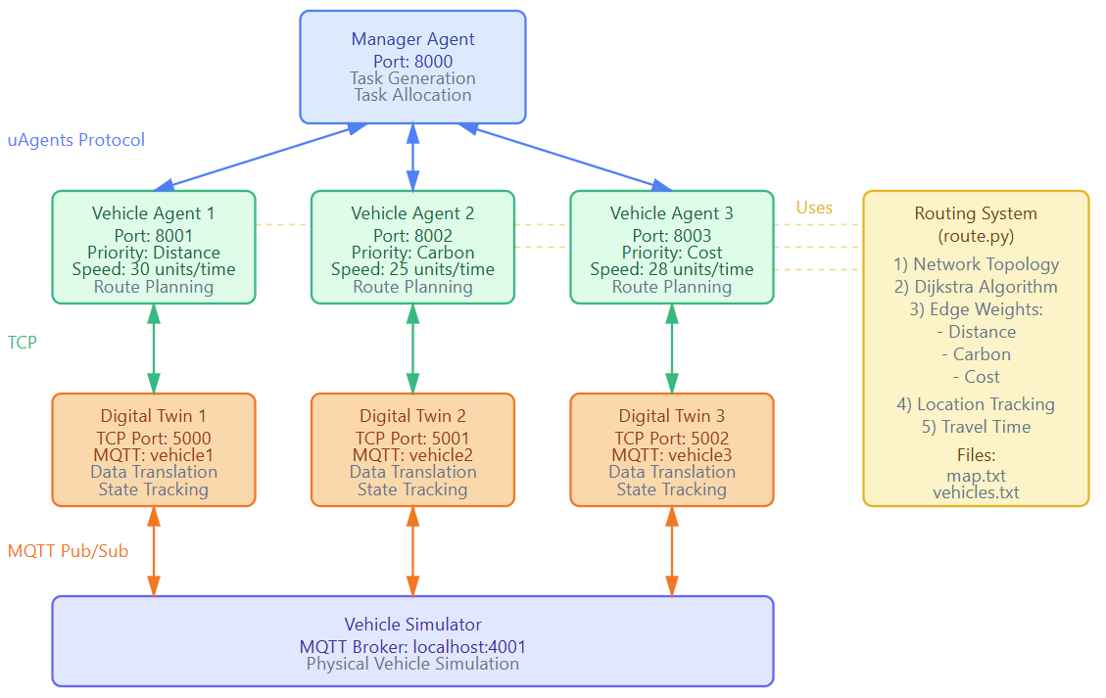
Figure 2: Implemented system architecture showing communication protocols and component interactions.
Fault isolation represents a key architectural benefit. Each component operates as an independent operating system process with separate memory spaces and failure domains. If a vehicle agent crashes or becomes unresponsive, the manager detects this through proposal timeout mechanisms (waiting maximum five seconds for responses) and allocates tasks to remaining operational vehicles without system-wide disruption. If a DT process fails, only the corresponding vehicle is affected - the failed vehicle stops sending proposals due to lost simulator connectivity, but other vehicles continue operating normally. The manager itself, while currently a single point of failure, detects its own issues through intermediate checkpoints.

Network Topology and Data Model
The network topology is taken from the vehicle simulator program through its map.txt file. The map.txt format represents each node with name, coordinates, and connections using a human-readable structure that can be manually edited for testing. The parsing implementation in route.py includes comprehensive validation and error handling. When a node cannot be parsed (malformed format, missing brackets, invalid coordinates), the system raises an exception with descriptive error message rather than silently skipping problematic entries or inserting default values. This fail-fast approach ensures that configuration errors are detected immediately during startup rather than causing mysterious behaviour during execution. The parser explicitly handles bidirectional connections by checking both forward and reverse connections, ensuring graph traversal works correctly regardless of how edges are specified in the input file.
Edge weights are computed during initialization using a fixed random seed (42) rather than allowing truly random generation. This reproducibility proves essential for system testing and performance evaluation. Without reproducibility, it’s hard to distinguish whether performance differences result from algorithmic changes or random network variations. The weights include distance (Euclidean geometric distance), carbon emissions (distance × random factor 0.1-2.0), and cost (distance × random factor 0.1-5.0), creating realistic variation where some routes have higher per-unit-distance emissions due to elevation differences or costs due to factors like road grade, traffic, or toll roads.
The vehicles.txt file specifies characteristics of the vehicle. Each vehicle's speed influences travel time calculations and task allocation decisions. Faster vehicles naturally produce shorter travel times for identical routes, making them more competitive during proposal evaluation. The starting node imported from vehicle.txt provides the baseline from which DTs begin tracking location updates, ensuring vehicles have valid initial positions before receiving their first simulator telemetry. The vehicle routing network implemented in this mini project is illustrated in Figure 3.
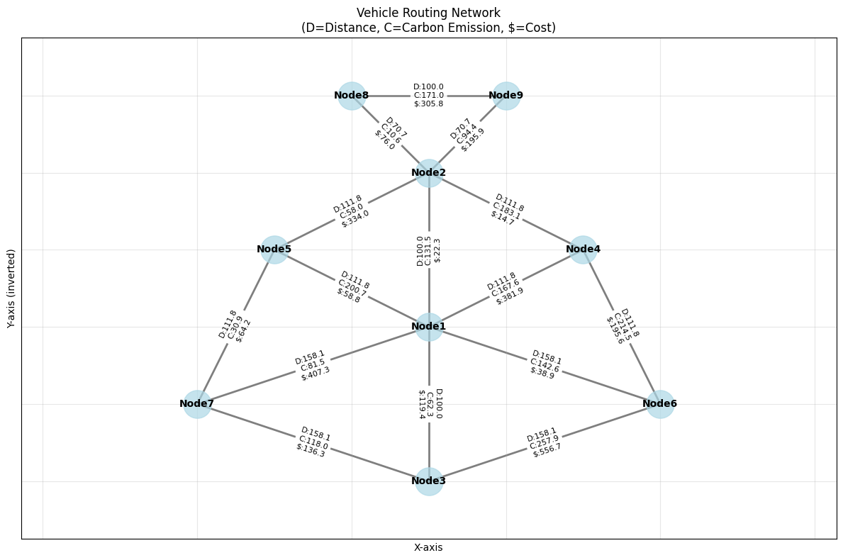
Figure 3: Network topology showing nodes and weighted edges with three routing criteria: distance (D), carbon emissions (C), and cost ($).

System Implementation

Agent Implementation

Manager Agent
The manager agent (01_manager.py) employs a greedy allocation algorithm that minimizes travel time. It assigns each task to the vehicle that can complete the journey the quickest. This simplified approach is justified because multi-criteria optimization occurs at the vehicle level. Each agent independently optimizes its route, and hence proposed travel time, using its assigned criterion (distance, carbon emissions, or cost). State persistence through uAgents' JSON storage enables crash recovery. If the manager fails mid-allocation, it recovers active_assignments on restart and continues monitoring in-progress tasks. The storage maintains the current task identifier, destination node, proposals dictionary, active_assignments tracking vehicle-task pairings, completed_tasks history, and an awaiting_responses flag that prevents overlapping proposal collection cycles.
To maintain steady-state operation, tasks are generated on a fixed five-second interval. The core allocation mechanism follows a broadcast-with-timeout pattern. After broadcasting CallForProposal messages, the manager collects responses for five seconds or until all vehicles respond, whichever occurs first. This timeout ensures forward progress even when vehicles crash or lose communication - the manager simply proceeds with available proposals, treating non-responders as unavailable. Before selecting the minimum-time proposal, the manager filters out busy vehicles as an admission control mechanism. This reduces failed allocations by only considering vehicles that declared availability. A TaskAcceptance confirmation is sent by the selected vehicle agent to the manager to provide secondary validation to catch these edge cases.

Vehicle Agent
The vehicle agent (02_vehicle_agent.py) implements a state machine that manages transitions between idle, proposing, executing, and completing states. While more complex than linear control flow, this architecture provides critical robustness. Each transition is explicit and logged for operational transparency, and state variables (is_busy, executing_full_path, waiting_for_completion) act as guards preventing invalid transitions like accepting tasks mid-execution. The VehicleState class encapsulates all runtime state in a single object rather than using module-level variables, improving testability and enabling multiple vehicle instances per process for unit testing. State includes vehicle_id, TCP reader/writer streams for DT communication, connectivity status, a VehicleRoutingSystem instance, current_node location, availability flags, task identifiers, and planned routes with progress tracking.
DT connectivity establishes during startup through connect_to_dt using asyncio.open_connection. Connection failures - from DT unavailability, network issues, or port conflicts - are logged with the connected flag remaining False, preventing the vehicle from accepting tasks it cannot execute. This fail-safe ensures vehicles never claim unavailable capabilities. Upon successful connection, the agent spawns listen_for_dt_updates as a background task continuously processing telemetry until closure or exception. The telemetry processing loop implements a timeout-based heartbeat using await state.reader.readline() with a 30-second timeout. It allows periodic connection health checks even during inactivity and prevents indefinite blocking of the DT. Consequently, when timeout expires without data, the loop continues and logs the wait rather than treating it as an error, maintaining graceful operation during normal idle periods.

Vehicle Routing System
The VehicleRoutingSystem class (route.py) encapsulates all routing intelligence as a cohesive service layer, providing graph representation, pathfinding algorithms, and vehicle-specific travel time calculations. Internal graph representation uses complementary data structures optimized for different access patterns: a nodes dictionary for O(1) coordinate lookups, a connections defaultdict providing adjacency lists for traversal, and an edge_weights dictionary using sorted node tuples as keys to ensure bidirectional edges share weights regardless of query direction. This multi-dictionary approach balances memory efficiency with query performance - separate dictionaries enable fast hash-based lookups while the sorted-tuple key technique avoids redundant storage for bidirectional edges.
Vehicle data storage separates static configuration from dynamic runtime state, such as tracking simulator-reported positions, and agent-declared destinations. Static configuration provides baseline values during initialization, while dynamic state reflects actual runtime conditions. The get_vehicle_current_location method implements a fallback logic and uses the tracked position when available, otherwise default to start_node, ensuring routing calculations can proceed during startup before first telemetry arrival.
Path Optimization and Multi-Criteria Routing
Figure 4 demonstrates how different optimization priorities produce distinct route selections when traveling from Node7 to Node4 based on the network in Figure 3. Vehicle 1 (distance priority) selects Node7→Node1→Node4, achieving minimum distance of 269.92 units but incurs 249.12 kg CO₂ emissions and costs $789.24. Vehicle 2 (carbon priority) chooses the identical route Node7→Node1→Node4, as this path also minimizes emissions at 249.12 kg CO₂, maintaining the same distance and cost. On the other hand, Vehicle 3 (cost priority) opts for Node7→Node5→Node1→Node2→Node4, minimizing expenditure to $159.97 while accepting significantly greater distance of 435.41 units and higher emissions of 546.20 kg CO₂. This illustrates fundamental trade-offs in multi-criteria optimization - optimizing one criterion typically compromises others, requiring explicit priority selection based on operational objectives.
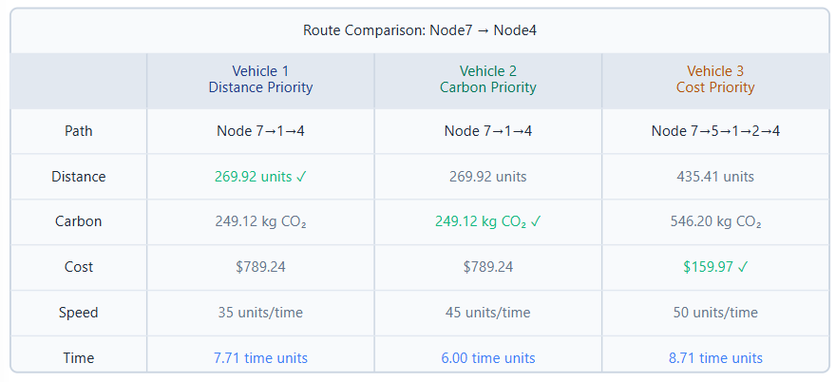
Figure 4. Route comparison demonstrating how different optimization priorities produce distinct path selections from Node7 to Node4.
The dijkstra_shortest_path method implements Dijkstra's algorithm with configurable weight_type parameter, enabling optimization for any criterion by simply changing which edge weight drives the algorithm. The calculate_path_metrics method computes comprehensive metrics for complete paths, returning distance, carbon, and cost values even when the path was optimized for only one criterion. This enables comparison against what other optimizations would achieve and assess whether the program is functioning correctly. The calculate_travel_time method provides vehicle-specific time calculations by dividing path distance by specified vehicle speed. The mathematical expression of the decision-making process is summarized in Appendix A.
Dynamic Location Tracking and Routing Integration
The update_vehicle_location method provides the interface through which vehicle simulator can inform the DTs of position changes. The method validates both vehicle existence and location, functioning as a checkpoint before sharing messages. Invalid updates are rejected and logged. The set_vehicle_target method records agent-declared destinations separately from actual locations, enabling distinction between "where the vehicle is" (current_location) and "where the vehicle intends to go" (target_location). This separation allows agents to instruct vehicles to reach intermediate waypoints (Node1→Node3→Node5→Node7) in order to reach the final destination (Node7). The find_optimal_path_for_vehicle method serves as the primary routing interface for vehicle agents.

DT Implementation
The DT (03_digital_twin.py) serves as an intelligent intermediary layer bridging the semantic gap between low-level simulator telemetry and high-level agent reasoning. Each vehicle has a dedicated DT process with its own communication channels and state storage. This clean isolation means that if one twin crashes, only the corresponding vehicle is affected while others continue operating normally.

Protocol Translation
The DT implements bidirectional protocol translation between MQTT (simulator-side) and TCP (agent-side), allowing each subsystem to use communication protocols suited to their respective needs.
Command Flow (Agent → Simulator): The DT receives TCP messages with type "assign_mission" and destination field, performs format conversion via convert_agent_mission_to_simulator_format (currently pass-through but designed as an extension point for inclusion of more data if needed), and publishes to the vehicle simulator via MQTT. The JSON command includes vehicle identifier and destination, with the twin logging the forwarding operation for operational visibility.
Telemetry Flow (Simulator → Agent): The on_message callback processes MQTT messages arriving on vehicle-specific update topics. The callback logs raw data with timestamp before any transformation, then parses as JSON and appends to state_history. The convert_simulator_data_to_agent_format method performs semantic translation, constructing a dictionary with agent-friendly field names and semantics. [Figure 4] illustrates this transformation. The most complex mapping involves determining the vehicle's current location. The simulator provides the next_location and previous_location field, but this is semantically misleading - it represents the origin and next node of the current path segment, not the vehicle's actual position. Since the simulator does not explicitly report true location, the digital twin derives it by combining previous_location, next_location, and progress fields. The mapping applies multi-level fallback logic: when progress equals 100%, the vehicle has reached its destination, so next_location becomes current_location; when progress is less than 100%, the vehicle is still at or departing from the origin, so current_node is reported as current_location. If the mapping cannot be resolved for any reason, current_location defaults to "Unknown" to signal temporary uncertainty. This robust fallback logic handles the simulator’s static current_node field systematically, preventing agents from acting on outdated location data that could lead to incorrect routing or task execution errors. After that, the converted data is forwarded to the agents through forward_to_agents, which iterates through agent_writers to write JSON-encoded messages to each TCP stream. The method uses fire-and-forget transmission without awaiting drain(). Writers that raise exceptions are collected in dead_writers set and removed after iteration completes, handling agent disconnections without disrupting the remaining connected agents.
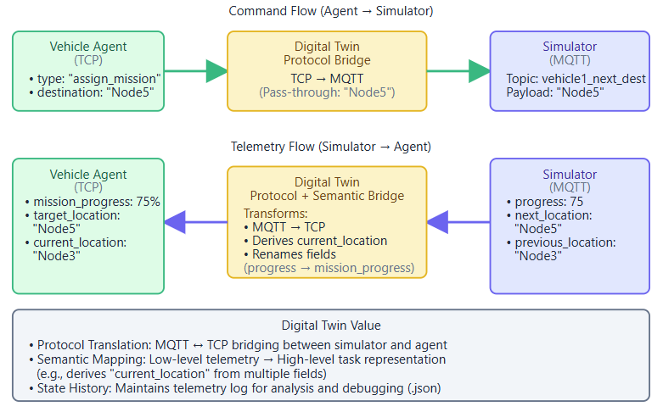
Figure 5: DT bidirectional data flow showing command and telemetry processing.

State Buffering and History Management
The digital twin maintains a timestamped log of all simulator updates in the state_history list. This transforms it from a simple message forwarder into a data recorder that preserves the complete history of vehicle state evolution. The conversion includes additional metadata: raw_current_node preserving the original simulator value (enabling comparison of raw vs. converted data), and conversion_timestamp recording when transformation occurred (supporting analysis of transformation latency or identification of stale data). After execution, the export_history method serializes history to JSON and Pandas DataFrames, enabling offline analysis including trajectory visualization, execution time statistics, correlation analysis between progress and location updates, and identification of abnormal behaviour patterns.

Monitoring Capabilities
During execution, history enables the twin to detect anomalies - if the simulator stops sending updates for more than 10 seconds (detected by comparing current time against last_update_time), the twin logs a warning indicating potential simulator failure, network disconnection, or subscription problems. This anomaly detection provides early warning of issues before they cause task execution failures.
Progress monitoring checks if progress reaches 100% and current_location matches next_location to detect mission completion. Upon completion, the message_ack event signals that the vehicle reached its destination. The detect_anomalies method logs warnings if more than 10 seconds elapse since the last update. This simple timeout-based detection could be extended with sophisticated checks like detecting impossible state transitions (decreasing progress, location jumps) or identifying vehicles reporting high progress without location changes (indicating simulator bugs or telemetry corruption).

Communication Protocol Specification
The protocol implements a clear separation between coordination messages (CallForProposal, ProposalResponse, TaskAssignment, TaskAcceptance, TaskCompletion) that drive the contract net protocol and monitoring messages that provide operational visibility. This separation ensures that monitoring services can be added, removed, or modified without impacting core allocation mechanisms. For example, NodeUpdate frequency could be increased from 5 seconds to 1 second for finer-grained tracking, or additional monitoring messages could be introduced for debugging, without requiring changes to the fundamental coordination protocol. Figures 2-3 document the complete task execution flow demonstrating end-to-end operation across all layers.
Phase 1: Task Generation and Proposal Collection begins when the manager generates a new task with a unique identifier and randomly selected destination. The manager broadcasts CallForProposal to all registered vehicles, initiating the contract net protocol's first phase. Each vehicle receives the broadcast and immediately checks its availability. If the vehicle is busy executing a previous task, it constructs a ProposalResponse with is_busy=True, informing the manager it cannot fulfil the request.
Where the vehicle is not busy, it queries its current location from the DT, validates that the destination exists in the map.txt, and invokes find_optimal_path_for_vehicle to determine the most optimal path based on the agents’ preference. The vehicles then construct a comprehensive ProposalResponse message with the estimated delivery time and send to the manager. The manager's handle_proposal callback receives each response, validates task_id matches the current task (discarding stale responses from previous cycles), and stores the proposal. After receiving all three responses or after five-second timeout expires, evaluate_proposals executes. The evaluation filters out the busy proposal, compares the available estimated times, and selects the vehicle that offers the minimum completion time. The greedy selection prioritizes fastesr task completion, a simple strategy providing predictable behaviour suitable for demonstration and debugging.
Phase 2: Task Assignment and Acceptance proceeds with the manager sending TaskAssignment exclusively to the vehicle with the minimum delivery time informing it of selection. This is an implicit rejection mechanism, where non-selected vehicles detect rejection through assignment absence rather than receiving explicit rejection messages. Explicit rejection would require the manager to send rejection messages to N-1 vehicles for each task, doubling message traffic. Once the assigned vehicle handle_assignment callback receives the assignment, it verifies that the vehicle_id matches (preventing cross-vehicle assignment errors) and checks availability (detecting race conditions where the vehicle became busy between proposal and assignment) before transitioning to busy status. The assigned vehicle then sends TaskAcceptance to the manager confirming execution will begin, then sends the first waypoint to the DT via send_mission_to_dt.
Phase 3: Incremental Execution and Progress Monitoring begins with an assign_mission command that includes destination and request_id, and the agent awaits acknowledgment (task_ack) with a 10-second timeout. This three-way handshake (proposal → assignment → acceptance with acknowledgment) establishes committed task execution, providing the agent with confirmation that the vehicle has begun work and enabling the agent to detect communication failures if acknowledgments don't arrive. The simulator publishes progress updates every second on vehicle1update. The DT receives each update, performs semantic transformation and forwards converted data to the vehicle agent.
The agent's process_vehicle_data callback extracts mission_progress and current_location from each update. When progress reaches 100% and current_location matches the expected waypoint, the agent recognizes waypoint arrival and invokes handle_waypoint_reached. This function identifies the next waypoint and sends this as a new mission to the DT. This incremental progression, executing one waypoint at a time with confirmation before proceeding, provides multiple safeguards to ensure that the vehicle actually takes the planned route to reach the destination. Throughout execution, the Agent also sends NodeUpdate messages every five seconds to the manager, reporting current_location and progress percentage. These periodic updates provide the manager with real-time visibility into task execution.
Phase 4: Task Completion and State Reset occurs when the vehicle reaches the final destination on the planned path. Once the agent’s process_vehicle_data detects that current_location matches final_destination, it performs a state reset returning the vehicle to idle status and constructs a TaskComplete message with task_id, vehicle_id, final_node, and success=True and sends to the manager. The manager's handle_task_completion callback receives the completion message, removes the task from active_assignments (freeing Vehicle 1 for new allocations), adds the task_id to completed_tasks (maintaining historical record), and logs the completion with full details. The manager continues its periodic task generation, broadcasting a new CallForProposal every five seconds.
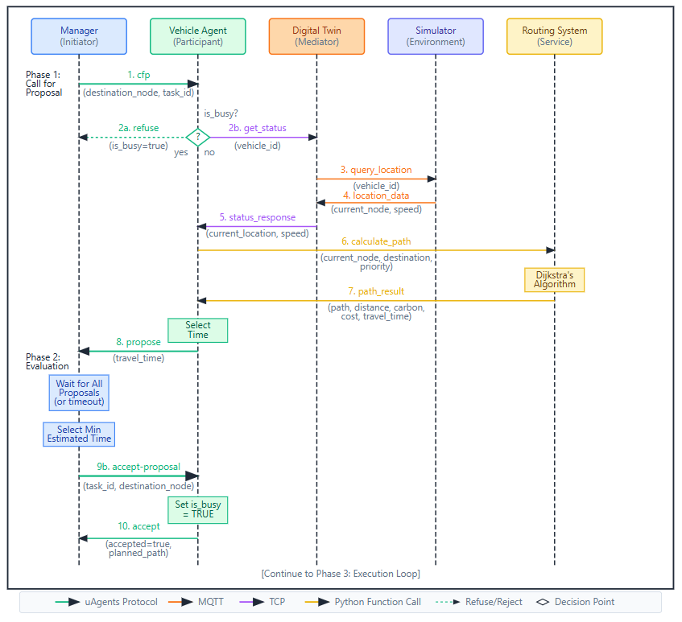
Figure 6: Contract Net Protocol Phases 1 and 2.
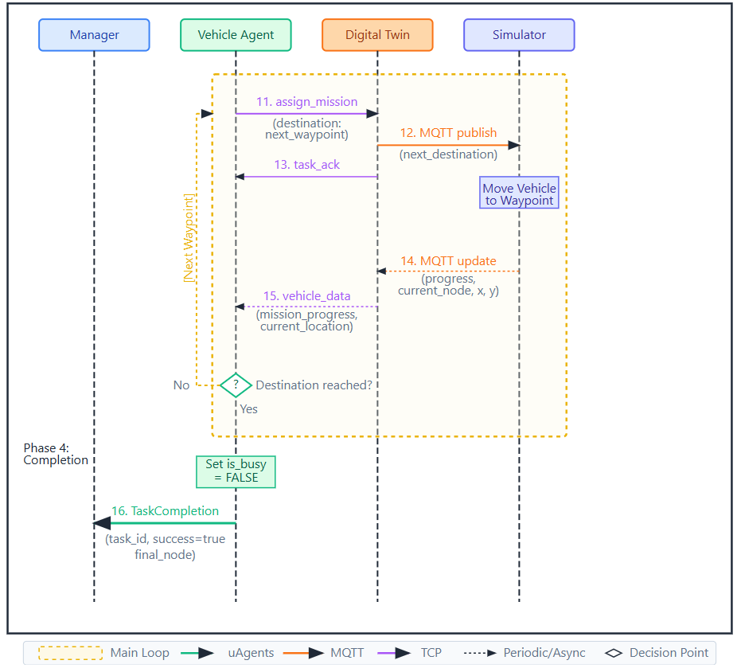
Figure 7: Contract Net Protocol Phases 3 and 4.
This complete cycle illustrates the system’s emphasis on transparency, reliability, and robustness. Explicit state transitions and detailed logging facilitate clear interpretation of behaviour and efficient debugging. Acknowledgment-based communication ensures commands are reliably delivered, while incremental execution with continuous verification guards against routing errors and stalled progress. Each task concludes with a full state reset, preventing residual data from influencing subsequent operations.

Startup Sequence and Dependency Management
System execution follows an orchestrated startup sequence that establishes all necessary connections before task processing begins. The vehicle simulator launches first, initializing MQTT broker connection and beginning periodic telemetry publication. The simulator operates independently. DT processes start next, connecting to the MQTT broker and subscribing to vehicle-specific topics. Each twin immediately begins processing simulator telemetry even though no agents have connected yet, ensuring that DTs capture the complete simulation history rather than missing initial updates that occur before agent connections. Vehicle agents launch after DTs are operational, preventing connection failures if agents attempted to connect before twin TCP servers were listening. The startup sequence includes validation - if topology files are missing or malformed, if DT connection fails, or if configuration errors exist, the agent logs descriptive errors and exits rather than attempting operation with incomplete initialization. The manager agent starts last, after all vehicles are operational and ready to receive proposals.

