Complete the following questions for your study guide. You can work in teams of 1-3 to complete this study guide. Make sure to put all of your names on the document that you turn in.

1. Write the Binary Search Algorithm (in steps, code, or flow chart form) on the white board. You can use different color markers if you would like to make it clear. Take a picture of this algorithm, and insert it as the answer for this question.
2. Write out the Algorithm for one of your simple sorts (in steps, code, or flow chart form) on the white board. You can use different color markers if you would like to make it clear. Take a picture of this algorithm, and insert it as the answer for this question.
3. Write out the Algorithm for another one of your simple sorts (in steps, code, or flow chart form) on the white board. You can use different color markers if you would like to make it clear. Take a picture of this algorithm, and insert it as the answer for this question.
4. Write out the Algorithm for one of the last simple sort we went over (in steps, code, or flow chart form) on the white board. You can use different color markers if you would like to make it clear. Take a picture of this algorithm, and insert it as the answer for this question.
5. Which sort is usually considered the best and why?
6. Name an algorithm that runs in Big O (log n) time. Explain which type of algorithm this is; sorting, searching, inserting, deleting, creating, etc.

Binary Searching

1. What is Big O notation – explain in your own words. This answer must be between 50-100 words – no more, no less.

The Big O notation is a simple explanation of number that goes higher than we can possible can conceive. Which is represent in N. If the number is not changing or limit the array will be 1. N^2 would be two for loops. Like bubble short slow going through the array numerous times swapping high to low until it reach the end. Then repeating until no sort is done.

1. Write out a class definition for a Tennis Racquet object that will be used in a game about Tennis. Make sure to include between 2-4 attributes. Make at least 2 constructors, 2 accessors and 2 mutators. Make the toString method.

public class E {

private String player;

private String racketName;

private String brandRacket;

private String shoesBrand;

public E(String player, String racketName, String brandRacket, String shoesBrand) {

super();

this.player = player;

this.racketName = racketName;

this.brandRacket = brandRacket;

this.shoesBrand = shoesBrand;

}

public E() {

super();

player = "Sandy";

racketName = "Gucci Grill 2019";

brandRacket = "LOUIS VUITTON";

shoesBrand = "Gucci is Life";

}

/**

* **@return** the player

*/

public String getPlayer() {

return player;

}

/**

* **@param** player the player to set

*/

public void setPlayer(String player) {

this.player = player;

}

/**

* **@return** the racketName

*/

public String getRacketName() {

return racketName;

}

/**

* **@param** racketName the racketName to set

*/

public void setRacketName(String racketName) {

this.racketName = racketName;

}

/**

* **@return** the brandRacket

*/

public String getBrandRacket() {

return brandRacket;

}

/**

* **@param** brandRacket the brandRacket to set

*/

public void setBrandRacket(String brandRacket) {

this.brandRacket = brandRacket;

}

/**

* **@return** the shoesBrand

*/

public String getShoesBrand() {

return shoesBrand;

}

/**

* **@param** shoesBrand the shoesBrand to set

*/

public void setShoesBrand(String shoesBrand) {

this.shoesBrand = shoesBrand;

}

*@Override*

public String toString() {

return "E [player=" + player + ", racketName=" + racketName + ", brandRacket=" + brandRacket + ", shoesBrand="

+ shoesBrand + "]";

}

}

1. Make a picture of the Linked List on the white board for the following code, take a picture of it and turn it in for this answer. Here is the code:

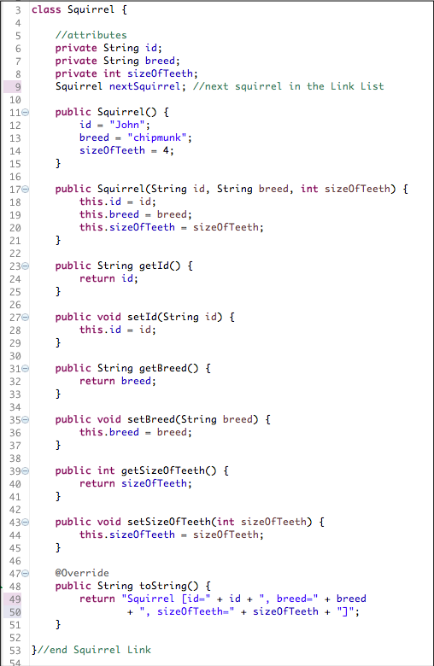

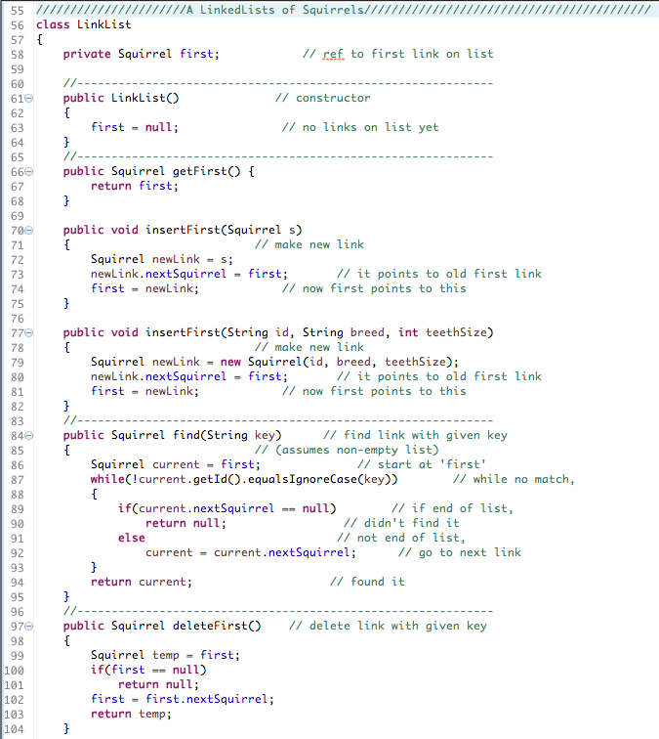



1. Write code in Eclipse to make a Stack or a Queue of Squirrel objects. Draw a picture of your Squirrel Stack or Queue and paste it here as the answer to this question. Take a screen shot of this code and paste it into this document – make sure it is readable.