DEVELOPMENT AND IMPLEMENTATION OF A CRAD MANAGEMENT SYSTEM USING OPENAI GPT-4.1 FOR AI-ASSISTED DOCUMENT ANALYSIS AND INTELLIGENT DEFENSE SCHEDULING AT BESTLINK COLLEGE OF THE PHILIPPINES

A Capstone
Presented to the Faculty of
The College of Computing Studies
Bestlink College of the Philippines

In Partial Fulfilment
of the Requirements for the Degree
Bachelor of Science in Information Technology

ABEJUELA, JOHN KENNETH C.
AUSAN, KHEN ANDRIE M.
CADAY, JOPEL J.
CAMACHO, JOHN IVAN F.
SANCHEZ, ASHLEY L.
2026

ACKNOWLEDGMENT
The researchers extend their sincere gratitude to Bestlink College of the Philippines, the College of Computing Studies, and the Center for Research and Development for providing the academic environment, institutional guidance, and resources that made the completion of this capstone project possible.
The researchers are deeply thankful to their capstone adviser for the direction, constructive criticism, patience, and professional guidance provided throughout the planning and preparation of the study. The adviser’s recommendations helped the group strengthen the project’s scope, documentation, and technical direction.
The researchers also acknowledge the faculty members, panel members, and technical evaluators whose comments and recommendations contributed to the improvement of the proposed Center for Research and Development Management System.
Special appreciation is extended to the CRAD personnel and intended system users who shared their time, experiences, and observations regarding the existing capstone documentation, status-monitoring, and defense-scheduling processes.
The researchers likewise express their appreciation to their classmates, friends, and colleagues who offered encouragement, suggestions, and practical assistance during the development and documentation of the project.
The group is especially grateful to their families for their understanding, patience, and continued support throughout the demanding stages of research, system planning, revision, and preparation for evaluation.
Finally, the researchers acknowledge every individual who contributed directly or indirectly to this study. Their support helped the group complete the manuscript and continue working toward the successful implementation and evaluation of the system.
The Researchers
DEDICATION
This capstone project is dedicated to our families, instructors, advisers, and friends whose guidance, patience, encouragement, and support inspired us to continue despite the challenges encountered throughout the study.
It is also dedicated to the students, advisers, panel members, and CRAD personnel who may benefit from a more organized, transparent, and efficient capstone research process.
ABSTRACT
The Center for Research and Development (CRAD) of Bestlink College of the Philippines manages various research-related activities, including proposal submission, document review, adviser coordination, defense scheduling, and research monitoring. The existing process relies heavily on manual coordination, resulting in delays, inconsistent document tracking, communication challenges, and scheduling conflicts among researchers, advisers, panel members, and CRAD personnel.

This study aims to design and develop a web-based Center for Research and Development Management System that integrates OpenAI GPT-4.1 to support AI-powered document analysis, automated research status tracking, and intelligent defense scheduling. The proposed system is designed to assist CRAD personnel in managing research activities more efficiently while providing researchers with a centralized platform for document submission, progress monitoring, and communication.

The system adopts a role-based access approach involving Student Researchers, Research Advisers, Panel Members, and CRAD Personnel. It also provides a centralized repository for research documents, automated notifications, dashboard analytics, and reporting functionalities to improve research administration and decision support.
The proposed system is expected to improve the efficiency, accuracy, transparency, and organization of research management processes while supporting timely communication and effective coordination among all stakeholders.
Keywords: Center for Research and Development, CRAD Management System, OpenAI GPT-4.1, Artificial Intelligence, Document Analysis, Research Management, Defense Scheduling, Status Tracking.

TABLE OF CONTENTS
Page
TITLE PAGE i
APPROVAL SHEET ii
ACKNOWLEDGMENT iii
DEDICATION v
ABSTRACT vi
TABLE OF CONTENTS viii
LIST OF TABLES xiii
LIST OF FIGURES xiv
LIST OF APPENDICES xv
CHAPTER
1 INTRODUCTION
1.1. Project Background and Motivation 1
1.2. Problem Statement 5
1.3. Project Vision and Scope 8
1.4. Objectives and Goals 12
1.5. Significance and Relevance 16
1.6. Definition of Terms 21
1.7 Structure of the Document 28

CHAPTER
2 RELATED LITERATURE, STUDIES, AND TECHNICAL BACKGROUND
2.1 Review of Related Literature 31
2.2 Analysis of Related Studies
and Existing Systems 35
2.3 Agile Scrum Methodology 41
2.4 Emerging Technologies, Intelligent
Systems, and Standards in Modern
Information Systems 43
2.4.1 Microservices Architecture 43
2.4.2 Artificial Intelligence (AI) 44
2.4.3 Data Analytics and Business
Intelligence 45
2.4.4 Polyglot Persistence 46
2.4.5 Cybersecurity 46
2.4.6 Data Privacy 47
2.4.7 Software Quality Standards 48
2.4.8 Cloud Computing 49
2.4.9 Edge Computing 50

2.5 DevOps Culture and CI/CD Practices 50
2.6 Enterprise Architecture & System Integration 51
2.7 Conceptual Framework 52
2.8 Theoretical Paradigm 53
CHAPTER
3 METHODOLOGY AND PROJECT MANAGEMENT
3.1 The Adapted Agile Scrum Framework 56
3.1.1 Team Roles and Responsibilities 57
3.1.2 Scrum Events 61
3.1.3 Scrum Artifacts 64
3.1.4 Toolstack 65
3.2 Architectural Design Decisions 70
3.2.1 Why Microservices? 71
3.2.2 Core Architectural Patterns Used 75
3.3 Development, Operations, and Quality Assurance (QA) Methodology 82
3.3.1 DevOps Toolchain 83
3.3.2 CI/CD Pipeline Design 84
3.3.3 Testing Strategy 86
3.3.4 Operational Definitions and Evaluation Measures 90
3.3.5 Sample Test Cases 92
3.4 Innovation Framework 94
CHAPTER
4 SYSTEM DESIGN, DEVELOPMENT, AND
4.1 Requirements Engineering
4.1.1 Stakeholder Analysis
4.1.2 Elicitation Techniques
4.1.3 Functional Requirements
4.1.4 Non-Functional Requirements
4.1.5 User Stories, Acceptance Criteria, and Use Cases
4.2 High-Level System Design
4.2.1 System Context Diagram
4.2.2 Overview of the Integrated System
4.3 Business Process Architecture (BPMN 2.0)
4.3.1 As-Is Process Model
4.3.2 To-Be Process Model
4.3.3 Analysis of Improvements
4.4 Application Architecture
4.4.1 Component Diagram
4.4.2 Detailed UML Diagrams for Key Services
4.5 Data Architecture and Design
4.5.1 Logical Data Model
4.5.2 Physical Data Model
4.5.3 Data Dictionary
4.5.4 Data Flow Diagrams (Level 0, Level 1)
4.6 Technology Architecture & Infrastructure
4.6.1 Technology Stack Justification
4.6.2 Deployment Architecture
4.6.3 Network and Security Design
4.6.4 Cloud Infrastructure
4.7 Development Journey
4.7.1 Sprint Summaries
4.7.2 Key Technical Challenges and Solutions
4.8 Implementation Strategy
4.8.1 Deployment Plan
4.8.2 Migration Plan
4.8.3 User Training and Change Management
4.9 Testing and Quality Assurance Report
4.9.1 Test Plan
4.9.2 Summary of Test Results
4.9.3 Performance Test Report
4.9.4 Security Audit Findings
4.10 Results and Evaluation
4.10.1 User Acceptance Testing (UAT) Protocol and Results
4.10.2 Validation Against Objectives
4.10.3 Project Retrospective

CHAPTER
5 CONCLUSION 5.1 Summary of the Project
5.2 Conclusion
5.3 Project Contributions
5.4 Recommendations
5.4.1 For Future Enhancement
5.4.2 For Implementation
5.4.3 For Future Researchers

REFERENCES 97
APPENDICES
CURRICULUM VITAE

LIST OF TABLES
Table Page
- Comparative Analysis of Related Studies and Existing Systems (Table 2.1) 37
- Project Team Roles and Responsibilities within the Adapted Scrum Framework (Table 3.1) 59
- Project Toolstack Mapped to Purpose (Table 3.2) 68
- Architectural Patterns and Traceability (Table 3.3) 78
- To-Be-Aligned CRAD Functional Component Summary (Table 3.4) 79
- Traceability Matrix: Specific Objectives, Related CRAD Components, and Primary QA/Validation Activities (Table 3.5) 81
- Selected Test Cases (Table 3.6) 93

LIST OF FIGURES
No figures are included in Chapters 1–3.

LIST OF APPENDICES
Appendix A DETAILED TECHNICAL DOCUMENTATION
A.1 System Architecture
A.2 Information Systems Integration
A.3 Application Design and Development
A.4 Database Schema and Data Management
A.5 Network Configuration
A.6 Deployment and Infrastructure
A.7 Security Measures
A.8 Testing and Quality Assurance
A.9 System Monitoring and Maintenance
A.10 APIs and Integration Points
A.11 User Documentation
A.12 Known Issues and Troubleshooting
A.13 Version Control and Source Code Repository
A.14 DevOps and CI/CD
A.15 Licensing and Open Source Libraries
A.16 Performance Metrics and Monitoring
Appendix B: Project Management Artifacts
B.1 Project Charter / Proposal
B.2 Sprint Backlogs and Burndown Charts
B.3 Meeting Minutes (Key decisions should be documented)
B.4 Gantt Chart or Project Timeline
Appendix C: Research and Requirements Artifacts
C.1 Approved Adviser Acceptance Form
C.2 Company Endorsement / Memorandum of Agreement
C.3 Survey Questionnaires and Raw Data
C.4 Interview Transcripts and Guides (Anonymized)
C.5 UAT Forms and Sign-off Sheets
C.6 Certificate of Originality
Appendix D: Certificate of Technical Adviser and Grammarian
Appendix E: Defense and Validation
E.1 Panel Evaluation Sheets (Signed)
E.2 Photos from Defense and Pilot Testing
E.3 Certificates of Copyright / Patent Application (If any)
Appendix F: Access Links (All valid for 3 years)
F.1 Live System URL
F.2 Source Code Repository (e.g., GitHub)
F.3 Comprehensive Online Documentation (e.g., ReadTheDocs, GitBook)
F.4 System Demo Video (YouTube/Vimeo)
F.5 CI/CD Pipeline Dashboard (if publicly accessible)
Appendix G: Technical Adviser Curriculum Vitae
Appendix H: Research Adviser Curriculum Vitae
Appendix I: Researcher’s Curriculum Vitae

Chapter 1

INTRODUCTION
1.1. Project Background and Motivation
Research and development (R&D) is embedded as a policy priority for Philippine higher education institutions (HEIs) under Republic Act No. 7722 (1994), the law that created the Commission on Higher Education (CHED), which explicitly identifies the advancement of learning and research among the objectives of higher education alongside academic freedom and professional development. Within institutions offering technology-oriented programs, this priority is most directly expressed through the capstone or thesis requirement, in which graduating students design, develop, and evaluate an original system or study that demonstrates the technical and research competencies they have developed throughout their program. Because this process spans multiple stages, extensive documentation, and coordination among several stakeholders, most institutions establish a dedicated office to oversee and support it from proposal to defense.
At Bestlink College of the Philippines, this office is the Center for Research and Development (CRAD), which coordinates the research activities of the College of Computing Studies (CCS), including the capstone projects undertaken by Bachelor of Science in Information Technology (BSIT) students. Such offices typically oversee the full capstone life cycle: receiving and monitoring chapter submissions, coordinating communication between student researchers and their assigned research and technical advisers, checking each group’s documentation against institutional formatting and content standards, and organizing the scheduling of proposal and final defense panels together with the concerned panel members.
At present, CRAD’s capstone documentation process at Bestlink College of the Philippines is managed manually: submissions proceed through a hard-copy process, while document checking and defense-schedule verification are likewise conducted manually (Bergado et al., 2024). Under this manual, non-centralized process, several recurring difficulties tend to emerge. The status of a given group’s documentation is not always readily visible to advisers, panel members, or the CRAD office itself, often requiring repeated follow-up simply to determine which chapter a group is currently working on or whether a previously submitted document has already been reviewed and returned. Reviewing submitted chapters for completeness and compliance with formatting and content requirements is similarly time-consuming when performed entirely through manual reading, particularly considering the volume of documentation that each group produces across five chapters and multiple revision cycles. Scheduling proposal and final defense panels introduces a further layer of coordination difficulty because it requires reconciling the availability of multiple panel members, advisers, and student groups within a limited defense period; when this reconciliation is performed manually, it becomes prone to scheduling conflicts, delayed confirmations, and last-minute adjustments that affect both students and faculty.
Recent work in artificial intelligence has demonstrated the growing capability of large language models (LLMs) to support tasks that were previously dependent on manual human review. Haryanto (2024) presented LLAssist, a tool built on LLMs that extracts key information from academic documents and evaluates their relevance against defined criteria, substantially reducing the manual screening workload for researchers while keeping a human reviewer in the loop to validate its output. Findings of this kind indicate that LLM-based analysis is a practical complement to, rather than a replacement for, human academic judgment, and that its most defensible use is in surfacing information and flagging items for human decision-makers to confirm. The increasing accessibility of LLM application programming interfaces, such as OpenAI’s GPT-4.1, has made it practical for institution-specific systems to incorporate this kind of assistance directly into existing administrative workflows rather than depending solely on additional manual staffing.
It is within this context that the present study proposes the development and implementation of a Center for Research and Development Management System for Bestlink College of the Philippines. The proposed system integrates OpenAI GPT-4.1 to provide AI-powered document analysis, automated status tracking, and intelligent defense scheduling within a single, centralized web-based platform accessible to student researchers, advisers, panel members, and CRAD personnel. Consistent with the human-in-the-loop principle observed in comparable LLM-assisted academic tools, the system is intended to support, rather than substitute for, the professional judgment of advisers, panel members, and CRAD personnel in evaluating capstone documentation and readiness for defense. By consolidating capstone submission, monitoring, and defense coordination into one system supported by AI-assisted document review and scheduling, the study is motivated by the goal of reducing the manual workload of the CRAD office, improving the visibility of each research group’s progress to all stakeholders, and supporting a more consistent and efficient capstone research process for the College of Computing Studies.
1.2. Problem Statement
The institutional context and motivation described in the preceding section point to a set of specific operational problems that the proposed system is intended to address. The discussion below describes these problems in general terms, consistent with the institutional context presented in Section 1.1.
The first cluster of problems concerns the analysis and review of capstone documentation. When each submitted chapter must be read and evaluated manually against formatting, structural, and content requirements, the process is inherently time-consuming and susceptible to inconsistency between reviewers, particularly as the number of concurrently supervised research groups grows. A related difficulty is version control: without a centralized system of record, it is not always straightforward to determine which version of a chapter is the most current, whether a group has already addressed previously noted revisions, or whether a document under review has since been superseded by a newer submission. Bergado et al. (2024) likewise reported that CRAD’s manual handling of research data, hard-copy submissions, and document checking is time-consuming. This finding directly supports the need for centralized document tracking and version management in the proposed system.
The second cluster of problems concerns the tracking of research progress and the communication that surrounds it. In the absence of a centralized repository, the status of a given group’s documentation, whether it is awaiting review, undergoing revision, or ready to proceed to the next stage, is not consistently visible to student researchers, advisers, panel members, and CRAD personnel at the same time. Status updates instead depend on separate, informal follow-up through whichever channel happens to be in use for a given group, which increases the likelihood of delayed feedback and miscommunication, and leaves CRAD personnel with limited means of monitoring overall progress across research groups without manually consolidating information from multiple sources.
The third cluster of problems concerns the scheduling of proposal and final defense panels. This task requires reconciling the availability of several panel members, an adviser, and a student group within a constrained defense period; at present, this scheduling is carried out manually (Bergado et al., 2024). Almeida et al. (2024) describe thesis defense scheduling as a distinct and nontrivial academic scheduling problem in its own right, separate from the more extensively studied problems of course timetabling and examination scheduling, and note that manual scheduling approaches are difficult to scale as the number of defenses to be accommodated increases. When this reconciliation is carried out manually, through exchanged messages or informally polled availability, it is prone to scheduling conflicts, delayed confirmations, and last-minute adjustments.
Collectively, these problems affect the stakeholders of the capstone process differently but interdependently. Student researchers experience uncertainty about the status of their submissions and delays in receiving the feedback needed to proceed to the next chapter. Advisers and panel members must divide limited time between substantive review of research work and the administrative effort of tracking multiple groups and reconciling schedules. CRAD personnel absorb the cumulative coordination burden of monitoring compliance and organizing panels across all supervised groups, a burden that scales with the number of concurrent research groups rather than remaining constant. At the institutional level, these inefficiencies contribute to a slower and less predictable capstone research cycle, which works against the emphasis that Philippine higher education policy places on the advancement of research, as established in Section 1.1.
Addressing these problems is therefore central to improving the capstone research process at Bestlink College of the Philippines. Specifically, this study identifies the following problems as the primary concerns to be addressed by the proposed system:
1. Manual and time-consuming review of capstone documentation for compliance with formatting and content requirements;
2. Inconsistent version control across chapter submissions and revisions;
3. Limited visibility into the real-time status of each research group’s documentation;
4. Scattered, informal communication and delayed feedback among student researchers, advisers, and CRAD personnel;
5. The absence of a centralized repository for capstone documentation and records; and
6. Inefficient, manually coordinated scheduling of proposal and final defense panels.
The following section outlines the vision and scope of the proposed system in response to these identified problems.
1.3. Project Vision and Scope
The problems identified in the preceding section point toward the need for a centralized, AI-assisted platform capable of supporting document review, progress tracking, and defense scheduling within a single system, rather than continuing to rely on separate, manually coordinated processes for each. This section describes the vision behind the proposed system and defines the boundaries within which it is intended to operate.
The vision of this study is a Center for Research and Development in which the BSIT capstone research process for the College of Computing Studies is managed through a single, centralized platform: the status of every research group’s documentation is visible in real time to the appropriate stakeholders, chapter submissions are reviewed with the support of AI-assisted analysis rather than manual reading alone, and proposal and final defense panels are scheduled through a system that reconciles participant availability rather than depending on manually exchanged messages. In line with the human-in-the-loop principle discussed in Section 1.1, the envisioned system is not intended to replace the judgment exercised by advisers, panel members, and CRAD personnel, but to remove the repetitive coordination and tracking work that currently competes with that judgment for their time, allowing a greater share of their effort to be spent on the substantive evaluation of research work rather than its administration.
To realize this vision, the scope of the proposed system is defined around the four user roles already established in this study, namely student researchers, research and technical advisers, panel members, and CRAD personnel, and around the following features, each of which corresponds to a specific problem identified in Section 1.2:
1. Centralized document submission and repository, providing a single system of record for capstone chapters and revisions in place of the scattered storage described under Problems 2, 3, and 5;
2. AI-powered document analysis using OpenAI GPT-4.1, supporting the review of submitted chapters for completeness and compliance with formatting and content requirements, addressing the manual review burden described under Problem 1;
3. Automated status tracking and notifications, giving student researchers, advisers, panel members, and CRAD personnel a shared, real-time view of each group’s documentation status, addressing Problems 3 and 4;
4. Intelligent defense scheduling, which reconciles the availability of panel members, advisers, and student groups to propose feasible proposal and final defense schedules, addressing Problem 6; and
5. Monitoring and reporting functions for CRAD personnel, consolidating the progress of all supervised research groups into a single view rather than requiring this information to be assembled manually from multiple sources.
Access to these features is governed by role-based permissions corresponding to the four user roles identified above; no additional user roles beyond these four are introduced within the scope of this study.
The scope of the proposed system is bounded in the following respects. The system evaluates and reports on the structural completeness and formatting compliance of submitted documents through AI-assisted analysis, but it does not render the substantive academic judgment of whether a chapter or defense meets the standard required for approval; that determination remains the responsibility of advisers, panel members, and CRAD personnel, consistent with the human-in-the-loop boundary described above. Similarly, the system schedules and coordinates proposal and final defense sessions but does not host or conduct the defense itself, nor does it perform plagiarism or originality screening as a separate function beyond the structural and compliance analysis described in its document analysis feature. Financial operations such as fee collection, payment processing, research grant disbursement, budgeting, and institutional accounting are outside the scope of this study. The system is limited to the capstone research process administered by CRAD for BSIT students under the College of Computing Studies; it does not extend to other academic programs, and matters such as general student records, admissions, and broader institutional accounting or financial management remain outside the scope of this study.
Within these boundaries, the proposed system is expected to support more efficient use of CRAD personnel’s time, more consistent application of documentation standards across research groups, clearer visibility into research progress for all stakeholders, and a more predictable capstone research cycle overall, in keeping with the emphasis that Philippine higher education policy places on the advancement of research, as established in Section 1.1. The following section defines the specific objectives through which this vision and scope are intended to be achieved.
1.4. Objectives and Goals
The vision and scope defined in Section 1.3 establish the direction and the boundaries within which the proposed system is expected to operate. This section translates that vision into the specific objectives that will guide the development, implementation, and evaluation of the Center for Research and Development Management System.
General Objective
This study aims to develop and implement a web-based Center for Research and Development Management System that integrates OpenAI GPT-4.1 to provide AI-powered document analysis, automated status tracking, and intelligent defense scheduling in support of the BSIT capstone research process administered by the Center for Research and Development (CRAD) of the College of Computing Studies at Bestlink College of the Philippines.
Specific Objectives
In support of this general objective, the study seeks to achieve the following specific objectives, each of which addresses one or more of the problems identified in Section 1.2 and remains within the scope established in Section 1.3:
1. To design and implement a centralized, web-based repository for capstone document submission and version control, addressing the absence of a centralized system of record and the version-control difficulties identified under Problems 2, 3, and 5;
2. To integrate OpenAI GPT-4.1 into the system to support the review of submitted chapters for structural completeness and compliance with formatting and content requirements, addressing the manual review burden identified under Problem 1, without altering the evaluative role that advisers, panel members, and CRAD personnel exercise in determining whether a chapter or defense meets the required academic standard;
3. To automate the tracking of each research group’s documentation status and provide real-time notifications to student researchers, advisers, panel members, and CRAD personnel, addressing the visibility and communication problems identified under Problems 3 and 4;
4. To develop an intelligent scheduling module that reconciles the availability of panel members, advisers, and student groups to generate feasible proposal and final defense schedules, addressing the manual scheduling difficulties identified under Problem 6;
5. To design monitoring and reporting functions that consolidate the progress of all supervised research groups for CRAD personnel, reducing the effort of manually assembling this information from multiple sources; and
6. To evaluate the developed system against four specific characteristics of ISO/IEC 25010 – functional suitability, usability, reliability, and security – using a Likert-scale-based User Acceptance Testing instrument administered to respondents drawn from the four approved user roles established in Section 1.3, prior to its deployment for use by the College of Computing Studies. Findings will be reported in Section 4.10 of Chapter 4.
Goals
The achievement of these objectives is intended to produce outcomes that extend beyond the technical implementation of the system itself. For student researchers, these outcomes include more timely feedback on submitted chapters and clearer visibility into the status of their own research progress. For advisers and panel members, they include a reduction in the administrative effort spent on tracking and scheduling, allowing more time for the substantive review of research work. For CRAD personnel, they include a consolidated view of research progress across all supervised groups and a more consistent basis for enforcing documentation standards. At the institutional level, these outcomes are expected to contribute to a more efficient and predictable capstone research cycle for the College of Computing Studies, consistent with the emphasis that Philippine higher education policy places on the advancement of research, as established in Section 1.1.
The following section discusses the significance and relevance of these objectives to the stakeholders of the capstone research process and to the institution as a whole.
1.5. Significance and Relevance
Beyond describing what the proposed system does, it is necessary to establish why the achievement of the objectives defined in the preceding section matters to the stakeholders and institution involved. This section discusses the significance of the study in institutional, stakeholder, academic, and technological terms, and its relevance to researchers who may build on this work in the future.
Institutional Significance
For the Center for Research and Development, the significance of achieving these objectives lies less in the specific operational efficiencies already discussed in Section 1.4 than in what those efficiencies make possible for CRAD’s broader mandate. A centralized system of record and a consistent, AI-assisted review process give CRAD a uniform basis for enforcing documentation standards across all supervised research groups, rather than a basis that depends on how closely any one adviser or personnel member happens to track a given group. This has a direct bearing on the fairness and consistency with which the capstone research process is administered, and supports CRAD’s capacity to sustain this level of oversight as the College of Computing Studies continues to produce BSIT capstone research, consistent with the emphasis Philippine higher education policy places on the advancement of research, as established in Section 1.1.
Stakeholder Significance
For student researchers, the significance of real-time status visibility and more consistent feedback extends beyond convenience: it allows a group to plan its remaining work around an accurate understanding of where it stands, rather than around uncertainty about whether a submitted chapter has already been reviewed, which reduces the risk of last-minute compliance issues immediately before a scheduled defense. For advisers and panel members, time reclaimed from administrative tracking and scheduling is significant primarily because it can be redirected toward substantive mentorship and review, which are the aspects of their role most directly tied to the quality of the resulting research. For CRAD personnel, a consolidated view of all supervised groups is significant not only as a time-saving measure but as a basis for identifying groups that may need additional support earlier in the capstone timeline, rather than only after a deadline has already been missed.
Academic Significance
The academic significance of this study lies in its contribution as an applied reference for integrating large language model-based analysis into an existing academic administrative workflow, rather than in a claim to advance artificial intelligence, natural language processing, or information systems research as academic fields in their own right. As an undergraduate capstone project, the study applies an existing, publicly available AI capability, OpenAI GPT-4.1, to a specific institutional problem, and in doing so documents a human-in-the-loop implementation pattern, AI-assisted analysis that supports rather than replaces adviser, panel, and CRAD judgment, that may be of practical reference value to similarly structured research administration offices considering comparable systems.
Technological Significance
The technological significance of the proposed system follows directly from the problems it is intended to address. AI-assisted document analysis is relevant because the manual review burden identified as Problem 1 scales with the number of concurrently supervised research groups in a way that purely procedural solutions do not address, and its role remains limited to supporting, rather than replacing, the evaluative judgment of advisers, panel members, and CRAD personnel. Automated status tracking is relevant because the visibility and communication difficulties identified as Problems 3 and 4 stem from the absence of a shared system of record rather than from any deficiency on the part of individual stakeholders. Intelligent defense scheduling is relevant because the coordination difficulty identified as Problem 6 is a scheduling problem that becomes harder to resolve manually, not easier, as the number of groups requiring a defense slot increases. In each case, the relevant technology responds to a specific, previously identified difficulty rather than being adopted for its own sake.
Future Researchers
This study may also serve as a reference for future work extending AI-assisted research administration beyond the boundaries established in Section 1.3. Future studies could examine, for example, the extension of a comparable system to other programs within the College of Computing Studies or to other colleges within Bestlink College of the Philippines, the addition of dedicated plagiarism or originality screening as a distinct feature separate from structural document analysis, or the longer-term evaluation of AI-assisted review accuracy against adviser judgment across multiple academic years. These directions are not limitations that the present study fails to address, but extensions that fall outside the scope defined in Section 1.3 and that future researchers may reasonably pursue.
Acknowledged Boundaries of the Present Study. Several boundaries apply to the conclusions that may be drawn from the present study. First, the evaluation described in Objective 6 is anchored to School Year 2025-2026 and the College of Computing Studies; generalization beyond this cohort should be approached with caution. Second, conclusions regarding AI-assisted document analysis apply specifically to OpenAI GPT-4.1 as released on April 14, 2025, and accessed through the OpenAI API; subsequent model versions may exhibit different performance characteristics and would require separate evaluation. Third, the proposed system is calibrated to the scale of CRAD’s BSIT capstone administration at Bestlink College of the Philippines; performance under significantly larger or multi-college research administration loads has not been tested. Fourth, the system does not include automated Continuous Integration/Continuous Deployment (CI/CD) at the time of writing; release verification is performed manually through the workflow described in Section 3.3.2, and automated pipeline adoption is identified as a future-work item. These boundaries are not failures of the present study but defined limits of its conclusions, and they frame the directions for future research discussed earlier in this section.
The following section defines the key terms used throughout this documentation to ensure a shared and precise understanding of the concepts discussed.
1.6. Definition of Terms
This section defines the technical, academic, and project-specific terms used throughout this documentation, to support a shared and unambiguous understanding of the concepts discussed in the preceding and succeeding sections. Definitions established here constitute the official terminology of this manuscript and are used consistently in the chapters that follow. Terms are arranged alphabetically.
AI-Powered Document Analysis refers to the use of artificial intelligence techniques, particularly natural language processing, to automatically read, extract information from, and assess documents against defined criteria, in place of an entirely manual reading process. In this study, the term refers specifically to the system feature, established in Section 1.3 and Objective 2 of Section 1.4, in which OpenAI GPT-4.1 is used to review submitted capstone chapters for structural completeness and compliance with formatting and content requirements. Following the same human-in-the-loop principle carried throughout this documentation, the output of this analysis, such as a flagged formatting issue, is a recommendation for human reviewers; it does not determine whether a chapter or defense meets the academic standard required for approval, a judgment that remains with advisers, panel members, and CRAD personnel.
Artificial Intelligence (AI) refers to computer systems designed to perform tasks that would typically require human cognitive abilities, such as pattern recognition, language understanding, and decision support, without being explicitly programmed for each individual case. Within this study, AI refers specifically to the large language model capability provided through OpenAI GPT-4.1, which the proposed system uses to support the review of capstone documentation, as discussed in Section 1.1. Its role is assistive and analytical rather than decisional: in keeping with the human-in-the-loop principle applied throughout this documentation, AI-generated output is first validated by a human reviewer before it informs any institutional decision, and it does not exercise independent academic or administrative authority.
Automated Status Tracking refers to a system capability that automatically records and displays the current state of a process or item, such as a document under review, without requiring a person to manually update or communicate that status. This is the scope feature, established in Section 1.3 and Objective 3 of Section 1.4, that gives student researchers, advisers, panel members, and CRAD personnel a shared, real-time view of each research group’s documentation status, together with related notifications, addressing the visibility and communication problems identified as Problems 3 and 4 in Section 1.2.
Center for Research and Development (CRAD) refers to an institutional office or unit responsible for coordinating and overseeing research activities within an academic institution. At Bestlink College of the Philippines, CRAD is the office responsible for coordinating BSIT capstone research within the College of Computing Studies, as discussed in Section 1.1, and is the primary institutional stakeholder of the proposed system.
Center for Research and Development Management System refers, as a general category, to a software system designed to support the submission, review, and administration of institutional research activities. In this study, the term refers to the specific system proposed and developed in this documentation, integrating AI-powered document analysis, automated status tracking, and intelligent defense scheduling as described in Sections 1.1 through 1.5. This exact name is used consistently throughout the manuscript and is not interchanged with other naming variants such as “Research Management System” or “Research Portal.”
Centralized Repository refers to a single system of record in which documents or data are stored, version-tracked, and made accessible to authorized users, in place of storage distributed across multiple disconnected locations. This is the component of the proposed system that stores capstone chapter submissions and revisions, addressing the absence of a centralized system of record identified as Problem 5 in Section 1.2 and supporting the version control discussed under Problem 2.
CRAD Personnel refers, in general, to administrative staff responsible for the coordination and oversight of an institution’s research office. In this study, CRAD personnel is one of the four user roles of the proposed system established in Section 1.3, referring to the administrative staff of the Center for Research and Development responsible for monitoring documentation compliance, coordinating with advisers and panel members, and organizing proposal and final defense schedules. This role is the only administrative role recognized within the proposed system and is not treated as distinct from the general term “administrator” as it may appear elsewhere in information systems literature.
Human-in-the-Loop refers to a design principle in AI systems in which a human reviewer remains actively involved in reviewing, validating, or making the final decision on AI-generated output, rather than allowing the AI system to act autonomously. This is the governing principle behind the AI-powered document analysis feature of the proposed system: GPT-4.1’s output is treated as a recommendation for human reviewers, specifically advisers, panel members, and CRAD personnel, who retain sole authority over academic and administrative decisions, consistent with Sections 1.1, 1.3, 1.4, and 1.5 of this documentation.
Intelligent Defense Scheduling refers to the use of automated or algorithmic methods to reconcile the availability of multiple parties and generate a feasible schedule, in contrast to manual, message-based coordination. This is the scope feature, established in Section 1.3 and Objective 4 of Section 1.4, that reconciles the availability of panel members, advisers, and student groups to propose feasible proposal and final defense schedules, addressing the scheduling difficulties identified as Problem 6 in Section 1.2.
Large Language Model (LLM) refers to a type of AI model trained on large volumes of text data to recognize patterns in language and to generate or analyze natural language text, including tasks such as summarization, classification, and information extraction. OpenAI GPT-4.1, the specific LLM integrated into the proposed system, is applied to the analysis of submitted capstone chapters, as discussed in Section 1.3; the use of LLMs for comparable document-analysis tasks in academic settings is discussed in Section 1.1 with reference to Haryanto (2024).
OpenAI GPT-4.1 is a large language model released by OpenAI on April 14, 2025, accessed through the OpenAI API, offering a context window of up to 1 million tokens and improved instruction-following and long-document comprehension relative to earlier GPT-4o models (OpenAI, 2025). The model is documented in OpenAI’s official API model reference, which records its capabilities, limits, and intended use. In this study, GPT-4.1 is the specific LLM integrated into the proposed system to perform AI-powered document analysis, as established in Section 1.3. Throughout this study, references to “GPT-4.1” or “the AI component” refer specifically to this model version and not to any other OpenAI model or LLM provider.
Panel Member refers, in general, to an individual assigned to evaluate the quality of academic or professional work, typically as part of a formal review or defense process. In this study, panel member is one of the four user roles of the proposed system established in Section 1.3, referring to a faculty evaluator assigned to assess a research group’s capstone project during proposal and final defense.
Research Adviser (Technical Adviser) refers, in general, to a faculty member or subject-matter expert assigned to guide and supervise a student’s research project. In this study, research/technical adviser is one of the four user roles of the proposed system established in Section 1.3, referring to the faculty member assigned to guide and supervise a research group throughout the capstone process, as discussed in Section 1.1.
Role-Based Access refers to an access control approach in which a user’s permissions within a system are determined by their assigned role rather than being individually configured for each user. This is the access model used in the proposed system, in which the four user roles established in Section 1.3, namely student researchers, advisers, panel members, and CRAD personnel, determine what each user is able to view or perform within the system.
Student Researcher refers, in general, to an undergraduate student conducting a research or capstone project as a requirement of their academic program. In this study, student researcher is one of the four user roles of the proposed system established in Section 1.3, referring to a BSIT student at Bestlink College of the Philippines undertaking a capstone project under CRAD supervision.
Version Control refers to a method of managing changes to documents or files over time, allowing the identification of the most current version and the history of prior revisions. This capability is addressed by the proposed system’s centralized repository, in response to the version-control difficulties identified as part of Problem 2 in Section 1.2.
Web-Based Information System refers to a system accessible through a web browser over a network rather than software installed locally on a single device. In the wider institutional architecture adopted for this project, each major system module is treated as one independently deployable microservice with its own module-owned database and API boundary. The Center for Research and Development Management System is the CRAD module/microservice: its approved research-management functions operate inside that deployment unit, while communication with other institutional modules is performed through REST APIs. This describes the general form of the proposed system, which remains accessible to all four established user roles, as stated in Section 1.3.
The following section presents the structure of this documentation, outlining the organization of the remaining chapters.
1.7. Structure of the Document
Understanding how this documentation is organized allows the reader to follow the logical progression of the study, from its motivating context through its design, development, and evaluation. This section outlines the organization of the chapters that comprise this manuscript.
Chapter 1, Introduction, presents the background and motivation for the study, the problems identified in the current capstone research management process, the vision and scope of the proposed system, its general and specific objectives, the significance of the study to its stakeholders, the definition of terms used throughout the manuscript, and this overview of the document’s structure.
Chapter 2, Related Literature, Studies, and Technical Background, presents a review of related literature and studies, an examination of existing systems comparable to the proposed Center for Research and Development Management System, and a discussion of the technologies, development approaches, and standards relevant to its design and implementation.
Chapter 3, Methodology and Project Management, discusses the methodology and project management approach adopted for the development of the system, including the composition and roles of the development team, the phases of development, the technology stack, and the quality assurance practices applied throughout the project.
Chapter 4, System Design, Development, and Results, presents the design and development of the proposed system, including its architecture and the implementation of its AI-powered document analysis, automated status tracking, and intelligent defense scheduling components, in keeping with the human-in-the-loop principle established in Chapter 1. This chapter also presents the testing and evaluation conducted to assess the system’s functionality, usability, and reliability, corresponding to the objective established in Section 1.4, together with the results obtained.
Chapter 5, Conclusion, presents a summary of the study, the conclusions drawn from its development and evaluation, its contributions, and recommendations for future work, consistent with the directions discussed in Section 1.5.
Together, these chapters present a complete account of the study, from the problems that motivated it to the system developed to address them and the outcomes of its evaluation. Chapter 2 begins this account with a review of related literature, studies, and technical background relevant to the proposed system.

Chapter 2

RELATED LITERATURE, STUDIES, AND TECHNICAL BACKGROUND
This chapter reviews related literature, studies, and existing systems that inform the design of the proposed CRAD Management System, along with the methodologies, technologies, and standards relevant to its development. It draws mainly from peer-reviewed foreign and local sources published between 2021 and 2026, with earlier works included only when foundational to the concepts discussed.
2.1 Review of Related Literature
Foreign Literature
1. Zhang and El-Gohary (2015) developed a semantic NLP method that automatically extracts requirements from regulatory documents and checks compliance against them, reducing the manual effort needed to review lengthy text. This supports the AI-assisted document analysis feature of the proposed system, though the proposed system uses a large language model (GPT-4.1) instead of a rule-based parser to handle unstructured academic writing.
2. Buddhadev et al. (2025) combined OCR, large language models, and the LangChain framework to automatically verify documents against compliance rules and flag irregularities for human review. The proposed CRAD system applies a similar OCR-plus-LLM approach but for academic manuscripts instead of financial audits, and further integrates scheduling and status tracking, which their system lacks.
3. Amaral et al. (2021) found that AI-enabled automation can reliably flag incomplete sections in policy documents, but works best when treated as a recommendation rather than a final decision. This directly supports the design principle of the proposed system, where AI feedback assists rather than replaces the judgment of advisers and CRAD staff.
4. Eyupoglu et al. (2026) deployed a human-in-the-loop AI system in a university setting that reduced request resolution time by 30.8% and misrouting by 32.6%, while keeping staff approval mandatory. The proposed system adopts the same human-in-the-loop principle, applied instead to document review and defense scheduling rather than general query routing.
5. Kocak et al. (2025) cautioned that AI-generated academic evaluations can vary in reliability, reinforcing the need for human verification whenever AI is used in academic assessment. This informs the proposed system’s design, where AI-generated compliance feedback is only a recommendation confirmed by the adviser, not an automatic approval.
Local Literature
1. Litera and Sonza (2026) developed an AI chatbot-based knowledge management system for NEUST using Agile development, which received a “Highly Acceptable” rating and reduced repeated inquiries during peak periods. This is a strong local precedent showing Philippine universities can successfully apply AI to reduce administrative bottlenecks, though the proposed system targets research document review rather than general inquiries.
2. Co (2025) reviewed AI applications across Philippine education and found that administrative and research-support tools remain comparatively underdeveloped versus instructional AI tools. This confirms a real gap in Philippine higher education that the proposed CRAD system, focused specifically on research administration, is positioned to address.
3. Mackay et al. (2026) examined digital transformation in Philippine educational institutions through a risk and change-based enterprise architecture approach, finding that institutions which align digital initiatives with a structured enterprise architecture framework experience fewer implementation risks and smoother organizational change. This supports the proposed system’s use of enterprise architecture principles, discussed further in Section 2.6.
4. Toquero (2026) examined the trends and trajectories of AI policy adoption across Philippine higher education institutions and found that formal AI governance remains limited, with most institutions still in early, informal stages of policy development. This highlights the importance of designing the proposed system with clear human-oversight safeguards.
5. Sibug et al. (2026) examined AI tool adoption among Philippine teachers and found that institutional support significantly predicted teacher confidence and attitudes toward AI adoption, with confidence mediating the relationship between support and attitudes. This reinforces the need for clear institutional guidance, training, and support when introducing the proposed system’s AI-assisted features.
2.2 Analysis of Related Studies and Existing Systems
Foreign Studies
1. Almeida et al. (2024) modeled thesis defense scheduling as a multi-objective optimization problem, later improving it with faster decomposition strategies — directly informing the proposed system’s scheduling feature.
2. Setiono et al. (2024) applied the Harris Hawk Optimization algorithm to defense scheduling, generating feasible schedules faster than manual coordination.
3. Palavesm and Joorel (2022) examined the implementation of a Research Information Management System in higher education and described its role in institutional research reporting, scholarly-information management, and support for stakeholders such as researchers, administrators, and policymakers. This supports the proposed system’s centralized research-information management direction, while the CRAD system extends the scope with AI-assisted document review and defense scheduling.
4. Aulia et al. (2026) built an integrated academic-administrative system using Agile methodology, supporting Agile Scrum (Section 2.3) as a fitting development approach for the proposed system.
5. Destini and Tony (2024) implemented Hierarchical RBAC for document administration, improving traceability — directly supporting the proposed system’s role-based access control feature.
Local Studies
1. Chio et al. (2022) built THESISIT, a thesis portal with automated defense scheduling via a genetic algorithm, though document review remains manual.
2. Perante et al. (2024) developed a thesis archiving system for EVSU–Ormoc that moved storage from paper to digital, though its function stops at archiving.
3. Mesa (2017) built UPMERS, UP Mindanao’s thesis repository designed mainly to reduce duplicated and misplaced files.
4. Orozco (2022) digitized defense evaluation scoring, though pre-defense compliance checking and scheduling remain outside its scope.
5. Celis and Lagda (2025) developed a Research Management System for the University of the East that centralizes research submission and approval workflows, earning strong usability and reliability ratings.
2.2.6 Comparative Analysis of Related Studies and Existing Systems. Table 2.1 below summarizes the ten studies and existing systems reviewed in Sections 2.2.1 through 2.2.5 in terms of platform focus, AI integration, scheduling algorithm, evaluation results, and limitation or gap relative to the proposed system.

Table 2.1 Comparative Analysis of Related Studies and Existing Systems
Study / System | Platform / Focus | AI Integration / Scheduling Approach | Evaluation Result / Limitation or Gap Relative to Proposed CRAD System
Chio et al. (2022) | Thesis portal | No AI-based compliance checking; Genetic Algorithm for defense scheduling. | Achieved functional-level results. Document review remained manual; the study supports algorithm-based scheduling while leaving the AI compliance gap addressed by Objective 2.
Perante et al. (2024) | Archiving / centralized storage system | Did not extend to scheduling or document review. | Performed well for storage. It supports centralized storage while leaving scheduling and review gaps consistent with Objectives 1 and 4.

Table 2.1 (continued)
Study / System | Platform / Focus | AI Integration / Scheduling Approach | Evaluation Result / Limitation or Gap Relative to Proposed CRAD System
Mesa (2017) | Thesis repository | No AI analysis or scheduling capability. | Reduced duplicated submissions. It supports the repository design while leaving AI-analysis and scheduling gaps within the present study's scope.
Orozco (2022) | Defense evaluation scoring system | Pre-defense compliance checking remained outside its scope. | Functioned well for its intended purpose. The remaining gap is pre-defense compliance checking tied to Objective 2.
Celis and Lagda (2025) | Research submission centralization platform | Limited AI features; no AI document analysis or defense scheduling. | Received strong usability and reliability ratings during UAT. It validates administrative centralization while leaving the AI document-analysis and defense-scheduling gaps.

Table 2.1 (continued)
Study / System | Platform / Focus | AI Integration / Scheduling Approach | Evaluation Result / Limitation or Gap Relative to Proposed CRAD System
Almeida et al. (2024) | Defense scheduling model | Multi-objective optimization with decomposition strategies; no AI document analysis. | Demonstrated improved scheduling performance. It directly informs the proposed Research Defense Scheduling component but does not provide AI document analysis.
Setiono et al. (2024) | Defense scheduling approach | Harris Hawk Optimization; scope limited to scheduling alone. | Generated schedules faster than manual coordination. It provides algorithmic context for comparison with the proposed Research Defense Scheduling component.
Palavesm and Joorel (2022) | Research Information Management System in higher education | No AI-assisted document analysis or defense scheduling. | Supported institutional research reporting and management. It supports the research-information-management scope while leaving the combined AI-analysis and scheduling gap.

Table 2.1 (continued)
Study / System | Platform / Focus | AI Integration / Scheduling Approach | Evaluation Result / Limitation or Gap Relative to Proposed CRAD System
Aulia et al. (2026) | Integrated academic-administrative system | No AI or defense scheduling features. | Validated the use of Agile methodology in development. It supports the selection of Agile Scrum but leaves the AI and defense-scheduling gaps.
Destini and Tony (2024) | Document administration system using Hierarchical RBAC | No AI or scheduling components. | Improved administrative traceability. It supports the RBAC-based Authentication and Access Control component but remains narrow in scope.
Synthesis. Across the ten studies reviewed, none simultaneously integrate (a) AI-assisted academic document analysis, (b) automated status tracking, (c) intelligent defense scheduling, and (d) microservices architecture under a single centralized platform. Most prior systems address only one or two of these concerns; those that integrate more concerns (such as Aulia et al., Celis and Lagda, and Chio et al.) do not combine them with AI-assisted review under a microservices architecture. The proposed CRAD Management System addresses this combined gap, while preserving the strengths documented in each prior system – namely, traceability, administrative centralization, repository organization (Mesa; Perante et al.), scheduling optimization (Almeida et al.; Chio et al.; Setiono et al.), and Agile methodology suitability (Aulia et al.; Ng).

2.3 Agile Scrum Methodology
Scrum is a lightweight framework for developing and sustaining complex products, structured around a defined set of roles, events, and artifacts that together support an iterative and incremental approach to software development (Schwaber & Sutherland, 2020). Under this framework, a Scrum Team typically comprises a Scrum Master, who facilitates adherence to the framework and helps remove impediments to the team’s progress; a Product Owner, who maintains and prioritizes the Product Backlog to maximize the value of the work performed; and a group of Developers responsible for delivering a usable increment of the product at the end of each iteration, or Sprint. Development work is organized around a small number of recurring events, namely Sprint Planning, the Daily Scrum, the Sprint Review, and the Sprint Retrospective, each of which provides a structured opportunity to inspect progress and adapt subsequent work. The framework’s artifacts, principally the Product Backlog, the Sprint Backlog, and the resulting Increment, provide a shared, transparent record of what has been planned, what is currently underway, and what has been delivered.
The application of Agile Scrum to capstone and student software development projects has been documented in Philippine higher education specifically. Ng (2025) examined the long-standing IT Capstone Program at the University of Asia and the Pacific, which applies Agile development through the Scrum framework to give students practical experience in consultancy and software development; the study found that while the approach was broadly effective in exposing students to real-world project constraints, sustained benefit depended on adequate attention to sprint planning discipline, code quality practices, and software maintainability, identified as areas requiring continued reinforcement throughout a capstone engagement rather than a one-time setup step.
For the present study, Agile Scrum is an appropriate development approach given the incremental, feature-based nature of the proposed system’s three core components, AI-powered document analysis, automated status tracking, and intelligent defense scheduling, each of which can be developed, tested, and refined as a largely self-contained increment of work. The framework’s emphasis on regular review and adaptation is also well suited to a project of this kind, where the behavior of the AI-powered document analysis feature is expected to require iterative refinement based on testing against actual capstone documentation, echoing the human-in-the-loop principle established in Chapter 1. The specific adaptation of the Agile Scrum framework applied to the development of the proposed system, including the composition of the project team and the structure of its sprints, is presented in Section 3.1 of the following chapter.
2.4 Emerging Technologies, Intelligent Systems, and Standards in Modern Information Systems
This section discusses technologies and standards commonly associated with modern web-based information systems. Each is discussed in general terms and, where it does not form part of the proposed system’s actual scope, the reason for its exclusion is stated explicitly, consistent with the boundaries established in Section 1.3.
2.4.1 Microservices Architecture
Microservices architecture structures an application as a suite of small, independently deployable services, each built around a specific business capability and communicating through lightweight mechanisms such as HTTP APIs. In contrast, a monolithic architecture packages the user interface, business logic, and data access layer as a single deployable unit (Fowler & Lewis, 2014). Comparative performance and scalability research shows that microservices can provide benefits such as fault isolation, horizontal scalability, and development agility, but smaller organizations should not assume that adopting microservices will automatically reproduce the benefits reported by large global firms; the added distributed-system complexity and operational requirements must also be considered (Blinowski et al., 2022). For the wider institutional architecture applicable to this project, the deployment rule is one major module equals one microservice. Each module can be deployed independently, owns one MySQL database, and communicates with other module-microservices through REST APIs. Under this rule, the Center for Research and Development Management System is the CRAD module/microservice. Its internal business functions follow the approved To-Be processes: Research Proposal Submission & Tracking, Adviser & Panel Assignment, Documentation & Publication Management, Research Analytics & Reporting, and Research Defense Scheduling, with Authentication and Access Control applied as a cross-cutting technical component. These functions are internal parts of the CRAD microservice rather than separate deployment units. This decision is elaborated further in Section 3.2 of the following chapter.
2.4.2 Artificial Intelligence (AI)
As discussed in Section 1.1, artificial intelligence, and large language models in particular, have increasingly been applied to tasks that were previously dependent on manual human review, including document evaluation and information extraction (Haryanto, 2024). Within information systems more broadly, AI is most commonly applied as an assistive layer, one that surfaces information, flags items for review, or generates a recommendation, rather than as an autonomous decision-maker, particularly in contexts such as academic and administrative evaluation where accountability for the final decision must remain with a human reviewer (Kocak et al., 2025). This assistive framing mirrors the human-in-the-loop principle applied throughout the proposed system’s AI-assisted document analysis feature, as established in Sections 1.1, 1.3, and 1.4.
2.4.3 Data Analytics and Business Intelligence
Data analytics and business intelligence refer to the practice of consolidating operational data into reports and visualizations that support organizational decision-making. This concept is relevant to the proposed system in a limited, specific sense: its monitoring and reporting feature, established in Section 1.3, consolidates the progress of all supervised research groups into a single view for CRAD personnel, which is a basic form of operational reporting. It does not extend to predictive analytics, trend modeling, or a dedicated business intelligence platform, which fall outside the scope defined in Section 1.3.
2.4.4 Polyglot Persistence
Polyglot persistence refers to the practice of using multiple, differently structured data storage technologies within a single system, selecting each according to the specific data access pattern it must serve, rather than storing all application data in a single database technology. Polyglot persistence, in the sense of combining heterogeneous database technologies, is not part of the proposed system’s design. Consistent with the module-to-microservice architecture adopted in Section 2.4.1 and the approved technology stack, each independently deployable institutional module/microservice owns one MySQL database. Accordingly, the CRAD microservice uses one CRAD-owned MySQL database for the tables required by its internal functional components; those internal components do not receive separate databases. When CRAD requires data owned by another institutional module, access is performed through REST API connections rather than through direct access to that module’s database.
2.4.5 Cybersecurity
Cybersecurity encompasses the practices and controls used to protect systems, networks, and data from unauthorized access, disclosure, or disruption. For a system that handles capstone documentation and coordinates access among multiple user roles, relevant controls include authentication, encryption of data at rest and in transit, and access control mechanisms that limit each user to the functions appropriate to their role. The proposed system addresses these concerns through custom PHP and MySQL authentication with bcrypt password hashing, secure PHP sessions, CSRF protection, CAPTCHA and login lockout controls, TOTP-based two-factor authentication, WebAuthn passkeys, AES-256 encryption for data protection, and the role-based access model defined in Section 1.3, which restricts system functions to the four established user roles.
2.4.6 Data Privacy
In the Philippines, the processing of personal data is governed by the Data Privacy Act of 2012 (Republic Act No. 10173), which establishes transparency, legitimate purpose, and proportionality as core principles governing the processing of personal information. The Act and related National Privacy Commission guidance also distinguish between a Personal Information Controller and a Personal Information Processor that processes personal data on a controller’s behalf (National Privacy Commission, 2024). This distinction is relevant to the proposed system’s AI-assisted document analysis feature because submitted capstone chapters may be transmitted to OpenAI’s API for analysis. Whether OpenAI acts as a Personal Information Processor for CRAD depends on the applicable data-processing arrangement and contractual terms and must therefore be formally assessed rather than assumed. NPC Advisory No. 2024-04 further requires personal information controllers using AI to provide transparent disclosure of AI-based processing, conduct an appropriate privacy impact assessment, apply data minimization, and maintain governance mechanisms that allow meaningful human intervention (National Privacy Commission, 2024). Addressing these requirements, including whether document text is redacted or minimized before submission to the API and what data-processing terms govern the CRAD–OpenAI relationship, is necessary for the proposed system’s compliance and is treated as a specific requirement to be addressed in the system’s design in Chapter 4 rather than assumed to be satisfied by the human-in-the-loop safeguard alone.
2.4.7 Software Quality Standards
Software quality standards provide a structured basis for evaluating a system’s non-functional characteristics. ISO/IEC 25010:2011, the edition adopted as the evaluation basis in this study, defines software product quality characteristics including functional suitability, performance efficiency, usability, reliability, security, and maintainability (ISO/IEC, 2011). This manuscript evaluates the developed system using the four characteristics identified in Objective 6—functional suitability, usability, reliability, and security. The use of the 2011 edition is stated as the project’s adopted evaluation basis and is not described as the current edition of the standard.

2.4.8 Cloud Computing
Cloud computing refers to the delivery of computing resources, such as servers, storage, and managed services, over the internet on a provisioned, on-demand basis, rather than through infrastructure maintained entirely on-premises. The proposed system makes limited use of cloud-based services consistent with this model: OpenAI GPT-4.1 is accessed as a cloud-hosted API for AI-powered document analysis, as established in Section 1.3. Authentication and primary CRAD application functions are implemented using PHP, MySQL, HTML, CSS, JavaScript, Bootstrap, Python where required for scheduling computation with Google OR-Tools, and related controls in the approved stack, rather than a third-party managed authentication platform. Deployment follows the approved module-level microservice model: the CRAD module is one independently deployable microservice with one CRAD-owned MySQL database, while REST APIs are used for communication with other institutional modules and approved external services.
2.4.9 Edge Computing
Edge computing refers to the practice of processing data physically close to where it is generated, such as on a local device or nearby server, rather than transmitting it to a centralized data center, typically to reduce latency for applications with real-time or bandwidth-sensitive requirements. Edge computing is not applicable to the proposed system, which is a centrally hosted, web-accessible administrative platform with no real-time or on-device processing requirement; all AI-powered analysis, status tracking, and scheduling functions are processed centrally, consistent with the system’s scope as defined in Section 1.3.
2.5 DevOps Culture and CI/CD Practices
DevOps refers to cultural and technical practices that connect software development and operations to improve the reliability and traceability of software delivery. Continuous Integration and Continuous Delivery (CI/CD) commonly automate building, testing, and, when appropriate, deployment after code changes are committed to a shared repository. GitHub Actions is a suitable future automation option because the project already uses GitHub for version control. For the current project stage, however, automated CI/CD is not yet implemented: completed changes are reviewed and verified manually before release, as described in Section 3.3.2. GitHub Actions therefore remains part of the intended future automation path rather than a claim that automated tests or deployments already run on every commit.

2.6 Enterprise Architecture & System Integration
Enterprise architecture provides a structured method for aligning an organization’s business processes with its technology components, typically organized into layers such as business architecture, application architecture, data architecture, and technology architecture, so that a system’s design remains traceable to the operational needs it is intended to serve. The Open Group Architecture Framework, in its current published form, The TOGAF Standard, 10th Edition, provides a standard method and set of tools for developing an enterprise architecture in a consistent, traceable manner. For the proposed system, this layered view provides a useful structure for presenting the system’s design in Chapter 4: its business architecture corresponds to the CRAD capstone workflow described in Chapter 1; its application architecture represents the CRAD module as one independently deployable microservice containing the approved internal research-management components; its data architecture assigns one MySQL database to the CRAD microservice; and its integration architecture uses REST APIs at module boundaries. The approved technology stack remains HTML, CSS, JavaScript, Bootstrap, PHP, Python, SQL, REST APIs, OpenAI GPT-4.1, Google OR-Tools, custom PHP and MySQL authentication, and GitHub with GitHub Actions as a future automation path. External integration with OpenAI remains handled inside the CRAD microservice rather than as a separate deployment unit.
2.7 Conceptual Framework
The conceptual framework of this study follows an Input-Process-Output (IPO) model, which organizes the system’s operation into the information it receives, the operations it performs on that information, and the results it produces. The input to the proposed system consists of capstone chapter submissions, the status and scheduling information associated with each research group, and the availability of advisers, panel members, and student groups for proposal and final defense sessions. These inputs are processed through the system’s three core components, established in Section 1.3: AI-powered document analysis, which reviews submitted chapters for structural completeness and formatting compliance; automated status tracking, which consolidates and updates each group’s documentation status; and intelligent defense scheduling, which reconciles participant availability into a feasible schedule. As with the human-in-the-loop principle established in Chapter 1, the output of these processes, compliance observations, status updates, and proposed schedules, is presented to advisers, panel members, and CRAD personnel as a recommendation for their review and confirmation, rather than as a final, autonomously executed decision. This framework is illustrated further, together with its corresponding process diagram, in Section 4.1 of Chapter 4.
2.8 Theoretical Paradigm
The theoretical basis of the proposed system draws on Human-Computer Interaction (HCI) theory concerning task allocation between automated systems and human operators, specifically the principle that automation is most effective and most trusted when it is designed to support, rather than replace, human judgment in tasks that carry consequential, accountable decisions. This principle underlies the human-in-the-loop design applied throughout the proposed system’s AI-assisted document analysis feature, as established in Sections 1.1, 1.3, and 1.4: the system is theorized to reduce the manual burden associated with the problems identified in Section 1.2 not by removing human decision-makers from the process, but by supplying them with consolidated, machine-assisted information that allows their existing judgment to be exercised more efficiently. This theoretical position is consistent with the assistive framing of AI adoption discussed in Section 2.4.2 and provides the conceptual basis for the objectives established in Section 1.4.

Chapter 3

METHODOLOGY AND PROJECT MANAGEMENT

This chapter presents the methodology and project management approach used in the design and development of the Center for Research and Development Management System. It explains the adapted Agile Scrum framework, the architectural design decisions that operationalize the approved Microservices Architecture, the development and quality assurance practices applied during implementation, and the innovation framing of the project. The discussion remains consistent with the problems, objectives, and scope established in Chapter 1, the technical background established in Chapter 2, the adviser-approved module-to-microservice decision, and the official technology stack.

Chapter 3 implements the approved Center for Research and Development Management System for Bestlink College of the Philippines under the BSIT Capstone Project of the College of Computing Studies. The practices described in this chapter support the CRAD-administered capstone research process already defined in Chapters 1 and 2. They do not reopen approved scope boundaries, technology choices, or architectural decisions.

3.1 The Adapted Agile Scrum Framework

Chapter 2 established that Agile Scrum is an appropriate development approach for the proposed system because the work can be organized into incremental, inspectable deliveries rather than a single large release. Section 2.3 specifically noted that the AI-Powered Document Analysis capability is expected to require iterative refinement when tested against actual capstone documentation, while remaining inside the human-in-the-loop boundary. This section presents the project-specific adaptation of Scrum used by the development team.

The adaptation treats the approved To-Be business processes as the primary units of functional planning while preserving the module-level deployment boundary. Sprint planning maps backlog items to CRAD components such as Research Proposal Submission & Tracking, Adviser & Panel Assignment, Documentation & Publication Management, Research Analytics & Reporting, and Research Defense Scheduling, together with the cross-cutting Authentication and Access Control component. These functions belong to one CRAD module/microservice and are not separate deployment units. Work that requires another institutional module is recognized explicitly as inter-module integration and is implemented through REST API contracts rather than direct database access.

Scrum events inspect both functional progress and architectural discipline. Reviews verify the rule that one major module is one independently deployable microservice, each module owns one database, and module-to-module communication uses REST APIs. The CRAD internal components share the CRAD-owned database. Retrospectives address API integration, validation consistency, and AI recommendation behavior under human review.

3.1.1 Team Roles and Responsibilities

The project uses an adapted Scrum structure with a client-side Product Owner function, a Scrum Master, technical development roles, and documentation-support roles. These project roles are distinct from the system’s four end-user roles established in Chapter 1: Student Researcher, Research Adviser / Technical Adviser, Panel Member, and CRAD Personnel. The role mapping below reflects the team’s actual division of work and does not assign programming ownership to members whose primary responsibility is documentation.

The Product Owner function is represented by the CRAD client or system-owner side for backlog prioritization and scope validation. Its purpose is to keep development traceable to the problems and objectives in Chapter 1, preserve the human-in-the-loop boundary for AI-generated recommendations, and prevent out-of-scope additions such as payment or financial-processing functions.

The Scrum Master facilitates Scrum events, helps the team follow the adapted framework, and removes process impediments. In this project, impediments commonly involve clarifying internal CRAD component responsibilities, keeping inter-module integration discussions focused on REST contracts, and preventing undocumented shortcuts that would introduce direct access to databases owned by other modules.

Technical development is led by John Kenneth C. Abejuela as Lead Programmer / Developer, with Ashley L. Sanchez responsible for security and authentication implementation and validation. Documentation work is handled separately: Jopel J. Caday serves as Documentation Specialist, while John Ivan F. Camacho provides research and documentation support and prepares project diagrams. Khen Andrie M. Ausan serves as Scrum Master and coordinates Scrum activities. Table 3.1 records these actual responsibilities without assigning unverified internal-component ownership to documentation members.

Table 3.1

Project Team Roles and Responsibilities within the Adapted Scrum Framework

Project Role | Primary Responsibilities in This Project | Assigned Member
Client / Product Owner Function | Prioritize the Product Backlog, validate scope, review increments, and preserve human-in-the-loop and out-of-scope boundaries. | CRAD Representative / System Owner
Scrum Master | Facilitate Scrum events, sprint planning and monitoring, team coordination, and impediment removal. | Khen Andrie M. Ausan
Lead Programmer / Developer | Lead core system coding, backend development, database design and development, REST API integration, and CRAD microservice/module integration. | John Kenneth C. Abejuela
Security and Authentication Developer | Implement and validate authentication, authorization, session protection, access control, encryption safeguards, and security testing. | Ashley L. Sanchez
Research and Documentation Support / Diagram Support | Support data gathering, requirements documentation, manuscript development, diagrams, and visual documentation. | John Ivan F. Camacho
Documentation Specialist | Lead documentation writing and review, consistency checking, formatting compliance, citation/reference checking, and documentation QA. | Jopel J. Caday

The Product Owner function is represented by the CRAD client or system-owner side, while Khen Andrie M. Ausan serves as Scrum Master. John Kenneth C. Abejuela is the Lead Programmer / Developer responsible for the principal system implementation. Ashley L. Sanchez is the Security and Authentication Developer. Jopel J. Caday is the Documentation Specialist, and John Ivan F. Camacho provides Research and Documentation Support, including preparation of project diagrams. These assignments describe actual project responsibilities and do not create additional system services or user roles.

3.1.2 Scrum Events

Sprint Planning identifies the sprint goal and the backlog items that the team commits to deliver. Planning decisions are made with explicit reference to the approved To-Be-aligned CRAD components while keeping the CRAD module as the deployment unit. For example, a sprint goal may focus on proposal submission and real-time tracking, manuscript repository/versioning and AI-assisted analysis within Documentation & Publication Management, adviser/panel assignment, or defense scheduling. Dependencies on other institutional modules, when required, are identified at planning time and are implemented through REST API contracts rather than direct database access.

The Daily Scrum provides a short inspection of progress and blockers. Technical updates focus on endpoints, validation, integration, external APIs, and security; documentation updates cover manuscript revisions and evidence. Internal CRAD components use the CRAD-owned database, while integration with another institutional module is resolved through REST APIs rather than direct database access.

The Sprint Review demonstrates the increment to stakeholders in terms of observable behavior. Demonstrations are organized around user-recognizable outcomes that map to the approved CRAD components: a Student Researcher submits a chapter; an authorized reviewer sees an AI recommendation; status updates appear for the concerned roles; CRAD Personnel view consolidated progress; and a defense schedule proposal can be inspected. Feedback from the review is returned to the Product Backlog only when it remains inside the approved scope.

The Sprint Retrospective examines how the team worked. Recurring topics include internal component responsibilities, validation consistency, OpenAI GPT-4.1 API failures, and keeping the CRAD module independently deployable and integrable through REST APIs. Process improvements are applied in later sprints when they strengthen quality or reduce integration risk.

The project records the following confirmed sprint-event schedule for the initial development sprint. Sprint Planning was held on July 7, 2026, to define the scope of the initial prototype for the Center for Research and Development Management System, identify the core features to be developed within the sprint, and assign initial tasks among members. Daily Scrum communication was conducted ongoing through the team’s Discord server, where members provided informal updates on task progress and raised development issues. The Sprint Review was held on July 12, 2026, after completion and review of the initial prototype deliverables planned for that sprint. The Sprint Retrospective was held on July 17, 2026; the team acknowledged that certain parts of the module were not fully completed as originally planned, identified workaround solutions, and still considered the sprint’s core objectives met. On this basis, the confirmed duration of the initial sprint is approximately one week. Subsequent development continues through iterative sprints of comparable structure. The full development plan comprises six sprints of approximately one week each, spanning the six-week initial development window from July 7, 2026 through August 18, 2026. The forecasted sprint sequence, derived from the Product Backlog and aligned with the CRAD To-Be processes, is as follows: Sprint 1 (July 7-12, 2026) – initial CRAD microservice scaffold and core data model; Sprint 2 (July 14-19, 2026) – Research Proposal Submission & Tracking with authentication/access controls; Sprint 3 (July 21-26, 2026) – Documentation & Publication Management with AI-assisted document analysis; Sprint 4 (July 28-August 2, 2026) – Adviser & Panel Assignment and supporting status/notification functions; Sprint 5 (August 4-9, 2026) – Research Defense Scheduling with Google OR-Tools; and Sprint 6 (August 11-18, 2026) – Research Analytics & Reporting, integration testing, and UAT preparation. Sprint goals for Sprints 2 through 6 will be refined at each Sprint Planning session based on the most current Product Backlog state and the experience of the preceding sprint’s Retrospective.

3.1.3 Scrum Artifacts

The Product Backlog is the ordered list of work needed to realize the approved system. Backlog items are derived from the Chapter 1 problem statements, scope features, and specific objectives. Each backlog item is expected to identify the affected CRAD component or module-level integration boundary, the intended user role impact where relevant, and the acceptance expectation that will be checked during review. Items that would expand the system into grants management, plagiarism detection as a separate engine, or multi-campus tenancy are excluded because they fall outside the Chapter 1 scope boundaries.

The Sprint Backlog contains the Product Backlog items selected for the current sprint and the plan for delivering them. Feature work changes one or more internal CRAD components within the same deployable module. Integration work establishes or revises REST interactions between the CRAD microservice and another institutional module or approved external provider while preserving module-level database ownership.

The Increment is the usable result of the sprint. For this project, an increment is considered meaningful when it can be demonstrated through the web client and the affected internal CRAD components without violating the established architecture. An increment may be limited to one internal component or may include a thin vertical slice across several CRAD components when the user outcome requires it. In all cases, the resulting code remains part of the single independently deployable CRAD microservice; any interaction with another institutional module must remain behind a REST API boundary.

3.1.4 Toolstack

The toolstack used in the project is limited to the official technology stack and the collaboration tools already adopted for the manuscript. Tool selection is justified by feasibility for a BSIT capstone team, consistency with Chapters 1 and 2, and direct support for the problems and objectives that the system must address.

PHP is used for backend implementation because it supports rapid development of web-accessible endpoints, integrates cleanly with MySQL, and remains practical for a student team implementing the independently deployable CRAD microservice. HTML, CSS, JavaScript, and Bootstrap are used for the web client because they provide a maintainable presentation layer for the four confirmed user roles. MySQL is used as the persistence engine for the CRAD module, which owns one database containing the tables required by Research Proposal Submission & Tracking, Adviser & Panel Assignment, Documentation & Publication Management, Research Analytics & Reporting, Research Defense Scheduling, and cross-cutting authentication/access-control functions. Other institutional modules retain their own databases. REST APIs are used for communication between the CRAD microservice and other module-microservices, as well as for approved external integrations, because they make module dependencies explicit and prevent direct cross-module database access.

OpenAI GPT-4.1 is used within the Documentation & Publication Management component to provide AI-assisted review of structural completeness and formatting compliance for capstone documents under human-in-the-loop control. Google OR-Tools is used within the Research Defense Scheduling component because schedule generation must reconcile researcher, adviser, panel, venue, and time availability and detect conflicts in a computationally disciplined manner. Adviser and panel availability/assignment data are handled through the Adviser & Panel Assignment component and are made available to the scheduling workflow through the CRAD application layer. Custom PHP and MySQL authentication, together with bcrypt, secure sessions, CSRF protection, CAPTCHA, login lockout, TOTP 2FA, WebAuthn passkeys, and AES-256 where applied, are implemented as cross-cutting controls within the CRAD microservice. GitHub is used for version control and team collaboration. GitHub Actions remains part of the approved future automation path; however, the current project practice does not yet operate an automated CI/CD pipeline and instead uses manual review and deployment, as detailed in Section 3.3.2.

Table 3.2

Project Toolstack Mapped to Purpose

Layer / Concern | Tools | Purpose in This Project
Web client | HTML, CSS, JavaScript, Bootstrap | Present role-appropriate interfaces that consume service APIs
CRAD microservice implementation | PHP | Implement the independently deployable CRAD microservice and its To-Be-aligned internal functional components
Data ownership | MySQL | Persist all CRAD-owned tables in the single MySQL database owned by the CRAD module/microservice; other institutional modules own separate databases
Inter-module and external communication | REST API | Exchange data between the CRAD microservice, other institutional module-microservices, and approved external providers through REST APIs
AI analysis | OpenAI GPT-4.1 | Support AI-assisted structural and formatting-compliance review within Documentation & Publication Management
Scheduling computation | Google OR-Tools, Python where required | Support feasible defense schedule generation within Research Defense Scheduling
Authentication and security controls | Custom PHP + MySQL Authentication, bcrypt, secure PHP sessions, CSRF protection, CAPTCHA, login lockout, TOTP 2FA, WebAuthn passkeys, AES-256 | Protect all CRAD functions through the cross-cutting Authentication and Access Control component
Version control | GitHub | Maintain source history and collaboration records
CI/CD / release practice | GitHub; GitHub Actions approved in stack, manual review/deploy in current practice | Store and track service changes in GitHub; currently verify and release manually; GitHub Actions retained as the approved future automation path

No additional framework, database engine, authentication platform, or cloud product outside this stack is introduced in the methodology. Table 3.2 summarizes the same defined toolstack and shows how each layer supports implementation of the Chapter 1 features without expanding scope.

The adapted Scrum workflow used in this project is already defined through the Product Backlog, Sprint Planning, Daily Scrum, Sprint Review, Sprint Retrospective, and Increment discussed in Sections 3.1.1 through 3.1.4. The confirmed six-sprint development plan and its dates are recorded in Section 3.1.2; no separate Scrum diagram is required in this chapter.

The Product Backlog is derived from Chapter 1 objectives and processed through Sprint Planning, Daily Scrum, Sprint Review, and Sprint Retrospective. Increments are demonstrated through the web client and affected CRAD components. All approved CRAD functions remain inside one deployable CRAD microservice, while REST APIs are reserved for other modules and approved external providers. AI outputs remain subject to human review.

3.2 Architectural Design Decisions

This section documents the architectural decisions already approved for the project. It does not reopen architecture selection. Chapter 2 Section 2.4.1 adopts a Microservices Architecture at the institutional module level. The adviser instructions require that each major module be independently deployable, that each module/microservice own its own database, and that connections between modules use APIs. The implementation clarification applied in this manuscript is therefore: one module equals one microservice. Under that rule, the Center for Research and Development Management System is the CRAD module/microservice, with one CRAD-owned MySQL database and REST API connections to other institutional modules when data exchange is required. The approved CRAD functions are implemented as internal components of this microservice rather than as separate microservices.

3.2.1 Why Microservices: Rationale over Monolithic Architecture

A monolithic architecture packages the user interface, business logic, and data access of an application as one deployable unit. A microservices architecture structures the application as a set of small services, each organized around a business capability, independently deployable, and communicating through lightweight mechanisms such as HTTP APIs (Fowler & Lewis, 2014). Comparative research indicates that microservices can improve scalability and fault isolation, but they also introduce distributed-system and operational complexity that may outweigh their benefits in smaller or less mature environments (Blinowski et al., 2022). That comparison is retained here as literature context only.

For the Center for Research and Development Management System, Microservices Architecture is adopted at the module boundary. The justification follows the adviser-approved requirement that major institutional modules remain independently deployable rather than being combined into one institution-wide monolith. The CRAD Management System therefore constitutes one deployable microservice responsible for the CRAD capstone workflow. Its internal functional structure is derived from the approved To-Be business process models: Research Proposal Submission & Tracking, Adviser & Panel Assignment, Documentation & Publication Management, Research Analytics & Reporting, and Research Defense Scheduling, with Authentication and Access Control operating as a cross-cutting technical component. These functions belong to the same CRAD module and operate on the same CRAD-owned data domain; they are not separate microservices. Database ownership is applied per module/microservice: the CRAD microservice owns one MySQL database, while other institutional modules own their respective databases. REST API communication is required whenever CRAD exchanges data with another module, so one module does not directly read or write tables owned by another. This structure preserves independent deployment and explicit integration boundaries while keeping the implementation consistent with the To-Be processes used to design the system.

The adoption of microservices does not transfer academic or administrative authority to software components. AI recommendations remain subject to human review. Schedule proposals support CRAD coordination but do not replace institutional decision-making. Architecture improves the organization and deployment of the system; it does not alter the human-in-the-loop principle established in Chapter 1.

The official deployment architecture follows directly from these decisions: the browser-based CRAD presentation layer communicates with one independently deployable CRAD backend microservice, and that microservice owns one MySQL database for CRAD data. In the wider institutional system, other major modules are deployed as their own microservices with their own databases, and module-to-module communication is performed through REST APIs. Within the CRAD microservice, OpenAI GPT-4.1 is invoked as part of Documentation & Publication Management for AI-assisted document analysis, while Google OR-Tools is invoked as part of Research Defense Scheduling for conflict-aware schedule generation. These are internal capabilities and not separate deployment units. Payment processing, financial gateway integration, and grant disbursement remain outside the approved project scope.

The architecture is organized from the presentation layer downward. The HTML, CSS, JavaScript, and Bootstrap web client provides role-appropriate interfaces for Student Researchers, Research Advisers / Technical Advisers, Panel Members, and CRAD Personnel and consumes the CRAD microservice through defined API endpoints. Authentication and role verification are handled by a cross-cutting Authentication and Access Control component. The To-Be-aligned CRAD components operate within the same deployment boundary and persist their owned CRAD records in the single MySQL database assigned to the CRAD module.

The approved Chapter 1 feature set is realized through To-Be-aligned components inside the CRAD microservice. Research Proposal Submission & Tracking manages proposal records, research-group information, progress states, and related status visibility. Adviser & Panel Assignment manages the assignment and availability information required for adviser, panel, and later defense coordination. Documentation & Publication Management manages manuscript submission, repository/versioning functions, reviewer workflow, and the GPT-4.1-assisted structural and formatting-compliance analysis; AI output remains recommendation-only and does not make academic approval decisions. Research Defense Scheduling manages participant and venue availability, schedule proposals, conflict checks, confirmations, and rescheduling, and uses Google OR-Tools for scheduling computation. Research Analytics & Reporting consolidates CRAD-owned operational data into dashboards and reports for authorized CRAD personnel. Authentication and Access Control remains a cross-cutting technical component enforcing identity, sessions, and role permissions across these functions. All of these functions persist their CRAD-owned records in the single MySQL database owned by the CRAD microservice. Functions excluded by Chapter 1, including payment processing, grant disbursement, and dedicated plagiarism/originality screening, are not treated as implemented CRAD components.

The design rationale is threefold. First, the CRAD module remains independently deployable as one microservice within the wider institutional architecture. Second, the CRAD microservice owns one MySQL database, while the To-Be-aligned internal components organize and access the tables needed for their responsibilities within that CRAD data domain. Third, all data exchange between CRAD and another institutional module remains visible as REST API communication rather than direct cross-module database access. External integrations remain inside the responsible CRAD functions: OpenAI GPT-4.1 supports AI-assisted analysis within Documentation & Publication Management, while Google OR-Tools supports Research Defense Scheduling. No payment gateway or financial-processing integration is included.

3.2.2 Core Architectural Patterns Used

The project uses a small set of architectural patterns that are directly implied by the approved module-to-microservice rule and the approved Chapters 1 and 2 decisions.

Module-to-microservice mapping. Each major institutional module is treated as one independently deployable microservice. For this manuscript, the Center for Research and Development Management System is the CRAD module/microservice. Its To-Be-aligned business functions are implemented as internal components and do not constitute additional deployment units.

Database-per-module/microservice. Each deployed module/microservice owns one MySQL database. The CRAD microservice therefore owns one CRAD database containing the tables required by proposal/tracking, adviser/panel assignment, documentation/publication, analytics/reporting, defense scheduling, and authentication/access-control functions. These internal CRAD components do not receive separate databases. A different institutional module owns a different database, and the CRAD microservice is not permitted to directly read from or write to that external module’s tables.

REST-based inter-module communication. The CRAD microservice exposes and consumes REST APIs when communicating with other institutional module-microservices. REST is selected because it keeps integration contracts visible, supports independent deployment over HTTP, and prevents hidden coupling through direct cross-module database access. Internal CRAD functions remain within the same microservice and coordinate through the CRAD application layer and the CRAD-owned data domain.

External integration inside the responsible CRAD function. OpenAI GPT-4.1 is integrated within Documentation & Publication Management because that function owns AI-assisted document-analysis behavior. Google OR-Tools is integrated within Research Defense Scheduling because that function owns schedule generation. These integrations are internal capabilities of the CRAD microservice and are not promoted into additional microservices.

Role-based access within the CRAD microservice. Access to CRAD functions is determined by the four established user roles. Authentication, session handling, and role verification are implemented through the internal Authentication and Access Control component so that credential protection and authorization rules remain consistent across CRAD functions without creating another deployment unit.

Human-in-the-loop AI assistance. AI output is packaged as recommendation data. Final academic judgment remains with advisers, panel members, and CRAD personnel. This pattern is mandatory because Chapter 1 defines AI as assistive support rather than autonomous academic decision-making.

Table 3.3

Architectural Patterns and Traceability

Pattern | Purpose in This Project | Related Module / Component(s) | Related Chapter 1 Anchor
Module-to-microservice mapping | Make each major institutional module independently deployable | CRAD module/microservice; other institutional modules | Adviser deployment decision; Section 1.3
Database-per-module/microservice | Keep one owned database per deployed module | CRAD microservice owns one MySQL database | Problems 2, 3, 5, 6; Objectives 1-5
REST inter-module communication | Explicit module-to-module data exchange | CRAD ↔ other institutional module-microservices | Adviser API connection decision
External integration within CRAD | Contain third-party dependencies inside the responsible CRAD function | Documentation & Publication Management; Research Defense Scheduling | Objectives 2 and 4
RBAC within CRAD microservice | Enforce four designated roles | Authentication and Access Control component | Section 1.3 roles
Human-in-the-loop AI | Keep AI assistive, not decisive | Documentation & Publication Management | Objective 2; Sections 1.1 and 1.3

Table 3.3 summarizes these architectural patterns and shows their traceability to Chapter 1 anchors. Internally, the CRAD microservice is organized around API endpoints, controllers, validation, business logic, data access, and the To-Be-aligned functional components. The OpenAI integration belongs to Documentation & Publication Management, while the OR-Tools handler belongs to Research Defense Scheduling. These functions are not separate deployable microservices; the deployment boundary remains the CRAD module.

Table 3.4 summarizes the To-Be-aligned functional structure of the CRAD microservice so that examiners can inspect each component’s responsibility, the type of CRAD-owned data it uses, and its interface or integration responsibility without treating the components as separate microservices.

Table 3.4

To-Be-Aligned CRAD Functional Component Summary

CRAD Functional Component | Primary Responsibility | Data in CRAD Database | Interface / Integration Responsibility
Authentication and Access Control | Authenticate users and enforce role-based access. | Accounts, credentials, sessions, permissions, and security-state records. | Apply authentication, session, and role checks to protected CRAD endpoints.
Research Proposal Submission & Tracking | Register proposals and research groups; track completeness, status, and workflow. | Proposals, groups, members, proposal documents, and status/history records. | Create/update/view proposals, track status, and trigger workflow notifications.
Adviser & Panel Assignment | Manage adviser/panel expertise, availability, and assignment records. | Adviser/panel references, expertise, availability, and assignment records. | Provide assignment and availability data to CRAD workflows; use REST only for external module data.
Documentation & Publication Management | Manage manuscript upload, versioning, review, archive/publication, and GPT-4.1-assisted analysis. | Documents, versions, reviews/comments, AI-analysis, and archive/publication records. | Handle document operations and OpenAI API requests; recommendation-only; no dedicated plagiarism engine.
Research Defense Scheduling | Generate and manage feasible defense schedules from participant, venue, and time constraints. | Schedules, availability, venue/time slots, conflicts, confirmations, and reschedule records. | Use assignment/availability data, run Google OR-Tools, and handle schedule proposals, checks, confirmations, and rescheduling.
Research Analytics & Reporting | Consolidate CRAD-owned operational data into dashboards and reports. | Report queries/snapshots, aggregates, and reporting records as implemented. | Generate CRAD dashboards/reports; use REST only when external module data is required.

Table 3.5 then completes the traceability chain from Chapter 1 Specific Objectives through the related To-Be-aligned CRAD components to the primary quality-assurance activities used during development and evaluation. The matrix keeps methodology discussion attached to the problem-objective-feature structure while preserving the rule that the CRAD module is one deployable microservice.

Table 3.5

Traceability Matrix: Specific Objectives, Related CRAD Components, and Primary QA / Validation Activities

Specific Objective (Chapter 1) | Related CRAD Component(s) | Primary QA / Validation Activity
Objective 1 - Centralized web-based repository for capstone document submission and version control | Research Proposal Submission & Tracking; Documentation & Publication Management; Authentication and Access Control | Unit tests for proposal/document submission and version sequencing; integrated CRAD tests for authenticated upload/retrieval and status visibility; UAT for Student Researcher and adviser access
Objective 2 - Integrate OpenAI GPT-4.1 for structural completeness and formatting-compliance review | Documentation & Publication Management; Authentication and Access Control | Unit tests for AI recommendation packaging and document retrieval; AI validation that outputs remain recommendation-only under human-in-the-loop review
Objective 3 - Automated status tracking and notifications for the four established roles | Research Proposal Submission & Tracking; supporting notification functions; Authentication and Access Control | Unit tests for status transitions and notification rules; integrated CRAD tests for workflow updates; UAT for role-aware real-time status visibility
Objective 4 - Intelligent defense scheduling | Adviser & Panel Assignment; Research Defense Scheduling; Authentication and Access Control | Unit/integration checks for assignment/availability handling and conflict-aware schedule proposals using Google OR-Tools; UAT for schedule proposal and confirmation
Objective 5 - Monitoring and reporting functions for CRAD personnel | Research Analytics & Reporting; supporting CRAD components | Integrated CRAD tests confirming consolidated monitoring/reporting from CRAD-owned data; REST boundary tests where another institutional module is involved; UAT for CRAD Personnel dashboards/reports
Objective 6 - Evaluate the system against selected ISO/IEC 25010 characteristics prior to deployment | CRAD microservice, its To-Be-aligned components, and the web client | Cross-cutting functional, usability, reliability, and security testing; UAT organized by the four confirmed roles; results recorded during actual evaluation activities

3.3 Development, Operations, and Quality Assurance (QA) Methodology

Development and quality practices protect both feature correctness and architectural integrity. The CRAD system is one independently deployable microservice containing several internal components. Testing therefore covers local component behavior, integrated CRAD workflows, and REST API boundaries when CRAD communicates with other institutional modules or approved external providers.

3.3.1 DevOps Toolchain

The DevOps toolchain is centered on GitHub for version control, CRAD source code, implementation documentation, and collaboration history. Component-level changes remain traceable through commits, and completed work undergoes manual review before local or staging verification. This approach fits the team’s scale while preserving the CRAD deployment boundary and its integration contracts.

Chapter 2 Section 2.5 identified GitHub Actions as an appropriate automation approach for a student team already using GitHub. GitHub Actions therefore remains part of the approved technology stack as the intended path for automated checks in later iterations. The current toolchain, however, does not yet incorporate automated build tools, dependency-management pipelines, or containerization. Present DevOps practice is therefore an entry-level application of version control and manual verification rather than a fully automated pipeline. The toolchain does not introduce commercial monitoring suites or authentication products outside the designated stack.

3.3.2 CI/CD Pipeline Design

The proposed system does not currently implement an automated Continuous Integration / Continuous Deployment (CI/CD) pipeline. Team members push completed code to the GitHub repository for storage and version tracking. The code is not automatically tested or deployed by a workflow runner. Instead, completed contributions are reviewed and consolidated, and the affected CRAD functions are manually verified in a local or staging environment before the CRAD microservice is transferred to the system’s hosting environment. Where an increment depends on another institutional module, verification follows the approved REST communication pattern and does not permit direct access to the other module’s database. Deployment remains aligned with the adviser instruction: the CRAD module can be prepared and deployed independently from other institutional modules.

This manual release process is functional for the team’s current scale, but it introduces dependence on careful human review to catch errors before they reach the live environment. The team acknowledges that adopting GitHub Actions would allow later iterations to run automated checks whenever new code is pushed, reducing the risk of human error and shortening the time between completing a feature and making it available for use. For the present capstone scope, development effort has been prioritized on the core AI-powered document analysis, status tracking, defense scheduling, repository/versioning, authentication, and monitoring/reporting components inside the CRAD microservice rather than on pipeline automation. If GitHub Actions is activated in a later iteration, workflow configuration will be maintained in the project repository alongside the CRAD codebase.

The current release workflow is manual: developers commit component-level changes to GitHub, completed work undergoes manual review and CRAD-level verification, REST integration checks are performed when another module or approved external provider is involved, and one independently deployable CRAD microservice output is prepared for transfer to the hosting environment. GitHub Actions remains an optional future automation path and is not presented as an already operating CI/CD pipeline.

In current practice, a developer commit is followed by manual review, component-level verification, and REST integration checks where needed before preparing the independently deployable CRAD microservice for hosting. Future GitHub Actions workflows may automate selected checks. The architecture remains fixed: CRAD is one deployable microservice, its internal components use the CRAD-owned database, and other modules connect through APIs rather than direct database access.

3.3.3 Testing Strategy

Testing is planned by layer and by architectural concern, and it is organized so that each major Chapter 1 objective has a corresponding validation focus, as summarized earlier in Table 3.5.

Unit testing examines local behavior inside the CRAD microservice: validation rules, business logic decisions, and data access operations belonging to individual functional components. For example, proposal/status transitions are tested within Research Proposal Submission & Tracking, document versioning and AI recommendation packaging are tested within Documentation & Publication Management, assignment rules are tested within Adviser & Panel Assignment, and scheduling constraints are tested within Research Defense Scheduling. Unit testing is used because faults should be detected within their responsible CRAD function before they affect integrated workflows or external API interactions.

Integration testing examines interactions among the To-Be-aligned CRAD functions and, where applicable, REST interactions between the CRAD microservice and another institutional module or approved external provider. Typical CRAD workflow paths include authentication before protected operations, proposal tracking before adviser/panel assignment, document retrieval before GPT-4.1 analysis, assignment/availability data before defense scheduling, status updates after workflow changes, and analytics/reporting over CRAD-owned operational data. External module data, when required, is requested through REST rather than by reading another module’s database directly. Integration testing is used because the architecture’s correctness depends on both coherent internal workflows and explicit module-level API contracts.

Security testing focuses on the established authentication and protection controls: credential handling with bcrypt, session protections, CSRF-related checks, CAPTCHA and lockout behavior, TOTP 2FA, WebAuthn passkey support where implemented, and AES-256 protection where applied. Tests also verify that unauthorized roles cannot perform restricted CRAD actions. These controls are tested because role-based access is central to Chapter 1 scope and because credential and session failures would undermine the protected functions inside the CRAD microservice.

The implemented security controls also support compliance with the Data Privacy Act of 2012 (Republic Act No. 10173) during development and testing. Role-based access through the internal Authentication and Access Control component limits personal and research-process data to authorized users among the four adopted roles. Credential protection, secure sessions, CSRF controls, lockout and CAPTCHA measures, optional stronger authentication factors, and AES-256 protection where applied reduce unauthorized access and disclosure risk. During testing, security and UAT scenarios verify that access remains purpose-limited and that unrestricted cross-role exposure of capstone records does not occur, consistent with the transparency, legitimate purpose, and proportionality principles discussed in Chapter 2.

User Acceptance Testing (UAT) is organized around the four confirmed system roles. Scenarios follow approved capabilities: document submission and version visibility, review of AI recommendations by human decision-makers, status and notification visibility, defense schedule proposal and confirmation, and CRAD monitoring views. UAT does not invent numeric satisfaction scores in this chapter; results are to be recorded during actual evaluation activities.

AI-related validation confirms that the AI-assisted analysis function within Documentation & Publication Management returns recommendations and does not autonomously approve academic outcomes. Scheduling-related validation confirms that Google OR-Tools supports feasible schedule generation through Research Defense Scheduling as decision support. These checks keep testing aligned with Chapter 1 scope limits and with Objective 6’s later evaluation against ISO/IEC 25010 characteristics such as functional suitability, usability, reliability, and security.

3.3.4 Operational Definitions and Evaluation Measures. For purposes of the evaluation described in Objective 6, the following operational definitions and measures will be used without treating project-defined thresholds as institutional CRAD policy:

Feasible Schedule. A defense schedule generated by the Research Defense Scheduling component in which participants are assigned only within their declared availability, no panel member, adviser, or student group is assigned to overlapping defense sessions, and every assigned session satisfies the configured hard scheduling constraints.

Conflict-Free Schedule. A feasible schedule with zero overlapping assignments for panel members, advisers, student groups, rooms, or time slots governed by the scheduling input. Any additional institutional scheduling rules will be implemented only when they are formally provided as system requirements.

Usability Measure. The mean Likert-scale response for UAT items mapped to the selected ISO/IEC 25010 usability characteristics will be computed and reported using the interpretation scale adopted in the approved UAT instrument.

Reliability Measure. The mean Likert-scale response for UAT items mapped to reliability will be computed and reported together with observed failures or unsuccessful test cases recorded during evaluation.

Functional Suitability Measure. UAT responses and executed functional test cases will be summarized for the four designated user roles to determine whether the implemented functions support the approved requirements and objectives.

Security Measure. Role-based access tests will verify that unauthorized roles are blocked from protected functions, while security-test findings will be reported by severity rather than replaced by an unverified numerical threshold.

AI Compliance Recommendation. Output from the AI-assisted document-analysis function within Documentation & Publication Management consisting of identified structural or formatting observations, explicitly labeled as a "recommendation," never labeled as an "approval," "rejection," or equivalent.

These measures will be reported per selected ISO/IEC 25010 characteristic in Section 4.10 of Chapter 4 together with the actual UAT and testing evidence.

3.3.5 Sample Test Cases. Table 3.6 presents selected sample test cases in a consolidated format showing the tested feature/component, test scenario, and combined expected result/pass criteria. Actual execution records for these and additional test cases will be maintained in the UAT Forms and Sign-off Sheets referenced in Appendix C.5.

Table 3.6 Selected Test Cases

Test ID | Feature / Component | Test Scenario | Expected Result / Pass Criteria
TC-01 | Chapter Submission / Documentation & Publication Management | Authenticated Student Researcher submits a Chapter 1 PDF through the role-appropriate web client. | A document record and version record are created, the current version is retrievable, and the corresponding status record is created.
TC-02 | AI Compliance Check / Documentation & Publication Management | Authorized reviewer requests AI-assisted review of a submitted capstone chapter. | The component returns structural and formatting recommendations. No autonomous approval, rejection, or equivalent academic decision is produced.
TC-03 | Status Visibility / Research Proposal Submission & Tracking | Authorized reviewer records a documentation status change such as Revision Required or Approved Revision. | The status transition is logged and the concerned Student Researcher and CRAD Personnel see a consistent current status.
TC-04 | Schedule Proposal / Research Defense Scheduling | CRAD Personnel submits student-group, adviser, panel-member, venue/room, time-slot, and availability data for schedule generation. | Google OR-Tools returns a feasible schedule with zero overlapping assignments and all returned assignments satisfying declared availability and configured hard constraints.
TC-05 | RBAC Enforcement / Authentication and Access Control | Student Researcher attempts to access an adviser-only protected endpoint. | Access is denied with the appropriate authorization response, and the security event is recorded in the authentication/audit log.
TC-06 | Notification Dispatch / Research Proposal Submission & Tracking | A status transition requiring notification, such as Defense Scheduled, is recorded. | A notification record is created and the intended recipient is sent the configured message through the approved notification channel.

3.4 Innovation Framework

The innovation of the project is applied and institutional rather than a claim to invent a new AI model. The Center for Research and Development Management System brings together, within one independently deployable CRAD microservice, the capstone administration concerns that Chapter 1 identified as fragmented under manual practice. Each contribution below is therefore stated in terms of the problem or objective it answers.

The first innovative contribution answers Objective 2. OpenAI GPT-4.1 supports AI-assisted structural and formatting-compliance review within Documentation & Publication Management. Its output remains recommendation-only under human review; advisers, panel members, and CRAD personnel retain final academic authority.

The second contribution answers Problem 6 and Objective 4. Research Defense Scheduling uses adviser/panel availability and Google OR-Tools to generate conflict-aware feasible schedule proposals within the approved scheduling scope.

The third contribution is architectural. Each major institutional module is one independently deployable microservice with one owned MySQL database and REST API communication at module boundaries. CRAD is therefore one microservice; its To-Be-aligned functions and cross-cutting Authentication and Access Control remain internal components, not separate microservices.

The fourth contribution answers Problems 3 and 4 and Objectives 3 and 5. Research Proposal Submission & Tracking provides shared progress visibility, while Research Analytics & Reporting consolidates CRAD-owned information into dashboards and reports. Notifications support relevant workflow transitions.

Taken together, these contributions remain inside the approved Chapter 1 scope. The project does not replace institutional judgment or invent a new AI model; its innovation lies in applying approved technologies and the module-to-microservice architecture to the CRAD capstone workflow.

Overall, Chapter 3 establishes the adapted Scrum process, the CRAD module/microservice architecture, the DevOps and quality-assurance approach, and the innovation framework that connect the project’s implementation to the problems and objectives defined in Chapter 1. These form the foundation for the system design, development, and results presented in Chapter 4.

REFERENCES
Almeida, J., Santos, D., Figueira, J. R., & Francisco, A. P. (2024). A multi-objective mixed integer linear programming model for thesis defence scheduling. European Journal of Operational Research, 312(1), 92–116. https://doi.org/10.1016/j.ejor.2023.06.031

Amaral, O., Abualhaija, S., Torre, D., Sabetzadeh, M., & Briand, L. C. (2021). AI-enabled automation for completeness checking of privacy policies. IEEE Transactions on Software Engineering, 48(11), 4647–4674.

Aulia, A. H. F., Zaldiputra, M. R., Setiawan, A. F. P., Pratama, R. P., Indriasari, S., & Renanti, M. D. (2026). Development of an integrated web-based academic and administrative information system with e-learning and student interest recommendation. J-INTECH (Journal of Information and Technology), 14(2), 465–475. https://doi.org/10.32664/j-intech.v14i02.2323

Bergado, W., Juntilla, A., Jr., Lagutan, G., Lucero, J., & Joshua, R. (2024). Center for Research and Development Management System (research grant and application, researchers information management, research archive, research accession list, research defense schedule). Ascendens Asia Singapore–Bestlink College of the Philippines Journal of Multidisciplinary Research, 4(1). https://ojs.aaresearchindex.com/index.php/aasgbcpjmra/article/view/14185

Blinowski, G., Ojdowska, A., & Przybyłek, A. (2022). Monolithic vs. microservice architecture: A performance and scalability evaluation. IEEE Access, 10, 20357–20374. https://doi.org/10.1109/ACCESS.2022.3152803

Buddhadev, Y., Chitaliya, H., Kotha, V., Sankhe, D., Nasikkar, P., Kanani, P., & Rane, M. (2025). Automated compliance checking of unstructured data using large language models and LangChain. Mathematical Modelling of Engineering Problems. https://doi.org/10.18280/mmep.120927

Celis, J. R., & Lagda, E. (2025). Development and evaluation of UE – Research Management System. UE Research Journal, 28(2).

Chio, M. E. B., et al. (2022). THESISIT: Web-based university thesis management portal with a defense scheduling system. Science International (Lahore), 34(6), 531–536.

Co, S. J. (2025). Artificial intelligence in Philippine education: A narrative review of applications, perceptions, and challenges. https://doi.org/10.5281/zenodo.15902950

Destini, J. S., & Tony, T. (2024). Implementing hierarchical role-based access control for document administration in student organizations. Internet of Things and Artificial Intelligence Journal, 4(4), 785–802. https://doi.org/10.31763/iota.v4i4.832

Eyupoglu, A., Jazayeri, K., & Çelebi, E. (2026). Knowledge-driven human-in-the-loop decision support for student services using active learning and large language models. Applied Sciences, 16(4), Article 1802. https://doi.org/10.3390/app16041802

Fowler, M., & Lewis, J. (2014). Microservices: A definition of this new architectural term. martinfowler.com. https://martinfowler.com/articles/microservices.html

Haryanto, C. Y. (2024). LLAssist: Simple tools for automating literature review using large language models. arXiv. https://arxiv.org/abs/2407.13993

ISO/IEC. (2011). ISO/IEC 25010:2011 – Systems and software engineering – Systems and software Quality Requirements and Evaluation (SQuaRE) – System and software quality models. International Organization for Standardization. https://www.iso.org/standard/35733.html

Kocak, B., Onur, M. R., Park, S. H., Baltzer, P., & Dietzel, M. (2025). Ensuring peer review integrity in the era of large language models: A critical stocktaking of challenges, red flags, and recommendations. European Journal of Radiology Artificial Intelligence, 2, Article 100018. https://doi.org/10.1016/j.ejrai.2025.100018

Litera, K. J. E., & Sonza, R. L. (2026). AI based knowledge management system. European Journal of Applied Science, Engineering and Technology, 4(2), 199–206. https://doi.org/10.59324/ejaset.2026.4(2).12

Mackay, R. M., Valencia, P. L., & Tangkeko, M. (2026). Digital transformation in Philippine educational institutions: A risk and change-based enterprise architecture approach. In ICT for intelligent systems (Lecture Notes in Networks and Systems, Vol. 1507). Springer. https://doi.org/10.1007/978-981-96-8750-3_23

Mesa, A. (2017). Design and development of an online repository system for thesis and special problem manuscripts. International Journal of Open and Distance e-Learning, 3.

National Privacy Commission. (2024, December 19). Guidelines on the application of Republic Act No. 10173 or the Data Privacy Act of 2012, its implementing rules and regulations, and the issuances of the Commission to artificial intelligence systems processing personal data (NPC Advisory No. 2024-04). https://privacy.gov.ph/wp-content/uploads/2025/02/Advisory-2024.12.19-Guidelines-on-Artificial-Intelligence-w-SGD.pdf

Ng, G. (2025). Enhancing IT capstone programs through Agile practices: Insights from Filipino community projects. Journal of ICT in Education, 12(2), 99–123. https://doi.org/10.37134/jictie.vol12.2.7.2025

OpenAI. (2025, April 14). Introducing GPT-4.1 in the API. OpenAI. https://openai.com/index/gpt-4-1/

Orozco, M. M. (2022). Web-based thesis/capstone project defense evaluation system of the CCS Biñan [Unpublished manuscript].

Palavesm, K., & Joorel, J. P. S. (2022). IRINS: Implementing a research information management system in Indian higher education institutions. Procedia Computer Science, 211, 238–245. https://doi.org/10.1016/j.procs.2022.10.197

Perante, W. J. A., Barnaba, E. O., Jr., Cañete, J. R., & Niegas, M. E. (2024). Design and develop a thesis and capstone project manuscript archiving management system for Eastern Visayas State University Ormoc Campus. International Journal of Recent Advances in Multidisciplinary Research, 11(11), 10417–10422.

Schwaber, K., & Sutherland, J. (2020). The Scrum Guide: The definitive guide to Scrum: The rules of the game. Scrum.org. https://scrumguides.org/docs/scrumguide/v2020/2020-Scrum-Guide-US.pdf

Setiono, K., Setiawan, M., Dewi, G. L., & Dhaniswara, E. (2024). Thesis defense scheduling optimization using Harris Hawk Optimization. INSYST: Journal of Intelligent System and Computation, 6(2), 69–77.

Sibug, V. B., Cruz, M. A. D., Vital, V. P., Grume, J. C., Gamboa, A. B., Fernando, E. Q., Feliciano, L. D., Salenga, J. L., & Miranda, J. P. P. (2026). AI adoption among teachers: Insights on concerns, support, confidence, and attitudes. arXiv. https://doi.org/10.48550/arXiv.2605.00343

The Open Group. (n.d.). The TOGAF Standard, 10th Edition. The Open Group. https://www.opengroup.org/togaf

Toquero, C. M. (2026). Trends, trajectories and tomorrows of AI regulations in Philippine higher educational institutions. Higher Education Quarterly, 80(1). https://doi.org/10.1111/hequ.70090

Zhang, J., & El-Gohary, N. (2015). Semantic NLP-based information extraction from construction regulatory documents for automated compliance checking. Journal of Computing in Civil Engineering, 29(2), 04015014. https://doi.org/10.1061/(ASCE)CP.1943-5487.0000346

Chapter 4
SYSTEM DESIGN, DEVELOPMENT, AND
REQUIREMENTS ENGINEERING
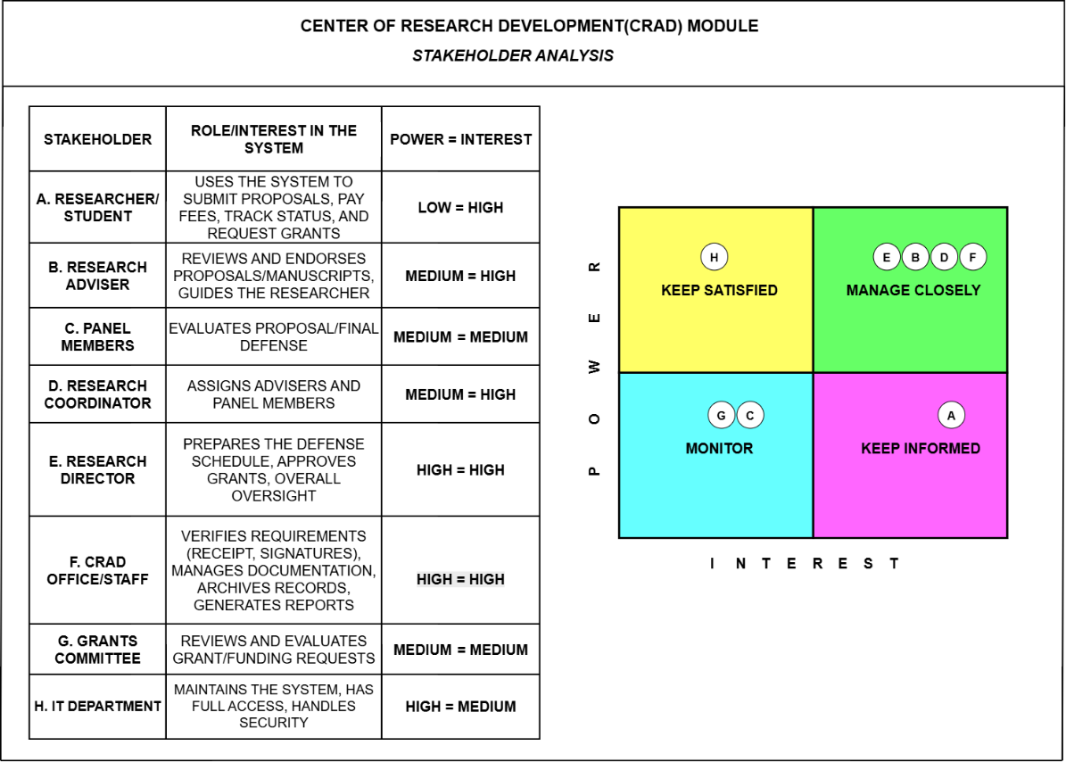
4.1.1. Stakeholder Analysis
Figure 4.1. Stakeholder Power-Interest Grid
This section identifies the individuals and groups with a stake in the CRAD Module, categorized according to their level of power (influence over the project) and interest (degree to which they are affected by or concerned with its outcome). This Power-Interest grid, a widely used stakeholder prioritization tool, guides how the development team engages with each group throughout the project — stakeholders in the "Manage Closely" quadrant require the most active engagement and validation of requirements, while those in "Monitor" require comparatively less direct involvement.
As shown in Table 4.1 and Figure 4.1, the Research Adviser, Panel Members, Research Coordinator, and Research Director all fall within the "Manage Closely" quadrant, reflecting their direct, high-interest involvement in the proposal review, panel assignment, and defense scheduling processes that the proposed system automates. The CRAD Office/Staff and Research Director hold the highest combined power and interest, positioning them as the most critical stakeholders overall, since they are both the primary administrators of the system and the parties most affected by improvements to document review, status tracking, and scheduling efficiency.
The Researcher/Student, though the system's primary end user, holds comparatively low power over the project's direction and is therefore placed in the "Keep Informed" quadrant, receiving regular status updates without being consulted at every design decision. The Grants Committee and IT Department, while part of the broader CRAD Module scope, are positioned in the "Monitor" and "Keep Satisfied" quadrants respectively, reflecting their more peripheral involvement in the specific document analysis, status tracking, and defense scheduling functions that form the core of the proposed system.
4.1.2. Elicitation Techniques
The primary requirements elicitation technique used by the development team was a structured interview questionnaire, administered to CRAD Office staff across two sessions — an initial interview conducted on July 21, 2026, followed by a second interview on July 28, 2026. This method was chosen because it allowed the team to gather firsthand, authoritative information about the CRAD's actual operating procedures directly from the personnel responsible for executing them, rather than relying on assumptions or secondhand documentation.

The second interview, formalized as the CRAD Module Client Interview Questionnaire, was organized into three sections corresponding to the major functional areas of the CRAD office: (A) Research Grants & Funding Assistance, (B) Documentation & Publication Management, and (C) Research Analytics & Reporting. For each section, the team asked a consistent set of four guide questions designed to progressively narrow from a general understanding to actionable process detail:
- What exactly is [the process] at BCP?
- Could you walk us through the actual process of [the process]?
- What are the major stages or steps in [the process]?
- Who are the users, and what is each one's responsibility?
This structured, repeatable question format allowed the team to capture comparable information across all three CRAD functional areas despite their differing purposes, making it easier to identify overlapping actors (such as CRAD staff and the Research Committee, who recur across multiple processes) and to distinguish which parts of the overall CRAD Module fall within the scope of the proposed system.
Both interviews were conducted in person with a CRAD Office representative, with responses recorded in writing on the questionnaire form itself. This qualitative, open-ended approach was selected over a closed-ended survey because the team's primary goal at this stage was to build a complete, narrative understanding of the As-Is process, including the internal hand-offs between researcher, CRAD staff, and the Research/Grants Committee, rather than to quantify opinions or preferences, which is typically better suited to later stages of requirements validation, such as the User Acceptance Testing phase discussed in Section 4.10.1.
4.1.3. Functional Requirements
Functional requirements describe the specific behaviors and capabilities the proposed system must perform, derived from the core features established in Section 1.3 and validated against the elicitation findings in Section 4.1.2.

FR-1: User Authentication and Access Control
- FR-1.1 The system shall allow users to register and log in using a custom PHP/MySQL-based authentication mechanism.
- FR-1.2 The system shall enforce password security through bcrypt hashing.
- FR-1.3 The system shall support Time-based One-Time Password (TOTP) two-factor authentication and passkey (WebAuthn) login as alternative authentication methods.
- FR-1.4 The system shall restrict access to specific functions and data based on the user's assigned role (Researcher/Student, Research Adviser, Panel Member, Research Coordinator, Research Director, CRAD Staff).
FR-2: AI-Powered Document Analysis
- FR-2.1 The system shall allow researchers to upload capstone/thesis manuscript files for review.
- FR-2.2 The system shall use the OpenAI GPT-4.1 API to analyze uploaded documents for formatting and content compliance.
- FR-2.3 The system shall generate a compliance report flagging specific issues for CRAD staff or adviser review.
- FR-2.4 The system shall require human confirmation (CRAD staff or adviser) before a document's status is marked as approved.
FR-3: Automated Status Tracking
- FR-3.1 The system shall automatically update and display the current status of each research group's submission (e.g., Submitted, Under Review, Needs Revision, Approved).
- FR-3.2 The system shall maintain a status history log for each submission.
- FR-3.3 The system shall notify relevant users when a status change occurs.
FR-4: Intelligent Defense Scheduling
- FR-4.1 The system shall use the Google OR-Tools API to generate optimized defense schedules based on the availability of researchers, advisers, panel members, and venues.
- FR-4.2 The system shall detect and flag scheduling conflicts.
- FR-4.3 The system shall allow the Research Director to review and finalize a generated schedule before it is confirmed.
- FR-4.4 The system shall verify processing fee payment status via the PayMongo API before finalizing a defense schedule.
FR-5: Notification System
- FR-5.1 The system shall send automated notifications to researchers, advisers, and panel members regarding status changes and defense schedules.
FR-6: Dashboard and Reporting
- FR-6.1 The system shall display a role-appropriate dashboard summarizing document status, review progress, and upcoming defense schedules.
- FR-6.2 The system shall allow CRAD staff and administrators to generate reports on research submission activity.
4.1.4 Non-Functional Requirements
Non-functional requirements describe the quality attributes the system must satisfy, organized according to the ISO/IEC 25010 software quality model referenced in Section 2.4.8.
NFR-1: Functional Suitability
- The system shall correctly perform document analysis, status tracking, and scheduling functions as specified in the Functional Requirements above.

NFR-2: Performance Efficiency
- The system is designed to return AI document analysis results within approximately 10–15 seconds of document upload, accounting for the processing time required by the OpenAI GPT-4.1 API on multi-page manuscripts.
- The system is designed to support at least 30 concurrent users without noticeable degradation in response time, consistent with its intended use within a single institution's CRAD office rather than as a public-facing platform.
- Dashboard and status pages are designed to load within approximately 3 seconds under normal usage conditions.

NFR-3: Reliability
- The system shall maintain data consistency in the event of a failed transaction (e.g., an incomplete payment verification).
- The system shall be available during standard CRAD office operating hours.

NFR-4: Usability
- The system's interface shall be navigable by users with minimal technical training, consistent with the varied technical backgrounds of CRAD staff, advisers, and panel members identified in Section 4.1.1.
NFR-5: Security
- The system shall encrypt sensitive data using AES-256 encryption.
- The system shall protect against Cross-Site Request Forgery (CSRF) through secure session tokens.
- The system shall lock user accounts after repeated failed login attempts (CAPTCHA + lockout).
NFR-6: Maintainability
- The system's codebase shall follow the feature-based modular organization described in Section 3.2.2 to support ease of modification and debugging.

NFR-7: Portability
- The system shall be accessible through standard modern web browsers without requiring additional client-side software installation.
4.1.5 User Stories
Table 4.2 User Stories per CRAD Module
User Story no. | Module | User Story
1.1 | Research Proposal Submission & Tracking | As a researcher, I want to submit my proposal online, so that I don't need a physical copy.
1.2 |  | As a researcher, I want to pay the forum fee online, so that I skip the in-person visit.
1.3 |  | As a researcher, I want real-time status tracking, so that I know my proposal's progress.
1.4 |  | As an adviser, I want to sign the title form digitally, so that approval is faster.
1.5 |  | As CRAD staff, I want automatic receipt/signature verification, so that review is quicker.
1.6 |  | As CRAD staff, I want auto-registration and group numbering, so that I skip manual logging.
2.1 | Adviser & Panel Assignment System | As a coordinator, I want to assign advisers/panels online, so that matching is faster.
2.2 |  | As an adviser, I want to view my assigned proposals, so that I can start guiding right away.
2.3 |  | As a panel member, I want access to only my assigned documents, so that confidentiality is kept.
2.4 |  | As CRAD staff, I want assignments recorded automatically, so that records stay updated.
3.1 | Research Grants & Funding Assistance | As a researcher, I want to submit a grant request online, so that applying is faster.
3.2 |  | As a committee member, I want to review requests online, so that evaluation is efficient.
3.3 |  | As the Director, I want to approve grants in-system, so that approvals stay traceable.
3.4 |  | As CRAD staff, I want to process funding release online, so that disbursement is logged.
3.5 |  | As a researcher, I want to submit utilization reports online, so that compliance is easier.
4.1 | Documentation & Publication Management | As a researcher, I want to submit final documents online, so that they are properly recorded.
4.2 |  | As a committee member, I want to review and approve for publication, so that quality is ensured.
4.3 |  | As CRAD staff, I want auto-archiving of final documents, so that records stay organized.
5.1 | Research Analytics & Reporting | As a researcher, I want to submit my data online, so that it supports institutional monitoring.
5.2 |  | As CRAD staff, I want automatic data validation and analysis, so that report preparation is faster.
5.3 |  | As admin, I want to view generated reports, so that I can use data for planning.
6.1 | Research Defense Scheduling System | As the Director, I want automatic proposal completeness checks, so that only compliant proposals proceed.
6.2 |  | As the Director, I want automatic availability checks, so that I can schedule without conflicts.
6.3 |  | As a stakeholder, I want automatic schedule notifications, so that I do not need to follow up manually.
6.4 |  | As a panel member, I want to encode results in-system, so that outcomes are recorded immediately.
6.5 |  | As an adviser, I want to monitor revisions online, so that I can confirm compliance without extra meetings.

Acceptance Criteria
Table 4.3 Acceptance Criteria for Core User Stories
No. | Acceptance Criteria (Given–When–Then)
1.1 | Given a logged-in researcher, when they upload a proposal file and submit it, then the system shall store the file and display a confirmation with a unique submission reference.
1.2 | Given a submitted proposal, when the researcher initiates payment through PayMongo, then the system shall record the payment status and display a receipt upon successful transaction.
1.3 | Given a submitted proposal, when its status changes at any stage, then the system shall update the researcher's dashboard to reflect the current status in real time.
1.4 | Given a title approval form pending signature, when the adviser reviews and approves it in-system, then the system shall record a timestamped digital approval in place of a physical signature.
1.5 | Given a submitted proposal with payment and signatures, when CRAD staff opens the submission, then the system shall display a completeness check confirming whether payment and signatures are valid.
1.6 | Given a verified proposal, when CRAD staff approves it for registration, then the system shall automatically generate and assign a unique research group number.
2.1 | Given a registered proposal, when the Research Coordinator selects an adviser and panel members, then the system shall record the assignment and notify the assigned individuals.
2.2 | Given an assigned proposal, when the adviser logs in, then the system shall display the proposal under their list of assigned researchers.
2.3 | Given a panel member account, when they attempt to access proposal documents, then the system shall restrict visibility to only proposals to which they are assigned.
2.4 | Given a completed adviser/panel assignment, when the assignment is finalized, then the system shall log the assignment with a timestamp for audit purposes.
6.1 | Given a proposal nearing defense, when the Research Director initiates scheduling, then the system shall verify that all required documents and approvals are complete before proceeding.
6.2 | Given a complete proposal, when the system checks availability, then it shall use the Google OR-Tools API to identify a time slot with no conflicts among researcher, adviser, panel, and venue.
6.3 | Given a finalized defense schedule, when the schedule is confirmed, then the system shall automatically notify the researcher, adviser, and panel members of the date, time, and venue.
6.4 | Given a completed defense, when the panel inputs the result, then the system shall record the outcome (Approved, Approved with Revisions, or Resubmit) against the corresponding proposal.
6.5 | Given a defense result of "Approved with Revisions," when the researcher submits revised content, then the system shall notify the adviser and update the status upon adviser confirmation.

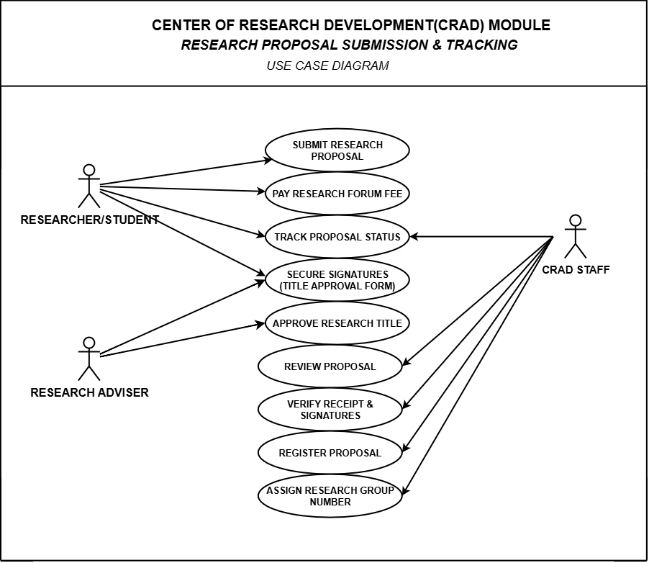
Use Cases
Figure 4.3. Use Case Diagram — RPST
As shown in Figure 4.3, three of the four established user roles interact directly with this module: the Researcher/Student, the Research Adviser, and CRAD Staff. The Panel Member role does not participate at this stage, as panel involvement begins only after a proposal has been assigned an adviser and panel, consistent with the sequence established in the Adviser and Panel Assignment module discussed in the following subsection.
The Researcher/Student initiates the process by submitting a research proposal, paying the required research forum fee, and securing the necessary signatures on the Title Approval Form from the Research Adviser prior to submission. Once submitted, the Researcher/Student may continue to track the proposal's status throughout its review, in line with the automated status tracking capability established under FR-3.
The Research Adviser participates in two use cases within this module: securing signatures on the Title Approval Form, in which the adviser co-signs to endorse the proposed research title, and approving the research title, which represents the adviser's formal sign-off before the proposal proceeds to CRAD Staff for administrative processing.
CRAD Staff perform the remaining administrative use cases in this module, consistent with their role as defined in Section 1.6: verifying the receipt of payment and the completeness of signatures, reviewing the submitted proposal, registering the proposal into the system of record, and assigning a unique research group number that subsequently serves as the reference identifier used across the Adviser and Panel Assignment, Research Defense Scheduling, and Research Analytics and Reporting modules.

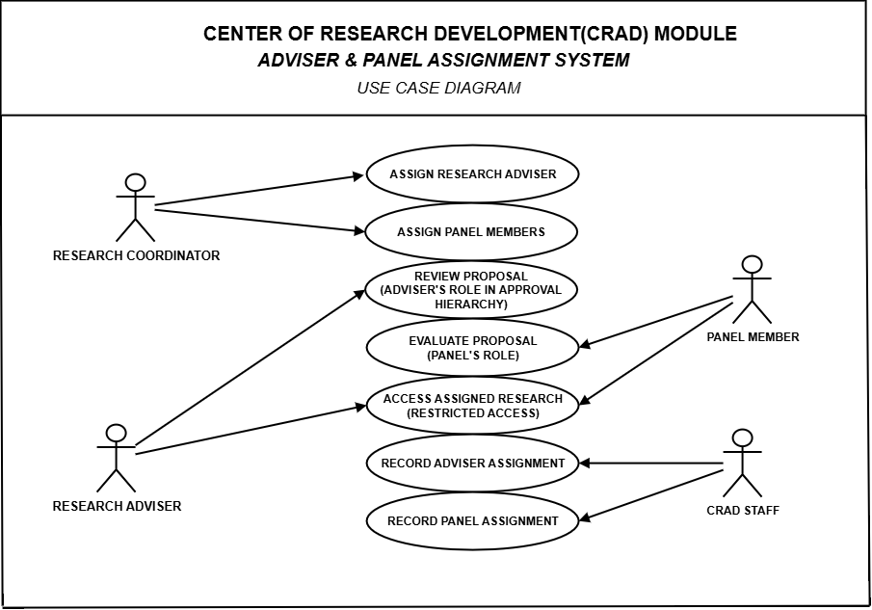
Figure 4.4. Use Case Diagram — APAS
As shown in Figure 4.4, this module involves three of the four established user roles: CRAD Staff, the Research Adviser, and the Panel Member. Consistent with the role consolidation discussed in Section 4.1.1, the assignment functions previously distributed between a separate Research Coordinator role in the initial draft are performed by CRAD Staff, in accordance with the four-role access model established in Section 1.3.
CRAD Staff perform four use cases within this module: assigning the Research Adviser and assigning Panel Members to a proposal, both based on subject-matter expertise and availability, and recording each assignment once finalized. These recorded assignments are linked to the research group number established in the preceding module, allowing the assignment to be referenced by subsequent modules, particularly Research Defense Scheduling.
The Research Adviser and Panel Member roles each participate in two use cases. The Research Adviser reviews the proposal in fulfillment of the adviser's position within the institutional approval hierarchy, and accesses only the research assigned to them, consistent with the role-based access control requirement identified under FR-1. Similarly, the Panel Member evaluates the proposal in fulfillment of the panel's evaluative role, and is likewise restricted to accessing only assigned research.
The "Access Assigned Research" use case is shared between the Research Adviser and Panel Member actors, reflecting a common access-control behavior enforced identically for both roles rather than a role-specific function. This shared use case reinforces the restricted-access principle described in Section 1.6, wherein each non-administrative role is limited to research explicitly assigned to them, while CRAD Staff retain broader administrative access necessary to perform assignment and recording functions.

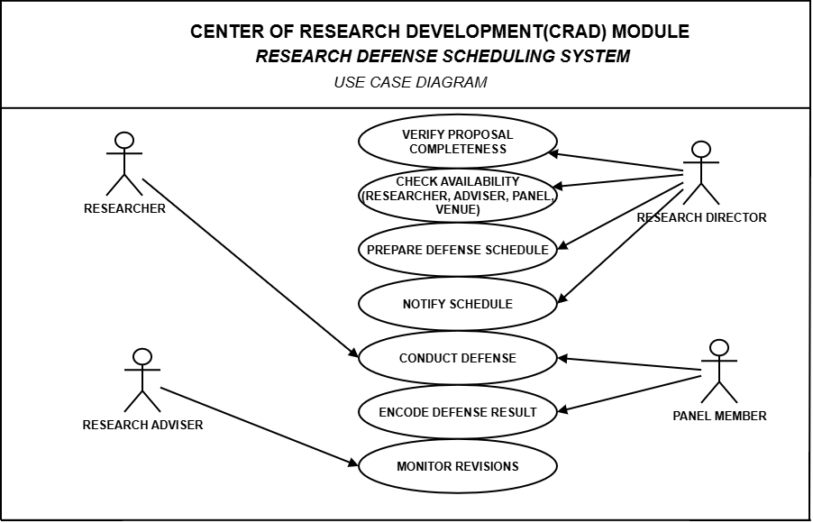
Figure 4.5. Use Case Diagram — RDSS
As shown in Figure 4.5, the Research Defense Scheduling System (RDSS) supports the preparation, coordination, notification, and recording of research defense schedules. The module involves the Researcher, Research Adviser, Panel Member, and the authorized personnel responsible for defense scheduling. These actors participate in different stages of the defense scheduling process according to their assigned responsibilities and access privileges.
The scheduling process begins with the verification of proposal completeness to determine whether a research group has satisfied the necessary requirements for defense scheduling. Once the proposal is considered ready, the availability of the Researcher, Research Adviser, Panel Members, and the required venue is checked. The collected availability information and scheduling constraints are then used to prepare an appropriate defense schedule while minimizing possible conflicts among the involved participants.
After the proposed schedule has been reviewed and finalized by the authorized personnel, the corresponding defense schedule is recorded and notifications are provided to the Researcher, Research Adviser, and Panel Members. This allows the concerned participants to view the finalized date, time, and other relevant scheduling information before the scheduled defense. The system serves as a scheduling and coordination mechanism, while the final approval of the defense schedule remains under the responsibility of the authorized personnel.
During the defense process, the Researcher and Panel Members participate in the actual defense outside the scheduling functions of the system. Following the defense, the authorized Panel Member records the corresponding defense result, which becomes part of the research group's records. The Research Adviser may subsequently monitor the required revisions and the research group's progress based on the recommendations and results recorded after the defense.
Through the RDSS module, defense-related information is maintained in a centralized manner, allowing the system to provide better visibility of schedules, participant availability, defense results, and required revisions. This reduces dependency on manually coordinated schedules and helps maintain traceability throughout the research defense process.
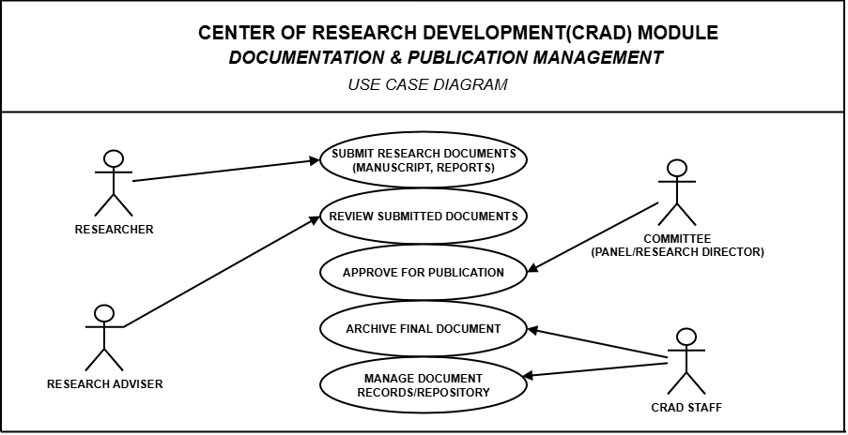
Figure 4.6. Use Case Diagram — DPM
As shown in Figure 4.6, the Documentation and Publication Management (DPM) module supports the submission, review, approval, archiving, and management of research documents throughout the research process. The module involves the Researcher, Research Adviser, Committee, and CRAD Staff, with each actor performing specific functions according to their responsibilities in handling research documentation and maintaining official research records.
The process begins when the Researcher submits the required research documents, such as manuscripts, reports, and other supporting files, through the system. Submitted documents are stored together with their corresponding research information to provide a centralized location for document access and management. This allows the Researcher to maintain organized records of submitted requirements while reducing reliance on manually transferred or separately stored document copies.
The Research Adviser reviews the submitted research documents to determine whether the necessary revisions, corrections, or improvements have been addressed. The review process allows the adviser to examine the documents associated with the assigned research group before they proceed to the succeeding stage. Once the required documentation has satisfied the established research requirements, the appropriate Committee reviews the final submission and performs the corresponding approval action based on the institution's research procedures.
Following the completion of the review and approval process, CRAD Staff are responsible for archiving the final research document and managing the corresponding records within the repository. Archived documents are retained as part of the official research records and can be retrieved when required for monitoring, documentation, or institutional reference. CRAD Staff also maintain the organization of document records to ensure that finalized research outputs remain associated with the correct research group and research information.
Through the DPM module, research documents are maintained within a centralized repository from initial submission to final archiving. The module improves document organization, facilitates access to submitted and finalized research files, and provides traceability of research documentation throughout the review process. This helps minimize problems associated with scattered files, inconsistent document records, and manual management of research outputs.
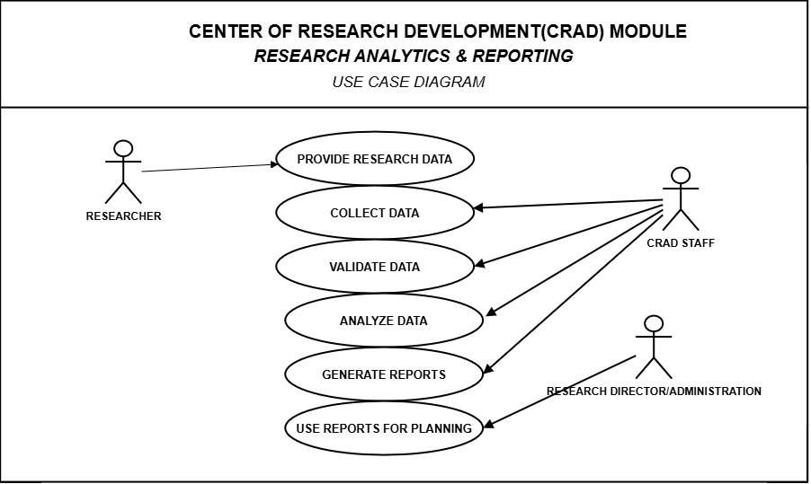
Figure 4.7. Use Case Diagram — RAR
As shown in Figure 4.7, the Research Analytics and Reporting (RAR) module supports the collection, validation, analysis, and presentation of research-related information for monitoring and decision-making purposes. The module involves the Researcher, CRAD Staff, and authorized administrative personnel, with each actor participating according to their assigned responsibilities and access privileges.
The process begins with the availability of research data generated or recorded throughout the research management process. Relevant information may include research submissions, document status, defense-related records, and other research progress data maintained within the system. CRAD Staff are responsible for collecting and validating the available records to ensure that the information used for monitoring and reporting is complete and appropriate before it is processed for analysis.
Once the required information has been validated, the system assists CRAD Staff in organizing and analyzing the recorded research data. The resulting information is used to generate reports that provide an overview of research activities, progress, and other relevant indicators. These reports allow authorized personnel to review consolidated research information without manually compiling records from separate sources.
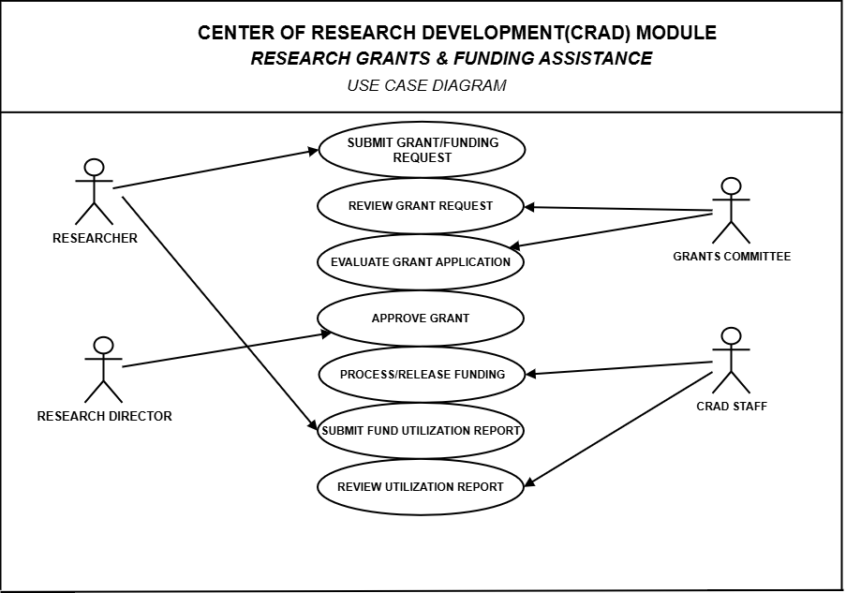
Through the RAR module, authorized personnel can use generated reports as supporting information for monitoring, planning, and administrative decision-making. The module provides a centralized means of transforming existing research records into organized and understandable reports, helping CRAD Staff maintain better visibility of ongoing research activities while improving the accessibility and consistency of institutional research information.
Figure 4.4. Use Case Diagram — RGFA
As shown in Figure 4.4, the Research Grants and Funding Assistance (RGFA) process represents the activities associated with the submission, evaluation, approval, release, and monitoring of research-related funding requests. The process involves the Researcher, Grants Committee, Research Director, and CRAD Staff, with each participant performing specific responsibilities in accordance with the institution's research funding procedures.
The process begins when the Researcher submits a grant or funding request together with the required supporting information. The Grants Committee reviews the submitted request and evaluates the corresponding grant application based on the applicable requirements and criteria. Following the evaluation, the appropriate recommendation is forwarded to the Research Director, who performs the required approval action for qualified funding requests.
Once a funding request has been approved, CRAD Staff facilitate the administrative processing and release of the corresponding funds according to institutional procedures. After the utilization of the approved research funds, the Researcher submits the required fund utilization report. CRAD Staff subsequently review the submitted utilization records to ensure that the necessary documentation associated with the approved funding has been properly recorded.
Through the RGFA process, research funding activities can be documented from the initial request up to the review of fund utilization records. However, grant management, budgeting, accounting, and the actual processing or release of funds are outside the functional scope of the proposed CRAD Management System. Therefore, this use case should be presented only as part of the existing institutional research process or contextual documentation and should not be interpreted as a function implemented by the proposed system.

4.2 High-Level System Design
The High-Level System Design presents the overall structure of the proposed CRAD Management System and illustrates how its major components interact with the different system users and external services. It provides an architectural overview of the system before presenting the more detailed application and data architecture in the succeeding sections.
The proposed system follows a microservices-based architecture in which major system functions are separated into independently manageable services. These services communicate through REST APIs and maintain their respective data storage to reduce direct dependencies between system components. This design supports modularity and allows individual services to be maintained or deployed without requiring direct access to another service's database.
The high-level design is presented through the System Context Diagram and the Overview of the Integrated System. The System Context Diagram defines the system boundary and its interactions with users and external services, while the integrated system overview illustrates the relationship among the major functional services of the proposed CRAD Management System.

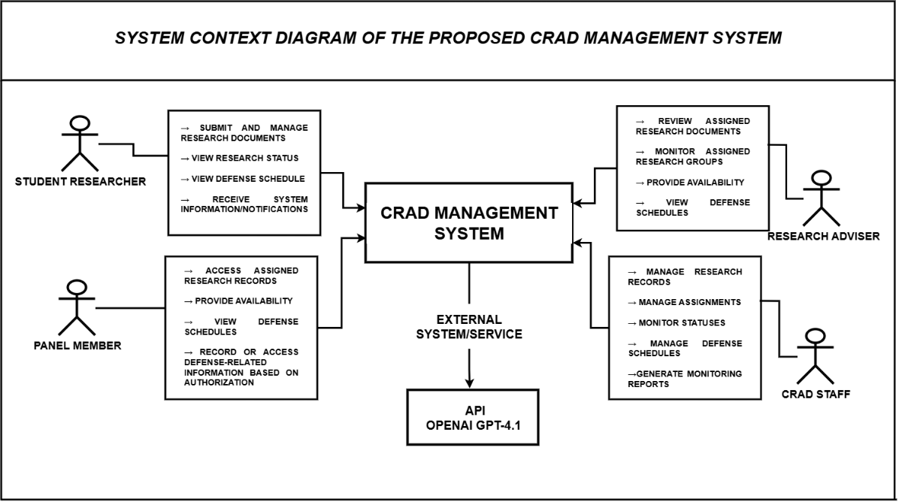
4.2.1 System Context Diagram
Figure 4.5. System Context Diagram of the Proposed CRAD Management System
As shown in Figure 4.5, the System Context Diagram presents the interaction between the proposed CRAD Management System and its primary users and external service. The system supports four established user roles: Student Researcher, Research Adviser, Panel Member, and CRAD Staff. Each user interacts with the system according to the functions and information permitted by his or her assigned role.
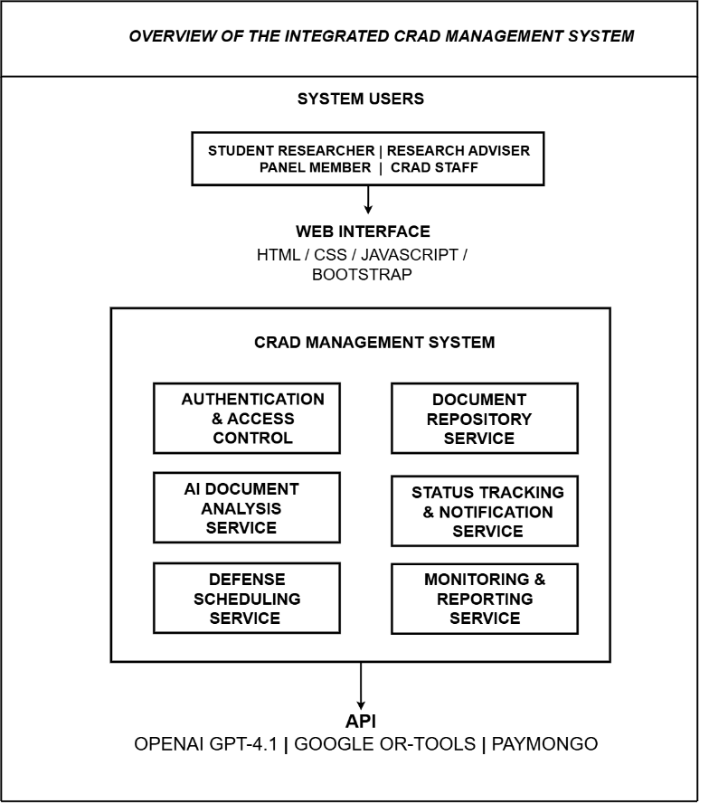
4.2.2 Overview of the Integrated System

Figure 4.6. Overview of the Integrated CRAD Management System

As shown in Figure 4.6, the proposed CRAD Management System integrates six major services that collectively support the management of research-related activities. These services include the Authentication and Access Control Service, Document Repository Service, AI Document Analysis Service, Status Tracking and Notification Service, Defense Scheduling Service, and Monitoring and Reporting Service. Each service is assigned a defined set of responsibilities while remaining connected to the overall research management workflow.
The Authentication and Access Control Service manages user authentication and role-based access to system functions. The Document Repository Service manages research submissions, document records, and document versions, while the AI Document Analysis Service provides AI-assisted observations on submitted research documents through integration with the OpenAI GPT-4.1 API. The Status Tracking and Notification Service maintains changes in research status and provides relevant updates to authorized users.
The Defense Scheduling Service supports the management of availability, scheduling constraints, and defense schedule proposals, while the Monitoring and Reporting Service consolidates relevant system information for monitoring and report generation. Together, these services allow research information generated from different stages of the process to remain connected while preserving the functional responsibilities of each service.
Communication among the services is performed through REST APIs rather than through direct access to another service's database. Each service maintains its own MySQL database in accordance with the database-per-service approach of the proposed architecture. This structure provides clear separation of responsibilities and establishes the foundation for the more detailed component, UML, and data architecture presented in the succeeding sections.

4.3 Business Process Architecture (BPMN 2.0)
The Business Process Architecture presents the sequence of activities, responsibilities, decision points, and interactions involved in the research management processes of the Center for Research and Development (CRAD). The process models are represented through swimlanes to distinguish the responsibilities of the different participants and to illustrate how research-related activities are transferred from one responsible role to another.

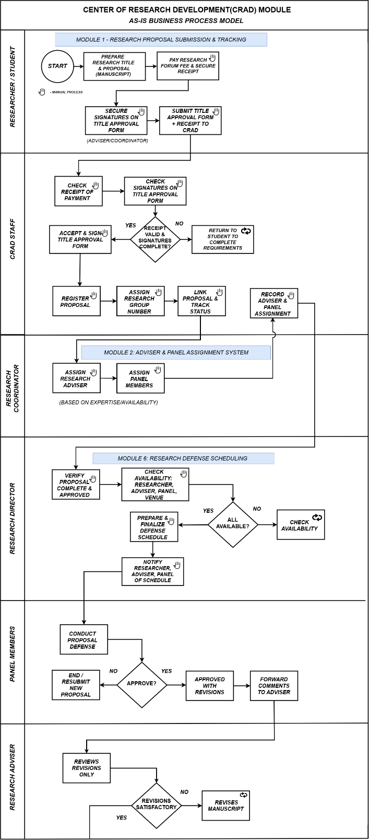
4.3.1 As-Is Process Model

Figure 4.7. As-Is Business Process Model — Part 1
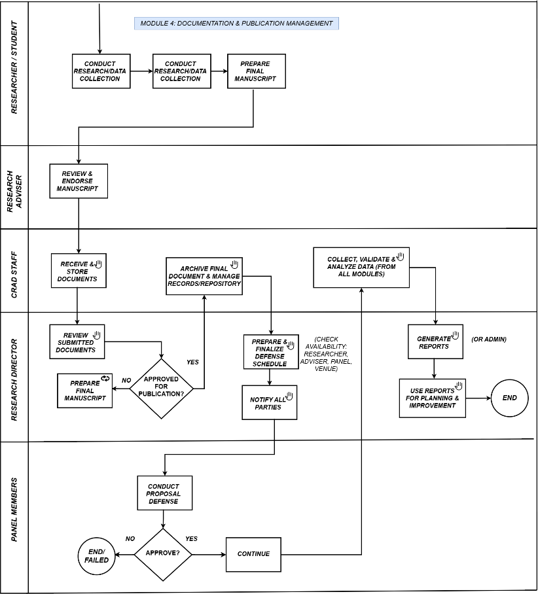

Figure 4.7. As-Is Business Process Model — Part 2

As shown in Figures 4.7, the As-Is Process Model presents the existing CRAD research workflow involving the Researcher or Student, CRAD Staff, Research Coordinator, Research Director, Panel Members, and Research Adviser. The process covers research proposal preparation and submission, verification of requirements, proposal registration, adviser and panel assignment, defense scheduling, conduct of the proposal defense, revision monitoring, final document preparation and archiving, and research reporting. Several activities rely on manual document handling, verification, approval, availability checking, and coordination among the involved participants. The existing process also requires information to pass through multiple responsible personnel before a research activity can proceed to the succeeding stage. These manual and distributed procedures may contribute to delays, fragmented records, limited status visibility, and additional effort in coordinating research activities, which provide the basis for the improvements introduced in the proposed To-Be Process Model.

Research Grants and Funding Assistance — As-Is Process Model
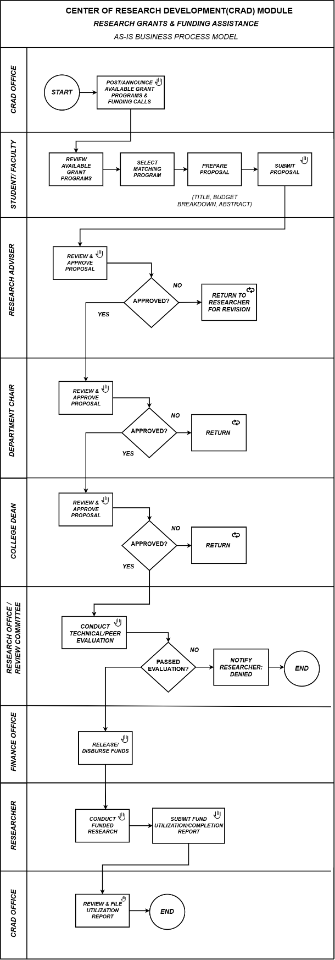



Figure 4.8. As-Is Business Process Model

As shown in Figure 4.8, the As-Is Research Grants and Funding Assistance process begins with the announcement of available grant programs and funding opportunities, followed by the Researcher or Student reviewing the available options, preparing the required proposal, and submitting it for evaluation. The proposal passes through several levels of review and approval involving the Research Adviser, Department Chair, College Dean, and Research Office or Review Committee, with applications that do not meet the requirements being returned for revision. Approved proposals proceed to technical or peer evaluation and, once successfully evaluated, the corresponding funds are released through the Finance Office. The Researcher then conducts the funded research and submits the required fund utilization or completion report, which is subsequently reviewed and filed by the appropriate CRAD office. This process reflects the existing institutional workflow for research funding and is presented for process documentation purposes, while grant administration, financial disbursement, budgeting, and fund utilization processing remain outside the functional scope of the proposed CRAD Management System.
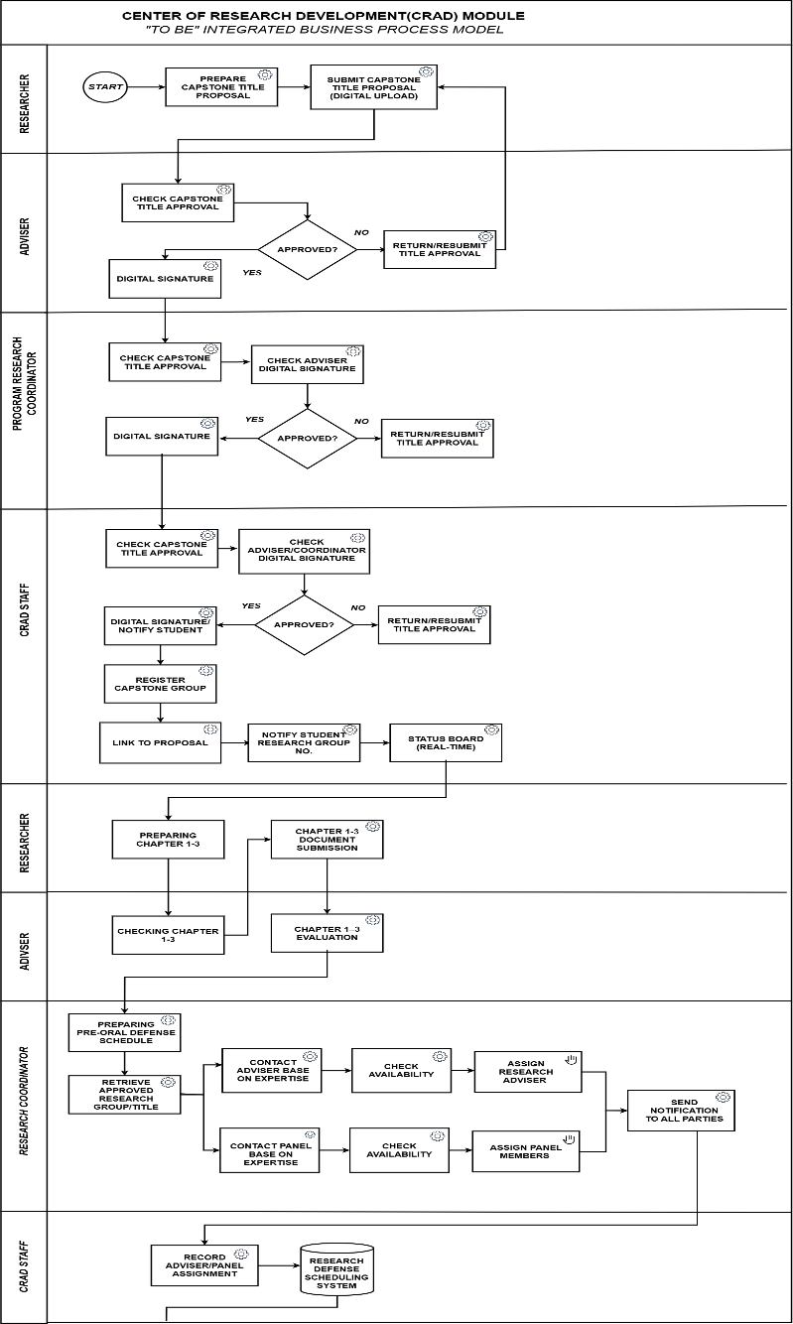
4.3.2 To-Be Process Model

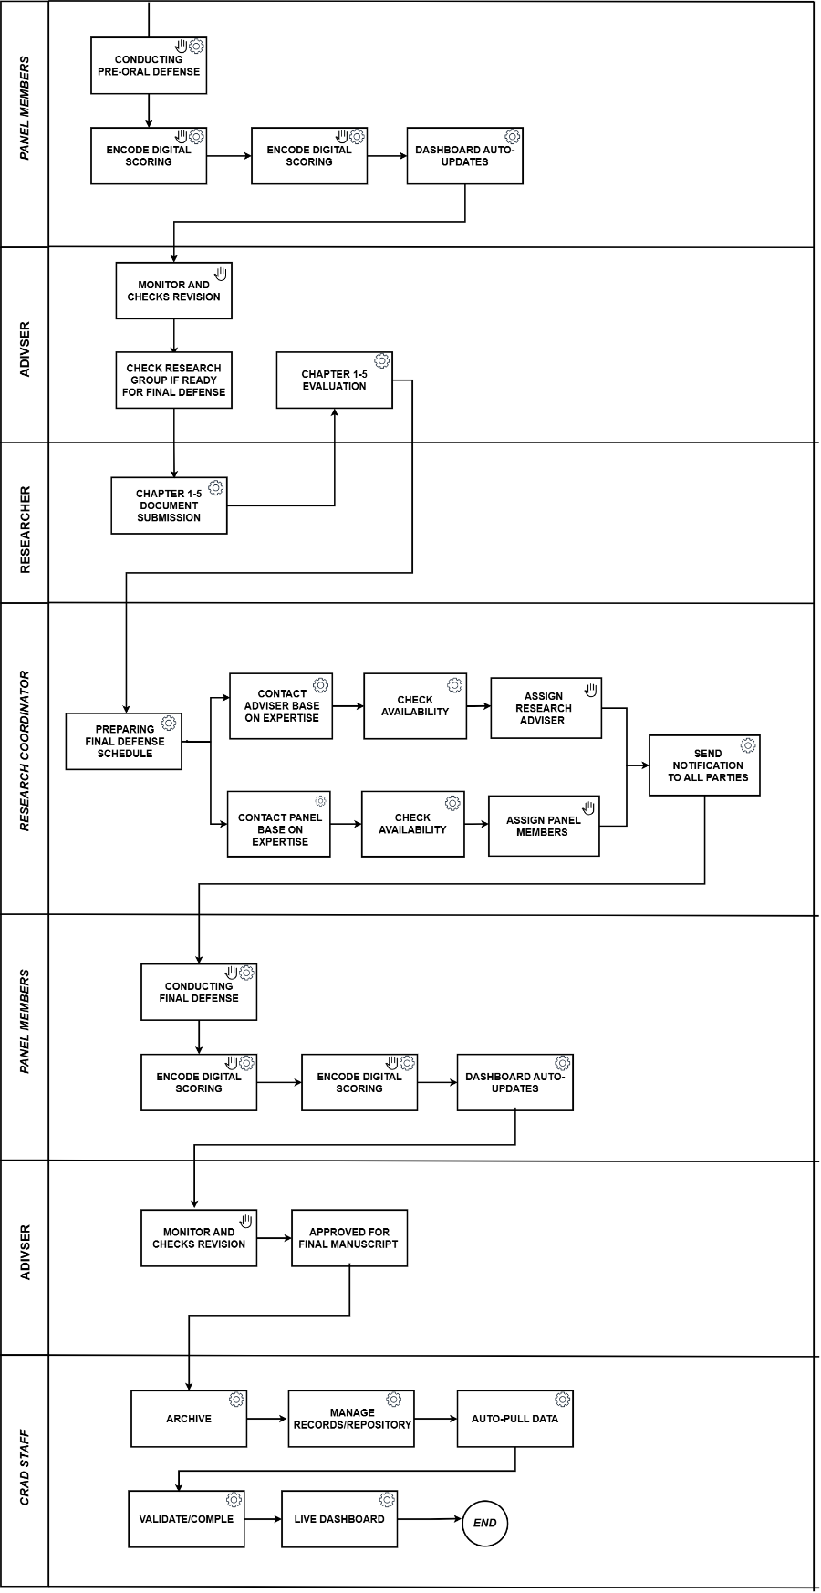

Figure 4.9. To-Be Business Process Model

As shown in Figures 4.9, the To-Be Process Model presents the proposed integrated CRAD workflow beginning with capstone title proposal submission and approval, followed by research group registration, adviser and coordinator management, research progress monitoring, and Chapter 1–3 document submission and evaluation. Research groups that satisfy the required conditions proceed to Pre-Oral Defense scheduling and evaluation, after which revisions and research progress are monitored by the Research Adviser before recommendation for Final Defense. The succeeding process includes Chapter 1–5 document submission and evaluation, Final Defense scheduling and evaluation, revision and compliance monitoring, final manuscript approval, publication record management, and archiving of completed research documents. Throughout the workflow, the proposed system provides centralized document records, status updates, notifications, defense-related information, and monitoring functions, while academic evaluations, approvals, and final decisions remain under the responsibility of authorized personnel. Research information generated across the supported processes is subsequently consolidated for dashboard monitoring, analytics, and report generation.

4.3.3 Analysis of Improvements
The proposed To-Be Process Model improves the existing CRAD workflow by centralizing research records and providing system-supported processes throughout the capstone research lifecycle. Compared with the As-Is process, title proposals, research groups, adviser assignments, Chapter 1–3 and Chapter 1–5 submissions, revisions, and defense-related records can be maintained within an integrated platform with improved status visibility and traceability. Pre-Oral and Final Defense activities are represented as separate stages, allowing scheduling, evaluation results, revisions, and progression toward succeeding research requirements to be monitored more clearly. Automated notifications reduce repeated manual follow-ups, while centralized document management supports organized submission and version handling. AI-assisted document analysis may provide structural and formatting-related observations to support document review without replacing the decisions of authorized evaluators. The proposed monitoring, dashboard, analytics, and reporting functions further consolidate research information for CRAD personnel, reducing fragmented record handling and improving coordination across the research process.

4.4 Application Architecture
The Application Architecture presents the structural organization of the proposed CRAD Management System and defines how its major software components interact to support the research management processes. The proposed system follows a microservices-based architecture in which major functional responsibilities are separated into individual services that communicate through REST APIs. This approach provides clear separation of responsibilities while allowing the services to be developed, maintained, and deployed independently.
The application architecture supports research activities from capstone title proposal and group registration through document submission, adviser and panel assignment, Pre-Oral and Final Defense scheduling, revision monitoring, final manuscript management, publication records, and research analytics. User access to these functions is controlled according to assigned roles and permissions, while information required by multiple processes is exchanged through defined service interfaces rather than through direct database access.

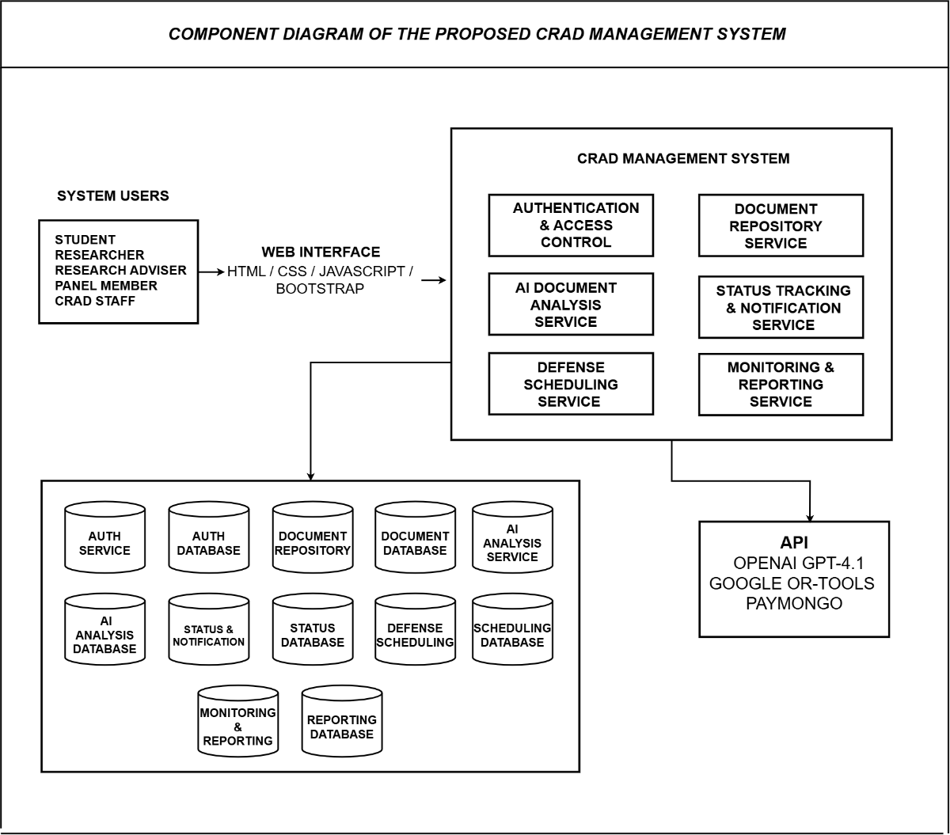
4.4.1 Component Diagram
FIGURE 4.10. - Component Diagram
As shown in Figure 4.10, the component architecture of the proposed CRAD Management System is organized into six major services: Authentication and Access Control, Document Repository, AI Document Analysis, Status Tracking and Notification, Defense Scheduling, and Monitoring and Reporting. Users access these services through the web-based user interface, while access to system functions is determined by the user's assigned role and authorization.
The Document Repository Service manages research-related documents and their versions, including capstone title proposals, Chapter 1–3 submissions, Chapter 1–5 submissions, revisions, and final manuscripts. The AI Document Analysis Service communicates with the OpenAI GPT-4.1 API to provide assistive structural and formatting-related observations on submitted documents. The Status Tracking and Notification Service maintains research progress, approval states, revision status, and user notifications, while the Defense Scheduling Service supports both Pre-Oral and Final Defense scheduling through the management of availability and scheduling constraints.
The Monitoring and Reporting Service consolidates relevant research information for dashboards, analytics, and report generation. Communication among the services is performed through REST APIs, and each service maintains its own MySQL database in accordance with the database-per-service architectural approach. This structure prevents direct cross-service database access and maintains functional separation among system components.

