COURSE CODE: PRAC101 Section: BSIT - 4105/NA
COURSE TITLE: OJT / PRACTICUM 1
TERM: 1st Semester, SY 2026-2027
PROFESSOR: MR. GELERA, EMERSON D.
NAME OF STUDENT: ABEJUELA, JOHN KENNETH C.

OJT NARRATIVE REPORT

- TOPIC: Familiarizing With AI Session:4 Workshop
- SPEAKER: MR. MARC TONIDO
- DURATION: 8:00 AM – 9:30 AM
- SCREENSHOT OF DUTY
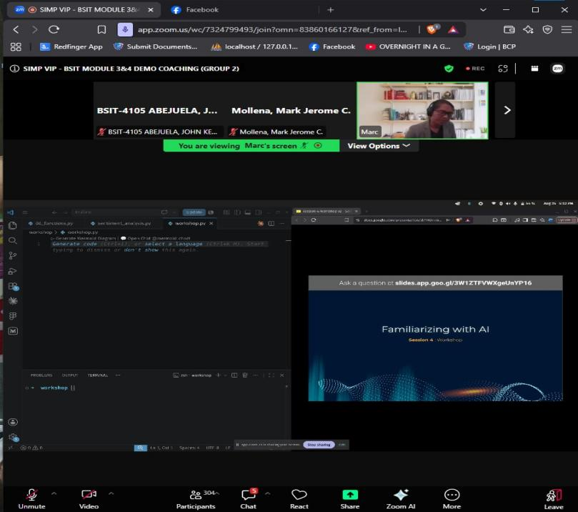
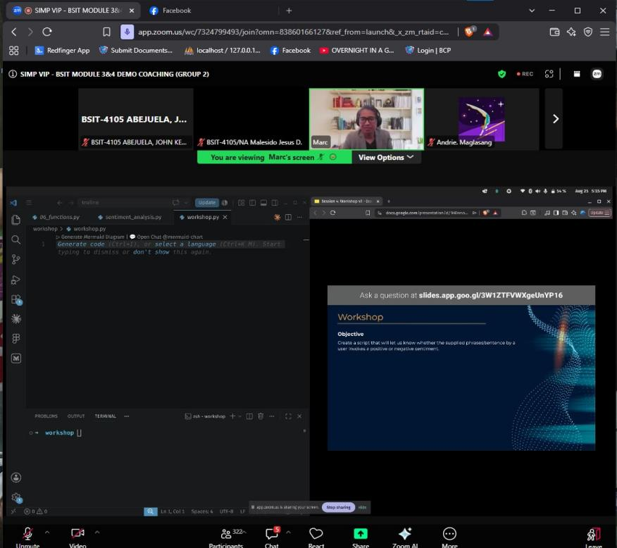

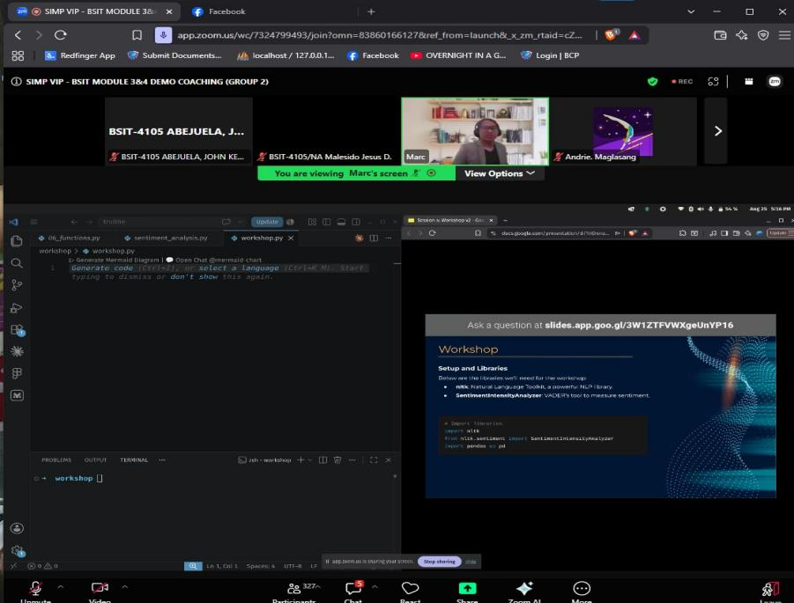
E. REFLECTION
During our SIMP VIP – BSIT Module 3 & 4 Demo Coaching, we attended a workshop about Familiarizing with AI. The activity focused on learning how Artificial Intelligence can understand the emotion or feeling behind a sentence. The discussion was easy to follow because the instructor showed the process step by step and also demonstrated the code during the online session.
At the start of the workshop, we learned about the libraries needed for the activity. We used NLTK, or Natural Language Toolkit, which is a Python library used for working with text. We also used the SentimentIntensityAnalyzer, which is part of VADER and is used to measure the sentiment of a sentence. Another library introduced was Pandas, which can be used for handling and organizing datasets. We learned that these libraries are useful when working with text, reviews, comments, or other written data.
The instructor also explained the VADER Lexicon. It contains words, phrases, and even emoticons that already have sentiment scores. The scores can range from negative values to positive values. Because of this, the program can check whether the words used in a sentence show a positive, negative, or neutral feeling. This helped us understand how a computer can analyze text without reading it the same way a person does.
After the discussion, we moved to the sample analysis. We created a SentimentIntensityAnalyzer and tested different sentences such as positive, negative, and neutral statements. The program generated scores for each sentence, including negative, neutral, positive, and compound scores. The compound score was then used to decide the final sentiment. If the score was high enough, the result was Positive. If the score was low, the result was Negative, and scores near the middle were considered Neutral.
We also created a simple function that automatically returned the sentiment of each sentence. When the sample sentences were tested, the program correctly showed results such as Positive and Negative. This part of the workshop helped us understand how a small amount of Python code can already perform basic sentiment analysis.
The last part of the activity was the Interactive User Input. Instead of using only prepared sentences, the program allowed the user to type any sentence. After entering the sentence, the program immediately displayed its sentiment. The process continued until the user entered the word quit. This made the activity more interesting because we could personally test different statements and observe how the AI analyzed them.
Overall, the workshop gave us a better understanding of basic sentiment analysis using Python, NLTK, and VADER. It showed us how AI can be used to understand the emotion behind text. The activity was simple but useful because we were able to see both the explanation and the actual coding process. It also helped us become more familiar with how AI and Natural Language Processing can be applied in real programs.

