

INTERNSHIP PROJECT REPORT ON

**IBM HR Analytics**

Submitted By:

KENNETH AMAN (3PD21AI012)

BACHELOR OF ENGINEERING IN

ARTIFICIAL INTELLIGENCE AND MACHINE LEARNING

POOJYA DODDAPPA APPA COLLEGE OF ENGINEERING KALABURAGI

Unified Mentors Internship :

Data Analytics 12-16 weeks 10th Oct to 10th Feb(online) Unified Mentors is a professional training platform specializing in data analytics, AI, ML, DATA Science and more. The organization focuses on equipping aspiring interns with real-world experience, hands on projects, and industry relevant skills under expert mentorship

Address:

Plot No 247B/7,Dhola Kuva Road Hansi City, Hansi Hisar, Haryana 125033 India

Contact Information:

• Phone: +91 6283 800330

• Email: [hello@unifiedmentor.com](mailto:hello@unifiedmentor.com)

**IBM HR Analytics Employee Attrition & Performance Analysis Report**

**Project Overview**

The project titled "IBM HR Analytics Employee Attrition & Performance" aims to uncover the factors that lead to employee attrition and explore important questions related to employee demographics, job roles, and satisfaction levels. This analysis is crucial for understanding the underlying reasons for employee turnover and implementing effective retention strategies.

**Problem Statement**

Employee attrition, commonly known as turnover, is a significant challenge for companies. High attrition rates can lead to increased recruitment and training costs, disrupt team dynamics, and result in the loss of valuable institutional knowledge. The objective of this analysis is to understand the current turnover rates, identify key factors influencing turnover, and provide actionable recommendations to reduce attrition.

**Tools Used**

* **Python**: For data manipulation, analysis, and visualization.
* **Pandas**: For data manipulation and analysis.
* **NumPy**: For numerical operations.
* **Matplotlib and Seaborn**: For data visualization.
* **SQL**: For database management and querying.
* **Excel**: For additional data analysis and reporting.

**Data Sources**

The dataset used in this project is a fictional dataset created by IBM data scientists. It contains 1,470 rows and 35 columns, covering various aspects of employee demographics, job roles, satisfaction levels, and attrition status. The dataset can be downloaded from the provided link.

**Data Analysis and Cleaning**

**Initial Data Inspection**

* **Data Shape**: The dataset contains 1,470 rows and 35 columns.
* **Duplicate Data**: There are no duplicate rows in the dataset.
* **Missing Values**: There are no missing values in the dataset.
* **Data Types**: All columns have appropriate data types, ensuring that the data is correctly formatted for analysis.

**Descriptive Statistics**

* The dataset includes various numerical and categorical variables such as age, education, job satisfaction, monthly income, and attrition status.
* Summary statistics indicate that there are no apparent outliers in the dataset, as the values fall within expected ranges.

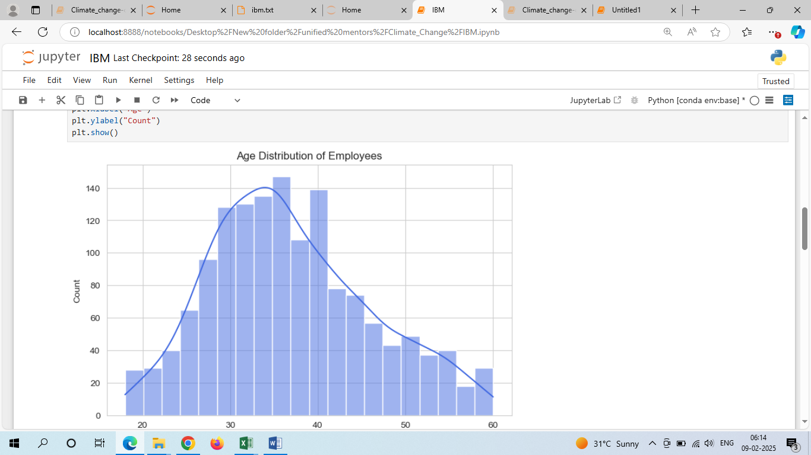

**Visualization**

**Attrition Rate**

* The attrition rate is calculated as the percentage of employees who leave the company. The dataset shows an attrition rate of 16.12%.
* A bar plot visualizes the distribution of attrition rates, showing that a significant number of employees decide to leave the company.

**Average Tenure**

* The average tenure of employees before they decide to leave is 7.01 years, indicating that many employees feel comfortable and have been with the company for a long time.

**Employee Demographics**

* **Age**: Most employees are in the 30-35 age group, indicating a productive and experienced workforce.
* **Gender**: The majority of employees are male, with significantly more male employees than female employees.
* **Department**: Most employees are concentrated in the research and development department, indicating a focus on product or service research and development activities.

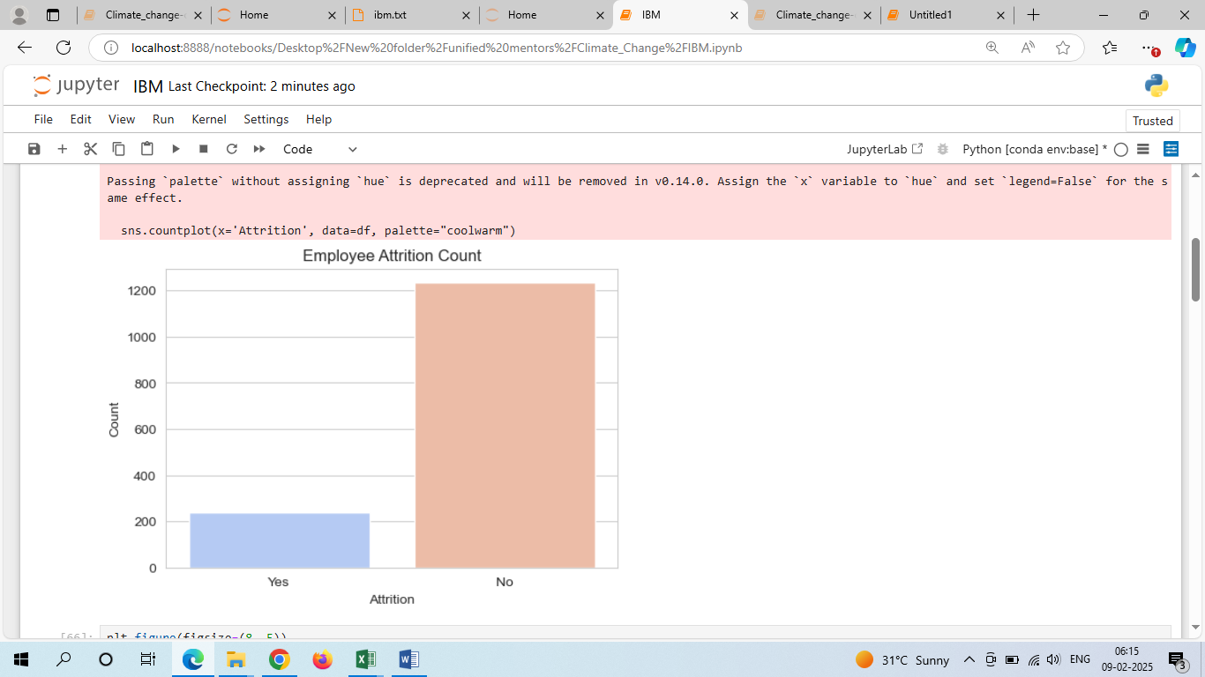

**Exploratory Data Analysis (EDA)**

**Attrition by Age**

* A KDE plot shows the distribution of attrition by age, revealing patterns in which age groups are more likely to leave the company.

**Attrition by Gender**

* A bar plot shows the attrition rate by gender, indicating differences in attrition rates between male and female employees.

**Attrition by Department**

* A bar plot shows the attrition rate by department, revealing which departments have higher attrition rates.

**Attrition by Job Role**

* A bar plot shows the attrition rate by job role, indicating which roles have higher attrition rates.

**Results**

* The analysis reveals that certain demographics and job roles have higher attrition rates.
* Key factors influencing attrition include job satisfaction, work-life balance, monthly income, and education level.

**Recommendations**

1. **Improve Job Satisfaction**: Implement initiatives to enhance job satisfaction, such as regular feedback and recognition programs.
2. **Enhance Work-Life Balance**: Promote a better work-life balance through flexible working hours and remote work options.
3. **Competitive Compensation**: Ensure competitive monthly incomes and salary hikes to retain employees.
4. **Targeted Retention Strategies**: Develop targeted retention strategies for departments and job roles with higher attrition rates.
5. **Diversity and Inclusion**: Address gender imbalances by promoting diversity and inclusion initiatives.

**Conclusions**

The analysis provides valuable insights into the factors contributing to employee attrition. By understanding these factors and implementing targeted retention strategies, the company can reduce attrition rates, improve workforce stability, and maintain a competitive edge in the market. Future work may include more advanced predictive modeling to forecast attrition and further explore the impact of various interventions.