Kenneth Chuson

CSC 620-01 Natural Language Processing Spring 2022

HA#9 Report

1. While adding a classifier at the end of the pipeline after the sklearn has been trained the text. The cross validation gives us enough flexibility and to determine how many tress and how deep should we go. After I changed from 5 to 3 cross validation I started to realize the hyper parameters has been changed little bit. And also the prediction changed a little bit, but it increase the mean prediction when I turned on to the 3 cross validation.
2. 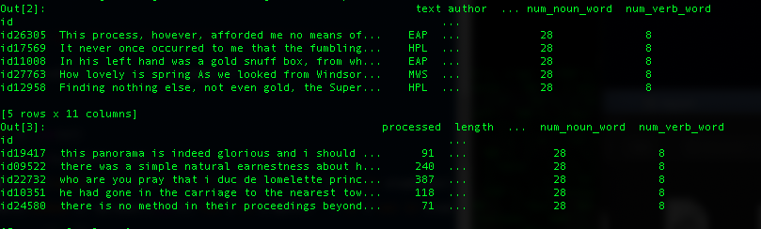 In the previous HA#8, I added number of adjectives, nouns, and verbs.

Class important and least important features I found.

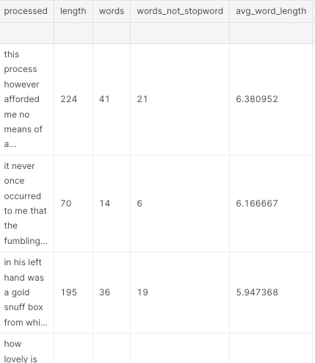Important features

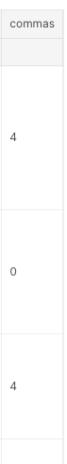least important features

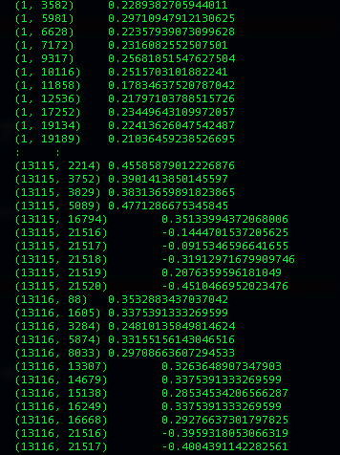 After training the data, some of the text have wrong prediction which if they have negative probabilities.