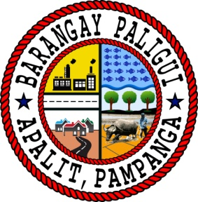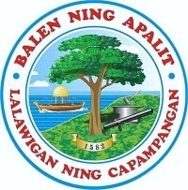Republic of the Philippines

Region III

Province of Pampanga

Municipality of Apalit

**BARANGAY PALIGUI**

*Office of the Sangguniang Kabataan*

**AN EXCERPT FROM THE MINUTES OF THE MEETING DURING THE 6th SANGGUNIANG KABATAAN REGULAR SESSION HELD ON APRIL 14 2024,**

**11:00 A.M. AT BARANGAY PALIGUI SESSION HALL, APALIT, PAMPANGA.**

**Present:**

Hon. Arjay L. Saclao - SK Chairperson/

Presiding Officer

Hon. Paul C. Alfonso - SK Kagawad

Hon. Ervie R. Dizon - SK Kagawad

Hon. Angelo F. Umali - SK Kagawad

Hon. Chin Jean M. Meneses - SK Kagawad

Hon. Ian Jaspher C. Villarico - SK Kagawad

Hon. Michaela Lorine R. Amparo - SK Kagawad

Hon. Karen B. Bautista - SK Kagawad

Mr. Kenneth D. Bautista - SK Secretary

Ms. Angel Mae B. Bautista - SK Treasurer

**Absent:**

*x------------------------------------------------------------------------------------------------------------------x*

**RESOLUTION NO. 04**

**Series of 2024**

**A RESOLUTION APPROVING THE 2024 ANNUAL BARANGAY YOUTH INVESTMENT PROGRAM (ABYIP) OF BARANGAY PALIGUI, APALIT, PAMPANGA AMOUNTING TO SIX HUNDRED THREE THOUSAND EIGHT HUNDRED FOURTHEEN AND SIXTY CENTAVO (PHP 603,814.60)**

**WHEREAS,** Article 2 Section 12 of the 1987 Philippine Constitution states that “the state recognizes the vital role of the youth in nation-building and shall promote and protect their physical, moral, spiritual, intellectual and social well-being. It shall inculcate in the youth, patriotism and nationalism and encourage their involvement in public and civic affairs.”;

**WHEREAS,** Implementing Rules and Regulations of RA 10742 also known as the Sangguniang Kabataan Reform Act of 2015 provides in Chapter 2 Section 8 paragraph (a) states that “In constitution and with the concurrence of the Katipunan ng Kabataan, and within three (3) months from the assumption of office, formulate a three (3) year rolling plan, which shall be known as the Comprehensive Barangay Youth Development Plan, which shall serve as basis in the preparation of the Annual Barangay Youth Investment Program”;

**WHEREAS,** the Sangguniang Kabataan, with the concurrence of the Katipunan ng Kabataan of Barangay Paligui, Apalit, Pampanga drafted and approved the Comprehensive Barangay Youth Development Plan for FY 2024-2026.

**WHEREAS,** the Sangguniang Kabataan of Barangay Paligui has prepared the 2024 Annual Barangay Youth Investment Program in accordance with the approved Comprehensive Barangay Youth Development Plan;

**NOW THEREFORE, BE IT RESOLVED, AS IT IS HEREBY RESOLVED,** to approve its 2024 Annual Barangay Youth Investment Program.

**RESOLVED FURTHER.** that copy of this resolution be given to the Local Youth Development Office of Apalit, Pampanga, Municipal Office of the Interior and Local Government, and Municipal Budget Office for their information and record.

x------------------------------------------------------------------------------------------------------------------x

**ADOPTED,** this 18th day of March 2024 at Barangay Cansinala, Apalit, Pampanga.

Attested by:

**MR. KENNETH D. BAUTISTA**

SK Secretary

Approved by:

**HON. ARJAY L. SACLAO**

SK Chairperson

**HON. PAUL C. ALFONSO HON. ERVIE R. DIZON**

SK Kagawad SK Kagawad

**HON. ANGELO F. UMALI HON. CHIN JEAN M. MENESES**

SK Kagawad SK Kagawad

**HON. IAN JASPER C. VILLARICO HON. MICHAELA LORINE R. AMPARO**

SK Kagawad SK Kagawad

**HON. KAREN B. BAUTISTA**

SK Kagawad