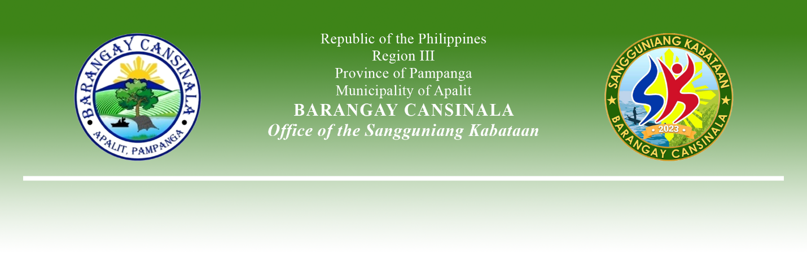**AN EXCERPT FROM THE MINUTES OF THE MEETING DURING THE 5th SANGGUNIANG KABATAAN REGULAR SESSION HELD ON MARCH 18, 2024,**

**5:00 P.M. AT BARANGAY CANSINALA SESSION HALL, APALIT, PAMPANGA.**

**Present:**

Hon. Ivan John B. Arceo - SK Chairperson/

Presiding Officer

Hon. Joyce Ann T. Manuel - SK Kagawad

Hon. Arnie M. De Guzman - SK Kagawad

Hon. Elcied V. Lopez - SK Kagawad

Hon. Edrian Paul G. Mandap - SK Kagawad

Hon. Arabella C. Castro - SK Kagawad

Hon. Alexcis M. Bamba - SK Kagawad

Hon. Anton Kyle M. Estanislao - SK Kagawad

Mr. Ricardo C. Reyes Jr. - SK Secretary

Mr. Rodel L. Binuya - SK Treasurer

**Absent:**

*x------------------------------------------------------------------------------------------------------------------x*

**RESOLUTION NO. 02**

**Series of 2024**

**A RESOLUTION APPROVING THE COMPREHENSIVE BARANGAY YOUTH DEVELOPMENT PLAN (CBYDP) FOR THE CUMULATIVE CALENDAR YEAR FROM 2024-2026 OF BARANGAY CANSINALA, APALIT, PAMPANGA**

**WHEREAS,** Republic Act No. 10742 also known as the Sangguniang Kabataan Reform Act of 2015 and its implementing rules and regulations, the SK, in consultation with the concurrence of the Katipunan ng Kabataan, shall formulate a three (3) year rolling plan, which shall be known as Comprehensive Barangay Youth Development Plan (CBYDP);

**WHEREAS,** the Comprehensive Barangay Youth Development Plan (CBYDP) shall be aligned with the Philippine Youth Development Plan (PYDP) and the Local Youth Development Plan (LYDP) of the Province and Municipality;

**WHEREAS,** the CBYDP shall give priority to the programs, projects, and activities that will promote and ensure the equitable access to the quality education, environmental protection climate change adaption, disaster risk reduction and resiliency, youth employment and livelihood, health, including health service and adolescent, sexual and reproductive health, anti-drug abuse, gender sensitivity, sports development and capacity building which emphasizes leadership training.

**WHEREAS,** the Comprehensive Barangay Youth Development Plan (CBYDP) shall serve as the legal basis for the preparation of the Annual Barangay Youth Investment Plan (ABYIP);

**NOW THEREFORE, BE IT RESOLVED, AS IT IS HEREBY RESOLVED,** to approve the Comprehensive Barangay Youth Development Plan for the Cumulative Calendar Year from 2024-2026 of Barangay Cansinala, Apalit, Pampanga.

**RESOLVED FURTHER.** that copy of this resolution be given to the Local Youth Development Office of Apalit, Pampanga, Municpal Office of the Interior and Local Government, and Municipal Budget Office for their information and record.

x------------------------------------------------------------------------------------------------------------------x

**ADOPTED,** this 18th day of March 2024 at Barangay Cansinala, Apalit, Pampanga.

Attested by:

**MR. RICARDO C. REYES JR.**

SK Secretary

Approved by:

**HON. IVAN JOHN B. ARCEO**

SK Chairperson

**HON. JOYCE ANN T. MANUEL HON. ARNIE M. DE GUZMAN**

SK Kagawad SK Kagawad

**HON. ELCIED V. LOPEZ HON. EDRIAN PAUL G. MANDAP**

SK Kagawad SK Kagawad

**HON. ARABELLA C. CASTRO HON. ALEXCIS M. BAMBA**

SK Kagawad SK Kagawad

**HON. ANTON KYLE M. ESTANISLAO**

SK Kagawad