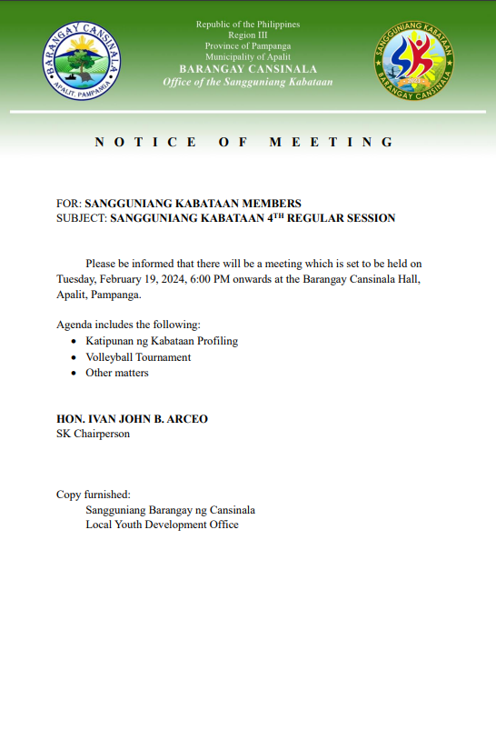

**EXCERPTS FROM THE MINUTES OF THE SPECIAL SESSION OF THE SANGGUNIANG KABATAAN OF BARANGAY CANSIANALA HELD AT THE SANGGUNIANG KABATAAN SESSION HALL ON FEBRUARY 20, 2024 AT 6:00 P.M.**

Present:

HON. IVAN JOHN B. ARCEO - SK Chairperson

Presiding Officer

HON. JOYCE ANN T. MANUEL - SK Kagawad

HON. ARNIE M. DE GUZMAN - SK Kagawad

HON. ELCIED V. LOPEZ - SK Kagawad

HON. EDRIAN PAUL G. MANDAP - SK Kagawad

HON. ARABELLA C. CASTRO - SK Kagawad

HON. ALEXCIS M. BAMBA - SK Kagawad

HON. ANTON KYLE M. ESTANISLAO - SK Kagawad

ALSO PRESENT:

MR. RICARDO C. REYES JR. - SK Secretary

MR. RODEL L. BINUYA - SK Treasurer

Absent:

NONE

x-----------------------------------------------------------------------------------------------------------------------------------x

RESOLUTION NO. 01

Series of 2024

**A RESOLUTION AUTHORIZING THE SK CHAIRMAN IVAN JOHN B. ARCEO AND THE SK TREASURER RODEL L. BINUYA TO UPDATE THE SIGNATORIES FOR LANDBANK APALIT BRANCH WITH ACCOUNT NUMBER 3422-1045-76 TO TRANSACT OFFICIAL BUSINESS WITH THE LANDBANK OF THE PHILS. APALIT BRANCH AND ACT AS OFFICIAL SIGNATORIES OF SANGGUNIANG KABATAAN FUNDS OF BARANGAY CANSINALA, APALIT, PAMPANGA.**

**WHEREAS,** in the interest of the service and for the continuous delivery of basic services to the constituents, the Barangay Council should authorize the SK Chairman and the duly appointed SK Treasurer to transact business with the Landbank of the Philippines- Apalit Branch;

**WHEREAS,** specimen signatories of the authorized signatories should be forwarded for the said bank for their record and guidance;

**NOW THEREFORE,** on motion of **SK KAGAWAD ANTON KYLE M. ESTANISLAO,** Budget Monitoring Officer (BMO) duly seconded by all members present

**RESOLVED THAT, SK CHAIRMAN IVAN JOHN B. ARCEO** AND **SK TREASURER RODEL L. BINUYA are hereby** authorized to transact official business with Landbank of the Philippines

Apalit Branch to act as the official signatories of SK Funds of Barangay Cansinala, Apalit, Pampanga.

**RESOLVED FURTHER,** that copy of this resolution be furnished the concerned local government offices pertaining to this matter;

ADOPTED, February 20, 2024.

x-----------------------------------------------------------------------------------------------------------------------------------x

I HEREBY CERTIFY to the correctness of the foregoing Resolution which was duly adopted by the Sangguniang Kabataan during its special session held on February 20, 2024.

**RICARDO C. REYES JR.**

SK Secretary

ATTESTED AND CERTIFIED

TO BE DULY ADOPTED

**____HON. IVAN JOHN B. ARCEO_____**

Presiding Officer/SK Chairperson

|  |  |
| --- | --- |
| **HON. JOYCE ANN T. MANUEL**  SK Kagawad | **HON. ARNIE M. DE GUZMAN**  SK Kagawad |
| **HON. ELCIED V. LOPEZ**  SK Kagawad | **HON. EDRIAN PAUL G. MANDAP**  SK Kagawad |
| **HON. ARABELLA C. CASTRO**  SK Kagawad | **HON. ALEXCIS M. BAMBA**  SK Kagawad |
| **HON. ANTON KYLE M. ESTANISLAO**  SK Kagawad | |
|  | |
|  | |
|  | |