Payroll glitch for the period of Febaury 1 – 15, 2020 (semi-monthly)

1. Should have 4 mins late and no undertime.

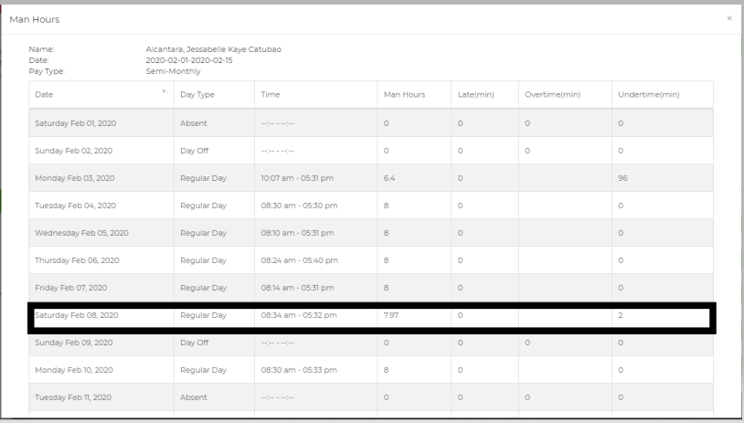

1. Can’t figure out how it was computed. She has 2 time in and out on the same date.

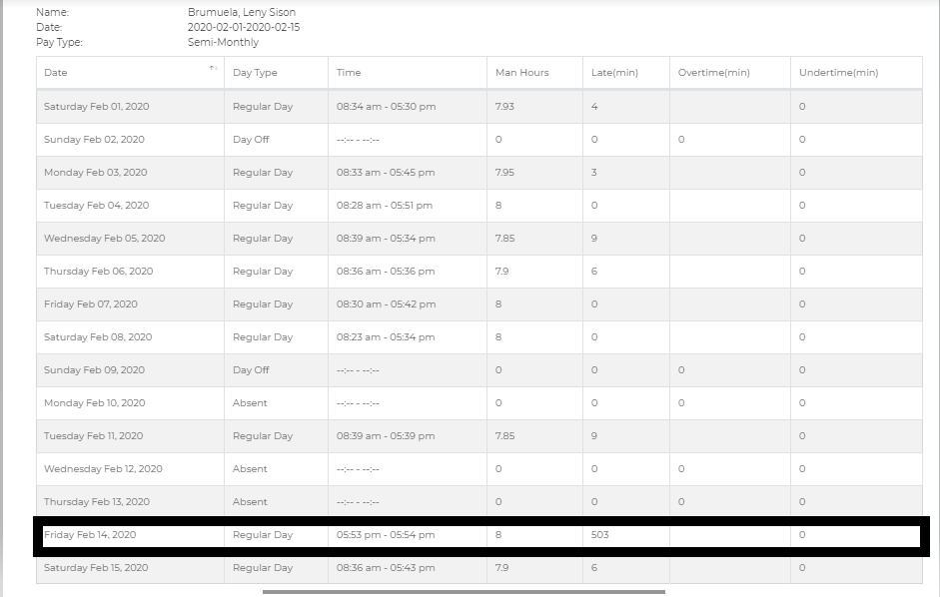

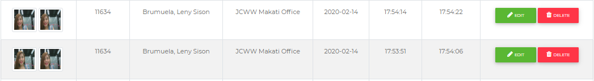

1. April fortin
2. Feb 7, 2020 should not be paid as 1 day.

Feb 20, 2020 should be computed as halfday.

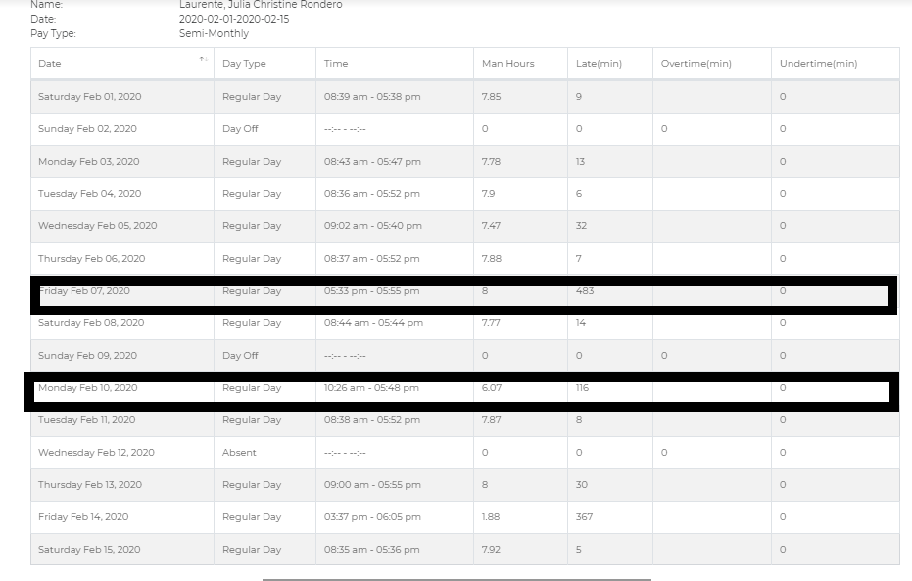

1. Feb 3, 2020 undertime should be 30 minutes only instead of 150 minutes.

Feb 7, 2020 undertime should be 30 minutes only instead of 75 minutes.

Feb 15, 2020 undertime should be 180 minutes only instead of 210 minutes.

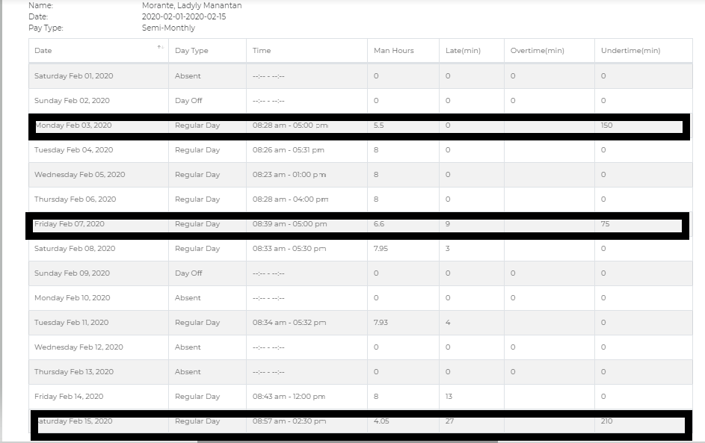

1. Should be computed as one whole day and no undertime.

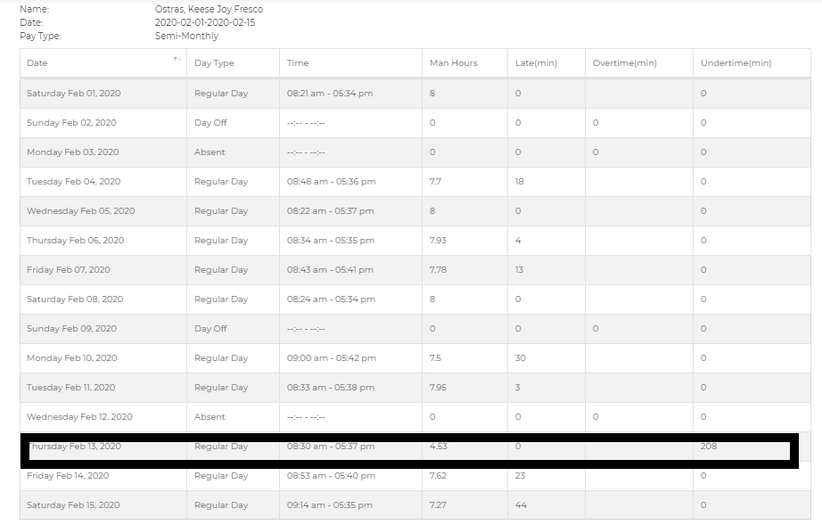

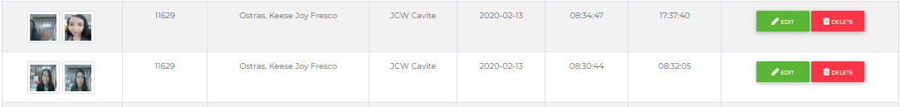

1. Should be computed as halfday duty.

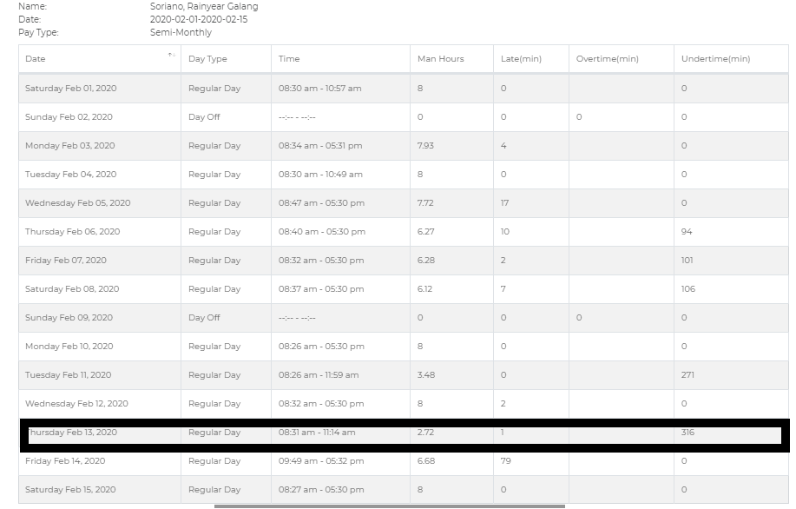

1. Feb 5, 2020 should be computed as halfday.

Feb 6, 2020 undertime should be 90 minutes only instead of 180 minutes.

Feb 7, 2020 undertime should be 30 minutes only instead of 75 minutes.

Feb 14, 2020 there should be no undertime computed.

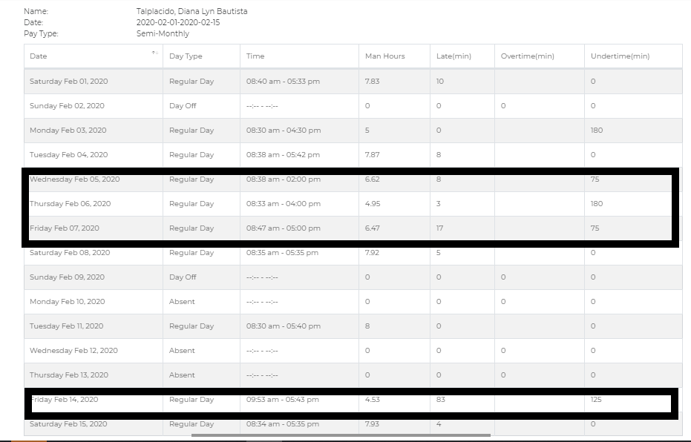

1. Should be no undertime computed.

