Salespeople-data
Kenneth Manuel
3/27/2021
library("tidyverse")
## -- Attaching packages --------------------------------------- tidyverse 1.3.0 --
## v ggplot2 3.3.3 v purrr 0.3.4
## v tibble 3.0.6 v dplyr 1.0.4
## v tidyr 1.1.2 v stringr 1.4.0
## v readr 1.4.0 v forcats 0.5.1
## -- Conflicts ------------------------------------------ tidyverse_conflicts() --
## x dplyr::filter() masks stats::filter()
## x dplyr::lag() masks stats::lag()
library("readxl")
library("NbClust")
library("factoextra")
## Warning: package 'factoextra' was built under R version 4.0.4
## Welcome! Want to learn more? See two factoextra-related books at https://goo.gl/ve3WBa
library("MASS")
##
## Attaching package: 'MASS'
## The following object is masked from 'package:dplyr':
##
## select
library("caret")
## Warning: package 'caret' was built under R version 4.0.4
## Loading required package: lattice
##
## Attaching package: 'caret'
## The following object is masked from 'package:purrr':
##
## lift
data <- read_excel('Salespeople-data.xlsx')
head(data)
## # A tibble: 6 x 7
## Salegrow saleproft Newsale createst Mechtest absttest mathtest
## <dbl> <dbl> <dbl> <dbl> <dbl> <dbl> <dbl>
## 1 93 96 97.8 9 12 9 20
## 2 88.8 91.8 96.8 7 10 10 15
## 3 95 100. 99 8 12 9 26
## 4 101. 104. 107. 13 14 12 29
## 5 102 108. 103 10 15 12 32
## 6 95.8 97.5 99.3 10 14 11 21

Menentukan keputusan berapa kluster yang akan digunakan
fviz_nbclust(data, kmeans, method = "wss") +
geom_vline(xintercept = 2 , linetype = 2)+
labs(subtitle = "Elbow method")
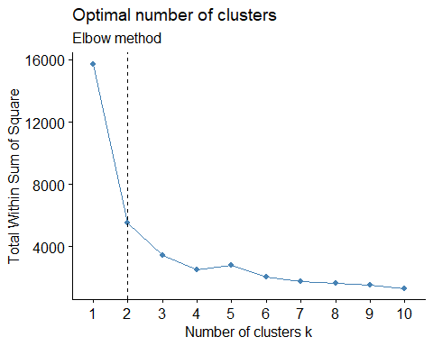
fviz_nbclust(data, kmeans, method = "silhouette")+
labs(subtitle = "Silhouette method")
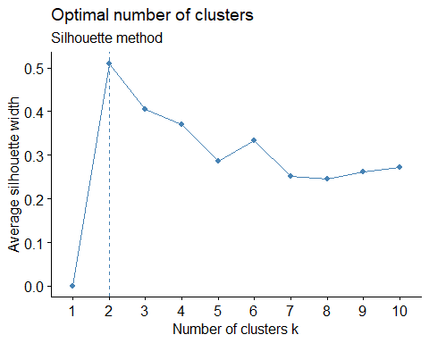
fviz_nbclust(data, kmeans, nstart = 25, method = "gap_stat", nboot = 50)+
labs(subtitle = "Gap statistic method")
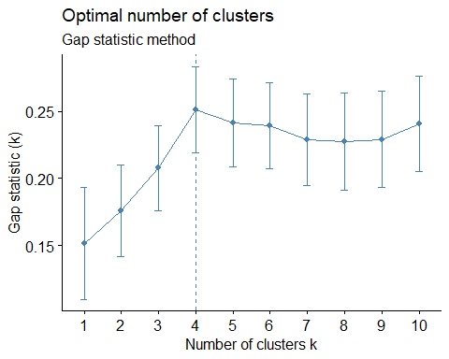
Terlihat bahwa metode elbow dan metode silhouette menyarankan untuk menggunakan 2 cluster sedangkan gap statistics menyarankan untuk menggunakan 4 cluster.
Karena dua metode yaitu silhouette dan elbow menyarankan untuk menggunakan 2 cluster maka clustering akan dibagi menjadi 2 cluster

K-means clustering
km.res <- eclust(data, "kmeans", k = 2,
nstart = 25, graph = FALSE)
# k-means group number of each observation
km.res$cluster
## [1] 2 2 2 1 1 2 2 1 1 1 1 1 1 1 1 2 1 1 2 1 2 1 2 1 1 2 1 1 2 1 1 2 2 2 1 1 2 2
## [39] 1 1 1 2 1 2 2 1 2 2 1 1
fviz_cluster(km.res, ellipse.type = "norm")
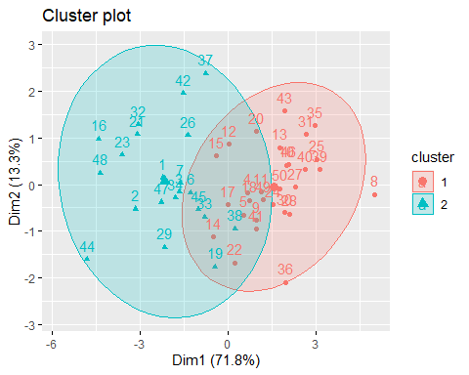
#fviz_silhouette(km.res)

Hierachical clustering dengan jarak euclidean dan metode single linkage
# dissimilarity matrix
res.dist <- dist(data, method = 'euclidean')
res.hc <- hclust(d = res.dist, method = 'single')
hc.cluster <- cutree(res.hc, k = 2)
hc.cluster
## [1] 1 1 1 1 1 1 1 2 1 1 1 1 1 1 1 1 1 1 1 1 1 1 1 1 1 1 1 1 1 1 1 1 1 1 1 1 1 1
## [39] 1 1 1 1 1 1 1 1 1 1 1 1
fviz_dend(res.hc, rect = TRUE, show_labels = TRUE, cex = 0.5, color_labels_by_k = TRUE)
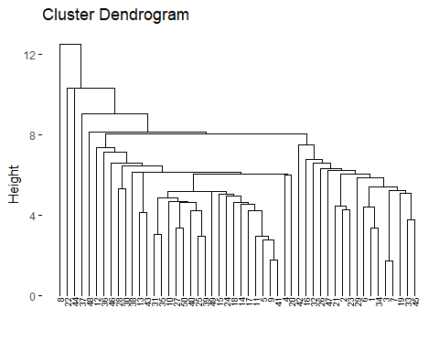
#fviz_silhouette(res.hc)

Comparing hierachical clustering and K-means clustering
km.res$cluster
## [1] 2 2 2 1 1 2 2 1 1 1 1 1 1 1 1 2 1 1 2 1 2 1 2 1 1 2 1 1 2 1 1 2 2 2 1 1 2 2
## [39] 1 1 1 2 1 2 2 1 2 2 1 1
hc.cluster
## [1] 1 1 1 1 1 1 1 2 1 1 1 1 1 1 1 1 1 1 1 1 1 1 1 1 1 1 1 1 1 1 1 1 1 1 1 1 1 1
## [39] 1 1 1 1 1 1 1 1 1 1 1 1
Attaching cluster result label to data
cluster.member1 <- data.frame(cluster = km.res$cluster)
data.c1 <- cbind(data, cluster.member1)
cluster.member2 <- data.frame(cluster = hc.cluster)
data.c2 <- cbind(data, cluster.member2)

Linear discriminant analysis hasil K-Means
Dengan mengasumsi bahwa masing - masing variabel berdistribusi normal univariate.

1. Data preparation

Split data to training and test set
# Split the data into training (80%) and test set (20%)
set.seed(123)
training.samples <- data.c1$cluster %>%
createDataPartition(p = 0.8, list = FALSE)
train.data <- data.c1[training.samples, ]
test.data <- data.c1[-training.samples, ]

Normalize data
# Estimate preprocessing parameters
preproc.param <- train.data %>%
preProcess(method = c("center", "scale"))
# Transform the data using the estimated parameters
train.transformed <- preproc.param %>% predict(train.data)
test.transformed <- preproc.param %>% predict(test.data)

Compute LDA
model <- lda(cluster~., data = train.transformed)
model
## Call:
## lda(cluster ~ ., data = train.transformed)
##
## Prior probabilities of groups:
## -0.646418705528501 1.50831031289984
## 0.7 0.3
##
## Group means:
## Salegrow saleproft Newsale createst Mechtest
## -0.646418705528501 0.5430821 0.5055945 0.4661681 0.2414054 0.2591322
## 1.50831031289984 -1.2671915 -1.1797205 -1.0877255 -0.5632794 -0.6046417
## absttest mathtest
## -0.646418705528501 0.3392754 0.5026441
## 1.50831031289984 -0.7916426 -1.1728362
##
## Coefficients of linear discriminants:
## LD1
## Salegrow -2.08620271
## saleproft -1.33833281
## Newsale -0.26834511
## createst -0.06032613
## Mechtest 0.88695151
## absttest -0.08842310
## mathtest 1.25657273

2. Make predictions
predictions <- model %>% predict(test.data)
names(predictions)
## [1] "class" "posterior" "x"

3. Model accuracy
mean(predictions$class==test.transformed$cluster)
## [1] 0.1

Linear discriminant analysis hasil Hierachical clustering
Dengan mengasumsi bahwa masing - masing variabel berdistribusi normal univariate.

1. Data preparation

Split data to training and test set
# Split the data into training (80%) and test set (20%)
set.seed(123)
training.samples <- data.c2$cluster %>%
createDataPartition(p = 0.8, list = FALSE)
train.data <- data.c2[training.samples, ]
test.data <- data.c2[-training.samples, ]

Normalize data
# Estimate preprocessing parameters
preproc.param <- train.data %>%
preProcess(method = c("center", "scale"))
# Transform the data using the estimated parameters
train.transformed <- preproc.param %>% predict(train.data)
test.transformed <- preproc.param %>% predict(test.data)

Compute LDA
model <- lda(cluster~., data = train.transformed)
model
## Call:
## lda(cluster ~ ., data = train.transformed)
##
## Prior probabilities of groups:
## -0.158113883008418 6.16644143732834
## 0.975 0.025
##
## Group means:
## Salegrow saleproft Newsale createst Mechtest
## -0.158113883008418 -0.0421968 -0.03730924 -0.06884791 -0.04332918 -0.04315877
## 6.16644143732834 1.6456753 1.45506023 2.68506851 1.68983814 1.68319184
## absttest mathtest
## -0.158113883008418 -0.05332308 -0.04969867
## 6.16644143732834 2.07959996 1.93824821
##
## Coefficients of linear discriminants:
## LD1
## Salegrow -2.3012237
## saleproft -3.1539512
## Newsale -1.0298809
## createst 1.5560344
## Mechtest 1.3197588
## absttest 0.9053936
## mathtest 5.0205975

2. Make predictions
predictions <- model %>% predict(test.data)
names(predictions)
## [1] "class" "posterior" "x"

3. Model accuracy
mean(predictions$class==test.transformed$cluster)
## [1] 1
Dilihat dari model akurasi dapat disimpulkan bahwa metode hierachical clustering dengan jarak euclidean + metode single linkage lebih akurat dibanding metode k-means.
#simpan kluster
clusterSales <- cbind(data, Cluster = km.res$cluster)
head(clusterSales)
## Salegrow saleproft Newsale createst Mechtest absttest mathtest Cluster
## 1 93.0 96.0 97.8 9 12 9 20 2
## 2 88.8 91.8 96.8 7 10 10 15 2
## 3 95.0 100.3 99.0 8 12 9 26 2
## 4 101.3 103.8 106.8 13 14 12 29 1
## 5 102.0 107.8 103.0 10 15 12 32 1
## 6 95.8 97.5 99.3 10 14 11 21 2
group <- cutree(res.hc, k=2)
HierarchySales <- cbind(data, Group = as.factor(group))
head(HierarchySales)
## Salegrow saleproft Newsale createst Mechtest absttest mathtest Group
## 1 93.0 96.0 97.8 9 12 9 20 1
## 2 88.8 91.8 96.8 7 10 10 15 1
## 3 95.0 100.3 99.0 8 12 9 26 1
## 4 101.3 103.8 106.8 13 14 12 29 1
## 5 102.0 107.8 103.0 10 15 12 32 1
## 6 95.8 97.5 99.3 10 14 11 21 1
HierarchySales %>%
group_by(Group) %>%
summarise_all("mean")
## # A tibble: 2 x 8
## Group Salegrow saleproft Newsale createst Mechtest absttest mathtest
## * <fct> <dbl> <dbl> <dbl> <dbl> <dbl> <dbl> <dbl>
## 1 1 98.7 106. 103. 11.1 14.1 10.5 29.3
## 2 2 111. 122 115. 18 20 15 51
##iv. Buatkan analisis diskriminan untuk memperoleh: #a. Prosentase ketepatan klasifikasi 50 slaesman ke hasil iii.a. maupun ke hasil iii.b.
#b. fungsi diskriminan berdasarkan hasil iii.a. maupun ke hasil iii.b.
lda(Cluster~., data = clusterSales)
## Call:
## lda(Cluster ~ ., data = clusterSales)
##
## Prior probabilities of groups:
## 1 2
## 0.58 0.42
##
## Group means:
## Salegrow saleproft Newsale createst Mechtest absttest mathtest
## 1 104.07931 113.80345 105.90690 12.82759 15.68966 11.413793 37.13793
## 2 91.88095 96.70476 98.53333 9.00000 12.09524 9.380952 19.57143
##
## Coefficients of linear discriminants:
## LD1
## Salegrow -0.2355171
## saleproft -0.2280978
## Newsale -0.2413533
## createst 0.1330236
## Mechtest 0.2773746
## absttest 0.1525134
## mathtest 0.1723275
lda(Group~., data = HierarchySales)
## Call:
## lda(Group ~ ., data = HierarchySales)
##
## Prior probabilities of groups:
## 1 2
## 0.98 0.02
##
## Group means:
## Salegrow saleproft Newsale createst Mechtest absttest mathtest
## 1 98.71429 106.3082 102.5551 11.08163 14.06122 10.46939 29.32653
## 2 110.80000 122.0000 115.3000 18.00000 20.00000 15.00000 51.00000
##
## Coefficients of linear discriminants:
## LD1
## Salegrow -0.4387502
## saleproft -0.3523443
## Newsale -0.1098142
## createst 0.3371347
## Mechtest 0.4602539
## absttest 0.3701557
## mathtest 0.5176323

