WITHDRAWAL FORM
In terms of section 71(2)(b)(i) of the National Credit Act 34 of 2005

TO: (An individually addressed notification must be sent to credit department of each credit provider listed in application for debt review)
Creditor | Address | Contact | Account Details
TRUWORTHS | 3 The Crescent  East Westway Office Park  Westville  3630 | Tel: 031 251 4252  Fax: 086 643 8456  E-mail: courts@consumerfriend.co.za | Current Balance: R730.00  Instalment: R121.00  Interest Rate :0.00
BAYPORT | Postnet Suite 116  Private Bag X43  Sunninghill  2157 | Tel 086 145 6456  Fax: 086 587 5703  E-Mail: DRCourtmatters@bayport.co.za | Current Balance: R91691.00  Instalment: R4011.00  Interest Rate : 10.00

From: Name of Debt Counselor Aaron Nzotho
NCR Registration number: NCRDC3693
Address: Suite 2 Second Floor
Central House
17 Central Road
Mabopane
0198
E-Mail: debtreview@zenowethu.co.za

Contact Number: 081 310 9585

Date form16 Signed: 23 June 2021
Full Names and Surname of Consumer |  |  | Legodi Thato Phyllis
Identity No: of consumer |  | 8 |  | 8 |  | 0 | 3 | 1 |  | 6 |  | 0 | 7 |  | 1 | 1 |  | 0 | 8 |  | 0
This notice serves to advise you that: (Select the appropriate option)

A) The consumer has withdrawn from the debt review process prior to issuance of Form 17.2 and the credit
bureaus have been updated accordingly via the NCR Debt help System.
B) The debt counsellor has suspended provision of service due to non-cooperation by the consumer. The debt
counsellor remains the debt counsellor on record.
C) The consumer has obtained a court order to rescind the debt review order. Credit bureaus have been updated
via the NCR Debt Help System.
D) The consumer has obtained an order declaring the consumer no longer over indebted. Credit bureaus
have been updated via the NCR Debt Help System.
Signed at | Pretoria |  |  |  | On this [day] |  |  |  | 09 |  | Of [month] |  |  | October |  |  | Of [year] |  |  | 2023
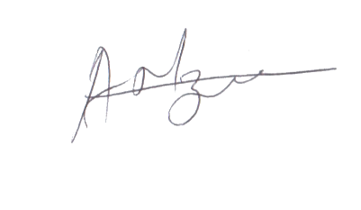
Signature

