WITHDRAWAL FORM
In terms of section 71(2)(b)(i) of the National Credit Act 34 of 2005

TO: (An individually addressed notification must be sent to credit department of each credit provider listed in application for debt review)
Creditor | Address | Contact | Account Details
NEDBANK PERSONAL LOAN | 135 Rivonia Road  Gauteng | Tel: 086 010 9279  Fax: 010 251 0055  E-mail: debtcounselling@nedbank.co.za | Current Balance: R5 866.00  Instalment: R854.00  Interest Rate: 10.00
TRUWORTHS | 1 Mostert Street  Cape Town City Centre  Cape Town  8000 | Tel: 031 251 4151  Fax: 087 943 0170  E-Mail: courts@consumerfriend.co.za | Current Balance: R25 070.00  Instalment: R878.00  Interest Rate: 10.00

From: Name of Debt Counselor Aaron Nzotho
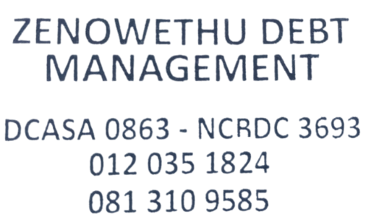
NCR Registration number: NCRDC3693
Address: Suite 2 Second Floor
Central House
17 Central Road
Mabopan
0198
E-Mail: debtreview@zenowethu.co.za

Contact Number: 081 310 958
Full Names and Surname of Consumer |  |  | FONTO NONHLANHLA
Identity No: of consumer |  | 8 |  | 2 |  | 0 | 6 | 0 |  | 3 |  | 1 | 5 |  | 1 | 2 |  | 0 | 8 |  | 5
This notice serves to advise you that: (Select the appropriate option)

A) The consumer has withdrawn from the debt review process prior to issuance of Form 17.2 and the credit
bureaus have been updated accordingly via the NCR Debt help System.
B) The debt counsellor has suspended provision of service due to non-cooperation by the consumer. The debt
counsellor remains the debt counsellor on record.
C) The consumer has obtained a court order to rescind the debt review order. Credit bureaus have been updated
via the NCR Debt Help System.
D) The consumer has obtained an order declaring the consumer no longer over indebted. Credit bureaus
have been updated via the NCR Debt Help System.
Signed at | Pretoria |  |  |  | On this [day] |  |  |  | 20 |  | Of [month] |  |  | December |  |  | Of [year] |  |  | 2024
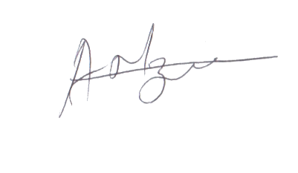
Signature

